Human Resource Management
Assessment 1

Student name: Nicholas Batty
Student number: 1706986
University of Wales Trinity St David
Module: SBMA7101D Human Resource Management Assessment 1
Raspberry Pi Foundation report ‘Employee Engagement’
Date: 30th April 2018
Word count excluding titles, figures and Bibliography: 2574

Contents
1. Executive Summary 3
2. Introduction 3
3. ‘Concepts of Employee Engagement and Employee involvement’ 4
3.1 What is employee engagement and employee involvement? 4
3.2 What is employee involvement? 8
3.3 Motivational Traits 8
4. Advantages of employee engagement and involvement 10
5. What does the company need to do? 11
5.1 Strategic HRM 11
5.2 Benefits of SHRM 12
5.3 The Harvard model 12
6. Recommendations 15
6.1 First recommendation 15
6.2 Second recommendation 15
6.3 Third recommendation 16
7. Conclusion 17
8. Bibliography 19

- Executive Summary

I have been asked to formulate a report by my manager, whom has just returned from a conference on ‘Employee involvement - enhancing morale and improving performance’. She is convinced employee engagement is the way forward. The organisation currently employs 100 staff, which is planned to grow in the very near future. The employees are a mix of full-time permanent and volunteers. This paper provides a report to senior management to consider ways to enhance the employee engagement within the Raspberry Pi Foundation. I will firstly discuss the concepts of employee engagement and their involvement. Secondly, what the advantages of improved employee engagement /involvement may be, and what problems may arise. Finally, what recommendations the foundation needs to be aware of, in which to implement.
- Introduction
The Raspberry Pi foundation (for this report abbreviated to Pi), is a learning and educational third sector non-profit organisation. It was established by Eben Upton, Rob Mullins, Jack Lang and Alan Mycroft in May 2009 in England and Wales (Raspberry Pi, 2018 & Upton, 2016). The rationale behind the Pi foundation establishment, evolved when the founders were in Cambridge University in 2006. The number of students applying for Computer Science courses was declining. The attitude to programming today is far from what was happening in the 80’s as described by History Extra. Upton, Mullins, Lang and Mycroft wanted to change the attitude of young individuals and open computer programming opportunities to the younger generations, thus increasing more interest in computer science skills.
The foundation was established to enhance young minds in computer science skills, using proprietary languages called ‘Rasbian’ and ‘Noobs’, and by also producing a mini, low-cost microcomputer that can be programmed to perform many different tasks for less than $35, with the option to expand and enhance functionality later. Upton’s ambition is to provide every child in Britain with a programmable credit card sized computer (Joyce, 2012). Pi was originally manufactured in China, however in 2012 the manufacturing process was moved to the Sony Technology Centre at Pencoed in Mid Glamorgan in Wales. The factory, as of September 2016 announced more than 10 million units were produced (Pi, 2016). According to research by the UK government, the UK is facing a skills shortage in IT and the digital communities, as outlined in a Government paper, (HC270, 2016-17) which explains some of the industry concerns with respect to a training, and knowledge shortage. Google has funded ‘Code Club Pro’ to train 200 hundred teachers in computing, and Pi to train a further 750 teachers across the country through ‘Picademies’ aimed at Key Stages 3 and 4 (HC270, 2016-17).
- ‘Concepts of Employee Engagement and Employee involvement’

In the next paragraphs I will discuss the concepts of employee engagement and involvement.
  - What is employee engagement and employee involvement?

Several academics and researchers see the meaning of the word ‘Employee Engagement’ as unclear or ambiguous as explained by Macy & Schneider, (2008). Employee engagement can be embraced directly by employees within an organisation according to Lewis, (2011), rather than the job itself. Each employee is different, and each role or task differs from each other. Engagement will differ among individuals as explained by Gourlay et al, (2012). By understanding the employees, they will feel more committed, enthusiastic, positive and dedicated to an organisation, potentially leading to loyalty and lower attrition if an investment is made in them (May et al., 2004). They will use their talent to the highest abilities.
There is much research pertaining to the value of employee engagement, as an example Kahn, (1990) – (Psychological Conditions of Personal Engagement and Disengagement) explains in his paper, that personal engagement is to permit employees the ability to self-express, and to promote collaborative working with others.
Figure 1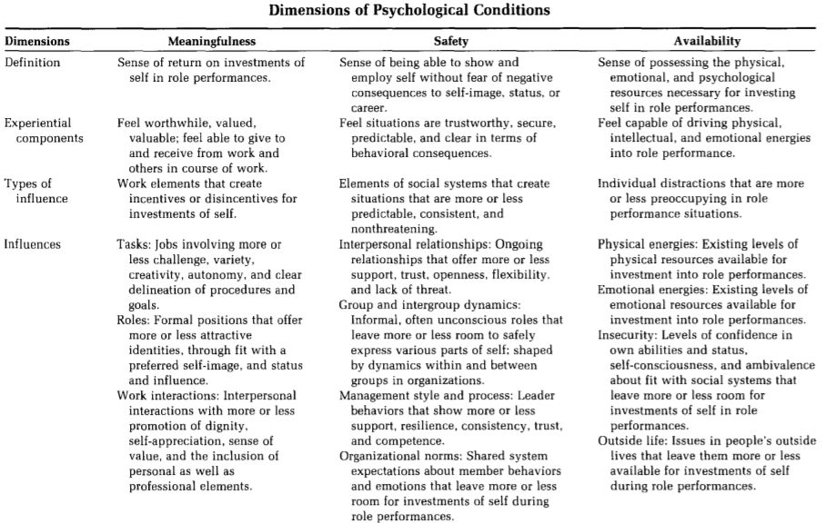
(Kahn, 1990)
I summarise from Kahn’s, (1990) paper. If employees feel safe they will exhibit many positive traits as described in Figure 1.
By providing employees the empowerment to work with emotional attachment, be able to express themselves physically & verbally, to instil positivity in the work place, and allow them to feel safe, it is believed that productivity, efficiencies and job satisfaction will be gained, as explained by Kahn, (1990).
As cited by Spreitzer, (1995) ‘Psychological availability’, produces employee engagement. According to Kahn, (1990) 'Psychological availability' is also the ability to engage because of having the emotional and physical ability.
Markos & Sridevi from International Journal of Business and Management (December, 2010) cited that the cost to USA economy is $292 to $355 Billion per annum for disengaged employees. In a more recent study performed by Gallup, according to them, 85% of employees are not engaged at work, and that approximately $7 trillion is lost in productivity (Jim Harter, Gallup, 2017).
According to Robertson-Smith and Markwick, (2009) if employees are empowered with traits of emotion, passion, collaboration, verbal and physical expression, the output traits are job satisfaction, feeling valued, co-operation, opportunity and length of service.
This is summarised in Figure 2, whereby they bring several factors into consideration. Job satisfaction, feeling valued and involved, equality of opportunity, health as safety, length of service, ethnicity, communication and co-operation, all these traits are not that dissimilar to what Khan, (1990) also summarised. They will also feel enthusiastic, inspired, empowered and confident (Dale Carnegie, 2012).
Figure 2
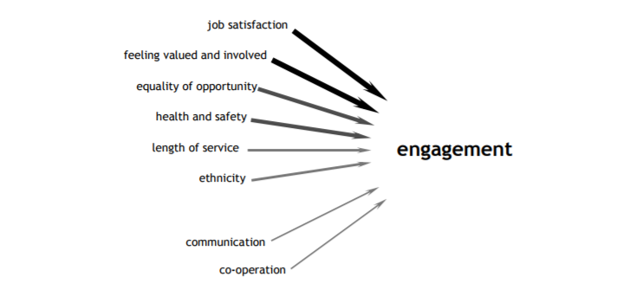
(IES Engagement Survey, 2005)
I pulled my own summary together as detailed in Figure 3. By applying (input) the traits as summarised by Kahn, (1990), Carnegie, (2012), Robertson-Smith and Markwick, (2009) with the outputs listed.
Figure 3
(Batty, 2018)
  - What is employee involvement?

Employee involvement is a direct participation in tasks, goals, milestones, and objectives all with the aim and focus of completing the main mission.
This would involve collaborative communication, ownership and control of a directive mission, task or objective. Quote from CEO Linda Stewart, Interactive Associates - “share in the responsibility for the success of the organisation” (Stewart, 2012).
Employee involvement is also enabling an environment where employees have an impact on business decisions as explained by Kular et al., (2008).
Continuous improvement programs like Kaizen are a good example of this, as explained by Tannenbaum and Schmidt (1958) and Sadler (1970).
  - Motivational Traits

Motivational traits will vary between employees, and each employee is unique. Taking the models from Kahn, (2009), Dale, Robertson-Smith and Markwick, (2012) we can summarise several behaviours in engagement and motivation.
The desire to work (job satisfaction, feeling valued), belief in the organisational direction (opportunity/feeling safe), going the extra mile (co-operation, committed, feeling valued) are some of the traits that enhance motivation.
According to Robinson, Perryman and Hayday IES, (2004) an engaged employee has a positive attitude towards the organisation and its values, as detailed in Figure 4.

Figure 4
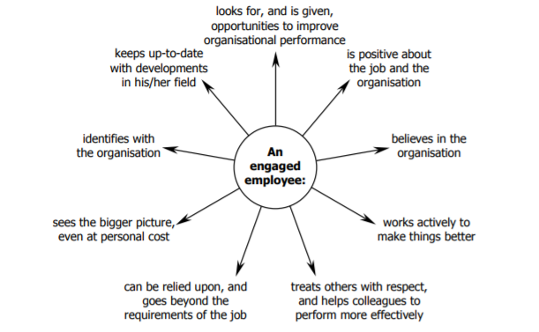
(Robinson, Perryman, Hayday, IES, 2004)
There are many academics that have detailed motivational and behavioural traits. Taking into consideration the motivation traits as detailed by Armstrong, (2016), he believed that psychology played a big part in the connection with an organisation, or motivation and engagement.
As Pi has a mix of employees, some are volunteers, we need to consider the ‘psychological contract’ within the organisation (Rousseau, 1990).
A psychological contract is one which is unwritten setting out informal arrangements, beliefs, commitments, tasks and perceptions between the parties involved.
The psychological contract will develop over time with continual communication between the manager and the employee (CIPD, 2018). We can expect employee engagement and involvement, if employees that have a defined formal written contract, as well as a verbal mutually agreeable, fair and achievable psychological contract, with continual communications between the manager (Rousseau, 1990) & (Jones, 2017).
- Advantages of employee engagement and involvement

According to Armstrong, (2016) motivated and engaged employees will output higher levels of performance.
The advantages of employee engagement and involvement are;
Productivity increase – engaged and involved employees will work harder, smarter faster, longer and with more enthusiasm (CIPD, 2015). When you have a connected employee that is showing interest and positive spirit, productivity will increase. According to APA, (2012), feeling valued by their management team is also very important.
A survey undertaken in North America by Gallup in 2017, showed that with engaged employees, productivity increased by 17% (Gallup, 2017).
Motivated employees – employees that feel special, feel important in meetings, have a voice, have continual encouragement, have an evolving role (not doing the same thing day in, day out) will be of more benefit for Pi (CIPD, 2015).
The employee will try harder to innovate, be more productive, instill positive traits in other employees and will grow and exceed in the organisation (CIPD, 2015. Gallup, 2017). Only 4 in 10 US employees felt they had opportunity to grow (Gallup, 2017).
Influential – if employees feel confident, they are more likely to be involved and engaged in situational matters and can positively influence other employees.
Commitment – employees that are committed, will contribute to the overall success of the organisation. When they are satisfied in their job, they are more likely and willing to go the extra mile for the organisations’ success (Robinson, Perryman, Hayday, 2004).
Innovation – research undertaken by Kingston Business School, (2018), suggested engaged employees are more likely to try new methods to do things, and transform innovated ideas into applications.
The research suggested that 38% of employees develop ideas a few times a year, and 15% showed innovative ideas weekly, showing disengaged employees at 47% in creating innovate solutions (MacLeod, Clarke., 2012).
Pi is an innovative organisation, and thus needs its employees to embrace and show exceptional positivity and innovation.
- What does the company need to do?

In this paragraph I will discuss an HR model best suitable for the Pi organisation.
  - Strategic HRM

Pi currently has 100 employees with the aim to grow quickly. Being an organisation in an innovative and evolving industry, the organisations’ need to be proactive is paramount to its success. The ability to see the environmental changes in the sector, set long term goals and monitor the anticipated growth in the very near future is also of importance to Pi (Kane et, al 2016).
The SHRM methodology will enable talent attraction, development, reward and recognition, and staff retention, benefiting the employees and the organisation overall (Armstrong, 2017). Using an SHRM model in Pi will be beneficial for the success of the employees and organisation, it offers a model where long-term goals, and business goal frameworks can be recognised (CIPD, 2017).
  - Benefits of SHRM

- Strategic planning
- Exceed customer expectations
- A clear business strategy
- Highlight the organisational strengths, weaknesses opportunities and threats (SWOT)
- Develop the employees
- Motivate the employees
- Increase productivity
- Retain the staff
- Reward and recognition
(whatishumanreource.com) (CIPD, 2017)
  - The Harvard model

The model offers a soft approach in its methodologies, better suited to third sector organisations, it will contribute more to the organisational engagement effort and overall success of the business (Beer et al,. 1984) once implemented.
Employee engagement will be more prevalent with this approach.
It allows employees to have input, a voice and is a more humanistic model. Many of the employees are volunteers and should not be treated like part of a business resource (Rees & Smith, 2014).
The Harvard model as detailed in Figure 5, enables 4 key HR outcomes – the 4 C’s.
Commitment – Attachment & Psychological
- Loyalty
- Identity
- Performance
- Satisfaction
Cost efficiencies
- Salary
- Benefits
- Attrition
Competence – ability to execute in the role
- Policies
- Attract, develop and retain employees
- Benefits
- Well-being and sense of worth
Congruence – harmony (no conflict of interests)
- Conformity
- Objectives/goals

Figure 5
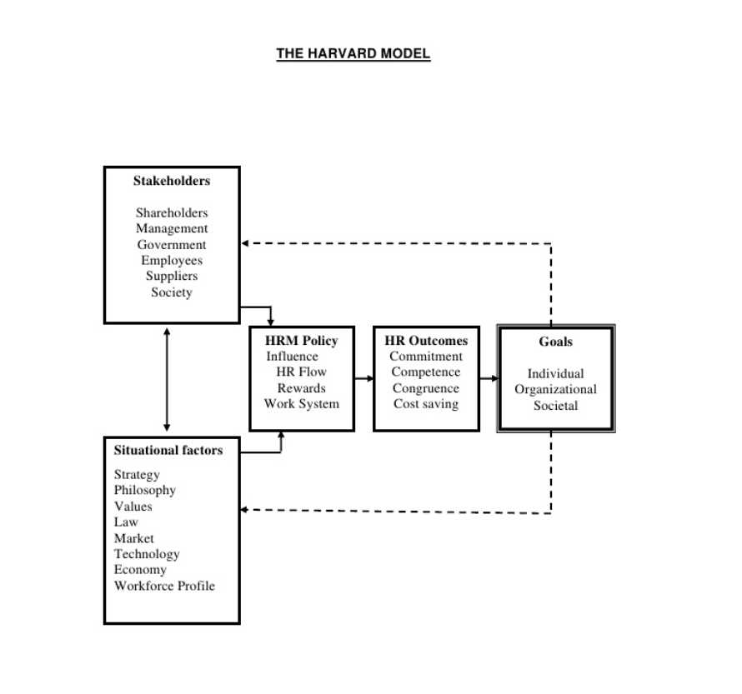
(Beer et al,. 1984).
A ‘Michigan model’ or hard approach model, is not appropriate for a third sector organisation, this is due to the lack of employee input, less humanistic approach, people are treated like a raw material, a company asset, are part of the business, and a resource to achieve the organisational goals (Truss et a, 1997).
- Recommendations

As Pi is a third sector organisation, staff are more likely to be motivated by the social, environmental success of the business, ‘value driven’, rather than the financial gain of the organisation as outlined by National Audit Office (NAT).
  - First recommendation

The first recommendation step is to implement ‘The Harvard model’ (Beer et al,. 1984), this the most suitable model to adapt in the Pi organisation as its more suited to a third sector organisation as detailed in section 5.2 (Truss et al, 1995). The Harvard model exhibits 6 parts, stakeholders (management, society, suppliers, employees), HR policy (influence, rewards, systems), HR outcomes, goals, situational factors, and a loop for continual feedback. What it lacks is a development and training part, of which can be implemented by my second recommendation and they can work in conjunction with each other.
  - Second recommendation

The second recommendation step is to take small steps in implementing the 5 phases of the employee lifecycle (Lawrence, 2015) as detailed in Figure 6. From the outset is recruiting the right candidates in line with the organisational values (best suited to a third sector organisation), develop the employees with a full organisational induction into the organisation’s core values, strategy, training, and knowledge transfer. We then need to look at the advancing the skillset, driving productivity - how? Through mentorship and support from management (Hamm, 2006) to motivate the employee as discussed in section 4. Employee engagement in the ‘Progression phase’ with rewards and recognition allowing the employee to take ownership and ‘manage the mission’ (Tannenbaum and Schmidt, (1958) and Sadler, (1970). Take lessons learned as to What? Why? How? and at what cost did we lose an employee due to the ‘Exit’ phase (Sullivan, 2014). Learn what needs to be done to retain employees.

Figure 6
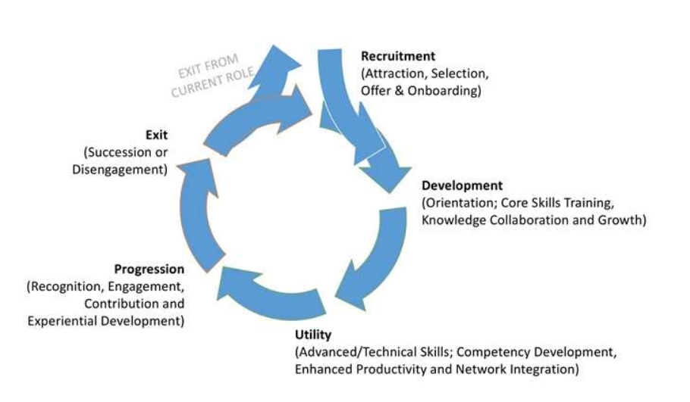

(Mark T Lawrence, 2015)
  - Third recommendation

Working in collaboration with the Harvard model, and the employee 5 phase model, implement an EVR congruence model (Thompson, 2005) (Figure 7). Roll this out in a slow manner, continually analysing the congruence and engagement of the employees. As well as this continually measuring how the organisation is performing against the environmental changes. E= Environment, V= Values, R = resources, this model also embodies SWOT (Strengths, Weaknesses, Opportunities and Threats) part of the SHRM process.
Figure 7

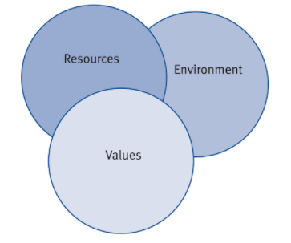
(Kew and Stredwick, 2008)
Continual performance measurement of the organisation is key to its success, as explained by Neely et al,(2001). For example, technology changes in the industry - the hardware on the Pi computer will need to change in line with new technology releases. If Pi gets congruence correct it will aid in the engagement and involved into the organisation.
- Conclusion

I have discussed many facets of employee engagement and involvement, what motivates them, and which best practices are best tailored to implement an employee engagement strategy. Employees need to have trust in the organisation, encouragement, continual development, clear fair management, a safe environment, and a psychological contract. As Pi is forecasted to grow in employee numbers soon, it is important to implement the initiatives and recommendations now. By implementing the three recommendations it will empower the employees with the engagement, involvement and positive attitude, increasing the competency, productivity and capabilities of the employees, thus making Pi a stronger organisation.
Pi is an innovative organisation and needs innovators with energy, passion, motivation and drive, this cannot happen if the employees are disengaged. The impact of disengaged employees will have a negative effect on the organisations’, motivation, productivity, talent retention, skillset and knowledge, all key contributors to Pi’s success, which should be avoided at all costs.

- Bibliography

Armstrong. (2016). Armstrong’s Handbook of Management and Leadership for HR
(4th Edition)

APA. (2012). APA Survey Finds Feeling Valued at Work Linked to Well-Being and Performance
http://www.apa.org/news/press/releases/2012/03/well-being.aspx
Last accessed: 9th March 2018

Beer et al,. (1984). The “Harvard” Model
Source: Beer et al. (1984), , 1, p. 16, Map of the HRM Territory

Boxall. (2013). Mutuality in the management of human resources: assessing the quality of alignment in employment relationships

Dale Carnegie. (2012).
What drives employee engagement and why it matters - White Paper
https://www.dalecarnegie.com/assets/1/7/driveengagement_101612_wp.pdf
Last accessed: 28th February 2018

CIPD. (2015). Learning and Development
https://www.cipd.co.uk/Images/learning-development_2015_tcm18-11298.pdf
Last accessed: 15th March 2018

CIPD. (2017). Strategic human resource management
https://www.cipd.co.uk/knowledge/strategy/hr/strategic-hrm-factsheet
Last accessed: 2nd March 2018

CIPD. (2018). The Psychological contract
https://www.cipd.co.uk/knowledge/fundamentals/relations/employees/psychological-factsheet
Last accessed: 9th March 2018

Gemma Robertson-Smith and Carl Markwick. (2009). pages 1-59
Institute for Employment Studies
Employee Engagement A review of current thinking
http://www.employment-studies.co.uk/system/files/resources/files/469.pdf
Last accessed: 27th February 2018

Hamm. (2006) John Hamm May 2006. - HBR.Org
The Five Messages Leaders Must Manage
https://hbr.org/2006/05/the-five-messages-leaders-must-manage
Last accessed: 8th March 2018

History Extra. (2016). A brave new world: the 1980s home computer boom
The official website for BBC History Magazine and BBC World Histories Magazine
https://www.historyextra.com/period/20th-century/a-brave-new-world-the-1980s-home-computer-boom/
Last accessed: 2nd March 2018

HC270. (2016-2017). House of Commons Science and Technology Committee
Digital skills crisis.
https://publications.parliament.uk/pa/cm201617/cmselect/cmsctech/270/270.pdf
Last Accessed: 10th March 2018

Business.kingston.ac.uk. (2018).
http://business.kingston.ac.uk/sites/default/files/Emotional%20or%20Transactional%20Engagement%20CIPD%202012.pdf
Last accessed 10th March 2018

Kular et al,. (2008). Sandeep Kular, Mark Gatenby, Chris Rees, Emma Soane, Katie
Truss – Kingston University
Employee Engagement: A Literature Review – Working Paper Series No 19
http://business.kingston.ac.uk/sites/default/files/6_rp_emplyengag.pdf
Last accessed: 28th February 2018

Melissa Jones. (2017). Breathing Space
‘What is a psychological contract?’
https://www.breathehr.com/breathingspace/what-is-a-psychological-contract
Last accessed: 2nd March 2018

Joyce. (2012). Raspberry Pi Computer:
Can kids get into code?
BBC News
http://www.bbc.co.uk/news/technology-17192823
Last accessed: 3rd March 2018

Kahn. (1990). – William A Kahn - Psychological Conditions of Personal Engagement
and Disengagement at Work Pages 692-724 Academy of Management Journal; Dec 1990; 33, 4; ProQuest
https://engagementresearch.wikispaces.com/file/view/Kahn+(1990)_Psychological+conditions+of+personal+engagement+and+disengagement+at+work.pdf
Last accessed: 3rd March 2018

Kane et, al. (2016). Gerald C. Kane, Doug Palmer, Anh Nguyen Philips, David
Kiron, and Natasha Buckley.
Aligning the organisation for its digital future
MIT Sloan Review
https://sloanreview.mit.edu/projects/aligning-for-digital-future/
Last accessed: 3rd March 2018

Kew and Stredwick. (2008). John Kew and John Stredwick CIPD
Business environment – Managing in a strategic context
https://books.google.co.uk/books?id=APAoDwAAQBAJ&pg=PA14&lpg=PA14&dq=thompson+2005+congruence&source=bl&ots=QhNEWeGpzd&sig=sBwaNVdodxg3oHQBsEHrodBFe9k&hl=en&sa=X&ved=0ahUKEwiqp_Txjt3ZAhXHJ8AKHZwPA60Q6AEIXTAF#v=onepage&q=thompson%202005%20congruence&f=false
Last accessed: 8th March 2018

Lawrence. (2015). Mark T. Lawrence
Automation, analytics and data in HR – HR Zone
https://www.hrzone.com/perform/business/employee-lifecycle-get-deeper-insight-by-aligning-analytics-initiatives
Last accessed: 8th March 2018

Lewis, S. (2011). Positive Psychology at Work: How Positive Leadership and
Appreciative Inquiry Create Inspiring Organizations.

David MacLeod and Nita Clarke. (2012). Employee Engagement Task Force
“Nailing the evidence” workgroup
Engaged for success
http://engageforsuccess.org/wp-content/uploads/2015/09/The-Evidence.pdf
Last accessed: 2nd March 2018

May, D., Gilson, R. and Harter, L. (2004).
The psychological conditions of meaningfulness, safety and availability and the engagement of the human spirit at work. Journal of Occupational and Organizational Psychology.
http://www.paulmarciano.com/wp-content/uploads/2011/03/The-psychological-conditions-of-meaningfulness-safety-and-availability-.-.-.-.pdf
Last accessed: 1st March 2018

NAT National Audit Office
What are third sector organisations and their benefits for commissioners?
https://www.nao.org.uk/successful-commissioning/introduction/what-are-civil-society-organisations-and-their-benefits-for-commissioners/
Last accessed: 8th March 2018

Neely et al. (2002). Andy Neely, Chris Adams, Mike Kennerley
The Performance Prism: The Scorecard for Measuring and Managing Business Success
Pearson Education 2002
http://akhealth.co.nz/Tertiary%20Conference/PDF's/2009/General%20Papers/NM%20Performance%2520Prism.pdf
Last accessed: 12th March 2018

D Robinson, S Perryman, S Hayday. (2004). The Drivers of Employee Engagement
report 408
http://www.employment-studies.co.uk/system/files/resources/files/408.pdf
Last accessed: 15th March 2018
Solomon Markos & M. Sandhya Sridevi. (2010). International Journal of Business
and Management (Vol. 5, No. 12; December 2010)
Employee Engagement: The Key to Improving Performance
http://www.ccsenet.org/journal/index.php/ijbm/article/viewFile/6745/6332
Last Accessed: 12th March 2018

Stewart (20120 Linda Stewart CEO Interactive Associated
Leaders and Employee Involvement
https://www.youtube.com/watch?v=UQWzz9VdiU4
Last accessed: 13th March 2018

Raspberry Pi (2018). About Us
https://www.raspberrypi.org/about/
Last accessed: 3rd March 2018

Pi (2016). Raspberry Pi Weekly issue #169
10MillionPi
https://www.raspberrypi.org/weekly/10millionpi/
Last accessed: 8th March 2018

Truss et al,.m. (1997). Catherine Truss, Lynda Gratton, Veronica Hope-Haley,
Patrick McGovern, Philip Stiles
Soft and hard models of human resource management: a reappraisal
https://www.researchgate.net/publication/38176140_Soft_and_Hard_Models_of_Human_Resource_Management_A_Reappraisal
Last accessed: 8th March 2018

Robert Tannenbaum and Waren H Schmidt. (1973). HBR
How to Choose a Leadership Pattern

Sullivan. (2014). Dr John Sullivan 28th July 2014 ere.net
Retention — The Top 10 Ways a Manager Can Identify Who Is About to Quit
https://www.ere.net/retention-the-top-10-ways-a-manager-can-identify-who-is-about-to-quit/
Last accessed: 8th March 2018

Upton. (2016). The Story of Raspberry Pi
The Centre for Computing History
https://www.youtube.com/watch?v=UCt6d0SCxO4
Last accessed: 3rd March 2018

Whatishumanresource.com. Website on HRM for students
http://www.whatishumanresource.com/strategic-human-resources-management
Last accessed: 3rd March 2018

William H. Macey & Benjamin Schneider. (2008).
Society for Industrial and Organizational Psychology
The Meaning of Employee Engagement pages 3-30

