Student Name: Sarda-Anu-Stefania Kumar  Student ID: 2230813  Module Title: Foreign Languages & Cultural Awareness  Module Code: BMIH5003  Lecturer: Lisa Bassler  Date: 09.02.2024 | 
ASSIGNMENT 1: PORTFOLIO
(4 Components)

Component 1: Professional Reflection (500 words +/- 10%)

Weighting: 25%
The role of our culture plays a significant part in shaping our conduct, convictions, and way of life. It entails appreciating and valuing differences while also understanding and respecting the social norms, etiquette, religions, languages, and clothing customs specific to each culture. (Fadiloglulari, Y., 2023)
In an era where cross-cultural collaboration is becoming more prevalent worldwide, the potential for intercultural misunderstandings is also on the rise. (Glowacka, M., 2023)
One example of a cultural misunderstanding I’ve been witness to happened during dinner time at the hotel’s restaurant where I did my placement.
A couple staying at the hotel wanted to take dinner at our hotels restaurant, important to specify is that this was their first stay at Forest Pines Hotel, and also that they were Muslims by religion.
The man asked my colleague, about the menu and if a specific dish was, as they call it “halal” food.
The mistake was made because the waiter did not know the fully meaning of the word and he answered “yes”.
In particular, halal food refers to meals that been made, produced and stored using equipment and utensils that have been thoroughly cleaned in accordance with Islamic law – shariah. (ICV, 2022)
Some time after serving them, my colleague was called back by the couple. The husband noticed some meat seemed to be pork so he asked that. The answer lead to a huge argument in the restaurant because the waiter told him that the dish contains indeed also pork.
It appears that my new colleague did not asked further in the kitchen how the dish is prepared in order to be sure that he can properly answer the clients question, so the manager was called.
My manager apologised and assured them that this was a unique situation as the waiter was a new employee and did not know better, although this was no excuse for him not to ask further, and offered the couple a free dinner and a complementary stay of two days whenever they would like to return.
I, personally would have not made this mistake, mainly because, having different religion parents, my culture awareness is slightly more developed concerning the food culture – so I know what “halal” means.
I think that a hospitality industry employee should be trained properly for these type of cases; they must know different types of food culture, especially since a hotel is having worldwide customers.
Some of the skills required are the attention to details, fast learning, strong willed, communication and customer focus. I consider that I already have these skills, although I can work more on developing the communication part – as English is not my native language – and I can do this by taking complementary English lessons.
The whole situation could’ve been avoided if the hotel had trained its employees properly before starting the job.
Although the customers were nice enough to understand the whole situation in the end, they said that they will not be eating at the hotel’s restaurant anymore and they weren’t sure if would ever came back, so I can say that the hotel’s reputation will be impacted, as they will most definitely not recommend it to anyone or give a positive feedback.
This example demonstrates exactly why the cultural awareness is important.

References:
- Fadiloglulari Yaren, 2023, What Are the Benefits of Cultural Awareness? – (online) available at 7 Impactful Benefits of Cultural Awareness | GoAbroad.com accessed on 25th January 2024
- Glowacka Mary, 2023, Intercultural misunderstandings: causes and how to avoid them – (online) available at Intercultural Misunderstandings: Causes and How to Avoid Them -Preply Business – accessed on 25th January 2024
- Islamic Council of Victoria (ICV), 2022, Definition of Halal – (online) available at What is Halal? The Meaning of Halal Explained In Reference to Food (halalhmc.org) – accessed on 25th January 2024
- Perihan KORKUT, Mustafa DOLMACI, Burcu KARACA, 2018, A Study on Communication Breakdowns: Sources of Misunderstanding in a Cross-Cultural Setting, Volume: 18 Issue: 78, 139 - 158, 20.11.2018 – (online) available at Eurasian Journal of Educational Research » Submission » A Study on Communication Breakdowns: Sources of Misunderstanding in a Cross-Cultural Setting (dergipark.org.tr) – accessed on 3rd February 2024

Component 2: Training Plan (500 words +/- 10%)

Weighting: 25%

Identified cultural misunderstanding (in a few words) :
The cultural misunderstanding identified was a religious one. The fact that some religions have food restrictions and others don’t it caused an argument and may have costed the hotel some customers.
Training plan (Why/What//Who/Where/When):
Cultural awareness training in the workplace helps the employees with the necessary abilities to understand, collaborate, and thrive when interacting with different cultures apart from their own and it avoids situations like the one described above.
My objective with this training plan is to incorporate cultural sensitivity by comprehending and engaging with the functioning of diverse cultures. When individuals with varied backgrounds collaborate, they exchange their unique experiences and perspectives. (Impactly, 2022)
We, as employees, are coming from diverse backgrounds and we contribute an assortment of qualities stemming from our personalities, ideas, principles, educational histories, lifestyles, and life encounters, among others.
Firstly, in order to implement the cultural awareness at the workplace we should increase awareness by highlighting the importance of various cultures, races, genders, ethnicities, perspectives, life journeys, and ideas.
Furthermore, the workplace sensitivity forms a pivotal aspect of cultural awareness training. Through this training, employees acquire aptitudes that foster exemplary collaboration and decision-making. They are taught to be conscious of diverse perspectives and comfort levels, as well as how their attitudes and actions might inadvertently lead to offense.
Consequently, this fosters a harmonious and inclusive work atmosphere characterised by equilibrium. (Evolve communities, 2022)
Throughout the training, several key topics will be incorporated such as:
- self-awareness
- effective communication across language barriers
- the recognition and avoidance of biases and stereotypes
- understanding diverse cultures and their values
- proficiently managing teams with cultural diversity
- the importance of sensitivity training.
My opinion is that the cultural awareness training should be held for every employee, from the manager, to the waiters, cooks, the housekeeping team and every other hotels employee no matter how much time they’ve worked at the Forest Pines Hotel.
Cultivating cultural sensitivity stands as a pivotal element within the realm of the hospitality industry, guaranteeing that individuals hailing from diverse backgrounds truly experience a sense of ease and admiration. (Joseph, Y., 2023)
The training will be held at the hotel for every new employee before starting their literally jobs, and periodically for old employees in order to keep the cultural awareness information up to date.
In order for the training to be more effective the hotel should hire an expert in cultural awareness, offer a flexible training so all employees will have the time for it without interfering with their work priorities, the hotel must be clear with their goals and objective of this training and present it as a long term solution to avoid the cultural misunderstandings.
The hotel must know also that this is not a plan for a day only and that it will take time for the cultural awareness training to be effective and should lead by example with their policies and guest rules.
The cultural awareness training enhances employees' understanding of unconscious biases and other obstacles associated with cultural differences, fostering favourable behaviours and attitudes that are vital for establishing and preserving a highly regarded and inclusive work environment.

References:
- Evolve communities, 2022, Why is Cultural Awareness Important In The Workplace? – (online) available at Why is Cultural Awareness Important In The Workplace? | Evolve Communities Pty Ltd (evolves.com.au) – accessed on 25th January 2024
- Impactly, 2022, Cultural Awareness Training In The Workplace – (online) available at Cultural Awareness Training In The Workplace (getimpactly.com) – accessed on 25th January 2024
- Joseph Yvonne, 2023, The role of cultural sensitivity in the hospitality industry – (online) available at The role of cultural sensitivity in the hospitality industry | by Yvonne Joseph | Medium – accessed on 25th January 2024
- Marcia Taylor, Laura McArthur, 2009, Cross-Cultural Knowledge, Attitudes and Experiences of Hospitality Management Students, Journal of Hospitality & Tourism Education, 21:4, 6-14 – (online) available at https://doi-org.ezproxy.uwtsd.ac.uk/10.1080/10963758.2009.10696955 - accessed on 3rd February 2024

Component 3: Student Self-Reflection (500 words +/- 10%)

Weighting: 25%
The cultural awareness within hospitality industry has been proved to be one of the most important values a hotel must have.
Exploring the process through which individuals acquire their cultures and appreciating the vital role that culture plays in shaping personal identities, lifestyles, as well as the mental and physical well-being of individuals and communities. (NCCC, 2007)
As I stated before, the cultural awareness refers to having a keen understanding and appreciation of the distinctions and commonalities among diverse cultures. It involves leveraging this deep understanding to foster inclusive communication and design accommodating environments.
In a world of diverse cultures, it is of utmost importance to ensure that every customer feels secure, embraced, and valued when availing any kind of service. (ConversionDigital, 2021)
There exist certain elements that can be integrated into hospitality jobs to enhance both employee and customer experiences and that can be the trainings, accommodating the hotel for different beliefs and rituals if possible and also catering the food requirements as there are numerous religions and diverse cultures that adhere to specific dietary guidelines that encompass practices such as veganism, Kosher observances, and Halal traditions.
In order to describe my own experience with the cultural awareness I will use the Gibbs’ reflective cycle. (TheUniversityOfEdinburgh, 2020)
I have different culture parents as my father is from India and my mother from Romania, so my culture awareness is somehow developed since childhood.
The thing that I’ve come to appreciate over the time is that people are curious to learn things from diverse countries and cultures so I believe that the cultural awareness lectures is helping with that.
Personally, I’ve got to learn in the Teams sessions that what may seem normal in some countries, it may not be the same in others – for example in Argentina is better to be late at a dinner meeting, while in most of the other countries is considered disrespectful.
I feel like I have a better understanding now, after some lessons, about the things that I can learn just by traveling to a new country – for example, as I learned from the Iceberg theory, as a tourist you get to know about the food, clothes, language, holidays and places/ locations, but you do not always get to discover the beliefs, traditions, values or personal space at first sight, but only if you are willing to learn.
Engaging with people from diverse backgrounds, as I did when I moved to this country and when I enrolled at this University, presented me with a valuable chance to interact with those who are different and increase my cultural awareness.
Through these interactions, one can keenly observe instances of tension that may potentially lead to arguments and conflicts so I believe it’s in everyone’s interest to avoid any cultural misunderstandings by educating ourselves and others about the differences that exists everywhere near us.
As a conclusion I can say that at the time of writing this essay and since attending the lectures I have a better understanding of cultural awareness and I can also understand better the differences between visiting a country and learning about it, differences about things that are normal or polite in some places and impolite in others; and more.

References:
- ConversionDigital, 2021, Understanding Cultural Awareness in Hospitality – (online) available at Understanding Cultural Awareness in Hospitality - Complete Hospitality Training (cht.edu.au) – accessed on 25th January 2024
- NCCC, 2007, Cultural Awareness – (online) available at NCCC: Curricula Enhancement Module Series (georgetown.edu) – accessed on 25th January 2024
- The University of Edinburgh, 2020, Gibbs' Reflective Cycle – (online) available at Gibbs' Reflective Cycle | The University of Edinburgh – accessed on 25th January 2024

Component 4: Training Presentation (6 Slides)

Weighting: 25%

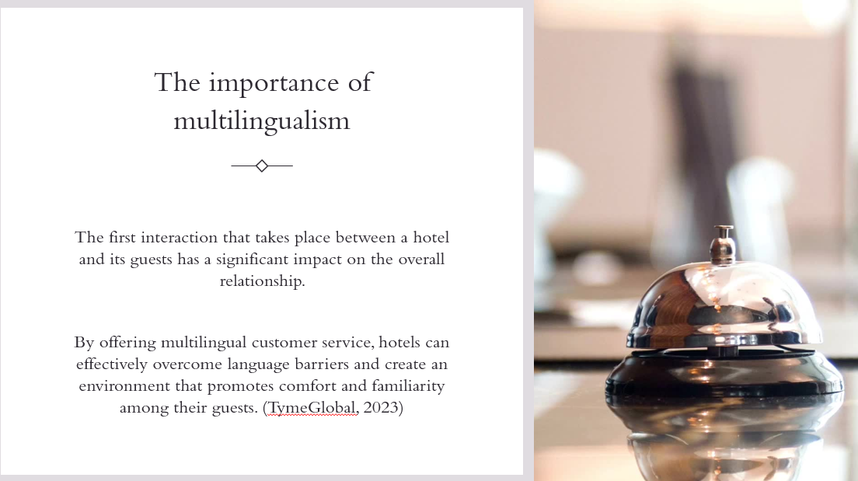
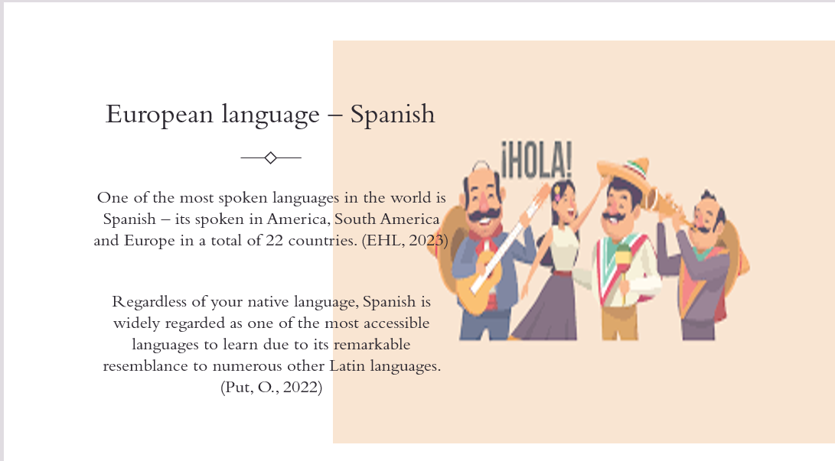
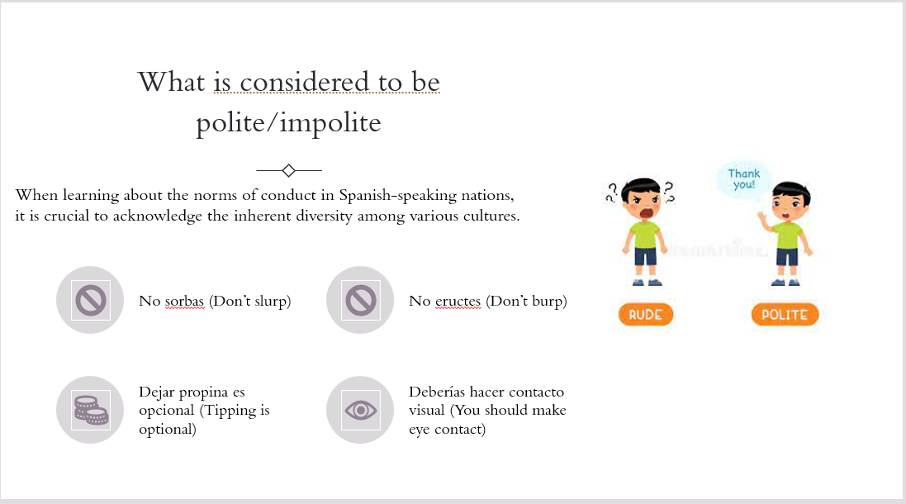
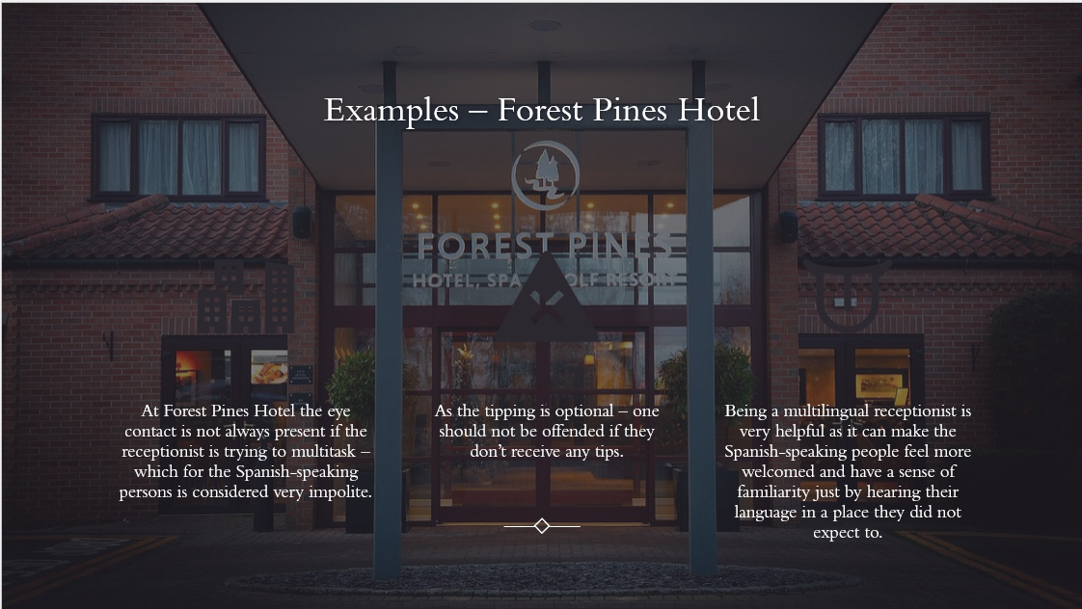
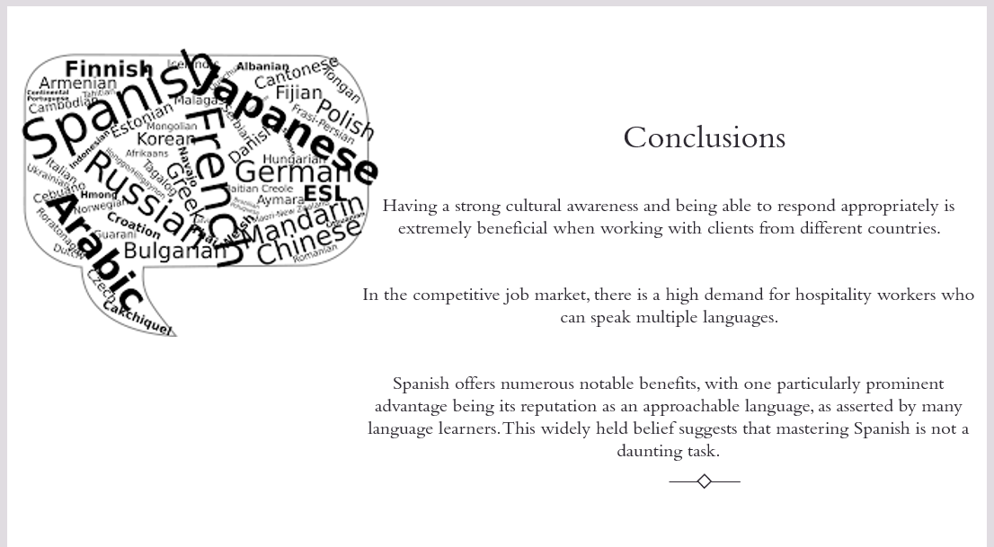
References:
- Eberhard, David M., et al., 2022, Top 10 most spoken languages – (online) available at What are the top 200 most spoken languages? | Ethnologue Free – accessed on 28th January 2024
- EHL, 2023, The best languages to learn for business and the hospitality industry – (online) available at The best languages to learn for business and the hospitality industry (ehl.edu) - accessed on 28th January 2024
- Put, O., 2022, Is Spanish Hard to Learn? – (online) available at Is Spanish Hard to Learn? The Reasons Why It Is and It Isn't – accessed on 28th January 2024
- SpanishPod101, 2020, Guide to Etiquette in Spanish-Speaking Countries – (online) available at Spanish and Latin American Etiquette Rules: The Do’s and Don’ts (spanishpod101.com) – accessed on 28th January 2024
- Tyme Global, 2023, Multilingual Customer Service: Key to Global Success in the Hotel Industry – (online) available at Multilingual Customer Service: Key to Global Success in the Hotel Industry (linkedin.com) – accessed on 28th January 2024

