
University of Wales Trinity Saint David
School of Business
Feasibility & Market Research Study
The Star Inn
Consultancy Project M6X02113
Kirsty Alexandra Smith
P149187

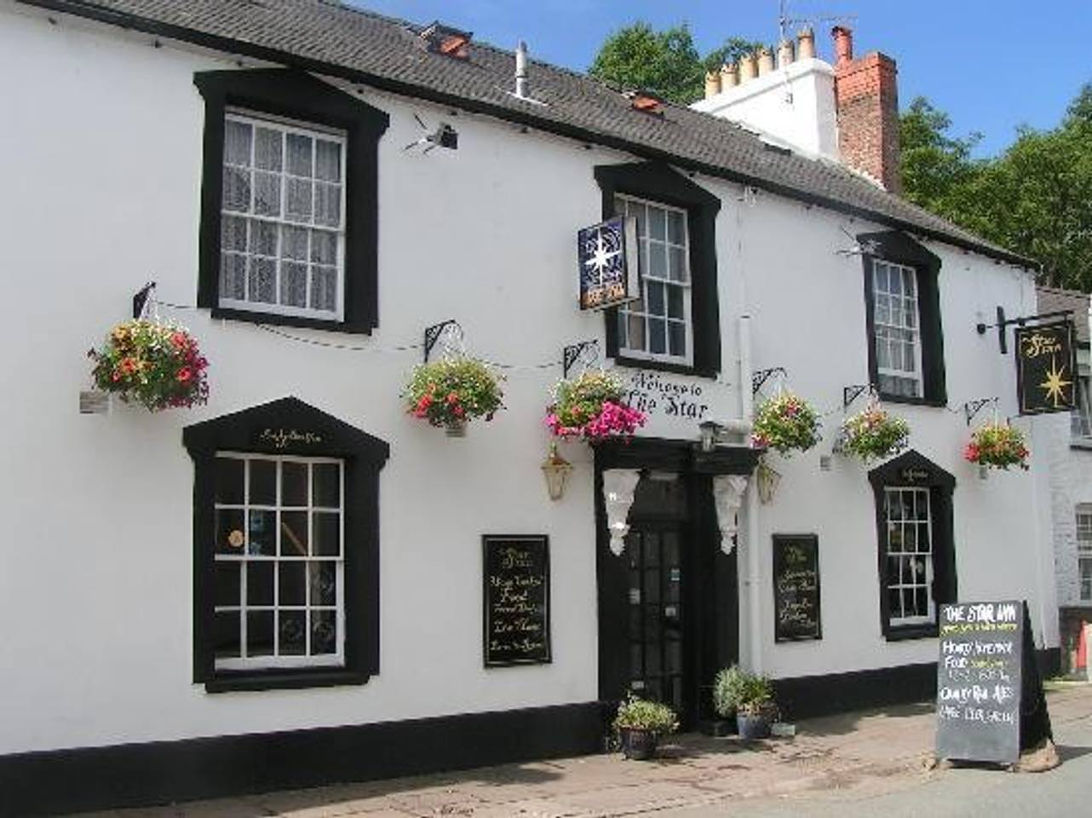

Contents
1 Acknowledgments i
2 Executive summary i
3 Introduction ii
3.1 Terms of Reference iii
3.2 Research Method iii
4 Issue log iii
5 Findings iv
v
6 Market research viii
6.1 Swot and Pestle viii
7 Recommendations x
8 Conclusion x
9 Appendices xi
10 References xv

Acknowledgments
Firstly, the deepest appreciation and gratitude to Mathew the owner of the Star Inn who allowed the consultant to undertake this project for his business and for the support and helpfulness throughout. To Michael Davies and Suzanne Wells the lecturers at University of Wales Trinity Saint David for educated support and advice throughout this consultancy project. Finally, many thanks to the respondents of the questionnaires. This report would not be possible without all of the mentioned parties in this project.

Executive summary
The Star Inn is a local real ale pub and bed and breakfast located in Talybont on Usk in the heart of the Brecon Beacons, who have vacant space and have been looking to do some market research to deliver the best product and service to meet the consumers needs. The business owner Mathew’s initial idea was either to turn the spare space into another B&B room or to renovate it into a bunk house style accommodation to sleep up to 6 guests. The purpose of this research is to discover what the consumers motivations for booking accommodation were and to distinguish how receptive the respondents of the surveys were to bunkhouse style accommodation were they for it opposed to it? The researcher conducted qualitative primary research through unstructured interviews and quantitative through the sample questionnaire, in a descriptive research method so that the client Mathew can use the research to build upon thereafter or to make a decision on the findings of this report. The data analysis has been shown through bar charts and pie charts, to exhibit the results more easily in percentages displaying patterns of trends in the questions asked. The findings of the sample questionnaires were that out of 49 respondents the majority answered were aged between 30-49 years old and travelled as a group. The biggest motivation behind booking accommodation was value for money and that breakfast be included, this indicats that people expect more for their money. The biggest trend of all of the research was that the respondents preferred to stay in B&B accommodation however they were not against the idea of staying in a bunk house. The secondary research was undertaken on the internet in a competitor analysis to measure the competition in the immediate area and the pricing strategies they use. The result of the competitor analysis was that the businesses current pricing strategy was quite low in comparison to its competitors as their current accommodation appeared to much more visually appealing and modern and other B&B businesses offered somewhere between £90 to £130 per room per night for a middle range B&B room, nevertheless, these prices included breakfast. A brief SWOT analysis was prepared before conducting this research outlining the strengths, weaknesses, threats and opportunities the project would have and to be considered before diving into the project blindly. The key aspects of the SWOT analysis were that the Star Inn already has strength in being a well-established business, with loyal guests and in a great business location. The weaknesses discovered were that there is a lot of competition in the area already offering bunk house accommodation which made the project not so unique and that the financing and staffing could be costly. Nonetheless, the opportunities could be a great way to boost the revenue to see through the winter months and that there is a market for a bunk house as other establishments have a high occupancy rates and the Beacons see a lot of active tourism. The biggest threat to the project would be that it could cost a lot of money which might not bring in a good return for investment. The consultant finalises this report with recommendations for the client to enable them to make an informed decision moving forward with the project. Firstly, that the pressure of the competition may mean that the client should focus solely on one idea to make the business unique and have the competitive advantage through focus on the pricing strategy, revamping the current offering or improving the service already offered. Though, there is a high demand for bunk house accommodation in the area which would indicate that there is a possibility for the project to take off and be very successful. Primary research indicated that consumers have a higher preference for B&B accommodation over bunk house style accommodation. Conclusively, the consultant recommends that the best return for investment would be to work on providing a better service, breakfast being inclusive of the room rate and renovating the current and available space into another B&B room which would enable the business to elevate the price to be in par with competitors to maximise the businesses profit margin.

Introduction
‘A feasibility study is an analysis that takes all of a project's relevant factors into account.…. Project managers use feasibility studies to discern the pros and cons of undertaking a project before they invest a lot of time and money into it. Feasibility studies also can provide a company's management with crucial information that could prevent the company from entering blindly into risky businesses.’ (Investopedia, 2019)
In 2017 it was recorded that the hospitality industry accounted for 3.2 million jobs and 2.8 million jobs indirectly. Generating ‘£72bn of Gross Value directly to the UK economy, and a further £86bn indirectly (Ukhospitality.org.uk, 2019)
The Star Inn a traditional real ale pub and B&B located in Talybont on Usk in the Brecon beacons national park The client and owner of the ‘Star Inn’ currently has a vacant room and is looking to do some market research to see what the consumers’ needs are to modify this space to suit those needs. The consultant believes that this is a valuable project because market research is important to the growth of an idea in business planning which can have many positive effects on the future of a business. (Thestarinntalybont.com, 2019)
‘A feasibility study is an analysis that takes all of a project's relevant factors into account.…. Project managers use feasibility studies to discern the pros and cons of undertaking a project before they invest a lot of time and money into it. Feasibility studies also can provide a company's management with crucial information that could prevent the company from entering blindly into risky businesses.’ (Investopedia, 2019)

Terms of Reference
This report is written for Matthew and the University of Wales Trinity St David by third year International Travel and Tourism Management student Kirsty Smith. The report will discover the best option for the available space in the Star Inn Talybont in a feasibility study of accommodation or at the very least be a great stepping stone for the business to take the project on to the next step of the business plan.

Research Method
As outlined in the project initiation document the research conducted will be of a descriptive mixed method. The primary data collected for this research was done through the use of questionnaires to gain insight to what consumers want and to understand the motivation behind booking accommodation for leisure stays. (Mcleod, 2017)
The research conducted was of a mixed method as the consultant undertook unstructured interviews of a qualitive nature asking open questions to understand trends from the interviews and also quantitative research as the questionnaires produced numerical data where percentages were drawn from the responses. (Mcleod, 2019)
The secondary research conducted includes a competitor analysis, to recognise the offering in the area, pricing and what platforms they use to market their product.

Issue log
Communication is key when managing a project, listening to all of the stakeholders and paying close attention to issues and concerns is vital for project success. (Palmer, 2018) Risk management gives project planning an advantage to foresee any issues that may arise in the future which could stop the project from moving forward and could cost a considerable amount of money. (Cook, 2005) an initial SWOT analysis and issue log can be reviewed in 5.1.
One of the main issues that was faced in this project was that the main objective is really market research as the consultant and the business owner did not discuss funding and costs of the project that is proposed. The consultant has therefore turned the project into more of a market research study which can be taken further from the research undertaken if the client so wishes to do so as the study includes ‘descriptive research’. This type of research does not ask why or what the answer is but lets us build up on and understand trends of what people want. (Dudlock,1993)
If the consultant were to do this research again there are a few things that could have been done differently. Primarily, the questions being asked in the questionnaires could have been tweaked to gain further information from the respondents to really narrow down the responses. Secondly, more time to complete the project would have given the consultant a better chance of getting more respondents for the validity of the questionnaires. Finally, the consultant would have done the project during a quieter time for the client as there were a lot of bank holidays in the time the research was conducted which proved to make things more difficult to meet up and discuss the research before the final report was completed.

Findings
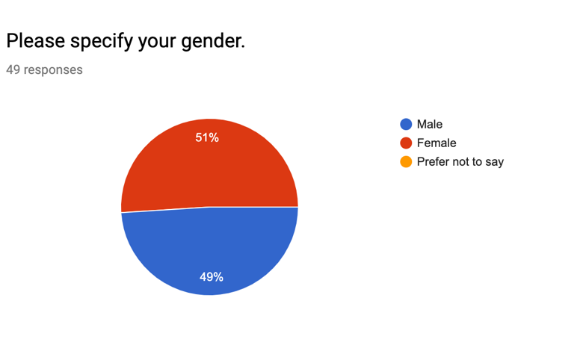
A sample questionnaire was put together and distributed face to face on three occasions where the consultant walked up popular walkers spot Pen Y Fan to capture people’s opinions and motivation for booking accommodation. A total of 49 respondents filled out the questionnaires. Out of the 49 respondents 51% were female and 49% were male, there was an equal response from both genders.

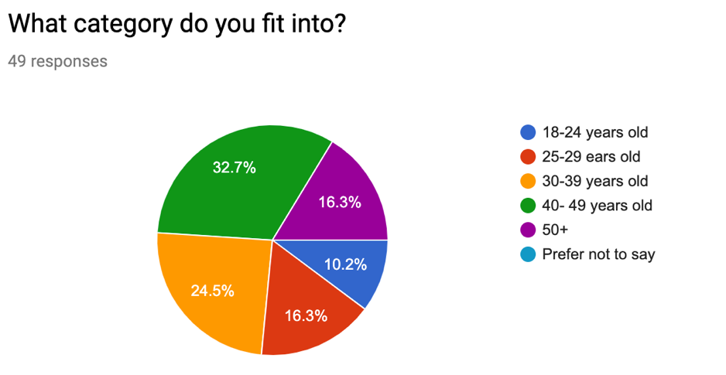
The demographics of the respondents ranged between 18 and 50+, the main age of the respondents was 40-49 (16) & 30-39 (12) age range, nevertheless the consultant did get respondents of all age categories listed but they were considerably lower.

Another question used was to identify the type of party they would travel with the majority of respondents answered as a group 30.6%, with a partner 28.6% and with family 26.5%. Another 2 respondents answered other and stated they travelled with a friend. This was a great way to discover from the findings why people answered what they did as circumstances influence decisions.
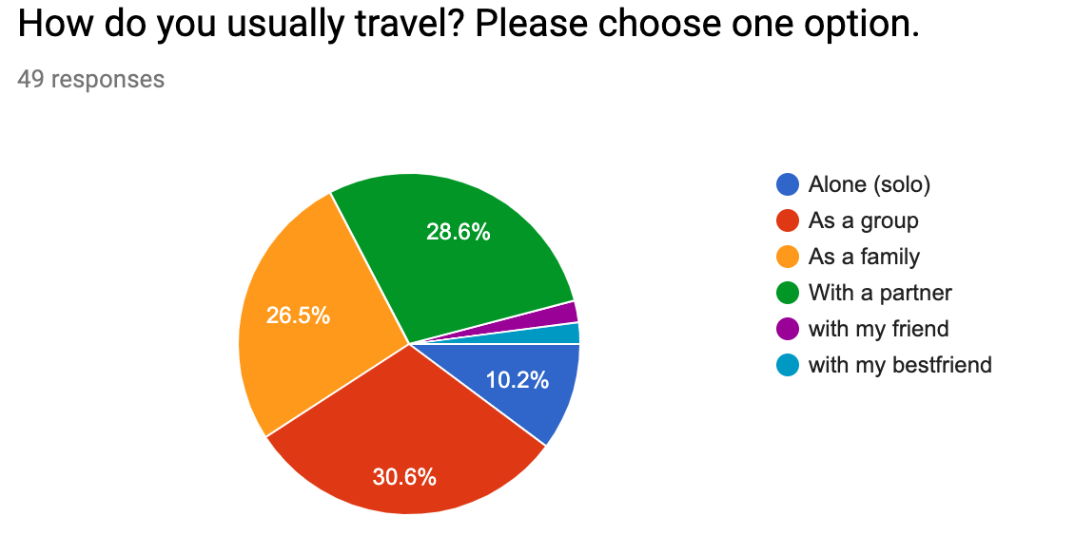
Question 4 sought out to find what motivates the respondent’s decision to book accommodation, there was a tie between ‘low cost’ and ‘value for money’ at 22.4% each followed closely by ‘breakfast included’ 20.4% and finally ‘price’ 16.3%. other respondents said that activities, outdoors and area would be there focal point for motivation when choosing accommodation. This information demonstrates that the consumers are looking for their money to spread a lot further nowadays as they want quality and food to be inclusive of the price.

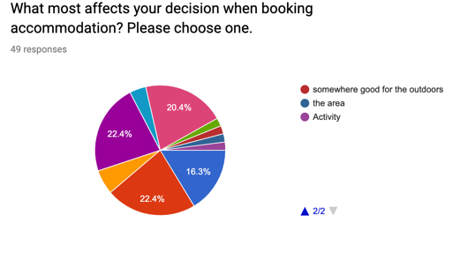
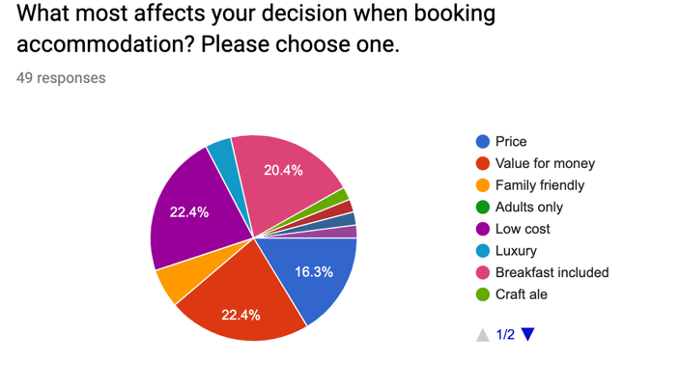

To understand current trends and consumer needs a rating question asked the respondents to rate from (1 – 6) with 1 being most likely to 6 being least likely. The result saw that over 20 of the respondents answered Bed and Breakfast as being the most likely accommodation they would book, camping in second place with just under 20 votes. The majority of respondents voted bunk house in 6th place as their least likely accommodation choice.
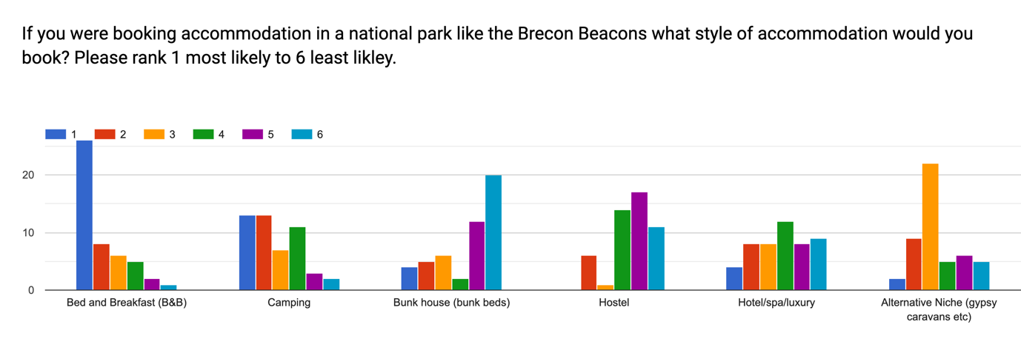

The consultant asked the respondents to answer roughly how much they would expect to pay to stay in a national park area, though it was not specified in what accommodation. 44.9% of respondents answered £80-110 and 30.6% respondents answered £60-£80. This data set says a lot about the businesses current pricing strategy as it is considerably lower than this and that they may have the competitive advantage for being cheaper but there is room for a raise to boost profit margins.
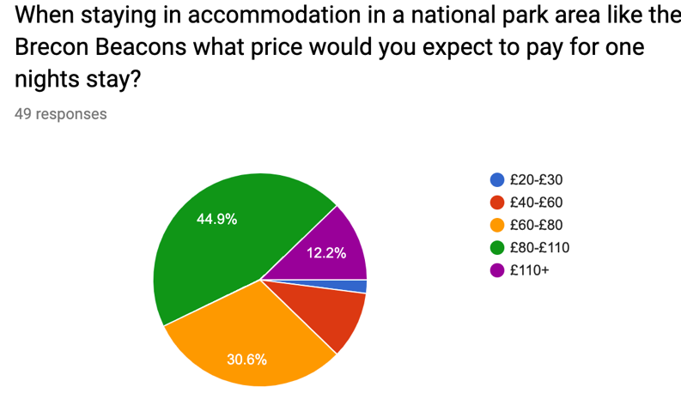

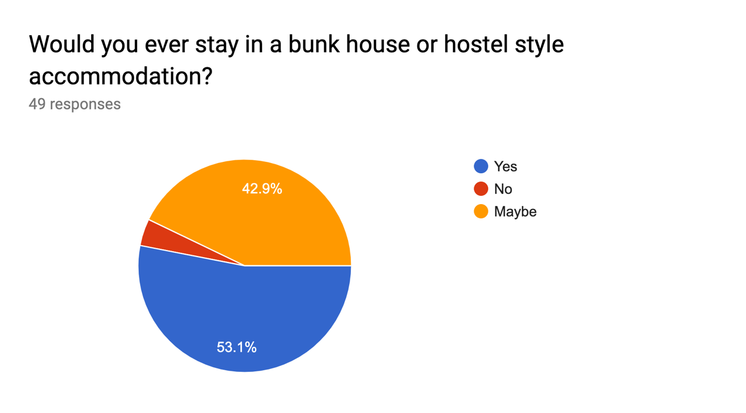
The next question looks to discover people’s opinion on whether they would stay in a bunk house or hostel accommodation. It was a close call 53.1% of respondents said they would and 42.9% said maybe however only 4.1% said no. This data proves that people were not totally against the idea of bunk house style accommodation.

The final question asked was to discover what platform people used to book accommodation out of 49 questionees only 39 answered. The most popular method was online using booking.com, air B&B, late rooms, lastminute.com and Trivago.

Discussions with the respondents brought forward the research, respondents allowed the researcher to discuss the questions further. Respondent 4 said “we usually travel as a family and would be happy to stay in a B&B but would not be comfortable staying in mixed accommodation with a bunk house upstairs.” They explained that “it may be too loud, and that type of setting would usually involve drunken and rowdy behaviour.” Respondent 12 made a statement similar to this that they usually travel with their partner and “drunken individuals travelling in big groups or singular would turn them away from booking in a mixed B&B and bunk house accommodation.” Respondents 13, 19 and 27 also made it clear that they were happy to stay in either accommodation, but they were unsure if the mixed bunk and B&B option would attract them as the standards of accommodation should be different. However, respondent 32 and 41 said that they would be happy to stay in mixed accommodation, but their circumstances were different to the families as they would usually travel as a group and their main focus was saving money by having low cost accommodation.

Market research
Talybont
The Star Inn - Current pricing strategy – 40 Single 60 twin 80 triple occupancy per room per night. (Thestarinntalybont.com, 2019)
The White Hart Inn – 20 Bed Bunkhouse, £25 PPPN, Premium low-cost, modern advertising
The Usk Inn – 10-bedroom guest house B&B, £90-£130 Per room Per night, Middle range/ old fashioned. (Uskinn.co.uk, 2019)
Travellers Rest Inn- 2 ensuite rooms double and single bed £90 for double £115 triple room £55 Single occupancy (Travellersrestinn.com, 2019)
Beacons Holiday Cottages- Variety of accommodation types from budget to more costly. (Breconcottages.com, 2019)
Hawthorns B&B- 2 rooms twin/ double with ensuite - Single ensuite £55, Twin room £60, Double room £60, Twin ensuite £72, Double ensuite £72 old fashioned room style and marketing.
Aber
YHA, - hostel, glamping and camping. Hostels £14-21pnpp (YHA, 2019)
Llangynydir
The Star Bunk House- 20-person bunkhouse £19pppn basic bunk house (Starbunkhouse.com, 2019)

Swot and Pestle
Swot analysis for a bunk house
Strengths:
The Star Inn already has a well-established field of returning customers.
Great location with just a short drive, cycle or hike away from many popular walker spots.
Attractive village location with canal right on the back doorstep.
Under new ownership which gives the business the advantage to put a personalised stamp on products offered.
Weaknesses:
Lack of financing and staff. As discussed in the client meetings of the initial PID process, it was not clear what funding would be available and that the staffing was minimal, and the client was doing 90% of the work.
Production cost; staff hired and renovation work.
Mixing bunk house with B&B could be guest deterrent.
Not unique enough there is a lot of competition in the surrounding area.

Opportunities:
To earn a higher revenue
Target market; active (hikers, Cyclists and backpackers)
Threats:
Business competition
Renovation can be costly as well as staffing costs
The idea might not take off
PESTEL Analysis
“Both new business owners and veterans should include PEST analysis in their business plan. PEST can help you identify significant changes in the political, economic, social, and technological landscape. And these landscapes will affect your business in the future. By breaking down the critical influences in these four categories, business owners get a better understanding of whether their next business move is strategic or idiotic.” (Frue, 2018)

Political  - Brexit and political instability.  - Welsh funding for small businesses not the best.  - Rise in domestic tourism because of Brexit | Economic  - Labour cost high as minimum wage has risen  - People have more disposable income | Sociological  - Health conscious tourism. More people are choosing active holidays.  - More leisure time  - Unemployment is low
Technological  - Growth of the online booking  - People are booking things more themselves as ease of technology and smartphones | Environmental  - Green tourism and sustainability | Legal  - Health and safety  - Pay regulations

Recommendations
In depth research in this project has enabled the consultant to find valuable recommendations that the client may wish to consider before pursing the project any further. Firstly, there is a lot of competition in the area that already provides both bunk house and B&B accommodation. The client may wish to focus on one idea, making it unique and to stand out against the competition. Whether that be the pricing strategy the makeup and design or the service provided.
Furthermore, the competition that has bunk house accommodation have a high occupancy rate which would suggest that there is a strong market for it in the area. However, primary research would suggest that the majority of the consumers would prefer to stay in bed and breakfast accommodation as over 20 respondents ranked this as their first option on the sample questionnaire.
Finally, the consultant would agree that the best return for investment would be to improve the current bed and breakfast offering, perhaps a revamp of the current accommodation and to turn the other space into more bed and breakfast rooms offering the breakfast service and providing quality service. This option would be better suited to the business as the price of the accommodation is very low compared to the competitors in the area and prices could be elevated due to this. The B&B’s in the area are quite outdated and old fashioned but they charge a higher rate and most have a minimum two nights stay.

Conclusion
To conclude, the research method for this research was descriptive which permits the client to use the research for future growth and development. The primary research conducted through sample questionnaires derived many trends. Firstly, the demographics of respondents ranged between 30-39 and 40-49 years old and respondents predominantly travelled as a group, with a partner and as a couple. The biggest influence behind booking accommodation was value for money, respondents expect to quality for what they are paying, breakfast included was the second favourite influence, this is a great way for businesses to bump up their prices if breakfast is included. Respondents were not opposed to staying in a bunk house accommodation, but it did not rate as highly as the bed and breakfast accommodation did. Competitor analysis showed that the Star Inns current pricing is quite low considering the accommodation is much more modern than some of its competitors. The typical pricing range for bunk houses was between £14 and £25 per person per night and the mid-range of bed and breakfasts were between £90-£130 per room per night and the lower range was between £50 and £80 per night. The consultant’s final recommendations were that the client should try to stand out against the competitors, by choosing to be one singular type of accommodation either bunk house or B&B and that mixing the two would be against the consumers interest.

Appendices

Client Meetings & minutes
Feb 24th initial ideas meeting
What the project will be
What Mathew wants to do: Market research for the feasibility of either another B&B room or a bunk house.
Concerns and timeline for the project and how the research would be done.
Rules and guidelines for what he wanted me to look at.

17th of march to finalise PID
Discussed with the client the research and what he wanted to find out.
Reviewed all questions from the primary research and adapted questions to the client’s needs.
Signed off on the PID and discussed how communication would proceed from there on.

Email correspondence
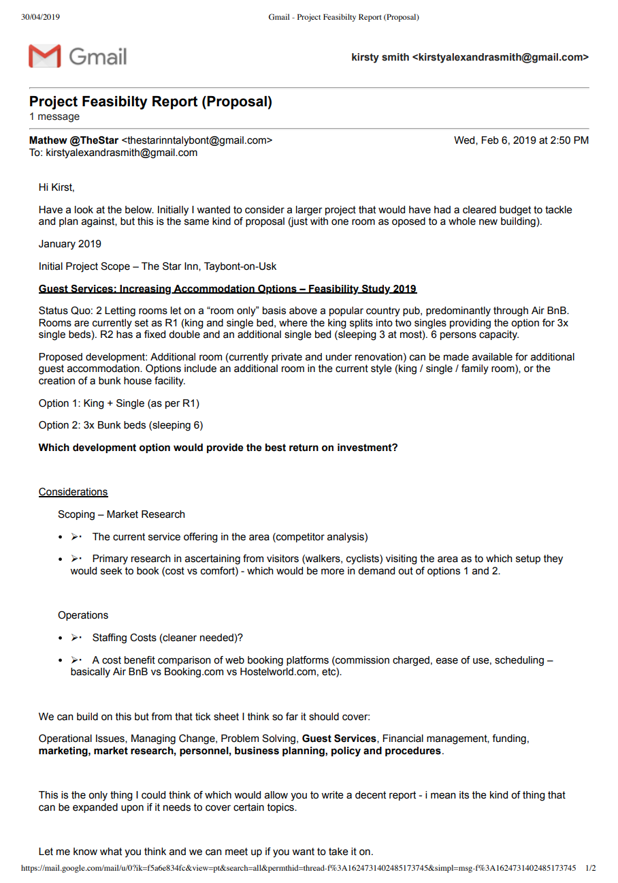
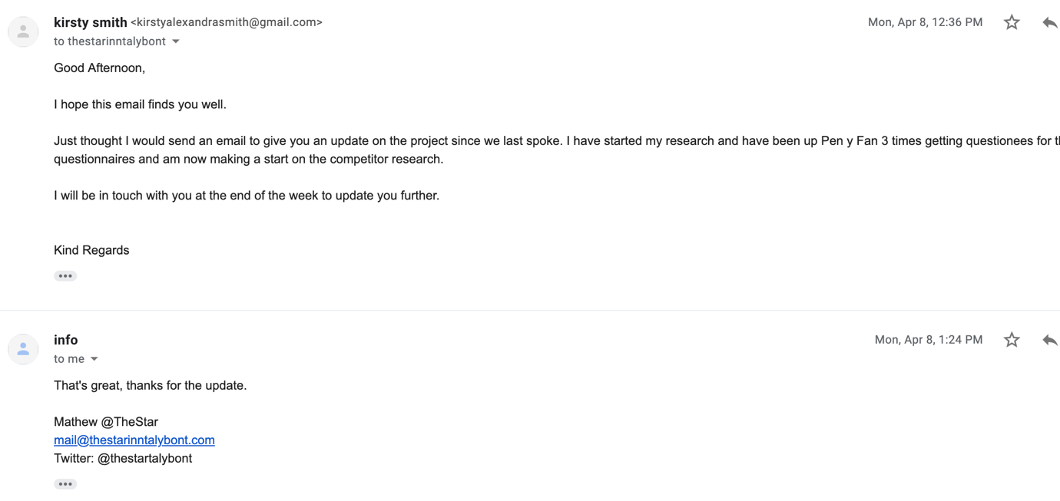
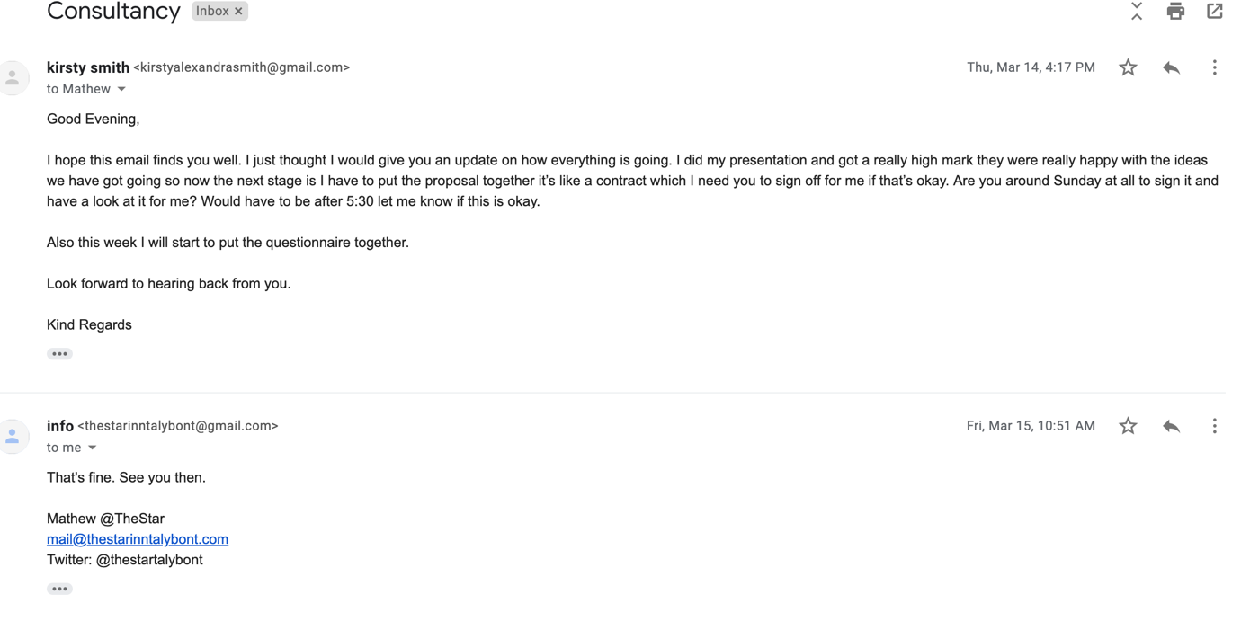
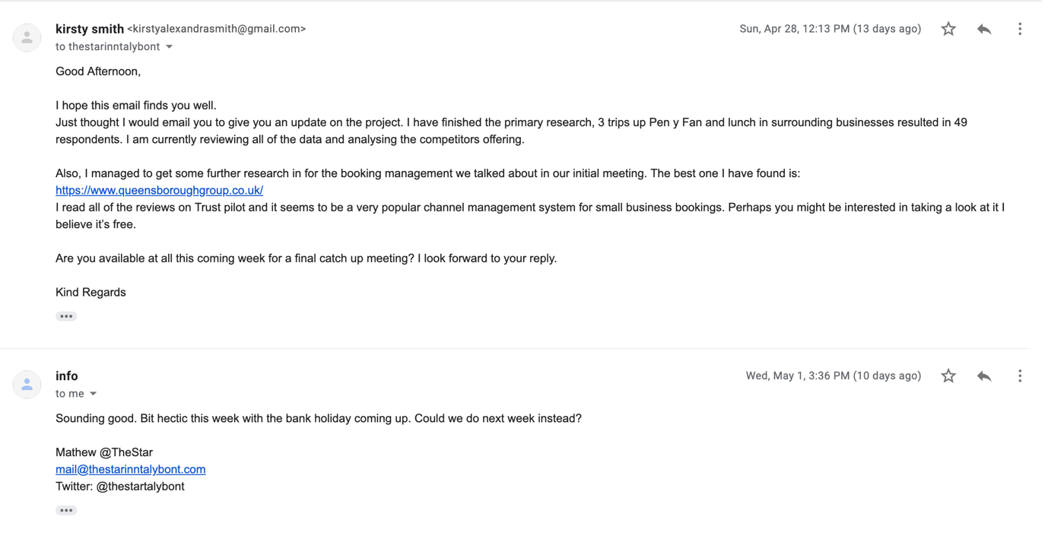

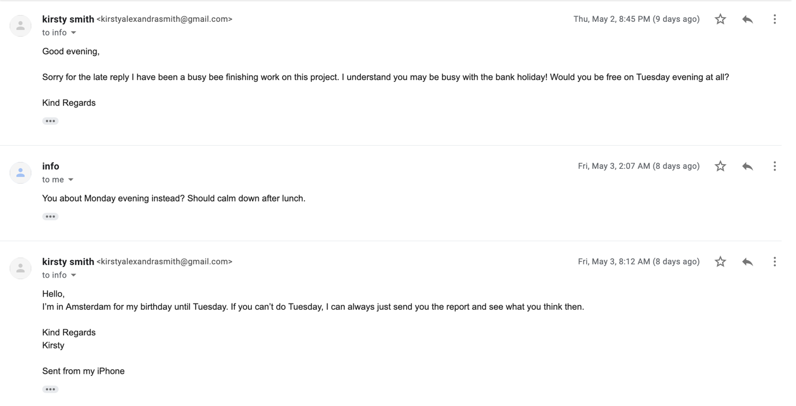
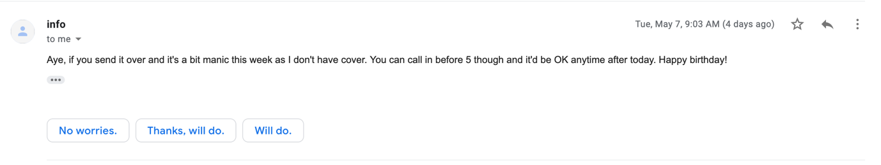

References
Breconcottages.com. (2019). Homepage. [online] Available at: https://www.breconcottages.com/ [Accessed 15 Apr. 2019].
(Frue, K. (2018). This is Why PEST Analysis Is Important For Every Business. [online] PESTLE Analysis. Available at: https://pestleanalysis.com/why-pest-analysis-is-important-for-every-business/ [Accessed 24 Apr. 2019].
Ignite Economics, (2018) The Economic Contribution of the UK Hospitality Industry(2018) -UKHospitality [online] Available at: https://www.ukhospitality.org.uk/page/EconomicContributionoftheUKHospitalityIndustry2018 [Accessed 29 Mar. 2019].
Investopedia. (2019). Considering a New Venture? Then Consider a Feasibility Study.. [online] Available at: https://www.investopedia.com/terms/f/feasibility-study.asp [Accessed 29 Mar. 2019].
Mcleod, S. (2019). Qualitative vs Quantitative Research | Simply Psychology. [online] Simplypsychology.org. Available at: https://www.simplypsychology.org/qualitative-quantitative.html [Accessed 3 May 2019].
Palmer, E. (2018). Five Factors That Lead to Successful Projects. [online] Project-Management.com. Available at: https://project-management.com/five-factors-that-lead-to-successful-projects/ [Accessed 30 Mar. 2019].
Starbunkhouse.com. (2019). Bunkhouse. [online] Available at: http://www.starbunkhouse.com/bunkhouse.html [Accessed 17 Apr. 2019].
Thestarinntalybont.com. (2019). The Star Inn Talybont. [online] Available at: http://www.thestarinntalybont.com/ [Accessed 19 Apr. 2019].
Travellersrestinn.com. (2019). Travellers Rest, Talybont on Usk in the Brecon Beacons, Mid Wales your Welsh B&B, Guesthouse, Cottage. [online] Available at: http://www.travellersrestinn.com/ [Accessed 13 Apr. 2019].
Uskinn.co.uk. (2019). The Usk Inn Talybont in the Brecon Beacons. [online] Available at: http://www.uskinn.co.uk/ [Accessed 14 Apr. 2019].
Virgin Islands Law Blog. (2017). Conducting a SWOT Analysis, Feasibility Study for Your New Business | Virgin Islands Law Blog. [online] Available at: https://lawblog.vilaw.com/2017/08/articles/business/conducting-a-swot-analysis-feasibility-study-for-your-new-business/ [Accessed 30 Mar. 2019].
YHA. (2019). YHA Brecon Beacons Danywenallt Hostel | Talybont Hostel Accommodation. [online] Available at: https://www.yha.org.uk/hostel/yha-brecon-beacons-danywenallt [Accessed 17 Apr. 2019].

