

Course: Business management
Module name: Strategic Management & Sustainability
Module code: LCBB6004
Lecturer: Dr Jayalakshmi Gopalkrishnan
Title of report: Coursework 1
Student: Stanimira Nikolova Nikolova
ID Number: 2118452

Astra Zeneca and the tools that the company uses to be successful
TABLE OF CONTENT
1.Introduction……………………………………………………………………page 3
2.Overview of Astra Zeneca……………………………………………………page 3
3.The importance of business and corporate strategy in the organisation……………………………………………………………………page 4-5
4.Resources and capabilities are crucial parts of a firm’s competitive advantage………………………………………………………………………page 4-4
5. VRIO Framework and its importance………………………………………page 6
6.Analysing Internal Context of Astra Zeneca…………………………………page 7
7.1. VRIO Analysis of Astra Zeneca……………………………………………………………………………page 7
7.2. Astra Zeneca uses AI (Artificial Intelligence) as a growth strategy…………………………………………………………………………page 7-8
8.Analysing External Context of Astra Zeneca……………………………page 8-12
8.1. PESTEL Analysis is a valuable strategic tool that helps Astra Zeneca understand the external context and to create a competitive advantage……………………………………………………………………page 8-12
9.Conclusion…………………………………………………………………page 12-13
10.Reference list……………………………………………………………page 14-18
11.Appendix……………………………………………………………………page 19

Introduction
Strategic management is defined as the process by which organisations decide, analyse, and implement actions to maintain competitiveness and achieve long-term objectives. Strategic management also involves the use of resources to achieve an organization’s vision and mission by navigating aims and objectives to achieve those goals. Sustainability is the context of strategic management which refers to the integration of social, environmental, and economic considerations into business operations and strategies which plays a vital part in business success (Whittington et al,2020). Astra Zeneca 3 (2024) states that Astra Zeneca's strategic business units focus on three specific areas: oncology, biopharmaceutical, and rare diseases. This report will analyse Astra Zeneca and what tools the company pursue to apply as their strategic choice and action to achieve competitive advantage.
Overview of the Astra Zeneca
According to the London Stock Exchange (2024) Astra Zeneca is a global science-led biopharmaceutical company that focuses on the development, discovery, commercialisation, and development of prescription medicines, primarily for the treatment of diseases in of Cardiovascular, Oncology, Respiratory & Immunology and Renal& Metabolism. The company is based in Cambridge, UK and it operates in more than 100 countries. Its innovative medicines are used worldwide by millions of patients.
Please refer to Figure 1 to see Astra Zeneca’s revenue growth according to Statista (2024)
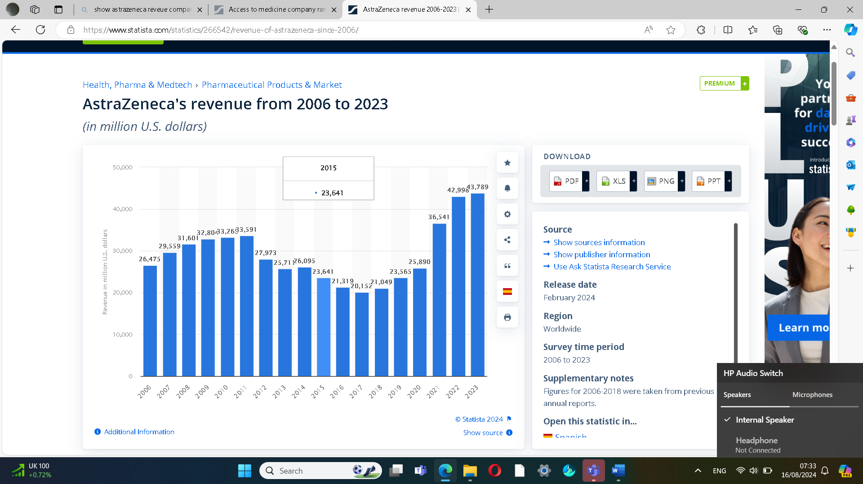

Figure 1: (https://www.statista.com/, date:19/08/2024)
According to Inspired Economist (2023), the revenue growth rate is crucial for investors and companies, indicating effective strategies and potential profitability, referring to successful businesses with the potential for lucrative investment returns.
The importance of business and corporate strategy in the organisation
According to Kotler et al (2010), the authors discuss various aspects of branding, including the relationship between the business and corporate strategy and the interdependence of this strategy in business success. Kotler et al (2010) suggest several strategies for businesses to effectively leverage ingredient brandings such as including highlighting unique components, forming a strategic partnership with well-known ingredient brands, using consistent and clear messaging, measuring performance as well and using metrics to access sales, investing in research and development to improve or create unique ingredients, customer satisfaction and brand equity. This strategy can help businesses to create a competitive advantage, differentiate products and achieve long-term success.
Kotler et al (2010) also emphasise the importance of the corporate strategy of ingredient branding outlining the key points such as value, proportion, strategic alignment, innovation, partnership, and brand management. The branded ingredient is vital to support the company’s vision, mission and long-term objectives as well as partnering with high-quality ingredient suppliers can strengthen the corporate brand, continuous innovation in R&D investment is also crucial for maintaining a competitive edge and ingredient branding can be integrated into a company’s overall corporate strategy. Kotler et al (2010) points out the importance of leveraging unique resources and capabilities in ingredient branding to create value for consumers and host brands. This includes expertise, technology, high-quality ingredients, innovation, research and development, supply chain management, and marketing. Therefore, both business and corporate strategy are essential for maintaining a competitive edge and following these strategies company can achieve sustainable growth, enhance overall performance and improve operational efficiency.
Resources and capabilities are crucial parts of a firm’s competitive advantage
According to Whittington et al (2020), resources and capabilities are key concepts in strategic management. Resources refer to the assets that organisations have or can access, such as physical assets, financial resources, human resources and intangible assets such as intellectual property and brand reputation. Capabilities are abilities and skills that enable an organisation to effectively utilize its resources and include knowledge, processes and competencies that allow the organisation to achieve its strategic goals. Analysing these resources and capabilities is essential to understand how they can contribute to a firm’s competitive advantage and they should be utilized to create and sustain competitive advantage. Whittington et al (2020) state that by effectively leveraging resources and capabilities, organisations can create unique values that are difficult for competitors to imitate, achieving long-term success.
According to Whittington et al (2020), the leading global pharmaceutical company Astra Zeneca has 8,400 employees as part of their resources and capabilities in their R&D organisation, with the three strategic R&D centres in the US, Sweden and Cambridge. The company uses their distinctive scientific capabilities, as well as investing to deliver life-changing medicine. Springler Nature Limited (2024) points out also that AstraZeneca as part of its business and corporate strategies collaborates with other companies and research institutions to access advanced science and innovation, enhancing its product pipeline and bringing new treatments to market more efficiently. Astra Zeneca 3 (2024) points out that as part of its sustainability and Corporate Responsibility, the company is committed to operating sustainably, focusing on building health system resilience, expanding access to healthcare, and driving a climate agenda. Astra Zeneca 4 (2024) states that Astra Zeneca’s leadership includes a Board of Directors and a Senior Executive team and the Board is responsible for setting the company’s policies and strategy, while the Senior Executive Team managers and day-to-day operations as part of their leadership and governance.
VRIO Framework and its importance
According to Jurevicius (2023) VRIO Framework is a tool that analyses a company’s internal resources and capabilities to see whether they have a source of sustained competitive advantage. In terms of understanding, VRIO comes from the words value, rarity, imitability, and organisation and resources must be valuable, rare, imperfectly imitable and non- substitutable. Firms are also using many tools to analyse their external environment such as Porter’s 5 Forces, PEST Analysis and internal such as BCG Matrix, and Value Chain Analysis. Therefore, frameworks like VRIO, SWOT, PESTEL, PORTER FIVE FORCES, Value chain and Matrix Analysis frameworks play a vital role in business and corporate strategies and analysis and organisations pursue them to achieve and sustain competitive advantage.
Analysing internal context of Astra Zeneca
VRIO Analysis of Astra Zeneca
Pro Resources (2022) suggests that strategic resources can offer Astra Zeneca a sustainable competitive advantage and increase industry profit. Astra Zeneca's financial resources also can attract talent in the Global Market which are great company strategy for further growth. Astra Zeneca’s patient strategy is built on successful innovation which provides value in the industry given the various segmentation and customer preferences. The company also has valuable marketing expertise, human resources, and operation management.
Pro Resources (2022), states that their products are also rare which is critical to firms’ growth as well Astra Zeneca’s products are difficult to imitate which provides the ability to attract talent in the local and global market. The analysis of the operational capabilities and competence of the company evaluates how the company can utilise its resources, emphasising the quality of its human resources. The strategy and execution team have an impact on this level, and as the company develop its strategic resources, capabilities frequently arise or grow.

Astra Zeneca uses AI as a growth strategy
According to Gartner (2024), Astra Zeneca shifted its focus to sustainable growth and enhanced innovation as it delivers life-changing medicine to patients’ societal values and needs. The company also embed digital and artificial intelligence across various therapy areas and R&D, which helps its scientists uncover critical insights as well as speed up the discovery, delivery, and development of potential new medicines to patients. Pro Resources 1 (2022) states that innovation also plays a crucial role in Astra Zeneca’s growth strategy within the Ansoff Matrix framework. Innovation plays a crucial role in market penetration, market development, product development and diversification and the success of the company.
Gartner (2024) states that AstraZeneca is leveraging data, digital, and AI to revolutionize medicine discovery and development. Gartner collaborated with the company to develop its Data and Artificial Intelligence Ethics Vision, Guiding Principles, and Governance Framework. Stobierski (2020) points out that Value chain analysis evaluates a company's activities to identify areas for improvement, considering how each step adds or subtracts value to the final product or service. Therefore, innovation is embedded across Astra Zeneca's value chain, ensuring the delivery of life-changing medicine, and driving sustainable growth.

Analysing External context of Astra Zeneca
PESTEL Analysis is a valuable strategic tool that helps Astra Zeneca understand the external context and to create a competitive advantage
VanZandt (2023) states that PESTEL is a strategic management framework that helps business to understand any market growth or decline, potential, business position and direction for operation by analysing Political, economic, social, technological, environmental, and Legal factors. Is a crucial tool for strategy in action and strategic choices as it helps organisations to understand the external macro-environmental factors which can impact their operations. PESTEL can help organisations to make informed decisions, identify potential opportunities and threats in the market and contribute organisation's competitive advantage.
Astra Zeneca (2023) states that Astra Zeneca as part of their PESTEL analysis acting on climate change to drive sustainability which is fundamental for society, and the health of people and the planet as it has a strong connection between healthy people and a healthy planet. The organisation is also investing in biodiversity which is part of their initiatives to plant and maintain 200 million trees worldwide by the end of 2030. Astra Zeneca strives to achieve 100 per cent electrical vehicles in their fleet as well as transitioning to 100 per cent renewable energy for power and heat to the manufacture of medicine which is core to Astra Zeneca’s Ambition Zero Carbon commitment which is part of their environmental and social responsibility.
Astra Zeneca (2023) points out that as part of their ethic and transparency, Astra Zeneca makes positive contributions to local needs and continues to support initiatives and issues of importance to local communities that can foster innovation and breakthrough ideas. It aims to have a positive impact on society to meet the rising global demand for effective healthcare which is part of their legal requirements (Gov.UK, 2022)
According to Politico (2021) through a combination of strategic contracts, and active government involvement, which is part of Astra Zeneca’s political analysis framework, AstraZeneca has successfully negotiated UK political considerations while maintaining a solid connection with UK officials.
The pharmaceutical giant AstraZeneca has given the UK access to doses of a life-saving vaccine earlier than the EU. The UK government claims to be oversee the contracts, which are governed by English law. AstraZeneca is obligated by the UK contract to ensure that the British supply chain is suitable and adequate for the provision of the dosages the UK purchased. The goal of the EU contract is to make sure that vaccines are distributed fairly among EU member states. AstraZeneca has successfully negotiated the political landscape in the UK by utilising a combination of proactive government engagement, strategic contracts, and retaining close ties with UK officials (Politico,2021)
Astra Zeneca 1 (2023) states that as a part of their economic impact alongside the UK Astra Zeneca supported £5.3 billion which is the equivalent of 0.2 percent of the UK GDP. The company is also a major exporter with around £8.9 billion in sales to the global market generated from the UK which is equivalent to 1.4. per cent of all UK exports. It also employs over 8700 people around the UK and supports just under 66,000 jobs in the UK economy.
According to Astra Zeneca 2 (2024), AstraZeneca is leveraging innovative technologies to accelerate drug discovery and achieve breakthroughs, leveraging data and technology to deliver life-changing medicines to patients. The company's technologies and imaging platforms aim to enhance disease biology, target disease drivers, predict clinical success, and improve patient experience and outcomes. These efforts help shape the future of healthcare and advance the understanding of disease biology. Therefore, Astra Zeneca pursues these strategies to be competitive as part of company’s business and corporate strategy. S&P (2023) states that from Astra Zeneca’s SWOT Analysis, the company is rated first in the innovative index but has a bad public relations image because of the COVID-19 vaccine that caused blood clots. Other prosperous and larger firms also threaten Astra Zeneca. Please refer to figure 2 in Appendix to see Astra Zeneca’s SWOT Analysis.
According to Affstuff (2023), a positive corporate image is vital for any company as it can increase brand recognition and customer loyalty. It can help businesses navigate crises and to attract top talent and create strategic partnerships that drive growth. Negative corporate image, on the other hand, can seriously impact a company’s profits and sales, with legal consequences as well as reducing employee turnover. Eichie et al (2020) point out that positive corporate image can increase by retaining and attracting customers, investors, employees, and partners. However, is accepted that employee satisfaction is a function of a good and effective corporate image. Service offering for example also has an impact on profitability such as a good positive relationship with customer satisfaction. Therefore, a positive corporate image is crucial for a company’s success and sustainability. According to Osum (2024), SWOT Analysis helps Astra Zeneca to gain insights into its internal strengths and weaknesses as well as external threats and opportunities. To address weaknesses, maximise its strengths, mitigate potential threats and capitalize on opportunities, this analysis can help the company make informed strategic decisions to achieve competitive advantage.
Porter 5 Forces Analysis
Porter’s Five Forces (2024) states Porter's Five Forces Analysis, developed by Professor Michael E. Porter in 1979 at Harvard Business School, is a widely used model for evaluating companies' strategies to neutralize competition and increase margins and are used to analyse and identify an industry’s competitive forces. Please refer to figure 3.

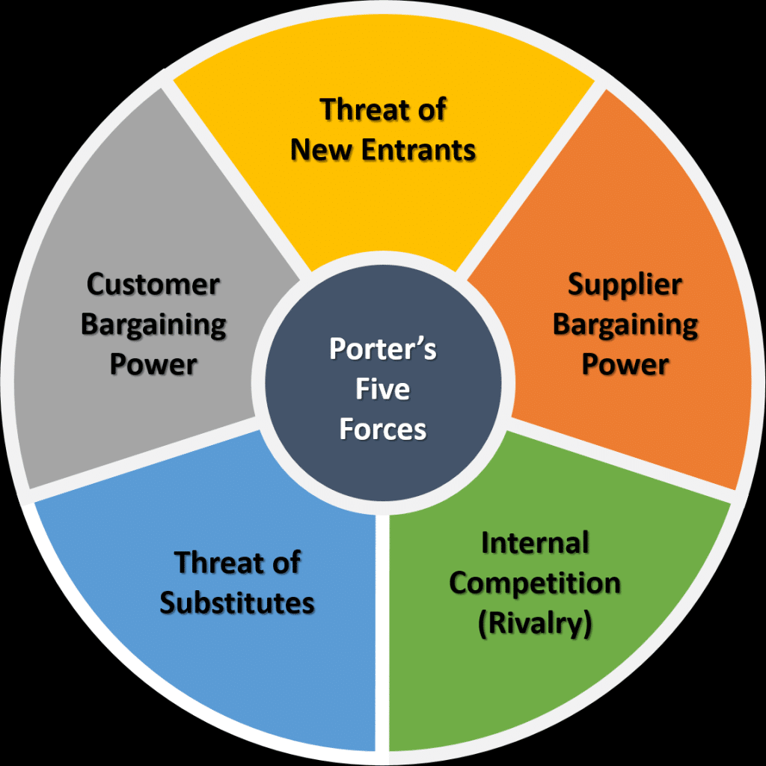

Figure 2: what Porter 5 Forces consider - Search Images (bing.com) - Search Images

According to Porter’s Five Forces (2024), Astra Zeneca's Rivalry among existing competitors- Astra Zeneca specialises in rare diseases and distributes more than 43 medications. Johnsons& Johnsons also sells health-care products and Pfizer and Roche Holding.
Astra Zeneca's Threat of new entrants requires high capital investment, which is why to strengthen its market position Astra Zeneca trains human resources and invests in research and development. Astra Zeneca spent more than 27 per cent of its total revenue on research and development and is among the top ten pharmaceutical corporations in the world by early 2021 (Porter’s Five Forces,2024)
Astra Zeneca Bargaining Power of Supplier-Astra Zeneca, a leading global COVID-19 vaccine supplier, supplied 2,5 billion doses to 180 countries in 2021. AstraZeneca has a supply chain financing program with supplier collaboration to help its external suppliers with cash flow which is a company’s strategy to manage supplier relationships to remain competitive (Porter’s Five Forces,2024)
Astra Zeneca Bargaining Power of Buyers- Astra Zeneca has high differentiation and good customer satisfaction, vital for services the company’s success (Porter’s Five Forces,2024)
Astra Zeneca's threat of substitute products and services - over the last two decades, the industry has grown significantly. Recent advancements in vaccines and medications for rare illnesses and COVID-19 have enabled Astra Zeneca to earn a significant market share and increase the goodwill in emerging countries which shows an increase in brand loyalty, which allows the company to reduce the threat of substitutes (Porter’s Five Forces,2024)
Porter’s Five Forces (2024), states that according to McKinsey& Company pharmaceutical business should reevaluate its long-term sourcing, manufacturing, and supply-chain decisions considering the pandemic, inflation, and new working practices.
Pro Resources 2 (2022) states that Astra Zeneca as part of its generic strategies focus on cost leadership that involves pursuing economies of scale, proprietary technology, supply chain management options, and diversification of suppliers. Differentiation involves offering unique value propositions to customers, seeking premium prices due to differentiation and uniqueness. Focus strategy involves choosing a competitive scope within an industry and tailoring its strategy to serve a specific segment. Both strategies depend on differences between AstraZeneca's target segment and other industry segments.
Conclusion
Based on research Astra Zeneca follows business and corporate strategy to remain competitive in the pharmaceutical industry and to maintain competitive advantage using leverage of various strategic analyses in the pharmaceutical industry. For instance, Porter's Five Forces helps Astra Zeneca to understand the competitive dynamics of the industry, and PESTEL examines micro-environmental factors that affect the company to create a competitive advantage over rivals. Value chain Analysis helps the company to identify activities that create competitive advantage and value. VRIO analysis evaluates Astra Zeneca’s resources and capabilities to determine their potential for sustained competitive advantage.
By systematically applying these tools and frameworks the company can better understand its competitive environment, leveraging its strengths to achieve and sustain a competitive advantage and identify strategic opportunities that help business to integrate effectively. Therefore, these tools must be considered by an organisation in the implementation of a strategy. By consistently applying these strategies such as investing in research and development, improving products or services, staying updated with technological advancements, building a strong personal brand, maintaining strong supply chain management, invest in employee training and development as well as considering climate change, organisation can sustain their competitive advantage and continue to thrive in a dynamic market environment. Continuously improvement is essential for the company because fosters innovation and allows adaption to change which is crucial for Astra Zeneca as it improves growth and resilience, increases productivity in a fast-changing world and is a key component of growth and success.

Reference list:
Affstuff (2023) Understanding Corporate Image [Online] Available at:
https://affstuff.com/glossary/corporate-image/#:~:text=A%20positive%20corporate%20image%20can%20increase%20brand%20recognition,ease%2C%20and%20create%20strategic%20partnerships%20that%20drive%20growth. (Accessed: 13 August 2024)

Astra Zeneca (2023) Sustainability [Online] Available at:
https://www.astrazeneca.co.uk/sustainability (Accessed: 9 August 2024)

Astra Zeneca 1 (2023) Economic Impact [Online] Available at:
https://www.astrazeneca.co.uk/about-us/economic (Accessed: 12 August 2024)

Astra Zeneca 2 (2024) Our technologies [Online] Available at:
https://www.astrazeneca.com/r-d/our-technologies.html (Accessed: 12 August 2024)

Astra Zeneca 3 (2024) Our company [Online] Available at:
https://www.astrazeneca.com/our-company.html (Accessed: 19 August 2024)

Astra Zeneca 4 (2024) Our leadership [Online] Available at:
https://www.astrazeneca.com/our-company/leadership.html (Accessed: 19 August 2024)
Eichie and Evbodaghe, A (2020) Effective Corporate Image Management as a strategy for enhancing profitability [Online] Available at:
https://www.dpublication.com/wp-content/uploads/2019/09/23-20032.pdf (Accessed: 13 August 2024)
Gartner (2024) Driving Growth through Innovation [Online] Available at:
https://www.gartner.com/en/information-technology/customer-success-stories/driving-growth-through-innovation (Accessed: 14 August 2024)

Gov. UK (2022) Healthcare regulation: deciding when statutory regulation is appropriate [Online] Available at:
https://www.gov.uk/government/consultations/healthcare-regulation-deciding-when-statutory-regulation-is-appropriate/healthcare-regulation-deciding-when-statutory-regulation-is-appropriate (Accessed: 9 August 2024)

Inspired Economist (2023) Revenue Growth: Understanding and Calculating the Key Business Metric [Online] Available at:
https://inspiredeconomist.com/articles/revenue-growth/ (Accessed: 16 August 2024)

Jurevicius, O (2023) VRIO Framework Explained [Online] Available at:
https://strategicmanagementinsight.com/tools/vrio/#:~:text=In%20order%20to%20understand (Accessed: 13 August 2024)

Kotler, P and Waldemar, P (2010) Ingredient branding: making the invisible visible, 1st Ed, Springler

London Stock Exchange (2024) Astra Zeneca. What science can do [Online] Available at:
https://www.londonstockexchange.com/stock/AZN/astrazeneca-plc/our-story (Accessed: 8 August 2024)
Osum (2024) A deep dive into Astra Zeneca SWOT Analysis [Online] Available at:
https://blog.osum.com/astrazeneca-swot-analysis/#:~:text=By%20conducting%20a%20thorough%20SWOT%20analysis%2C%20AstraZeneca%20can,weaknesses%2C%20capitalize%20on%20opportunities%2C%20and%20mitigate%20potential%20threats. (Accessed: 15 August 2024)

Politico (2021) How the UK gained an edge with Astra Zeneca’s vaccine commitments [Online] Available at:
https://www.politico.eu/article/the-key-differences-between-the-eu-and-uk-astrazeneca-contracts/ (Accessed: 12 August 2024)

Porter’s Five Forces (2024) Astra Zeneca Porter’s 5 Five Forces: 2022 Detailed Overview [Online] Available at:
https://www.portersfiveforces.org/astrazeneca-porters-5-five-forces/?utm_content=cmp-true (Accessed: 14 August 2024)

Pro Resources (2022) Astra Zeneca: Transforming how new medicines flow to patients VRIO/VRIN Analysis& Solutions/MBA Resources [Online] Available at:
https://embapro.com/frontpage/vrioanalysis/6070-astrazeneca-patients (Accessed: 13 August 2024)

Pro Resources 1 (2022) Astra Zeneca: Transforming How New Medicines Flow to Patients Ansoff Matrix/ product Market Grid Analysis & Solution/ MBA Resources [Online] Available at:
https://embapro.com/frontpage/ansoffanalysis/6070-astrazeneca-patients (Accessed: 14 August 2024)

Pro Resources 2 (2022) Astra Zeneca: TRANSFORMING How New Medicines Flow to Patients Porter Five Forces Analysis& Solution/MBA Resources [Online] Available at:
https://embapro.com/frontpage/porter5forcesanalysis/6070-astrazeneca-patients (Accessed: 18 August 2024)

S & P (2023) Astra Zeneca SWOT and PESTEL Analysis [Online] Available at:
https://www.swotandpestle.com/astrazeneca/ (Accessed: 14 August 2024)

Springler Nature limited (2024) Thinking differently: how Astra Zeneca finds value in the competitive oncology sector through industry-leading dealmaking [Online] Available at:
https://www.nature.com/articles/d43747-022-00153-y (Accessed: 19 August 2024)

Statista (2024) Astra Zeneca’s revenue from 2006 to 2023 [Online] Available at:
https://www.statista.com/statistics/266542/revenue-of-astrazeneca-since-2006/ (Accessed: 16 August 2024)

Stobierski, T (2020) What is a Value Chain Analysis? 3 Steps [Online] Available at:
https://online.hbs.edu/blog/post/what-is-value-chain-analysis#:~:text=Value%20chain%20analysis%20is%20a%20means%20of%20evaluating,subtracts%20value%20from%20your%20final%20product%20or%20service. (Accessed: 14 August 2024)

VanZandt, P (2023) What is PESTEL analysis? Definition, Benefits, Examples, Strategic Management and best practices [Online] Available at:
https://ideascale.com/blog/what-is-pestel-analysis/ (Accessed: 12 August 2024)

Whittington, R et al (2020) Exploring Strategy, 12th Ed. Harlow: Pearson

Appendix:
According to S&P (2023) Astra Zeneca’s SWOT Analysis is shown in Figure 2
Strengths | Weaknesses
1.Astra Zeneca is ranked first in innovation index  2. It has also high percentage of R&D Expenditure among another industry leaders  3. Astra Zeneca has strong financial performance | 1.The company has bad public relations image as well as other controversies  2. High operational losses and a high failure rate among drug leaders  3.Their Covid-19 vaccine caused problem with blood clots
Opportunities | Threats
1.In the emerging market Astra Zeneca has vast growth opportunities which can be future drivers for company’s growth | 1. Acquisition by more prosperous and larger-sized financial firms

(Sources: self-created)

