University of Wales
Trinity Saint David.
London Campus.
Name: Anthony Chukwunonso Agwuenu
Student ID No: 1921241.
Module Title: Academic and Employability Skills
BMSW4001_LON.
Assignment Title: Employability and Analysis of Employability Skills.
Lecturer’s Name: Jonna Walsh.

Table of Contents
1: 0 Introduction - - - - - - - - - - - - - - - - - - - - - - - - - - - - - - - - - - - - - - - - - - - - - - - - - 3
2:0 Article 1 – How to keep Your Skills Current - - - - - - - - - - - - - - - - - - - - - - - - - - - 5
3:0 Article 2 – Six ways to improve your Employability while Studying - - - - - - - - - - 7
4:0 Article 3 – The Construction sector can help lead the economic recovery - - - - - 9
5:0 Article 4 – Can technology transform the fashion Industry? - - - - - - - - - - - - - - - 10
6:0 Analysis of Student’s own Employability Skills - - - - - - - - - - - - - - - - - - - - - - - - - 12
7:0 Conclusion – What have you found out in General? - - - - - - - - - - - - - - - - - - - - - 14
8:0 Student Note on Employability Skills - - - - - - - - - - - - - - - - - - - - - - - - - - - - - - - - 15
8:0 Reference list - - - - - - - - - - - - - - -- - - - - - - - - - - - - - - -- - - - - - - - - - - - - - - - - - 22

INTRODUCTION:
According to report carried out by Hillage and Pollard (1998) of the institute for Employment Studies on developing a framework for policy analysis on employability, they found that Employability is being able to gain employment, maintain employment and of course get a new employment if need be. They also found that one must develop some qualities like knowledge, skills, and attitudes to be employable. The way an individual uses these qualities in communication, solving problems, bringing the qualities into effective action is also a count for one to be suitable for employment. People should be able to show their qualities, market them and sell them (Hillage and Pollard, 1998).
The aim of government policy is basically: On the way people put their qualities into workforce rather than bringing the qualities into effective action, more at the development and accreditation of knowledge and vocational skills than the softer skills and attitudes, more on the individual and supply side than the employers and demand side, more on educated or unemployment people looking for job than people already working.
Yorke, 2001, Knight & Yorke, 2001, States that there are two main concepts of employability which are Educational conception where a graduate has all it takes for a job and be capable of being employed than learning and developing of a skills.
The ability of the graduate to get a job is mostly used by the government in the construction of the Employability Performance Indicators (EPIS) and the first concept mostly considered in higher education. Employers perspective about employability is the propensity of the graduate to show ideas that will probably be useful in the future for the progress of their Organisation (Harvey, 1997).

ARTICLE 1
It is important for an individual to have the qualities to keep his or her job, it is also important to keep job skills current. Every occupation has its motive and most in demand skills befitting a job. Doing a research about your current job or the job you are seeking for. Find out what the employer wants to achieve most in that field, read up what the job is all about and compose the skills that the employers look forward to seeing in applicants.
Having a communication with Human resource worker will help you acquire the skills needed for your career as the conversation will help you to gain an accurate and deep understanding of your job title. Read about the agendas for conferences and online workshops in your job specialisation to acquire more knowledge.
Make a professional development plan as this will help to acquire the skills mostly needed for your job.
Attending a workshop or online programmes can help you keep your job skills currents. Communicate with IT Professionals at your workplace to know what your employer offers and where you job can acquire more knowledge.
Enrolling in a local colleges and adult education will help job seekers or keep job skills current and upgrade your knowledge/skills as they tutor courses and seminars concerning your area of specialisation.
Attending Professional Networking Conferences, reading professional journals, working as a volunteer in your area of specialisation, developing hard and soft skills will make you gain more insight into the most preferred skills for your profession. This article is focusing mainly on communication as it is a way of clear interaction, being able to clearly pass information to others. Employers want job candidates who can speak, write and be a good listener both to their clients and their employers.

ARTICLE 2
This states clearly on how to develop skills that make you more employable while studying. Having a work experience either as a part time job or a full-time job really matters as every practical work has a lot to contribute to the future. Being a Student and working as a part time creates a room to know what its like to work in a workplace especially if you are working in an organisation that interests you. You will be able to relate the practical with your studies with that you will be able to put what you learnt into action for a better understanding. The part – time job will also earn you an extra cash which will go a long way especially if you are in college.
Working as a volunteer aids in developing a reasonable employability skill. As you are working, you are interacting with people thereby improving your communication skill, being able to solve problems, always at alert, dedicated and motivated with what is happening around you. Working as a volunteer in your area of profession makes you to learn more which makes it easier to comprehend so well when its being taught in school.
Having a good social media status can also make an individual more employable as some employers might go through it before employing their applicants. Imagine a Facebook user whose profile or page is full of illegal drugs, I think an employer will have a second thought in accepting an application if he has such an applicant.
Building a positive online presence like creating a blog or useful group or a helpful platform is more favourable, as you’re not using it against the rule of Social media, a good network to find opportunities and expand your connection will be provided by social media.
Being a member of a club or society gives you the opportunity to engage in some activities like sports and hobbies that you are not opportune to have. It will also help in building your personal life and increase the level of your employability. It will also help in developing your communication skills, being able to work as a team, being an opportunity to meet new people, acquiring new skills which will be good for any future job after graduation.
Speak to the careers leader who are always at your service to help you discover any suitable work experience contacts as this will help you in discovering your future career.
In as much as the above tips are so helpful in making one more employable, focusing on one’s studies is very crucial as some employers prefer to know the level of knowledge you have in your profession. Secondly, having paid so much money to go to school, you would not like to make a bad result. This article is related to problem solving and decision making. The way you reason, think, understand, analyse and conclude information to solve a problem and make a sensible judgement.
ARTICLE THREE
It argues if Technology can transform the fashion industry. According to the Better Work Programme, it says that the fashion industry which include those that make the cloths we wear can add a positive change to the Society.
Although there are not enough evidence to support this but the aim of introducing a new idea of Technology is to be beneficial to the customers since it will be more convenience, more choice, more variety and there will also be improvement in the delivery times.
In as much as it benefits the consumers, it can add stress to production cycles, increase workplace harassment, cause accidents at work which are unforeseen implication to the workers and the manufactures. In the last report of the International Labour Organisation on the future of work, experts prefer a human -in-command approach to technology where people will always have control over machines to being controlled by it. The research also suggest that some section of industry are working well with the new technologies but the main part of manufacturing which are cutting of fabric, sewing, checking and packing are not, which on the other hand creates a job opportunity to millions of people. Bringing people out of poverty and as well improving economic growth. This is focusing on negotiation, persuasion and influencing skills.

ARTICLE FOUR
Maikel Lieuw-Kie – Song, States that the construction sector can help revive economies affected from the Covid – 19 Pandemic. He suggests that Government can invest in infrastructure projects especially in the maintenance section because it can create demand and job opportunities. He states that construction has a massive role in recovering the national economy since it can easily employ a lot of people from other sector to work mainly where the post – Covid recession is mostly affected. Construction work will also benefit the poorest since the local business will benefit from large projects by supplying Raw Materials, Transport, Accommodation, Food and Other Goods and Services.
Prior to Covid-19, many Construction workers were on contracts and do not earn much. Those in or from underdeveloped countries are likely to lack safety net and need their work as soon as possible. Small or medium-sized enterprises in the sector highly at risk if they cannot find their footings. Infrastructure projects can be made to support employment and business activity, provide foundation for the ‘’build back better’’ approach, sustainable development talked by the policy makers inclusive of environmental Objectives and improve access to basic services for the poor.
Maikel made some suggestion that will help get our economics and workforce back. He added Administrative plans and programmes are quickly needed so construction sectors can restart, protect its workers, and prevent wider spread of the Virus.
He suggested that: Investments can work more on the maintenance areas of existing infrastructures since its accepted faster though more labour – intensive compared to other types of construction.
- Labour- intensive activities and local based construction systems can be introduced where unemployment is in abundance and/or low wage cost.
- Large projects and smaller rural should be at equilibrium as well as community infrastructure funding (e.g. health care, waste management, water treatment, upgrading informal housing) as they engage local resources and businesses.
- The widely accepted international labour standards offer and systems can ensure quick start recovery projects and protect the need of the unsafe and casual workers, still meet up with excellent occupational safety and health, better dialogue, right to sort and be heard.
- Family plans (such as renewable energy systems) and national projects like transportation and ecosystem restoration promotes green infrastructure if prioritized in other to ‘’build back better’’. This is focusing more on conflict resolution and mediation.

ANALYSIS OF EMPLOYABILITY SKILLS.
Employability skills are those qualifications you have that made you employable. The practical knowledge you have about a job are the skills behind that job and that is what made you to be employable. Among all the skills, they are top employability skills one should possess to be more employable like communication, working as a team, critical thinking, problem-solving and decision making, emotional intelligence, conflict resolution and mediation, negotiation, persuasion and influencing skills, computer skills etc.
I am good at communication. Communication as it sounds seems very easy and simple after all we communication with people every day, but this is beyond communicating with people every day. Communication has a process which involves understanding, sharing and so forth. There are skills that made up communication – Communication skill is the ability to understand a given message as a receiver and as a source be understood by the audience. As a good communicator, I was able to successfully convey message to audience, attentively sending and collecting feedback, effectively thinking, attentively listening to discussions, constructively speaking publicly and was able to use and understand non-verbal cues. These skills help me to realise the variance on how to transmit or convey messages through phone conversation, face-to-face communication in my present workplace as I work in a production company as a customer care representative.

CONCLUSION:
Employment is quite different from Employability as being employed is simply having a job while employability is being employable where an individual has the qualities or assets needed to maintain employment. The qualification and skills one have to be upgraded as this will help in promotion at work and will also keep job skills current. Carrying out a research and reviewing of job titles/employers’ requirements will boost your job skills thereby increasing the chance of doing well in your career. Once individual have skills/experiences, you are opened to more job opportunities be it in Construction Company, Manufacturing Industry and so on.

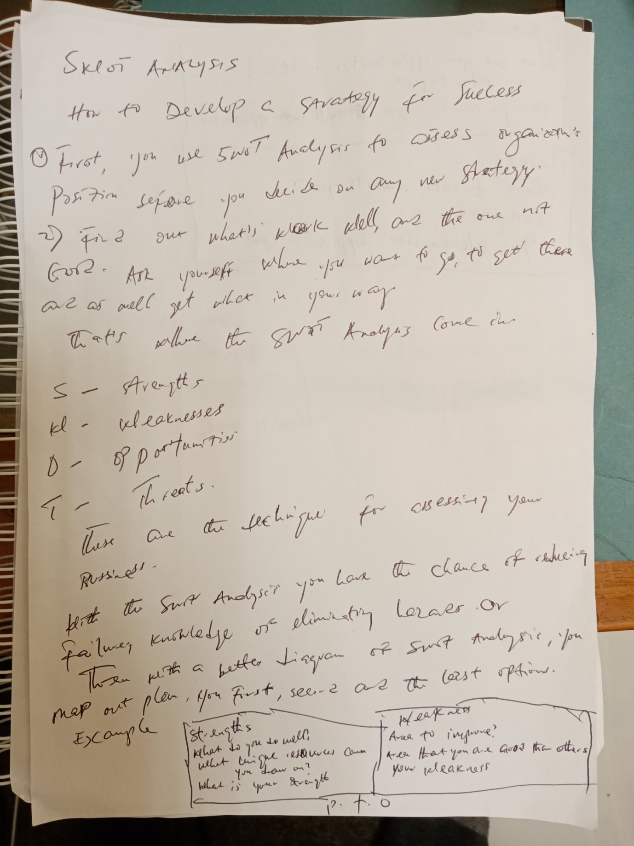
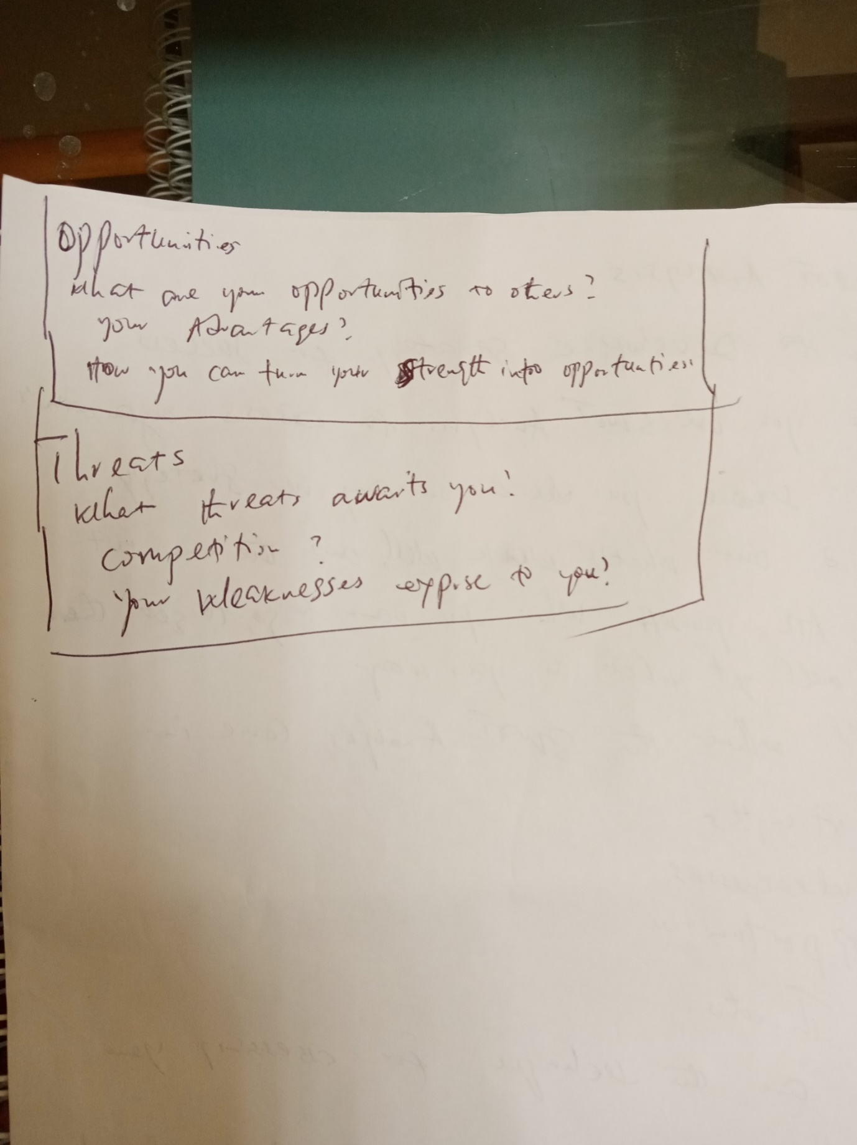






Reference:
Alison Doyle, September 02,2019, how to keep your skills current, viewed 31/07/2020, https://www.thebalancecareers.com/how-to-keep-your-job-skills-current-2063756
Dan Rees, 16/05/2019, can technology transform the fashion industry, viewed 31/07/2020, https://iloblog.org/2019/05/16/can-technology-transform-the-fashion-industry/
Dr Dawn Lees, Hillage and Pollard (1998), Yorke, 2001; Knight & Yorke 2001, Harvey 1997, Employability Skills, viewed 30/07/2020, file:///C:/Users/44754/Downloads/leeslitreview%20uche%20employability%20skills.pdf
Maikel Lieuw-Kie-Song, 11/05/2020, the construction sector can help lead the economic recovery, viewed 31/07/2020, https://iloblog.org/2020/05/11/the-construction-sector-can-help-lead-the-economic-recovery-heres-how/
Pareto, understanding the pareto principle (the 80/20 rule),viewed 10/08/2020, https://betterexplained.com/articles/understanding-the-pareto-principle-the-8020-rule/#:~:text=Understanding%20the%20pareto%Z...
Springpod, All rights reserved, The Education Hub Group Ltd. Registered Company No: 10150500, Vat number: 287276850, six ways to improve your employability while studying, viewed 31/07/2020, https://blog.springpod.co.uk/improve-your-employability-while-studying/
Mind Tools, Swot Analysis, viewed 10/08/2020, https://www.mindtools.com/pages/article/newTMC_05.htm
The balance careers, viewed 14/08/2020, https://www.thebalancecareers.com/employability-skills-list-and-examples-4143571

