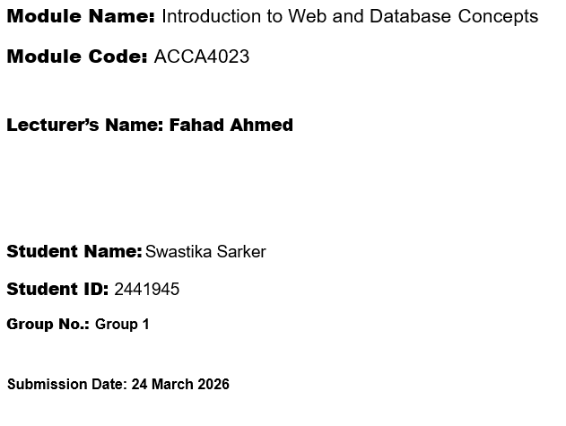

Contents
Introduction 3
1.0 Scenario Analysis 3
1.1 Summary of Task 1 Development Work 4
1.2 Relationships between entities 5
1.3 Entity Relationship Diagram (ERD) 6
1.4 Normalised Entity Relationship Diagram (ERD) 7
1.5 Tables created 7
2.0 Normalisation (Up to 3NF) 9
2.1 Explaining decisions 10
2.2 Sample Data 11
2.3 Query Development 14
3.0 Validation and Testing 23
3.1 Summary of Testing Approach 23
3.2 Field-Level Validation 23
3.3 Relationship and Referential Integrity Testing 23
3.4 Query Testing 24
3.5 Results 25
3.6 Issues Identified and Fixes Applied 25
4.0 Design Decisions, System Summary, and Reflection 26
4.1 Challenges faced 26
4.2 Improvements for Future Development 27
5.0 Conclusion 28
References 30
Appendices: 31

Introduction
MediLink Pharmacy's reliance on manual stock management, manual customer record management, manual prescription processing, manual sales tracking for stock management, and manual data collection results in errors due to the need to produce duplicate records and information collection problems, making management processes more complex. These constraints only become more prominent as the business expands, and the requirements for accurate data maintenance get more convoluted. The pharmacy needs a database system that will have digital records of its entire operation. Through well-defined relationship mapping, its essential parts connect suppliers, medicines, customers, doctors, prescriptions, and sales records. Just like real prescription or sales performance of pharmaceutical operations, it supports accurate inventory management, prescription tracking, and client operations tracking. The relational database of the system obviates all additional manual operations, less repetition in data creation, better data accuracy, and improved data storage. The database system enables three major processes associated with how inventory and prescriptions get managed, sales are tracked, and so on. The toolkit is, in turn, a reporting capability, which means that upper management can supervise the processes as they happen and monitor the business processes. The system supports the organization for process management and accurate data, allowing for flexible storage for the future expansion of such facilities in current pharmacy operations.

Scenario Analysis
Medi Link Pharmacy is an expanding community pharmacy that currently processes prescriptions, medicines, customer records and sales through paper-based, manual systems. The document uploaded also states that manual operations result in “data entry errors, misplaced records, slow reporting, and limited visibility of stock levels.”
To address these issues, the CEO has put forward a relational database to:
- Ensure data accuracy
- Automate record keeping
- Enhance reporting and decision making
- Support inventory and prescription management
Data created in Task One includes core components such as Supplier, Customer, Medicine, Doctor, Prescription, Sales Transaction, and has junction tables to track many-to-many relationships.

1.1 Summary of Task 1 Development Work

- Entity Identification
Entities and attributes identified include:
Entity | Attributes
Supplier | Supplier ID (PK), Supplier Name, Contact Number, Email, Address
Customer | Customer ID (PK), Full Name, Date of Birth, Contact Number, Address
Medicine | Medicine ID (PK), Medicine Name, Category, Unit Price, Stock Quantity, Reorder Level, Supplier ID(FK)
Doctor | Doctor ID (PK), Doctor Name, Contact Number, Email, Registration Number
Prescription | Prescription ID (PK), Prescribe Date, Customer ID(FK), Doctor ID(FK), Notes, Prescription Details
Sales Transaction | Sales Transaction ID (PK), Customer ID (FK), Sale Date, Payment Method, Total Amount

1.2 Relationships between entities

- One Supplier supplies many Medicines, but each medicine is supplied by only one supplier (1:M).
- One Customer can have multiple Prescriptions, but each prescription belongs to one customer (1:M).
- One Doctor can issue many Prescriptions, but each prescription is issued by one doctor (1:M).
- One Prescription can include multiple Prescription Details, but each prescription detail belongs to one prescription (1:M).
- Medicine can appear in many Prescription Details, but each prescription detail refers to one medicine (1:M).
- One Customer can have multiple Sales Transactions, but each sales transaction is linked to one customer (1:M).
- One Sales Transaction can include multiple Sales Details, but each sales detail belongs to one transaction (1:M).
- One Prescription can contain many Medicines. one Medicine can appear in many Prescriptions. (M: N)
- Many medicines can contain one prescription. One medicine can appear in many prescriptions. (M: N)
A sales transaction can consist of several medicines. One medicine may be sold in numerous transactions.

1.3 Entity Relationship Diagram (ERD)

The ERD illustrates all relationships, including:
- Supplier → Medicine (1:M)
- Customer → Prescription (1:M)
- Doctor → Prescription (1:M)
- Prescription → Prescription Details (1:M)
- Sales Transaction → Sales Details (1:M)

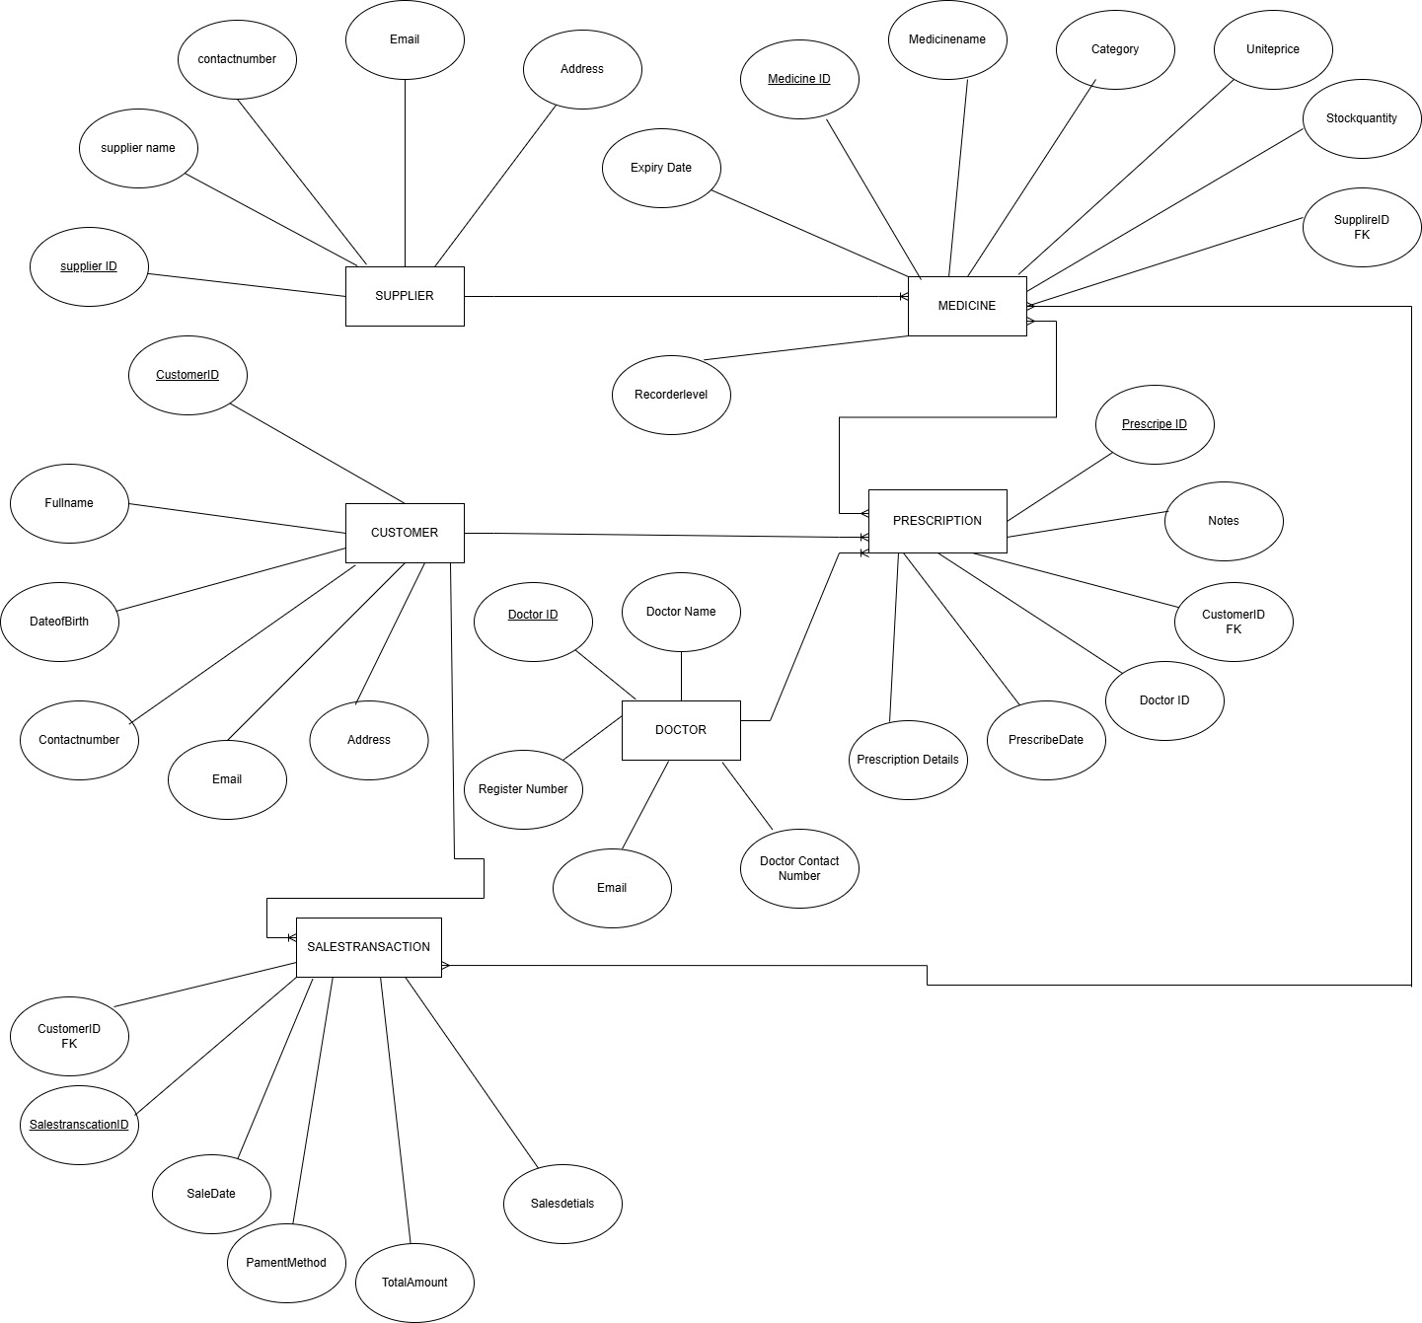

Figure: Entity Relationships Diagram (ERD)

1.4 Normalised Entity Relationship Diagram (ERD)
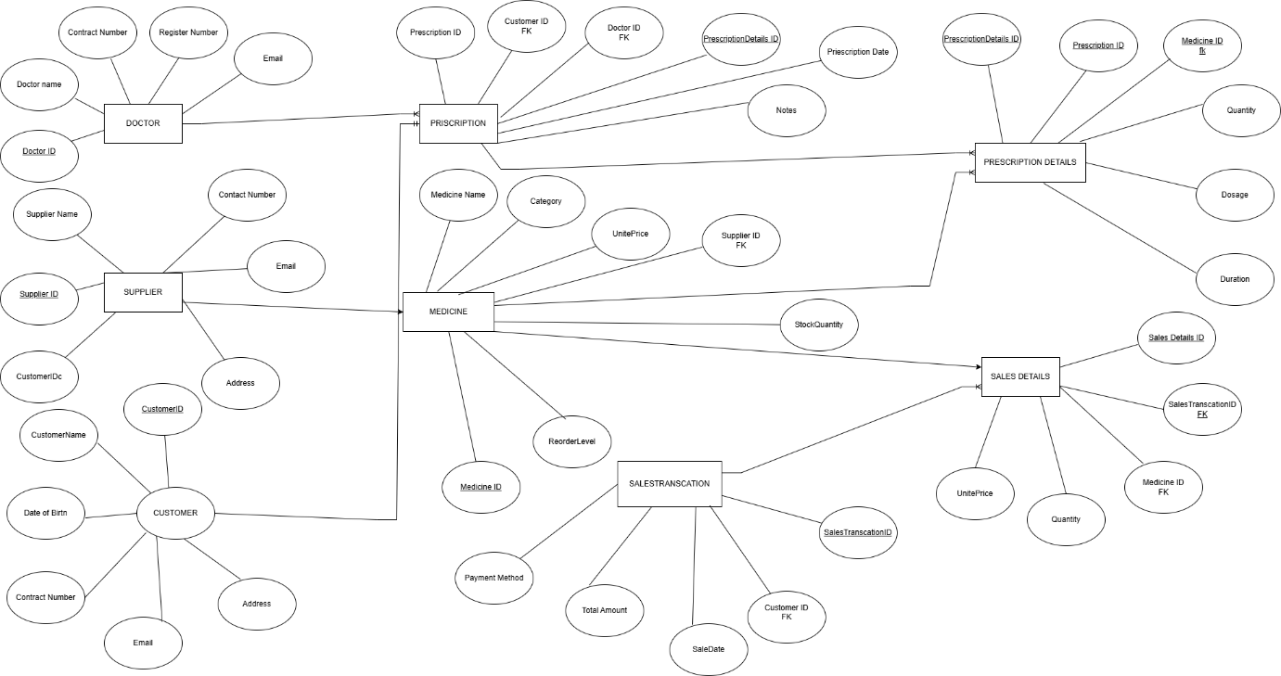

Figure: Normalised Entity Relationship Diagram (ERD)

1.5 Tables created

Table Name | Field  Names | Data  Types | Primary  Key | Foreign  Key | Relationships & Constraints
Supplier | Supplier ID, Supplier Name, Contact Number, Email, Address | AutoNumber, Short Text, Short Text, Short Text, Short Text | Supplier  ID |  | One supplier supplies many medicines (1:M). Referential integrity enforced.
Medicine | Medicine ID, Medicine Name, Category, Unit Price, Stock Quantity, Reorder Level, Supplier ID | AutoNumber, Short Text, Short Text, Currency, Number, Number, Number (Long Integer) | Medicine  ID | Supplier ID | One medicine can be supplies by many suppliers(1:M). Referential integrity Enforced.
Customer | Customer ID, Full Name, Date of Birth, Contact Number, Address | AutoNumber, Short Text, Date/Time, Short Text, Short Text | Customer ID |  | One customer can have many prescriptions and sales (1:M). Referential integrity Enforced.
Doctor | Doctor ID, Doctor Name, Contact Number, Email, Registration Number | AutoNumber, Short Text, Short Text, Short Text, Short Text | Doctor  ID |  | One doctor can issue many prescriptions (1:M). Referential integrity Enforced.
Prescription | Prescription ID, Prescribe Date, Customer ID, Doctor ID, Notes | AutoNumber, Date/Time, Number, Number, Long Text | Prescription  ID | Customer ID,  Doctor  ID | Linked to Customer and Doctor. Referential integrity enforced.
Sales Transaction | Sales Transaction ID, Customer ID, Sale Date, Payment Method, Total Amount | AutoNumber, Number, Date/Time, Short Text, Currency | Sales Transaction S ID | Customer ID | One customer can have many transactions (1:M).

2.0 Normalisation (Up to 3NF)
Normalisation Compliance (Up to Third Normal Form)
The database has been normalised to Third Normal Form (3NF), which improves efficiency and reduces redundancy.
- First Normal Form (1NF)
- All tables contain atomic values.
- No repeating groups or multi-valued attributes exist.
- Each record is uniquely identifiable via a primary key.

- Second Normal Form (2NF)
- All non-key attributes fully depend on the entire primary key.
- Composite dependency issues are removed through junction tables.
For example, Sales Details depends on Sale ID and Medicine ID rather than duplicating sale data.
- Third Normal Form (3NF)
- No transitive dependencies remain.
- Supplier details are separated from Medicine.
- Customer information is stored once and referenced elsewhere.
According to Relational Database Design (RDB), it follows best practices
[1].

2.1 Explaining decisions

It is one of the basic methods to organise the structure of the database fields using First Normal Form (1NF), Second Normal Form (2NF) and Third Normal Form (3NF). You eliminate redundancy and increase the integrity of the information with these implementations. First Normal Form (1NF) defines every column to contain only atomic (single) values, and no repeating groups. First Normal Form (1NF) retains each value in a single column entity. In other words, a field cannot hold more than a single value in its own record. You are also presented with 1NF structured data, and this makes it clearer. 2NF merely puts 1NF in the picture and eliminates partial dependence. All non-key attributes depend not just on a certain key but on all this primary key. When a table possesses composite key, all other columns need to depend exclusively on the whole key. This rules out duplicating and storing unnecessary data. Transitive dependency is not maintaining Third Normal Form (3NF). In this case, non-key attributes must be dependent only on the primary key and not on any other non-key attributes. Thus, if supplier detail is solely related to Supplier ID, we should not list those in the medicine table. This separation ensures consistency and reduces update issues. This is how 1NF makes data organised, 2NF prevents data from being partially duplicated, 3NF ensures consistency of logic. Combined, these provide a clean, effective and reliable database structure.

2.2 Sample Data
We use sample data from Microsoft Access for database analysis, and it helps end users in the database testing process to test the database system effectively. The database demonstrates its functionality through populated tables that link Supplier and Medicine, Doctor and Customer to Prescription, and Customer to Sales Transaction. This data should be used as it is a prerequisite for practical evaluation of the ERD.

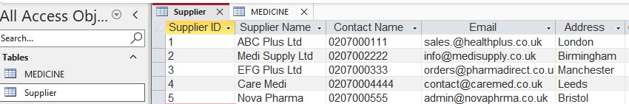

Figure: Supplier Table
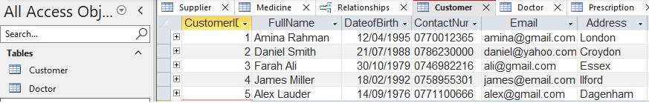

Figure: Customer Table
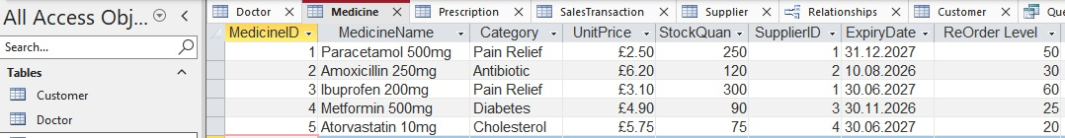

Figure: Medicine Table
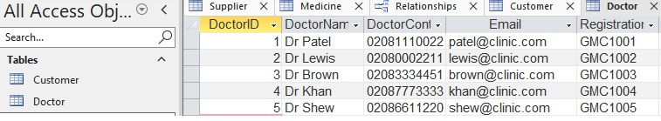

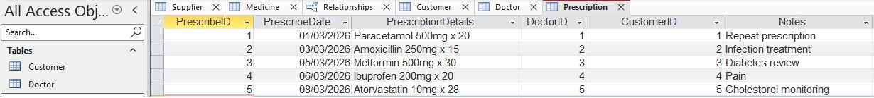
Figure: Doctor Table

Figure: Prescription Table
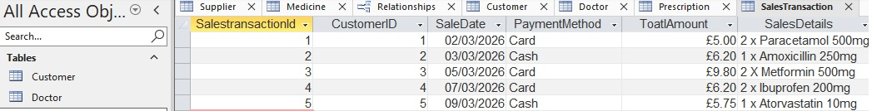

Figure: Sales Transaction Table
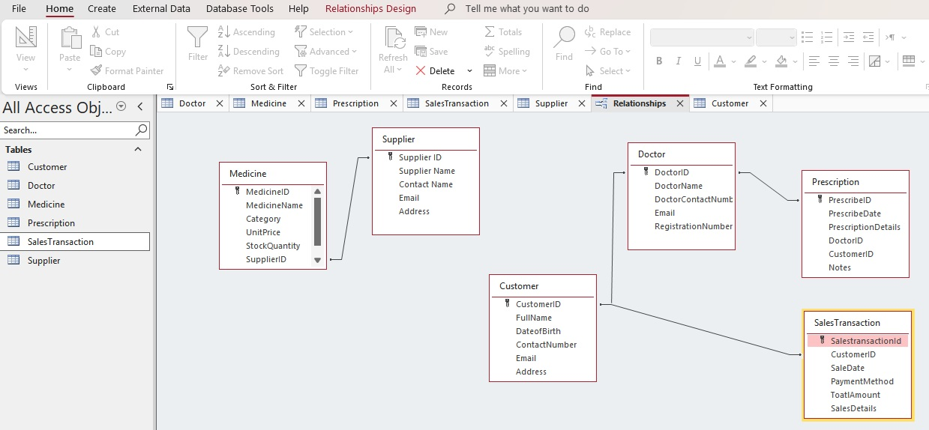

Figure: Relationships Table

2.3 Query Development

Six queries were created:
Query Name | Purpose
Customer_Prescription_query | To view prescription history for a customer
Customer_Salestransaction_query | To track customer sales
Doctor_customer_prescription_query | To show which doctor issued prescriptions to which customers
Doctor_prescription_query | To list prescriptions issued by a doctor
Medicine_supplier_query | To display medicines with their suppliers
Stock_quantity_query | To identify medicines with low stock
2.4 Screenshots of query with results
- Customer_Prescription_query
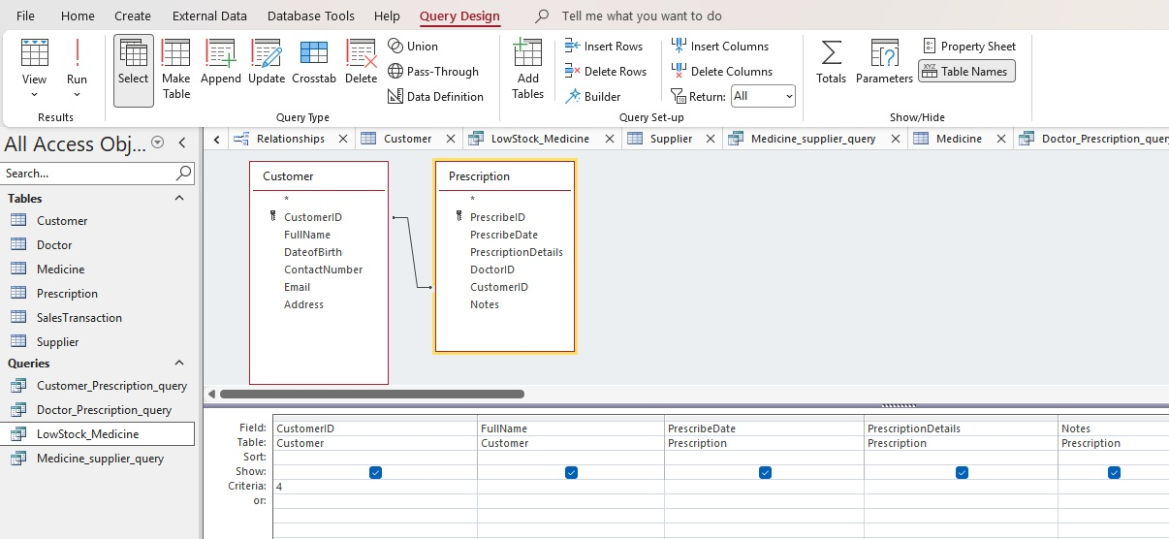

Figure: Design view of Customer_Prescription_query
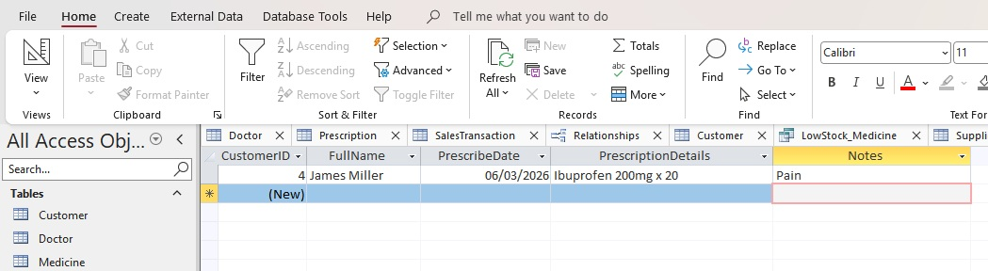

Figure: Table view of Customer_Prescription_query
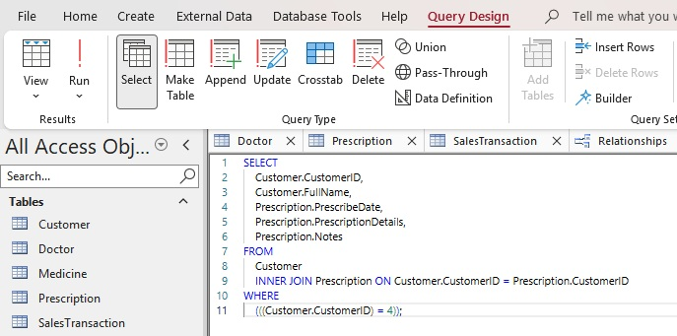

Figure: SQL view of Customer_Prescription_query

- Customer_Salestranscation_query
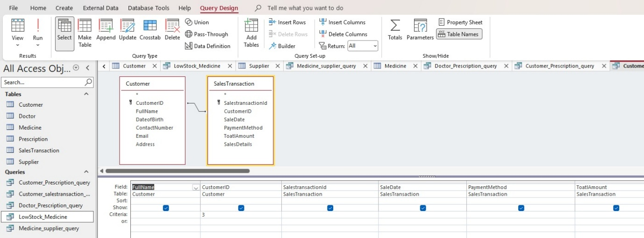

Figure: Design view of Customer_Salestranscation_query
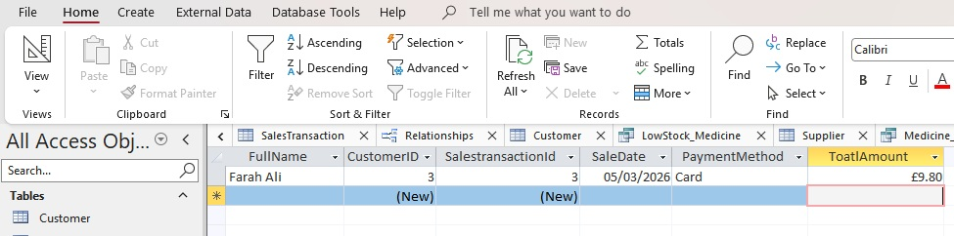

Figure: Table view of Customer_Salestranscation_query
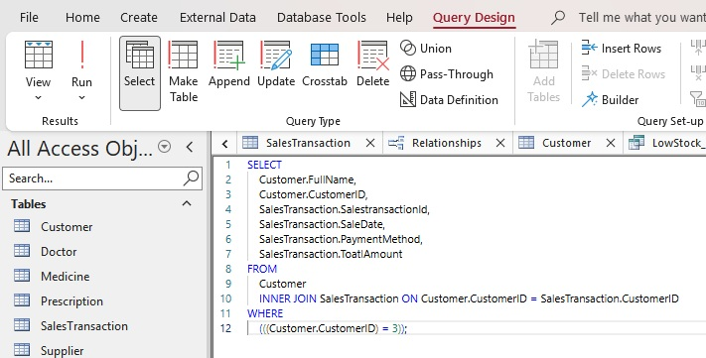

Figure: SQL view of Customer_Salestranscation_query

- Doctor_customer_prescription_ query
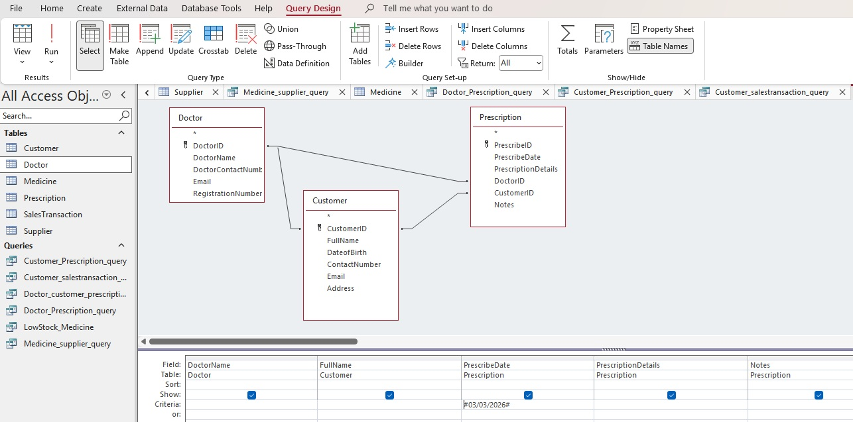

Figure: Design view of Doctor_customer_prescription_ query
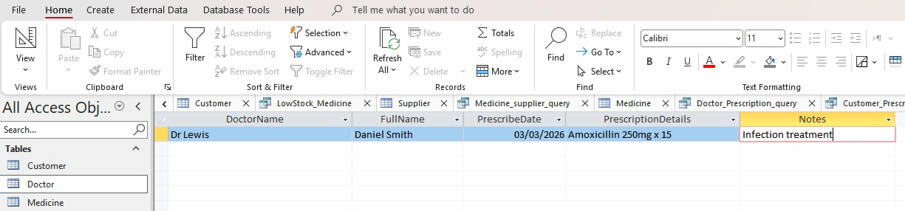

Figure: Table view of Doctor_customer_prescription_ query

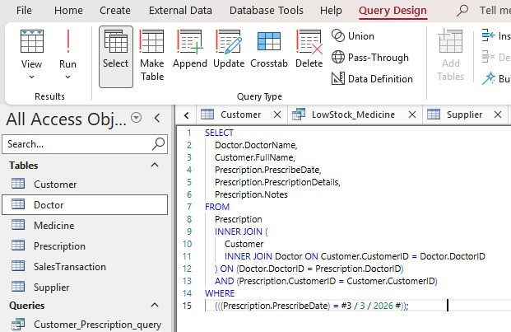

Figure: SQL view of Doctor_customer_prescription_ query

- Doctor_prescription_query
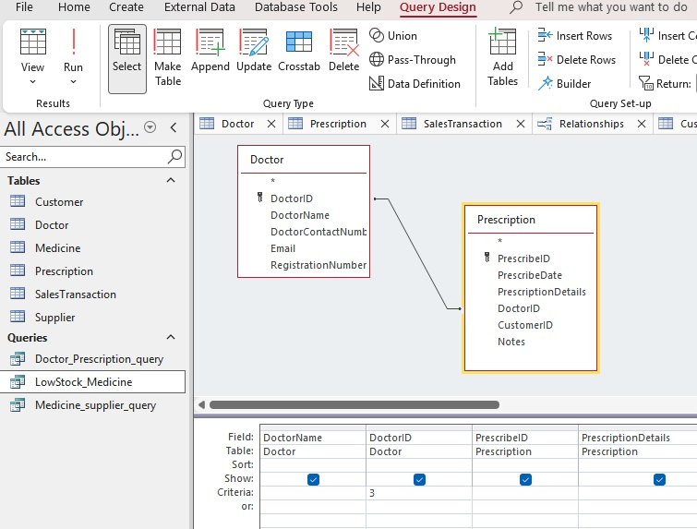

Figure: Design view of Doctor_prescription_query
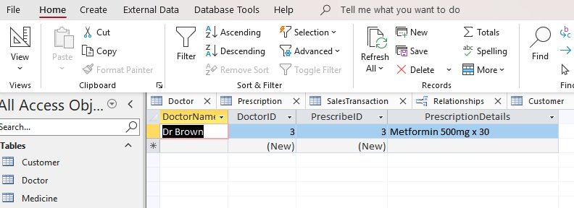

Figure: Table view of Doctor_prescription_query

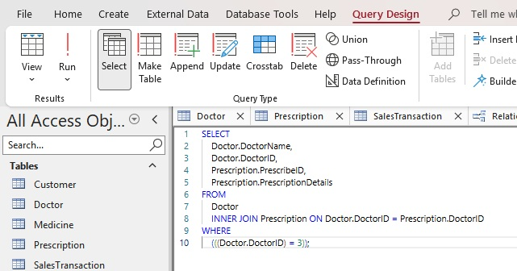

Figure: SQL view of Doctor_prescription_query

- Medicine_supplier_query
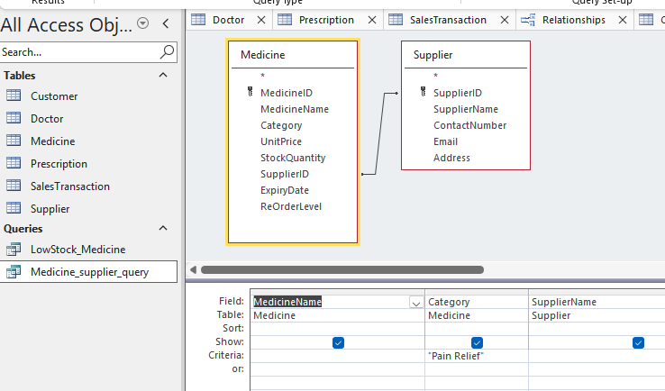

Figure: Design view of Medicine_supplier_query
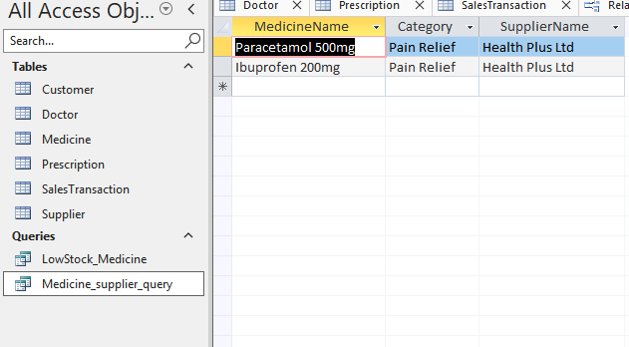

Figure: Table view of Medicine_supplier_query
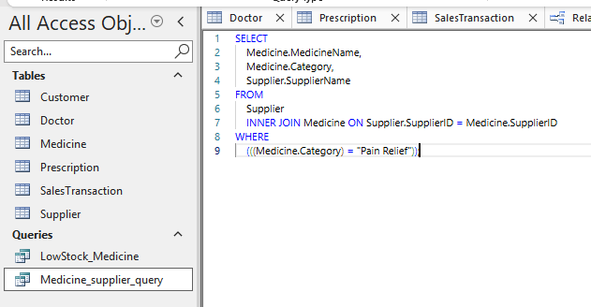

Figure: SQL view of Medicine_supplier_query

- Stock_quantity_query
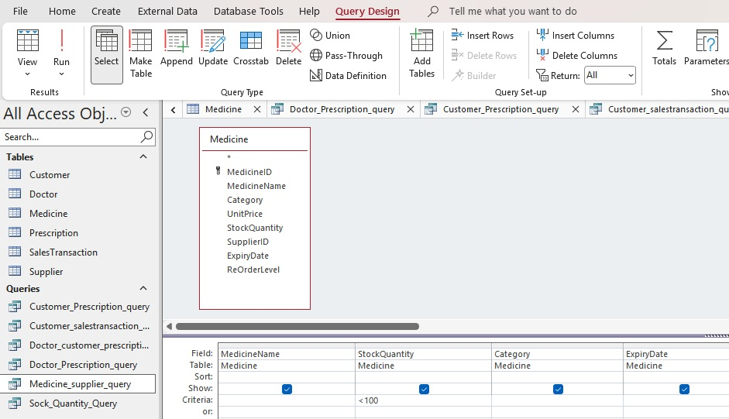

Figure: Design view of Stock_quantity_query
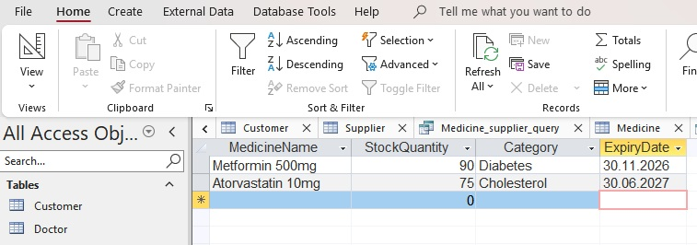

Figure: Table view of Stock_quantity_query

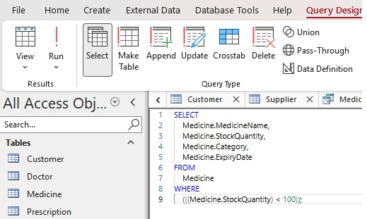

Figure: SQL view of Stock_quantity_query

3.0 Validation and Testing

3.1 Summary of Testing Approach

The testing process used a structured testing plan to confirm that the MediLink Pharmacy database system fulfilled all its functional and technical requirements. The database development process requires validation and referential integrity and iterative testing to achieve system reliability which represents best practice standards in the field [2].

3.2 Field-Level Validation
Field-level validation rules are used to avoid errors and missing information during the data entry process. These included:
- Essential fields: MedicineName, UnitPrice, CustomerName, PrescriptionID
- Data format validation for dates, currency, and numeric values.
- Range checks, such as QuantityIn > 0 and ReorderLevel ≥ 0.
- Input masks for phone numbers and NHS numbers making formats consistent.
The validation approaches implement the recommended methods described in Microsoft’s reference [3] in Access database design.
Testing outcome:
Invalid entries triggered appropriate error messages, proving that validation was working properly.

3.3 Relationship and Referential Integrity Testing

Referential integrity was tested to ensure that:
- Prescriptions could not be created without valid CustomerID and PrescriberID values.
- SaleItems could not be added without an existing SaleID.
- Medicines referenced in prescriptions or sales could not be deleted (cascade delete disabled).
Maintaining referential integrity is essential for preventing orphan records and ensuring consistent relational structures.
Testing outcome:
All relationship constraints performed as expected.

3.4 Query Testing

Queries were tested using realistic sample data to verify accuracy:
- Stock Level Query: Correctly calculated available stock.
- Low Stock Report: Identified medicines below reorder level.
- Prescription History Query: Displayed all prescriptions for a selected customer.
- Top-Selling Medicines Query: Aggregated sales quantities accurately.
Query testing is a critical step in validating the usefulness and reliability of database outputs.

3.5 Results
The data was successfully added into the system with validation rules to ensure correctness and to prevent invalid/incomplete data [3]. Foreign key violations were rejected with referential integrity constraints in place to prevent any relationships between related tables or orphan records [2]. It also processed sums and summaries that generated outputs to confirm input correctness and query logic to see if the data processing was correct or not. The low stock detection performed as anticipated, as it detected all medicines that had reached or fallen below the reorder threshold allowing for timely inventory management. All references to related tables were prevented from deleting records, ensuring integrity of the data while maintaining important relationships.

3.6 Issues Identified and Fixes Applied

Issue | Cause | Fix
Incorrect stock totals | Missing grouping in query | Added GROUP BY and corrected joins
Duplicate supplier entries | No uniqueness constraint | Added validation rule + form-level check
Sales transactions are not linked to prescriptions | Missing PrescribeID foreign key in SalesTransaction table | Add PrescribeID to SalesTransaction and enforce referential integrity

4.0 Design Decisions, System Summary, and Reflection

- Design Decisions
The MediLink Pharmacy database was designed as a fully normalised system with clear entities such as Medicine, Supplier, Customer, Prescription, and Sale to reduce redundancy and improve data integrity. Associative tables like Supplier, Medicine and Prescription were added to manage many‑to‑many relationships and maintain 3NF [3]. Referential integrity rules ensured consistent links between prescriptions, stock, and sales. Queries, forms, and reports were created to support key pharmacy tasks such as stock checks, prescription tracking, and sales analysis.

- Summary of What Was Built
The system includes a normalised relational database, a complete ERD, Access tables with validation rules, realistic sample data, practical queries (stock levels, low‑stock alerts, prescription history, top‑selling medicines), user‑friendly forms, and management reports. Validation and testing confirmed that the system meets all functional requirements.

4.1 Challenges faced

- Creating Complex Relationships
The handling of prescriptions, medicines, and doctors also needed to be carefully planned. A main challenge was making sure each prescription could contain multiple medicines without duplicating data.
- Ensuring Validation Rules Did Not Restrict Legitimate Data
Initially, certain validation instructions excluded valid data on entry (e.g., medicines with zero inventory when they are at entry). These were further refined to enable the process to operate.
- Query Logic and Readability
Generating meaningful queries that produced results took constant iteration to test. For instance, if you linked more than one table it may end up with duplicate rows and you needed to perform DISTINCT or improve the join condition [4].
- Maintaining Consistency Across Sample Data
It was necessary to sequence input data entry to guarantee that sample data obeyed referential integrity rules

4.2 Improvements for Future Development

- Automation Features
For example, automated reorder alerts could be developed to alert staff that stock is already at the reorder level.

- Barcode Integration
Use of barcode scanning can improve accuracy and speed in sales and stocking updates.

- Role Based Security
User roles (pharmacist, assistant, manager) could be created to protect sensitive data [1].

- Migration to a Scalable Platform
When the company scales, moving from Access to SQL Server or MySQL would increase the performance as the business grows and support multiple users [5].

- Enhanced Reporting
Dashboards and graphical reports could enable real-time updates to sales patterns, stock levels, and customer activity.

5.0 Conclusion
The MediLink Pharmacy database solution meets the organizational needs, with a complete solution through structured design and reliable operation. The data normalization approach by the database design works upon the principle of the Third Normal Form (3NF), aiming at preventing duplication of data while preserving the integrity and consistency of data through complete dependency removal. The key relationships of primary and foreign keys directly link the core elements of one another such as customers, suppliers, medicines, prescriptions, and sales transactions. That is where the relational organization serves as a direct representation of operations in actual pharmacy, with accurate data processing and appropriate retrieval methods. Both validation rules and referential integrity mechanisms implemented in the system help in ensuring that the system has continuous data accuracy. The database plays the role of a core business for organizations by providing them with basic data (inbound and outsourced), helping them in performing all the important business processes like inventory control and prescription management and tracking of sales and providing them with key data for making decision and reporting on compliance. The design supports future growth with its scalable framework that enables system upgrades which may include automation and advanced analytics of customer data. The database system illustrates how structured design and normalization work together in forming a system that delivers reliable performance and maintenance convenience for today's pharmacy management demands.

References
[1] T. Connolly and C. Begg, Database Systems: A Practical Approach to Design, Implementation, and Management, 6th ed. Harlow, UK: Pearson, 2015.
[2] R. Elmasri and S. B. Navathe, Fundamentals of Database Systems, 7th ed. Boston, MA, USA: Pearson, 2016.
[3] A. Silberschatz, H. Korth, and S. Sudarshan, Database System Concepts, 7th ed. New York, NY, USA: McGraw-Hill, 2020.
[4] J. Viescas and J. Hernandez, Microsoft Access 2019 Inside Out. Redmond, WA, USA: Microsoft Press, 2019.
[5] C. J. Date, An Introduction to Database Systems, 8th ed. Boston, MA, USA: Pearson Education, 2004.

Appendices:

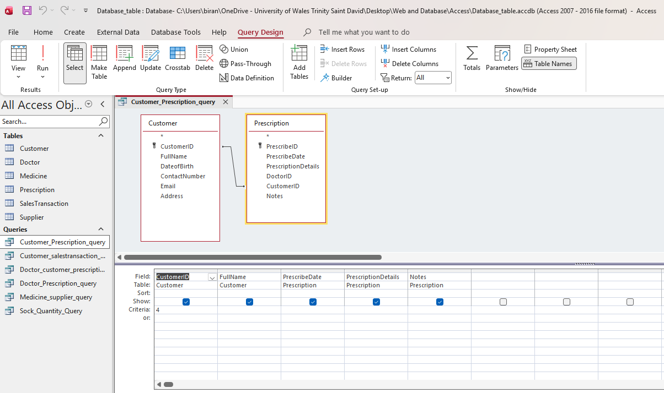

Picture: Customer_Prescription_query

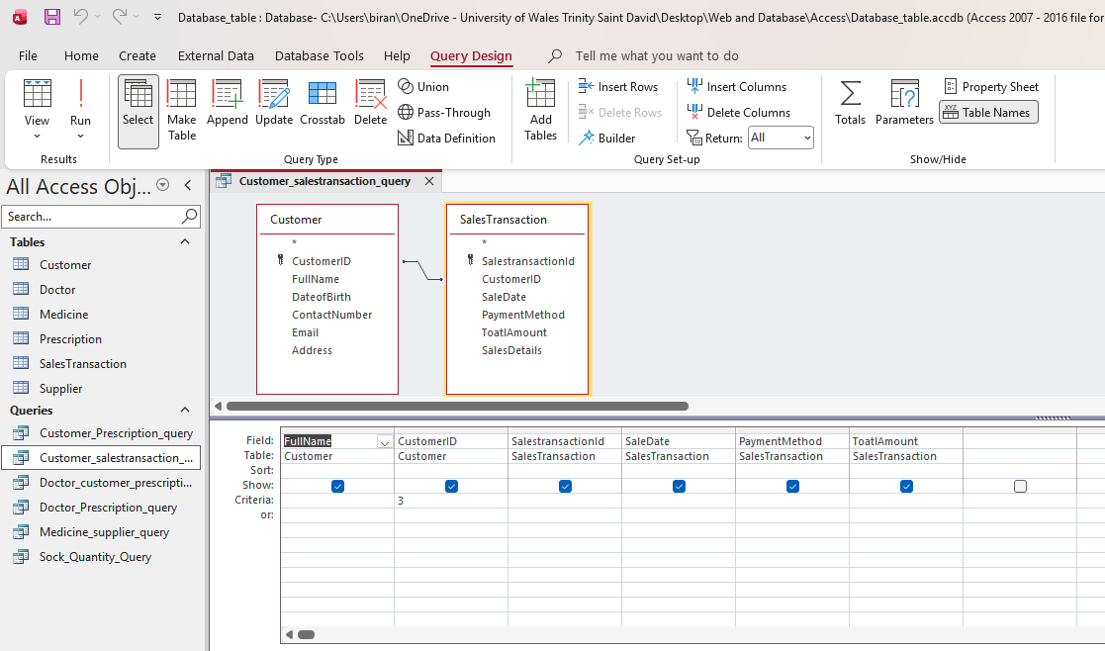

Picture: Customer_saletrasaction_query

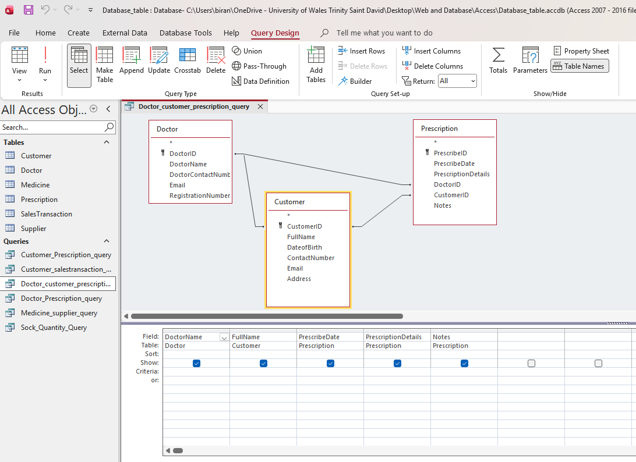

Picture: Doctor_Customer_Prescription_query

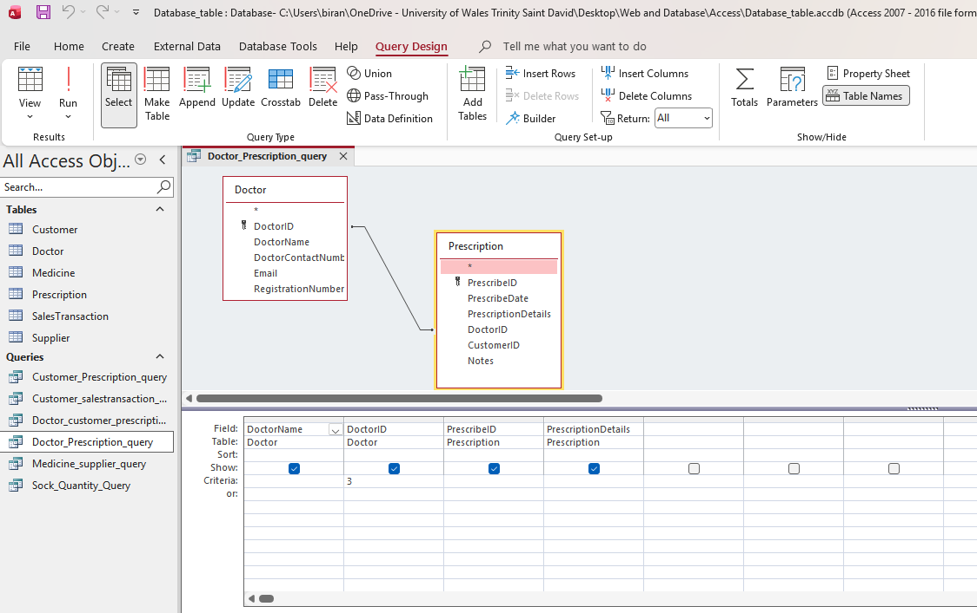

Picture: Doctor_Prescription_query

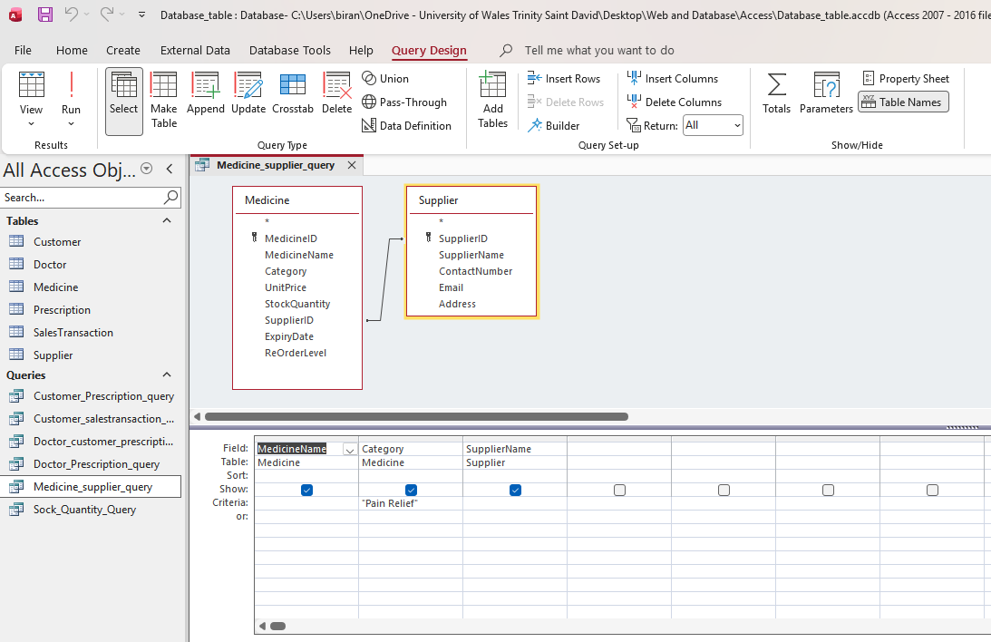

Picture: Medicine_Supplier_query
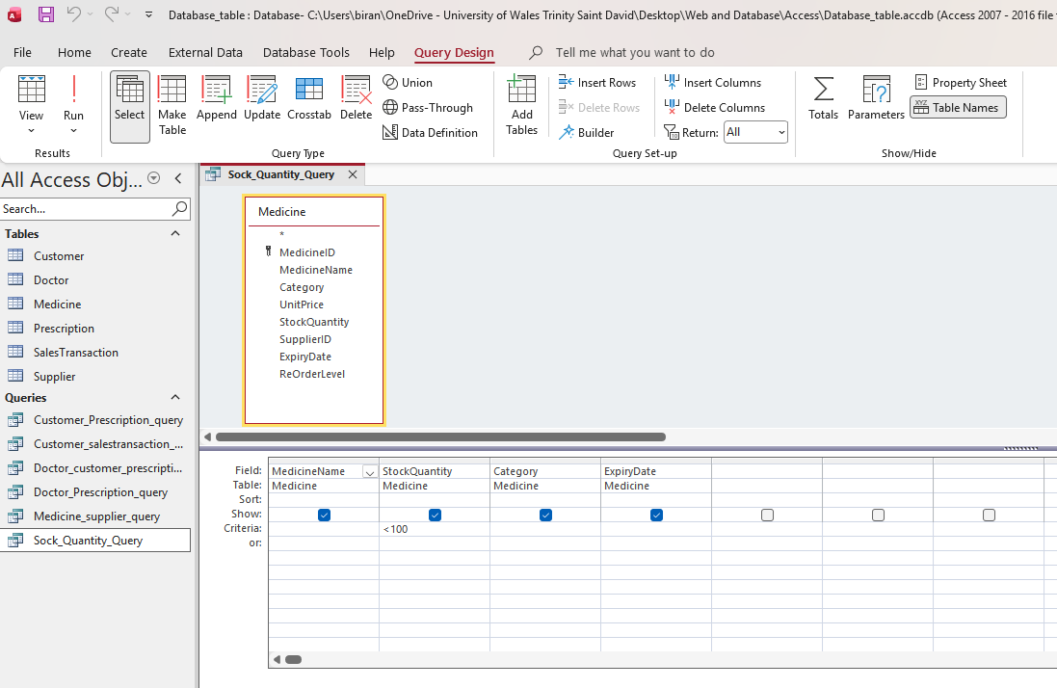

Picture: Stock_Quantity_query

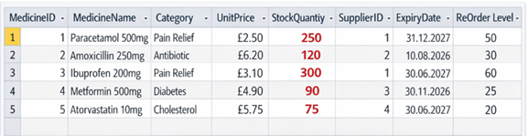

Picture: Incorrect stock totals
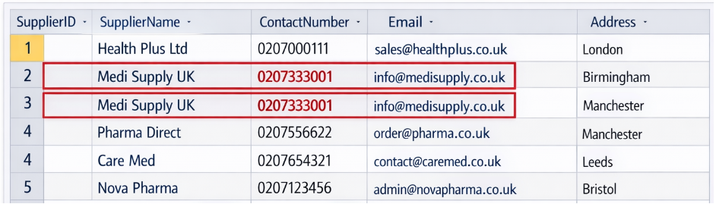

Picture: Duplicate supplier entries

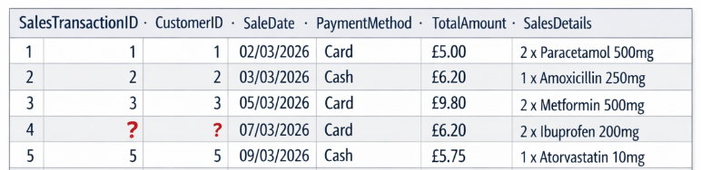

Picture: Sales transactions are not linked to prescriptions

