Lab – Understanding Ethernet Cable Standards
Topology
Addressing Table
Device | Interface | IP Address | Subnet Mask | Default Gateway
PC-A | NIC | 192.168.10.1 | 255.255.255.0 | N/A
PC-B | NIC | 192.168.10.2 | 255.255.255.0 | N/A
Objectives
Part 1: Analyze Ethernet Cabling Standards and Pinouts
Part 2: Build an Ethernet Crossover Cable
Part 3: Test an Ethernet Crossover Cable
Background / Scenario
In this lab, you will build and terminate an Ethernet crossover cable and test it by connecting two PCs together and pinging between them. You will first analyze the Telecommunications Industry Association/Electronic Industries Association (TIA/EIA) 568-A and 568-B standards and how they apply to Ethernet cables. You will then construct an Ethernet crossover cable and test it. Finally, you will use the cable you just constructed to connect two PCs together and test it by pinging between them.
Note: With autosensing capabilities available on many devices, such as the Cisco 1941 Integrated Services Router (ISR) switch, you may see straight-through cables connecting like devices.
Required Resources
- One length of cable, either Category 5 or 5e. Cable length should be 0.6 to 0.9m (2 to 3 ft.)
- 2 RJ-45 connectors
- RJ-45 crimping tool
- Wire cutter
- Wire stripper
- Ethernet cable tester (optional)
- 2 PCs (Windows 7 or 8)
- Analyze Ethernet Cabling Standards and Pinouts
The TIA/EIA has specified unshielded twisted pair (UTP) cabling standards for use in LAN cabling environments. TIA/EIA 568-A and 568-B stipulates the commercial cabling standards for LAN installations; these are the standards most commonly used in LAN cabling for organizations and they determine which color wire is used on each pin.
With a crossover cable, the second and third pairs on the RJ-45 connector at one end of the cable are reversed at the other end, which reverses the send and receive pairs. The cable pinouts are the 568-A standard on one end and the 568-B standard on the other end. Crossover cables are normally used to connect hubs to hubs or switches to switches, but they can also be used to directly connect two hosts to create a simple network.
Reflection:
Write a research report (Max word count 600) on Cat 5e and 6 Ethernet cable standards.
  - Analyze diagrams and tables for the TIA/EIA 568-A standard Ethernet cable.
The following table and diagrams display the color scheme and pinouts, as well as the function of the four pairs of wires used for the 568-A standard.
Note: In LAN installations using 100Base-T (100 Mb/s), only two pairs out of the four are used.
568-A 10/100/1000Base-TX Ethernet
Pin Number | Pair Number | Wire Color | 10Base-T Signal  100Base-TX Signal | 1000Base-T Signal
1 | 2 | White/Green | Transmit | BI_DA+
2 | 2 | Green | Transmit | BI_DA-
3 | 3 | White/Orange | Receive | BI_DB+
4 | 1 | Blue | Not Used | BI_DC+
5 | 1 | White/Blue | Not Used | BI_DC-
6 | 3 | Orange | Receive | BI_DB-
7 | 4 | White/Brown | Not Used | BI_DD+
8 | 4 | Brown | Not Used | BI_DD-

The following diagrams display how the wire color and pinouts align with an RJ-45 jack for the 568-A standard.
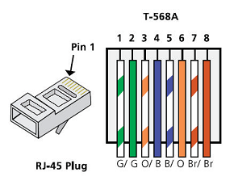
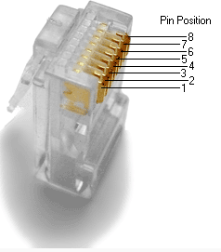
  - Analyze diagrams and tables for the TIA/EIA 568-B standard Ethernet cable.
The following table and diagram display the color scheme and pinouts for the 568-B standard.
568-B 10/100/1000-BaseTX Ethernet
Pin Number | Pair Number | Wire Color | 10Base-T Signal  100Base-TX Signal | 1000Base-T Signal
1 | 2 | White/Orange | Transmit | BI_DA+
2 | 2 | Orange | Transmit | BI_DA-
3 | 3 | White/Green | Receive | BI_DB+
4 | 1 | Blue | Not Used | BI_DC+
5 | 1 | White/Blue | Not Used | BI_DC-
6 | 3 | Green | Receive | BI_DB-
7 | 4 | White/Brown | Not Used | BI_DD+
8 | 4 | Brown | Not Used | BI_DD-
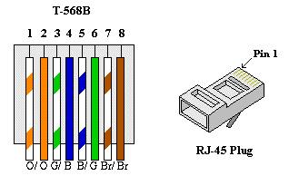

- Build an Ethernet Crossover Cable
A crossover cable has the second and third pairs on the RJ-45 connector at one end, reversed at the other end (refer to the table in Part 1, Step 2). The cable pinouts are the 568-A standard on one end and the 568-B standard on the other end. The two following diagrams illustrate this concept.
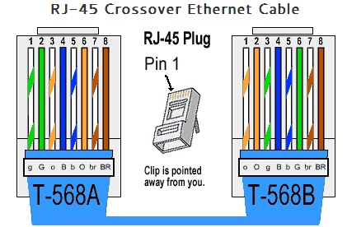
  - Build and terminate a TIA/EIA 568-A cable end.
    - Determine the cable length required. (Your instructor will let you know the cable length you should make.)
Note: If you were making a cable in a production environment, the general guideline is to add another 12 in. (30.48 cm) to the length.
    - Cut off a piece of cable to the desired length and using your wire stripper, remove 5.08 cm (2 in.) of the cable jacket from both ends.
    - Hold the four pairs of twisted cables tightly where the jacket was cut away. Reorganize the cable pairs into the order of the 568-A wiring standard. Refer to the diagrams, if necessary. Take as much care as possible to maintain the twists in the cable; this provides noise cancellation.
    - Flatten, straighten, and line up the wires using your thumb and forefinger.
    - Ensure that the cable wires are still in the correct order for the 568-A standard. Using your wire cutters, trim the four pairs in a straight line to within 1.25 to 1.9 cm (1/2 to 3/4 in.).
    - Place an RJ-45 connector on the end of your cable, with the prong on the underside pointing downward. Firmly insert the wires into the RJ-45 connector. All wires should be seen at the end of the connector in their proper positions. If the wires are not extending to the end of the connector, take the cable out, rearrange the wires as necessary, and reinsert the wires back into the RJ-45 connector.
    - If everything is correct, insert the RJ-45 connector with cable into the crimper. Crimp down hard enough to force the contacts on the RJ-45 connector through the insulation on the wires, thus completing the conducting path. See the following diagram for an example.
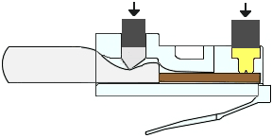
  - Build and terminate a TIA/EIA 568-B cable end.
Repeat steps 1a to 1g using the 568-B color wiring scheme for the other end.
- Test an Ethernet Crossover Cable
  - Test the cable.
Many cable testers will test for length and mapping of wires. If the cable tester has a wire map feature, it verifies which pins on one end of the cable are connected to which pins on the other end.
If your instructor has a cable tester, test the crossover cable for functionality. If it fails, check with your instructor first as to whether you should re-cable the ends and re-test.
  - Connect two PCs together via NICs using your Ethernet crossover cable.
    - Working with a lab partner, set your PC to one of the IP addresses shown in the Addressing Table (see page 1). For example, if your PC is PC-A, your IP address should be set to 192.168.10.1 with a 24-bit subnet mask. You partner’s IP address should be 192.168.10.2. The default gateway address can be left empty.
    - Using the crossover cable you made, connect the two PCs together via their NICs.
    - On the PC-A command prompt, ping the PC-B IP address.
Note: The Windows firewall may have to be temporarily disabled for pings to be successful. If the firewall is disabled, make sure you re-enable it at the conclusion of this lab.
    - Repeat the process and ping from PC-B to PC-A.
Assuming IP addressing and firewall are not issues, your pings should be successful if the cables were properly made.
Reflection
  - Which part of making cables did you find the most difficult?
Ensuring the cables stay in the correct order as they are being slid into the RJ45 connector.
  - Why do you have to learn how to make a cable if you can easily buy pre-made cables?
One type of cable (e.g. straight-through) can be converted to the other type by re-terminating the ends with the appropriate pinout. It also allows for custom length cables which may be useful for longer runs or cable management in network cabinets.

Report – CAT5e and CAT6 cable standards

Introduction
With the introduction of Gigabit Ethernet, there came the requirement for interconnecting media that could support the increased transmission speeds. Category 5 (CAT5) cable can at times support the higher speeds, but it is not rated for Gigabit speeds at cable lengths over 100 metres [1]. Category 5e (CAT5e) was introduced to resolve this shortcoming and was the first category of cable since Category 3 to be recognised by TIA/EIA [2]. The cable is physically the same as CAT5 cable, but the standards for crosstalk are more stringent [3]. Category 6 (CAT6) cables provide improved performance compared to CAT5e, with the specification having more stringent requirements for system noise and crosstalk [1].
The additional performance of CAT6 is achieved through a higher operational frequency. The requirement for greater resilience to interference is due to the increase in frequency. Table 1 shows the data rate and bandwidth of the two categories.

Category | Data rate (Gigabit per second) | Bandwidth (MHz)
CAT5e | 1 Gbps at 100 metres | 100
CAT6 | 1 Gbps at 100 metres  10 Gbps at 55 metres | 250
Table 1:Comparison of CAT5e and CAT6 data rates and bandwidths [3][1]

Cable construction
Both categories of cable are available with various levels of shielding depending on the given application [3][4].
- Unshielded Twisted Pair (UTP) – no shielding around the twisted pairs or whole cable
- Shielded Twisted Pair (STP) – shielding around each individual twisted pair but not the whole cable
- Shielded/Unshielded Twisted Pair (S/UTP) – no shielding around the twisted pairs but the whole cable is shielded
- Shielded/Shielded Twisted Pair (S/STP) – shielding around the twisted pairs and the whole cable
Shielding around the twisted pairs prevents crosstalk between the pairs inside the cable as well as preventing interference from outside the cable [3]. Shielding around the cable also prevents against external interference and can increase the mechanical strength of the cable. Different types of shielding, such as foil or braided shielding [2], may be used based on the mechanical strength required [5].
Both CAT5e and CAT6 use copper cores in four twisted pairs [3][4] to reduce interference. The copper cores can either be stranded or solid. Stranded cable are more flexible than solid cable but are not as durable [2]. Both categories use RJ45 connectors, although the CAT6 connectors arrange the copper cores differently (see Figure 1) to reduce interference and due to the larger gauge wires [6].
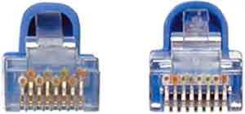
Figure 1: CAT6 RJ45 connector (left) compared to CAT5e RJ45 connector (right). Note the difference in layout of the copper cores. Source: [1]

Cable termination
The RJ45 connectors can be terminated using one of two standards; TIA/EIA 568-A or TIA/EIA 568-B. What standard is used at each end of the cable defines the type of Ethernet cable. If both ends are the same standard, it is a ‘straight-through’ cable. If one end is TIA/EIA 568-A and the other is TIA/EIA 568-B, it is a ‘crossover’ cable [7]. Figure 2 shows the pinout for each standard. Straight-through cables are used for ‘dissimilar’ devices (e.g. PC to switch). Crossover cables are used for connecting ‘similar’ devices (e.g. PC to PC, switch to router), although networking devices that support automatic medium-dependent interface crossover (Auto MDI-X) allow straight-through cables to be used in place of crossover cables [8].
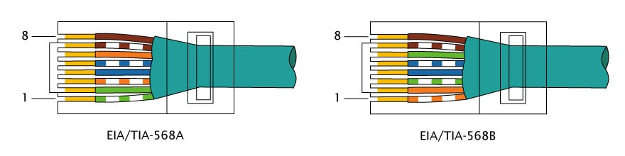
Figure 2: Illustrations of the pinouts for TIA/EIA 568-A and TIA/EIA 568-B [9]

Conclusion
With the increasing amount of data being transferred across networks, the author believes CAT6 or newer category cables (Category 8 is now available [10]) should be used instead of CAT5e due to the better ‘future-proofing’ and additional performance potential they provide.

Reference list
[1] Cablek Industries, “CAT 5, cat 5e, cat6, cat6a, cat7, cat8 Cable Standards | Cablek,” Cablek Industries. [Online]. Available: http://www.cablek.com/technical-reference/cat-5---5e--6--6a---7--8-standards. [Accessed: 02-Nov-2019].
[2] Electronics Notes, “Ethernet Cable: Types, Pinout - Cat 5, 5e, 6, 6a, 7 » Electronics Notes,” Electronic Notes. [Online]. Available: https://www.electronics-notes.com/articles/connectivity/ethernet-ieee-802-3/cables-types-pinout-cat-5-5e-6.php. [Accessed: 02-Nov-2019].
[3] J. Garrison, “What Kind of Ethernet (Cat5, Cat5e, Cat6, Cat6a) Cable Should I Use?,” How-To Geek, 2016. [Online]. Available: https://www.howtogeek.com/70494/what-kind-of-ethernet-cat-5e6a-cable-should-i-use/. [Accessed: 02-Nov-2019].
[4] M. Sei, “Ethernet Cables: The complete guide – Marksei,” Marksei, 2016. [Online]. Available: https://www.marksei.com/ethernet-cables-complete-guide/. [Accessed: 02-Nov-2019].
[5] T. Czyz, “Shielded Cable: Foil Shielding vs. Braided Shielding in Cable Assemblies,” ICONN Systems blog, 2017. [Online]. Available: https://www.iconnsystems.com/blog/foil-shielding-vs.-braided-shielding-in-cable-assemblies. [Accessed: 02-Nov-2019].
[6] “How to tell the difference between CAT5 / CAT6 solid / stranded core RJ45 plugs - YouTube,” 2014. [Online]. Available: https://www.youtube.com/watch?v=hnN3HZ5TAEw. [Accessed: 04-Nov-2019].
[7] “Difference between TIA/EIA 568A and 568B terminations,” Fiberbit Technology Co Blog, 2013. [Online]. Available: http://fiberbit.com.tw/difference-between-tiaeia-568a-and-568b-terminations/. [Accessed: 02-Nov-2019].
[8] “Catalyst 2960-X Switch Interface and Hardware Component Configuration Guide, Cisco IOS Release 15.0(2)EX - Configuring Auto-MDIX [Cisco Catalyst 2960-X Series Switches] - Cisco,” 2018. [Online]. Available: https://www.cisco.com/c/en/us/td/docs/switches/lan/catalyst2960x/software/15-0_2_EX/int_hw_components/configuration_guide/b_int_152ex_2960-x_cg/b_int_152ex_2960-x_cg_chapter_011.html. [Accessed: 02-Nov-2019].
[9] S. Cooper, “The difference between straight through, crossover, and rollover cables,” Comparitech blog, 2018. [Online]. Available: https://www.comparitech.com/net-admin/difference-between-straight-through-crossover-rollover-cables/. [Accessed: 02-Nov-2019].
[10] Panduit Corp., “The Future of Copper : Category 8 Cabling Understanding the characteristics and capabilities of the next-generation of twisted pair copper cabling Dependability and Deployment Speed,” p. 7, 2016.

