James Breen
150383
Commercial Processes and Cost Management
M5X01871
BSc/HND/HNC Built Environment Portfolio
19/02/2019

Table of Contents
Contents
1.0 Introduction 3
1.1 Overview of estimation 3
1.2 Types of estimation 3
1.2.1 Cube method 3
1.2.2 Conference estimate 3
1.2.3 Approximate Quantities 3
1.2.4 Cost model 3
1.3 Aim of the report 4
1.4 Assumptions 4
1.4.1 Assumed dimensions 4
1.5 Estimation 5
1.6 Labour costs 7
1.6.1 Assumptions 7
1.7 Cost Data/Information and limitation 8
1.7.1 Cost Data 8
1.8 Types of Cost Data 8
1.8.1 Forecasting of Cost 8
1.8.2 Cost comparison 8
1.8.3 Cost balancing 8
1.8.4 Analysis of cost trends 8
1.9 Limitations 9
1.9.1 Accuracy & Consistency 9

1.0 Introduction

1.1 Overview of estimation
Throughout this task, I am to assume the role of an estimator/ quantity surveyor. Estimation in the construction industry is a crucial component as it is a way to anticipate the expense of building a structure. Therefore, it aims to predict as accurately as possible the expenditure of a project. This, in turn, allows clients to assess the feasibility and affordability of the overall project and aids in determining whether the project is worth the risk. Along with outlining a set budget and determining risks involved. There are several methods involved estimation, it is usually in client interests to use a range of methods in order to evaluate a projects expenditure before proceeding.

1.2 Types of estimation

1.2.1 Cube method
This technique is based on a single rate method, which depends on the cubic content of a structure. The costs per cubic meter are specific for each project.

1.2.2 Conference estimate
Often used for the preparation of the earliest price, this method relies on analyses and knowledge form individuals with relevant experience in order to get an estimate for a project.

1.2.3 Approximate Quantities
The function of an approximate estimate is to produce a projection of detailed costs for the overall project. This is before the project has been put out for tender, this allows the client to assess financial risk before the construction is undertaken. (I.H.Seeley, 1996)

1.2.4 Cost model
This method is a more modern approach to estimation. It can be used to forecast an estimated cost of a proposed project by using models, previous statistic and research techniques that can be applied to the overall cost. This isn’t an accurate cost, although it can allow a client to form a rough idea of the financial expenditure.

1.3 Aim of the report
The aim of this report is to establish a building cost estimate for a proposed semi-detached property for a client, this report aims to aid the client in determining the feasibility of the project. I also aim to factor in the labour costs for 4 craftsmen over 50 weeks, taking into consideration overheads. To also discuss costs date and their limitation. I aim to achieve these objectives by splitting up each task and outlining any assumption that I have made.

1.4 Assumptions
Due to the nature of the task and a limited description of certain aspects of the project, I will outline any assumption that I have made that may affect the project. The aim of these assumptions is to clear up any factors that may cause confusion and to provide a more accurate estimate.

Before the calculations of estimations being, I am to assume the following:
- Site clearance has already been completed
- No contaminants found in the soil
- Mains Services, gas, water electric already laid
- Assume no Greenland or conservation area on or nearby the land
- No Archaeological Discoveries
- Geotechnical Ground Report Conducted

1.4.1 Assumed dimensions
(Note: These dimensions are per structure and dimensions used, aim to represent floor plans provided in the assignment brief)
Gross internal floor area:

Ground floor | Dimensions | Area m²
Hall | 1.59 x 3.11m | 5
Lounge | 5.27 x 3.79m | 19.9
Dining | 3.16 x 3.15m | 10
Kitchen | 3.15 x 4.59m | 14.5
WC | 1.19 x 1.78m | 2.1
 |  | 51.5 m²
(Turnberry Homes Detail, 2019)
First Floor | Dimensions | Area m²
Bedroom 1 | 3.22 x 2.90m | 9.3
Bedroom 2 | 2.99 x 2.86m | 5.9
Study | 3.39 x 2.54m | 8.6
Bathroom | 1.76 x 2.05m | 3.6
En-suite | 1.83 x 2.20m | 4
 |  | 31.4 m²

Second floor/loft | Dimensions | Area m²
Bedroom 3 | 3.07 x 3.87m | 11.9
WC | 1.76 x 2.05m | 3.6
 |  | 15.5 m²

Gross internal floor area = 98.4

1.5 Estimation
In order to prepare an accurate estimate, I have used BCIS as a benchmark for cost per m². I have also used the NRE 1 Order of Estimate to calculate estimations. All result have been rebased to Swansea and set them to the current date. BCIS is a good way to compare and inform a client of expected overall costs, it also provides a breakdown cost of each element to the building. I have chosen to use the average price search for cost per m², as this reflects a more accurate and fair estimate. It is very important to show a fair and accurate estimation as this will affect the client's decision, it will determine whether the project is feasible. The cost per m2 on the screenshot below has been used to estimate the cost of the project. Below I have highlighted cost per m² used for estimation. I have attached a PDF to this report in order for better viewing. It is also important to note that this is just a rough estimate and in order for pretender, a bill of quantities will need to be produced along with an accurate set of plans. The benefit of BCIS is that you can get a rough idea of the cost of a project without investing considerable time and money on design fees before you are sure of a decision.

In order to estimate the cost per m² for GIFA I have used BCIS as a guide. 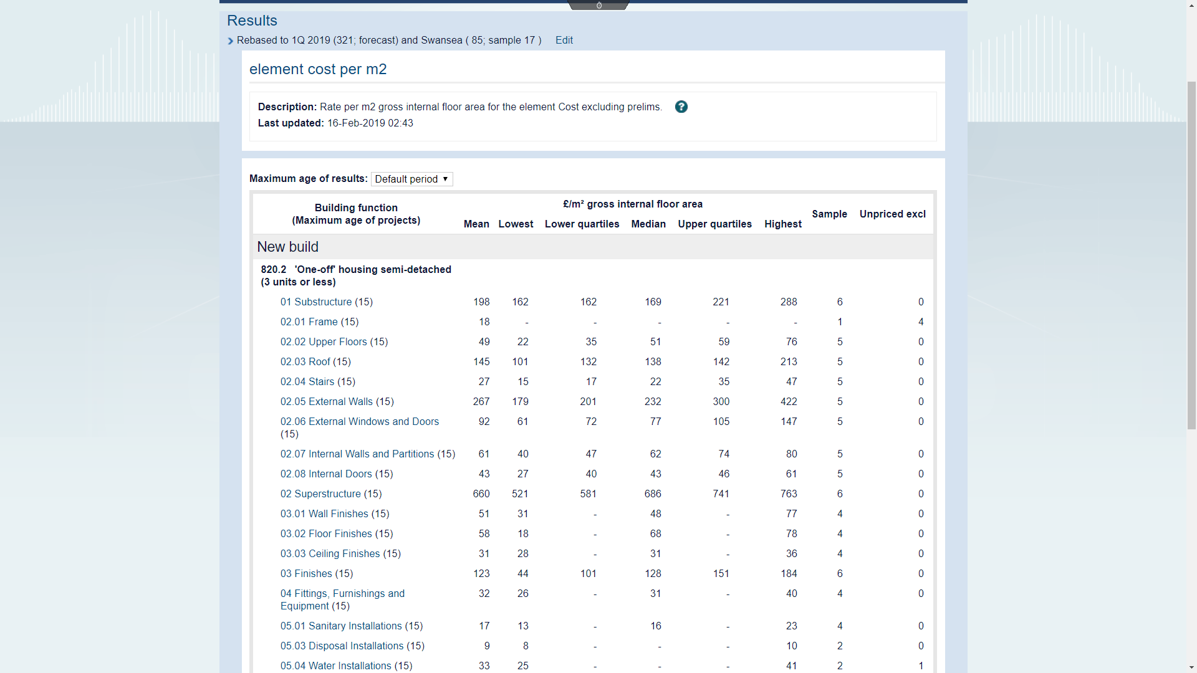

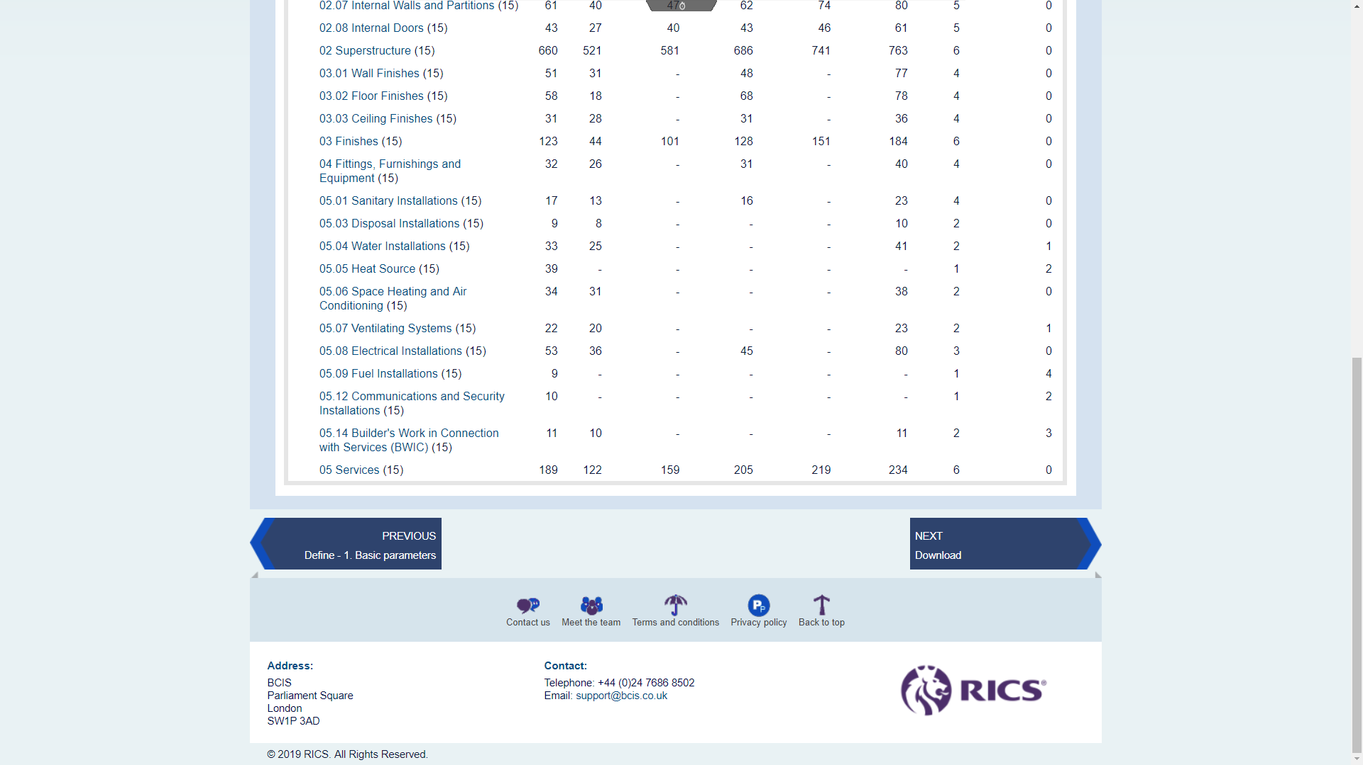

Element | Cost per m2 (Median) | Unit | Total cost
Substructure | £169 | 98.4 m² | £16,629
Superstructure | £686 | 98.4 m² | £67,502
Finishes | £128 | 98.4 m² | £12,595
Fittings, Furnishings, and Equipment | £ 31 | 98.4 m² | £3,050
Services | £205 | 98.4m² | £20,172
 | £1219

1.5.1 Summary

Price per building
Location: Town hill, Swansea
Building Cost: £119,948
Cost/m ² :£1,219
Floor Area: 98.4m²

The total price of the project: £239,896

1.6 Labour costs

1.6.1 Assumptions
For this task, I am to assume that:
- 4 craftsmen of various trade: plumber, electrician, bricky and labour
- All have taken a 14 day holiday: 9 national and 5 days
- All craftsmen are over the age of 18
- Are all fully qualified
- All craftsmen work 39 hours and have weekends off.

All figure for craftsmen were provided by BCIS.

 | Plumber | Electrician | Bricklayer | Labour
Basic Pay | £603.72 | 567.45 | 499.98 | 471.9
Hourly Rate | £15.48 | £14.55 | £12.82 | £12.10
Holiday pay (14 days ) | £1,690 | £1,588 | £1,399 | £1,321
Pay over 50 weeks | £30,186 | £28,372 | £24,999 | £23,550
National insurance per weekly (13.8%) | £83.31 | £78.31 | £68.99 | £65.12
Total National Insurance | £4,165 | £3,915 | £3,449 | £3,256
(BCIS, 2019)

1.7 Cost Data/Information and limitation

1.7.1 Cost Data
Cost analysis is required during the inception stage of, it provides clients with a prosed cost indication for the overall project. This helps to inform the client about possible costs that are associated with the project and aids them in deciding a budget. (A, Ashworth, 2010)

1.8 Types of Cost Data

1.8.1 Forecasting of Cost
In order to manage the overall cost of a project, it is crucial to plan ahead in order to avoid shortfalls that can result in the overspending on a project. Therefore, forecasting costs is a useful application when trying to decide the required expenditures at different stages of a project.

1.8.2 Cost comparison
Allows comparison between projects, which in turn aids in discussion making. This method allows for comparison on projects costs, therefore allowing the client to take into consideration which project would be more financially beneficial, and the route that would allow for less expenditure and more financial gain.

1.8.3 Cost balancing
This allows for the breakdown of overall cost into smaller sections. By breaking the cost down into sections it allows money to be spent in accordance with the budget. By allocating money to numerous components it allows for clients and professional to determine where overspending may occur and allocated budget based on that information. Using data from past projects and professional experience can also aid in the balancing of cost.

1.8.4 Analysis of cost trends
This is data that allows the estimator to analysis cost fluctuation and aid in the prediction of cost trends for future estimation. An example being cost percentages of materials are likely to increase by the time the project has reached the end of its life cycle. This aids the estimator to predict more accurately what the market price at a future date. So they can adjust for when the project goes out for tender.

1.9 Limitations

1.9.1 Accuracy & Consistency
Although cost data analysis can be a very useful tool, there are limitations. The accuracy can be one factor that highlights its limitation, as none of the main sources claim their information to be accurate. On the other hand, these prices are just guidelines and can be useful when trying to calculate the cost, which during decision making during the feasibility stage. Therefore, the following example should be considered. The consistency of cost data may vary from source, this could result in estimates being considerably more expensive in comparison to other projects. Figure 1.2 provides a list of items and their prices, this information is taken from three different sources of cost information.

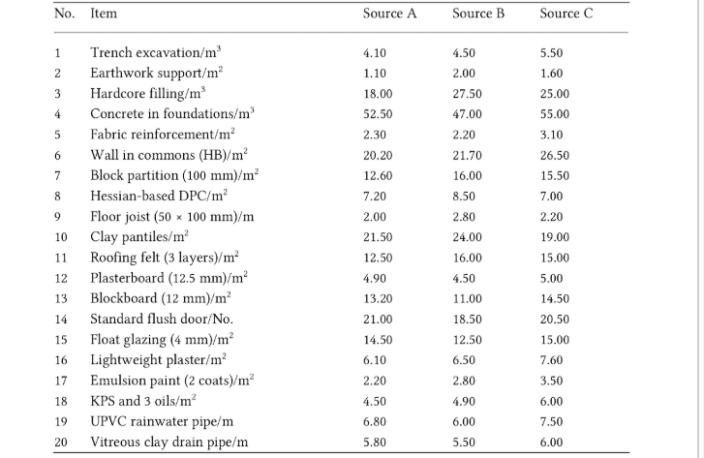
(Figure 1) (A, Ashworth, 2010)
From the figure above, one can see that cost data for works varies through each source. Therefore, finding an accurate price can be relatively complicated. Therefore, estimators usually place greater reliance on their own generated data.

https://link.springer.com/chapter/10.1007%2F978-1-349-13757-2_6

(https://www.turnberryhomes.co.uk/kg-house-styles.html, 2019)

https://www.spireconsultinggroup.com/en/professional-services/risk-management/cost-forecasting/

References
https://www.designingbuildings.co.uk/wiki/Estimate

https://www.costengineering.eu/project-estimation-techniques

