Revision 2
Q1
- For the functions the $F_{1}\text{ (A, B, }\text{C)=}∑_{m}\text{ (4,5,6,7)}$ and $F_{2}\text{ (A, B, }\text{C)=}∑_{m}\text{ (1, 2, 3)}$.
Answer the following.
  - Illustrate the implementation of functions F1 and F2 using a single decoder.
  - Present the truth tables and the fundamental Boolean expressions for both $F1$and$F2$.
  - Design $F1$ and$F2$ using Programmable Logic Array (PLA).

SOLUTIONS
- Illustrate the implementation of functions F1 and F2 using a single decoder.
$F_{1}\text{ (A, B, C)=}∑_{m}\text{ (4,5,6,7)}$ and $F_{2}\text{ (A, B, }\text{C)=}∑_{m}\text{ (1, 2, 3)}$.
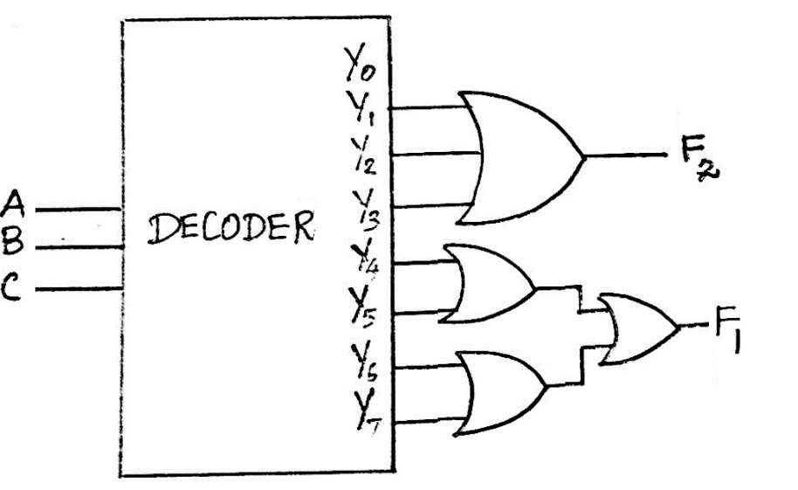
- Present the truth tables and the fundamental Boolean expressions for both $F1$and$F2$.
$$A$$ | $$B$$ | $$C$$ | $$F1$$ | $$F2$$
0 | 0 | 0 | 0 | 0
0 | 0 | 1 | 0 | 1
0 | 1 | 0 | 0 | 1
0 | 1 | 1 | 0 | 1
1 | 0 | 0 | 1 | 0
1 | 0 | 1 | 1 | 0
1 | 1 | 0 | 1 | 0
1 | 1 | 1 | 1 | 0
$F_{1}=A\overline{B}\overline{C}+A\overline{B}C+$AB$\overline{C}+ABC$
$$F_{2}=\overline{A}\overline{B}C+\overline{A}B\overline{C}+\overline{A}BC$$

- Design $F1$ and$F2$ using Programmable Logic Array (PLA).
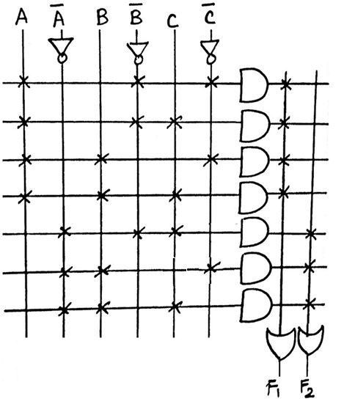
$F_{1}=A\overline{B}\overline{C}+A\overline{B}C+$AB$\overline{C}+ABC$
$$F_{2}=\overline{A}\overline{B}C+\overline{A}B\overline{C}+\overline{A}BC$$

Q2
For the functions $w(A, B, C, D) = ∑_{m}(2, 12, 13)$ and $z(A, B, C, D) = ∑_{m}(1, 2, 8, 12, 13)$
Answer the following:
- Illustrate the implementation of functions 𝑤 and 𝑧 using a single decoder.
- Present the truth tables and the fundamental Boolean expressions for both $w$ and$z$.
- Derive and show the simplified Boolean logic expressions for $w$ and$z$.
- Design $w$ and$z$ using Programmable Array Logic (PAL).

SOLUTIONS
- Implementing $w$ and $z$using Decoder
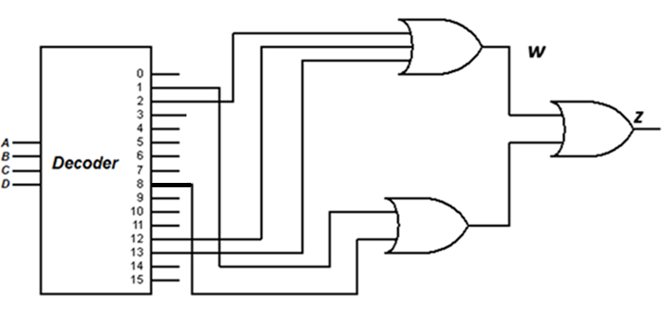

- Show the truth tables for the functions w and z

$$A$$ | $$B$$ | $$C$$ | D | $$w$$ | $$z$$
0 | 0 | 0 | 0 | 0 | 0
0 | 0 | 0 | 1 | 0 | 1
0 | 0 | 1 | 0 | 1 | 1
0 | 0 | 1 | 1 | 0 | 0
0 | 1 | 0 | 0 | 0 | 0
0 | 1 | 0 | 1 | 0 | 0
0 | 1 | 1 | 0 | 0 | 0
0 | 1 | 1 | 1 | 0 | 0
1 | 0 | 0 | 0 | 0 | 1
1 | 0 | 0 | 1 | 0 | 0
1 | 0 | 1 | 0 | 0 | 0
1 | 0 | 1 | 1 | 0 | 0
1 | 1 | 0 | 0 | 1 | 1
1 | 1 | 0 | 1 | 1 | 1
1 | 1 | 1 | 0 | 0 | 0
1 | 1 | 1 | 1 | 0 | 0

Logic Expressions from the Truth Table
$w= \overline{A}\overline{B}C\overline{D}+AB\overline{C}\overline{D}+AB\overline{C}D$
$z= \overline{A}\overline{B}\overline{C}D+\overline{A}\overline{B}C\overline{D}+A\overline{B}\overline{C}\overline{D}+AB\overline{C}\overline{D}+AB\overline{C}D$

Simplifying the above expressions $‘w’$ using Boolean Algebra, we get,
$w= \overline{A}\overline{B}C\overline{D}+AB\overline{C}(D+\overline{D})$
$w= \overline{A}\overline{B}C\overline{D}+AB\overline{C}$
Simplifying the above expressions $‘z’$ using Boolean Algebra, we get,
$$z= \overline{A}\overline{B}\overline{C}D+\overline{A}\overline{B}C\overline{D}+A\overline{B}\overline{C}\overline{D}+AB\overline{C}\overline{D}+AB\overline{C}D$$
$$z= \overline{A}\overline{B}\overline{C}D+\overline{A}\overline{B}C\overline{D}+A\overline{B}\overline{C}\overline{D}+AB\overline{C}(D+\overline{D})$$
$z= \overline{A}\overline{B}\overline{C}D+A\overline{B}\overline{C}\overline{D}+AB\overline{C}+\overline{A}\overline{B}C\overline{D}$
$z= \overline{A}\overline{B}\overline{C}D+A\overline{B}\overline{C}\overline{D}+w$

- Designing using Programmable Array Logic (PAL)

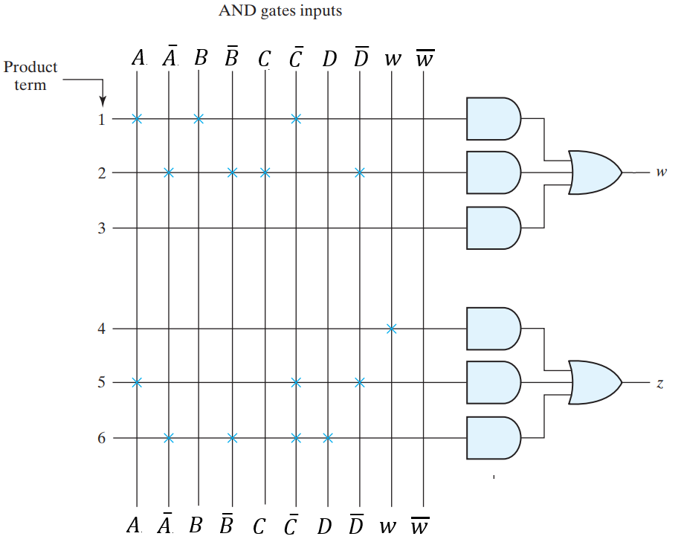

Q3
- Design the functions $f_{1}= x_{1}x_{2}{\overline{x}}_{3}+{\overline{x}}_{1}x_{2}x_{3}$and $f_{2}= {\overline{x}}_{1}{\overline{x}}_{2}$+ $x_{1}x_{2}x_{3}$ using PAL.
Solution

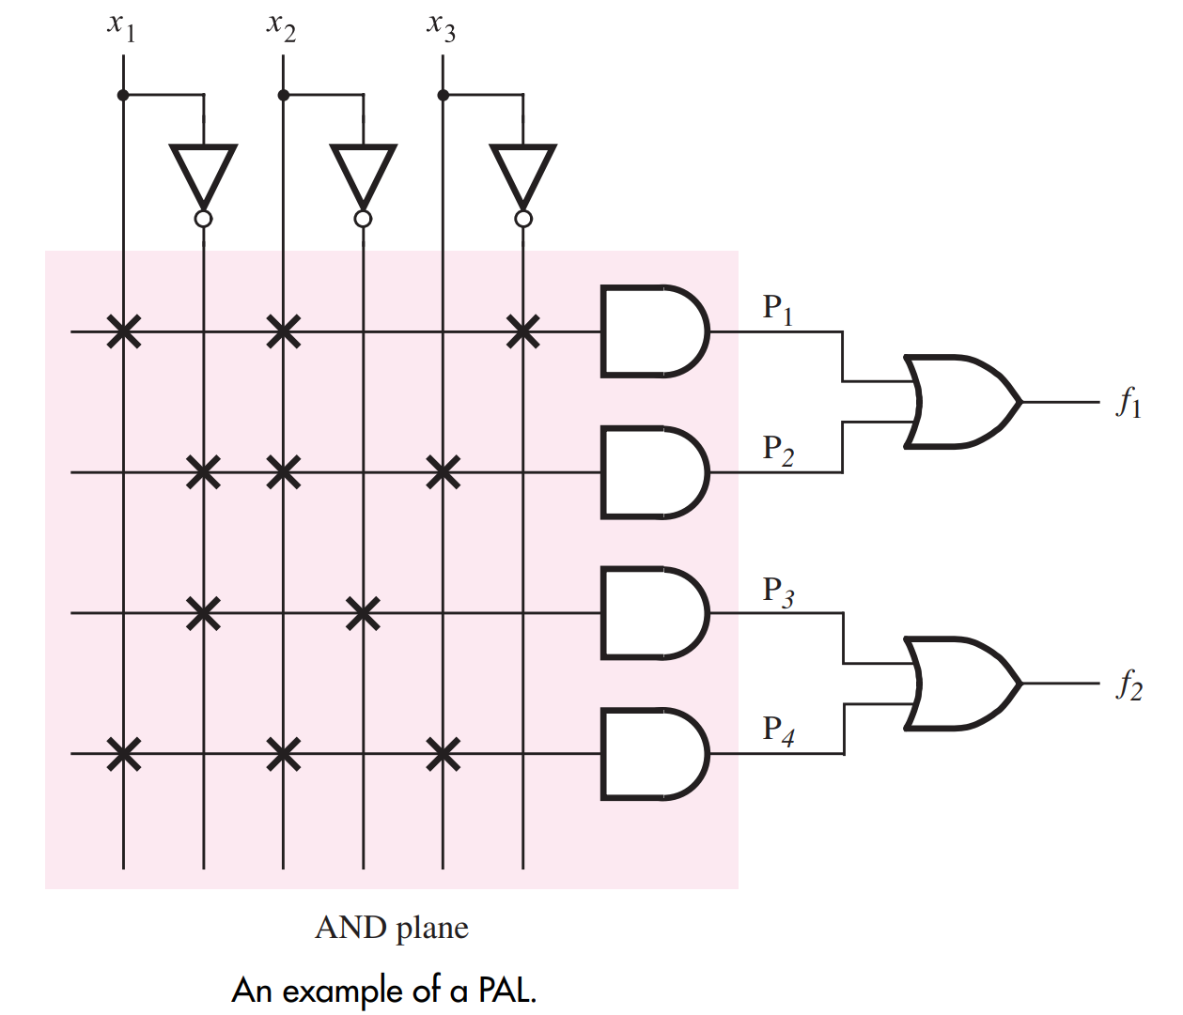

Q4
- For a 3- input LUT of an FPGA Logic block and determine the bits to be stored in its storage cell by using the function $f= \overline{A}\overline{B}\overline{C}+\overline{A}B\overline{C}+A\overline{B}\overline{C}+ABC$ to realize by answering the following
  - Truth Table
  - Design a 3- input LUT of an FPGA by assuming the value of inputs to be 001 respectively.

SOLUTIONS

- Truth Table
A | B | C | f
0 | 0 | 0 | 1
0 | 0 | 1 | 0
0 | 1 | 0 | 1
0 | 1 | 1 | 0
1 | 0 | 0 | 1
1 | 0 | 1 | 0
1 | 1 | 0 | 0
1 | 1 | 1 | 1

- Design a 3- input LUT of an FPGA by assuming the value of inputs to be 001 respectively.
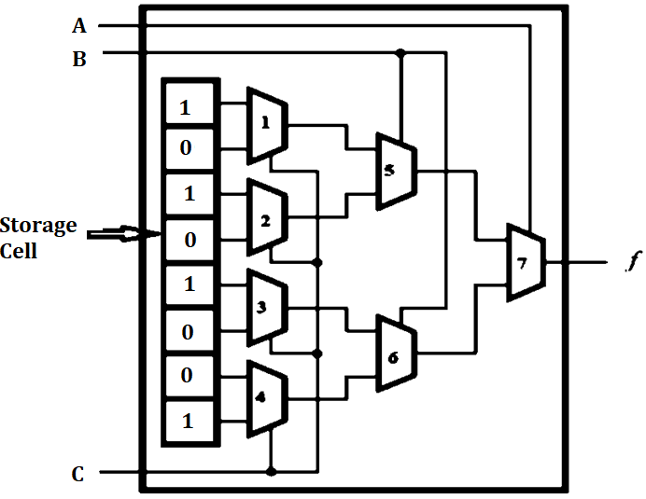

Q5
- For a 4- input LUT of an FPGA Logic block and determine the bits to be stored in its storage cell by using the function $f=A\overline{B}\overline{C}D+\overline{A}B\overline{C}D+A\overline{B}CD+ABC\overline{D}$ to realize by answering the following
- Truth Table
- With the help of the above truth table, design a 4- input LUT.
- Also, explain its operation in detail by assuming the values of inputs to be 0010.
SOLUTIONS
  - Truth Table : $=A\overline{B}\overline{C}D+\overline{A}B\overline{C}D+A\overline{B}CD+ABC\overline{D}$
A | B | C | D | f
0 | 0 | 0 | 0 | 0
0 | 0 | 0 | 1 | 0
0 | 0 | 1 | 0 | 0
0 | 0 | 1 | 1 | 0
0 | 1 | 0 | 0 | 0
0 | 1 | 0 | 1 | 1
0 | 1 | 1 | 0 | 0
0 | 1 | 1 | 1 | 0
1 | 0 | 0 | 0 | 0
1 | 0 | 0 | 1 | 1
1 | 0 | 1 | 0 | 0
1 | 0 | 1 | 1 | 1
1 | 1 | 0 | 0 | 0
1 | 1 | 0 | 1 | 0
1 | 1 | 1 | 0 | 1
1 | 1 | 1 | 1 | 0

- With the help of the above truth table, design a 4- input LUT. .
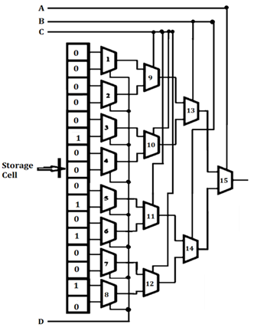

- Also, explain its operation in detail by assuming the values of inputs to be 0010.

- An FPGA Look Up Table is the combination of flipflops (storage cells) and series of Muxs (Multipliers ) interconnected.
- Each cell is capable of holding a single logic value, either 0 or 1. The stored value is produced as the output of the storage cell.
- A two-variable truth table has four rows, this LUT has four storage cells.
- One cell corresponds to the output value in each row of the truth table.
- The input variables A, B, C and D are used as the select inputs of four multiplexers, which, depending on the valuation of A, B, C and D.
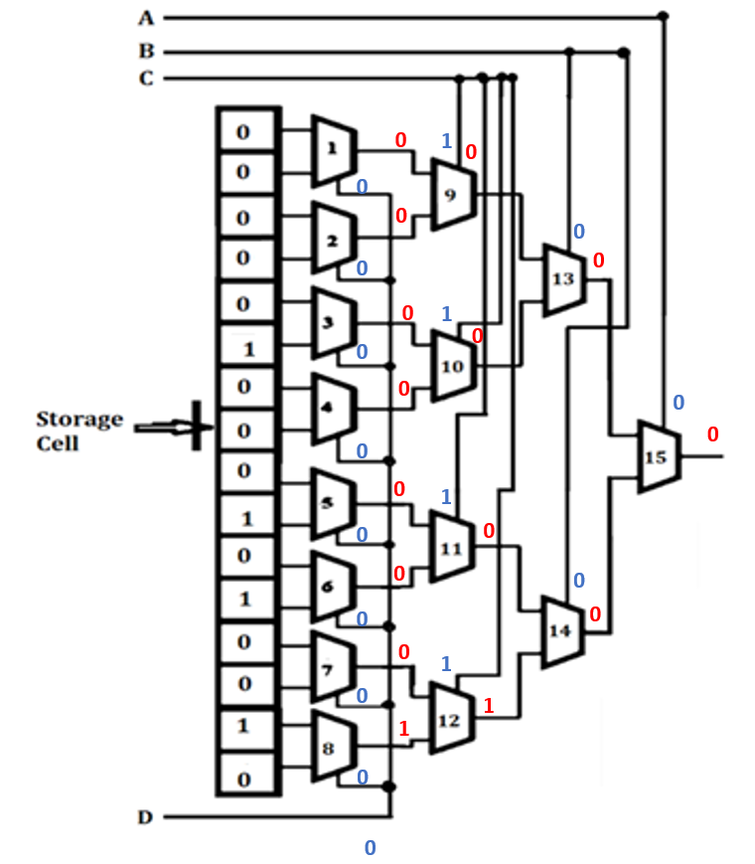
Operation
- When D is given O, the select inputs for the mux ranging from 1 to 8 will be 0. If the Mux gas the select inputs to be 0, the top storage level will be the output of the mux.
- It is does the same operation for the variables B and D. But when C = 1 , the select inputs for the mux ranging from 9 to 12 is logic 1. Hence the lower inputs of the previous mux will be the present mux output.
- Similarly, for all valuations of B and D, the logic value stored in the storage cell corresponding to the entry in the truth table chosen by the particular valuation appears on the LUT output.
- Providing access to the contents of storage cells and the output of f will be 1.

Q6
Program FPGA for the functions $f= f_{1}$+ $f_{2}$ by considering ${ f}_{1}= x_{1}x_{2} andf_{2}= {\overline{x}}_{2}x_{3}$
SOLUTION
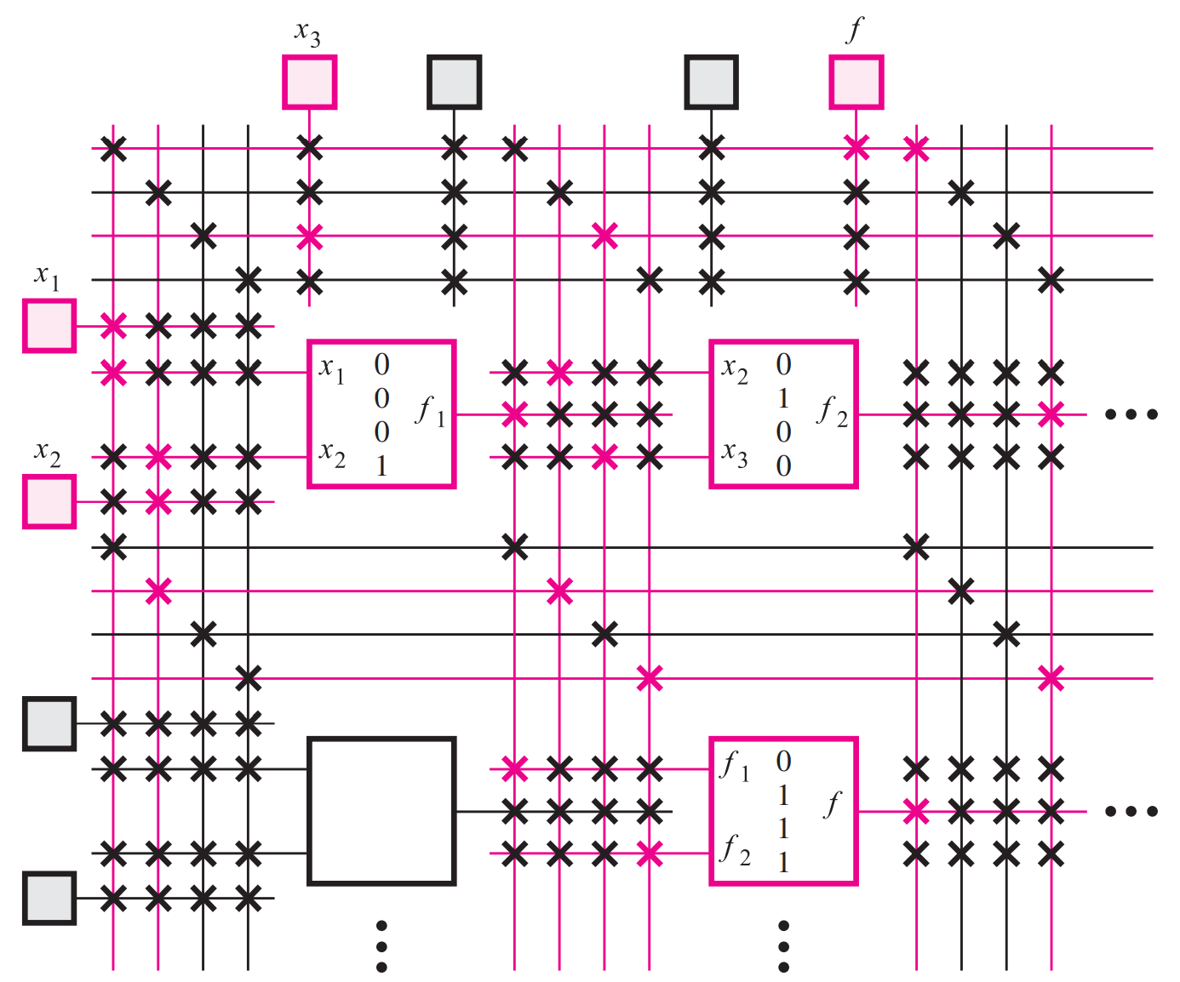

Q7
- Write short notes on Programming FPGA
SOLUTIONS
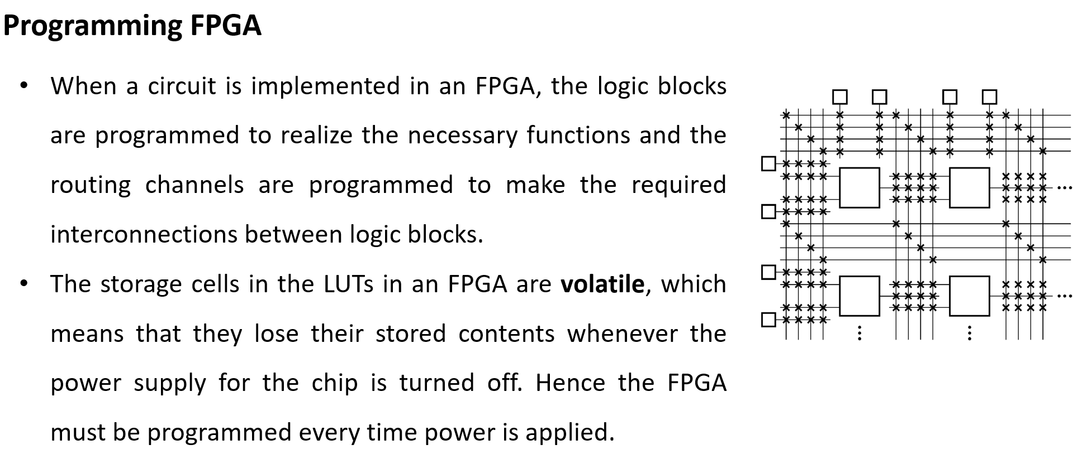
- Explain the operation of 3 input LUTs
SOLUTIONS
- 3 input Luts takes three binary inputs A, B, and C and uses them to produce an output f based on stored values in memory cells.
- There are eight storage cells, each representing one possible input combination (from 000 to 111), and each cell holds a binary value (0 or 1) which corresponds to the desired output for that input combination.
- The circuit uses a hierarchical arrangement of multiplexers (MUXes) to select one of these eight values.
- The first level of MUXes selects between pairs of storage cells based on the value of input C.
- The second level takes the outputs of the first level and selects between them based on input B, and the final MUX selects the output based on input A.
- This tiered selection process effectively navigates through the memory based on the binary inputs to retrieve the correct output.
For the specific input A = 0, B = 0, C = 1, the binary index is 001, which corresponds to the second storage cell (index 1). According to the values shown in the storage cells, the second cell contains a 0, so the output f = 0 for this input combination. This design allows any 3-variable Boolean function to be implemented simply by programming the appropriate values into the storage cells.

Q8
- Program FPGA for the functions $f= f_{1}$+ $f_{2}$ by considering ${ f}_{1}= x_{2}x_{3} andf_{2}= {\overline{x}}_{1}x_{3}$
SOLUTION

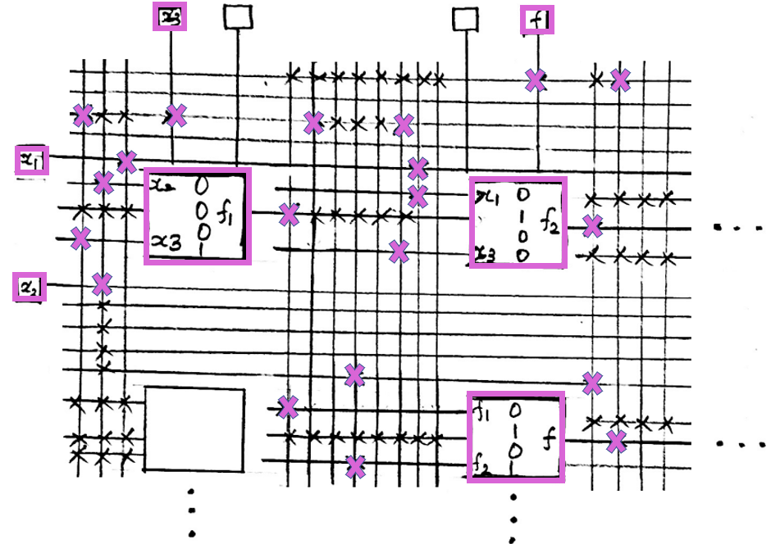

Q9
Differentiate Programmable Array Logic and Programmable Logic Array.
 | PLA | PAL
- Structure | Programmable AND & OR arrays (more flexible) | Programmable AND, fixed OR array (less Flexible)
2. Programmability | Highly programmable (both AND & OR) but complex and Expensive | Limited programmability (only AND is programmable) but Simple and less expensive
3. Speed | Can be faster due to optimized logic structure | May be slower due to fixed OR logic

