

Assignment Title: Individual Report on -
“Development of a plan by meeting the identified personal development
needs and expectations of individual employees in a chosen organisation”
Student's Name: Elena Radu
Student ID Number: 2121862
Course Name and Code: Developing Relationships and Workplace Achievements BMSW 5102
Due Date: 31/08/2023
University/Institution Name: University of Wales Trinity Saint David
BA (Hons) Leadership and Management Skills for the Workplace

Table of Contents
1.Introduction 2
2.Context of Business and Employee Engagement 3
2.1 BP’s Employee Development Strategy 4
3.Evaluation of Development Vehicles 5
3.1 360-Degree Feedback 5
3.2 MBO (Management by Objectives) 6
3.3 530 Feedback 7
4. Knowledge, Skills, and Competencies of an Individual 8
4.1 Knowledge 8
4.2 Skills 9
4.3 Competencies 9
5. Development of a Professional Development Plan (PDP) 10
5.1 Using the SMART Framework 10
5.2 Human Capital Theory and its Role in PDP 11
5.3 Motivation Theory and Employee Development 11
5.4 Scheduled Annual Review and Performance Assessment Plan 11
6. Conclusion 13
References: 13

1.Introduction

British Petroleum (BP), founded in 1908, is recognized as one of the prominent global corporations operating in the oil and gas industry, with six other important entities. The establishment of the Anglo-Persian Oil Company, known as its commencement, signified the identification of oil reserves in Persia, which is now recognized as modern-day Iran (Ferrier, 1982). Sir William D'Arcy, a prominent stakeholder, in conjunction with the Burmah Oil Company, observed the transformation of a nascent enterprise into a vast empire. Over the course of several years, the corporation underwent a transformation, resulting in a rebranding as British Petroleum in 1954 (Yergin, 1991). BP, a prominent entity in the energy industry, has established its position as a significant participant in several sectors, including upstream, downstream, and renewable energy operations on a global scale. The company's headquarters are located in London, United Kingdom.
In the current dynamic energy environment, organizations, particularly major players such as BP, are required to adjust their strategies and invest in the development of their human resources. The significance of connecting BP's workforce development with its strategic objectives, particularly in sustainability and the integration of renewable energy, cannot be overstated as the company redefines its position in the global energy sector (BP Annual Report, 2019). This article presents a critical analysis of the developmental vehicles and performance appraisal methods utilized by BP, from the perspective of an HR trainee. In order to align the personal development paths of individuals with the overall vision of the organization, this document presents a Professional Development Plan (PDP) that is specifically designed to meet the shared goals of both the firm and its employees. This study endeavours to establish a comprehensive framework by including pertinent human resources theories and building upon a strong academic basis. Its objective is to create a strategic plan that effectively aligns the personal ambitions of individuals with the overall achievements of the organisation.
Figure 1: BP plc. (formerly The British Petroleum Company plc. ) logo

2.Context of Business and Employee Engagement

BP's aspiration to transition into a carbon-neutral organization by the year 2050 demonstrates a dedication to environmental responsibility and the pursuit of sustainable development, particularly in response to significant transformations occurring within the worldwide energy industry (Looney, 2020). The strategic approach, referred to as "Reimagining Energy," not only represents a significant shift for the organization but also holds significant consequences for the employees.
Academic scholars have consistently emphasized the undeniable connection that exists between corporate strategies and human capital. According to Macey et al. (2009), the achievement of company objectives is contingent upon the establishment of successful employee engagement. Essentially, it is inadequate for a firm to just outline a visionary strategy. The employees, who serve as the carriers of this vision, must be fully integrated into its underlying values and beliefs. The involvement, enhancement of knowledge, and adaptation of skills are crucial factors.
The move of BP towards renewable energy sources and a sustainable energy framework requires more than just operational and technological changes. It also demands a significant adjustment in the skills and capabilities of its personnel. In this particular setting, it becomes crucial to adopt a concentrated and deliberate strategy when it comes to the growth and engagement of employees. According to Lennon (2010), there exists a fundamental connection between personal growth and the overarching objectives of an organization.
Recognising the interdependent nature of individual and organizational development is crucial for maximizing the capabilities of a workforce.
The involvement of employees in this transformation process is characterized by multiple dimensions. The process entails not only the acquisition of new skills or the adaptation of existing ones to meet the evolving technical requirements, but also encompasses the transformation of individuals' mindsets and attitudes towards the organization's revised mission. According to Schaufeli and Bakker (2004), a workforce that is engaged demonstrates qualities such as vigour, dedication, and absorption in their respective responsibilities. In the context of BP, the cultivation of these qualities results in a workforce that possesses not just advanced technical skills, but also possesses an inherent will to actively contribute to the organization's overarching goal of achieving a sustainable future.
This report will conduct a critical evaluation of the development options accessible to BP in the following areas, with a focus on their alignment with both individual goals and the strategic imperatives of the firm.

2.1 BP’s Employee Development Strategy

BP has consistently prioritized the cultivation and advancement of its workforce, acknowledging the vital role that its employees play in driving corporate achievements, particularly in the dynamic energy industry. BP's employee development strategy is based on a hierarchical structure that supports growth from entry-level training to advanced leadership development. This approach guarantees that employees possess both technical proficiency and the necessary leadership and management skills to navigate the complexities of the global energy industry. This hierarchy includes diverse training modules designed to meet the specific needs and roles within the company. The analysis shows that a considerable proportion of employees participate in specialized training sessions (Fig.2). The focus areas of these sessions vary depending on job roles, market dynamics, and technological advancements. BP's strategic focus on continuous learning and development underscores its dedication to innovation, safety, and operational excellence.(Fig.3)
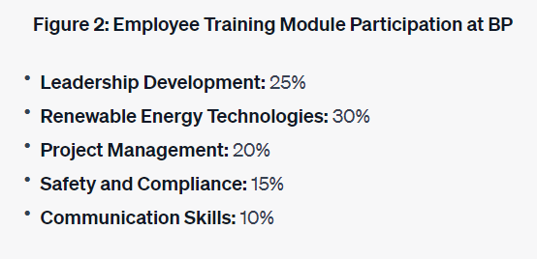 Fig. 3. the percentage of employees undergoing various training modules.
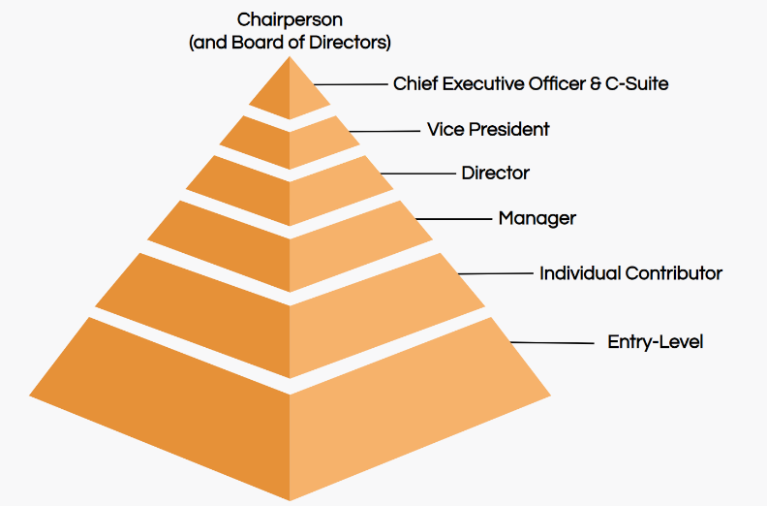Fig.3 A hierarchical depicting BP’S employee development structure, from entry-level training to leadership development. (Source: https://www.ongig.com/job-titles)

3.Evaluation of Development Vehicles

BP, in its commitment to fostering a culture of continuous learning and growth, has integrated a diverse array of performance appraisal tools and techniques. These vehicles are instrumental in both gauging and fostering the skills and competencies of the workforce.

3.1 360-Degree Feedback

360-degree feedback is one of the most comprehensive instruments utilised by BP. This technique solicits feedback on an employee's performance from a variety of sources, including superiors, peers, subordinates, and even the employee's self-evaluation (Bracken et al., 2001). Given BP's complex organisational structure and emphasis on collaborative work, 360-degree feedback provides a more complete comprehension of an employee's skills, competencies, and improvement areas.
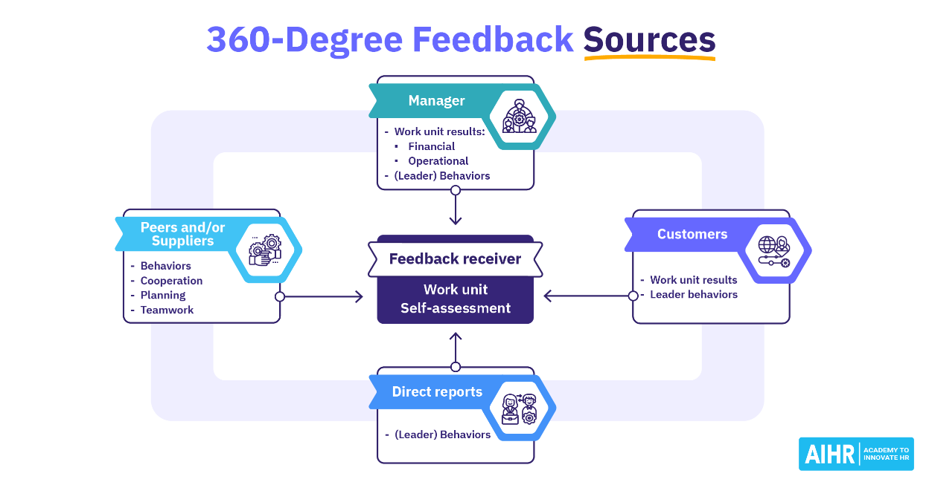( Erik van Vulpen,2022)
Advantages: The method eliminates biases and provides employees with a broader comprehension of how their work is perceived by various organizational levels (Nowack, 1992).
However, without proper feedback training, this instrument can result in ambiguous or contradictory feedback, which can lead to confusion and demotivation (Edwards & Ewen, 1996).(Fig.4)
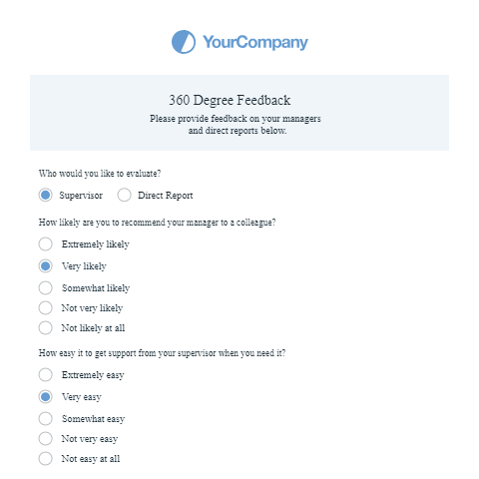Fig.4 A sample 360-degree feedback form or survey used by BP to provide an in-depth look at how feedback is collected.

3.2 MBO (Management by Objectives)

BP's strategic emphasis on matching individual aspirations with its overarching net-zero target is exemplified through its adoption of the Management by Objectives (MBO) strategy. The approach, proposed by Drucker (1954), requires the establishment of precise, quantifiable, and achievable objectives at the individual level that align with the broader corporate goals.
One of the advantages of Management by Objectives (MBO) is its ability to provide clarity in defining responsibilities and expectations, thereby motivating people to achieve desired outcomes and maintaining their alignment with the overall strategic goals of the organization (Locke & Latham, 2002).
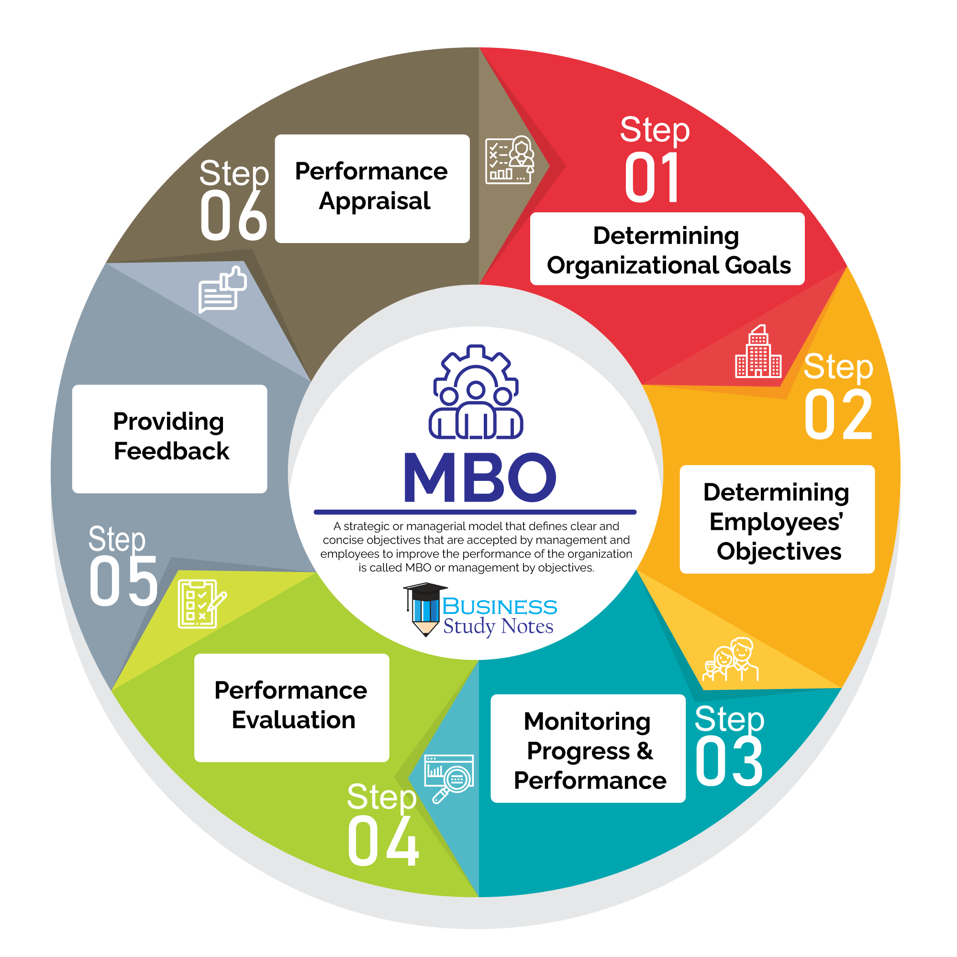 A flowchart showing the process of MBO from goal setting to review
Limitations: In cases where it is not implemented skilfully, Management by Objectives (MBO) may devolve into a bureaucratic routine, devoid of authentic involvement or substantial synchronization between individual objectives and strategic imperatives (Rodgers & Hunter, 1991).

3.3 530 Feedback

BP has implemented the 530 feedback system to incorporate perspectives from external stakeholders, taking into account its global presence and numerous partnerships. This system complements the internally focused 360-degree tool. This methodology collects feedback from external entities, including governmental bodies, partners, and stakeholders (Walker & Smither, 1999).
Advantages: This method provides BP with a comprehensive assessment of its employees' performance in external collaborations, promoting their adaptability and proficiency in diverse professional settings.
Limitations may arise due to the reliability of feedback obtained from external entities and the possibility of conflicts of interest or biased viewpoints. These limitations are particularly relevant when stakeholder objectives do not align perfectly with those of BP (London & Smither, 2002).
Overall, the various development vehicles provide BP with a strong framework to evaluate, enhance, and align its human resources with its strategic goals.
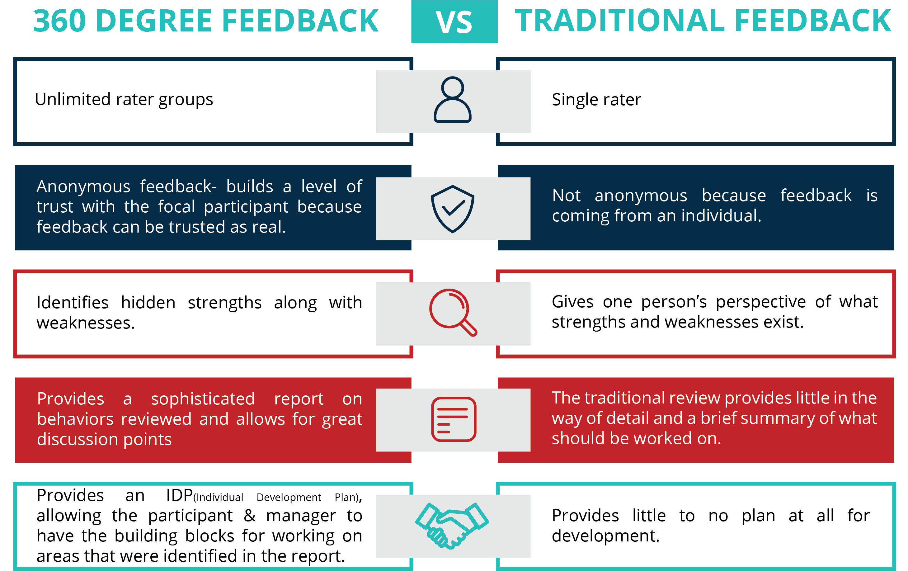 A visual representation of how this feedback mechanism differs from the 360-degree feedback.

4. Knowledge, Skills, and Competencies of an Individual

The triumvirate of knowledge, skills, and competencies is the foundation of any successful organization, and BP is no exception. A thorough comprehension of these dimensions, supported by academic research, reveals how they converge to propel BP towards its overarching goals.

4.1 Knowledge

Knowledge refers to the theoretical understanding or awareness of particular domains or fields (Anderson, 1982). BP must comprehend industry trends, safety mandates, and innovative energy solutions. BP's internal training modules, supported by the BP Annual Report (2020), aim to keep employees updated on industry knowledge, enabling them to make well-informed decisions.(Figure 5)
Strength: Training modules promote ongoing learning among employees, facilitating the maintenance of up-to-date knowledge and skills.
One limitation is the need for frequent updates of these modules due to the fast-paced advancements in technology and the energy sector, which can require significant resources (Eraut, 2004).
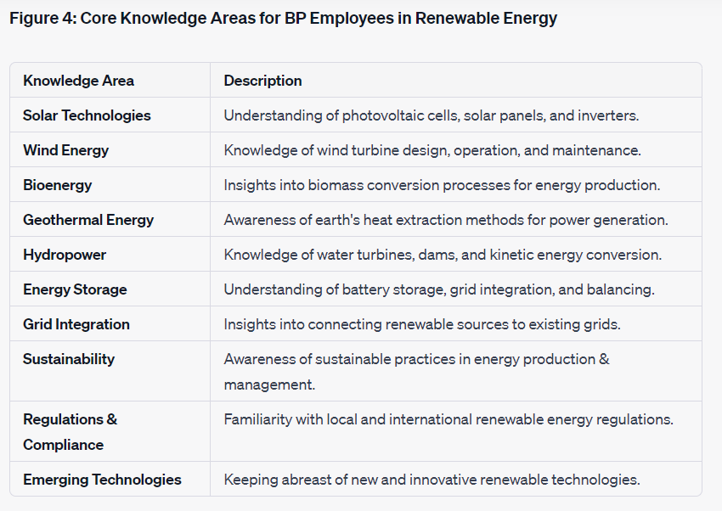Fig. 5 A table of core knowledge areas BP employees are expected to have in the realm of renewable energy.

4.2 Skills

Skills are the result of applying acquired knowledge, developed through experience and training (Ryle, 1949). BP achieves this by conducting field workshops and simulation exercises, which effectively prepare its employees to effectively address and navigate real-world challenges.
Strength: BP's focus on experiential learning enhances the practical application of theoretical knowledge, facilitating the development of a flexible and adaptable workforce.
One limitation is the difficulty of ensuring consistent skill development in a global workforce, which can be hindered by logistical challenges and inconsistent delivery (Spencer & Spencer, 1993).

4.3 Competencies

Competencies refer to a combination of inherent qualities in an individual, including knowledge, skills, motives, and traits, that contribute to successful performance (Boyatzis, 1982). BP places a high importance on key skills such as leadership, technological expertise, and environmental responsibility, in order to ensure that they are in line with their overall vision and strategic goals.
Strength: Developing competencies ensures that employee behaviour and capabilities are in line with the company's values and long-term goals.
One limitation is that developing competencies may require more time compared to acquiring skills or knowledge, as competencies are more complex. Additionally, there is a potential for subjective bias when assessing competencies (Draganidis & Mentzas, 2006).
Analysing the functions of knowledge, skills, and competencies in BP reveals their interconnectedness in enhancing individual performance and, by extension, the organization's overall accomplishments. BP strategically invests in various facets to position itself and its employees for sustained excellence in the volatile energy sector.

5. Development of a Professional Development Plan (PDP)

Human resource development is crucial for organizations to sustain competitiveness, especially in dynamic industries such as the energy sector. BP employs rigorous methodologies to develop a comprehensive professional development plan (PDP) that supports the career progression of its employees.

5.1 Using the SMART Framework

To galvanise efforts and yield discernible outcomes, BP adopts the SMART framework:
Specific: The project manager's role encompasses more than a general integration of renewable energy. The objective is to incorporate two distinct forms of renewable energy into BP's existing portfolio. The use of specificity eliminates any potential confusion, thereby ensuring a clear understanding of the intended objective by all individuals involved.
Measurable: The integration of two energy sources allows for a quantifiable metric of measurement. The focus is not on enhancing integration or investigating sources. The topic pertains to tangible accomplishments that are quantifiable and subject to assessment.
Achievable: BP's strong infrastructure, industry connections, and financial strength make the goal ambitious yet attainable.
Relevant: The increasing global focus on renewable energy indicates that BP's goal of transitioning to renewable energy sources is not merely a secondary consideration, but rather it is in line with the company's global strategy and vision for the future.
Time-bound: Setting a one-year timeframe ensures efficient resource allocation and maintains the goal as a top priority.
BP aligns individual objectives with the SMART criteria to provide their staff with clarity, direction, and motivation (Doran, 1981).

5.2 Human Capital Theory and its Role in PDP

Human Capital Theory posits that employees are the most valuable assets of an organization. BP's dedication to PDP demonstrates their confidence in this theory. Through consistent investment in training modules, workshops, and competency development:
BP recognizes a clear relationship between employee development and enhanced productivity.
This investment has a cascading impact. As employees progress, they contribute to innovation, enhance operational efficiency, and bolster BP's competitiveness in the market.
BP views PDP as more than just talent retention, but also as a means to develop individuals into industry leaders, thinkers, and innovators (Becker, 1964).

5.3 Motivation Theory and Employee Development

Maslow's Hierarchy of Needs serves as a framework for BP's employee motivation strategy.
BP prioritizes the provision of competitive salaries and safe working conditions for its employees.
BP encourages team collaborations to foster a sense of belonging and camaraderie among its employees.
Recognition, awards, and promotions fulfil employees' esteem needs by providing them with a sense of value and appreciation.
Self-actualization can be achieved by employees through the implementation of Personal Development Plans (PDPs), the provision of growth opportunities, and the assignment of challenging projects.
BP incorporates Maslow's theory into their reward and recognition system, promoting a comprehensive approach to motivation that fosters both individual achievement and collective success (Maslow, 1943).

5.4 Scheduled Annual Review and Performance Assessment Plan

Performance assessments at BP are not simply routine annual events. Dynamic tools have multiple purposes.
The utilization of a 360-degree feedback system allows employees to gain a comprehensive evaluation of their performance, incorporating input from peers, subordinates, and supervisors. This feedback provides a comprehensive assessment, highlighting both strengths and areas that can be improved.
The 530 evaluations provide quantitative metrics for assessing performance, offering clarity and direction to both the assessor and assessed.
Management by Objectives (MBO) is a strategic approach that aims to align the goals of individuals with the objectives of the organization, thereby promoting synchronization in their respective growth paths (Drucker, 1954).
BP's performance assessment incorporates feedback, quantifiable metrics, and alignment with organizational objectives. The holistic approach employed ensures ongoing development, flexibility in responding to feedback, and alignment with BP's overarching objectives.
In result, BP's comprehensive professional development program, which is grounded in academic theories and practical applications, provides a clear trajectory for employee advancement. BP's continuous evolution aligns with the changing landscape of its employees, thereby solidifying its status as a leading industry player.
Appendix D:Scheduled Annual Review and Performance Assessment Plan for BP's Renewable Energy Projects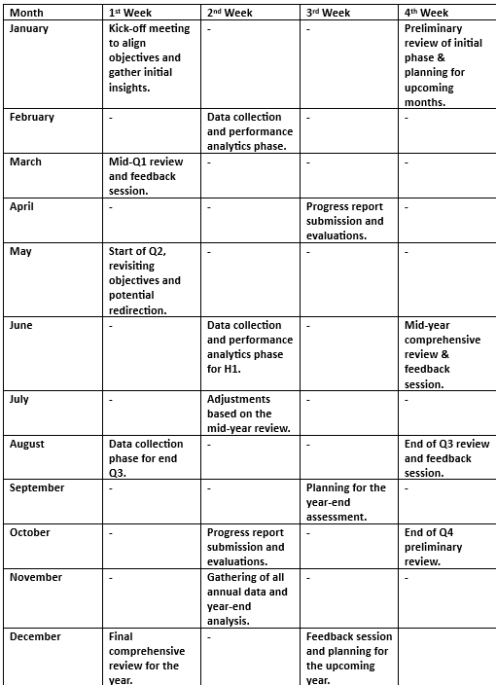

6. Conclusion

BP’s endeavours in the intricate realm of the energy sector signal a sophisticated understanding of the importance of developing individuals in the workplace. This report, through its careful dissection of BP's human resource approaches, offers critical insights into how the company derives tangible organizational benefits from such a stance.
The initial sections of the report emphasized the company's conscious effort in recognizing and managing individual expectations concerning personal development. By investing in in-house training modules tailored to keep employees abreast with the latest in industry trends and safety protocols, BP ensures its workforce remains at the zenith of industry knowledge and expertise (BP Annual Report, 2020).
Next, the exploration of BP's skill enhancement strategies, from field workshops to technology integration sessions, provided a detailed look into the development vehicles deployed by the company. Such avenues are meticulously chosen to match the ever-evolving needs of individuals, underpinning BP's commitment to ensuring that its staff are not only well-equipped but excel in their roles.
A highlight of this analysis was the in-depth construction of a Professional Development Plan (PDP), shaped by the SMART framework. This was not a mere academic exercise; it showcased BP's deliberate strategy to tailor personal development paths in sync with both individual aspirations and overarching organizational goals. Intertwining established theories such as the Human Capital Theory (Becker, 1964) and Maslow’s Hierarchy of Needs (Maslow, 1943), the PDP illuminated the alignment between theoretical constructs and practical applications within BP.
The report's penultimate sections dived into performance management, a cornerstone in understanding the developmental trajectory of an employee. BP's annual review mechanisms, buttressed by real-time feedback tools like the 360-degree system, are emblematic of the company's proactive stance towards performance enhancement and management.
In summation, BP's holistic approach to employee development emerges as a gold standard in the energy sector. The company's synthesis of strategic planning, employee development, and performance management not only embodies the module's learning outcomes but offers a roadmap for others in the industry to emulate.

References:

Anderson, J. R. (1982). Acquisition of cognitive skill. Psychological Review, 89(4), 369.
Becker, G. S. (1964). Human capital: A theoretical and empirical analysis, with special reference to education. The University of Chicago Press.
Boyatzis, R. E. (1982). The competent manager: A model for effective performance. John Wiley & Sons.
BP Annual Report. (2019). Reimagining Energy for People and Our Planet. BP p.l.c.
BP Annual Report. (2020). Strategic Report.
Bracken, D. W., Timmreck, C. W., & Church, A. H. (2001). The Handbook of Multisource Feedback. Jossey-Bass.
Draganidis, F., & Mentzas, G. (2006). Competency-based management: a review of systems and approaches. Information Management & Computer Security, 14(1), 51-64.
Doran, G. T. (1981). There's a SMART way to write management's goals and objectives. Management Review, 70(11), 35-36.
Drucker, P. F. (1954). The practice of management. Harper & Row.
Edwards, M. R., & Ewen, A. J. (1996). 360° feedback: The powerful new model for employee assessment & performance improvement. AMACOM.
Eraut, M. (2004). Informal learning in the workplace. Studies in Continuing Education, 26(2), 247-273.
Ferrier, R. W. (1982). The History of the British Petroleum Company: Volume 1, The Developing Years, 1901-1932. Cambridge University Press.
Lennon, D. (2010). Navigating the personal development maze. The Lennon Group, Inc.
Locke, E. A., & Latham, G. P. (2002). Building a practically useful theory of goal setting and task motivation. American Psychologist, 57(9), 705.
Looney, B. (2020). Reimagining energy, reinventing BP. BP Magazine.
Macey, W. H., Schneider, B., Barbera, K. M., & Young, S. A. (2009). Employee engagement: Tools for analysis, practice, and competitive advantage. John Wiley & Sons.
Maslow, A. H. (1943). A theory of human motivation. Psychological Review, 50(4), 370-396.
Nowack, K. (1992). Self-assessment and rater-assessment as a dimension of management development. Human Resource Development Quarterly, 3(2), 141-155.
Rodgers, R., & Hunter, J. E. (1991). Impact of management by objectives on organizational productivity. Journal of Applied Psychology, 76(2), 322.
Ryle, G. (1949). The concept of mind. Hutchinson.
Schaufeli, W. B., & Bakker, A. B. (2004). Job demands, job resources, and their relationship with burnout and engagement: A multi-sample study. Journal of Organizational Behavior, 25(3), 293-315.
Spencer, L. M., & Spencer, S. M. (1993). Competence at work: Models for superior performance. John Wiley & Sons.
Walker, A. G., & Smither, J. W. (1999). A five-year study of upward feedback: What managers do with their results matters. Personnel Psychology, 52(2), 393-423.
Yergin, D. (1991). The Prize: The Epic Quest for Oil, Money & Power. Simon & Schuster.

