

Disability and Health Inequalities in the United Kingdom
Module Code: LCHS7000
Module Name: Social Epidemiology and Public Health Development
Assignment Title: Analytical Report
Student Name: Ashok Bharat Patel
Student ID: 2532746
Lecturer: Dr Junaid Shaikh
Submission Date: 22/7/2026

Table of Contents
Disability and Health Inequalities in the United Kingdom 3
1. Introduction 3
2. Contextual Background and Underlying Factors 3
2.1 Cardiovascular Diseases 3
2.2 Chronic Kidney Disease 4
2.3 Mental Health Disorders 4
2.4 Poverty and Financial Inequality 5
2.5 Healthcare Access Barriers 5
2.6 Social Isolation and Discrimination 6
3. National Responses to Reduce Health Inequalities 7
4. Organisation Supporting Disabled People 7
5. Conclusion 7
References 8
1. Introduction 9
2. Incidence and Prevalence 10
3. Public Health Measures Using the 3Ps 10
4. Determinants and Risk Factors 11
5. Epidemiological Studies and Health Needs Assessment 12
6. Monitoring and Surveillance Systems 13
7. Public Health Impact of Cardiovascular Disease 13
8. Proposed Health Intervention Programme 14
9. Strengths and Weaknesses of the Epidemiological Approach 14
10. Conclusion 15
References 16

Disability and Health Inequalities in the United Kingdom

1. Introduction
Disability is a long term physical, sensory, intellectual or mental impairment which is incompatible with the environmental and social barriers and restricts a person's ability to function fully in society. Health inequalities are differences in health which are unfair and avoidable, between population groups in relation to their state of health, experience of health services, and health outcomes, (NHS England, 2023). Raised inequality of health is a common feature of the health situation of people with disabilities, due to the disadvantage in accessing health services, discrimination, poverty and social exclusion. This report examines some important inequalities in health experienced by disabled people in the United Kingdom, as well as policies and organisations which are attempting to tackle these inequalities.

2. Contextual Background and Underlying Factors

2.1 Cardiovascular Diseases
Cardiovascular disease (CVD) is still among the leading causes of death in the United Kingdom where each year it causes approximately 1/4 of all deaths with more than 7.6 million people suffering from heart and circulatory diseases (Smythe et al., 2026). Adults with disabilities are much more likely to have physical inactivity, obesity, diabetes, hypertension, and reduced access to preventive health care, which increases their risk for developing CVD. Long-term use of medication, mobility restrictions and socio-economic deprivation also increase cardiovascular risk. Poor outcomes are also due to delayed diagnosis and to decreased participation in screening programmes. Enabling more access to health promotion programmes, lifestyle interventions, physical activity programmes and routine cardiovascular screening and primary health providers for disabled people will help to tackle inequalities.
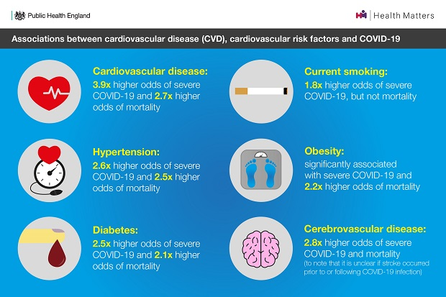
Figure: Cardiovascular disease risk factors infographic NHS
(Source: Smythe et al., 2026)

2.2 Chronic Kidney Disease
Many people with chronic kidney disease (CKD) in the United Kingdom are not diagnosed in the early stages; there are around 7.2 million people in the UK with the disease. Disabled people are particularly vulnerable as they are more likely to have chronic health conditions such as cardiovascular disease, hypertension and diabetes which are all major risk factors for kidney damage (Banks et al., 2024). Frequently not being able to move around, poor nutrition, side effects of medications, and a lack of regular health care contribute to an increased risk of CKD. The lack of communication and delayed referrals can lead to delayed diagnosis and treatment, which can cause the progression of the disease and impact the quality of life. To reduce these inequalities, routine kidney function tests should be offered to those at high risk, management of chronic kidney disease should be improved, health services should be accessible and health education programmes for early detection and effective self-management should be available.

2.3 Mental Health Disorders
People with a disability are more likely to have mental health disorders, such as depression, anxiety and psychological distress, than the general UK population. Chronic illness, social exclusion, financial issues and discrimination have been proven to increase the risk of common mental health disorders in disabled adults, making them almost twice as likely to be affected as non-disabled adults (Mitra et al., 2022). Emotional distress and diminished self-esteem are caused by physical limitations, diminished independence and employment restrictions. Even when there is good communication, or facilities that are not available, others also find it difficult to receive timely access to timely mental health care. A whole-of-system mental health, with early psychological support, community psychological interventions, peer support programmes and stigma reduction campaigns, will be required, to improve the emotional health and social inclusion of people with disabilities.

Figure: Mental health disability depression anxiety
(Source: Mitra et al., 2022)

2.4 Poverty and Financial Inequality
Inequalities in health are experienced by disabled people in the UK in disproportionate numbers, and are largely attributable to poverty. Many people's incomes can be reduced by less employment opportunities, workplace discrimination and other disability-related living costs (Kavanagh et al., 2022). Money constraints make it less likely that people will have access to nutritious foods, good housing and transport and health services, and can reduce mental health and increase the risk of chronic diseases. Economic disadvantage also restricts the opportunities available for physical activity and preventive healthcare, continuing health inequalities which are experienced over time. Thus, poverty alleviation, through inclusive employment policies and financial support is an important step to improve health outcomes.

2.5 Healthcare Access Barriers
Substantial barriers are often faced by disabled people when using health services. Certain buildings, equipment and transport are inaccessible to people which can prevent attendance to appointments. People with learning, visual and/or hearing impairments may not be able to fully understand medical advice and treatment options due to communication barriers (Aitken et al., 2022). These challenges frequently result in delayed diagnosis and limited adherence to screening programs and poor care management. Healthcare practitioners should be trained in disability awareness and have reasonable adjustments to ensure that the health care is available for all. Improving access and communication would help to reduce inequalities and to diagnose and treat early.

Figure: Wheelchair accessible healthcare hospital UK
(Source: Aitken et al., 2022)

2.6 Social Isolation and Discrimination
Disabled people are highly socially disadvantaged and discriminated against and this has a profound effect on their health and wellbeing. However, loneliness and exclusion can occur when social inclusion is not readily available, when the environment is not accessible, and when attitudes are negative in the public realm (Mulcahy et al., 2022). Stigma associated with disabilities can also lower self-confidence, limit employment and limit participation in the community. In the long term, isolation can cause depression, anxiety, cardiovascular diseases and decrease in quality of life (Argenyi et al., 2023). The provision of inclusive communities, the provision of social support networks, provision of accessible public space and challenging discriminatory attitudes are all critical aspects of physical and mental wellbeing for disabled people.

3. National Responses to Reduce Health Inequalities
The UK has made some efforts to address the barriers that disabled people encounter to health. The NHS LT plan aims to improve access to personalised care, raise the bar for prevention programmes and support better integration between the health and social care sector for individuals with long-term health issues to be diagnosed and treated earlier, and in order to help manage their long-term health conditions (Lund and Ayers, 2022). Furthermore, the Core20PLUS5 Programme is dedicated to tackling health inequalities by prioritising the most deprived communities and vulnerable population groups, such as many disabled people, by improving their access to screening, treatment and preventive health services (Kowal et al., 2023). All of these work towards making the health system more equitable, improving health outcomes, and eliminating unnecessary inequities in health between individuals.

4. Organisation Supporting Disabled People
A leading UK disability charity, Scope aims to create an Equal Society – one in which disabled people are partners in everyday life. It aims to address disability inequity in tangible ways, in research and as an advocate (Lundberg and Chen, 2024). Scope provides information and advice to disabled individuals and families on employment, financial issues and wellbeing services. It also carries on research, shapes government policy and provides public awareness raising campaigns to encourage accessibility, inclusion and equality of opportunity in the United Kingdom.

5. Conclusion
There are health inequalities in their health conditions such as increased risk of cardiovascular disease, chronic kidney disease, mental health conditions, and access to healthcare and social inclusion. Good government policies and organisations like Scope are crucial to ensuring that disabled people receive equitable healthcare, to minimising inequalities and to improving the health and wellbeing of people with disabilities in the United Kingdom.

Task 2

An Epidemiological Analysis of Cardiovascular Disease Among Adults in Leicester, United Kingdom

1. Introduction
Cardiovascular disease (CVD) is an umbrella term that groups together conditions affecting the heart and blood vessels, such as coronary heart disease, stroke, heart failure and peripheral arterial disease (PAD) (World Health Organization, 2023). CVD is the number one cause of death around the world, accounting for about 17.9 million deaths annually. Heart and circulatory diseases are an important public health problem in the United Kingdom where more than 7.6 million people are living with heart and circulatory diseases (Conrad et al., 2024). There are a wide range of socio-economic, deprivation and ethnic groups in Leicester, and a significant South Asian population, all of which increase the risk of cardiovascular disease. Epidemiology is an essential component in identifying patterns of disease, risk factors and effective public health interventions.

2. Incidence and Prevalence
Cardiovascular Disease (CVD) is the biggest cause of mortality in the world causing around 17.9 million deaths annually or around 32% of all deaths in the world (Allara et al., 2025). In the United Kingdom, there are over 7.6 million people who suffer from heart or circulatory diseases and about 170,000 deaths result from CVDs every year (Razieh et al., 2022). There are however higher rates of CVD within Leicester in deprived areas and within South Asian communities, as expressed in the Leicester Joint Strategic Needs Assessment, which shows higher rates of diabetes and hypertension. Although there has been improvement in treatment, cardiovascular disease is still a significant contributor of premature death and admissions to hospital in Leicester.
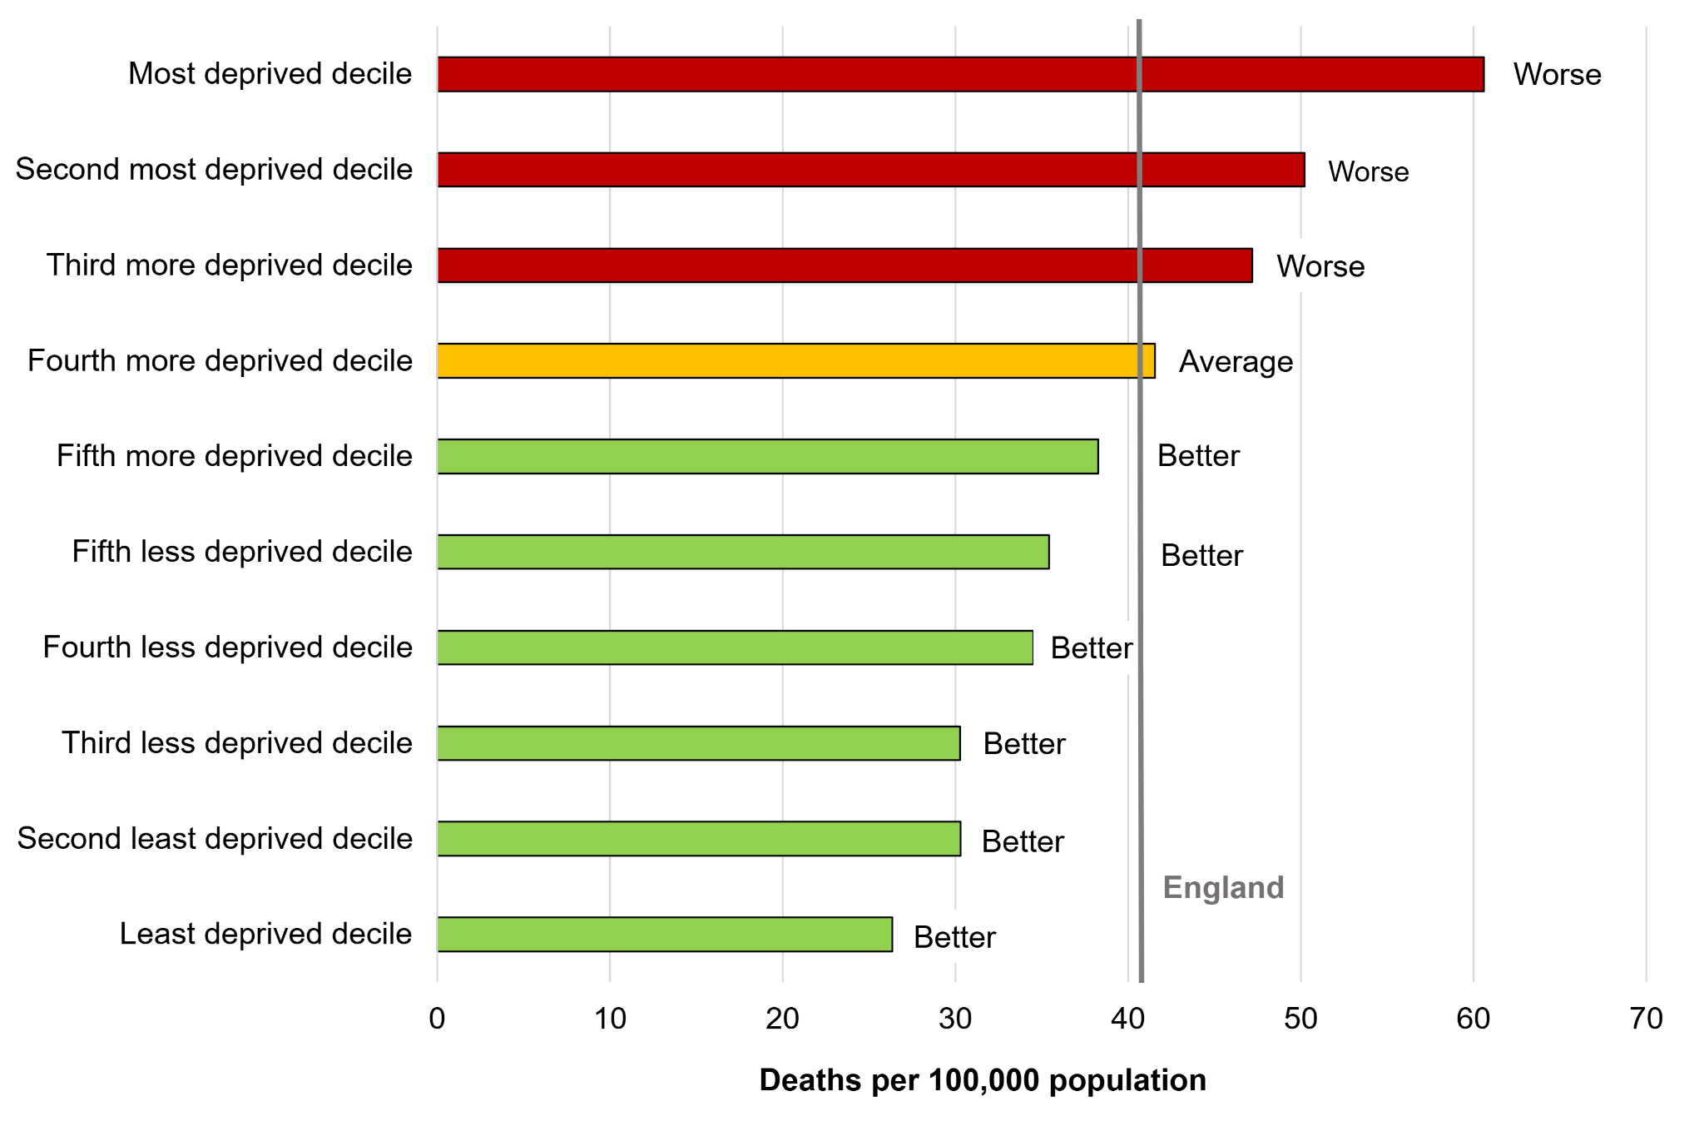
Figure: UK cardiovascular disease statistics
(Source: Razieh et al., 2022)

3. Public Health Measures Using the 3Ps
Prevention, protection and promotion are the key tenets of a public health approach to cardiovascular disease in Leicester. Prevention is an intervention that aims to lower risk factors which are modifiable before disease occurs. Smoking cessation services offer behavioural support and nicotine replacement therapy to assist people to stop smoking, and healthy eating initiatives promote a low-salt, low-sugar, and low saturated fat (SFA) diet (Battisti et al., 2022). Make an effort to exercise regularly to help prevent obesity, hypertension and diabetes. To minimise cardiovascular disease, early diagnosis and prompt treatment is required, which is achieved by those being identified as having a health risk through NHS Health Checks, blood pressure screening and cholesterol testing. Promotion can be used to encourage healthier lifestyles, for example through the Better Health Campaign, community education programmes and lifestyle interventions to promote long-term behaviour change (Shabnam et al., 2025). Combined, these public health interventions help to detect illness at an early stage, make healthier choices, lower cardiovascular risk and lead to less illness and death in the adult population of Leicester.
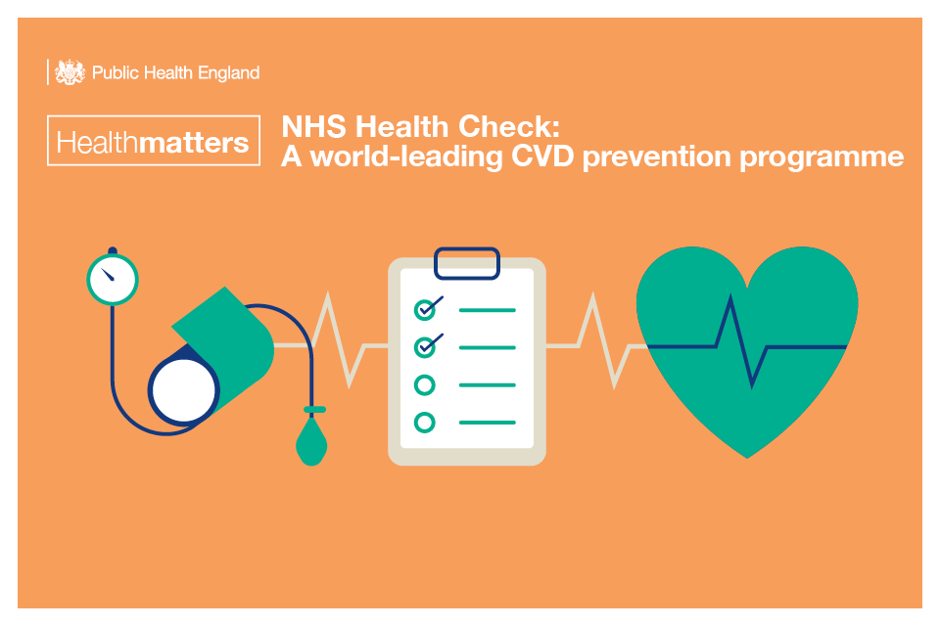
Figure: NHS Health Check cardiovascular screening
(Source: Shabnam et al., 2025)

4. Determinants and Risk Factors
CVD is due to nonmodifiable (and modifiable) risk factors interacting with each other. Risk factors that can be modified are: risk factors are increasing age, male sex, family history, genetic disposition and ethnicity. The vascular changes associated with aging are more likely to become exacerbated in older adults, placing them more at risk of developing cardiovascular disease (CVD) (Barker et al., 2022). The population of Leicester is large and South Asians have more CHD and diabetes in younger age groups than other ethnic groups. Certain people also have a genetic tendency of having high cholesterol and blood pressure. There are opportunities for modification of risk factors for prevention. Smoking cigarettes also damages blood vessels and accelerates atherosclerosis; and obesity increases pressure, cholesterol issues, and insulin resistance (Nadarajah et al., 2023). High blood pressure is one of the best risk factors for heart attacks and strokes. Over time, diabetes seriously affects blood vessels, thus raising the risk of cardiovascular disease. Over drinking, poor nutrition and lack of exercise are also a cause of heart disease.
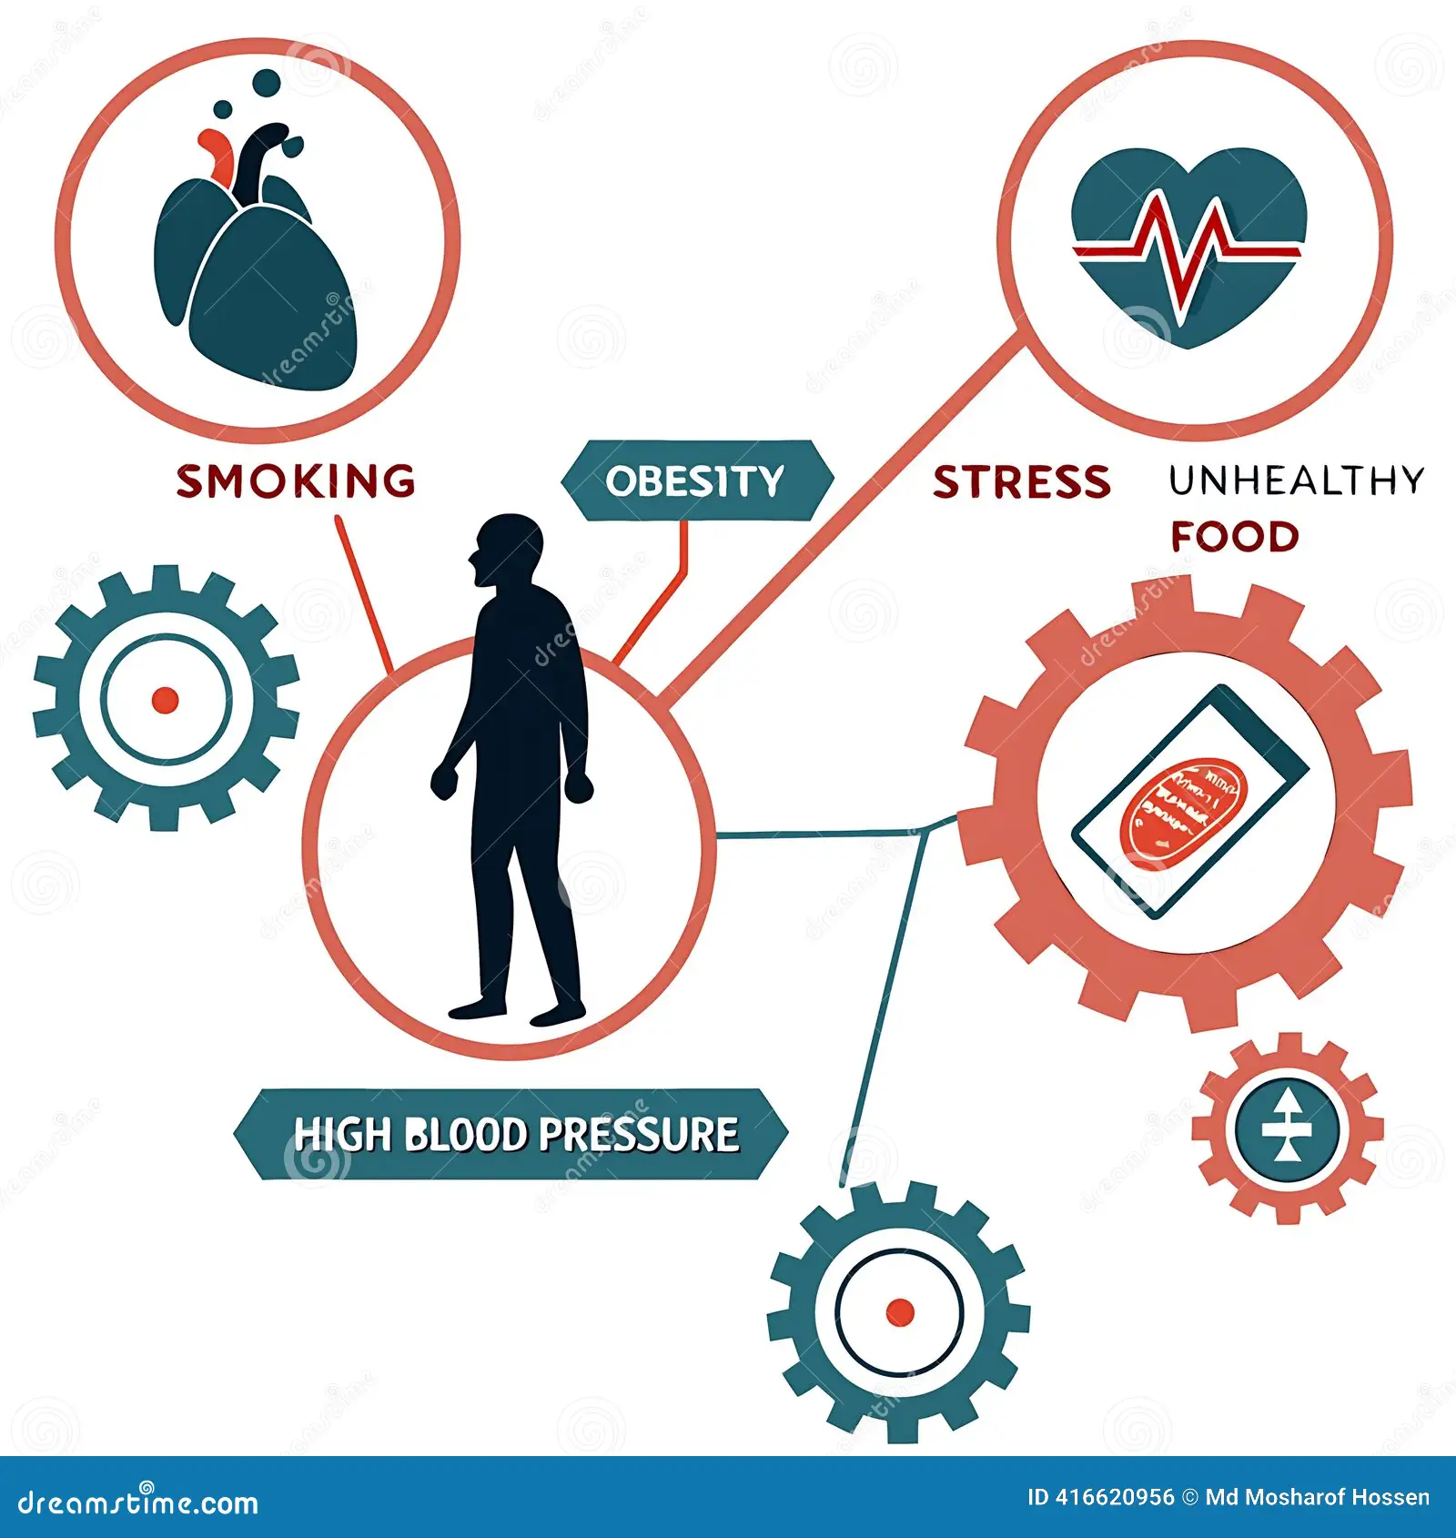
Figure: Cardiovascular disease risk factors infographic smoking obesity hypertension
(Source: Nadarajah et al., 2023)

5. Epidemiological Studies and Health Needs Assessment
Epidemiological studies show that cardiovascular disease is a disease of old age, mainly affecting people older than 65 years, although an increasing number of younger adults (with multiple risk factors) are also affected. Cardiovascular disease (CVD) is also more likely to occur at a younger age in Leicester's South Asian communities, compared to many other ethnic groups, which further increases their risk of developing coronary heart disease (CHD), hypertension, and type 2 diabetes (T2D) (Dale et al., 2023). There are also socio-economic inequalities that increase the burden of disease, as people living in deprived areas are likely to be under-nourished and inactive, smoke, and not have access to preventive care services. The Leicester Joint Strategic Needs Assessment (JSNA) is a review of information on the local population and health which is used to identify the priority health needs and allocate resources for cardiovascular prevention and treatment (Panchal, 2026). NHS Health Profiles are used to inform on the prevalence of disease and mortality, behavioural risk factors and health inequalities, allowing health organisations to track trends and create interventions to improve cardiovascular health outcomes for the diverse population in Leicester.

6. Monitoring and Surveillance Systems
Public health monitoring and surveillance systems are critical to monitoring and tracking health trends of cardiovascular disease, and to evaluating public health intervention. Information on hospital admissions, treatment outcomes and provision of primary care are collected from patients by NHS Digital for use in healthcare planning (Johnson et al., 2025). Mortality data at a national and local level is available from the Office for Statistics (ONS) which can be used to analyse mortality by cardiovascular causes and to assess trends in population health. The United Kingdom Health Security Agency (UKHSA) provides public health advice and guidance using surveillance to prevent diseases. The Quality and Outcomes Framework (QOF) is a series of standardised performance measures, including measures of blood pressure control and cholesterol management, that have been established to encourage monitoring and management of cardiovascular risk factors (Sharma et al., 2026). Cardiovascular disease audits are used to assess the quality of healthcare services for patients with cardiovascular disease in the NHS, GP records provide valuable information on individual risk factors, long term management of cardiovascular disease and uptake of cardiovascular disease screening.

7. Public Health Impact of Cardiovascular Disease
Cardiovascular disease has both short- and long-term implications for both the individual and the health care system. Heart attacks and strokes are often associated with immediate hospitalisation, disability and reduced quality of life (QOL) in the short-term (Conrad et al., 2024). There are many patients who need long-term hospital care, rehabilitation and continuing medical management to become independent. In the long term, cardiovascular disease can result in chronic disability, long term health and social care services and premature death (Allara et al, 2025). There is also a significant economic cost to the disease due to lost productivity, continued care and services, and informal care. Moreover, cardiovascular disease is a significant economic burden on the NHS with the cost of diagnosis, emergency care, surgery, medication, rehabilitation and the long-term management of cardiovascular disease all impacting the economic burden.

8. Proposed Health Intervention Programme
The health intervention programme proposed would help to tackle cardiovascular disease in Leicester by intervening at a young age to change behaviours. Intervention would include community-based blood pressure, cholesterol, diabetes and cardiovascular risk screening in local spaces that are easily accessible (Battisti et al., 2022). Therefore lifestyle education sessions to encourage good food intake, regular exercise and/or improved compliance with medication and services for smoking and weight management to encourage behaviour change would be beneficial. Identified as being high risk would be referred urgently to their GP for further assessment and treatment. Digital, including mobile, monitoring tools, such as remote blood pressure monitoring, would be used for continuous self-management (Shabnam et al., 2025). Evaluation of the programme would include all hospital admissions, BP control, uptake of cardiovascular screening and cardiovascular mortality in adult population in Leicester.

9. Strengths and Weaknesses of the Epidemiological Approach
The epidemiological approach has evidence-based information on cardiovascular disease patterns to support effective population monitoring, resource allocation and plan for public health policy. Can be useful for targeting high-risk groups and to measure the effectiveness of prevention programs (Nadarajah et al., 2023). Epidemiological studies have their limitations, too. The results might be under-representative because of under-reporting, incompleteness, missing data and/or confounding variables. Furthermore, the epidemiology of disease patterns could be influenced by ongoing health inequalities and inequities in health care access, which can make it difficult to interpret and compare epidemiological information.

10. Conclusion
Understanding the pattern of cardiovascular diseases and key determinants, such as smoking, obesity, hypertension, ethnicity and age, is essential to the understanding of epidemiology. Screening and lifestyle programmes can be effective public health interventions in reducing cardiovascular risk. The future steps to further reduce cardiovascular disease in Leicester should include: better prevention, better access to health services and action to address health inequalities.

Reference’s Task 1
Smythe, T., Rotenberg, S., Moyo-Chilufya, M., Wilbur, J. and Kuper, H., 2026. Health inequalities among people with disabilities: an umbrella review and evidence synthesis. EClinicalMedicine, 91. https://www.thelancet.com/journals/eclinm/article/PIIS2589-5370(25)00609-1/fulltext
Banks, J., Karjalainen, H. and Waters, T., 2024. Inequalities in disability. Oxford Open Economics, 3(Supplement_1), pp.i529-i548. https://academic.oup.com/ooec/article-abstract/3/Supplement_1/i529/7708071
Mitra, M., Long-Bellil, L., Moura, I., Miles, A. and Kaye, H.S., 2022. Advancing Health Equity And Reducing Health Disparities For People With Disabilities In The United States: Study examines health equity and health disparities for people with disabilities in the United States. Health Affairs, 41(10), pp.1379-1386. https://www.healthaffairs.org/doi/abs/10.1377/hlthaff.2022.00499
Kavanagh, A., Hatton, C., Stancliffe, R.J., Aitken, Z., King, T., Hastings, R., Totsika, V., Llewellyn, G. and Emerson, E., 2022. Health and healthcare for people with disabilities in the UK during the COVID-19 pandemic. Disability and Health Journal, 15(1), p.101171. https://www.sciencedirect.com/science/article/pii/S1936657421001370
Aitken, Z., Bishop, G.M., Disney, G., Emerson, E. and Kavanagh, A.M., 2022. Disability-related inequalities in health and well-being are mediated by barriers to participation faced by people with disability. A causal mediation analysis. Social Science & Medicine, 315, p.115500. https://www.jmir.org/2022/2/e33819/
Mulcahy, A., Streed Jr, C.G., Wallisch, A.M., Batza, K., Kurth, N., Hall, J.P. and McMaughan, D.J., 2022. Gender identity, disability, and unmet healthcare needs among disabled people living in the community in the United States. International journal of environmental research and public health, 19(5), p.2588. https://www.mdpi.com/1660-4601/19/5/2588
Lund, E.M. and Ayers, K.B., 2022. Ever-changing but always constant:“Waves” of disability discrimination during the COVID-19 pandemic in the United States. Disability and Health Journal, 15(4), p.101374. https://www.sciencedirect.com/science/article/pii/S1936657422001248
Lundberg, D.J. and Chen, J.A., 2024. Structural ableism in public health and healthcare: a definition and conceptual framework. The Lancet Regional Health–Americas, 30. https://www.thelancet.com/journals/lanam/article/PIIS2667-193X(23)00224-7/fulltext
Kowal, S., Ng, C.D., Schuldt, R., Sheinson, D., Jinnett, K. and Basu, A., 2023. Estimating the US baseline distribution of health inequalities across race, ethnicity, and geography for equity-informative cost-effectiveness analysis. Value in Health, 26(10), pp.1485-1493. https://www.sciencedirect.com/science/article/pii/S1098301523030322
Argenyi, M.S., Mereish, E.H. and Watson, R.J., 2023. Mental and physical health disparities among sexual and gender minority adolescents based on disability status. LGBT health, 10(2), pp.130-137. https://journals.sagepub.com/doi/abs/10.1089/lgbt.2022.0032

Reference’s Task 2
Conrad, N., Molenberghs, G., Verbeke, G., Zaccardi, F., Lawson, C., Friday, J.M., Su, H., Jhund, P.S., Sattar, N., Rahimi, K. and Cleland, J.G., 2024. Trends in cardiovascular disease incidence among 22 million people in the UK over 20 years: population based study. bmj, 385. https://www.bmj.com/content/385/bmj-2023-078523.abstract
Allara, E., Shi, W., Bolton, T., Chalmers, F., Brizzi, L.F., Musto, L., Shah, A.S., Tomlinson, C., Walter, I., Conrad, N. and Danesh, J., 2025. Burden of cardiovascular diseases in England (2020–24): a national cohort using electronic health records data. The Lancet Public Health, 10(11), pp.e943-e954. https://www.thelancet.com/journals/lanpub/article/PIIS2468-2667(25)00163-X/fulltext
Razieh, C., Zaccardi, F., Miksza, J., Davies, M.J., Hansell, A.L., Khunti, K. and Yates, T., 2022. Differences in the risk of cardiovascular disease across ethnic groups: UK Biobank observational study. Nutrition, Metabolism and Cardiovascular Diseases, 32(11), pp.2594-2602. https://www.sciencedirect.com/science/article/pii/S0939475322003295
Battisti, N.M.L., Welch, C.A., Sweeting, M., de Belder, M., Deanfield, J., Weston, C., Peake, M.D., Adlam, D. and Ring, A., 2022. Prevalence of cardiovascular disease in patients with potentially curable malignancies: a national registry dataset analysis. Cardio Oncology, 4(2), pp.238-253. https://www.jacc.org/doi/abs/10.1016/j.jaccao.2022.03.004
Shabnam, S., Zaccardi, F., Yates, T., Islam, N., Razieh, C., Chudasama, Y.V., Banerjee, A., Seidu, S., Khunti, K. and Gillies, C.L., 2025. COVID-19 pandemic and risk factor measurement in individuals with cardio-renal-metabolic diseases: A retrospective study in the United Kingdom. Plos one, 20(4), p.e0319438. https://journals.plos.org/plosone/article?id=10.1371/journal.pone.0319438
Barker, M.M., Zaccardi, F., Brady, E.M., Gulsin, G.S., Hall, A.P., Henson, J., Htike, Z.Z., Khunti, K., McCann, G.P., Redman, E.L. and Webb, D.R., 2022. Age at diagnosis of type 2 diabetes and cardiovascular risk factor profile: a pooled analysis. World Journal of Diabetes, 13(3), p.260. https://pmc.ncbi.nlm.nih.gov/articles/PMC8984563/
Nadarajah, R., Farooq, M., Raveendra, K., Nakao, Y.M., Nakao, K., Wilkinson, C., Wu, J. and Gale, C.P., 2023. Inequalities in care delivery and outcomes for myocardial infarction, heart failure, atrial fibrillation, and aortic stenosis in the United Kingdom. The Lancet Regional Health–Europe, 33. https://www.thelancet.com/journals/lanepe/article/PIIS2666-7762(23)00138-2/fulltext
Dale, C.E., Takhar, R., Carragher, R., Katsoulis, M., Torabi, F., Duffield, S., Kent, S., Mueller, T., Kurdi, A., Le Anh, T.N. and McTaggart, S., 2023. The impact of the COVID-19 pandemic on cardiovascular disease prevention and management. Nature medicine, 29(1), pp.219-225. https://www.nature.com/articles/s41591-022-02158-7
Panchal, K., 2026. Determinants and trends of heart failure in relation to other major cardiovascular events in people with diabetes (Doctoral dissertation, University of Leicester). https://figshare.le.ac.uk/articles/thesis/Determinants_and_trends_of_heart_failure_in_relation_to_other_major_cardiovascular_events_in_people_with_diabetes/31851565
Johnson, W., Norris, T., Pearson, N., Petherick, E.S., King, J.A., Willis, S.A., Hardy, R., Paudel, S., Haycraft, E., Baker, J.L. and Hamer, M., 2025. Are associations of adulthood overweight and obesity with all-cause mortality, cardiovascular disease, and obesity-related cancer modified by comparative body weight at age 10 years in the UK Biobank study? Epidemiology and Population Health. International Journal of Obesity, 49(5), pp.902-914. https://www.nature.com/articles/s41366-025-01718-4
Sharma, C., Goncalves Soares, A., Kulkarni, B., Byrne, N.M., Bhogadi, S., Mallinson, P.A.C., Lieber, J., Rameshwar Sarma, K.V., Radha Krishna, K.V., Kuper, H. and Gupta, R., 2026. Life-course trajectories of cardiovascular disease risk factors in rural India: Andhra Pradesh Children and Parents Study (APCAPS) 2003–2023. International journal of epidemiology, 55(4), p.dyag080. https://academic.oup.com/ije/article-abstract/55/4/dyag080/8715136

