University of Wales
Trinity Saint David
School of Applied Computing

Title: Database Analysis and Design

Module: Introduction to Web and Database Concepts
Code: ACCA 4023
Student: Martin Darzins
Student no.: 1909722
Programme: Computing Portfolio – Applied Computing: Year 1
Lecturer: Beverley Holland
Due Date: 5th May 2021

Acknowledgements
The author acknowledges the module course contents within Moodle module ACCA 4023 Introduction to Web and Database Concepts.

Table of Contents
1 Acknowledgements ii
3 Introduction 1
3.1 Aims 1
3.2 Objectives 1
4 Design techniques 2
4.1 Background 2
4.2 Context Diagram 4
4.3 Level 0 – Data Flow Diagram (DFD) 5
4.4 Entity Relationship Diagram (ERD) 6
5 Documentation 7
5.1 Relationship Diagram 7
5.1.1 Relationship Details 7
5.1.2 Membership Class 7
5.2 Tables 8
5.2.1 Table Additions & Deletions 8
5.3 Queries 9
5.4 Forms 10
5.5 Reports 11
5.6 User Requirements 12
5.6.1 Designed Invoice Form 12
5.6.2 Purchase Transactions Report 12
5.6.3 Event Booking Query 13
5.6.4 Profitability 14
6 functionality 15
6.1 Calculations in a Report 15
6.2 Master & Embedded Forms 16
6.3 Produce Reports & Forms from Macro Query 17
6.3.1 Form from Macro Query 17
6.3.2 Report from Macro Query 18
6.4 Database Displayed Menus 19
6.5 User Guide 19
7 References 20
7.1 Image 20
8 Report Planning Methodology 21

Figure 1: Context Diagram 4
Figure 2: Level 0 – Data Flow Diagram (DFD) 5
Figure 3: Entity Relationship Diagram (ERD) 6
Figure 4: ERD in Access 7
Figure 5: Tables 8
Figure 6: Table Additions, Deletions & Updates 8
Figure 7: Queries 9
Figure 8: View Ingredient Stock Qty 9
Figure 9: Forms 10
Figure 10: View Ongoing Customer Orders 10
Figure 11: Reports 11
Figure 12: Customer Details Report 11
Figure 13: Invoice Form 12
Figure 14: Purchase Transaction Report 12
Figure 15: Event Booking Query 13
Figure 16: Profitability Report 14
Figure 17: Calculations in a Report 15
Figure 18: Further Calculations 15
Figure 19: Master & Embedded Form 16
Figure 20: Macro Query – Form 17
Figure 21: Macro Query - Report 18
Figure 22: Displayed Menus 19

Introduction

Aims
The aim of this report is to demonstrate a systematic understanding of the underlying concepts of data and databases, along with the methodology of database design.

Objectives
This report will show the use of appropriate system investigation and analysis techniques in order to design and implement relational database solutions, highlighting new computerised processes and database requirements relating to the Celtic Catering company scenario.

Design techniques

Background
A Statement of Aims and Objectives for the Celtic Catering software system has been developed utilising MoSCoW and Functional/Non-Functional techniques, from the scenario set, resulting in the following;
Scope and Objectives Computerised System for Celtic Catering
Celtic Caterers (CC) supply catering services to local businesses and organisations for functions. They have Stores located in Swansea, Neath, Port Talbot, Llanelli and Carmarthen and utilise several Suppliers when Purchasing Ingredients for day-to-day business running. Each Store manager liaises directly with and takes Orders from Customers providing samples of menus and products on offer. Each store has a fully operational Kitchen and holds its own Ingredient Stocks. Store Kitchen staff receive Food Order information from Store manager and fulfil these Orders in a timely fashion.
At the Stores
- Store manager liaises directly with Customers providing samples of menus and products on offer.
- Orders are taken by Store manager.
- Each store has a fully operational commercial Kitchen.
- Each store holds Stocks in a suitably sized refrigerated area.
- Kitchen staff receive information about Food Orders from Store manager.
- Kitchen staff fulfil these Orders in a timely fashion
The current problems experienced include;
- Monitoring the hand-written Diary of Events.
- Coordinating Deliveries to catered Events.
- Accounts work via Paper Receipts.
- Poor Tracking of WIP (work in progress).
- No Online presence.
Project Objectives are;
- Upgrade entire data processing system to improve running of the business.
- Create Databases ( Ingredients, Events, Sales, Purchases, Client Records, Suppliers,
- Reliable, fast system.
- Online presence to increase grow Sales / financial status (profitability).
- Keep Storefront service at Stores.
- Maintain storefront service.
- Record customer details (info re: catering services and Events that Customers Order).
- Booking system to improve scheduling of the catering provisions (Events/Stocks/Ingredients).
- Automatic provision of Customer Invoices.
- Recording Income generated from catering.
- Accounting to be able to record Purchases & Sales.
- Able to Calculate quarterly and yearly Profitability.
- Standardise systems for all Store locations.
- Centralise data storage.
Project scope and constraints:
- Provide on screen viewable & printable Invoicing.
- View & Recording of Supplier (Ingredient) Purchases/Transactions.
- Ability to Query Event bookings.
Online presence.
- Adequate database storage.
- Ability to expand system for Profit calculations.
- Adequate database storage for customer data and operations.
- Time allocations
- Appropriate systems are needed to maintain and process data.
Constraints
- Budget is not unlimited.
- Possible retraining of staff.
- Insufficient data processing equipment.
- New system implementation not to adversely affect current business operations.
Preliminary ideas
- Look at possible hardware/software solutions.
- See if off-the-shelf solutions are available.
- Liaise with end-users and stakeholders.
Analysis
- Initial findings after investigation found the user requirements to be;
- View designed Invoices on screen and printable.
- View a Record of Purchases from Ingredient Suppliers.
- Query information concerning booked catering Events [1].

Context Diagram

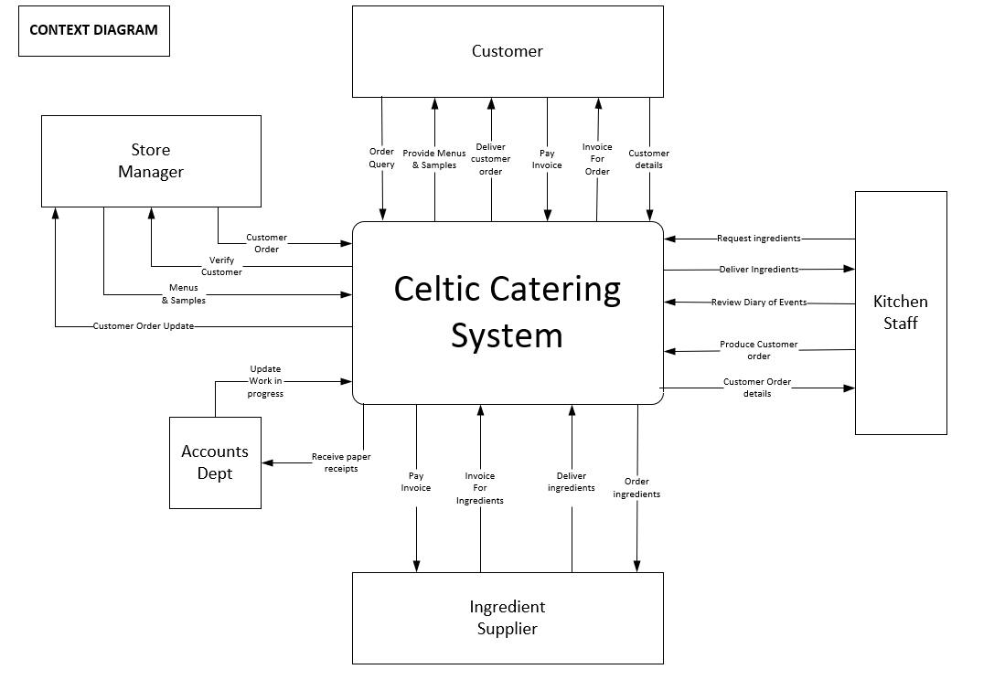
Figure 1: Context Diagram

Level 0 – Data Flow Diagram (DFD)
Figure 2: Level 0 – Data Flow Diagram (DFD)

Entity Relationship Diagram (ERD)

Figure 3: Entity Relationship Diagram (ERD)

Documentation
Data, tables, queries, forms and reports available via the separately attached Access Database file covering:

Relationship Diagram
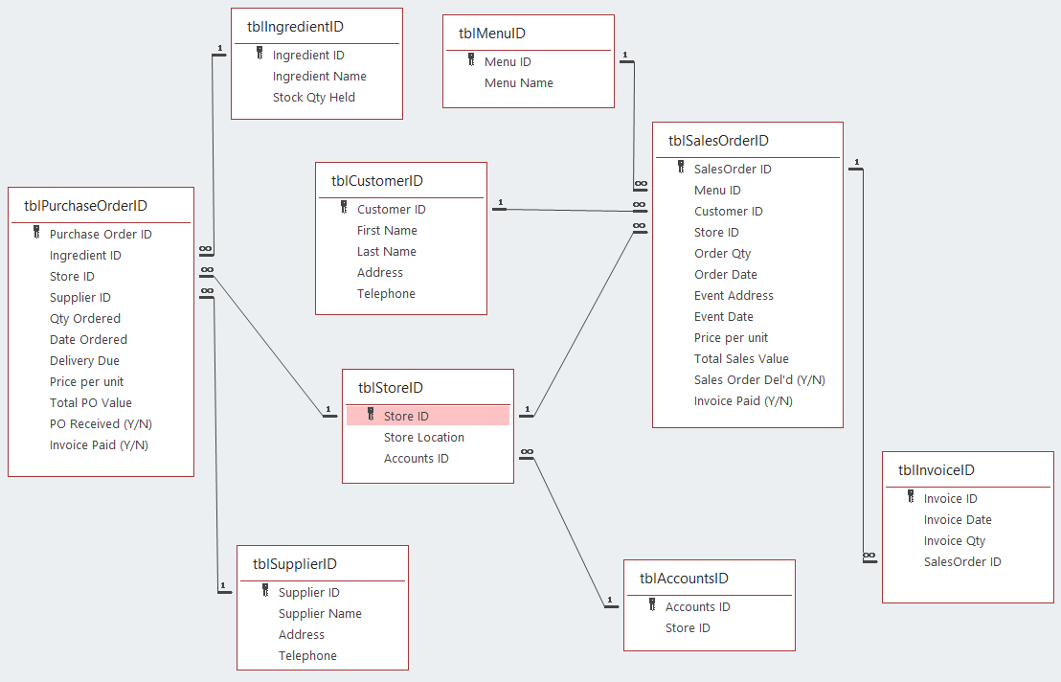
Figure 4: ERD in Access

Relationship Details
- 1 Customer may place many SalesOrders
- 1 Menu may appear on many SalesOrders
- 1 Store may receive many SalesOrders
- 1 SalesOrder may have many Invoices
- 1 Accounts Dept may manage many Stores
- 1 Store may place many PurchaseOrders
- 1 Supplier may receive many PurchaseOrders
- 1 Ingredient may appear on many PurchaseOrders

Membership Class
For this proposed Database, all membership classes have been determined as Mandatory,(i.e.. 1 to many).

Tables
Tables are objects used to define & store data, requiring defined fields, known as column headings [1, 2].
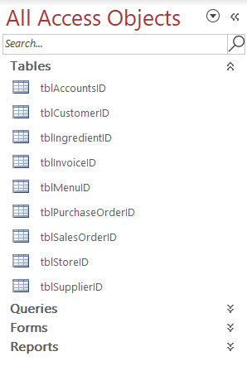
Figure 5: Tables

Table Additions & Deletions
All listed Tables have the facility to be updated by the User.
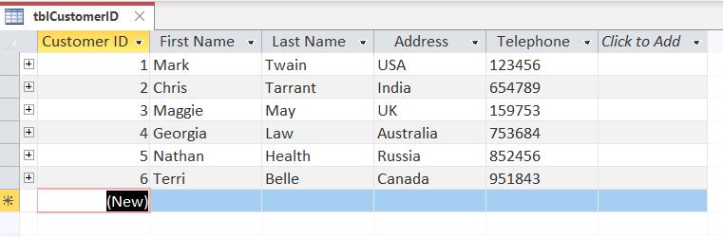
Figure 6: Table Additions, Deletions & Updates

Queries
Queries are objects that provide a custom view of data from tables and are a way of searching for and compiling data from one or more tables [1, 3].
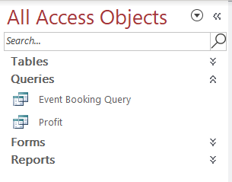
Figure 7: Queries
From the Ingredient table, User can view Stock currently being held, which will assist in determining whether ingredients need to be Purchased from Suppliers.
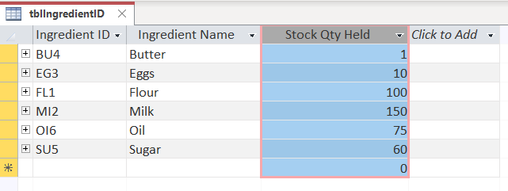
Figure 8: View Ingredient Stock Qty

Forms
Forms are an object in a desktop database designed primarily for data input or display or for control of application execution and are used to customise the presentation of data extracted from queries or tables [1, 4].
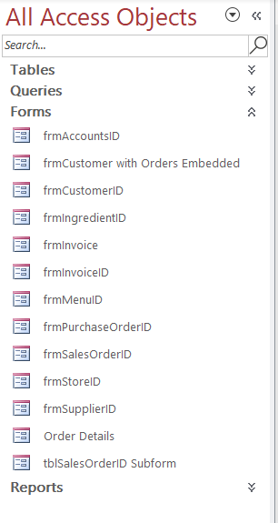
Figure 9: Forms
Customer Orders can be viewed via Forms.
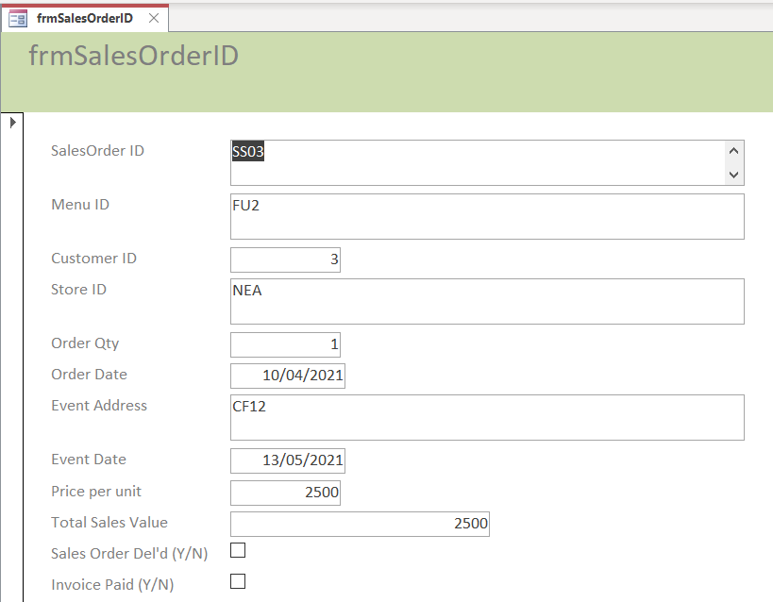
Figure 10: View Ongoing Customer Orders

Reports
Reports objects in desktop databases designed for formatting, calculating, printing, and summarising selected data [1, 5].
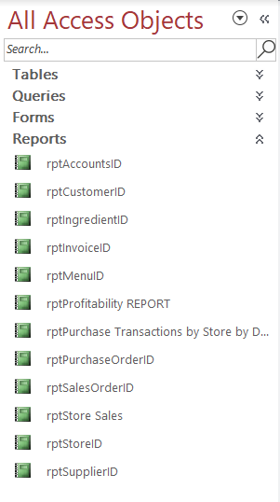
Figure 11: Reports
Various reporting facilities are available to the User.
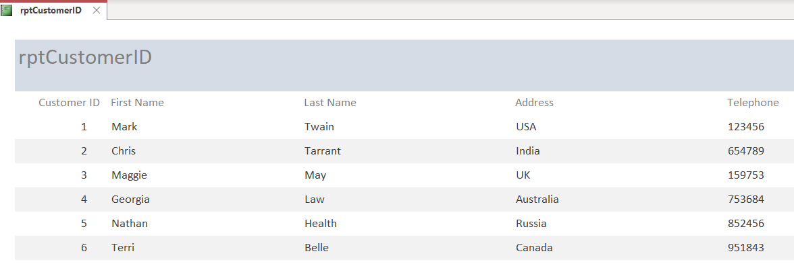
Figure 12: Customer Details Report

User Requirements

Designed Invoice Form
This invoice form contains a Calculated field which determines the Amount Due (GBP) value below
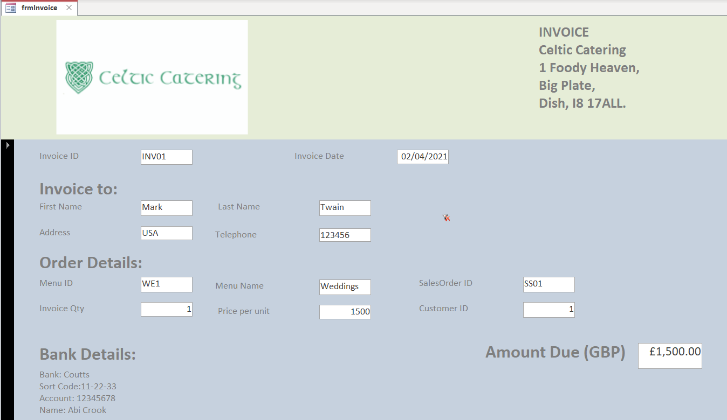
Figure 13: Invoice Form

Purchase Transactions Report
This report shows the various Ingredient purchases against individual Suppliers, by Store and is filtered by Date order, along with details as to whether the Order has been Received.
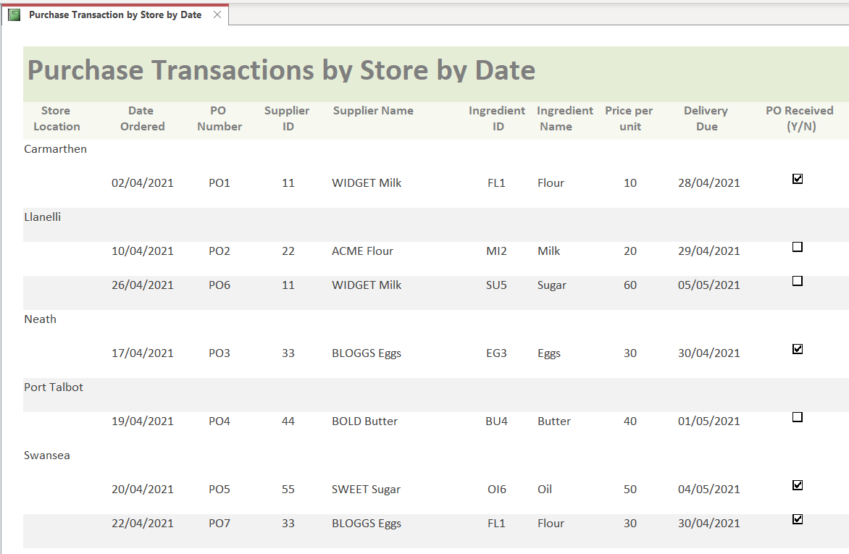
Figure 14: Purchase Transaction Report

Event Booking Query
All columns can be filtered in line with User preferences, this Query is filtered in Event Date order.
This allows all authorised Celtic Catering Users to view when Customer Events are due (Event Date), the delivery location (Event Address), the Customer selected Menu (Menu ID/Name), along with Customer information (Customer ID / Name) and Store (Store Location) who obtained the order.
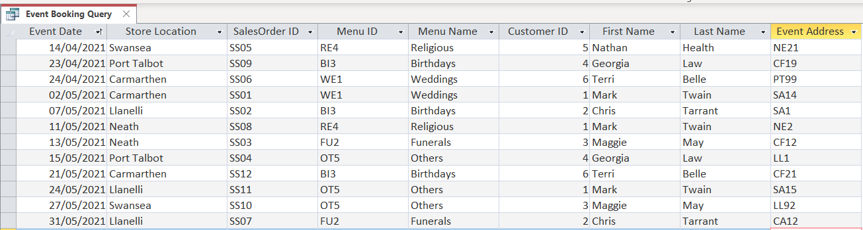
Figure 15: Event Booking Query

Profitability
From the Profit Query the associated Profitability Report is run, showing both the Total Sales and Total Purchases, determining whether Celtic Catering have made a Profit or Loss.
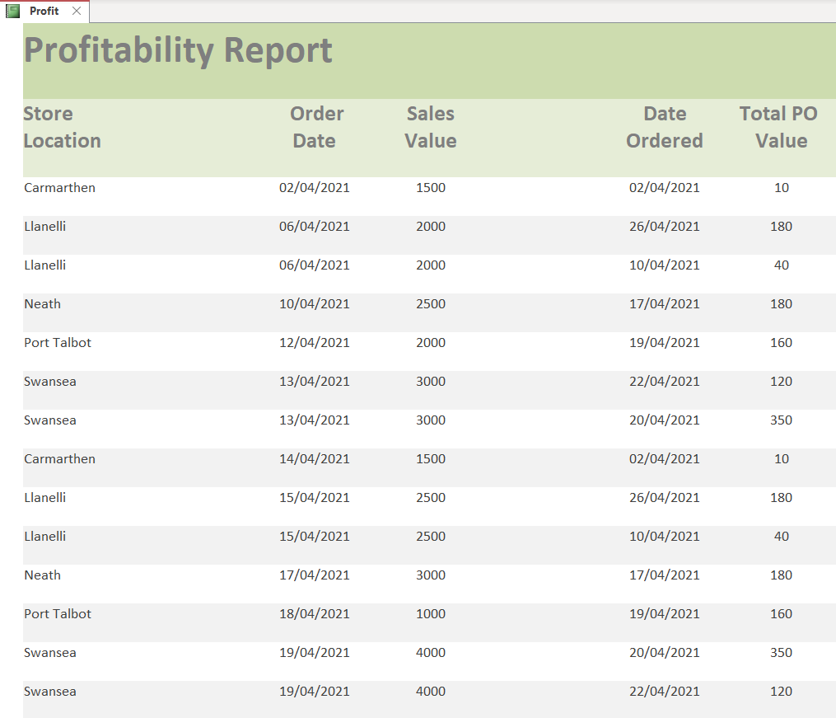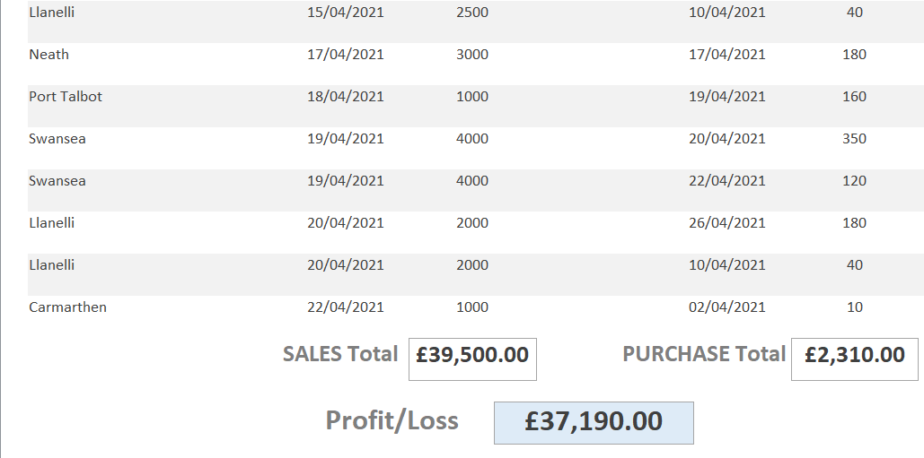
Figure 16: Profitability Report

functionality

Calculations in a Report
The attached screenshot details 2 Sales Value calculations within the Store Sales - Totalled Report, showing the individual Sales Order Total value per Order, along with a Cumulative Sales Total for the all the Orders by Store.
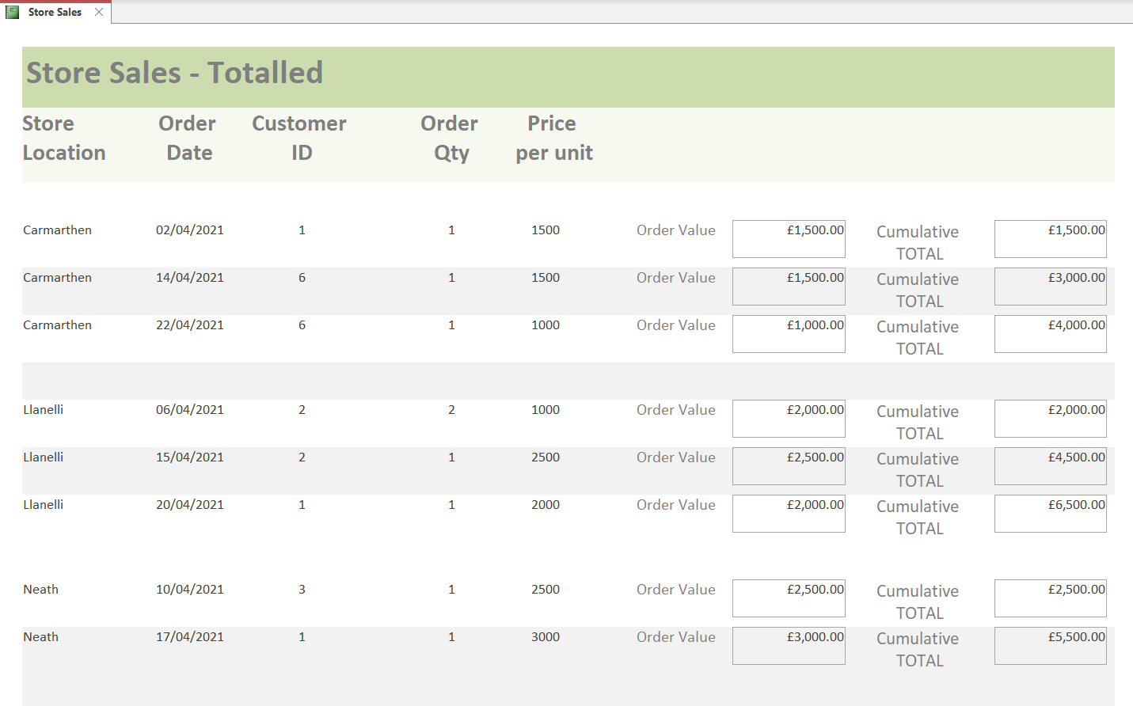
Figure 17: Calculations in a Report
Calculations are also shown in the above detailed Profitability Report.
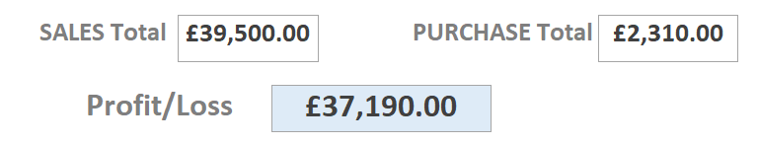
Figure 18: Further Calculations

Master & Embedded Forms
The embedded form below shows the master form details for Customer and embeds the related Sales Order details selected.
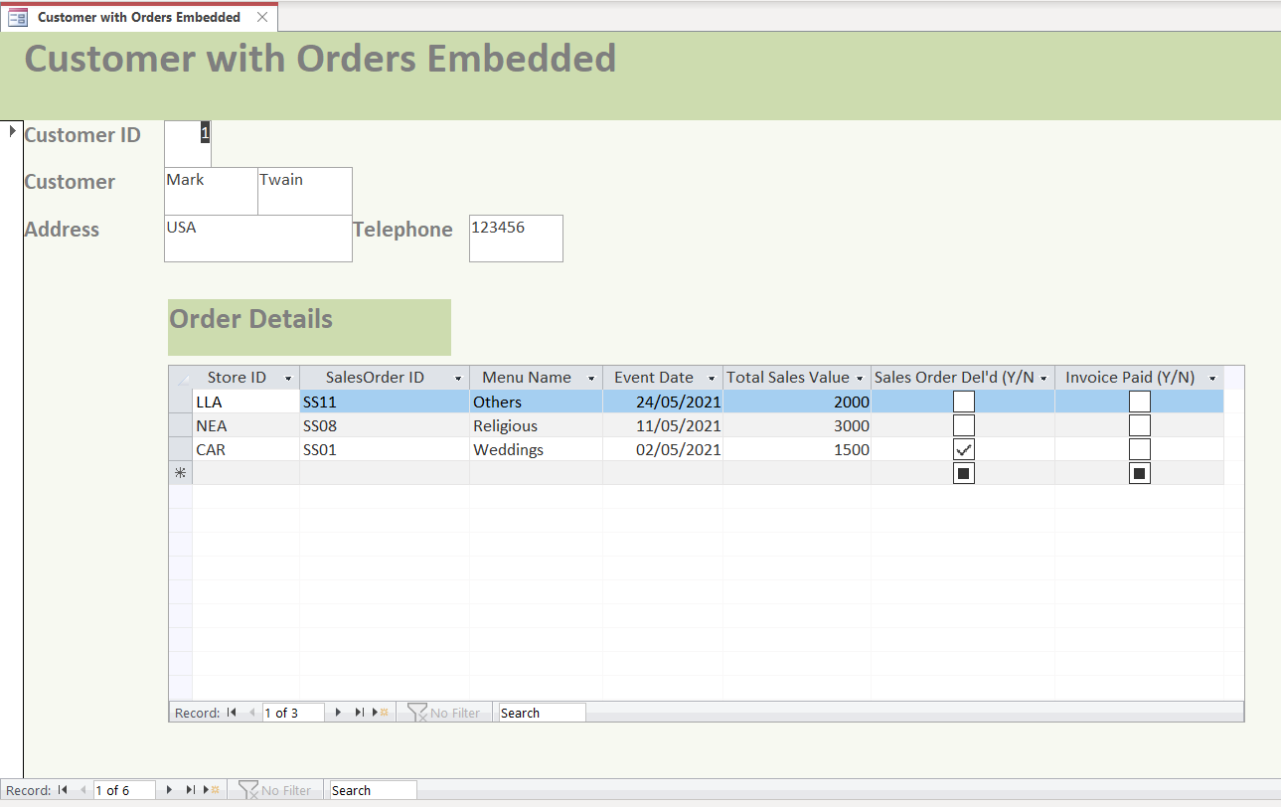
Figure 19: Master & Embedded Form

Produce Reports & Forms from Macro Query
Examples of macros in Access, that allow task automation and add functionality to forms, reports, and controls [1, 6].

Form from Macro Query
From the CustomerID form, the Sales Orders button directs you to the SalesOrderID form.
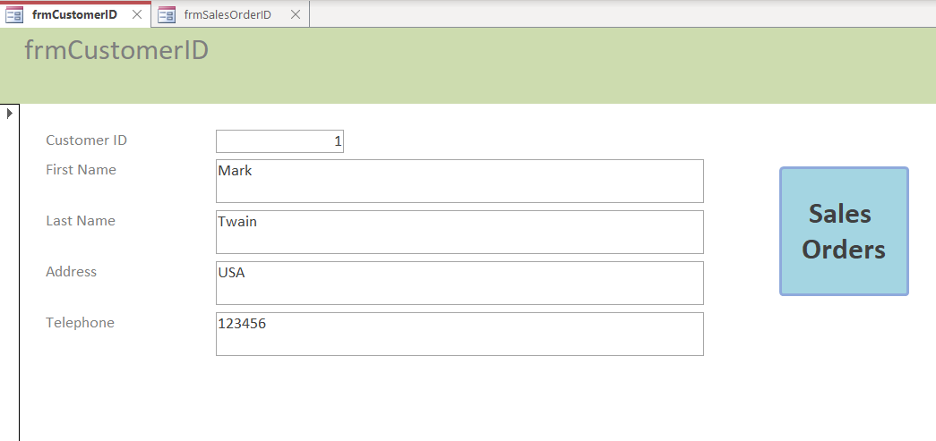
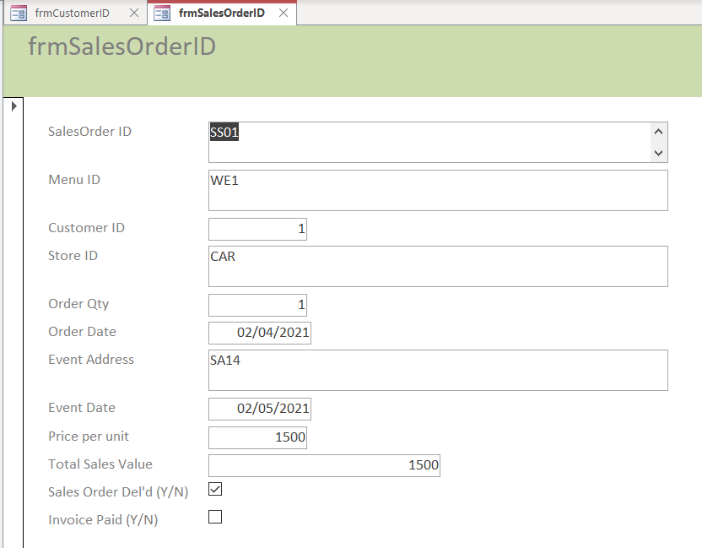
Figure 20: Macro Query – Form

Report from Macro Query
From the IngredientID form, the Ingredient Purchases Report button directs you to the PurchaseOrderID report [1, 6].
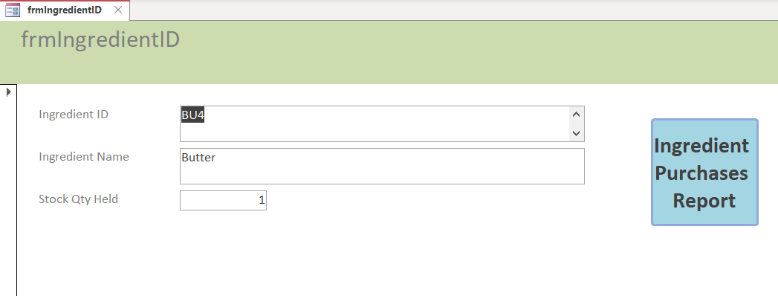
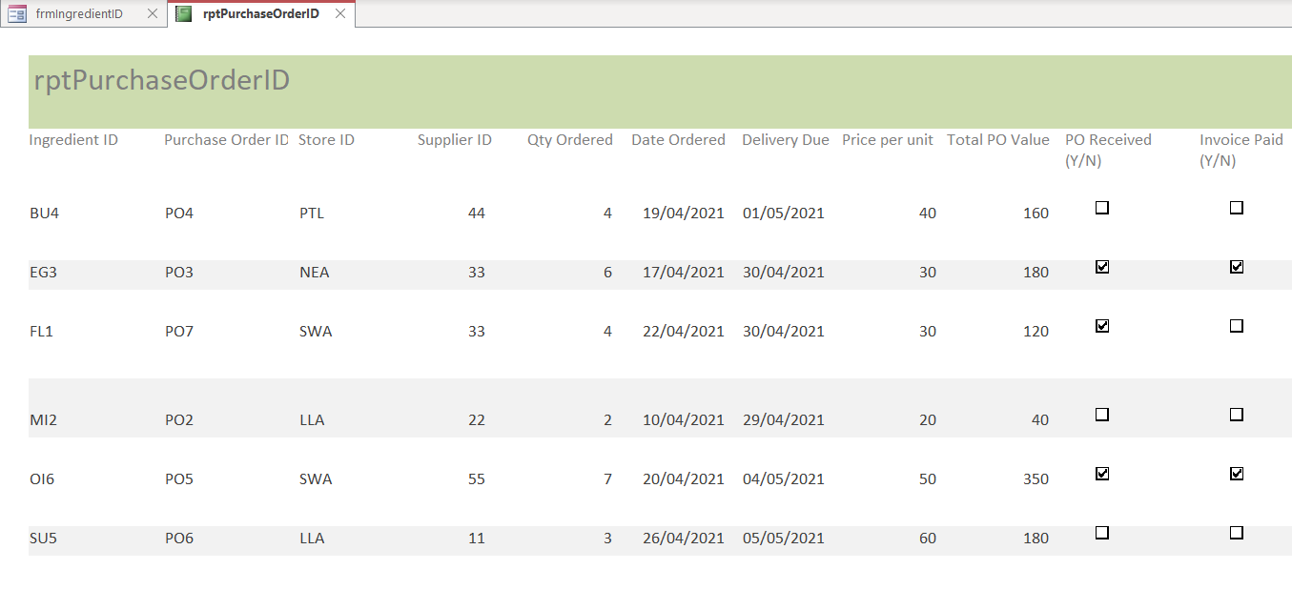
Figure 21: Macro Query - Report

Database Displayed Menus
From opening the Database, the following Menus are displayed (Tables, Queries, Forms & Reports), from which dropdown menus detail the various elements. Furthermore, from the Home ribbon, Database Tools, the Relationship diagram can be selected.
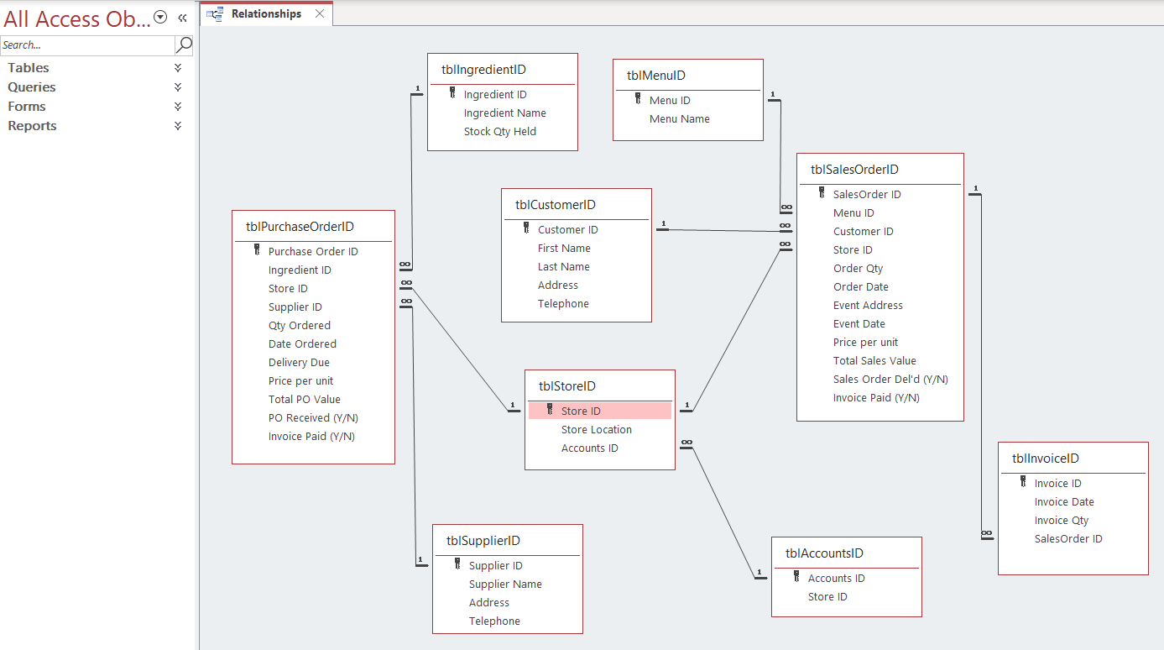
Figure 22: Displayed Menus

User Guide
The 7 identified processes will require 7 distinct data storage elements to be periodically updated, in order to complete accurate query, reporting and status actions. The system will allow for Bespoke reports and queries to be generated, as per any specific request, pulling information from the various table/form details. It is envisaged that each Store Manager will coordinate the activities within their respective Store managing the Kitchen actions, with the central HQ Accounting Dept having overall financial management responsibilities for the entire business.
From the MoSCoW review all User requirements have been met, apart from an Online presence (Won’t Have yet), which will require specialist solutions involving website design etc, and not considered part of this developed solution, albeit that the data storage facilities enabled will support this function.

Word count: 1,294 (excluding Title page and sections 1 - 3, and 7 – 8)

References
[1] Moodle, “MS Access.” 2021. [Online].
L4 - Introduction to Web and Database Concepts (ACCA4023).
[Accessed: May, 02, 2021].

[2] support.microsoft.com, “Introduction to tables.” 2021. [Online].
Available:https://support.microsoft.com/en-us/office/introduction-to-tables-78ff21ea-2f76-4fb0-8af6- c318d1ee0ea7
[Accessed: May, 02, 2021].

[3] support.microsoft.com, “Introduction to queries.” 2021. [Online].
Available:https://support.microsoft.com/en-us/office/introduction-to-queries-a9739a09-d3ff-4f36-8ac3- 5760249fb65c
[Accessed: May, 02, 2021].

[4] support.microsoft.com, “Create a form in Access.” 2021. [Online].
Available:https://support.microsoft.com/en-us/office/create-a-form-in-access-5d550a3d-92e1-4f38-9772- 7e7e21e80c6b
[Accessed: May, 02, 2021].

[5] support.microsoft.com, “Introduction to reports in Access.” 2021. [Online].
Available:https://support.microsoft.com/en-us/office/introduction-to-reports-in-access-e0869f59-7536-4d19- 8e05-7158dcd3681c
[Accessed: May, 02, 2021].

[6] support.microsoft.com, “Introduction to macros.” 2021. [Online].
Available:https://support.microsoft.com/en-us/office/introduction-to-macros-a39c2a26-e745-4957-8d06- 89e0b435aac3
[Accessed: May, 02, 2021].

Image
Courtesy of:
Company Logo: https://www.absolutemarquees.co.uk/brands/celtic-catering/

Report Planning Methodology
This Database Analysis and Design report assignment was completed by adhering to the following activities;
- Read and understand the report brief.
- Make plan (Gantt chart) including time management – planning/research most time consuming, catering for other exams.
- Create report format and style – using Moodle template example.
- Follow structure of:
  - Title Page
  - Acknowledgements
  - Introduction
  - Main Body
  - References
- Define the problem and purpose of the report – decide assignment title, aims & objectives.
- Define audience – Lecturer/Tutor (Beverley Holland/Gaynor Thomas).
- Brainstorm (Mindmaps) and Determine ideas to include.
- Research and gather information (Library, internet etc).
- Collect, sort, evaluate organise material.
- Complete references (as you go) during all research phases.
- Analysing my research/material.
- Prepare outline drafts.
- Write the report, check spelling and grammar.
- Issue draft into Turnitin for similarity checks.
- Incorporate changes into final redraft.
- Submit final report via Turnitin before due date (5th May 2021).

