
Programme: BSc (Hons) Health and Social Care
Module name: Changemakers: Creativity and Value Creation
Module Code: (BMHP5014_LON)
Name: Noemi Putz (2336726)
Lecture: Caroline Salami

Assignment Title: Online Portfolio

Table of Contents
Innovation, Creativity, Value Creation and Change in Health and Social Care 1
Mind map to solve problems in health and social care 2
Self-Reflection on Convergent and Divergent Thinking Activity 2
Case Study: NHS Virtual Wards 4
Current issue in health and social care: staff burnout 4
Benefit of Wearable Health Technologies for Chronic Condition Management 5
How Electronic Health Records Improve Communication and Collaboration 5
Digital Technology Supporting Preventative Care and Health Promotion 6
Leadership Behaviour to Encourage Creativity 6
Reflective Journal Entry 6
References 7

Innovation, Creativity, Value Creation and Change in Health and Social Care
Innovation refers to the deliberate introduction of new ideas, methods, or services that improve existing practices or outcomes. It involves translating novel solutions into practical applications that generate benefits. According to Greenhalgh et al. (2004), innovation in healthcare is “a complex process through which new knowledge, technologies or ways of working are adopted to enhance service quality.” Innovation is vital in health and social care because it supports better patient experiences, increases efficiency, and addresses emerging challenges such as ageing populations. For example, the adoption of telehealth consultations in community nursing has enabled faster access to care for housebound patients.
Creativity is the ability to generate original and useful ideas through flexible thinking. Amabile (1996) describes creativity as producing ideas that are both novel and appropriate within a given context. Creativity matters in health and social care because professionals often need to think beyond standard procedures - especially when supporting individuals with complex needs. For instance, social workers may design personalised activity plans for clients with dementia by creatively adapting familiar objects and routines to reduce anxiety and increase engagement.
Value creation involves delivering outcomes that are meaningful and beneficial to service users, professionals, or organisations. Porter (2010) emphasises that value in healthcare is achieved when health outcomes improve relative to the costs or resources used. Value creation is crucial in health and social care because it ensures services are person-centred, cost-effective, and focused on improving quality of life rather than simply delivering tasks. A practical example is the implementation of multidisciplinary care pathways for stroke rehabilitation, which reduce duplication of work while improving patient recovery outcomes.
Change refers to the process of moving from one state to another, often to improve systems, behaviours, or organisational performance. As noted by Hayes (2018), change is a planned or unplanned shift that affects how individuals or teams operate. Change is essential in health and social care because services must continually adapt to new evidence, policy demands, and population needs. A clear example is the change from paper-based records to electronic health records, improving communication and reducing medication errors.

Mind map to solve problems in health and social care
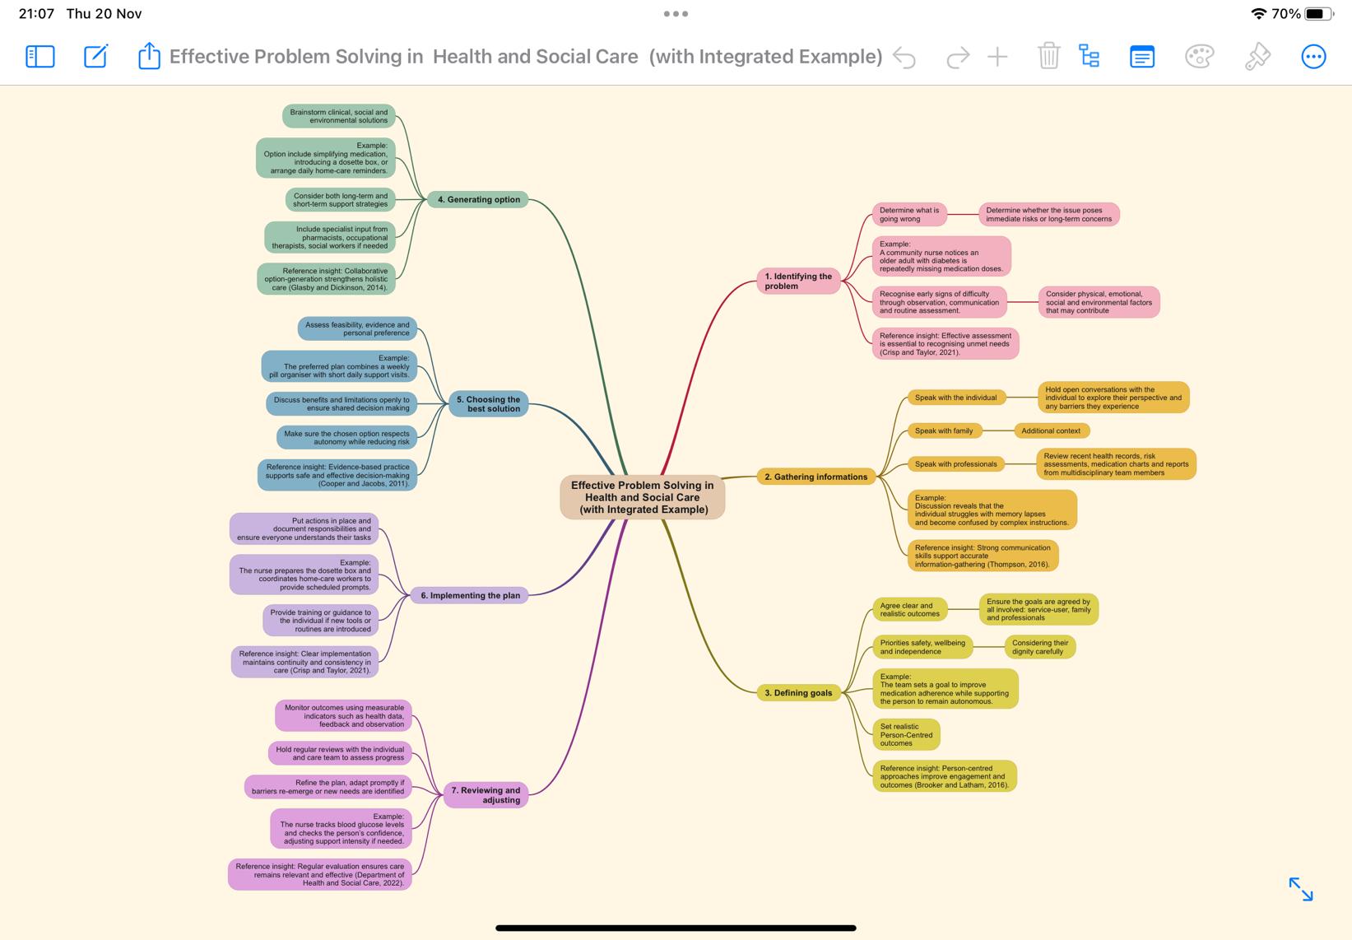

Self-Reflection on Convergent and Divergent Thinking Activity
During the class activity, I engaged with both convergent and divergent thinking. Divergent thinking involves generating multiple ideas and exploring possibilities without immediate judgment, while convergent thinking focuses on evaluating ideas to select the most practical or effective solution (Runco & Acar, 2012).
In the class activities, we explored couple things, like the issue of childhood obesity by breaking it down into several key areas. We first looked at the main problem and discussed what is causing high obesity rates in some communities, such as limited access to healthy food, too many fast-food outlets, and not enough safe places for children to play or exercise. We also talked about the effects obesity can have on children, including health problems, low confidence, and difficulties in school.
We then examined the local situation and considered how some neighbourhoods are affected more than others. This helped us understand why targeted support is needed. As a group, we discussed how schools, the council, and health services can work together - for example, by offering healthy eating lessons, creating more exercise opportunities, improving parks, and running regular health checks.
Another part of our discussion focused on reducing junk-food availability near schools, encouraging children to be more active, and helping families learn about healthier habits at home. We also identified who can play a role in supporting change, such as parents, teachers, doctors, and community organisations.
Finally, we talked about how progress can be monitored over time by tracking children’s health, reviewing activity levels, and checking whether local obesity rates are improving.

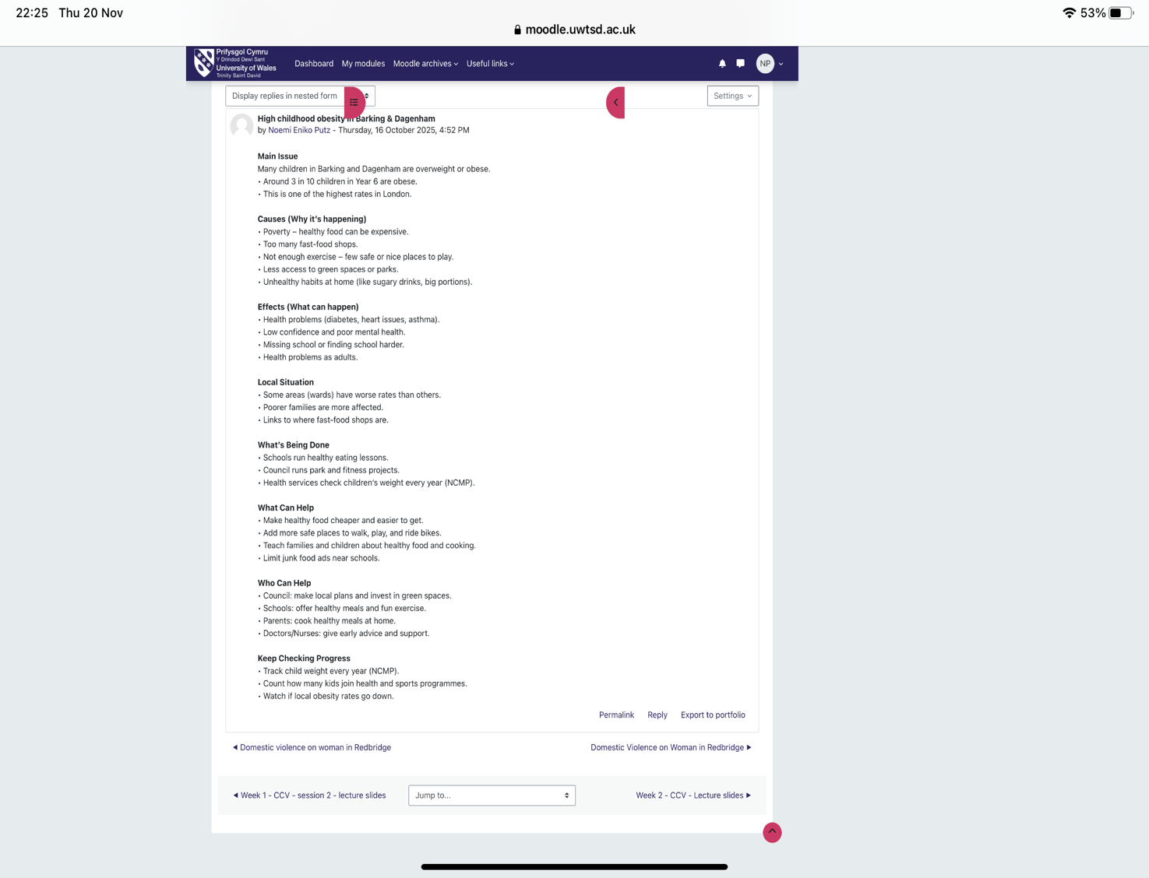
When I reflected on my own contribution, I realised that I am usually confident when suggesting ideas in the early stages, but I can be more cautious when it comes to analysing them. Working with others helped me improve in this area, as I could learn from how my teammates evaluated ideas and considered different viewpoints. I also recognised how helpful organised group methods - such as mind-mapping and creating simple prototypes - are for turning creative thoughts into real plans. Overall, the exercise strengthened my teamwork, critical thinking, and confidence in contributing to creative projects within health and social care.

Case Study: NHS Virtual Wards
The development of NHS Virtual Wards is a significant innovation designed to support patients with chronic or acute conditions at home through remote monitoring. Creativity played a central role in shaping this model, as clinicians and digital teams worked together to rethink traditional hospital care. By combining wearable devices, mobile apps, and daily clinical reviews, teams creatively redesigned patient pathways so that hospital-level observation could be provided safely beyond the physical ward (Bardsley, 2021).
The innovation specifically targeted the growing problem of hospital capacity pressures and the need to reduce avoidable admissions - particularly for frailty, respiratory illness, and heart failure. Virtual wards were also developed to address service users’ desire for care closer to home while supporting clinical oversight.
Value was created by offering a more personalised and flexible form of care. Patients benefit from reduced disruption to daily life, while staff gain real-time data that supports proactive decision-making. Evidence suggests that virtual wards can shorten hospital stays, lower readmission rates, and improve patient satisfaction (NHS England, 2023). Early evaluations also show reductions in emergency department demand and improved coordination between community and acute teams.
Overall, NHS Virtual Wards prove how creative thinking, digital tools, and collaborative practice can deliver meaningful improvements for both patients and the wider health system.

Current issue in health and social care: staff burnout
1. Gemine et al. (BMJ Open, 2021) - Using a mixed-methods survey of NHS staff during COVID-19, the authors found that burnout was strongly linked to workplace factors that can change: excessive workload, inability to take regular breaks, unclear role demands and poor organisational support. Free-text responses added that rapid role changes, pressure to learn new COVID-related tasks and limited managerial communication intensified emotional exhaustion and made staff feel undervalued.
2. Dec-Pietrowska et al. (MDPI/International Journal, 2023) - A large cross-sectional study across healthcare occupations showed that elevated perceived stress, exposure to traumatic events at work, workplace bullying (mobbing) and increased hours versus pre-pandemic levels were significant predictors of burnout. The authors highlight that traumatic experiences and social/organisational harms (not just individual resilience) substantially raise burnout risk and that few affected staff access psychological support.
Synthesis (implication): both studies point to systemic drivers - chronic high demand, staffing shortfalls, role instability, and hostile work environments - rather than solely individual weakness. Interventions therefore need to focus on workload management, clear communication, anti-bullying policies, and accessible staff support to reduce burnout.

Benefit of Wearable Health Technologies for Chronic Condition Management
Wearable health technologies, such as smartwatches and sensor-based monitors, support chronic condition management by giving individuals continuous and personalised health data. This real-time insight allows users to notice early changes in symptoms and adjust their behaviours before problems escalate. Research shows that wearables can improve self-management by encouraging regular monitoring, supporting behaviour change, and strengthening communication with clinicians (Piwek et al., 2016). For example, people living with type 2 diabetes can use smartwatches linked to glucose sensors to track blood sugar trends throughout the day. These devices help identify patterns around meals, activity, and stress, enabling users to make informed decisions about diet or medication adjustments. Health professionals can also review remotely collected data during consultations, promoting more accurate care planning. Overall, wearables empower patients and encourage proactive management of long-term conditions.

How Electronic Health Records Improve Communication and Collaboration
Electronic Health Records (EHRs) enhance communication in health and social care by providing a single, accessible digital record that multiple professionals can update and review. This reduces duplication, prevents information loss, and supports safer decision-making. According to Zhang et al. (2019), EHRs streamline the sharing of clinical information by ensuring that test results, medication histories, and care plans are available instantly across settings. For example, when a patient moves from hospital care to community nursing, the nurse can immediately access discharge summaries and updated prescriptions. This reduces errors linked to incomplete or handwritten notes and ensures continuity of care. Multidisciplinary teams also receive help from shared documentation, which allows clearer coordination between doctors, nurses, therapists, and social workers. In practice, EHRs strengthen collaboration and contribute to more efficient, integrated patient care.

Digital Technology Supporting Preventative Care and Health Promotion
Digital tools play an increasingly vital role in preventative care by helping people track health behaviours, assess risk, and receive personalised guidance. Mobile health apps, online screening tools, and digital coaching programmes can provide timely prompts that encourage healthier lifestyles. Klasnja and Pratt (2012) note that digital interventions are particularly effective for behaviour change because they offer real-time feedback, reminders, and goal-setting features. A practical example is a hypertension-prevention app that uses blood pressure data from a connected cuff to give tailored advice on reducing salt intake, increasing activity, and recognising early warning signs. The app may also alert users to book a GP appointment if readings rise, supporting early detection of cardiovascular risk. For social care users, digital coaching can encourage mobility, hydration, or medication adherence. Such technologies help individuals stay well and reduce the long-term burden on services.

Leadership Behaviour to Encourage Creativity
Inspiring shared purpose is a leadership behaviour that can promote creativity and enhance patient care. By clearly communicating a vision that aligns staff around a common goal, leaders motivate teams to contribute ideas and think innovatively about care delivery (West et al., 2015). For example, a ward manager who inspires a shared purpose of “reducing patient falls by co-designing safety interventions” encourages nurses, therapists, and support staff to propose creative solutions. This collaborative approach improves engagement and results in more person-centred, effective care. By fostering a culture where staff feel their contributions matter, leaders can drive innovation and value creation in health and social care.

Reflective Journal Entry
Throughout this module, my understanding of creativity and value creation in health and social care has evolved significantly. Initially, I perceived creativity as a purely artistic skill, unrelated to clinical practice. However, engaging with tasks on innovation, case studies, and digital health solutions helped me appreciate that creativity involves problem-solving, adapting processes, and developing person-centred approaches to improve outcomes. For example, exploring NHS Virtual Wards illustrated how creative integration of technology can transform care delivery while generating measurable value for patients and staff.
Activities such as analysing real-world innovations and reflecting on leadership behaviours highlighted the importance of structured creativity within multidisciplinary teams. I now recognise that value creation is not just about cost efficiency but also about enhancing patient experience, safety, and staff satisfaction.
This learning will influence my future professional practice by encouraging me to seek innovative solutions, collaborate actively, and contribute ideas that improve care quality. I aim to foster environments where creativity is supported and where decisions are guided by both evidence and patient needs, enhancing service delivery and health outcomes.

References
Amabile, T.M. (1996) Creativity in Context. Boulder, CO: Westview Press.
Bardsley, M. (2021) Remote monitoring in health and social care: learning from experience. Nuffield Trust.
Barkway, P. (2020) Psychology for health professionals. 3rd edn. Sydney: Elsevier.
Brooker, D. and Latham, I. (2016) Person-centred dementia care. 2nd edn. London: Jessica Kingsley.
Cooper, A. and Jacobs, R. (2011) Evidence-based practice in health and social care. London: SAGE.
Crisp, J. and Taylor, C. (2021) Fundamentals of nursing. 7th edn. Sydney: Elsevier.
Dec-Pietrowska, J., Radziszewski, P., Modrzejewski, A., Rudzki, S., Cierniak-Emerych, A. and Kłosek-Wojciechowska, M. (2023) ‘Predictors of burnout among healthcare workers: the role of perceived stress, exposure to trauma and workplace mobbing’, International Journal of Environmental Research and Public Health, 20(7), pp. 1–15.
Department of Health and Social Care (2022) Integrated care: principles and practice. London: DHSC.
Gemine, R., Davies, G.R., Tarrant, S., Davies, R.M., James, M. and Chambless, L. (2021) ‘Factors associated with work-related burnout in NHS staff during the COVID-19 pandemic: a mixed-methods study’, BMJ Open, 11(1), pp. 1–10.
Glasby, J. and Dickinson, H. (2014) Partnership working in health and social care. 2nd edn. Bristol: Policy Press.
Greenhalgh, T., Robert, G., Macfarlane, F., Bate, P. and Kyriakidou, O. (2004) ‘Diffusion of innovations in service organisations: systematic review and recommendations’, Milbank Quarterly, 82(4), pp. 581–629.
Hayes, J. (2018) The Theory and Practice of Change Management. 5th edn. London: Palgrave.
Klasnja, P. and Pratt, W. (2012) ‘Healthcare in the pocket: mapping the space of mobile-phone health interventions’, Journal of Biomedical Informatics, 45(1), pp. 1–25.
NHS England (2023) Virtual wards: Supporting patients at home. NHS England Publications.

Piwek, L., Ellis, D., Andrews, S. and Joinson, A. (2016) ‘The rise of consumer health wearables’, PLOS Medicine, 13(2), pp. 1–9.
Porter, M.E. (2010) ‘What is value in health care?’, New England Journal of Medicine, 363(26), pp. 2477–2481.
Runco, M.A. and Acar, S. (2012) ‘Divergent thinking as an indicator of creative potential’, Creativity Research Journal, 24(1), pp. 66–75.
Sosik, J.J. and Godshalk, V.M. (2000) ‘Leadership styles, mentoring functions received, and job-related stress: a conceptual model and preliminary study’, Journal of Organizational Behavior, 21(4), pp. 365–390.
Thompson, N. (2016) People skills. 4th edn. London: Palgrave Macmillan.
West, M., Lyubovnikova, J., Eckert, R. and Denis, J.L. (2015) ‘Collective leadership for cultures of high-quality health care’, Journal of Organizational Effectiveness, 2(3), pp. 215–237.
Zhang, J., Tao, D. and Qu, Q. (2019) ‘The impact of electronic health records on healthcare quality’, Health Information Science and Systems, 7(1), pp. 1–10.

