
University of Wales Trinity Saint David

Module Title: Knowledge and Information Management Skills for the Workplace

Student Name: Racquel Lewis
Student ID: 1914918
Module Code: BMSW5106
Lecturer Name: Zainab Atta

Executive Summary

Amazon is a worldwide company that was founded by Jeffery Bezos after he saw a growing market for the use of internet that was becoming very popular. This company was started in 1994.

Mr. Bezos stated that the company tried to solve the problem of serving customers better. When the business was started, he first got a lot of negative reviews about, however, this did not in no way affected him. Amazon grew from nothing into being a very successful company, which is a market leader in internet sales.

Contents

Executive Summary……………………………………………………………………………………..2
Introduction………………………………………………………………………………………………..4
Amazon………………………………………………………………………………………………….5-6
Knowledge Management………………………………………………………………………………6-7
Importance and Need of Knowledge Management (KM)…………………………………………..7-8
Consumers Satisfaction and Competitive Edge Through Knowledge Management (KM)……..8-9
Knowledge Management Models and Theories……………………………………………………..9
SECI Model or Knowledge Management Spiral Model…………………………………………9-11
Von Krogh and Roos KM Model……………………………………………………………………11
WIIG’s KM Model…………………………………………………………………………………11-12
Complex Adaptive System Models……………………………………………………………..12-13
How KM Models Help Organizations in Creating and Managing Knowledge………………...13-14
KM Models used by Amazon…………………………………………………………………………15
Main Outcomes from the used Techniques………………………………………………………15-16
Recommendations for Amazon…………………………………………………………………....16-17
Conclusion……………………………………………………………………………………………….17
Reference…………………………………………………………………………………………….18-20

Introduction

Knowledge management is the science and arts of creating, sharing, distributing, and using information effectively for organizational productivity (Bhatt, 2002). This is an age of information and every organization needs to understand the requirements and management philosophies of knowledge and information. Knowledge and information give a competitive edge to the organization and helps the organization to lower its risks and yield better and improved business strategies (Easterby-Smith, et.al. 2003).

Knowledge management is a collaboration of data, information, knowledge and wisdom

Data: Data are the raw facts about some specific phenomenon or event. As for example – temperature, test score etc.

Information: When a collection of data and raw facts have meaning on a specific context then that set of data ad derived meaning are called information. As for example: if we have the age of all the customers, their mean, mode and standard deviation the n that would be information which businesses can use for understanding the customer’s behavior.

Knowledge: The course of actions that a business takes for using the collected data and information specifies the knowledge of the business. Thus, the way businesses use the derived information is called its knowledge (Lilley, et.al. 2004).

This paper analyzes the efficiency and genius techniques followed by the Amazon during this COVID-19 which has given a boost to the company’s revenue and has established an exemplary performance for others to follow.

Amazon
Amazon is the most renowned American multinational technology-based company and an online marketing platform which connects millions of sellers and buyers with the help of cloud computing. It was first founded by Jeff Bezos in 1994 and since then this ecommerce platform has been successful in increasing market and mind share (britannica.com. 2021.). Besides cloud computing the company has a grasp over artificial intelligence, digital streaming, and e-Commerce. Amazon exceeded Walmart as the most valuable retailer in the United States of America in 2015. Since then, it has been a trusted venture by numerous people around the globe for selling and buying their products and goods. Among many others e-commerce business Amazon has been successful in generating successful results and have been recognized a sone of the most profitable business (Figure – 1). During this Covid-19 pandemic, Amazon has succeeded in holding its previous rigor and has been working as the most responsible and approached retailers for distributing products. The company has faced a surge of online orders and had to improvise Project Ultraviolet with billions of dollars of investments for ensuring the safety of its workers. The most astonishing fact about Amazon was that it could store, process, save and sort all these real time data for sustaining its business in this coronavirus crisis and has been successful in managing its knowledge.

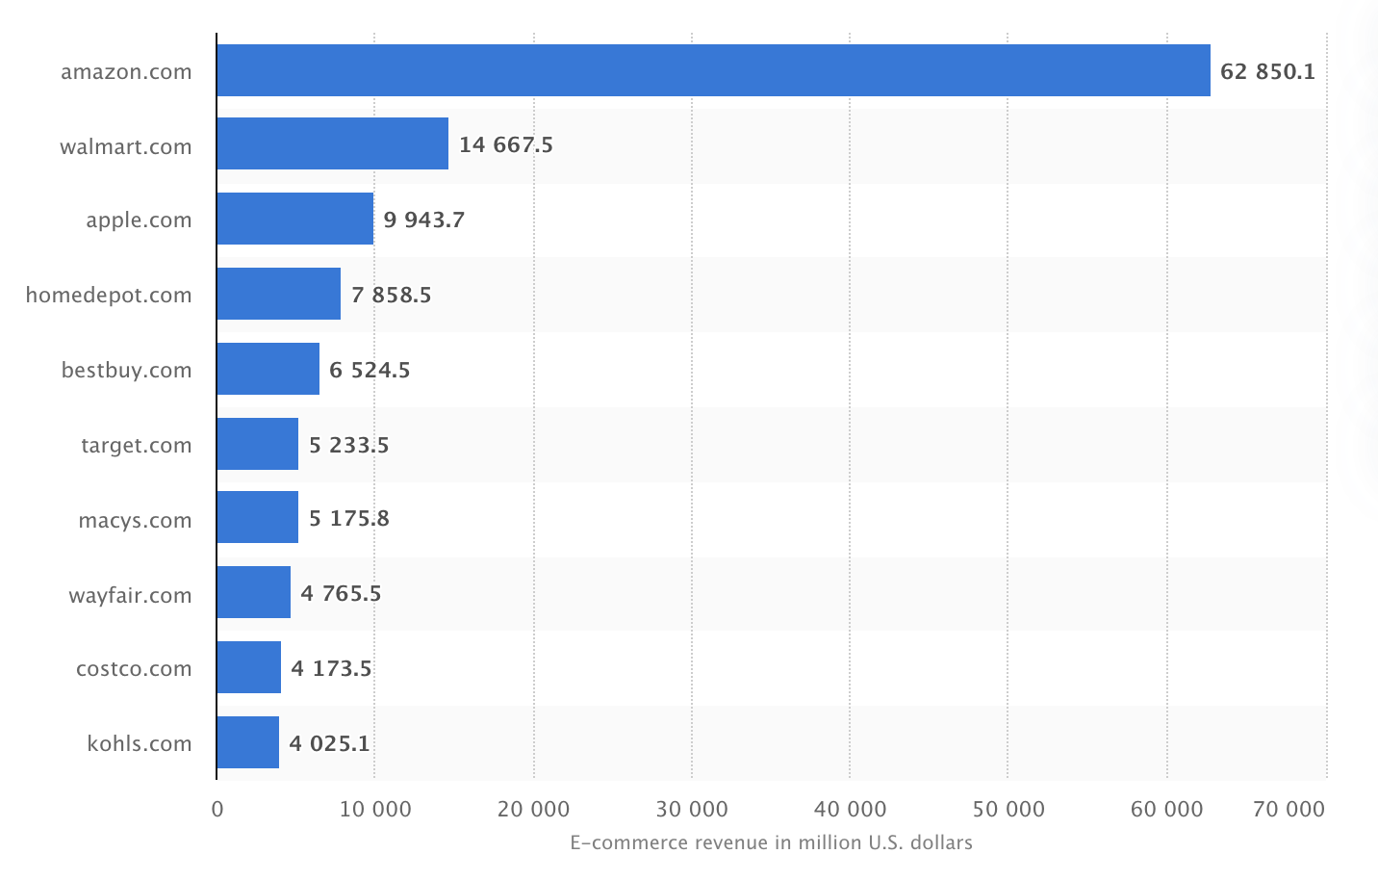
Figure – 1: Comparison of Amazon’s Revenue with other E-commerce Businesses (Source: Encyclopedia Britannica. 2021.)

As an ecommerce business Amazon has flourished immensely and has successfully managed its information and customers with much efficiency. The company believes in its customers and their skills in exploring the platform for finding what they need and want. Their success depends on both the technological boom and incorporation of Knowledge Management Principles (Learning Solutions Magazine. 2021.). Knowledge Management Principles and theories help the management in systematically managing ideas, knowledge, and information and to connect them with the customers (Laudon, et.al. 2014). Amazon has efficiently built the system for identifying, collecting, storing, and sharing the important information which would help the business and the customers for generating satisfactory results. The company deals with zillions of customers and their information with only “zigabytes”. This report explores the different knowledge management philosophies that have been used by Amazon for managing and dealing with their information. Organizational, ecological and techno-centric are the three segments of knowledge management which are used by Amazon for managing the information and its customers. This paper would elaborately discuss the needs of knowledge management for organizational success, different knowledge management processes with respect to the Amazon and suggest an integrated knowledge management framework for yielding organizational culture.

Knowledge Management - Amazon

Knowledge management means to accumulate, sort, and strategically use the knowledge of a group of people or other resources. In today’s business world, knowledge management means managing the database or portal where every real-time information of the company is being held (Easterby-Smith, et.al. 2003). The main purpose of the knowledge management is to increase the efficiency and productivity of a company and to collect, store and share relevant information and data for increasing the benefit of the company. This knowledge can be of any sort and is also based on the consumer’s information like perception, satisfaction and taste (KMWorld. 2021.). Many times, knowledge management refers to the training and learning of the employees of the business knowledge and its customers. In an Amazon, for managing the knowledge it builds a learning culture where people are willing to learn more and believe in sharing ideas and information. In this competitive environment, every business depends on collecting as much information as possible on its customers and managing them for generating satisfactory results (Laudon, et.al. 2014). Amazon collects and stores its information through electronic websites and databases and manages this knowledge carefully for managing millions of data. These data are used for making strategic decisions by the business.

The success of knowledge management depends on understanding the type of knowledge and using the proper way of managing and sharing that knowledge. Knowledge can be of two types - tacit and explicit knowledge (Okike, et.al. 2015). Tacit knowledge is more implied and harder to gather and share. Every manager and employee must be critical in thinking for understanding this knowledge and use this information while making decisions. Innovation and body language can be regarded as some of the tacit knowledge. Whereas explicit knowledge can be very easy to understand and can be inculcated in another human being. As for example - it is easy to teach employees how to use a specific software and how to make a sale. Even though the traditional definition of Knowledge Management only referred to the knowledge and learning of the company and managing it. Now it is specifically used in the context of using computer subsystems and databases for collecting, storing, and sharing information for producing higher efficiency and benefitting the business. Amazon tries to emphasize on both tacit and explicit knowledge for managing the knowledge of the company and for producing effective results.

Importance and Need of Knowledge Management (KM) - Amazon

The need and importance of knowledge management is manifold. In this new digital and globalized era, there is a myriad number of buyers and sellers. Thus, the competition is beyond imagination. Moreover, the needs and demands of customers have changed and as they have numerous options sustaining in this business world has become very difficult. Thus, Amazon contributes its concerted effort in collaborating all its parts and infusing knowledge management at every segments. Again, the different parts of the company are now disintegrated as we live in a world of globalization and many companies either have their businesses in different sectors of the world or their employees are dispersed in different remote places of the world. To manage this situation every Amazon tries to strategically collect, store, organize and share knowledge, ideas, and innovation for generating more efficient results. Effective knowledge management helps the company mold its own function with the requirements of the customers with very limited effort and the company is better equipped to meet the demands and needs of the customers. If the information is not at hand when required and is not shared at the right time, then its purpose becomes futile. Thus, KM helps an organization to effectively use the knowledge and information.

As the Amazon has been handling and managing its information and data effectively, its decision-making capacity increases manifolds which ultimately increases the productivity and efficiency of the company (Weber, 2010). Again, it is storing all the information properly and everyone related to the company has equal and appropriate access to the information. Thus, the employees can easily access the knowledge and use it as the new learning incentive (Lips, 2014). Every employee of Amazon can increase their excellence due to easy availability of knowledge and share his own knowledge effectively with others. This ultimately has led Amazon to a better learning environment and increase its efficiency.

From marketing to human resources every part of the business needs to understand and consider the perception of the customers for sustaining itself in the long run and effective knowledge management has made it easier for the companies. When an organization employs successful knowledge management, satisfaction and retention rate of the companies increase (management.simplicable.com. 2013.). This also helps in forming a collaborative learning business environment where people are more interested in sharing their ideas which ultimately leads to furnished and more successful ideas and innovation. Moreover, effective knowledge management leads to a better, improved, and optimized training process as the training structures and frameworks are decided only after collaborating all the information of the employees and their performances (Newell, et al. 2009). Thus, knowledge management is an effective and most desirable area of a company as this helps in generating a higher learning environment and effective use of information and data which ultimately generates higher profit.

Consumers Satisfaction and Competitive Edge Through Knowledge Management (KM)

Customers benefit from the new innovation Amazon as the new products and services are then better developed for satisfying them. Amazon believes that when the company is managing knowledge properly, everyone in the company would share ideas and knowledge which would result in higher innovation and thus higher customers’ satisfaction (Jones, 2001). The main reason for its success is the development of a robust database which is always updating the present information and is capable of generating effective business intelligence which helps the organization in decision making (Vala mis. 2021.). Amazon through its inbuilt software and systems have formed a bridge between customers and itself. This connection helps Amazon in developing their strategies and decisions which would best lure the customers.

Knowledge Management Models and Theories

Unprocessed data or information is of no use to a company. Companies use different processes for converting information into knowledge and these are regarded as knowledge management cycles. From the various options available the company must choose the most viable option for managing its knowledge for increasing efficiency and productivity. Some of the knowledge management models and theories are briefly discussed below:

SECI Model or Knowledge Management Spiral Model

The most used and helpful knowledge management model that is used by most of the organizations is the SECI model. It is very efficient in converting the tacit information into explicit company knowledge. Ikujiro Nonaka is known for his extensive contribution for establishing this model and he was the first one who pointed out that companies give more importance to explicit knowledge which deters effective knowledge management. In 1996, Nonaka and Takeuchi together introduced the SECI model for creating knowledge and transferring theories (O’Dell, et.al. 2011). They proposed four ways of converting and combining knowledge. These ways mainly refer to how knowledge is shared and created.

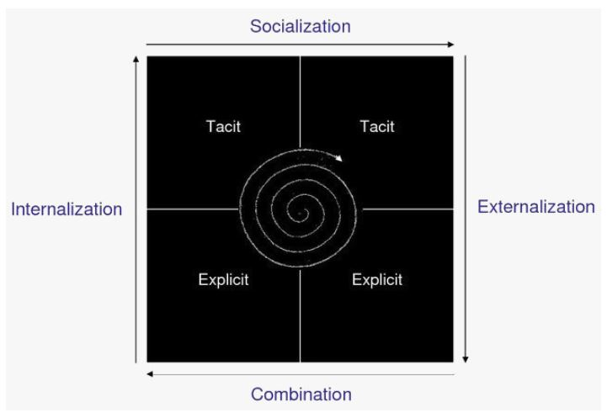
Figure - 2: SECI Model

Socializing: This method focuses on converting tacit knowledge to tacit. Through practice, guidance, observation and imitation one can transfer the tacit knowledge to another tacitly.

Externalization: Externalization is regarded as one of the challenging ways of transferring knowledge. Here tacit knowledge is transferred to explicit knowledge through accumulating the tacit knowledge into documents and texts. As tacit knowledge cannot be visualized, the extent to which it can be codified is contented. Metaphor can be a mechanism of this knowledge conversion.

Combination: This method focuses on the conversion of explicit knowledge to explicit. This is a rather easy form of conversion and codified documents are used for the conversion (Hajric, E., 2021.).

Internalization: This method converts the explicit source of knowledge into tacit knowledge. That is, the employees use the documents and other written forms of knowledge and internalize them to change their tacit form of knowledge (O’Dell, et.al. 2011).

Amazon can use this dynamic form of knowledge management to collaborate the socialization, externalization, internalization, and combination to create a better and improved knowledge management system inside the company. The biggest strength of this model is that it is continuously adapting to the need of the organization’s knowledge management process and is creating a learning environment. Amazon would be able to ensure the continuity through collaboration, practice, learning and interaction.

Von Krogh and Roos KM Model

Von Krogh and Ross Model have people to knowledge created through the minds of people and link between them. They have suggested a strategic framework solution for understanding and explaining knowledge management. Amazon can benefit from this model as it is established on special factors like knowledge employees, better communication skills, enterprise structure, network of workers and HR Management. This model is a cognitive system which strategically integrates these five factors for creating and converting the information (Sanchez, 2003).

Von Krogh and Roos founded their KM model in 1995. This model analyzes the aspects - the ways knowledge gets to the employees, the ways the knowledge arrives at the company, the meaning of the knowledge for both workers and organization and the barriers of organizational KM. Amazon can differentiate between social and individualistic knowledge with the help of this model.

WIIG’S KM Model

Amazon uses the Wiig’s Model for collecting, acquiring, organizing, and disseminating its knowledge. In 1993, Karl Wiig demonstrated one new model for managing knowledge which is based on the fact that knowledge and learning is not valuable unless it is organized and synchronized (The CloudTutorial. 2021.). The main dimensions of Wiig's model are - completeness, connectedness, congruence and perspective and purpose.

Completeness - This feature is based on the fact that knowledge must be complete and known. This aspect answers the question how much knowledge from a specific source is available. If no one knows about the availability of the knowledge, then it becomes meaningless to have that knowledge in the first place. Again, the knowledge must be complete. That form a single sour - whether it is from human bearings, or any other source, it is required all the knowledge has been accumulated.

Connectedness - This focuses on the connectivity of different knowledge objects. If the knowledge objects are well connected with each other it provides a strong base for the knowledge which introduces consistency for the knowledge.

Congruence - A knowledge base would be congruence when every knowledge objects, relations, perspectives, values, judgements, and other relevant aspects are clear and consistent. However, most knowledge bases do not portray such behavior. There would always be incongruity.

Perspective and Purpose - Human beings organize knowledge using the dual dimensions of perspective and purpose which results in a technique of knowing something from a specific point of view for a definite purpose.

Amazon uses this model for its strategic collaboration of different levels and stages for internalization of knowledge. This model can be regarded as a modified model of the fourth quadrant of the SECI model.

Complex Adaptive System Models

This model sees the organization as an adaptive, complex system and thus it learns and converts knowledge through adaptation and a complicated process. This sort of systems give rise to different entities and that ultimately results in complex adaptive phenomena due to their interactions. Due to the presence of some series of functions this model ensures the existence of any living entity and the organization itself in the model (Caruso, 2017). Through communication and control mechanisms the Intelligent Complex Adaptive System tries to understand, describe, and predict the feasible response of an organization during any situation. This model depends on the cybernetics principles. As the entities interact complexity arises, and the challenge is to extract the best outcome from the group of people when they are united. Amazon believes in teamwork and tries to empower its employees through decentralization. However, being a massive company, the number of groups are huge which evidently rises complexity. This model can help the company in coming to an evidence-based solution and decrease complexity.

How KM Models Can Help Amazon in Creating and Managing Knowledge

Collecting, organizing, and sharing information and data are performed by Amazon to sustain the business. Knowledge management has become the key responsibilities of the organization for generating revenue and for getting competitive edge. Amazon uses different software and databases for creating and converting for storing and sharing ideas, knowledge, and innovation. Thus, a learning environment is created in the whole company and this learning environment bolsters the sharing of every related knowledge among each member and entity of the business. As a well-established internet-based company, it is highly likely that Amazon receives numerous complaints from its customers. In ensuring that knowledge is shared amongst each member associated within Amazon a system of ensuring that all customer service representatives share knowledge with each other regarding how to handle complaints as well as reassuring the customers that their complaint is being handled speedily. In addition, employees should be equipped with manuals for appliances in the event a customer makes an enquiry.

For managing knowledge, the knowledge management model - WIIG Model helps Amazon for sustaining a learning environment and to promote sharing ideas and the correct knowledge. The WIIG’s Model is one of the most renowned knowledge management models which concretely defines the correct knowledge and how to collect and codify it. The four dimensions of Wiig’s KM model helps the organization to understand that integrity is more important in generating appropriate knowledge base and the strength of the base depends on the perspective and purpose. The internal framework or need of knowledge management depends on collecting, storing, and codifying the information that is available. However, Amazon can also use the SECI KM model as it is easier to understand and employ in the company management (atSpoke. 2021.). The SECI KM model can help Amazon in understanding the socializing, externalization, combination, and internalization aspects of the knowledge and help it to build a culture where through socialization and external knowledge the company members can accumulate, store, and share knowledge and internalize them for producing satisfactory results (Elcom.com.au. 2021.).

Amazon believes that for any company to flourish it is necessary to collect, process, retrieve, store and share information as much as possible and the correct knowledge must be accumulated for further processing. The company has been collaborating knowledge at every step of the work and uses a myriad of software and databases which integrates every correct and necessary information, and every member of the organization has access to the relevant information.

KM models specify the needs and frameworks needed to collect, store, process, present and use the knowledge for the successful operation of the company. Each old employee of Amazon gets to guide and mentor another newbie for sharing ideas and training him. Again, many companies use document management systems (Google Drive, Box etc.) for storing and sharing documents and information at a granular level. Some organizations use SlideShare or Bloomfire for content management. All these platforms allow Amazon to collect, organize and share information more effectively and thus generates higher revenue. As the companies like Google, Amazon, Microsoft, and many others are using effective digital platforms for collecting, collaborating, processing, organizing, and using knowledge, the companies become highly efficient and productive due to the mass availability of organized information (Elcom.com.au. 2021.). Storing the information and knowledge appropriately ensures that Amazon does not lose the valuable knowledge or information and it doesn't have to seek for the already existing knowledge. Improved and better knowledge management helps employees and the organization to get results sooner and use them with fewer mistakes.

KM Models used by Amazon

Amazon is the most successful online business. And it has achieved this business through incorporating the knowledge management principles, strategies, and models like Wiig’s model for connecting every information, organizing them, and then storing them for future use. The techniques used by Amazon are very helpful to collect, store, organize, retrieve, and use the knowledge for generating efficiency. The company uses one collaborative portal and interface through which everything is done by the customers (Learning Solutions Magazine. 2021.). Thus, this reduces complexity and helps in integrating every information. Again, the website and digital workplace exhibits consistency when it comes to content management. It helps the customer to better understand the specificity of each product and helps the database in accumulating, organizing, and storing customer related information. The company uses internal software for the employees of the company where each and every one can connect with another and can easily share ideas and innovation. Moreover, crowdsourcing, distributed upstream content section, modular content, easy presentation, user friendly interface, e-learning platform and robust database has helped Amazon to collect, organize, store, and use the knowledge across the company efficiently.

Main Outcomes from the used Techniques

Everyone is aware of the saying that knowledge is power. Knowledge refers to the intellectual assets of a company and Amazon has been successful in integrating all the intellectual assets of the company. Due to its KM strategies the company has increased customers satisfaction manifolds. The use of one portal and combined database has made it easier for the company to understand the needs of the customers and to increase its own efficiency profusely. Amazon has been providing e- learning platform for the employees which has increased the company’s productivity and has helped the company in garnering a learning environment. The customers have been facing an easy-to-use website for its service and the customer care provided by the company is up to the mark. However, due to the application of appropriate KM strategies the company’s performance has improved so much that the company has started facing lesser customer complaints (Learning Solutions Magazine. 2021.). Under Jeff Bezos guidance the company has shifted towards a more automated system over the last five years which has curtailed the number of the employees in the company. However, from 2020, the company has been successful in retaining its employees up to 96% (2021). Jeff Bezos has believed that a more automated system would help the company in better managing the information and would increase the efficiency of the business which seemed to be true as in COVID-19 the company has been the only retailer which could retain its rigor and has even hired employees for handling the workload (Learning Solutions Magazine. 2021.). Due to a more improved and automated system, the company tried to constrict its number of employees to more talented minds who would add value to the company and would be the organizational fit in increasing and sustaining a shared intelligence environment. Due to successful and commendable incorporation of KM strategies and techniques, Amazon Inc. has been successful in increasing customer’s satisfaction, innovation, employee retention rate and sustaining the business even in this pandemic.

Recommendations for Amazon

Amazon has been a successful retailer to a level that around 55% internet search begins through this website and people eventually end up buying products from this source. The company has been selling almost $120,000 worth of products every hour all over the world. Even in the COVID-19 this number did not decline rather increased. The company has done an incredible job handling this pandemic and turning the event in its favor. Every business is now trying to include the KM strategies undertaken by Amazon for increasing its sales and getting a higher market share. However, Jeff Bezos has been criticized since 2013 for its outrageous treatment towards employees and putting them under huge pressure for producing significant results. He believed that Amazon should not lower its level for the employees rather employees who are dedicated to fight for a larger cause and want to achieve more would be a part of this company and would be willing to work overnight if required. Moreover, socializing in the workplace is less appreciated and the company focuses on individual achievement. Even though all these have been criticized and looked down upon by the outside world, people are still joining the organization and the organization has been thriving (Engageemployee.com. 2021.). However, in this world of sharing and breeding knowledge, it is recommended that Amazon moves to a more integrated and socialized platform where employees are more interested in sharing ideas and innovation with each other even when not asked to. This would certainly mean a massive change for the company’s management and there even might be some resistance (as everyone tries to avoid changes), this would certainly bring employee satisfaction. A company should not lose employees as a leaving employee takes his knowledge and information with him. This is an irreparable loss for any company. Amazon has been able to create a strategic integrated knowledge management system where the absence of an employee does not pose that much of a threat, the loss of any individual must affect the company however infinitesimal it might be. Thus, Amazon should focus on this area for improving its employer brand and to sustain it for better knowledge management. In applying knowledge management to Amazon, current employees could show new employees a more effective way of sorting and assembling packages. This would in turn cause packages to be sorted and ready for collection for delivery in a more timely manner. In addition, workloadof would not seem overwhelming and any new employee or even current employees will have a sense of job satisfaction.

Conclusion

Knowledge management is the process where a company strategically employs methods and techniques to manage its knowledge for creating and increasing values. The main purpose is to form a learning environment where everyone in the company can obtain the required and correct information without any breach of privacy. Whenever a company is successful in forming a robust knowledge management system, the company witnesses better efficiency, productivity, customer satisfaction and employee retention rate. Amazon is one of such companies which has been successful in managing its knowledge and has developed a learning environment where people create and share ideas and knowledge for increasing efficiency of the company.

Reference

2021. [online] Available at: <https://www.seattletimes.com/business/amazon/amazons-turnover-rate-amid-pandemic-is-at-least-double-the-average-for-retail-and-warehousing-industries/>
[Accessed 10th April. 2021].

atSpoke. 2021. What is knowledge management, and why is it important? · atSpoke. [online] Available at: <https://www.atspoke.com/blog/knowledge-management/knowledge-management-importance/> [Accessed 10th April. 2021].

Bhatt, G., 2002. Management strategies for individual knowledge and organizational knowledge. Journal of Knowledge Management, 6(1), pp.31-39.

Easterby-Smith, M. and Lyles, M. A. (2003). The Blackwell Handbook of Organizational Learning and Knowledge Management. Malden, MA: Blackwell Pub.

Elcom.com.au. 2021. What is Knowledge Management and Why It's Important | elcom. [online] Available at: <https://www.elcom.com.au/resources/blog/what-is-knowledge-management-and-why-its-important> [Accessed 15th April. 2021].

Encyclopedia Britannica. 2021. Amazon.com | History & Facts. [online] Available at: <https://www.britannica.com/topic/Amazoncom> [Accessed 15th April 2021].

Engageemployee.com. 2021. How Amazon has damaged employer brand and capacity – Engage Employee. [online] Available at: https://engageemployee.com/how-amazon-has-damaged-employer-brand-and-capacity/ [Accessed 16th April 2021].

Getguru.com. 2021. What is Knowledge Management? Definitions, Types & Examples. [online] Available at: <https://www.getguru.com/reference/what-is-knowledge-management> [Accessed 16th April 2021].

Hajric, E., 2021. The SECI Model & Knowledge Conversion. [online] Knowledge-management-tools.net. Available at: <https://www.knowledge-management-tools.net/knowledge-conversion.php> [Accessed 18th April 2021].

Jones, B. (2001). Knowledge Capitalism. Oxford: Oxford University Press Pl.

KMWorld. 2021. What is KM? Knowledge Management Explained. [online] Available at: <https://www.kmworld.com/About/What_is_Knowledge_Management> [Accessed 18th April 2021].

Laudon, K., & Laudon, J. P. (2014). Management information systems: Managing the digital firm. Thirteenth edition. Pearson: London

Learning Solutions Magazine. 2021. The Knowledge Management Genius of Amazon.com. [online] Available at: <https://learningsolutionsmag.com/articles/1480/the-knowledge-management-genius-of-amazoncom> [Accessed 18th April 2021].

Learning Solutions Magazine. 2021. The Knowledge Management Genius of Amazon.com. [online] Available at: <https://learningsolutionsmag.com/articles/1480/the-knowledge-management-genius-of-amazoncom> ; [Accessed 19th April 2021].

Lilley, S. Lightfoot, G and Amaral, P. (2004) Representing organization: knowledge, management, and the information age. (Online) Oxford: Oxford University Press.

Lips, M. (2014). Transforming Government—by Default? In Society and the Internet (p. Society and the Internet, Chapter 12). Oxford University Press.

Mar Anna (2013). 7 Essential Knowledge Management Tools[online]. Available at https://management.simplicable.com/mana [Accessed 24th April 2021].

Newell, S. et al. (2009). Managing Knowledge Work and Innovation. 2nd ed. Basingstoke: Palgrave Macmillan.

Okike, E., & Mbero, Z. (2015). Information Technology (IT) Knowledge Management system stage model: A proposal for today's workplace. International Journal of Computer Science Issues (IJCSI), 12(5), 193-202.

Sanchez, R. (2003) Knowledge management and organizational competence. (Online) Oxford University Press: New York.

The CloudTutorial. 2021. Models of Knowledge Management (KM Models) Explained. [online] Available at: <https://www.thecloudtutorial.com/knowledge-management-models/> [Accessed 19th April 2021].

Valamis. 2021. What is Knowledge Management? Importance, Benefits, Examples. [online] Available at: <https://www.valamis.com/hub/knowledge-management> [Accessed 20th April 2021].

Weber, S. (2010). Sell on Amazon: A Guide to Amazon's Marketplace, Seller Central, and Fulfillment by Amazon Programs (Seventh Edition) SAGE.p : 33 – 37

