

BMHP5014
CHANGEMAKERS:Creativity and value creativity

Student Name: Samina Bibi

Student Number:2412887

Component 1: Portfolio Exercises Template

Lecturer: Parese Ahmed

Task 1 – Concept Map

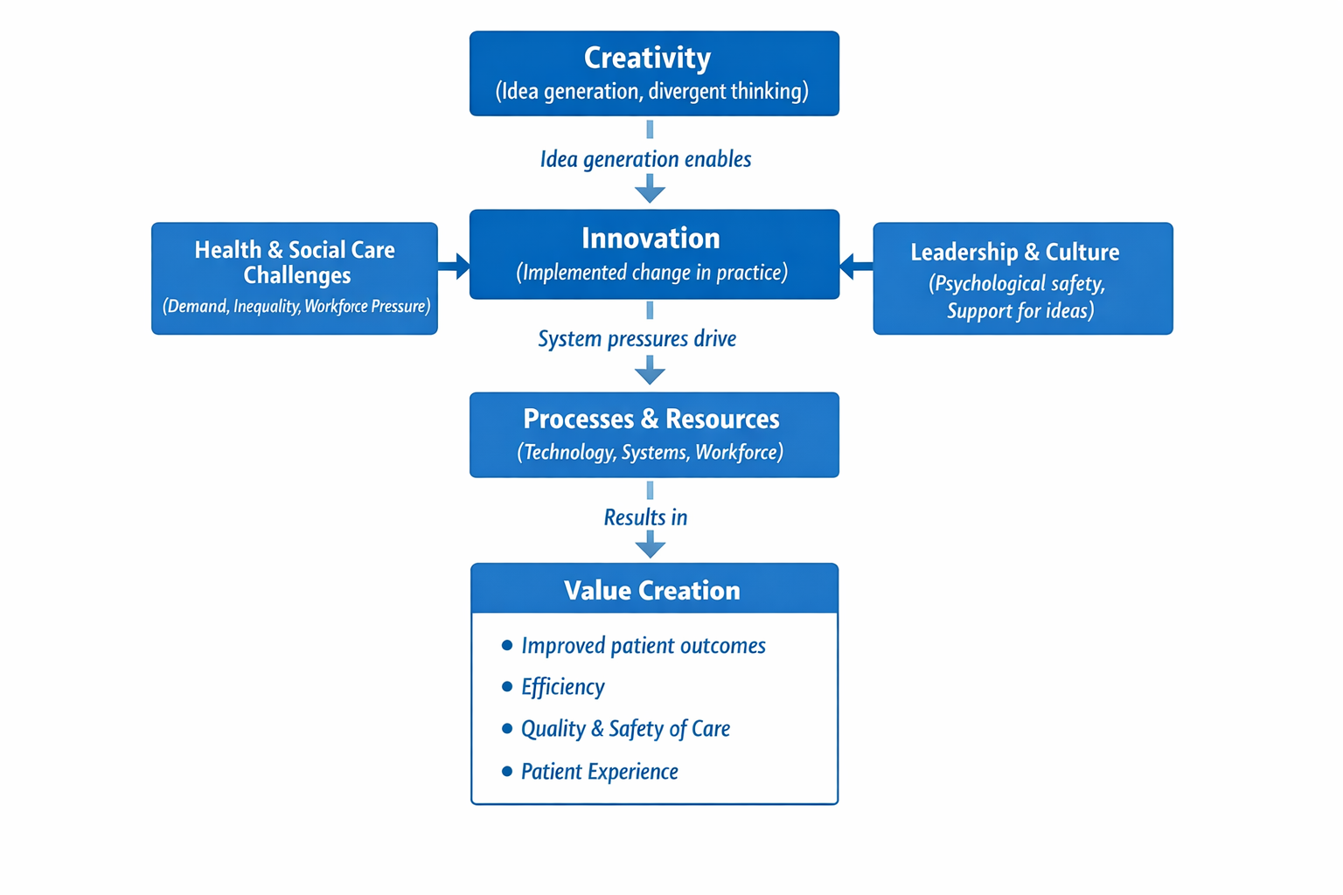
Figure 1: Concept map illustrating the relationship between creativity, innovation and value creation in health and social care.

Creativity and innovation are two different notions in close relationship in health and social care (Sawyer and Henriksen, 2024). Creativity is the act of generating novel ideas, thinking, or points of view by divergent thinking, and innovation is the act of putting these ideas into practice to make a meaningful change. Creativity is no longer effective, as shown in Figure 1, when there is no conversion to innovation, which is applicable in the actual health and social care context.
System pressures in health and social care, including rising service demand, health disparities, and labour shortages, can also lead to innovation. These problems result in the necessity of new approaches to work and prompt organisations to find innovative solutions to complicated issues. Nevertheless, leadership and organisational culture are highly important to the successful transformation of creative ideas into innovation. Positive leadership that empowers a sense of psychological safety allows personnel to contribute ideas, take risks, and cooperate, maintaining creativity and innovation.

Innovation should be sustained once initiated with proper mechanisms and resources, such as technology, organised systems, and a talented workforce. These factors guarantee the introduction of new ideas, testing, and operating them as a part of a daily routine. Innovation may not have a long-term effect without proper processes and resources.

Measurements of the value creation in the health and social care can be evaluated in measurable terms to include shorter waiting times, better patient satisfaction, higher efficiency, and less administrative workload.

Task 2 - Self-Reflection of Group Activity

I used the Reflective Cycle by Gibbs to discuss the paperclip activity done in class. We discussed the concept of creativity and its practical implications in health and social care (Galli and New., 2022). Creativity is becoming more relevant in solving complicated challenges like increasing demand for services, shortage of resources, and workforce pressure.

Description:

My group was required to find out the most possible creative applications of a paperclip in terms of both convergent and divergent thinking. In the beginning we concentrated on divergent thinking, generating as many ideas as possible without considering their usefulness. Before, I perceived creativity as an unstructured and informal process as I was studying or practising. The innovative ideas were raised and shared among the group. This free-flowing style allowed for innovation and made the group open minded to share their ideas openly and without fear but without further development or exploitation.

Feelings:

As the exercise continued to the convergent thinking phase, the group was narrowing down ideas and choosing the most realistic. At first, I was reluctant to share ideas because I was not sure whether they were practical, time-based, or how other people would accept them. This, at times, diminished my self-esteem and desire to contribute imaginatively.

Evaluation:

This module has enabled me to appreciate the fact that creativity does not just entail individual ideas, but it entails collaborative thinking, which is facilitated by leadership and organisational culture. In the class activity different people contributed in different ways, some used a convergent and some divergent thinking strategies. Innovation can be developed with the help of psychological safety in teams. As a result of this activity, I gained a better understanding of how divergent and convergent thinking intersect in the process of innovation. I came to realise that during the task i was more of a convergent thinker.

Analysis:

According to the literature, innovation can be developed out of creativity, if it is backed up by leadership and formal procedures in health and social care. This has enabled me to see the reason why certain creative ideas do not develop without organisational support. Within our activity i made a few different items with the paperclip such as a tool for cleaning small crevices, organising wires and bank notes and even to fix glasses and to use as a tiny screwdriver, a toothpick and also as a bra strap etc. So, it seems that there can be many uses found in even the smallest of everyday items. All what is needed is a little creativity and teamwork.

Conclusion and Action Plan:

I will in future become a participant in the team discussions and invite others to do the same in future practice, as i came to realise that i work very well in a team and i am a convergent thinker and like to lead in a team and offer many different ideas that contribute to the team using structured methods, i.e., brainstorming and reflective discussion. I will assist in boosting creativity and enhancing the service delivery. On balance this exercise demonstrated the role of teamwork, reflection, and flexibility in the process of coming up with creative but practical solutions in the domain of healthcare.

Task 3 - Case Study of a UK innovation

Innovation and creativity are important to tackle complicated problems in health and social care. One such vivid case is the creation of the NHS App, which illustrates the way in which creative thought can be translated into innovative practice to enhance the service delivery and patient experience (Bate and Robert, 2023).
It was created with the NHS after the primary care services began to feel pressures such as the growth of patients, excessive administration, and the scarcity of appointments. The old system made the patients make calls to the GP practices in order to perform activities like booking appointments or requesting repeat prescriptions, which burdened the staff and minimised efficiency. A creative input was required to rethink the way patients received healthcare services.
This innovation was made by introducing a digital platform, which enables patients to receive various services under a single roof. Using the NHS App, the user can make appointments, order repeat prescriptions, access medical records, and get health information online (Alturkistani et al., 2023). This innovation is the manifestation of the creative approach in the redesign of patient pathways based on technology that made the services more accessible and effective.
This innovation has created value in several spheres. To patients, the app enhances access to services, makes them more convenient, and encourages patients to become more engaged in self-care. In the case of the health care professionals, it saves administrative workload, enabling the employees to spend more time on direct patient care. In system terms, the NHS App provides efficiency and sustainability through the streamlining of processes and unnecessary appointments and phone calls.
Nevertheless, the process of so-called innovation implementation also reveals some significant issues. Digital exclusion is also a major concern, especially among the elderly, those who are digitally illiterate, or who may lack access to smartphones or the internet. To curb this, there should be other access points and support networks that are available to achieve equity of care (citation).

As evidenced in this case study, creativity is not enough to enhance health and social care +
services. To successfully implement the innovation, it must have supportive leadership and some resources, and the right process to do so. When such components are harmonised, innovations may turn creative ideas into innovations generating quantifiable value to the patients, staff, and the health system in general.

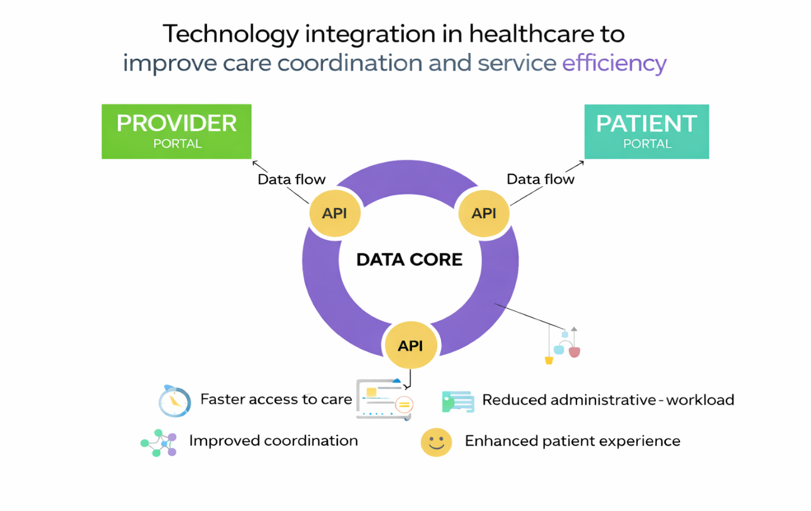

Figure 2: Digital innovation supporting patient–provider communication in health care.

Task 4 - Research Task

The socioeconomic and systemic support of inequality and the different utilisation of health and social care services are strong factors that influences access to health and social care services.
Chelak and Chakole (2023) note that socioeconomic status, education, employment, and living conditions are the main social determinants influencing health equity. People from lower socioeconomic backgrounds usually have problems with travel, affordable housing, food, and reliable jobs, complicating access to health services. These social determinants interact to produce enduring disabilities in care utilization and lead to lower health outcomes in disadvantaged groups (Mudd et al., 2024).
Also, the study of barriers to healthcare access has repeatedly demonstrated that complexity in healthcare systems and structural barriers may restrict the capacity of people to seek and obtain timely care. Among these are low health literacy, challenges in booking appointments and referrals, language and cultural barriers, and bureaucracy that discourage contact with care. According to Combs et al. (2022), the barriers are heightened in groups of the population that are marginalised, including older adults, minor ethnic groups, and individuals with lower education levels, which leads to unequal access and use of the healthcare services.
Both sources prove that access barriers are complex and work individually, at a community level, and at a system level. The socioeconomic disadvantage not only limits the possibilities of where and when people could receive care but also the interpretation and use of health services. These problems are further complicated by system complexity and barriers to communication that confuse and lead to an unwillingness to seek care options. Consequently, the disadvantaged people have a higher chance of having unmet health needs, late treatment, and worse health outcomes than more advantaged populations (Mudd et al., 2024).
These barriers necessitate an all-encompassing intervention beyond clinical care. Among the strategies are poverty reduction and education policies, efforts to ease healthcare navigation, culturally competent health promotion, and specific support of digital inclusion. Health and social care systems can pursue more equitable, accessible, and effective service delivery to all by addressing both social and systemic determinants.

Task 5 – Podcast

This podcast is proposing a new concept that is supposed to enhance access to primary healthcare.

Task 6 - NHS Leadership Framework Analysis

Part A: Overview of the NHS Leadership Framework

Creativity, innovation, and continuous improvement in health and social care require effective leadership to support them. The recent NHS leadership policy focuses on inclusive, caring, and evidence-based leadership to mitigate growing demands in service and achieve better results (NHS England, 2022). The NHS England leadership style, as articulated in the new NHS people and leadership frameworks, emphasizes the need to involve teams, relying on evidence to inform the decision, and assessing the effects of leadership practices on service provision.
One of the main aspects of modern NHS leadership models is the necessity of leaders to facilitate innovation and be accountable for performance supervision. The leaders are advised to measure results based on quantifiable measurements like patient experience feedback, staff engagement rates, service efficiency, waiting time, and quality-of-care measures. This makes sure that innovative ideas are not just encouraged but are followed and reviewed in a systematic manner (Benjamin and Chung, 2022).
The NHS leadership model encourages a culture of improvement by connecting the behaviours of leaders to quantifiable results. Creativity is perceived as a group process aided by leadership, and innovation is evaluated based on its contribution to quality, safety, and efficiency. The practice will guarantee that leadership choices are coordinated to organisational objectives and lead to visible changes in health and social care services.

Part B: Application to Practice – Engaging the Team

Engaging the team is one of the key leadership behaviours in the NHS leadership framework, as it is central to promoting creativity and innovation (Benjamin and Chung, 2022). Leaders who provide psychologically safe working conditions will promote staff sharing ideas, questioning the current practices, and joining service improvement efforts. The collaborative model makes it more probable that innovative ideas will be converted into viable innovations.
In terms of measurement, the team involvement could be measured by the indicators of staff engagement survey outcomes, the percentage of participation in improvement projects, staff retention rates, and rates of sickness absence (Benjamin and Chung, 2022). Enhanced interaction is usually linked with increased output, less burnout, and improved patient outcomes. Through these indicators, leaders can evaluate how their leadership style is facilitating innovation and service delivery.
In general, team involvement makes creativity turn into an innovation that leads to quantifiable increases in efficiency, quality of care, and patient experience.

Task 7 - Self-Reflection Journal Entry

This module has thoroughly equipped me with knowledge of creativity, innovation, and leadership in health and social care. My first thought of creativity was the generation of ideas, which were usually loose and unappreciable. Having worked on the portfolio tasks, I have come to appreciate creativity as a disciplined and participatory process that should be facilitated by the leadership and evaluated by quantifiable results to attain sustainable innovation.

Indicators that have been noted by my learning to relate to innovation in health and social care are patient experience, service efficiency, staff engagement, and quality-of-care outcomes. The case study and research work revealed that effective systems and relevant measures are the only way that creative ideas result in value creation. This has changed my thinking of looking at innovation as a one-time change to a continuous improvement, which must be monitored and reviewed.

My work in the future will involve the implementation of this learning through providing ideas within a team environment and helping others to do so. I will also promote the application of systematic methods, i.e., reflective conversation and service review, to determine whether innovations provide measurable enhancements. In general, this module has empowered me to connect creativity and leadership to the evidence-based improvement and outcome-oriented practice in health and social care.
Reference List
Alturkistani, A., Greenfield, G., Beaney, T., Norton, J., and Costelloe, C.E., 2023. Cross-sectional analyses of online appointment booking and repeat prescription ordering user characteristics in general practices of England in the years 2018–2020. BMJ open, 13(10), p.e068627.
Bate, P. and Robert, G., 2023. Bringing user experience to healthcare improvement: the concepts, methods and practices of experience-based design. CRC Press.
Benjamin, C. and Chung, D., 2022. Leadership practices and behaviours that enable and inhibit a continuous improvement culture in an NHS trust. BMJ leader, 7(2), pp.117-121.
Coombs, N.C., Campbell, D.G., and Caringi, J., 2022. A qualitative study of rural healthcare providers’ views of social, cultural, and programmatic barriers to healthcare access. BMC Health Services Research, 22(1), p.438.
Chelak, K. and Chakole, S., 2023. The role of social determinants of health in promoting health equality: a narrative review. Cureus, 15(1).
Galli, F. and New, K.J., 2022. Gibbs’ cycle review. Emotions as a part of the cycle. E-Motion: Revista de Educación, Motricidad e Investigación, (19), pp.92-101
Mudd, A.L., Bal, M., Verra, S.E., Poelman, M.P., de Wit, J. and Kamphuis, C.B., 2024. The current state of complex systems research on socioeconomic inequalities in health and health behaviour—a systematic scoping review. International Journal of Behavioural Nutrition and Physical Activity, 21(1), p.13.
NHS England. (2022). Developing people – improving care: NHS leadership and people development. NHS England. Available at: https://www.england.nhs.uk/people
Sawyer, R.K. and Henriksen, D., 2024. Explaining creativity: The science of human innovation. Oxford University Press.

