Exploring the relationship between Sensation Seeking and the likelihood of engaging in risky driving behaviours.
Demi Easter
University of Wales Trinity Saint David

Abstract

Risky Driving causes a lot of problems for drivers, including the risk of collisions and the possibility of fines. The aim of this report is to explore whether there is a link/relationship between Sensation Seeking and Risky Driving Behaviours. A Pearson’s Correlation Coefficient was carried for the initial hypothesis to be tested. This study used 26 participants from a Psychology Research Methods Module. It was found, using this test, that there was no present relationship between the two variables in this group of participants. This meant that people who scored high for sensation seeking, using the Brief Sensation Seeking Scale (BSSS; Stephenson, Hoyle, Slater & Palmgreen, 2003), did not seem to engage in risky driving. Possibilities for future research, in this area, are also discussed.

Introduction
In this report it will be examined whether there is a relationship/link between Sensation Seeking and risky driving behaviour. Sensation Seeking, as defined by Arnett (1994) and Zuckerman (1990), is considered a personality trait which involves the degree one desire intense and novel stimuli. Risky driving behaviour be defined, according to Ulleberg and Rundmo (2003), as behaviour that could have the chance of a negative outcome on the individual’s health and could also result in negative outcome for others also. Impulsivity is also a trait associated with risk-taking. Impulsiveness in concept is nearly the same as sensation seeking but instead deals with a person’s control over their own behaviour (Barrett, 1972). These behaviours can include speeding and not using a seat belt.
From a literature review, results show that, in a report by Dahlen et al (2005) using different scales to measure whether there was a relationship between risky driving behaviour and sensation seeking. This study used 224 undergraduate psychology students who volunteered to take part. The aim of this study was to see if driving anger impulsiveness and sensation seeking as well as boredom influenced unsafe driving. Result show that participant feedback from the Driving anger scale (DAS) and the Arnett inventory of sensation seeking (AISS) were unrelated, meaning there was no correlation present. However, from the results the researchers found that impulsivity and sensation seeking were positively correlated to each other.
Another piece of literature review was a report by Ulleberg and Rundmo (2003). This piece of work looked at attitudes and perceptions of young drivers as an indicator of any risky driving behaviour and relied on participants self-completing questionnaires. The study used 1932 Norwegian adolescents. The study found that anxious people who perceived traffic risks as high were more likely to report risky driving. Those who scored high for sensation seeking were less likely to see the risks of traffic accidents and these individuals reported that they had a higher chance of displaying risky driving behaviours. Overall, these researchers concluded that the higher the score on sensation seeking the more likely the individuals were to be associated with risk-taking behaviours displayed in traffic.
Other literature, such as a review by Jonah (1997), examines a range of studies which explored the topics of sensation seeking, impulsiveness and risky driving behaviour. The results of around 18 studies relating sensation seeking and risky driving, many of them have shown that there is a positive relationship between the two. Overall, the researcher identified a range of other relationships such as individuals who score higher in sensation seeking were had a higher chance to commit traffic violations and they had a higher percentage to be involved in collisions. Results also show that individuals acknowledge their driving behaviours are risky, they still carry it out to fuel the thrill of sensation seeking.
Overall, the literature shows that there is evidence that a relationship/link exists between sensation seeking and risky driving. Based on the literature reviewed above, the hypothesis for this study will be that there will be a strong relationship between sensation seeking and risky driving behaviours.

Method
Participants
There were 26 participants in total in this study. There were five males and 21 females. The participants were recruited using opportunity sampling and were recruited from a Research Methods Module class. The age range was 18 to 60. The mean age was 27.58 (M=27.58). The standard deviation was 11.13 (SD=11.13). Two of the participants do not own a full driving license.
Design
The design of this study was a Within subject design. The test used Pearson’s Correlation Coefficient. The variable involved were Sensation Seeking and Risky Driving Behaviours. The cause and effect cannot be determined in this study. The questionnaires were answered online.
Materials
A Risky Driving Behaviour questionnaire (Ivers et al, 2009) was provided to participants online (See Appendix A). Participants had to use a rating scale, to describe how often they carried out the behaviour (4=Very often, 3=Often, 2=Sometimes, 1=Hardly ever, 0=Never). The questionnaire consisted of statements such as ‘Drive with 2 or more passengers’, ‘Race or drag race for the fun of it’ etc. The score range of this questionnaire is 0-56 and participants who score higher show they had a higher chance being involved in risky driving behaviours. The other questionnaire that was used is the Brief Sensation Seeking Scale (BSSS; Stephenson, Hoyle, Slater & Palmgreen, 2003) was provided to participants after the first questionnaire (See Appendix B). Participants also had to use a scale on how much they agreed to statements on sensation seeking (1=Strongly disagree, 2=Disagree, 3=Neither disagree nor agree, 4=Agree, 5=Strongly agree). Statements include ‘I would like to explore strange places’ and ‘I like wild parties’. Scores range from 8 to 40 with high scores being more likely to have sensation seeking tendencies.
Procedure
Participants were provided with an email containing a link to the questionnaires as this was an online study. Firstly, participants were provided with an information and consent form which they had to consent to for them to take part in the study (See Appendix C). Participants were them asked to fill in a demographic information sheet before the study began (See Appendix D). Once this was completed, the participants were immediately provided with the Risky Driving Behaviour questionnaire (Ivers et al, 2009) with the frequency to which they carried out the presented statements. Once their answers were submitted, the next questionnaire was presented straight after. The Brief Sensation Seeking Scale (BSSS; Stephenson, Hoyle, Slater & Palmgreen, 2003) required participants to rate how strongly they agreed with the statement provided. Once their answers had been recorded, participants were finally provided with a debrief form (See Appendix E) which explained the aims of the study and provided them with information on how to withdraw from the study if they wished. The debrief sheet contained the final submission button.

Results
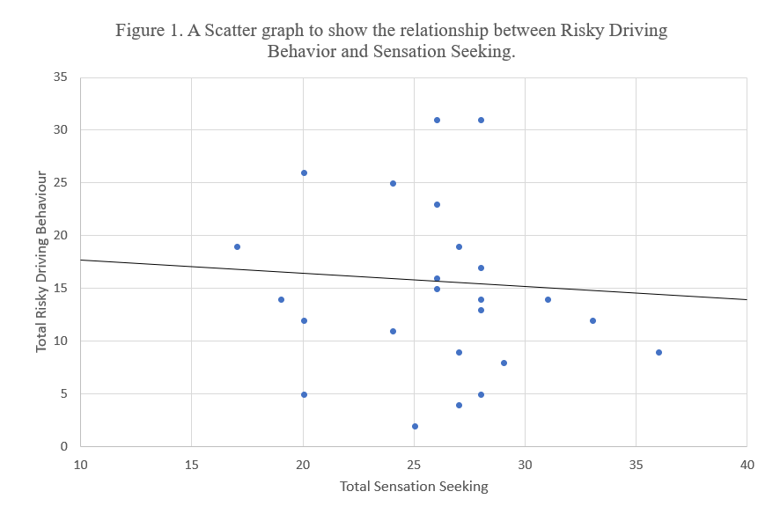
The relationship between Sensation Seeking (X) and Risky Driving Behaviour (Y) was investigated using the Pearson product-moment correlation coefficient. The results show, Risky Driving Behaviour (M=14.58, SD=7.89) and Sensation Seeking (M=25.88, SD=4.49). This means that the results are non-significant as there is a weak negative correlation between the two variables, r=-.076, n=26, p>.05. This means that, in this study, it is highly unlikely that the two variables are related as the p value is greater than .05. These results mean that the original hypothesis that there would be a strong relationship between sensation seeking and risky driving behaviours needs to be rejected.

Discussion
The outcome of this study means that the original hypothesis must be rejected in accordance with the results. The original hypothesis was not supported by most of the literature reviewed. Based on the results of this study there does not appear to be a relationship between sensation seeking and risky driving behaviour. The results of this study do not necessarily mean that there is no link between the two variables, as many studies, as shown in the literature review, have found evidence that a relationship between them exists. However, the results are supported by the study conducted by Dalen et al (2005), whose results found that there is no correlation/relationship between sensation seeking and risky driving behaviour. Although, the researchers did find sensation seeking and impulsivity to be related. The study by Ulleberg and Rundmo (2003) found that people who engaged in risk taking behaviour in traffic scored higher for sensation seeking tendencies. This is one of the many studies which support the initial hypothesis.
In conclusion, this study concluded that there is likely no relationship between Sensation Seeking and Risky Driving Behaviours. A possible limitation of this study could include the number of the participants taking part. As only 26 participants took part, it may be hard to generalise the results. Perhaps if more participants took part in the study, the results may have been significantly different. Dalen et al (2005) used 224 participants in their study and found that there was a significant relationship between the two variables. A high number of participants could be a possibility for future research in this topic. Furthermore, two participants did not hold a full driving license and their data was included in the results. Ulleberg and Rundmo (2003) only used the data for those who did hold a full license in their study. Maybe, only using participants with a driving license combined with a potential larger sample, in this report, would have found that the two variables are related.
A possibility for future research is to include a person’s personality in the findings as this could have an impact on whether a person would take part in risky driving behaviours. Ulleberg and Rundmo (2003) used this in their study and found aggression was indirectly linked to risk taking in traffic. Perhaps a larger amount of research is needed in this topic as not all studies support the initial hypothesis, but many reports, e.g. Jonah, 1997, have concluded that sensation seeking is likely to be related to risky driving behaviours.

References

Dahlen, E.R., Martin, R.C., Ragan, K & Kuhlman, M.M. (2005). Driving anger, sensation seeking, impulsiveness, and boredom proneness in the prediction of unsafe driving. Elsevier Ltd. doi: 10.1016/j.aap.2004.10.006
Jonah, B.A. (1997). Sensation Seeking and Risky Driving: A review and synthesis of the literature. vol 29, no. 5, pp. 651-665. Elsevier Science Ltd. PII: S0001-4575(97)00017-1
Ulleberg, P. & Rundmo, T. (2003). Personality, attitudes and risk perception as predictors of risky driving behaviour among young drivers. Elsevier Science Ltd. PII: S0925-7535(01)00077-7

Appendices

Appendix A
Risky Driving Behaviour
Ivers, R., Senserrick, T., Boufous, S., Stevenson, M., Chen, H-Y., Woodward, M., … & Norton, R. (2009). Novice drivers’ risky driving behaviour, risk perception, and crash risk: Findings from the DRIVE study. American Journal of Public Health, 99(9), 1638-1644.
Please respond to the statements below as honestly as possible, using the rating scales as follows:
Very Often Often Sometimes Hardly Ever Never
1. Drive with 2 or more passengers
2. Drive while listening to loud music
3. Drive about 50mph in a 40mph zone
4. Drive fast just for the thrill of it
5. Follow very closely behind slow drivers
6. Speed up if someone is trying to pass
7. Take some risks when driving because it makes driving more fun
8. Make rude gestures at other drivers
9. Honk your horn or flash your lights in anger at other drivers
10. Do burnouts, donuts, or skids just for the fun of it
11. Race or drag race for the fun of it
12. Drive while using SMS on a mobile phone
13. Drive while talking on a mobile phone
14. Drive without wearing a seatbelt
Scoring key:
Very often = 4 Often = 3 Sometimes = 2 Hardly ever = 1 Never = 0

Range 0-56 with higher scores indicating greater likelihood of engaging in risky driving behaviours

Appendix B
Brief Sensation Seeking Scale (BSSS)
Stephenson, M. T., Hoyle, R. H., Slater, M. D., & Palmgreen, P. (2003). Brief measures of sensation seeking for screening and large-scale surveys. Drug and Alcohol Dependency, 72, 279-286.

Please respond to the statements below about how you generally feel about yourself, using the rating scale as follows:
Strongly disagree Disagree Neither disagree nor agree Agree Strongly agree

- I would like to explore strange places
- I would like to take off on a trip with no pre-planned routes or timetables
- I like to do frightening things
- I would like to try parachute-jumping
- I like wild parties
- I like new and exciting experiences, even if I have to break the rules
- I get restless when I spend too much time at home
- I prefer friends who are excitingly unpredictable

Scoring key:
Strongly disagree = 1
Disagree = 2
Neither disagree nor agree = 3
Agree = 4
Strongly agree = 5

Range of scores between 8 and 40. Higher scores indicated greater sensation seeking tendencies.

Appendix C
Study information and consent

I understand that taking part in this research survey will involve me answering two short questionnaires regarding my driving behaviour.
I understand that participating in this study is entirely voluntary and I am free to withdraw my participation at any time by closing the browser screen. I am aware that if I have concerns about the study that I can contact the principal researcher via the details below following completion of the study.
I understand that the information provided by my will be used for the purpose of providing data for analysis, but that this data will be held confidentially and anonymously, with a code assigned in place of my name. These data will be stored in accordance with the Data Protection Act.
I also understand that at the end of the study I will be provided with debrief information outlining the full nature of the study. I will also have the opportunity to contact the researcher with any questions I may have.

Researcher details:
Miss Stacey Coleman
stacey.coleman@uwtsd.ac.uk

I have read and understood the information provided above
- Yes
- No

I consent to taking part in this study
- Yes
- No

Appendix D
Demographic information

- Please state your gender:
- Male
- Female
- Other
- Prefer not to say

- Please state your age:
______________

- What type of driving license do you have?
- Provisional driving license
- Full driving license
- No license

Q4 dependent on response to Q3 – if ‘no licence’ this question is not displayed

4. Do you drive regularly? (i.e., at least 2 to 3 times a week)
- Yes
- No

Appendix E
Debrief information

Thank you for taking part in this study.
The main aim of this study was to explore whether there is a relationship between levels of sensation seeking and the likelihood of engaging in risky driving behaviours. It was specifically hypothesised that higher levels of sensation seeking would be related to a greater likelihood of engagement in risky driving behaviours.
If you wish to withdraw your data from the study you must email the researcher now. Once you submit this form, all of your data will remain confidential and it will not be able to be traced back to you.
Researcher details:
Miss Stacey Coleman
stacey.coleman@uwtsd.ac.uk

Please click the button below to submit your answers

- SUBMIT

SPSS Outputs


