Project Title: Developing and Managing a Cloud-Based Smart Energy Monitoring
System: A Project Management, Innovation
Module Code: ACCA5033
Taishee Khan
2133060
Contents
Introduction 3
Task 1: Project Management 3
Question 1: Project Management and Planning 3
Project Scope and Resources 3
Project Schedule and Timeline 4
Development Method 4
Project Constraints 4
Question 2: Project Design 5
Task 2: Enterprise and Innovation 6
Q1. PEST and SWOT Analysis for a Tech Company – Tesla Inc. 6
Political 6
Economic 6
Social 7
Technological 7
Ethics and legal aspects 7
SWOT Analysis 7
Q2. Proposed Tech Start-up: “EcoWatt Analytics Ltd.” 8
Type of Business and legal classification: 8
Mission & Vision: 9
Logo and Brand Identity: 9
Business Strategy: 9
Market Opportunities: 9
Funding Initiatives: 10
Legal and Ethical Compliance: 10
Task 3: Project Reflection 10
Skill Development and Professional Growth 10
Societal Impact and Contribution 11
Risks and Mitigation Strategies 11
Conclusion 12
References 13

Introduction
This report examines the growth and business opportunity of a Cloud-Based Smart Energy Monitoring System, which is a project that aims to enhance the efficient use of energy and sustainable use of practices by means of digital innovation. The project adopts a hybrid Agile-Waterfall approach since the approach stresses formal delivery and iterative feedback, which are efficient and flexible. In addition, the elements of enterprise and innovation are assessed under the PEST and SWOT analysis, that is, considering the dynamic external and internal forces of the technology industry. EcoWatt Analytics Ltd. is the proposed start-up that can be discussed as the practical application of the given project, with the possibility to realise the technical ideas as business projects. Finally, reflective insights explain professional growth, contribution to society, and reduction of risks and how personal growth contributes to sustainability objectives and future directions of innovation.

Task 1: Project Management

Question 1: Project Management and Planning
The suggested Cloud-Based Smart Energy Monitoring System will enable households and small businesses to track, interpret, and optimise energy consumption in real-time with the help of cloud computing and IoT technology. This project aims to provide a smart, data-driven dashboard which is able to visualise energy consumption, address wastage, and encourage sustainable behaviour. This initiative is in line with the trends in the world toward renewable energy and the development of a smart city [1].

Project Scope and Resources
The project scope involves the requirement analysis, system and database design, development, cloud integration, testing and deployment. The result will be a viable prototype that has predictive analytics and intelligent energy. Such core technologies as Python (Flask) to develop the back-end programs, React.js to develop the front-end interface, MySQL to manage the databases and AWS Cloud to host them are used. The project resources include the following: Project Manager, Backend Developer, Frontend Developer, UI/UX Designer, Database Administrator, Cloud Engineer, and QA Engineer.

Project Schedule and Timeline
The 10-week project is configured in a hierarchical structure based on milestones with a meticulous order and allocations of resources created in Microsoft Project.
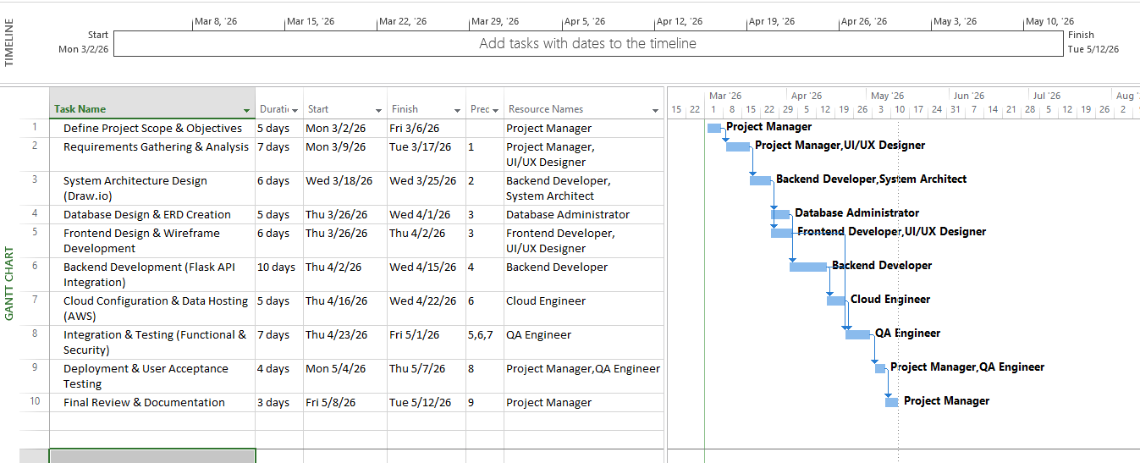
Figure 1: Gantt Chart

Development Method
An iterative Agile/Waterfall strategy is followed with the implementation of the structured planning of the Waterfall and Agile iterativeness. This framework contributes to greater efficiency and stakeholder cooperation as well as dynamic technical environment flexibility [2], [3]. It enables nonstop feedback in the design and testing period, which ensures quality and on-time delivery [4].

Project Constraints
There are several major limitations on the project that could affect its implementation and performance. To start with, time is of the essence since the system would have to be accomplished within a limited time frame of 10 weeks, where strict observation of milestones and effective task sequencing need to be followed. Secondly, budget constraints impair development resources, use of cloud services and possible procurement of hardware, hence affordable decision-making is required. Thirdly, technical limitations comprise compatibility between IoT devices and cloud and backend systems, which can impact the integration efficiency. Lastly, regulatory and data protection factors and fines, such as GDPR compliance and data security, need limitations to operations, which should be well-controlled during development.

Question 2: Project Design
The following Structure Diagram, created with the help of Draw.io, as shown in Figure 2, depicts the structure of the Cloud-Based Smart Energy Monitoring System. This architecture typifies the way in which the hardware and computer programs communicate to gather, analyse, and present energy usage information securely and cost-effectively.
At the first level, User Devices, e.g. IoT energy sensors, gather consumption data in real time and send it to the cloud over the Internet. A Firewall is an essential security barrier that should be installed to block traffic, both inbound and outgoing, that may cause unauthorised access and consequently maintain the confidentiality of the data. The use of a firewall at the architecture level is compatible with what is considered a best practice on secure IoT systems and safeguarded the vulnerabilities of the network [5].
The following phase is Backend (Flask) and Web Server that handles system-related logic, user authentication, as well as data routing. The Database Server contains organised data with the following features: usage logs, device data, which allows the system to be relied upon due to the encryption and redundancy system mechanisms. The APIs are used to communicate between any of these components, facilitating the safe and standardised data exchange among the user-facing applications and back-end processes [6].
This is a client-server architecture that works on the principle of modularity, which is flexible and can be able to be expanded in the future. Flask, a framework written in lightweight Python, is better placed to make the system more agile and easier to integrate with other cloud services, which has been a successful practice in agile software development [7].
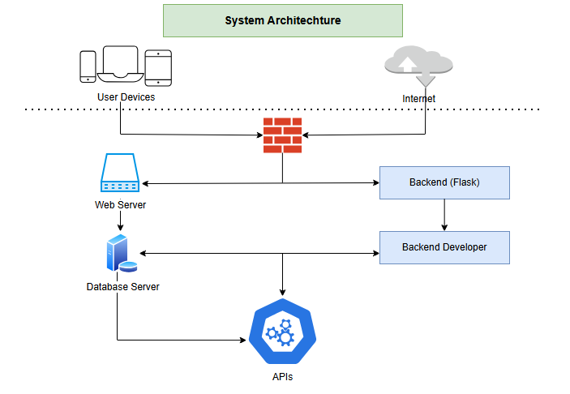
Figure 2: System Architecture

Task 2: Enterprise and Innovation

Q1. PEST and SWOT Analysis for a Tech Company – Tesla Inc.
The PEST and SWOT analysis of Tesla Inc. was performed with an aim to investigate external and internal business characteristics, as this example demonstrates sustainable innovation and forward-moving energy technology, which will be applicable in the sphere of smart-energy exploration within the field of this project.

Political
The political influences encompass high levels of support for renewable-energy incentives worldwide, incentive taxation, and carbon-credit policies. These policies have expedited the growth of Tesla in the energy storage and grid-management units [1]. Nonetheless, an exposure to fluctuating regulatory measures, trade tariffs, and geopolitical conflicts, in particular, between China and the U.S. continue to be a major risk.

Economic
The major economic causes are the inflationary pressures, supply-network complications, and lithium-cost fluctuations on the cost of the batteries. However, the clean-tech market is a market that keeps attracting investors who are interested in having sustainable portfolios, creating new capital inflows.

Social
The social factors indicate an increase in the number of eco-conscious consumers and awareness initiatives launched by governmental institutions to make people carbon neutral. The start-ups related to clean-energy analytics are directly supported by the social acceptance of electric and renewable technologies [8].

Technological
The technological reasons entail the swift development of AI, IoT, and cloud computing, which are the main facilitators of effective energy monitors. The advances also have risks of technological redundancy and vulnerability to cyber-attacks, which explain the need to consistently invest in R&D [9].

Ethics and legal aspects
Legal and ethical factors are imperative. Tesla needs to adhere to environmental conservation laws, intellectual-property laws and data-protection laws (e.g., GDPR). Such ethical issues as sustainable disposal of batteries, effects of AI-based automation, and access to green technologies should be highlighted as ethical concerns. To remain trusted by the stakeholders, the management of the data and ethical-supply chain needs to be transparent [10].

SWOT Analysis
The SWOT analysis, the company has strengths in the world brand image, information-driven design, and high levels of R and D. Among the weaknesses are: high costs of R&D and production, reliance on rare-earth materials, and having complicated supply logistics [11]. The threat is that existing automakers are increasing competition, and regulatory overreach may pose threats because of the move to a global value chain with renewable-energy systems and decentralised implementation of smart grids, and the opportunities lie in the need to outcompete other market players.
Table 1: SWOT Analysis

Strengths | Weaknesses
Strong world brand image | High R&D costs
Information-driven design | High production costs
High levels of research and development (R&D) | Reliance on rare-earth materials
 | Complicated supply logistics
Opportunities | Threats
Global move toward renewable-energy systems | Increasing competition from existing automakers
Decentralised implementation of smart grids | Regulatory overreach

The resilience of technology firms that combine sustainability, innovation, and ethical responsibility, which is revealed in this PEST-SWOT analysis, can be directly applied to the energy-monitoring start-up suggested in the present project.

Q2. Proposed Tech Start-up: “EcoWatt Analytics Ltd.”
Developing the concept of the project, the idea behind the suggested business is EcoWatt Analytics Ltd., a technological start-up based in the United Kingdom that specialises in cloud-based smart-energy monitoring of residential and small businesses.

Type of Business and legal classification:
EcoWatt Analytics Ltd. will also be incorporated as a UK Company Limited (Ltd.) company based on the Companies Act of 2006. The liability is also restricted by this structure, thereby increasing the level of credibility with investors and allowing them to be able to receive innovation-grant funding.

Mission & Vision:
The mission statement is empowering people and businesses to lower carbon emission use of smart, data-driven energy management. Its vision is to have a world in which energy transparency is the driver of sustainable behaviour.

Logo and Brand Identity:
The logo has a symbol of green power, and a node symbol that is circular in shape to represent continuity, efficiency, and flow of renewable energy. The brand character demonstrates a sense of environmental consciousness and cyber accuracy.


Business Strategy:
EcoWatt Analytics pursues a differentiation strategy in the form of providing real-time analytics, AI-based energy forecasting, and connection with internet of Things. The system will be based on a subscription model in which it offers freemium dashboards and premium analytical insights. Capturing strategic alliances with energy suppliers, manufacturers of smart-homes and local councils will be sought to increase accessibility and authority.

Market Opportunities:
The policies in the UK on Net Zero 2050 and the EU Green Deal offer a good environment to green-tech start-ups. The potential of adoption is further increased by the increasing domestic demand for smart-home technology and the rising expenses of energy [12].

Funding Initiatives:
The start-up will look at Innovate UK Smart Grants and Clean Growth Innovation Fund as a start-up in search of seed capital, along with the just-in-time involvement of the private-angel investors who may focus on the green-technology business. Interest (crowdfunding) through Kickstarter will get early adopters and confirm the product-market fit [13].

Legal and Ethical Compliance:
EcoWatt Analytics Ltd. will focus on compliance with GDPR in all data storage, ethical use of AI and transparent reporting. The company will also have a Code of Ethics of Sustainable Innovation that defines all technological choices in accordance with environmental and social responsibility criteria [14].
Through innovation, moral management, and offensive funding plans, EcoWatt Analytics Ltd. can play a vital role in the transformation of clean energy in the UK and still achieve profitability.

Task 3: Project Reflection

Skill Development and Professional Growth
Working on the Cloud-Based Smart Energy Monitoring System has become a pivotal experience, helping to solidify my technical and managerial skills. This project has given me the ability to implement and develop interdisciplinary skills, a mixture of data analytics, Internet of Things (IoT) integration, cloud computing and project management.
This project helped me to acquire skills in data analytics and predictive modelling, and work on consumption patterns and identify energy inefficiencies. Also, collaboration as an automated collaboration tool, teamwork in digital form through the use of Agile project management applications, Trello and Jira, as well as leadership development and team coordination, did not need a lot of time. The above experiences do not contradict the current industry standard requirements of sustainable innovation, in which iterative planning and cooperation are key drivers of success [15].
Using AI in energy analytics, I managed to understand more about the automation of data, decision support, and user-centric system design. In order to augment the levels of professional competence even more, I am going to get certification in AWS Cloud Services and Python in machine learning, so that I can be flexible and applicable in a changing digital ecosystem. These certifications will not only make me more employable but will also help me to spearhead upcoming projects through the integration of technology and environmental responsibility.

Societal Impact and Contribution
The longer-term societal effects of this project include the fact that it may lead to being energy-conscious and encourage the concept of sustainability, both at the individual and community levels. The system is empowering since it gives real-time analogies to users on their energy consumption and visual analytics. This openness allows making informed decisions and invites users to follow the practices that are energy-efficient, and minimise the total consumption. In turn, it leads directly to the United Nations Sustainable Development Goal 7 (Affordable and Clean Energy) as it contributes to affordable access to energy and promotes sustainable use of energy.
Besides, there is a potential to have a positive socioeconomic impact on the community in the implementation of this technology, such as creating new jobs within a green-energy economy, and enhancing environmental literacy. A study has shown that the implementation of digital energy-management systems can increase the level of public involvement and save a substantial amount of waste in residential areas, which proves the value of such technological advancement to society [16].

Risks and Mitigation Strategies
However, with all its possible advantages, the project is associated with various threats and obstacles that should be addressed with the help of strategic mitigation. Cybersecurity is the largest issue of concern, since IoT-based systems are prone to third-party interceptions, data theft and malware. To deal with this, the system will also use end-to-end encryption, multi-factor authentication and compliance with the ISO 27001 information security standard, which will guarantee data confidentiality and integrity.
Another problem is financial constraints that come especially in the initial years of implementation. To counter this, the project will be developed under a staged approach of development by using the partnership with renewable-energy companies, as well as soliciting early-stage investment from sustainability-oriented funds.
Another issue is the ability of the users to adopt it, which is a usual barrier in the adoption of new technologies. Resistance to change may arise as a result of a lack of awareness or seeming complexity. First, community-based programs and incentive programs will be held to show the long-term economic and environmental payback on energy monitoring. Such efforts will instil confidence in the community and make them engage.
Lastly, ethical threats like partial predictive calculations and incorrect use of user data should be tackled through strict management. Regardless of the presence of random algorithmic audits, an open policy on data-governance will support fairness, accountability, and societal trust [17].

Conclusion
To summarise, the Cloud-Based Smart Energy Monitoring System project shows that combining technological innovation, environmental sustainability, and strategic business can result in the creation of substantial environmental and societal impact. The Agile-Waterfall hybrid methodology, utilised through the project management planning, was used to have a structured progression and to permit flexibility, in terms of developing it in an iterative manner. The enterprise analysis, based on the PEST and SWOT framework of Tesla, demonstrated the role of sustainable innovation in the creation of a competitive edge, and EcoWatt Analytics Ltd. proposed and revealed the commercial viability and ethical basis of the project. The reflection part has pointed out the major areas of improvement in skills, social good, and positive risk mitigation. On the whole, the given project is consistent with modern tendencies in smart energy and green technology, as well as contributes to the essential role of innovation, enterprise, and social responsibility in achieving sustainable digital transformation.

References
[1] Li, A., Liang, W., & Ling, J. Evaluation of Tesla Based on PEST, POCD, SWOT and DCF. BCP Business & Management. 2022 https://doi.org/10.54691/bcpbm.v34i.3024.
[2] Eyieyien, O., Idemudia, C., Paul, P., & Ijomah, T. Advancements in project management methodologies: Integrating agile and waterfall approaches for optimal outcomes. Engineering Science & Technology Journal. 2024 https://doi.org/10.51594/estj.v5i7.1312.
[3] Marques, J., Morais, J., Alves, J., & Goncalves, M. EFFECTIVENESS ANALYSIS OF WATERFALL AND AGILE PROJECT MANAGEMENT METHODOLOGIES – A CASE STUDY FROM MACAU'S CONSTRUCTION INDUSTRY. Revista Gestão em Análise. 2023 https://doi.org/10.12662/2359-618xregea.v12i1.p23-38.2023.
[4] Mketiwa, P., Sibanda, B., Chigodora, T., & Ndawana, B. Agile vs. Traditional Project Management: A Comparative Study of Project Success Factors in the Tech Industry. International Journal For Multidisciplinary Research. 2025 https://doi.org/10.36948/ijfmr.2025.v07i04.49732.
[5] Romeo, J., Raglianti, M., Nagy, C., & Lanza, M. Capturing and Understanding the Drift Between Design, Implementation, and Documentation. 2024 IEEE/ACM 32nd International Conference on Program Comprehension (ICPC). 2024 https://doi.org/10.1145/3643916.3644399.
[6] Suartana, I., Puspitaningayu, P., Pratama, S., Dwiyanti, S., M., & Haryudo, S. Modeling agile development of Web application e-monev using UML. E3S Web of Conferences. 2024 https://doi.org/10.1051/e3sconf/202451302010.
[7] Florut, C., & Buchmann, R. Semantic Bridging between Conceptual Modelling Standards and Agile Software Projects Conceptualisations. Proceedings of the 30th International Conference on Information Systems Development. 2022 https://doi.org/10.62036/isd.2022.39.
[8] Moshou, H., & Drinia, H. Strategic Insights for Environmental Education in Greece: SWOT and PEST Analyses in the Context of the Climate Change Crisis. Sustainability. 2025 https://doi.org/10.3390/su17062633.
[9] Zhang, J. The Evaluation of miHoYo Technology Based on PEST, SWOT and POCD Analysis. BCP Business & Management. 2022 https://doi.org/10.54691/bcpbm.v34i.3002.
[10] Fu, J., & Liu, W. The Impact of the BBNJ agreement’s EIA provisions on China: a comprehensive analysis under the SWOT-PEST framework. Frontiers in Marine Science. 2025 https://doi.org/10.3389/fmars.2025.1686221.
[11] Xu, Z. Analysis of Toyota and its Competitors Based on PEST and SWOT. BCP Business & Management. 2023 https://doi.org/10.54691/bcpbm.v37i.3597.
[12] Dong, H., Liu, Z., Kong, K., Li, T., & Q. Evaluation of Input-Output Efficiency of Sports Industry Based on SWOT-PEST Model. Journal of Mathematics. 2021 https://doi.org/10.1155/2021/6294745.
[13] Jiang, Z., Sun, J., & Wei, K. The Application of PEST Analysis and POCD Framework to Skydio’s Venture Capital Investment. Proceedings of the 2021 International Conference on Financial Management and Economic Transition (FMET 2021). 2021 https://doi.org/10.2991/aebmr.k.210917.032.
[14] Gao, J., & Cai, Z. Comparison and prospect of Chinese and Western accounting standards based on SWOT-PEST model. Advances in Economics and Management Research. 2022 https://doi.org/10.56028/aemr.1.1.24.
[15] Lee, J., & Lee, Y. Utilising immersive technologies in interior design: Korean communication strategies through in-depth interviews and SWOT-PEST analyses. Digital Transformation and Society. 2025 https://doi.org/10.1108/dts-01-2025-0002.
[16] Peng, J. Research on Digitalisation of the Museum Industry in China- Based on SWOT-PEST Model. Asian Journal of Social Science Studies. 2022 https://doi.org/10.20849/ajsss.v7i1.982.
[17] Raszkowski, A. PEST Analysis of Piechowice Municipality - Power and Future Impact Direction of Environmental Factors. 2016 https://doi.org/10.15611/pn.2016.431.02.

