Evaluating Che-si:

Intro: Che-si is an international construction company with offices all over the globe. In order to be successful, they utilise video conferencing facilities, cloud storage facilities, and the latest technologies. On a first glance it appears the company is doing well and correctly keeping everything up to date and sticking to the current international GDPR laws (A1) [1].
On closer inspection however they have a lot of vulnerabilities and the policies are too vague and open. Staff, clients, and vendors can all access the network from any location and device allowing access from other networks and personal devices. This means that the network is always vulnerable to attacks from any direction.

Related work: A good example of where these vulnerabilities could go wrong is with the French submarine builder DCNS in 2016 where a disgruntled employee a former French naval officer and DCNS contractor leaked the information of the scorpene class submarine which is used by several nations and at the time India had purchased six to increase their naval power in the Indian ocean due to nations like china [2].
This could create huge issues in terms of security for these nations and leave them vulnerable to their submarine’s weaknesses being exploited. A similar thing could happen to Che-si if they were to have a disgruntled employee leak their information to competitors or put other members of staff at risk and vulnerable to black mail if someone were to get hold of their personal information.

Introducing my solution/s: My solution to avoid these issues is to have a tiered system put in place where each member of staff, clients and vendors get a username and a one-time password token (OTP) that generates a random password that only works for a certain time before changing ensuring two factor authentication, furthermore each member of staff due to their username will only be able to access certain parts of the network that are related to them through their role and relation to the company, meaning only the higher ups and bosses can access all the information.
This then does not affect their productivity, nor does it stop them from using the network as a portal could be set up so they can access the network from their personal devices, and it will only display the information relevant to them. And due to every person having a unique username if anything goes wrong it will be easier to track and find anyone that attempts to hurt the company.
If the company does have extra funds, I would suggest each member of staff getting a work phone/tablet/laptop based on their position and what they need in order to do their jobs affectively, this would also make tracking their movement in the network easier as each device’s IP would be registered and documented so that if something were to go wrong it would be easier to find out who the culprit is. A good example of this is KSB a German international pump manufacturer who uses the OTP tokens and purchases devices for employees to use such as printers, laptops, phones and monitors. The company works smoothly and does not seem to be affected in terms of productivity.

Implementation: To implement this; all personal devices should be banned, and all vendors/client’s device’s IP addresses should be registered, and each member of staff should be given devices that can enable them to their jobs without hinderance (phones, laptops and tablets), then the company should issue everyone with the OTP tokens and a username ideally their name with a number to make it memorable.
This should then be tested by looking at the network and monitoring who is using information and how they are using it. Once this is successful the company should monitor this and see if any issues occur.

Results/findings: My results and findings are that the company is now working back at full productivity and all information is protected with people only accessing the information related to them. Due to all digital signatures being now traced the company if suffering with issues can save time trying to find a culprit by looking at the IP address and login details to see if anyone is trying to breach anything they should not be.

Conclusion and recommendations for the future: My conclusion is that the company is now running a lot more smoothly they should work on encrypting information within the network to protect from external attacks, with firewalls and passwords being used heavily to ensure any outsiders cannot access things like the company’s finance.

Resources/own work/references (Bibliography and Appendices):

Bibliography (IEEE):
[1] Information Commissioners office
“International transfers after the UK exit from the EU Implementation Period” [online]
Available: https://ico.org.uk/for-organisations/guide-to-data-protection/guide-to-the-general-data-protection-regulation-gdpr/international-transfers-after-uk-exit/#whatarethe
[Accessed Jan 8, 2021]

[2] Financial Times
Jackie Range, Michael Stothard, Amy Kazmin “French submarine maker DCNS hit by data leak” [online]
Available: https://www.ft.com/content/182399f2-69be-11e6-a0b1-d87a9fea034f
[Accessed Jan 29th, 2021]

Appendix:

Appendix 1) An overview of what I believe Che-si’s Network looks like.
Appendix 2) GDPR laws.

Appendix 1:

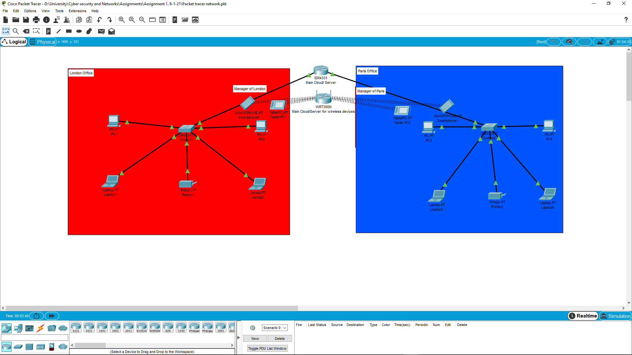

Appendix 2:
https://www.gov.uk/data-protection



