

University of Wales Trinity Saint David

School of Computing

Programming in C

Software Development

ACCA4017

Hafiz Uddin
1807533

24/04/2020

Contents Page
Table of Contents
Contents Page 1
1.0 Introduction 2
2.0 Methodology 2
2.1 Exercise 1 2
Fig 1.1 An example of how the preprocessor works 3
2.2 Pattern. 3
2.3 declaring the class’s which implement input and output operations 4
2.4 Variables 4
2.5 Results 5
3.0 exercise 2 6
3.1 Breakdown exercise 2 6
3.3 variables and pattern of a circle. 6
3.4 the Results of the circle. 7
3.5 variables and pattern of small rectangle. 7
3.6 Pattern of the calculations. 8
3.7 output of full program. 8
3.8 Testing the code. 9
4.0 Exercise 3. 9
4.1 The first attempts. 9
5.0 Exercise 4 12
5.1 Game Board 12
6.0 Conclusions 17
7.0 References 18
References 18
8.0 Appendices 19
Exercise 1 code: 19
Exercise 2 code: 20
Exercise 3 code: 21
Exercise 4 code: 22

1.0 Introduction

To look at given problems and solve them systematically, to then evidence the process, show stages of development, identify the patterns applied at each stage of the process to solve problems and show evidence of tests undertaken to show the aims of the tests, its inputs and outputs before producing the code to solving each problem.

2.0 Methodology

To break down each exercise into parts and show the process to testing and solving each exercise.

2.1 Exercise 1
“show how variables can contain different types of values by declaring three variables that will contain a book title, a measure of length (e.g. 4.74cm), and the number of items in a shopping cart”.
The first step would be to first identify the pre-processor directives. These are the compilers libraries where the source code gets preprocessed by the compiler before the main program gets compiled, then work out and identify which variables would be needed for each part of the code.
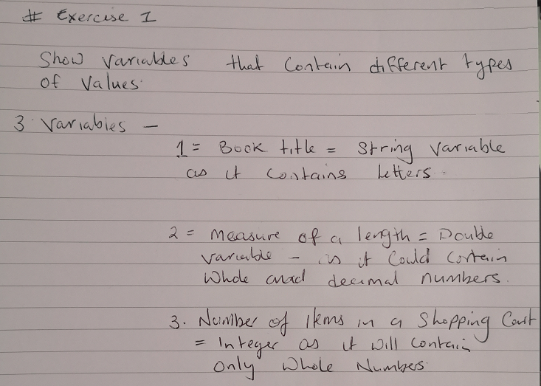

Fig 1.0 steps/process taken to solve the types of variables need for each problem.

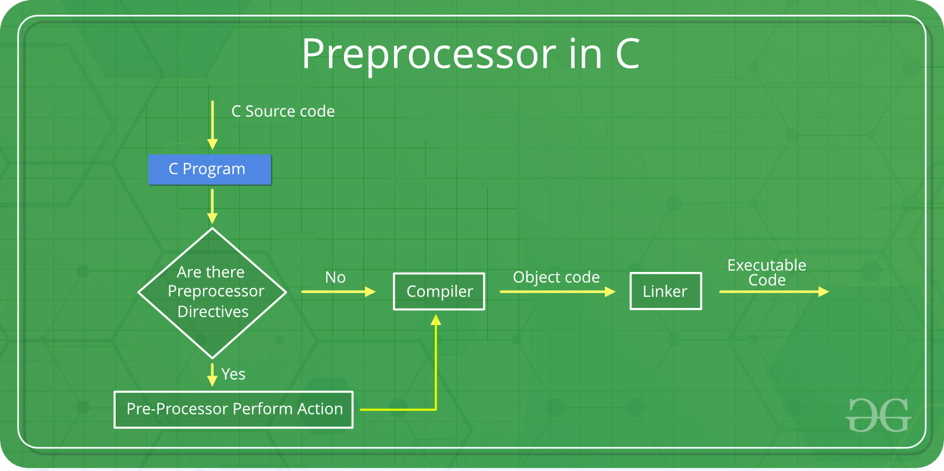

Fig 1.1 An example of how the preprocessor works. [1]

2.2 Pattern.

The next part of the pattern would be to declare the main functions including the command line arguments.
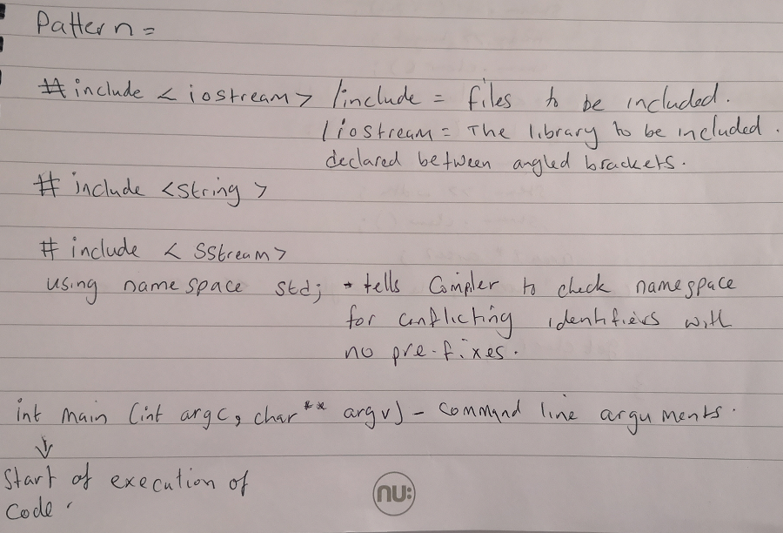

Fig 1.2 Declaring the preprocessor directives and main functions.

2.3 declaring the class’s which implement input and output operations

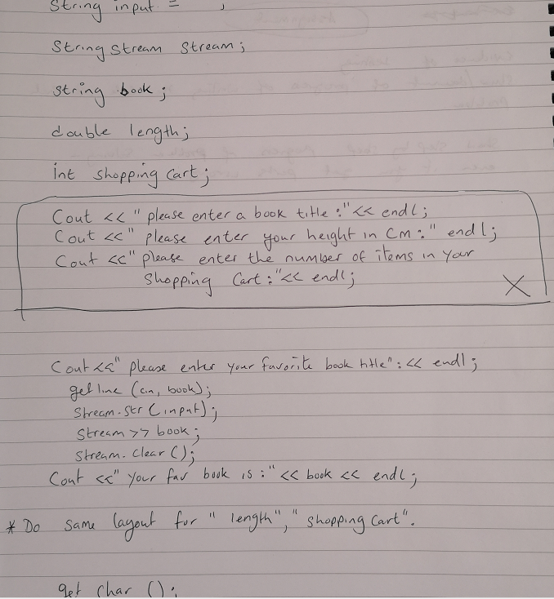

Fig 1.3 working out the variables needed.

2.4 Variables
“Book Title” which is a string as it would contain only letters, a double for numbers that include decimal numbers for length and an integer (int) for the number of items in a shopping cart as it would contain only whole numbers.
Also included is a “cout” command which displays the words/numbers or a question within the quotation marks, here we have asked a question to the user to input “their favourite book title”, the user can then input a answer and the program will display their answer.
The “getline (cine, input)” function is to read the string or a line from the input, the “Stream.str” function is which stream to read from, the “stream>>book” is the variable it needs to read from. This pattern is repeated for each question of this exercise.
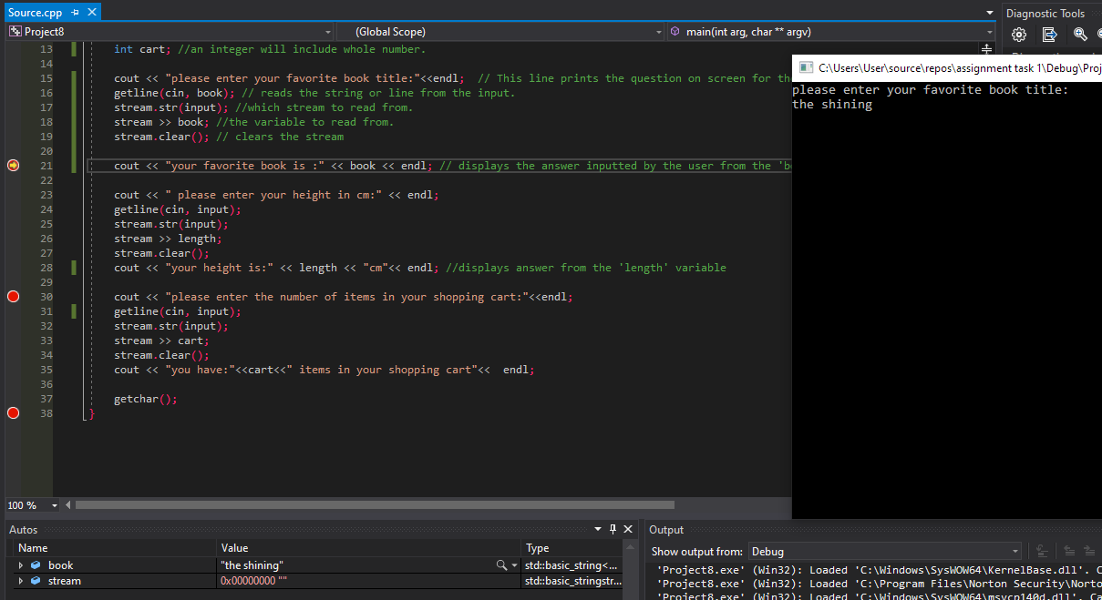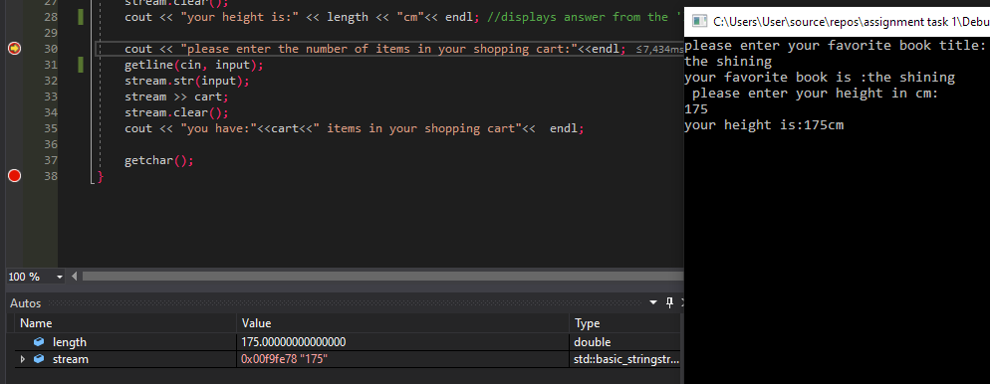

Fig 1.4 Using the debug function to test for errors

2.5 Results

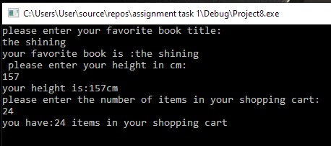

Fig 1.5 After running the code this is the result with the input from the user.

3.0 exercise 2
“Allow the user to enter the dimensions of the shape (rectangle with a circle and a small rectangle inside it), then calculate and display the area of the shape”.

3.1 Breakdown exercise 2

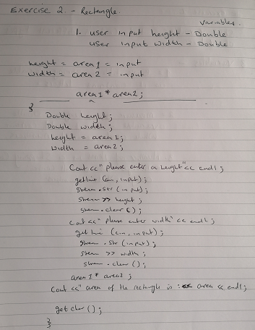

Fig 2.0 variables and pattern of rectangle

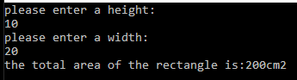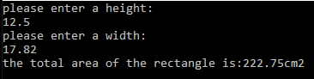

Fig 2.1 results of the area of the rectangle.

3.3 variables and pattern of a circle.
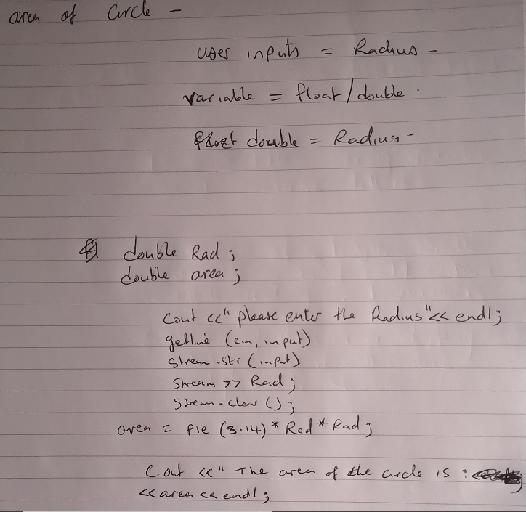

Fig 2.2 working out the variables and pattern needed to calculate the area of the circle.

3.4 the Results of the circle.

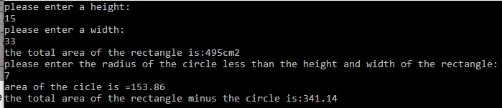
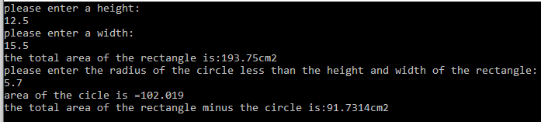

Fig 2.3 testing the area of the circle then minus its area from the rectangle.

3.5 variables and pattern of small rectangle.

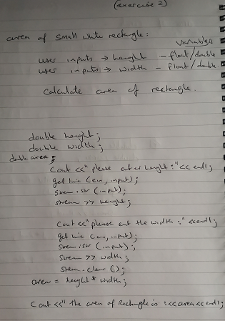

Fig 2.4 writing out the variables + pattern.

3.6 Pattern of the calculations.
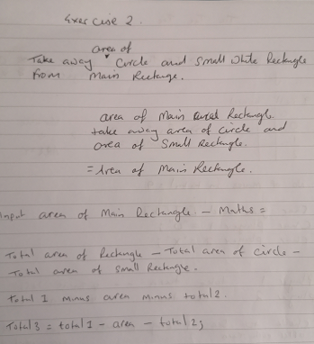

Fig 2.5 calculation of exercise 2.

3.7 output of full program.
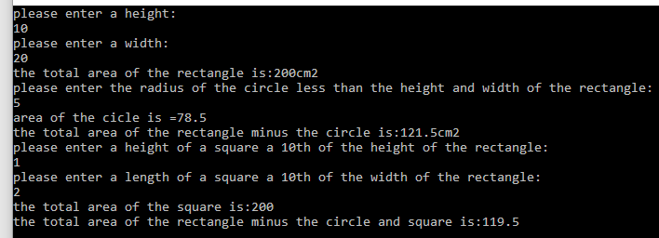
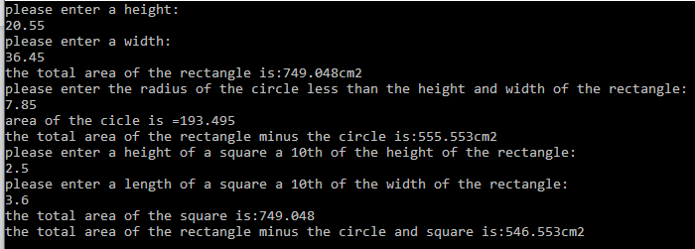

Fig 2.6 results of exercise 2

3.8 Testing the code.

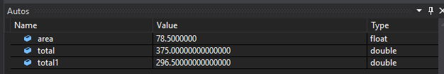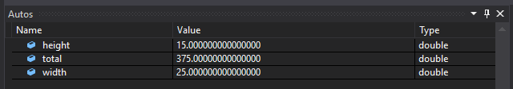
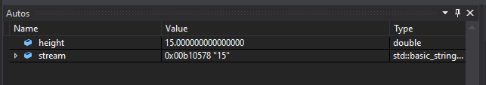

Fig 2.7 using the debugger to test the code for errors.

4.0 Exercise 3.

a) “Ask user to enter an arbitrary set of prices in GBP into an array and display all the entered prices”

4.1 The first attempts.

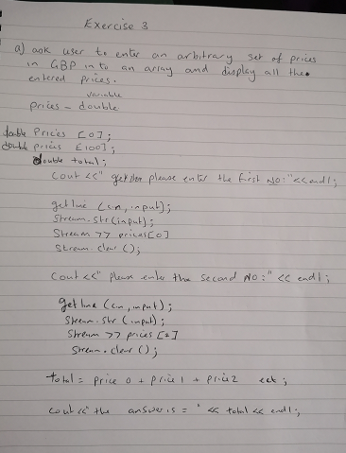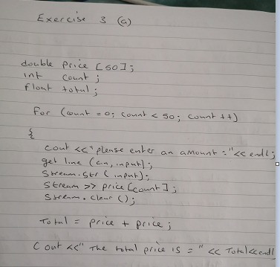

Fig 3.0 working out patterns for the different prices.

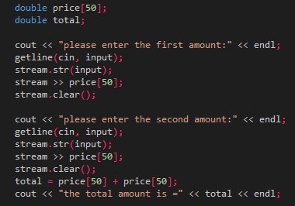

Fig 3.1Trying different patterns.

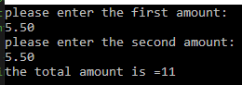
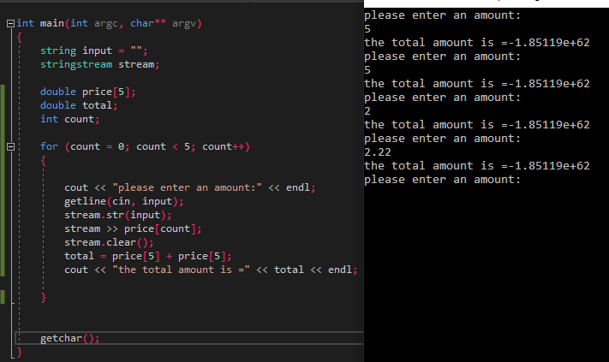
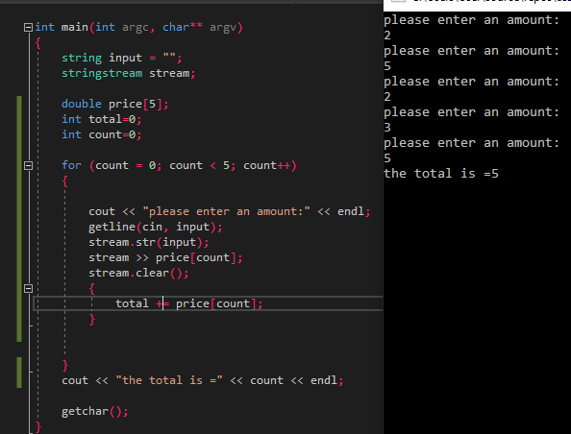

Fig 3.2 Trying different code patterns.

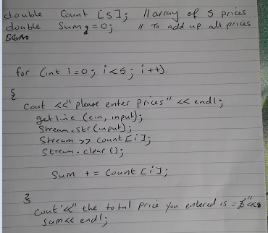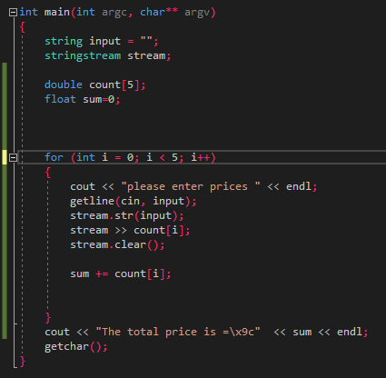

Fig 3.3 Working pattern code for adding the prices together.

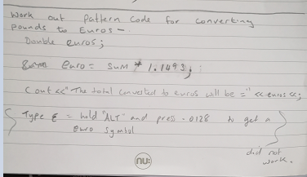

Fig 3.4 pattern for converting pounds to euros.

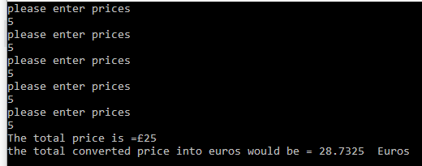

Fig 3.5 Using whole numbers to convert to euros.

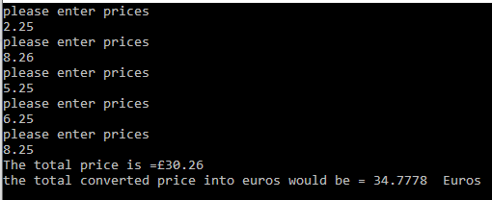

Fig 3.6 Using decimal numbers to convert to euros.

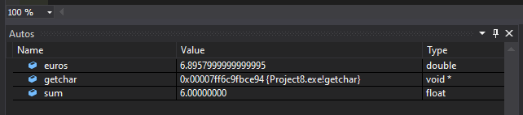

Fig 3.7 Testing the code through debugging.

5.0 Exercise 4

“build a two-player game where the first player hides 3 hidden treasures and the second has to guess where they are by entering the ‘x’ and ‘y’ coordinates on an 8x8 grid”.

5.1 Game Board

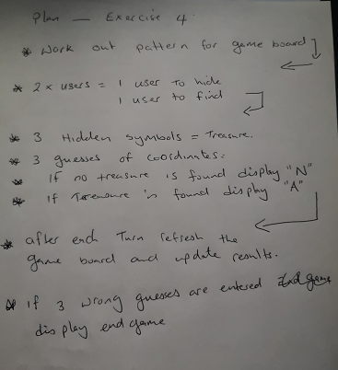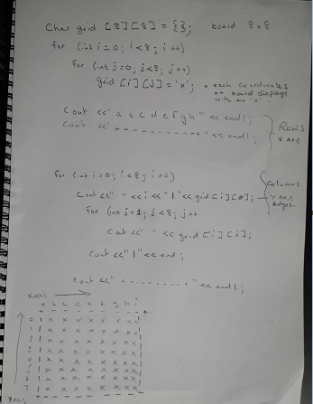
Fig 4.0 figuring out the patterns for game board
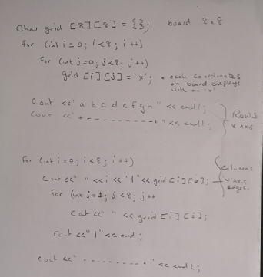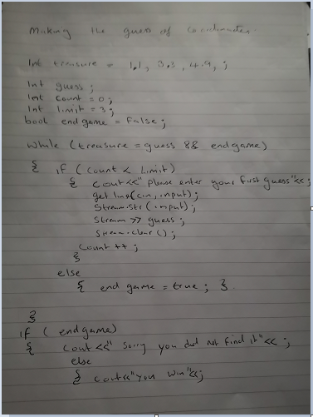
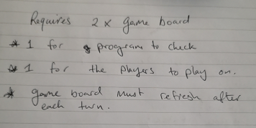

Fig 4.1 Steps taken to figure out exercise 4.

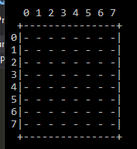

Fig 4.2 First display of gameboard.

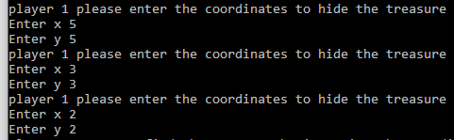

Fig 4.3 first input of player 1, hiding the treasure.

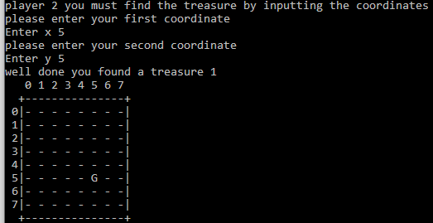

Fig 4.4 when a correct guess is made a ‘G’ is displayed

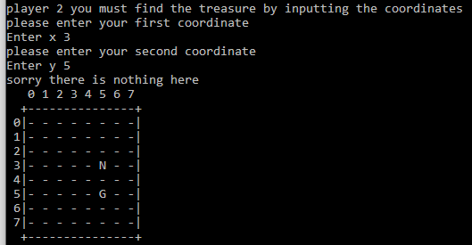

Fig 4.5 when a wrong guess is made a ‘N’ is displayed

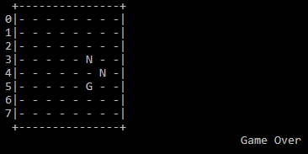
Fig 4.6 after 3 guesses the game is over.
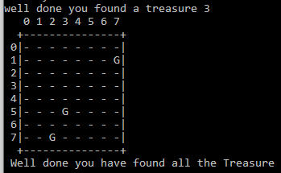

Fig 4.7 when all 3 guesses are right.

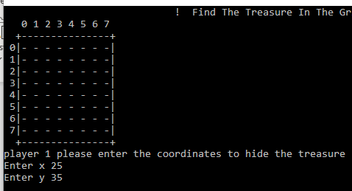
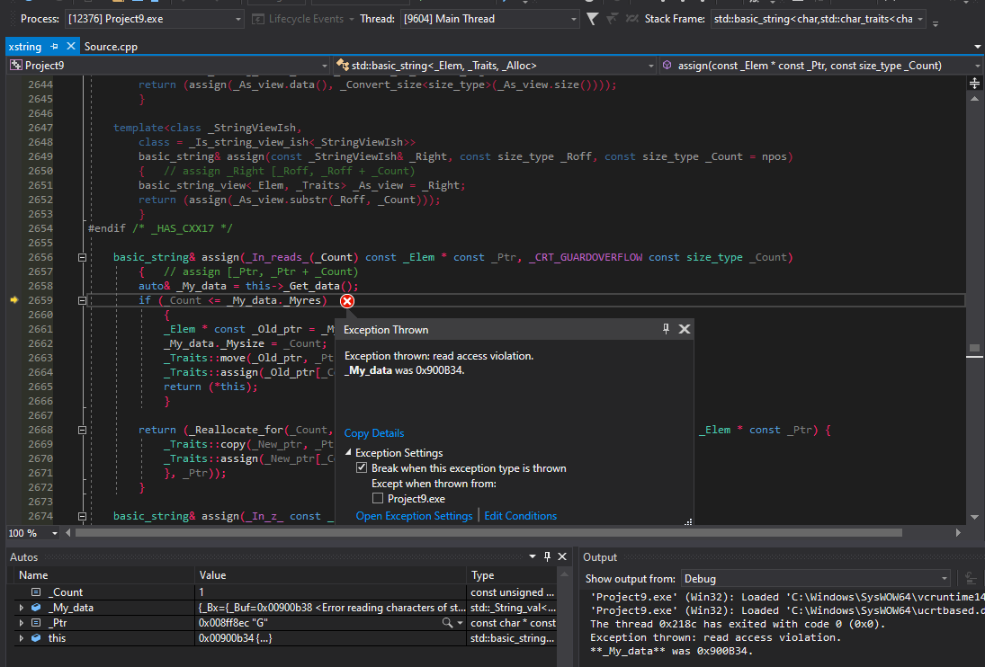

Fig 4.8 when coordinates that are out of range are entered. The code crashes.

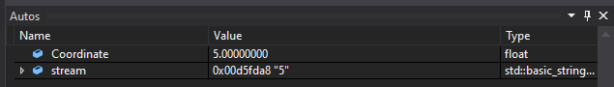
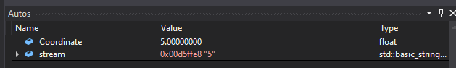
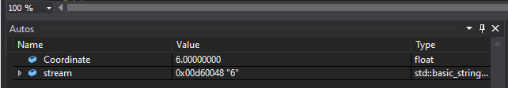
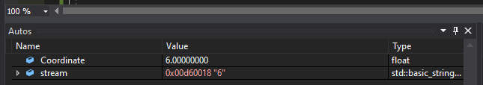
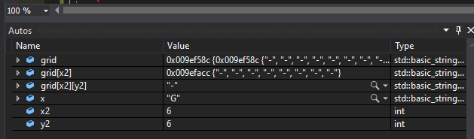
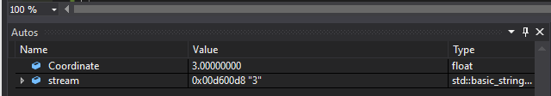
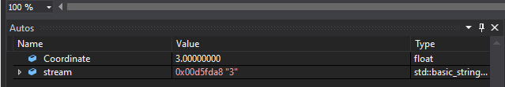
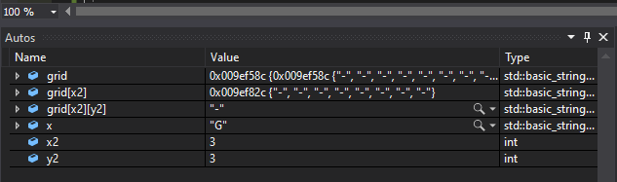

Fig 4.9 testing the code using the debugger.

6.0 Conclusions

Breaking down each exercise into workable sizes and coding each part, then identifying the variables needed makes it less challenging. Testing the code with the debugging function on Visual studios helped to identify errors. This allows you to rectify mistakes in the code.

7.0 References

References

[1] | G. -. H. Agarwal, “C/C++ Preprocessors,” 13 April 2020. [Online]. Available: https://www.geeksforgeeks.org/cc-preprocessors/. [Accessed 13 April 2020].

8.0 Appendices

Exercise 1 code:
#include <iostream> // include=files to be included. /iostream = the library to be included.
#include<string> // files and library to be included/stores and manipulates text strings.
#include<sstream> //files and library to be included/ converts strings to other data types.

using namespace std; //this will alow us to use standard identifiers like cin, cout and endl,tells the compiler to check namespace for conflicting identifiers with no pre-fixes.

int main(int arg, char** argv) // code to be executed/ command line arguements.
{
string input = ""; //reads the string input
stringstream stream;
string book;//string variable for a string of characters.
double length;//a floating point number, correct to 10 decimal points.
int cart; //an integer will include whole number.

cout << "please enter your favorite book title:"<<endl; // This line prints the question on screen for the user to see/ endl means move to the next line.
getline(cin, book); // reads the string or line from the input.
stream.str(input); //which stream to read from.
stream >> book; //the variable to read from.
stream.clear(); // clears the stream

cout << "your favorite book is :" << book << endl; // displays the answer inputted by the user from the 'book' variable.

cout << " please enter your height in cm:" << endl;
getline(cin, input);
stream.str(input);
stream >> length;
stream.clear();
cout << "your height is:" << length << "cm"<< endl; //displays answer from the 'length' variable

cout << "please enter the number of items in your shopping cart:"<<endl;
getline(cin, input);
stream.str(input);
stream >> cart;
stream.clear();
cout << "you have:"<<cart<<" items in your shopping cart"<< endl;

getchar();// reads in the code and returns the value.
}

Exercise 2 code:
#include <string>
#include<iostream>
#include<sstream>

using namespace std;

int main(int argc, char** argv)

{
string input = "";
stringstream stream;

double height, width,length;
float radius,area; // floating point number, correct to 6 decimal points.
double total,total1,total2,total3;

cout << "please enter a height: "<<endl;
getline(cin, input);
stream.str(input);
stream >> height;
stream.clear();

cout << "please enter a width: " << endl;
getline(cin, input);
stream.str(input);
stream >> width;
stream.clear();
total = height * width;// mathematical function-the height inputted X the width inputted= area of rectangle.
cout <<"the total area of the rectangle is:" <<total << "cm2" << endl; // reads out the output of the answer.

cout << "please enter the radius of the circle less than the height and width of the rectangle:" << endl;
getline(cin, input);
stream.str(input);
stream >> radius;
stream.clear();
area = 3.14*radius*radius; // the equation for working out the area of a circle with th input of the radius.
cout << "area of the cicle is =" << area<< endl;
total1 = total-area; // total area of rectangle minus the area of the circle.
cout << "the total area of the rectangle minus the circle is:" << total1 << "cm2" << endl;

cout << "please enter a height of a small rectangle a 10th of the height of the rectangle:" << endl;
getline(cin, input);
stream.str(input);
stream >> height;
stream.clear();

cout << "please enter a length of a small rectangle a 10th of the width of the rectangle:" << endl;
getline(cin, input);
stream.str(input);
stream >> length;
stream.clear();
total2 = height * length; // area of the small rectangle inside the big rectangle.
cout << "the total area of the square is:" << total << endl;

total3 = total - area - total2; // total area of the big rectangle minus the circle minus the small rectangle.
cout << "the total area of the rectangle minus the circle and square is:" << total3 << "cm2" << endl;

getchar();

}

Exercise 3 code:
#include <string>
#include<iostream>
#include<sstream>

using namespace std;

int main(int argc, char** argv)
{
string input = "";
stringstream stream;

double count[5];//using an array function where five items of data can be stored, this can be changed.
float sum=0;
double euros;

for (int i = 0; i < 5; i++)//using the loop function to execute the repeated input of the prices, in this case 5 inputs
{
cout << "please enter prices " << endl;
getline(cin, input);
stream.str(input);
stream >> count[i];
stream.clear();
sum += count[i];
}
cout << "The total price is =\x9c" << sum << endl;//display the total amount inputted with the pound symbol.
euros = sum * 1.1493; // this converts the total amount to euros.
cout << "the total converted price into euros would be = " << euros <<" Euros"<<endl;
getchar();
}

Exercise 4 code:
#include<string>
#include<iostream>
#include<sstream>

using namespace std;

int Coordinate(string message)
{
stringstream stream;
string input = "";

cout << message;

float Coordinate;
getline(cin, input);
stream.str(input);
stream >> Coordinate;
stream.clear();

return Coordinate;// by using this part of the code enables the getline, input out functions to run everytime it is encounter within the main code.
}

int main(int argc, char** argv)
{
string input = "";
stringstream stream;

int life = 3; // number of lives the second player has/number of guesses.
string x = "G", y = "N";

int x1, y1, x2, y2;

int treasure = 0;

cout << " ! Find The Treasure In The Grid Below ! " << endl;

string grid[8][8] = {};//grid layout 8 by 8 gameboard.
string grid2[8][8] = {};//secong grid layout.

for (int i = 0; i < 8; i++)
{
for (int j = 0; j < 8; j++)
{
grid[i][j] = '-';
grid2[i][j] = '-';// displays in the grid fo each grid coordinate.
}
}

cout << " 0 1 2 3 4 5 6 7 " << endl;
cout << " +---------------+" << endl;//top outskirt of the gameboard.

for (int i = 0; i < 8; i++)
{

cout << " " << i << "|" << grid[i][0];//right and left side of the drid.
for (int j = 1; j < 8; j++)
{

cout << " " << grid[i][j];
}
cout << "|" << endl;
}
cout << " +---------------+" << endl;//bottom of grid.

for (int i = 0; i < 3; i++)
{

cout << "player 1 please enter the coordinates " << endl; // player one hides the three treasures using the gameboard coordinates.
x2 = Coordinate("Enter x ");// X coordinates
y2 = Coordinate("Enter y "); // Y coordinates
grid[x2][y2] = x;
}

for (int i = 0; i < 3; i++)
{
cout << "player 2 you must find the treasure by inputting the coordinates" << endl; // player 2 enters 2 coordinates to guess where the treasure is in the gameboard.
cout << "please enter your first coordinate " << endl;
x1 = Coordinate("Enter x ");
cout << "please enter your second coordinate " << endl;
y1 = Coordinate("Enter y ");

if (grid[x1][y1] == x)
{
grid2[x1][y1] = x;
cout << "well done you found a treasure " << treasure + 1 << endl; //if the correct coordinates are inputed then this will be displayed.
treasure++;

cout << " 0 1 2 3 4 5 6 7 " << endl;
cout << " +---------------+" << endl;

for (int i = 0; i < 8; i++) //the grid is in a loop to display after each turn until game is over.
{

cout << " " << i << "|" << grid[i][0];
for (int j = 1; j < 8; j++)
{

cout << " " << grid2[i][j];
}
cout << "|" << endl;
}
cout << " +---------------+" << endl;

if (treasure == 3) // if all the treasure is correctly guessed display this.
{
cout << " Well done you have found all the Treasure " << endl;
}
}

else
{
grid2[x1][y1] = y;
cout << "sorry there is nothing here " << endl; // when a wrong guess is inputed display this.
life--;

cout << " 0 1 2 3 4 5 6 7 " << endl;
cout << " +---------------+" << endl;

for (int i = 0; i < 8; i++)
{

cout << " " << i << "|" << grid[i][0];
for (int j = 1; j < 8; j++)
{

cout << " " << grid2[i][j];
}
cout << "|" << endl;
}
cout << " +---------------+" << endl;

if (life == 0) // when all three guesses are inputted display this.
{
cout << " game over you are out of guesses " << endl;
}

cout << " Game Over " << endl;
}
}

getchar();
}

