


Contents

Executive Summary 3
1.Introduction 4
1.2 -Acknowledgements 4
1.3 – Notable changes from the Project Initiation Document 5
2.Research Analysis 5
2.1. Primary qualatative research – Interview 5
Table 1 – Interview results 5
2.2. Secondary data – comparisons of other UK festivals 7
2.3. Glastonbury 7
2.4. Download 8
2.5. Y Not 8
2.6. Count of Ten Group 9
2.7. Summary of secondary data 9
2.8. Primary research – survey 10
2.9. Infographic 11
3.0. Question six analysis 12
Responses 12
4.0. Summary of primary analysis – survey 14
5.0. Conclusion 15
6.0. Recommendations 15
7.0. Overall Cost 19
Bibliography 20

Executive Summary

This consultancy report contains primary and secondary research which that has been analysed by the researcher to find out the impacts of the weather on the Steelhouse Festival and how an enhanced weather contingency plan can improve the visitor experience and prevent a financial loss to the company.
Methods adapted by the consultant including both primary and secondary research. Firstly, a survey was published targeted at festivalgoers who had attended Steelhouse festival to analyse the opinions of the customers. To clarify the information gathered through this source the consultant held an interview with the festival co-founders Matthew Rhead and Mikey Evans to draw comparisons between the two methods of research and explain any discrepancies. Secondary research into other UK open air festivals was undertaken to establish the methods that similar events are using to mitigate the effects of adverse weather. This information was discussed at the interview with the co-founders to establish what they would consider or what was not an option to ensure the consultant gave realistic recommendations.
Results of the data collected showed that 37% of festivalgoers have had negative experiences at Steelhouse Festival because of the weather, especially those with live-in vehicles. From the survey it was established 18% of respondents were therefore reluctant to purchase early bird tickets to the following event because of the weather. This could potentially have dire financial consequences and without upfront liquid capital that the festival requires could stall the booking process for subsequent events. Matthew and Mikey who said they have seen no change in sales contested this. Possible explanations of why the information does not correspond has been discussed in the report. The consultant along with the organisation believes one of the potential reasons is because the festival is still experiencing growth, when a festivalgoer decides not to attend the following year a new customer will take their place thus having no impact general ticket sale trends.
The report determines that the current weather contingency plan in place for Steelhouse festival has shown to be ineffective in relation to the extreme weather conditions that occurred in both 2015 and 2017. Through interviews it is agreed by the co-founder it is part of the event management plan they would like to pay more attention and allocate more of the budget too it, now they are able. It is clear that those who attend Steelhouse festival are a loyal fan base and appreciate the work undertaken by volunteers, the quality of the music and the incomparable event location. The the only negative aspect they feel is the lack of weather contingency when conditions become challenging.
After reviewing different sources and comparing adverse weather policy examples from other national festivals the consultant chose elements of the findings and collaborated them to provide more sources of weather contingency that are both financial feasible and suitable to the ecology of the venue which is a working farm.
The consultant recommends a mixture of gravel, hay, track matting and using alternative areas on the farm to help prevent waterlogging of the ground resulting in difficult vehicle and pedestrian circumstances. An example of how much potentially these changes could cost has been included in the recommendations and a proposed car-parking fee to offset any additional costs to the Steelhouse Festival.

1.Introduction

The aim of the consultancy project is to source a practical weather contingency plan for the Steelhouse festival. The objectives of the consultancy project are to develop an understanding of logistical challenges for outdoor events, review measures implemented by events of a similar nature and to source viable materials to use in the event of adverse weather. The desired outcomes from the objectives are to make the overall Steelhouse festival experience better for attendees, the consultant will be able to produce realistic recommendations for the client by analysing primary and secondary data and lastly to give the client a number of options which can be implemented by the festival in July 2018.

The Steelhouse Festival is an annual classic rock festival located in Blaenau Gwent. The festival location is a unique selling point of the festival, on top of a mountain at Hafod-Y-Dafal farm making the Steelhouse Festival the UK’s highest festival. The festivals niche being the mountaintop is also the biggest challenge for the event organisers. Logistically the festival is a huge undertaking and when bad weather occurs the challenge increases exponentially. Disappointingly, the festival has a history of wet weather over the weekend and in 2015 and 2017, the festival site suffered from extreme mud, rain and wind making accessibility for traders, staff, volunteers and festivalgoers difficult.
The consultant has taken into account the above and identified the need for an enhanced weather contingency plan. This report will contain both quantative and qualitative research that the consultant has outlined in the project initiation document, any deviations from the original PID will be noted in the report giving reason why. The research gathered has been analysed by the consultant and comparisons have been made to find the common denominator. By utilising, all of the primary and secondary research undertaken by the consultant a conclusion will be made giving detailed recommendations, which will hopefully benefit the chosen organisation, The Steelhouse Festival and the upcoming 2018 event in the summer.
Aims and objectives for the consultancy project were clearly shown in the BID and PID and the consultant will adhere to the original plan as much as possible to ensure the client receives the project outcome, which was agreed to initially.

1.2 -Acknowledgements
The consultant would like to take this opportunity to thank Matthew Rhead, Mikey Evans for their invaluable support throughout the project and enabling the consultant to grasp the festival’s needs, and for the time they have dedicated to helping the consultant.
Every Steelhouse attendee who took the time to answer the survey and who encouraged other festivalgoers to do so creating a speedy response time, you have helped tremendously and the consultant is extremely grateful.

1.3 – Notable changes from the Project Initiation Document
Although the consultant has strived to adhere to the project initiation document, some changes have occurred. The adjustments are detailed below:
- Volunteers involvement – The consultant had originally planned to use the volunteers at Steelhouse Festival for research purposes separately to the attendees of the event. The researcher decided to create one survey and encourage responses by attendees and volunteers in one sample. The justification of this was to ensure data was concise and to prevent the same data being generated.
- Use of social media and blogs – The consultant felt enough research was gathered from primary sources that was representative of the attendees and social media and blog posts were not needed to justify this further.
- Presenting survey findings – In the PID the consultant stated the data collected would be presented as statistics. The consultant chose to use infographics for the final report instead, as the method is more reader friendly and straightforward.

2.Research Analysis

2.1. Primary qualatative research – Interview

The consultant chose primary research techniques as part of the research process for the project including an interview. The interviewees were Matthew Rhead and Mikey Evans who both own the Steelhouse Festival, the interview took place on Friday 20th April 2018 at 12pm.
In total, the consultant chose to ask the interviewees eleven questions about weather contingency at the Steelhouse festival and some added general questions for clarification on demographics and statistics for the event.
Secondary research was conducted prior to the visit and compared the practises of other UK festivals. This enabled the consultant to incorporate the findings into some of the questions to gain the owners perspectives on them. By doing so the consultant can define what recommendations are most suitable based on the owners answers.
The consultant also asked general questions about demographics and attendees. This information is needed to complete the analysis of both primary and secondary research.
A summary of the interview is below; the full interview can be obtained from the researcher.

Table 1 – Interview results
Question | Answer | Action
What is the demographic of a typical Steelhouse Festival Attendee? | 30-50 years old. 55% men versus 45% women approximately. | N/A.
Do you think the weather of previous years has hindered ticket sales? | No. Maybe there would be a steeper curve of ticket sales if weather had been better, but there has been continuous growth each year. | Compare this answer to the primary data, which was collected via survey.
Would you be opposed to charging a car-parking fee to cover costs of more weather contingency sources? | Not opposed to a fee as long as the fee is appropriate and in line with the rest of the festival pricing. | Work out an appropriate fee that will cover contingency plan and include this in the recommendations.
Do you have other areas of land that you are able to use on site? | Yes. The use of other fields will be implemented this year. | Display a map of the field with alternative fields highlighted. The consultant is unaware what fields are being used differently to 2017 so the results could be different to what the organisers have planned and produce further options.
If there were an opportunity to hold the event elsewhere would you consider it? | No. | A venue change was originally an option to put into the recommendations; however, it is now clear it would never be considered so the consultant is clear this is not suitable to recommend.
Thinking of previous years with bad weather, is there anything you wish you had done differently? | Yes. Budgets have been tighter before so the owners have not been able to allocate as much money to a contingency plan as they want to. There is more room in the budget now for this.  Owners agreed that every year is a learning curve and the site along with the weather is unpredictable. | Use the secondary data analysis of other festivals held on agricultural land to decipher a best practise that could work for Steelhouse Festival.  Budget carefully to ensure the project is financially viable.
On a scale of 1-10, how highly do you prioritise the weather contingency plan within the whole event management plan? | Around a six. It is difficult to rate it higher when sanitation, security and health and safety have to be priority although it does not mean it is not important but because of the nature of the site other things have to be ranked higher.  Overall visitor experience and sanitation are the highest priorities. | Demonstrate to the financial impact of losing ticket sales because of a poor weather contingency plan when analysing the survey responses.
How do you think track mats, gravel and extra hay would benefit the event location? | Less likely cars would get stuck.  Overall vehicle and pedestrian movements would be greatly improved. | Budget the costs of the resources in the recommendations and explain the areas the consultant believes they should be utilised in.
Do you think Steelhouse volunteers would benefit from the above? | Yes. It is a physically demanding job, which is more difficult in adverse weather conditions. | The consultant will consider the areas that volunteers frequent such as backstage areas and make sure appropriate contingency plans are made for these areas also.
If the date could be changed to earlier/later in the Summer, would you change it? | No, the great British weather will always be a gamble. Changing the date would not guarantee anything. | A date change will not be included in the recommendations.
Are there any materials you would be opposed to using on site for weather contingency? | Yes, many. We are conscious of the ecology of the site and would prefer to use materials with a minimal environmental impact. | The consultant will consider this when making recommendations and will not suggest anything that does not comply with the company’s ethos.

(Rhead, Evans, 2018)

2.2. Secondary data – comparisons of other UK festivals

One of the objectives of this consultancy project is to look at practises that other open-air festivals around the UK adopt. This was undertaken to establish what methods are successful and what could be transferable to the Steelhouse Festival’s weather contingency plan.
The organisations were carefully chosen for comparison because they all bear some sort of similarity to the Steelhouse Festival. Glastonbury and Steelhouse festival are held on agricultural land, Download attracts the same audience, Y Not festival is held on the same date and Count of Ten group are a small to medium enterprise.

2.3. Glastonbury
Glastonbury festival is an iconic UK music festival held at Worthy Farm, Pilton. The festival has become synonymous with bad weather conditions with photographs of the mud baths on the festival site easily found on social media and in news outlets. According to festival and gigs (2015) over the last ten years Glastonbury festival has had 9 festivals with significant mud since 2014 with 6 out of the 9 being ‘epic mud baths’.
The open air event is similar to Steelhouse Festival as they both share the logistical challenge of hosting a music festival on agricultural land.
Glastonbury deals with adverse weather by having a fallow year every five years to give the land time to recover. The founder of Glastonbury festival Michael Eavis has also considered moving the event to a new location in 2019 to further help venue recover but has stated this would not be a permanent move (Rawlinson, 2016 ).
Glastonbury and Steelhouse Festival differ in their event classification. Frame work put forward by Bowdin et al (2012) categorised events into 4 sections ‘local’, ‘major’, ‘hallmark’ and ‘mega-events’ (Ruth Dowson, 2015). Glastonbury would be categorised as a ‘Hallmark event’ according to this theory as it is easily identified by the general public and the Glastonbury and Somerset area has become synonymous with the event. Steelhouse Festival would be classed as a ‘major event’ bringing people from outside the area in the Blaenau Gwent borough and has an economic impact on the local community.
A fallow year could be detrimental to Steelhouse festival as the event is still developing and it does not have the same financial freedom that Glastonbury does.
Glastonbury festival attracts over 175,000 festivalgoers to each festival so the financial implications of a fallow year would be unlikely to effect the financial situation or popularity of the event. This would be very different for Steelhouse who attracted 13,000 people in 2017 and does not have anywhere near the amount of familiarity with the public that Glastonbury has.

2.4. Download
Download festival is held in Donnington with its predecessor being the Monsters of Rock Festival. The event is similar in nature to Steelhouse Festival as the target audience are parallel. Download enjoys a larger audience of over 100,000 festivalgoers over its festival weekend in June. Download and Steelhouse have also shared numerous performers over the years.
Download Festival is owned and managed by Festival Republic who have the monopoly of most major UK festivals including V Festival, Lattitude, Creamfields amongst other big names.
Festival Republic has a lengthy adverse weather policy, which covers all of its brands. The adverse weather plan reveals that Festival Republic uses temporary tracking and road surfacing to prevent water logged ground at event sites. Also to mitigate the effects of bad weather, where possible Festival Republic will avoid using grass areas as pathways. Provision of stock materials including woodchips, gazebos, track mat and straw are continually reviewed by festival organisers, who carefully monitor the weather forecast to ensure sufficient materials are accessible.
The plans also outline procedures for show stopping and evacuation of the site if needed (Festival Republic, Dublin, 2017).
The adverse weather policy is extensive and in depth and the consultant feels, it would be appropriate to share the plans with Steelhouse organisers to compare against their event management plan.This would ensure that all areas of adverse weather policy has been covered in the plan.
Avoiding using grass areas as pathways is not feasible for Steelhouse Festival with the event being on a farm and the road surface starting at the bottom of the mountain and ending where the festival location begins. The track mat would be useful for the festival to minimise the impact of rain waterlogging the ground and vehicles churning up the mud creating deep mud pits. The use of straw is already utilised by festival organisers for Steelhouse Festival but it will be useful to budget for surplus supplies to see if this is the most cost effective option.

2.5. Y Not
Y Not festival is a festival in its 13th year in Derbyshire. The consultant chose to examine this festival adverse weather plans as it was held on the same weekend as Steelhouse festival in 2017 when the weather was particularly bad. Y Not and Steelhouse Festival also have approximately the same amount of festivalgoers to their events and both started small. Although the music is different, they bear many similarities.
Whilst Steelhouse Festival stayed open and tried to mitigate the effects of the adverse weather, Y Not organisers decided closing the event and evacuating the site was the best course of action.
Y Not festival agreed to pay 50% refunds to festivalgoers after talks with insurers following the 2017 closure (BBC News, 2017). Steelhouse festival at present does not have an insurance policy, which will refund attendees in the event of cancellation. When discussed with Matthew it was revealed that the cost of insuring the event was defeasible as the sum required amounted to half of the overall festival budget (Rhead, 2018)

2.6. Count of Ten Group
Count of Ten Group is an events management company, which currently has 10 events in its portfolio all of which are held in the English countryside.
The adverse weather plan says that event organisers will start monitoring the weather 3 weeks prior to the event and if the weather forecast shows hazardous or dangerous weather then organisers will make the choice to cancel or postpone the event.
The plans include the laying of track matt in bottleneck areas and pathways but is mostly focused on the potential closure of the event if faced with adverse conditions (Count of Ten Group, 2015).
As previously mentioned closure of the Steelhouse Festival is the very last resort and not in the interest of the organisers. Similarly to Download festival the organisation uses track matt to alleviate weather impacts.

2.7. Summary of secondary data
Each festival or organisations adverse weather plan is diverse but there were similarities that could be made between them and to Steelhouse Festival. Particularly the consultant feels Download and Count of Ten group have similarities to Steelhouse festival and have contingency plans that could be useful for the event managers.
Track matting featured at both events, as well has hay, wood chipping and gravel which is a cost effective and environmentally friendly option for Steelhouse Festival.
The concept of a fallow year like Glastonbury would not be financially feasible to the Steelhouse Festival, as it does not have the guaranteed numbers that Glastonbury can pull, even after having a fallow year. The potential venue change would also not be considered by festival organisers as outlined in the primary research (Rhead, Evans, 2018).
Overall, it is evident to the researcher that each case study considered has different methods of dealing with adverse weather. Some cope well like Glastonbury that is a staple festival with worldwide recognition remaining largely unaffected by taking fallow years. Other festivals are still in the learning process such as Y Not who have faced negative press for the 2017 closure of the event. The consultant believes Steelhouse festival is middle ground amongst the strategies, the strategy exists but needs to be enhanced and the implementation needs to be more effective. The event has not gone as disastrous as Y Not festival, but it cannot mitigate the weather effects as well as Download yet.

2.8. Primary research – survey
The consultant created a survey, which consisted of six questions aimed only at people who have attended the festival. By using social media, the ‘Steelhouse Family’ group and official and unofficial event pages the consultant was able to target attendees directly. This technique proved effective as 158 responses were received over a three-day period. The consultant decided to use the first 100 responses when analysing the answers.
The consultant chose not to ask any gender or age questions as the demographic of the festival is already established and the consultant did not consider any correlation between these factors and answers about weather contingency to be valuable to the project.
An option of ‘impartial’ was introduced on some questions about ticket sales and the event venue for attendees who are at the festival but are not paying customers e.g. press pass holders, stage crews or volunteers.
Every participant was made aware that their involvement was voluntary and they could withdraw at any time. It was also made clear that involvement would be anonymous and the data collected would be for academic purposes.
The infographic below highlights answers to the first five questions, question six will be analysed differently as it was an open comments box.
The infographic is shown on the next page.

2.9. Infographic

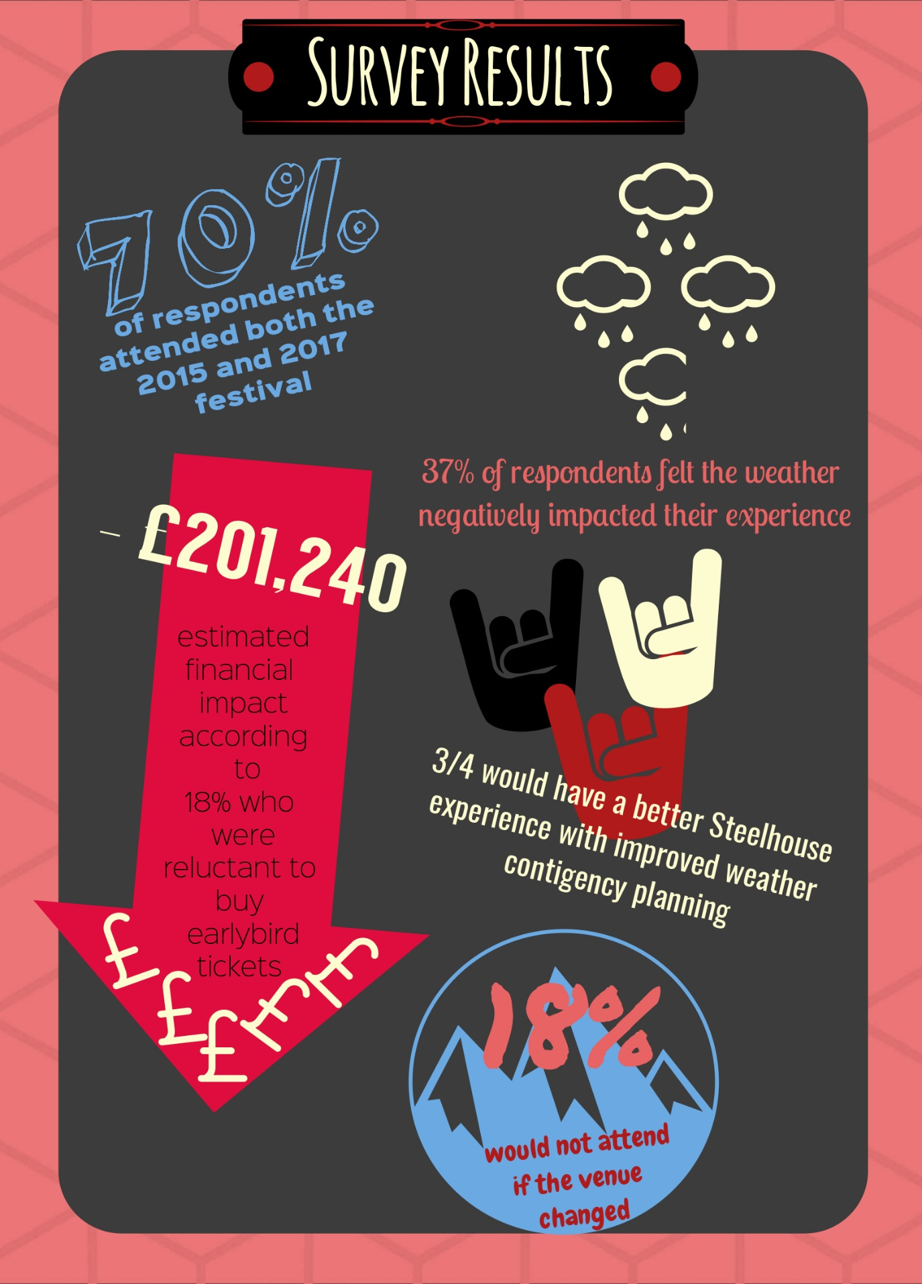
(Cook, 2018)

Question six analysis
The researcher chose an open question for the end of the survey to gain more qualitative data. The question was ‘Do you have any other comments about the weather contingency planning for Steelhouse Festival?’ there were 64 comments left meaning over a third of respondents chose to leave no further comment.
The answers ranged although most were positive, even those having complaints also praised the on-site staff for their work to mitigate the impacts of bad weather.
For the purpose of this report, the consultant has chosen to analyse six responses, which is approximately 10% of the comments.

Responses
“I’ve been every year to Steelhouse festival and the weather doesn’t bother me, but with children it bothers them. We have sometimes had to leave early or go dry off in the car, last year’s mud was the worst.”
The consultant chose to highlight this comment as it mentions the experience children are having at the festival. As it is a family friendly festival, it is important to consider the opinions of the younger generation attending with their parents or guardians as these children should be there to enjoy the festival, and if they are not enjoying the festival, it is likely the parents are impacted by this.
To mitigate the mud that was brought up track matting, hardcore and hay has been suggested in many comments left by attendees and it is a viable option for the festival. It’s difficult to act on the fact that the attendees are getting wet and having to dry off or leave early because it is an open air festival. It does provide shelter albeit the gazebos can be busy when the rain comes down, but they have enough space to accommodate most people on the mountain so if the customer chose not to utilise this area it’s not the responsibility of the event managers.
This respondent has attended Steelhouse festival in both 2015 and 2017 and felt the weather influenced the experience in a negative way but was not deterred from buying early bird tickets.
The following comment was long so the consultant has edited it for clarity and reduced the length.
“I go to Steelhouse every year and felt last year was the worst. The weather can’t be predicted but it was not prepared for either. I’m worried I will get my live in vehicle stuck in the field. I love the festival but last years conditions have stopped me purchasing tickets this year. The road is also getting worse each year yet the ticket prices are rising – which is understandable but there doesn’t seem to be anything extra. I believe a venue change is a better option.”
It is understandable that this commenter has concerned about getting live-in vehicles stuck in the field. The consultant is aware of the issue because of their personal experiences on the mountain and the live-in vehicle site becomes very difficult to manage when the fields get muddy. Although this response suggests they are reluctant to buy tickets after last year’s festival the answer to question three was ‘impartial’ which does not correlate with the comments left, this can affect the validity of this response, as it is not consistent.
As established by the interview conducted with festival organisers it is not an option to change the venue, however the comments about the live-in vehicle site will be considered and recommendations will be made to mitigate these impacts.

This comment has been edited for clarity.
“We were sent to an unsafe carpark to pitch our tent on. We ended up going home as we had nowhere for our whole party to sleep. We are reluctant to purchase tickets this year due to last year’s bad experience. The weather wasn’t the problem it was the inability of the organisers to deal with the conditions.”
The consultant is unsure what the commenter means by having nowhere for the whole party to sleep as 2017’s campsite was not at full capacity. It is clear that the respondent has not had a good time at Steelhouse festival as a result of the weather and the lack of contingency planning. This respondent only attended in 2017 which is disappointing that their first experience of Steelhouse festival was a negative one and they answered to say they are reluctant to buy tickets because of this.
This respondents answers strengthen the reasons to allocate a better budget to weather contingency instead of risking the huge financial impact that could arise if the festival proceeds the way it did in 2017.
The consultant has edited this comment as it was written in slang.
“The venue is what makes the festival special, I wouldn’t stop going but I think it would take the magic away. The weather can’t be predicted last year proves that. It is what it is and no matter what plans are put in place the weather could still surprise you, so we just have to take it on the chin and enjoy what has been given to us. There is no festival like it and I love that!”
The sentiments of this comment are echoed throughout the comments with many having the same view point that if bad weather occurs then attendees just need to get on with it. This could be because of the type of audience Steelhouse festival attracts who are predominantly rock fans that likely attend numerous festivals and have dealt with similar conditions before.
“Our issue is we come in our Motorhome & having to be towed every time is something we decided we would not do again. We will only be at steelhouse now if the weather is fine.”
Again, it is understandable that those who use the live-in vehicle site are concerned about the weather, not only is it inconvenient but Motorhomes are very expensive and the consultant empathises on why they would be reluctant to bring it to the venue when they are stuck.
The respondent has been put off purchasing early bird tickets to the festival because of the negative experience had, they also had attended in 2015 and 2017 so it’s disappointing to see a repeat customer could be lost through the weather effects on the live-in vehicle site.
“It really is about the availability of the facilities when the weather is bad that is the disappointing thing as in cleaning the toilets and the water delivery, after the bands these are the fundamental things when organising a festival. Therefore, it boils down to the access to the land in the event of particularly bad weather. I would have thought this would have had a contingency plan in place. This appeared not to be the case certainly for 2017.”
The comments made about facilities and drinking water are correct. The consultant can confirm that due to bad weather in 2017 deliveries of water and toilets were disrupted because the arena become logistically impossible for vehicles to move around. This does go against the founders idea of sanitation and visitor experience being the priority of the festival. The suggestions of hard core, track mats and ruby mats similar to those by the army have all been suggested in the comments, which could help vehicles, navigate around the site even in treacherous conditions.
Again, this respondent has been deterred from purchasing early bird tickets because of the 2017 festival.

4.0. Summary of primary analysis – survey

  - Financial Impacts
Question three asked respondents if negative experiences because of the weather has deterred them from purchasing early bird tickets for the following festival. This question was of particular importance because it shows the possible financial impacts that an ineffective weather contingency plan could have on the Steelhouse festival.
Early bird tickets are on sale immediately after the festival weekend and it is an essential form of revenue for the organisation to be able to instigate the planning process for the next festival.
Eighteen percent of respondents felt apprehensive about purchasing early bird tickets. Though this would not appear a large percentage when the sample is multiplied by the overall attendee numbers it could spell dire financial consequences for a self-sustaining festival.
The consultant estimates the financial loss to be in the region of £201,240.
The above figure was based on the following equation:
18% of 13,000 x £80 + 30% of 2,430 x £20
The above is based on a full weekend ticket at the early bird price based on 2017’s ticket pricing. The percentage of camping tickets that would be bought was worked out by using the average percentage of ticket holders who do camp at the event which is 30% (Rhead, Evans, 2018).
  - Further summary of primary analysis – survey
It is evident when comparing the interview and survey conducted that the owners have a differing opinion on the financial impacts of poor weather planning to the attendees. Matthew and Mikey claimed in their interview that they saw no impact on ticket sales in the years following particularly bad weather. It could be said that as owners there may be some bias in this opinion, as they would only want to believe positive things about the business. However, the consultant does not believe this is the case with Matthew and Mikey as they have been transparent throughout the project and fully address the need for a stronger weather contingency plan. Probable reasons the tickets are not impacted is because it is still a festival that is experiencing growth year on year. If a festivalgoer decides to not buy a ticket there will be a new customer taking their place.
The financial impacts of not providing sufficient weather contingency planning are frankly worrying for a business, which relies on the sale of early bird tickets to enable cash flow. It is a possibility that the customers who are hesitant to purchase early bird will still attend but purchase tickets closer to the time at a higher premium. This is positive because the tickets are sold at a higher price resulting in a bigger profit margin. Nevertheless, can also prove detrimental because without festivalgoers purchasing early bird tickets it is difficult to start planning the next festival. Bands often require fees upfront and contracts with logistic providers, glamping subcontractors and staging engineers often need to be agreed to far in advance before they are booked by another festival as the weekend of Steelhouse festival (last weekend of July) is popular on the festival calendar. Without liquid capital upfront it will delay the cash flow process and disable the owners from managing early relationships with creditors and performers which as essential to the festival.
The live-in vehicle site is mentioned frequently and subsequently will be considered in the recommendations. Other frequent comments left mentioned the use of track mat, rubber boards, palettes, hay, hard core and more covered spaces; some of which will be considered in the recommendations.

5.0. Conclusion

To conclude the consultant believes through the use of primary and secondary research it is evident that the attendees of Steelhouse Festival do want to see an enhanced weather contingency plan at the 2018 festival. If this is not implemented the consultant believes customer confidence will be effected and the visitor experience will be seriously impacted.
The interview and survey bore some resemblance in regards to the types of materials that could be used on site and had stark differences in attitudes to the financial impact of poor weather mitigation. A festival of this size cannot sustain an impact on cash flow that the respondents suggested. Fortunately, this has not been the case so far, but it is important to note that it could become a possibility if action is not taken.
The consultant believes that overall most of the festival attendees remain unfazed by the weather effects on the Steelhouse Festival. Nevertheless, the percentage of attendees who had a negative experience because of the weather are important because the company prioritises visitor experience. After some critical reviews left on the Steelhouse Festivals facebook page after the 2017 Matthew Rhead stated that himself and Mikey wanted to show the festivalgoers in 2018 that they are listening and making changes to ensure everyone on site is happy (Rhead, Evans, 2018).
It is unrealistic to please everyone, and the weather will always be unpredictable in Wales but if the owners show they are doing everything to mitigate the impacts then no more can be achieved. It is hoped that by implementing more weather contingency sources that overall visitor experience will improve. The consultant is aware that as a festival Steelhouse Festival receives minimal complaints from festival goers so it would be a shame that a festival, which is such a great experience all round would be hindered by weather impacts.
The consultant has chosen recommendations based on a collation of all of the data received and analysed to give realistic recommendations to the Steelhouse Festival owners. Options that are suitable for the ecology of the venue and financially viable as well as options to offset the costs of the weather contingency plans which will reserve budgets to improve other facilities on the site.

6.0. Recommendations

After analysing all of the feedback from Steelhouse Festival attendees, the festival owners and comparing various weather contingency plans from festivals around the UK the consultant has a number of recommendations.
These recommendations will be explained below and costed if applicable.
The consultant has also included a map of the site of Steelhouse festival with a key to highlight what sources are recommended for each areas.
  - Hay
Hay is already a staple of the Steelhouse festival contingency plan but supplies have been insufficient in previous years, such as 2017 shown below.
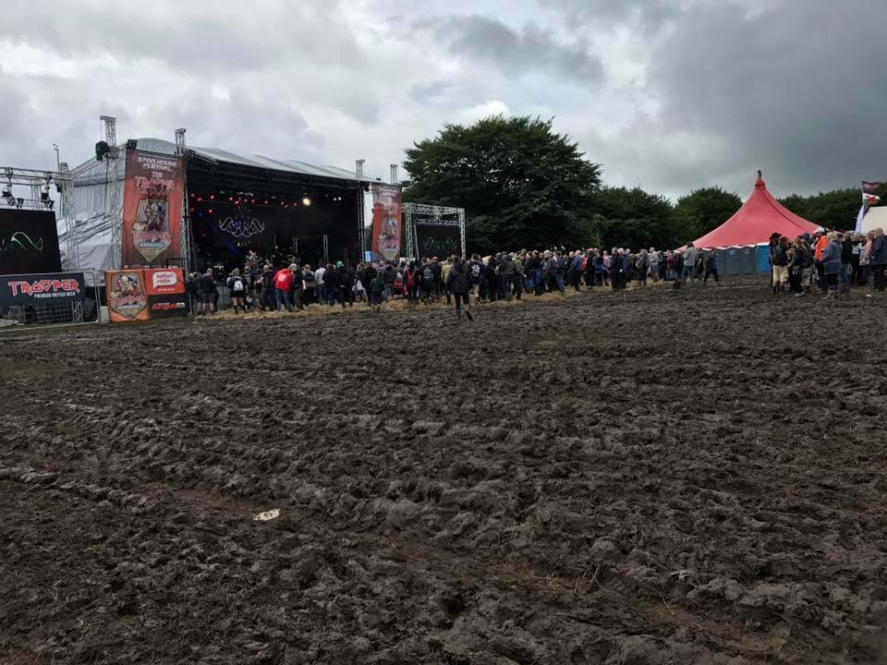
The consultant believes hay is a cost effective way to manage the main arena and is viable option for the sensitivity of the site. As shown above some hay is visible but there is also a great deal of mud, the consultant is aware that this is because of insufficient supplies. The hay that was laid worked very well to lessen the impact of the mud in the arena.
One round bale of hay is approximately £29.99 which is for sale on Ebay (Ebay, 2018). The consultant believes that the festival organisers could purchase this cheaper and in a bigger bulk through the farmer who they rent the ground from.
The consultant will exclude this cost from the budget because it’s unclear what deal the organisation has with the farmer to deliver hay supplies to the site.
  - Hard core/Gravel
Many responses from the survey conducted by the researched mentioned more hard core and gravel on site. However, the consultant knows from the interview with Matthew and Mikey that this is not suitable for the roads around the site. The consultant recommends this source be laid in the live-in vehicle site at entrances and exits to try stop vehicles being stuck in the mud thus causing delays in getting everyone on site and evacuating the site.
810kg of gravel is available from Travis Perkins for £53.40 (Travis Perkins , 2018). The consultant estimates that around 10 bags of gravel should be enough to lay an initial layer on the entrance and exit and have surplus supplies if the weather is bad to add more.
The consultant is reluctant to recommend this source all over the site as it is hard to remove and the venue has to be cleared as much as possible because it is a working farm.
The total cost of this would be £530.40, which is a reasonable price when considering that the live-in vehicle site users who left comments had voiced the concern of returning to the festival, which would cause a big financial loss to the company.
  - Track Mats
Track mats were an option, which appeared in other festivals adverse weather policies and was suggested by survey respondents. This is also a viable option as it has a minimal impact on the venue as it’s totally removable.
The consultant recommends the use of track mats on all main walkways into the arena and camping sites of which there are three – one family, one adult and one accessible camping. The track matting should also be used at the box office were every festivalgoer will enter the site and que to receive wristbands making the area muddy.
The consultant has sourced a reputable company who have the likes of Glastonbury, Download, T in The Park, London Marathon and the Rugby World Cup amongst their customers.
An approximate cost from this company for one weeks hire with full installation was £9,280 with the trackway being suitable for pedestrians and vehicles (Trakway, 2018).
  - Changing paths on bottleneck areas to relieve the ground
A small change which could relieve the main pathway into the festival site would be to alternate it between two paths or create two entrances so the number of people entering on one path would be reduced making the path less likely to be churned up.
This has been highlighted on the map below.
  - Changing fields to relieve land
To relieve the fields that are used every year, the consultant suggests utilising some other fields that are available to the event managers.
This plan has been used as a contingency plan in other years when the weather has been bad and the main field are impassable. It was successful and so it is being considered for the primary plan now instead of the contingency plan by the owners.
The map below has been updated by Matthew Rhead to show the fields that were previously used as contingency are now the primary fields for car parking.
  - Charging a car park fee
Approximately 1,500 vehicles use the car park at Steelhouse Festival over the weekend (Rhead, 2018). The owners of the festival have expressed they are not opposed to charging a car parking fee as long as it is marginally less than other UK festivals and the money made would be for better weather contingency sources only (Rhead, Evans, 2018).
The consultant has spoken with the festival owners and decided that £5 is a reasonable amount to charge per car, this is very good value as other UK festivals charge up to £60 to park in their carparks.
In total £7,500 could be raised through this method to add to the weather contingency budget giving the organisers the freedom to put more sources in place with less of a financial burden.

Please turn to the next page to view the venue map.
The venue map has been updated by Matthew Rhead to show the change of fields from the ones used in 2017 to help prevent the ground becoming water logged.
  - Map
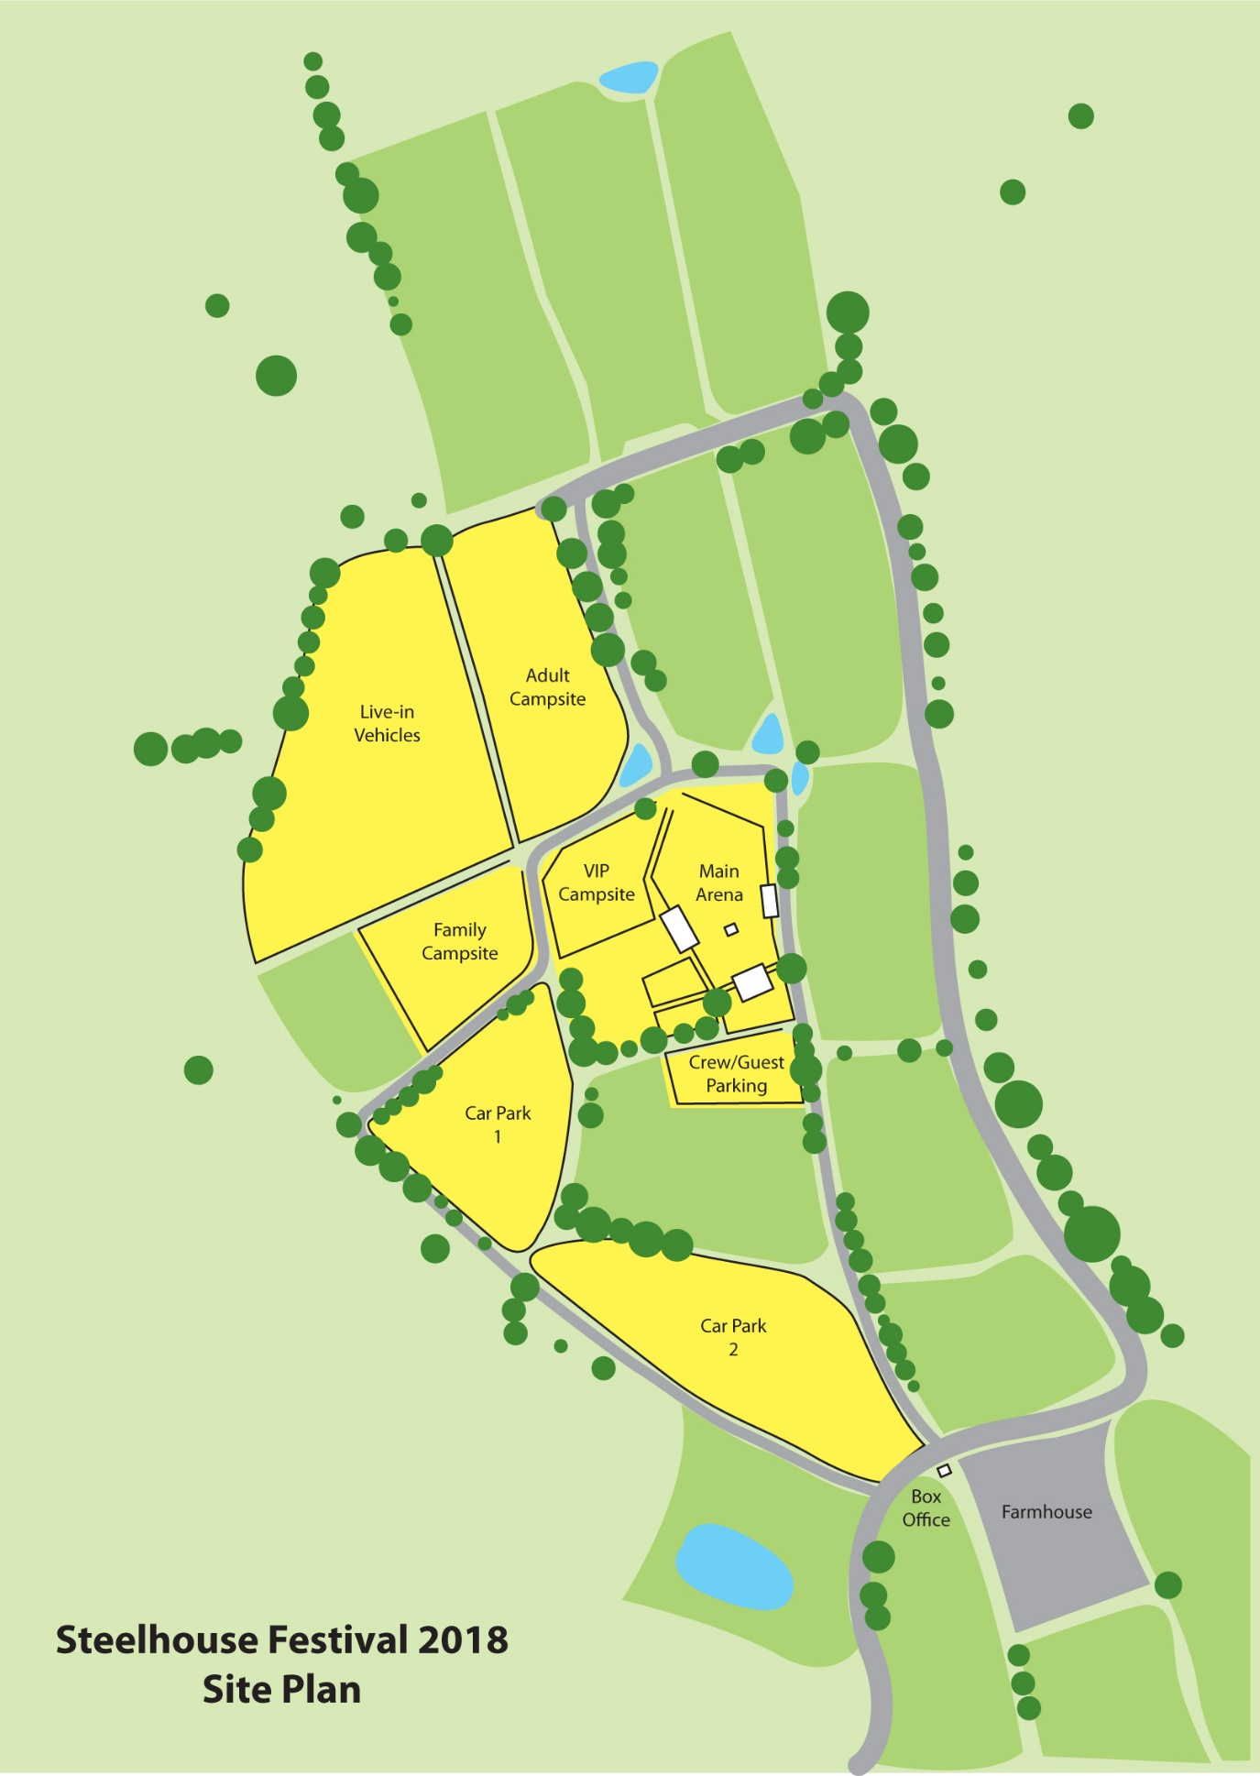
[Grab your reader’s attention with a great quote from the document or use this space to emphasize a key point. To place this text box anywhere on the page, just drag it.]
( Steelhouse Festival Ltd. , 2018)
  - Map Key
- Track matting
- Paths into festival
- Gravel/Hardcore
- Hay

7.0. Overall Cost
Overall, the cost of the weather contingency plan the consultant has put together would total:
£9,810.40 (excluding the cost of hay)
The client can use components of the plan where they see fit or invest in the whole plan. The consultant believes the initial investment of this contingency plan is cost effective for the festival and will stop any negative financial impacts that could be caused by lack of planning in the future.
The sources the client has come up with have been both cost effective and are suitable for the ecology of the site, which is a desired outcome of the project.
Because of the proposed car parking fee-generating revenue of £7,500 which is allocated entirely to the weather contingency plan. The amount that the organisers would have to allocate from the event budget would be £2,310.40. This extra working capital cost should be mitigated through marketing campaigns that will result in ticket sales. Targeted and sponsored social media posts should be utilised to announce the enhanced weather contingency plan to inspire consumer confidence, this is especially important to appeal to those who have left comments on the festival pages with their concerns about returning to the festival if the weather contingency plans were not improved.
Overall the investment into the weather contigency plan will show the customer base that Steelhouse Festival Ltd. are listening to their concerns and want to ensure there visitor experience is highly prioritised. A possible outcome will be increased customer satisfaction and better working conditions for volunteers, performers and most importantly to Steelhouse Festivals loyal attendees. The consultant is giving recommendations to the Steelhouse festival ltd. it is the choice of the organisation to implement these recommendations.

Bibliography

BBC News, 2017. Y Not festival: Organisers agree to give 50% refunds. [Online]
Available at: http://www.bbc.co.uk/news/uk-england-derbyshire-40837510
[Accessed 5th April 2018].

Count of Ten Group, 2015. Adverse Weather Plan, Derby : Derbyshiredales.gov.uk.

Steelhouse Festival Ltd. , 2018. Steelhouse Festival 2018 Site Plan. Cwm: Matthew Rhead.

Cook, R., 2018. Survey - How does weather affect your Steelhouse Festival experience?. Abertillery: Survey Monkey .

Ruth Dowson, D. B., 2015. Event Planning and Management: A Practical handbook for PR and Events.. 1st ed. London & Philadelphia : Kogan Page Limited .

Ebay, 2018. Bulk buy hay. [Online]
Available at: http://www.ebay.co.uk/itm/like/221289965870?clk_rvr_id=1513839879498&vectorid=229508&lgeo=1&item=221289965870&rmvSB=true
[Accessed 28th April 2018].

John, 2015. Festivals and Gigs. [Online]
Available at: http://www.festivalsandgigs.com/history-and-predictions-glastonbury-festival-weather
[Accessed 2nd April 2018].

Rawlinson, K., 2016 . Glastonbury Farm to move from Worthy farm in 2019, says founder. [Online]
Available at: https://www.theguardian.com/music/2016/dec/19/glastonbury-festival-to-move-from-worthy-farm-in-2019-says-founder
[Accessed 2nd April 2018].

Rhead, Evans, 2018. Interview by Rhian Cook with Matthew Rhead and Mikey Evans - 20th April 2018. Cwm: Rhian Cook.

Rhead, M., 2018. Meeting with Matthew Rhead - 19th March. Cwm: Rhian Cook and Matthew Rhead.

Trakway, 2018. Trakway - Quote email. Abertillery: Rhian Cook .

Travis Perkins , 2018. [Online]
Available at: https://www.travisperkins.co.uk/Gravel-Shingle-20mm-Bulk-Bag/p/938191
[Accessed 28th April 2018].

