Module: Strategic Management & Sustainability
Module code: LCBB6004
Assignment Title: Component 1 Coursework: Written Report
Student’s Name: Mariana Popa
Student’s ID:2122750
Lecturer: Stephen Asafo
Submission Date:28/08/2024

Table of Contents
Introduction 3
Corporate and Business Strategies 3
Resources and Capabilities 6
Evaluating Unilever's Success in Strategy Implementation and Competitive Advantage Creation 9
Recommendations 12
Conclusion 14
References 16
Appendix: Detailed Strategic Analysis 19
SWOT Analysis 19
PESTEL Analysis 19
Porter's Five Forces Analysis 20

Introduction
Unilever is a British multinational consumer goods company co-headquartered in London, United Kingdom. It is the largest producer of soap in the world and owns over 400 brands including Dove, Lifebuoy, Sunsilk, Axe, Lux, Omo and Surf. Unilever's products are available in around 190 countries and used by 2.5 billion people on any given day (Unilever, 2021). This report will analyse Unilever's key business and corporate strategies, how it has aligned its resources and capabilities to those strategies, evaluate its success in strategy implementation and in balancing competitiveness with sustainability, and provide recommendations for Unilever's future strategic direction. Strategic analysis tools like SWOT, PESTEL and Porter's Five Forces will be used to better understand Unilever's business environment, with the detailed analyses provided in the appendix.
Corporate and Business Strategies
Unilever's corporate strategy focuses on achieving sustainable growth and creating long-term value for its stakeholders. Its strategic priorities are: 1) Developing its portfolio into high growth spaces 2) Winning with brands and innovation 3) Accelerating in developing markets 4) Leading in the channels of the future and 5) Building a purpose-led, future-fit organization and growth culture (Unilever, 2021).
At the business level, Unilever operates three global divisions - Beauty and Personal Care, Foods and Refreshment, and Home Care. Each division has its own set of strategies tailored to the specific characteristics and demands of its product categories and markets.
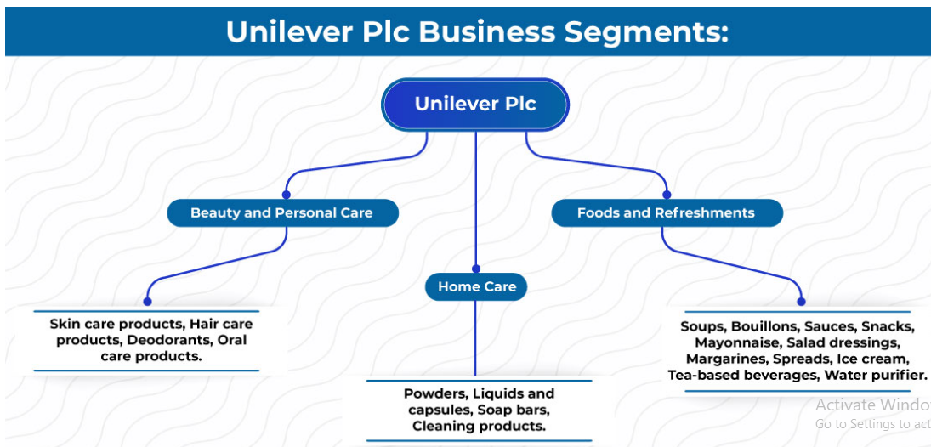
Figure 1: Unilever Plc Business segments
Source: (Unilever, 2021).
The Beauty and Personal Care division aims to deliver superior products that provide functional and emotional benefits. Its strategy revolves around building global mega-brands like Dove, Axe, Rexona and Sunsilk, while also developing a prestige portfolio in skin care and hair care through acquisitions (Unilever, 2020a).
The Foods and Refreshment division focuses on offering healthier and more sustainable food choices. Its strategy includes reformulating products to improve their nutritional profile, expanding its plant-based portfolio, reducing food waste, and developing brands with purpose such as Knorr, Hellmann's and Lipton (Unilever, 2020b).
The Home Care division's strategy is centred around making cleaning more sustainable and affordable while providing superior cleaning. This involves growing brands like Omo, Surf, and Sunlight; improving product formulations; pursuing new business models, including subscription services; and working with partners to drive systems change (Unilever, 2020c).
The business strategies at Unilever are steered by its compass strategy framework: to deliver superior long-term financial performance and to drive sustainable value creation. Compass guides the strategic choices of Unilever and measures its progress. It articulates Unilever's multi-stakeholder business model focused on brands with purpose, improved health and well-being, environmental sustainability, and more in business, long-term growth, and financial resilience (Unilever, 2021).
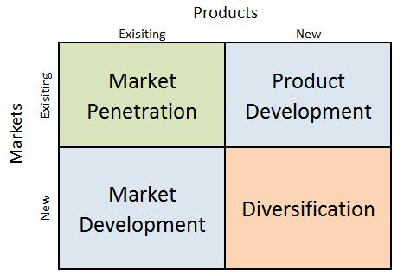
Figure 2: The Ansoff Matrix
Source: (Ansoff, 1957).
The Ansoff Matrix can be further used to understand the business strategies of Unilever. Unilever seeks out market penetration, which is an increase in the market share of its existing brands in current markets. Examples include the relaunch of Lifebuoy in India and Dove's campaigns to strengthen its connect with consumers (Unilever, 2020a). Product development exists in Unilever innovation across divisions, be it Dove's entry into the baby care market or the expansion of vegan and vegetarian food options under Vegetarian Butcher brand (Unilever, 2020a; 2020b). Unilever has also explored market development by extending brands to new markets, such as the launch of its Matey bubble bath brand in Brazil (Unilever, 2020d). Finally, diversification is a step Unilever has taken in entering the health and wellness platform through the acquisition of brands such as Olly, Equilibra, and Onnit (Unilever, 2021).
The corporate strategy therefore sets a clear direction for Unilever, and the divisional strategies elaborate on how it will achieve this with sustainable growth in its key businesses and markets. The strategies also closely relate to Unilever's renewed Compass framework and its purpose-driven, multi-stakeholder business model.
Resources and Capabilities
A firm's resources and capabilities shape its potential to establish a competitive advantage (Grant, 1991). Unilever's key resources and capabilities include:
Brand Portfolio: Unilever owns some of the world's most valuable consumer brands like Lipton, Knorr, Dove and Omo. 12 of its brands generate over €1 billion in revenue annually (Unilever, 2021). Unilever's brand-building capabilities, honed over its 90+ year history, are a source of competitive advantage.
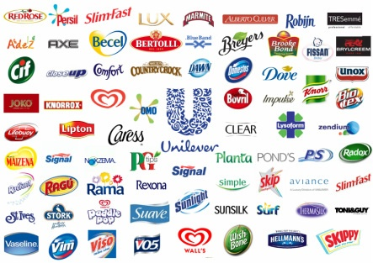
Figure 3: Unilever’s brand portfolio
Source: (Unilever, 2021).
Global Reach: Unilever products are sold in over 190 countries, giving it an unparalleled global presence and distribution reach. 58% of its 2020 turnover came from emerging markets, highlighting Unilever's penetration in these high-growth economies (Unilever, 2021).
R&D and Innovation: Unilever has world-class R&D capabilities with over 5000 people working across multiple global centres (Unilever, 2021). Its strong innovation pipeline is evidenced by the 19 billionEUR innovations launched over the last 10 years (Unilever, 2020a).
Sustainability Focus: Unilever has been a pioneer in integrating sustainability into its business model. Its Sustainable Living Brands delivered 75% of Unilever's growth in 2019 (Unilever, 2020e). Unilever's sustainability initiatives resonate with consumers and provide a differentiated positioning.
Talent and Culture: Unilever has a strong employer brand and is routinely ranked as a top employer globally (Forbes, 2020). It attracts and retains high-calibre talent which drives its growth and execution. Unilever's agile, growth-oriented culture fosters innovation and purpose.
Economies of Scale: Unilever's size provides significant scale economies in areas like procurement, manufacturing and distribution. This enables better margins which can be reinvested for growth. Unilever is the largest commercial buyer of palm oil globally and its scale allows it to influence the palm oil industry's sustainability standards (Unilever, 2021).
Financial Strength: Unilever is a financially robust company with steady revenue growth, healthy operating margins (~16%), strong cash generation and a solid balance sheet (Unilever, 2021). This provides Unilever the flexibility to make strategic investments.
To evaluate how Unilever's resource base aligns with its strategies, the VRIO framework can be applied (Barney, 1995):
Valuable | Unilever's resources like its brands, global presence, innovation capabilities, and sustainability focus allow it to exploit market opportunities and mitigate threats, making them valuable.
Rare | While some resources like financial strength are not rare, Unilever's brand portfolio and global reach are relatively rare, especially the combined brand value and scale within the consumer goods space.
Inimitable | Unilever's brand equity, R&D capabilities, talent and sustainability reputation have been built over decades and have strong historical and causal ambiguity, making them difficult to imitate.
Organized | Unilever appears to be well organized to exploit its key resources. Its divisional structure allows it to effectively manage its brand portfolio. Its HR and cultural practices enable it to harness talent. Sustainability is deeply embedded into its operations.

In summary, Unilever's VRIO resources align well with and enable its corporate and business strategies around brand focus, innovation, developing markets expansion and sustainability leadership. Unilever's strategies aim to leverage its historical strengths while developing new capabilities for the future.
Evaluating Unilever's Success in Strategy Implementation and Competitive Advantage Creation
Unilever has demonstrated considerable success in implementing its corporate and business strategies to compete effectively and create competitive advantages. At the corporate level, Unilever's strategy has centred on creating a more resilient, sustainable, and profitable business model. This has involved active portfolio management, with a focus on acquiring and growing brands in high-growth segments while divesting non-core or underperforming assets. Over 2017-2020, Unilever made €6.2 billion worth of acquisitions and €4.1 billion in divestitures (Unilever, 2021). Acquired brands like Dollar Shave Club (male grooming), Pukka Herbs (organic herbal tea), and Horlicks (health food drinks) have strengthened Unilever's presence in attractive, fast-growing categories.
Unilever's business strategies have focused on accelerating growth in its three core divisions through innovation, market development, and sustainability-led differentiation. In Beauty and Personal Care, Unilever has successfully premiumized its portfolio through innovations like Love Beauty and Planet (eco-conscious personal care) and Dove Hair Therapy (premium hair treatments). These launches have enabled Unilever to capture the growing consumer preference for natural, purpose-driven brands. In 2020, Unilever's Prestige Beauty business grew 5.3%, outperforming the overall Beauty and Personal Care division (Unilever, 2021). This highlights the competitive advantage of Unilever's premiumization strategy.
In Foods and Refreshment, Unilever has focused on improving its portfolio's health and sustainability profile. By the end of 2020, 61% of Unilever's food portfolio met WHO-aligned nutritional standards, up from 56% in 2019 (Unilever, 2021). Unilever has also accelerated its plant-based offerings, expanding brands like Hellmann's Vegan Mayo and Magnum Vegan ice cream. In 2020, Unilever's Vegetarian Butcher brand grew over 70%, indicating strong consumer traction (Unilever, 2021). These initiatives have helped Unilever compete more effectively in the fast-growing health and wellness segment.
In Home Care, Unilever has driven growth by expanding into premium segments and developing markets. The 2016 acquisition of Seventh Generation, a leader in eco-friendly homecare products, enhanced Unilever's 'natural' credentials (Unilever, 2016). In 2020, Seventh Generation grew double-digits, with products like disinfecting sprays seeing over 50% growth due to heightened hygiene concerns (Unilever, 2021). Unilever's Surf Excel brand, relaunched as 'purpose-driven homecare', has grown strongly in developing markets like India. These successes demonstrate Unilever's ability to leverage its sustainability focus for market share gains.
Unilever's implementation of its sustainability agenda has been a key source of competitive advantage. By the end of 2020, Unilever had reduced greenhouse gas emissions from its operations by 64% compared to 2015 (Unilever, 2021). It had also helped 1.3 million smallholder farmers gain access to training and improved agricultural practices (Unilever, 2021). Unilever's 'Sustainable Living Brands', which have integrated sustainability into their purpose and products, grew 69% faster than the rest of the business in 2019 (Unilever, 2020). Brands like Lifebuoy (hygiene soap) and Domestos (toilet hygiene) saw strong growth as their 'germ-kill' positioning resonated during the pandemic. Love Beauty and Planet (eco-conscious personal care) delivered €140 million in turnover in 2020, just two years after launch (Unilever, 2021). These results underscore how sustainability is creating competitive differentiation for Unilever.
However, there are areas where Unilever's strategy execution has faced challenges. In Foods & Refreshment, Unilever has struggled to drive sustained growth, with the division seeing muted 1.5% underlying sales growth in 2019 and a 1.2% decline in 2020 (Unilever, 2021). Changing consumer preferences, competition from niche brands, and portfolio complexity have hindered growth. In response, Unilever is undertaking a strategic review of its global tea business while investing in attractive segments like plant-based foods and 'healthy snacking'.
Unilever's sustainability journey has also faced obstacles. While it has made strong progress on several fronts, it has faced criticism for not doing enough to fight deforestation and protect workers in its palm oil supply chain (Watts, 2019). In 2020, Unilever was suspended from the Roundtable on Sustainable Palm Oil (RSPO) for breaches of its code of conduct (Ecosia, 2020). While Unilever's membership was later reinstated, the episode damaged its sustainability reputation. Unilever has also struggled to meet some of its packaging targets – in 2020, only 50% of its plastic packaging was recyclable, reusable or compostable against a target of 100% by 2025 (Unilever, 2021). These challenges highlight the complexities in executing a multi-stakeholder sustainability agenda.
Overall, Unilever's strategy implementation has enabled it to compete effectively across key categories and geographies. Its focus on innovation, premium segments, purpose-driven brands, and sustainability has created competitive advantages. However, sustaining growth in challenging market conditions and fully delivering on its sustainability agenda remain key priorities. Unilever's ability to adapt and execute at speed will determine its competitive success in the coming years.
Recommendations
Going forward, Unilever should consider the following strategic directions to further its sustainable growth agenda:
Strengthen footprint in high-growth segments: Unilever should double down on its presence in attractive, fast-growing market segments like Prestige Beauty, Health & Wellbeing and premium Asian skincare. Prestige Beauty is estimated to grow 6-8% annually till 2024, led by Asia (McKinsey, 2020). The global health and wellness food market is poised to grow at a 6% CAGR over 2021-2026 (Research and Markets, 2021). Accelerating expansion in these high-margin, purpose-aligned segments can unlock new sources of sustainable growth for Unilever.
Transform Foods and Refreshment: Unilever's Foods & Refreshment division has been a drag on growth, with underlying sales declining 1.2% in 2020 (Unilever, 2021). The company should comprehensively re-evaluate its portfolio and exit structurally challenged parts of the business. For example, in 2021, Unilever initiated a strategic review of its global tea business, which has seen sluggish growth amidst changing consumer preferences (Unilever, 2021). Simultaneously, Unilever should aggressively expand into the plant-based foods space, which is expected to grow at a 15% CAGR between 2020-2027 (Meticulous Market Research, 2020). Unilever's Vegetarian Butcher brand provides a strong foundation to scale plant-based offerings.
Accelerate digitization: E-commerce now accounts for 9% of Unilever's turnover (Unilever, 2021). With the pandemic accelerating e-commerce adoption globally, Unilever should further scale up its digital marketing, direct-to-consumer (D2C), and e-B2B capabilities. Prestige Beauty brand Dermalogica's D2C sales doubled in 2020, highlighting the potential for direct selling models (Unilever, 2020a). Unilever should extend D2C to more of its premium brands where consumers value personalized engagement. Establishing strategic partnerships with e-commerce players like Alibaba and Amazon can enhance Unilever's digital routes to market.
Achieve net positive sustainability: Unilever has made strong progress on sustainability but now needs to transition from doing 'less harm' to having a 'net positive' impact on people and planet. This involves initiatives like:
- Developing 'circular economy' solutions that design out waste and keep materials in use. Expanding refill and reuse platforms is one opportunity. Unilever has piloted in-store refill stations for brands like Sedal (Unilever, 2019).
- Achieving a deforestation-free supply chain for palm oil, soy, paper and beef.
- Supporting regenerative agricultural practices to enhance soil health, increase biodiversity and improve farmer livelihoods.
- Leveraging its scale to drive positive change across the wider ecosystem of consumers, suppliers, and peer companies.
Unilever's Cleaner Planet plan, aiming to collect and recycle more plastic than it sells by 2025, is a step in this direction (Unilever, 2020g). By proactively shaping the sustainability agenda, Unilever can build competitive advantage in an increasingly values-driven consumer landscape.
Pursue bolt-on acquisitions: While Unilever should be disciplined with M&A, it should continue to pursue selective bolt-on acquisitions to gain differentiated capabilities and access to strategic segments. Potential areas to explore include digital-native, purpose-led beauty brands, nutraceuticals, and sustainable home care solutions. Unilever's 2019 acquisition of OLLY, a premium gummy supplements brand, is an example of how bolt-ons can enhance Unilever's presence in high-growth, future-fit spaces (Unilever, 2019c).
Foster a growth mind-set culture: To thrive long-term, Unilever needs to further instil a growth mind-set among its 149,000 employees worldwide. This involves encouraging risk-taking, experimentation, agile ways of working and a 'founder's mentality' (Zook and Allen, 2016). Unilever should hardwire 'purpose' as a key driver of employee motivation. A 2019 Unilever study found that its most purpose-driven employees reported higher levels of customer focus, innovation and growth orientation (Vaughan-Lee, 2019). Fostering such a purpose-growth link among all employees can be a powerful cultural enabler.
Conclusion
Over its 90+ year history, Unilever has established itself as a global leader in the consumer goods industry through effective corporate and business strategies. Its focus on building purpose-led brands, expanding in developing markets, leading in innovation, and driving sustainability has enabled it to create significant value for its stakeholders. However, Unilever operates in a dynamic business environment characterized by rapidly evolving consumer preferences, disruptive technologies, and intensifying competition. To sustain its track record of long-term value creation, Unilever must proactively adapt its strategies to navigate emerging opportunities and challenges.
By strengthening its position in high-growth market segments, transforming its Foods and Refreshment division, accelerating digitization, pursuing a net positive sustainability agenda, making selective acquisitions, and fostering a purpose-growth culture, Unilever can build new avenues for competitive advantage. An unwavering commitment to sustainability and purpose must remain at the heart of Unilever's business model.
The Unilever Compass provides a robust strategic framework to guide these choices and initiatives. By delivering on its multi-stakeholder model that serves consumers, customers, employees, suppliers, communities, and the planet, Unilever can remain at the forefront of the industry. Effective strategy development and disciplined execution will be key to achieving Unilever's vision of being the global leader in sustainable business.

References
Ansoff, H. I., 1957. Strategies for diversification. Harvard business review, 35(5), pp.113-124.
Forbes, 2020. The World's Best Employers 2020. [online] Available at: https://www.forbes.com/lists/worlds-best-employers/ [Accessed 18 August 2024].
Grant, R., 1991. The resource-based theory of competitive advantage: implications for strategy formulation. California management review, 33(3), pp.114-135.
McKinsey, 2020. How COVID-19 is changing the world of beauty. [online] Available at: https://www.mckinsey.com/industries/consumer-packaged-goods/our-insights/how-covid-19-is-changing-the-world-of-beauty [Accessed 18 August 2024].
Meticulous Market Research, 2020. Plant Based Food Market by Product Type, Source, and Distribution Channel - Global Forecast to 2027. [online] Available at: https://www.meticulousresearch.com/product/plant-based-food-products-market-5108 [Accessed 18 August 2024].
Research and Markets, 2021. Health and Wellness Food Market - Growth, Trends, COVID-19 Impact, and Forecasts (2021 - 2026). [online] Available at: https://www.researchandmarkets.com/reports/5240784/health-and-wellness-food-market-growth-trends [Accessed 18 August 2024].
Unilever, 2016. Unilever acquires Seventh Generation, Inc. [online] Available at: https://www.unilever.com/news/press-releases/2016/unilever-acquires-seventh-generation.html [Accessed 18 August 2024].
Unilever, 2019a. Refill stations for Sedal shampoo and conditioner open across Mexico. [online] Available at: https://www.unilever.com/news/news-and-features/Feature-article/2019/refill-stations-for-sedal-shampoo-and-conditioner-open-across-mexico.html [Accessed 18 August 2024].
Unilever, 2020e. Unilever's Sustainable Living Brands continue to drive higher rates of growth. [online] Available at: https://www.unilever.com/news/press-releases/2020/unilevers-sustainable-living-brands-continue-to-drive-higher-rates-of-growth.html [Accessed 18 August 2024].

Appendix: Detailed Strategic Analysis
SWOT Analysis
Strengths | Weaknesses
- Diverse portfolio of market-leading brands across key categories  - Wide global presence and deep penetration in emerging markets  - R&D capabilities and track record of innovation  - Reputation for sustainability and corporate responsibility  - Talent and growth-oriented organizational culture  - Cost efficiency from economies of scale  - Strong financial performance and cash generation | - Dependence on mature, low-growth categories in foods and refreshments  - Gaps in portfolio in high-growth segments like health and premium beauty  - Sluggish growth in developed markets of North America and Europe  - Complexity of managing a highly diversified brand portfolio  - Exposure to volatility in raw material costs and exchange rates
Opportunities | Threats
- Expansion in high-growth segments of Prestige Beauty, health and wellness  - Accelerated growth in developing and emerging (D&E) markets  - Portfolio premiumization in high-margin categories  - Increased adoption of digital shopping and e-commerce  - Growing consumer preference for purpose-driven, sustainable brands  - Targeted M&A to access new markets, segments and capabilities | - Intensifying competition from global and local players  - Changing consumer preferences and market fragmentation  - Retail landscape disruption and consolidation of buying power  - Fluctuations in commodity costs and currency devaluations  - Tightening regulations around packaging and supply chain practices  - Economic slowdown and uncertain geopolitical environment

PESTEL Analysis
Political: | - Uncertain geopolitical environment and trade tensions (e.g. US-China, Brexit)  - Diversity in operating environments' political stability/policy across markets  - Regulations around data privacy and localization (e.g. EU's GDPR)
Economic | - Potential global economic slowdown impacting consumer spending  - High volatility in currency exchange rates, especially in emerging markets  - Rising inequality within and across countries
Social | - Growing consumer preference for health, wellness and natural products  - Increasing importance of sustainability and ethics in purchasing behaviour  - Aging population in developed markets, growing youth in developing regions  - Rising affluence and aspirations in developing and emerging (D&E) markets
Technological: | - Digital transformation and accelerated e-commerce adoption  - Advances in AI/analytics enabling personalized consumer engagement  - New technologies enabling product and packaging sustainability  - Disintermediation of traditional advertising models
Environmental | - Growing focus on climate change and environmental sustainability  - Regulations on plastic waste, sustainable packaging and ethical sourcing  - Rising activism around deforestation, biodiversity loss, water scarcity
Legal | - Diversity in legal and regulatory environments across operating markets  - Regulations on product safety, labelling and supply chain transparency  - Tax law changes and increased scrutiny of tax structures

Porter's Five Forces Analysis
Threat of New Entrants: Moderate
- High initial capital requirements and need for extensive distribution
- Entrenched loyalty to established brands among consumers and retailers
- Access to large-scale raw material supply and R&D a barrier
- Low asset specificity and absence of other exit barriers
- Insurgent brands gaining share through differentiation and digital channels
Bargaining Power of Suppliers: Moderate
- Unilever's large scale provides leverage over many suppliers
- Commoditized nature of many raw materials (oils, chemicals)
- High forward integration of some suppliers, especially in agribusiness
- Increasing attention to sustainable/ethical supplier practices
Bargaining Power of Buyers: High
- High buyer concentration, with large retailers and e-commerce players
- Low switching costs enable consumers to shift brands easily
- Retailer focus on private label and e-commerce enabling easier price comparison
- Low brand loyalty in many household goods categories
Threat of Substitutes: High
- Low perceived differentiation in some categories (e.g. laundry detergent)
- Easier for consumers to trade up/down to adjacent price points
- Emerging preference for natural, organic substitutes in personal care
- Private label a viable substitute in many packaged goods categories
Rivalry Among Existing Competitors: High
- Multiple global competitors (P&G, Nestle, Colgate) and strong local players
- Frequent new product introductions and short product lifecycles
- High advertising and trade spending intensity among major brands
- Slow overall industry growth putting pressure on market shares

