Contents
Contents 1
Personal statement 3
Education 3
Relevant Work Experience 3
Key Skills 3
Planning and Organisation 3
Team Work 3
Resilient 3
IT 4
Positions of Responsibility 4
Awards and Achievements 4
Hobbies and Interests 4
References 4
Job 5
Cover letter 6
References 7

Catherine Jones
2016142

CV and Cover letter

Table of Contents
Career Objective 2
Education 2
Relevant Work Experience 2
Additional Work Experience 2
Key Skills 2
Planning and Organisation 2
Communication 2
Team Work 2
IT 2
Positions of Responsibility 2
Awards and Achievements 2
Interests 2
References 2

Catherine Jones
Address: 14 Min Yr Afon, Ystalyfera, SA92EX
Email: 2016142@student.uwtsd.ac.uk
Telephone number: 07497254723

Personal statement
I am a reliable individual with enthusiasm for the cleaning industry. I thrive from being organised and an eye for finer details, this is due to having a form of OCD. Rather than let it be a negative I have used it as a positive and it has given me the drive to excel within this industry. Cleaning has been a passion of mine since leaving school. I have worked my way up, along with attending university to expand on my understanding on how businesses are run. I have the drive to further my career within this growing industry.

Education
GCSEs-Grade C in English, Math’s, Science
Cert HE Business skills for the work place
First Aid
Spray Tanning Certificate
COVID-19 and PPE Awareness

Relevant Work Experience
Cleaner at hcs 2010-2015
Commercial Cleaner at Amman Tawe Doctors 2015-2018
Head Cleaner at Aubrey Arms 2018-2020

Key Skills

Planning and Organisation
Organisation is a strength of mine. Planning and prioritising tasks is vital when managing a team and ensuring tasks are completed on time.

Team Work
Work well in a team and have good leadership skills.

Resilient
I am an resilient person and able to prosses and react accordingly when faced with obstacles and unforeseen circumstances.

IT
I am fairly confident using computers, to send emails, order stock, Microsoft word and power point.

Positions of Responsibility
At the Aubrey I have to stock check, order stock and ensure shifts were covered.

Awards and Achievements
Duke of Edinburgh award
1st place in Netball tournament local league

Hobbies and Interests
Countryside walks.
Hiking.
Attending the gym.
Swimming.
Visiting art galleries.
Wine tasting.
Reading fiction.

References
Available on request.

Job
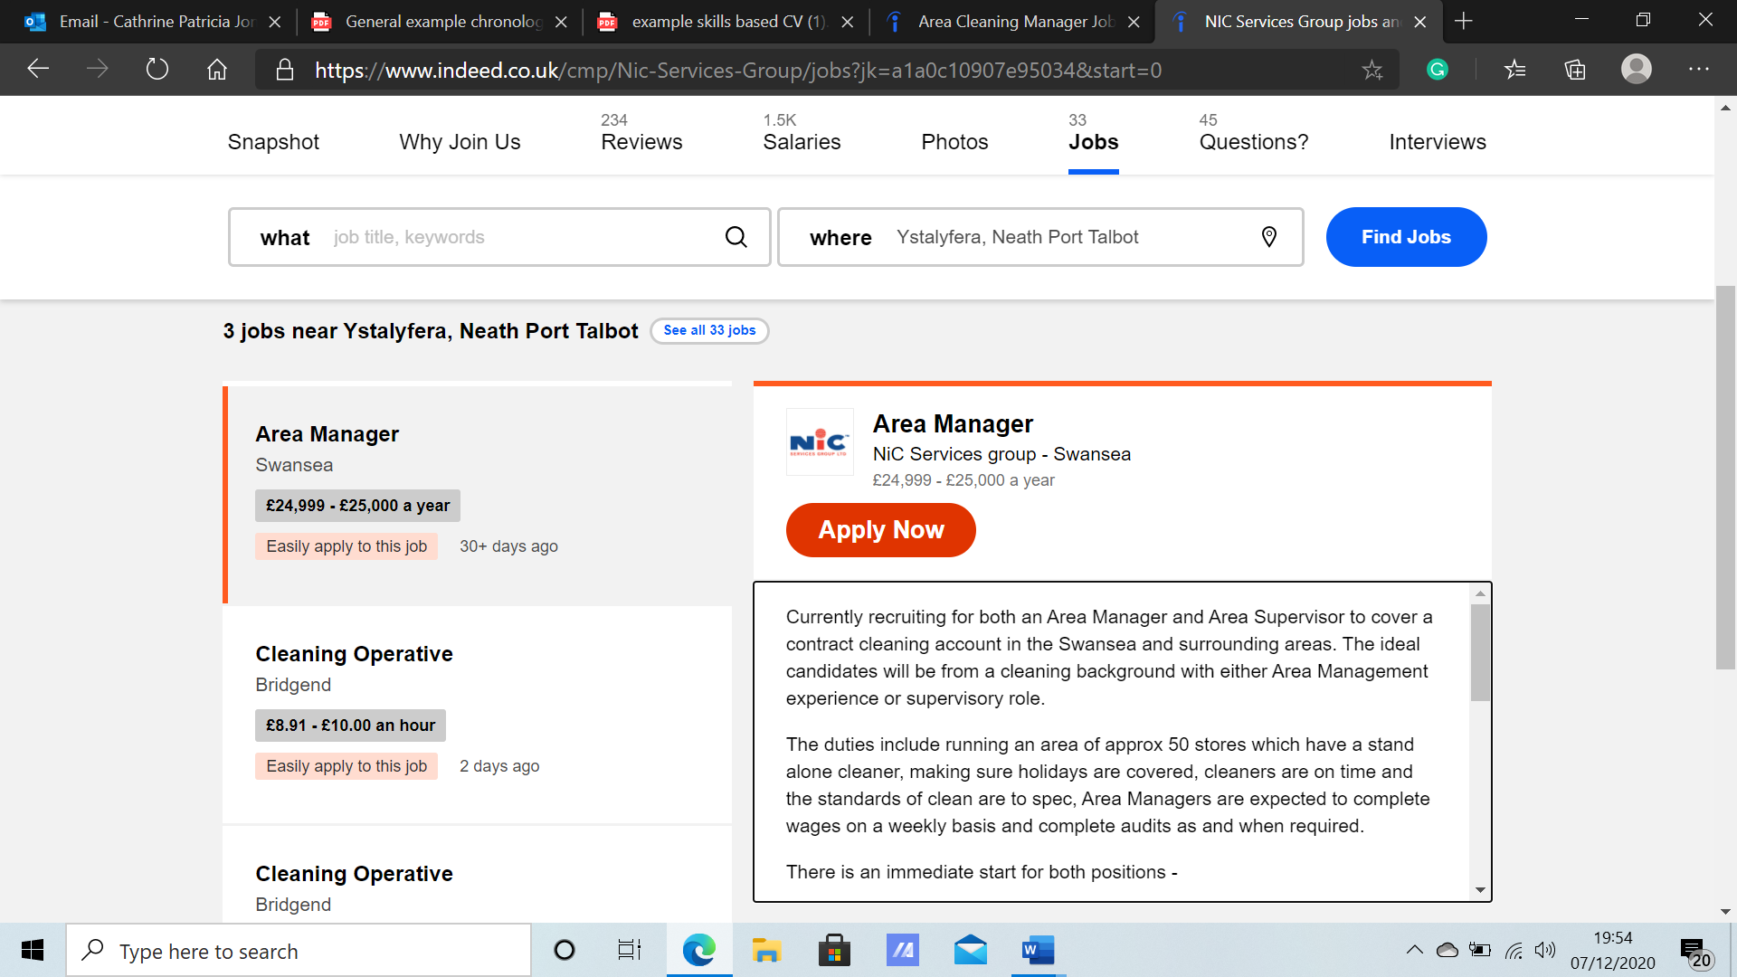
(Area Cleaning Manager Jobs in Ystalyfera - December 2020 | Indeed.co.uk, 2020)

Cover letter

Catherine Jones
8.12.2020
NIC services group
RE: Area Manager

To whom it my concern,
I came across your job advert online for an area managers position at NICS services group. Upon assessing the job description I recognized it is the ideal job for me based on my experience, skills and knowledge within the cleaning industry and your 50 years of success within the cleaning industry. I feel that this job would be ideal for me. Now would be the perfect time to further my career within this industry and your company is ideal for me to share and expand my knowledge.

Over the last ten years I have had a range of duties working my way up from cleaning toilets to over-seeing staff, ensuring that stock take was up to date and surfaces correctly sanitized using appropriate products. As an experienced cleaner not only are my hoovering skills impeccable but my attention to detail is next to none. I believe because of this experience alongside my Cert HE in business, I would be a great asset to successfully manage your workplace.

In my opinion for a business to be run successfully it starts with good teamwork, I work well alone and as part of a team as shown in my cv I enjoy team sports. If given this opportunity to become part of your team I will ensure that all employees under my management will maintain motivation and complete work to a high standard.

I await the opportunity of becoming part of your expanding team. Bringing with me my proven knowledge and skills to provided outstanding service. I also look forward to dissing this position with you. Thank you for contemplating me for this position and taking the time to read through my cv and covering letter, I hope to hear from you soon.

Kind regards
Catherine Jones

References
Indeed.co.uk. 2020. Area Cleaning Manager Jobs In Ystalyfera - December 2020 | Indeed.Co.Uk. [online] Available at: <https://www.indeed.co.uk/jobs?q=Area%20Cleaning%20Manager&l=Ystalyfera%2C%20Neath%20Port%20Talbot&vjk=a1a0c10907e95034> [Accessed 8 December 2020].

