Daniel James
2218766@student.uwtsd.ac.uk
University of Wales Trinity Saint David
BSc Computing (Computer Networks and Cyber Security)
Build, and deploy, a type 2 hypervisor platform based virtualised network
Network Operating Systems and Services

Table of Contents
1.0 Introduction 2
2.0 Research on Hypervisor 3
2.1 Types of Hypervisors 3
2.1.1 Type 1 Hypervisor 3
2.1.2 Type 2 Hypervisor 3
2.1.3 Security 3
2.1.4 Hardware Requirements, Compatibility and Scalability 3
2.2 Hypervisor Solutions on the Market 4
2.3 Chosen Hypervisor 5
3.0 Research on IP Addressing 5
3.1 IPv4 Addressing 6
3.2 IPv6 Addressing 6
3.3 Subnetting 6
3.4 MAC Address 8
4.0 Network Topology 8
5.0 Testing and Troubleshooting 10
5.1 Research on Testing and Troubleshooting 10
5.1.1 Ping Command 10
5.1.2 Firewall Configurations 10
5.2 Testing and Proof of Connectivity 11
6.0 Conclusion 13
7.0 References 14
8.0 Appendix 16

1.0 Introduction
With the rise of virtualisation, Software Defined Networking (SDN) has also evolved to meet modern standards. SDN utilises virtualisation to share the physical networking hardware across different networks. Each network has a slice of hardware they are assigned and can use, making networking much more affordable for smaller businesses and hobbyists. [1] This report will discuss the differences between hypervisors and why a type 2 hypervisor should be used for this use case. This report will also discuss IP addressing and troubleshooting, as well as a demonstration of a virtualised network.
Section 2 provides research on hypervisors and the justification as to which type has been chosen. Section 3 demonstrates the network topology that has been created using the network virtualisation tools. Section 4 analyses the research completed about IP addressing, including the differences between IPv4 and IPv6. Section 5 research different troubleshooting methods, this section also utilises relevant methods that are applicable to the network created in section 3. Finally, section 6 concludes the report, providing a reflection on the physical demonstration and a summary of the research throughout the report.

2.0 Research on Hypervisor

2.1 Types of Hypervisors
There are two types of hypervisors, Type 1, and Type 2. Virtualisation software use a modified version of one of these types of hypervisors to meet their needs. This can be demonstrated in figure 1, as the OS-Level virtualisation is a modified version of a type 2 hypervisor, whereas unikernel virtualisation is a modified version of a type 1 hypervisor. This report will only discuss the fundamental differences between Type 1 and Type 2 hypervisors. [2]

2.1.1 Type 1 Hypervisor
According to [2], [3] and [4], a type 1 hypervisor also commonly known as a ‘bare metal’ hypervisor, is installed directly to the hardware. The virtualisation software replaces the standard operating system of the machine allowing for direct access to the hardware by the hypervisors. Type 1 hypervisors are used for cloud computing services, or where remote access and performance is required, such as retail point of sale devices such as self-service checkouts.

2.1.2 Type 2 Hypervisor
To summarise [2], [3], and [4], type 2 hypervisors differ as they run as an application on the host system rather than as the operating system itself. This requires the virtual machine to ask permission from the host operating system for any action that requires administrator access. The virtualisation software is also required to ask the host operating system for permission to use hardware. Type 2 hypervisors are typically used in personal computers as they can be used on top of the current operating system without the need to reinstall, because of this, performance is neglected in favour of other features such as usability. Type 2 hypervisors also do not have direct access to the hardware, which means they must wait until it is allocated by the host OS, further decreasing the performance.

2.1.3 Security
According to [4], the simpler the hypervisor the better, reducing the places for attackers to target and mitigating vulnerabilities. Security in hypervisors heavily depend on the virtualisation software used, the virtualised operating systems are controlled and contained by the hypervisor software. Access to the operating systems can only be granted and accessible through the virtualisation software itself. The software also acts as a firewall to prevent unauthorised sharing of files and resources between virtual machines. Through this isolation, any compromised virtual machines cannot access other virtual machines that are operating on the device, however, if the hypervisor or host machine itself becomes compromised it will give full access to the physical hardware. [4]

2.1.4 Hardware Requirements, Compatibility and Scalability
Hardware requirements will differ from software to software as well as between type 1 and type 2 hypervisors. Below are the summaries of hardware requirements from popular virtualisation providers including both types.
As can be seen from the documentation for type 1 hypervisors, [5], [6] and [7], all require a minimum of 4GB to operate, allowing for a device to operate with a host operating system as well as up to a maximum of 4 virtual machines. The upper end for Hyper-V systems is 512GB of RAM per machine for Windows 10 [5], or 12TB per machine and up to 48TB in total for Windows Servers, allowing for up to 50 virtual machines to be ran at the same time. The Windows 2022 Server also allows for up to 512 logical processors, which can be assigned to a maximum of 240 virtual processors per virtual machine. [8] Both Windows and VMWare machines require a 64-bit processor to operate correctly, however, the VMware hypervisor requires a minimum of 2 cores per virtual machine on top of any cores assigned to the virtual machine. For example, if 4 cores are assigned to two different virtual machines, the virtualisation software will require 12 cores in total, 4 multiplied by 2 plus 2 multiplied by 2. [6]
Oracle Virtual Box (VB) offer documentation on the minimum specifications to run their type 2 hypervisor. Unlike the type 1 hypervisors, only a 32-bit processor must run the Oracle VB, however, the processor must be powerful and is recommended to be a recent intel or AMD processor. The minimum required RAM to run is only 512MB, however, this will be incredibly slow, so a recommended amount is closer to 2-4GB. The Oracle VB is also compatible with most operating systems, including Windows, Linux, MacOS, etc. [9]

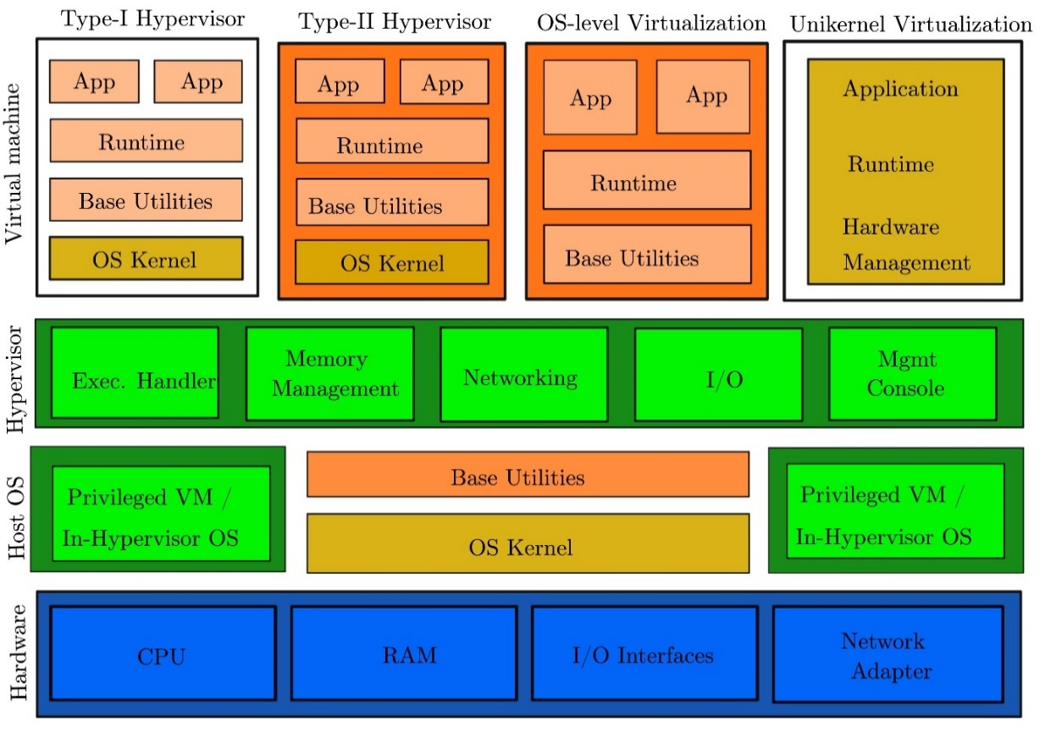
Figure 1 Examples of the two types of hypervisors and the modifications that have been made to create specialised versions for the market. [2]

2.2 Hypervisor Solutions on the Market
As discussed in section 2.1d there are many different hypervisor solutions on the market. Some of the popular solutions for Type 1 Hypervisors include Microsoft’s Hyper-V, KVM, VMWare ESXi, XenServer and Docker. Each software will have advantages and disadvantages, not limited to scalability, power usage, ease of use, stability, etc. The research paper, [10], goes into detail testing these factors, which is out of the scope of this report. Some examples of Type 2 Hypervisors on the market include Oracle Virtual Box and VMWare Workstation. [4]

2.3 Chosen Hypervisor
For the network topology that is required for this report, a type 2 hypervisor will be used. Only 4 machines are required to simulate the network which is feasible to run on a type 2 hypervisor. It is also not feasible and affordable to setup a dedicated machine with a type 1 hypervisor installed rather than an operating system to carry out this report.

3.0 Research on IP Addressing
As shown in figure 2 below, network traffic must travel through a router when attempting to reach a different network. The routers use the devices IP address to identify where to send the packets of information. Figure 3 demonstrates the structure of the packets of data, showing all the required information for a packet to be successfully sent or received; this process is called encapsulation. [11]
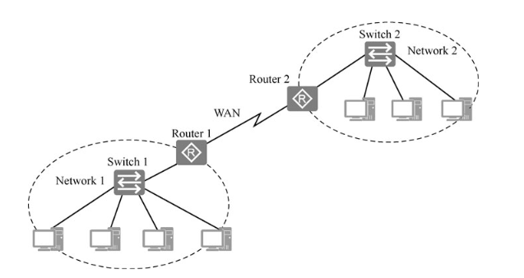
Figure 2 Illustration of two separate networks connected through the Internet. [11]
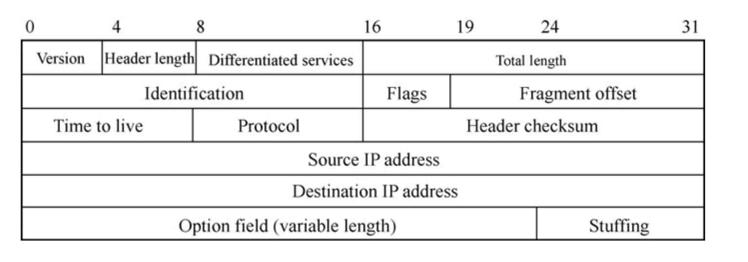
Figure 3 Structure of an IP packet. [11]

3.1 IPv4 Addressing
IPv4 Addresses are stored in a format called dotted-decimal notation. An example of this would be 192.168.0.1, where a number ranging from 0 to 255 is separated by a decimal place, these numbers are called an octet and represent eight bits. This is called the 32-bit binary form and provides the internet with 2³² unique addresses that can be assigned to networks and devices. [12] [11] With the size of the internet growing every day, the number of IP addresses has long since run out. To reduce the number of used IP addresses, a system was put in place which used public and private addresses. Public addresses are managed by the organisation called ICANN, then assigned to networks by internet service providers, whereas private addresses are only used within an internal network and are not required to be exclusive to a single network. [11]

3.2 IPv6 Addressing
The IPv6 addressing scheme differs from the IPv4 scheme slightly. Rather than using decimal digits, the IPv6 uses hexadecimal digits. This greatly improves the number of unique addresses without further increasing the length of the address for the user to enter. The format is two hexadecimal digits followed by a colon, repeated 8 times. An example would be: XX:XX:XX:XX:XX:XX:XX:XX. Each two-digit pair represents 16 bits of information, making IPv6 addresses able to hold 128 bits of information. [13][14] Due to the longer length of the address and hexadecimal digits, the IPv6 addressing scheme is unlikely to ever run out of usable addresses; this makes it much more favourable to use. Unfortunately, due to incompatibility with current systems and a lack of training IPv6 has not been as heavily adopted as it should be. [13] [11]

3.3 Subnetting
Table 1 below represents the number of usable hosts and networks per network class, this data highlights a glaring issue within IP addressing; most networks will not use every host assigned to the network, leading to wasted IP addresses that cannot be used by anyone else. This project will only focus on networks contained within class C, table 2 below shows the possible sizes of subnetworks within a class C IP address. As shown in the table, subnets /31 and /32 are not useful as they have no usable hosts, as such the range of usable subnets is /24 to /30. When determining which subnet to choose from, it is important to factor in future expansion and scalability as changing to a larger subnet in future would lead to a full redesign of the network. Figure 4 below shows an example topology with subnetting to reduce the number of wasted addresses, in this example the original network is split into two subnets, allowing for 126 hosts per subnet and a total of two networks. [12] [11] [15]
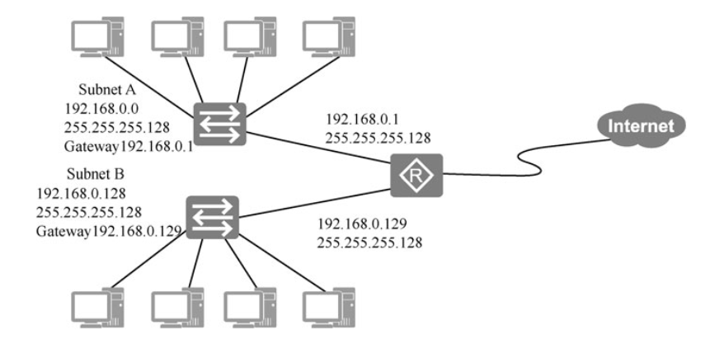
Figure 4 Example of a network utilising subnetting to reduce the wasted IP addresses. [11]

Class | IP Range | Number of Networks | Number of Hosts
A | 1 – 126 | 126 | 16,777,214
B | 128 – 191 | 16,384 | 65,534
C | 192 – 223 | 2,097,152 | 254
Table 1 Data representing the number of networks and hosts available per class of network. [15]
Subnet Mask | Classless Inter-Domain Routing (CIDR) | Number of Networks | Number of Hosts
255.255.255.0 | /24 | 1 | 254
255.255.255.128 | /25 | 2 | 126
255.255.255.192 | /26 | 4 | 62
255.255.255.224 | /27 | 8 | 30
255.255.255.240 | /28 | 16 | 14
255.255.255.248 | /29 | 32 | 6
255.255.255.252 | /30 | 64 | 2
255.255.255.254 | /31 | 128 | 0
255.255.255.255 | /32 | 256 | 0
Table 2 All possible subnet configurations for a class C network, including the number of usable networks and hosts. [12]

3.4 MAC Address
Media Access Control (MAC) addresses are 48-bit unique addresses that are assigned uniquely to each physical network interface. These are commonly referred to as physical addresses as they cannot be changed and are tied to the physical hardware. This differs from the IP addresses’ 32-bit addresses which can be changed whenever is needed. MAC addresses are not able to work with layer 3 devices such as Routers and such must be used in conjunction with IP addresses; MAC addresses can be used internally within a network for faster transfer speed, but the IP address takes over during the encapsulation process in the router. [16]
Fundamental issues with Ethernet are the root cause as to why MAC addresses cannot be used in wide area networks. New technologies are being developed to deal with these problems, such as layer 3 switches and virtual local area networks. However, these technologies have caused an increase in use of MAC addresses in most wide area networks. [16]

4.0 Network Topology
The network for this demonstration can be dissected into three distinct subnets, this is demonstrated in figure 5. Subnets A and B are the private networks in Swansea and London respectively, as shown in table 3 below, they have both been assigned a maximum of 14 hosts that can be assigned within the network. This provides scalability to the given networks, which only require 1 device in the current network, while reducing the amount of IPv4 addresses wasted. Subnet C is a connection between the two networks, meaning there will only be two devices requiring a connection. This table also identifies the network addresses, broadcast addresses and subnet masks for each subnet within the network; having this knowledge on hand is useful for troubleshooting and configuring new devices more efficiently. As can be seen in figure 6, every device has been assigned an IP address within its sub network.
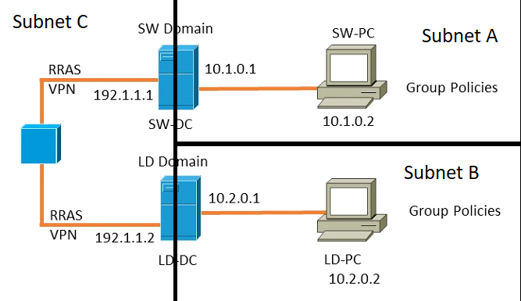
Figure 5 Network topology split into three different sub-networks.
Subnet | Network IP | Usable Address Range | Broadcast Address | Subnet Mask | Usable Hosts
A | 192.1.1.0 | 192.1.1.1 – 192.1.1.14 | 192.1.1.15 | 255.255.255.240 /28 | 14
B | 192.1.1.16 | 192.1.1.17 – 192.1.1.30 | 192.1.1.31 | 255.255.255.240 /28 | 14
C | 192.1.1.32 | 192.1.1.33 – 192.1.1.34 | 192.1.1.35 | 255.255.255.252 /30 | 2
Table 3 Proposed IP address ranges for the given network topology.
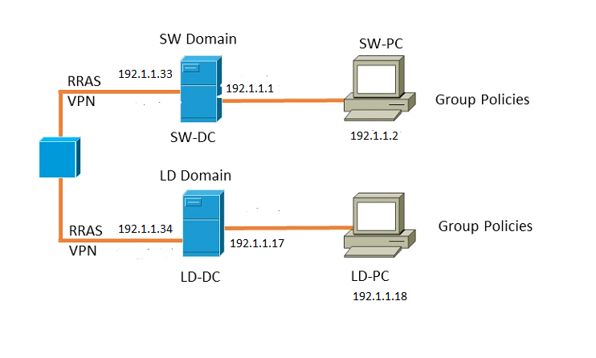
Figure 6 Finished network topology with correct IP addresses according to the subnet table.

5.0 Testing and Troubleshooting

5.1 Research on Testing and Troubleshooting

5.1.1 Ping Command
To test connectivity between devices on the network, the ping command is being used. For example, ping 192.1.1.1, would test the connection from the current device to the 192.1.1.1 device. The ping command provides lots of information that can be used to troubleshoot and diagnose issues with the network. The most common ones to surface are highlighted below:
- Destination Host Unreachable: This error means there is no route to the other device, this could be due to incorrect cabling or a lack of routing. To troubleshoot this further, the tracert command could be used to track where the packet is getting lost in the network to attempt to solve.
- Unknown Host: An unknown host will arise when an incorrect IP address is being pinged. The easiest solution for this is to check the configured IP address on the other device to ensure it is correct.
- General Failure Error: The general failure error usually occurs when there is a problem with the physical device or network interface. Troubleshooting this problem can be tricky as the device could be faulty, missing a driver or missing configurations such as IP addresses.
- Request Timed Out: This error occurs when packets are being lost when a device is connected. The firewall blocks ping requests by default and is the cause of this error most of the time. [17]

5.1.2 Firewall Configurations
To enable ping requests on Windows 10, echo requests must be enabled in the firewall. There are two different methods for enabling this; the first is to enable all echo requests coming from any device on the network, the second is to restrict this so only certain IP addresses will be able to ping the device. As shown in section 5.2 and 8.0, the first method was used to allow all devices to ping each other, this has been done for troubleshooting to ensure network connectivity. However, this causes significant security risks though as it can lead to unauthorised devices accessing the network and undertaking denial-of-service attacks. In a real-life network, the firewall should be correctly configured only allowing trusted IP addresses through. [18]

5.2 Testing and Proof of Connectivity
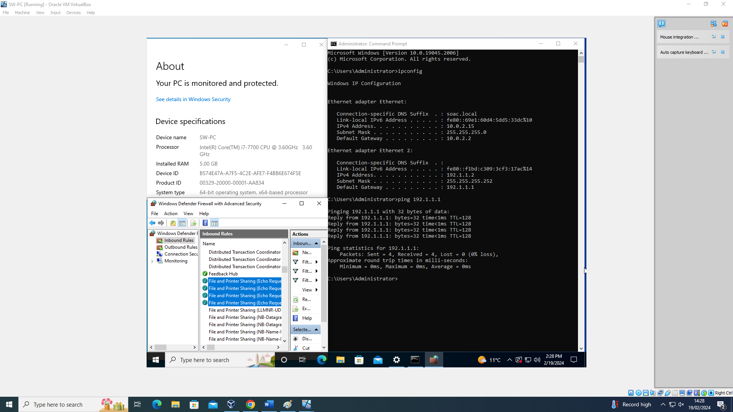
Figure 7 Demonstrating network connectivity from the Swansea PC to the Swansea Server.
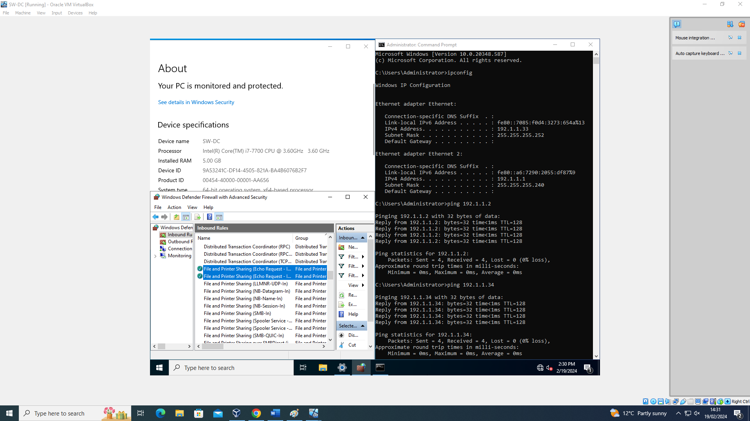
Figure 8 Demonstration of the network connectivity from Swansea Server to the Swansea PC and to the London Server.
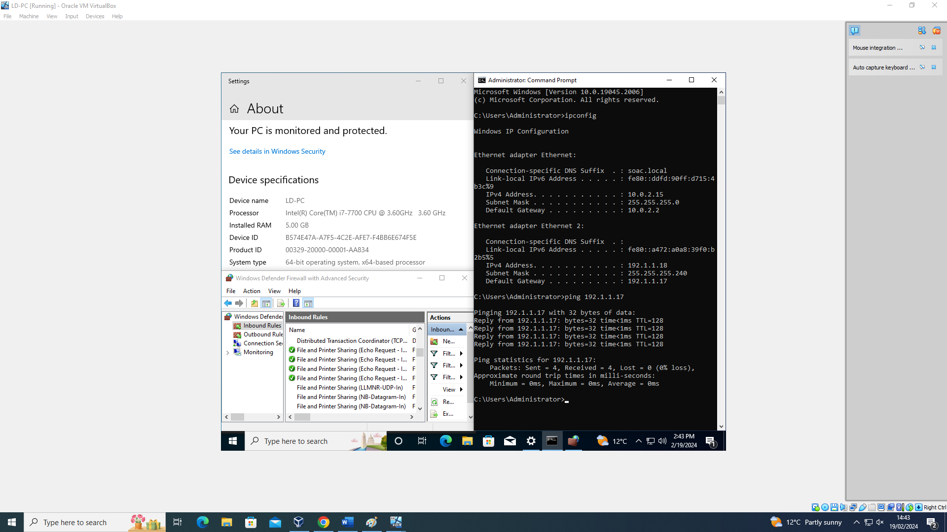
Figure 9 Demonstration of the network connectivity from London PC to the London Server.
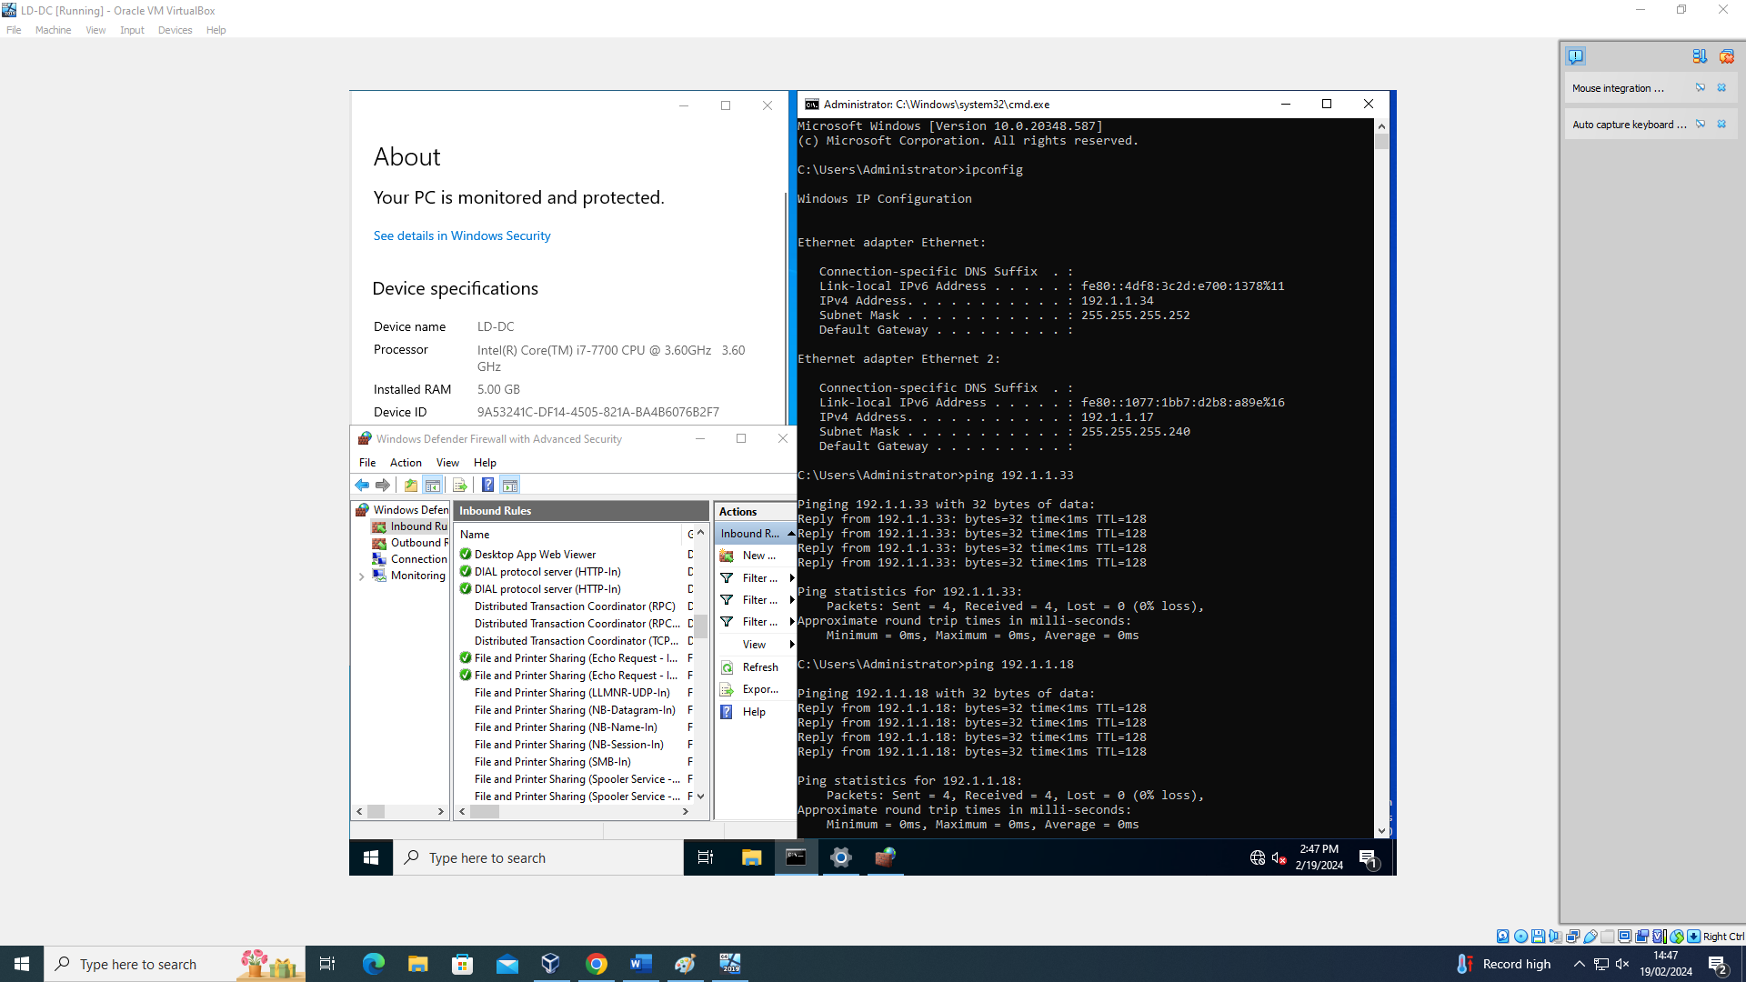
Figure 10 Demonstration of the network connectivity from London Server to London PC and to Swansea Server.

6.0 Conclusion
Hypervisors are more utilised than ever in everyday life, although they remain unheard of to non-computing specialists. This report has summarised the advantages and disadvantages of both types of hypervisors and firmly established the reason as to why the type 2 hypervisor was used for the network virtualisation. An area of improvement and future research would include routing to ensure full connectivity between the two networks and all devices within the virtualised network.

7.0 References
References
[1] A. Blenk, et al., "Survey on Network Virtualization Hypervisors for Software Defined Networking," COMST, vol. 18, no. 1, pp.655-685, 2016. doi: 10.1109/COMST.2015.2489183.
[2] M. Compastié, et al., "From virtualization security issues to cloud protection opportunities: An in-depth analysis of system virtualization models," Comput.Secur., vol. 97, pp.101905-20, 2020. doi: 10.1016/j.cose.2020.101905.
[3] R. Queiroz, T. Cruz and P. Simões, "Testing the limits of general-purpose hypervisors for real-time control systems," Microprocessors and microsystems, vol. 99, pp.104848, 2023. doi: 10.1016/j.micpro.2023.104848.
[4] Z. Aalam, V. Kumar and S. Gour, "A review paper on hypervisor and virtual machine security," Journal of physics.Conference series, vol. 1950, no. 1, pp.12027, 2021. doi: 10.1088/1742-6596/1950/1/012027.
[5] "Windows 10 Hyper-V System Requirements." Microsoft. https://learn.microsoft.com/en-us/virtualization/hyper-v-on-windows/reference/hyper-v-requirements (accessed Feb 13,).
[6] "Minimum Hypervisor Hardware Requirements." VMWare. https://docs.vmware.com/en/VMware-SD-WAN/5.4/vmware-sd-wan-partner-guide/GUID-17432A7A-693D-477E-8D7F-1D74673072AA.html (accessed Feb 13,).
[7] "System requirements for Hyper-V on Windows Server." https://learn.microsoft.com/en-us/windows-server/virtualization/hyper-v/system-requirements-for-hyper-v-on-windows (accessed Feb 13,).
[8] "Plan for Hyper-V scalability in Windows Server." Microsoft. https://learn.microsoft.com/en-us/windows-server/virtualization/hyper-v/plan/plan-hyper-v-scalability-in-windows-server (accessed Feb 13,).
[9] "User Manual." Virtual Box. https://www.virtualbox.org/manual/UserManual.html (accessed Feb 13,).
[10] C. Jiang, et al., "Energy efficiency comparison of hypervisors," Sustainable computing informatics and systems, vol. 22, pp.311-321, 2019. doi: 10.1016/j.suscom.2017.09.005.
[11] L. Huawei Technologies Co., Data Communications and Network Technologies, 1st Ed. Singapore: Springer Nature, doi: 10.1007/978-981-19-3029-4
[12] B. Gilmer, "IP addressing basics," Broadcast Engineering, vol. 51, no. 2, pp.30-33, 2009.
[13] A. Dhanapal and P. Nithyanandam, "AN OVERVIEW OF THE IPV6 ADDRESSING SCHEME," International journal of mathematics, game theory, and algebra, vol. 27, no. 1, pp.81-92, 2018.
[14] T. Savolainen, J. Soininen and B. Silverajan, "IPv6 Addressing Strategies for IoT," JSEN, vol. 13, no. 10, pp.3511-3519, 2013. doi: 10.1109/JSEN.2013.2259691.
[15] S. N. Sisat, P. S. Bhopale and V. K. Barbudhe, "IP Subnetting," International journal of electronics, communication and soft computing science and engineering, vol. 2, no. 5, pp.5, 2012.
[16] A. Sidorovs, et al., "SmartARP: merging IP and MAC addressing for low-cost gigabit Ethernet networks," Computer networks (1999), vol. 31, no. 21, pp.2193-2204, 1999. doi: 10.1016/S1389-1286(99)00095-X.
[17] "How to ping a network for testing connectivity
." Pager Duty. https://www.pagerduty.com/resources/learn/ping-network-testing-connectivity/ (accessed Feb 22,).
[18] Forristal, “Fireproofing against DoS attacks,” Network Computing, vol. 12, no. 25. Informa, Manhasset, pp. 65–74, 2001.

8.0 Appendix


