ACCA4023
BSc/HND Computing Portfolio

L4 - Introduction to Web and Database Concepts Module

Charlie Wilkins 2104032

2104032@student.uwtsd.ac.uk

HTML & CSS Web Development

Table of Contents:

Table of Contents
Introduction 3
Abstract 3
Requirements 3
Introduction to the website 3
Website purpose 3
Website subject matter 3
Website intended target audience 4
Implementation 5
Screen grabs of all of the pages of the completed website (not the code). 5
Validation 8
Evaluation 8
Website Usefulness (usability and utility) 8
Website Accessibility 9
Website Search Engine Optimisation (SEO) 10
References: 10
Appendices 11

Introduction

This report is the description of how I have used HTML and CSS to create a website for the family beekeeping business; Wild Close Bees.

Abstract

Websites need to be useful, accessible and easily found if they are to achieve their aim of communication across the internet space. These technical specifications are the first step on which to build the content which needs to be matched to the purpose of the site, making sure that this contains suitable information for the target audience. This report applies these principles to the creation of a website for Wild Close bees which is a family run apiary in the New Forest. The Website is the perfect way for people to find out about the bees on all levels, whether that is for interest about bees, because they want to buy honey or other bee products, or because they want to attend a Beekeeping Experience Day. The value of a website is that different people can look at it for different reasons and it meets each person’s needs by having all the information from which they view what they require. I have looked at each of these parameters in the report and also explained how I have implemented and validated the website.

Requirements

Introduction to the website
The information on my website is about beekeeping, specifically ‘Wild Close Bees’.
I have been beekeeping for 10 years now and what started as a simple hobby with my mother has now become a family business. We have up to 20 hives which means that during the ‘swarm season’ we could have 30 boxes in which the bees are ‘split’ to prevent swarming. These bees are combined again once the urge to swarm has passed, and they can focus on honey production. Beekeeping is a skill which requires the beekeeper to understand what the bees are doing at any time and importantly, why they are doing this. If you understand this, then you will be successful in producing a honey crop and not losing bees who have flown away as a swarm.

Website purpose
The purpose of my website is to inform people about Wild Close Bees. I have described who we are and what we have achieved in our apiary. The website is the perfect way for people to find out about the bees on all levels, whether that is for interest about bees, because they want to buy honey or other bee products, or because they want to attend a Beekeeping Experience Day. The value of a website is that different people can look at it for different reasons and it meets each person’s needs by having all the information from which they view what they require.

Website subject matter
The subject matter of the website is information about the apiary and what we provide. It is informative for interest, or education for those who have enough time for a hobby themselves so they can see what other people who are keen on beekeeping are doing. The website is useful for advertising to potential new customers as a business for the products we sell; honey, candles, lip salves and providing information about the Bee Experience Days. These are 3-4 hour sessions where we take people who may be complete novices or people who have some knowledge of the bees and introduce then to the art of beekeeping in a structured session. We start by talking about the bees, then do a practical session where the participants dress up in bee suits and look into the hive. The final session is back in the classroom for a discussion about what they have seen and an overview of what else is required in the processes of harvesting the honey and wax. The website has written words and pictures which show what the hives and products look like. In time this could be developed to show the processes of extracting the honey and processing the wax. Pictures are a really useful way of communicating this information and are more accessible and attractive than written words, so a website is the right platform for this information.

Website intended target audience
The target audience is very broad because the website is general information about bees and beekeeping as well as directing to services or goods provided. The intended audience everyone for information and local residents and visitors to the New Forest who may be interested in the bee products including honey and beeswax products that are for sale, or taking part in a Beekeeping Experience Day.

Implementation

Screen grabs of all of the pages of the completed website (not the code).

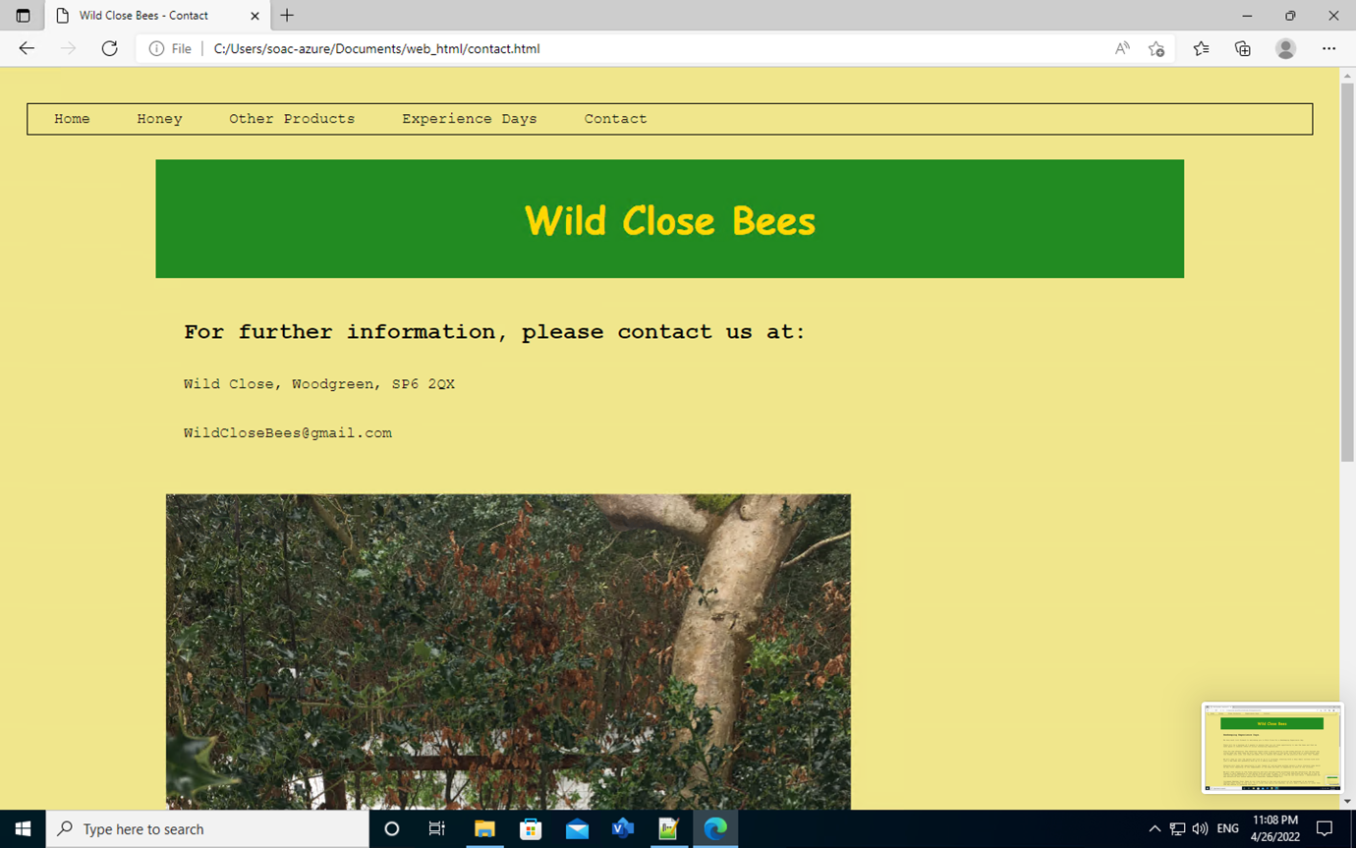

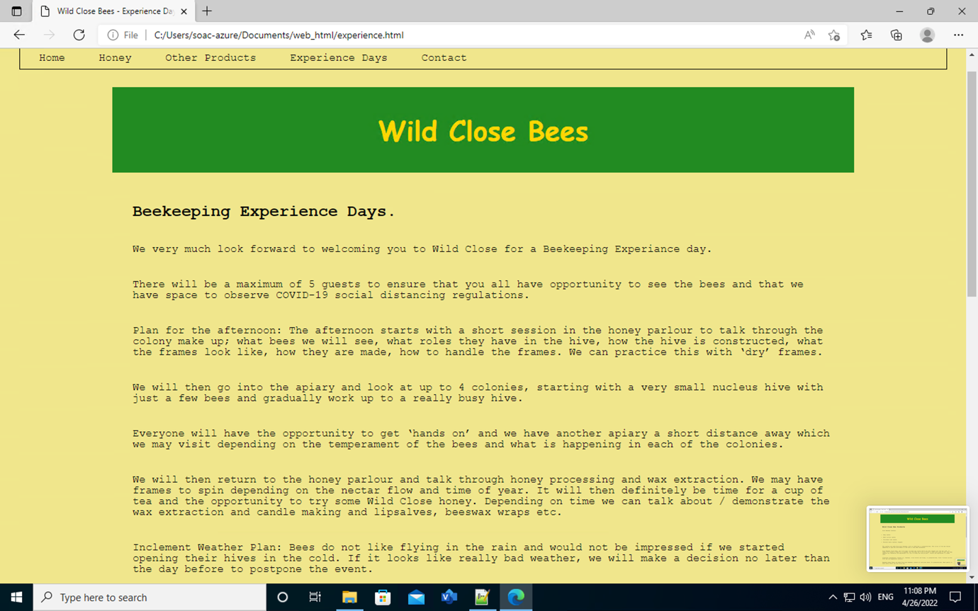
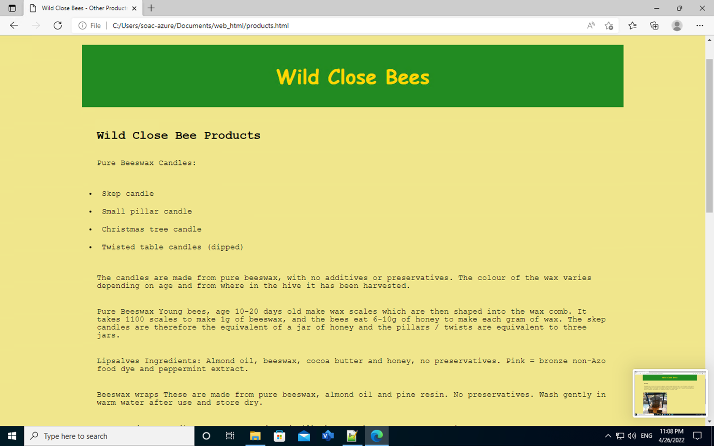

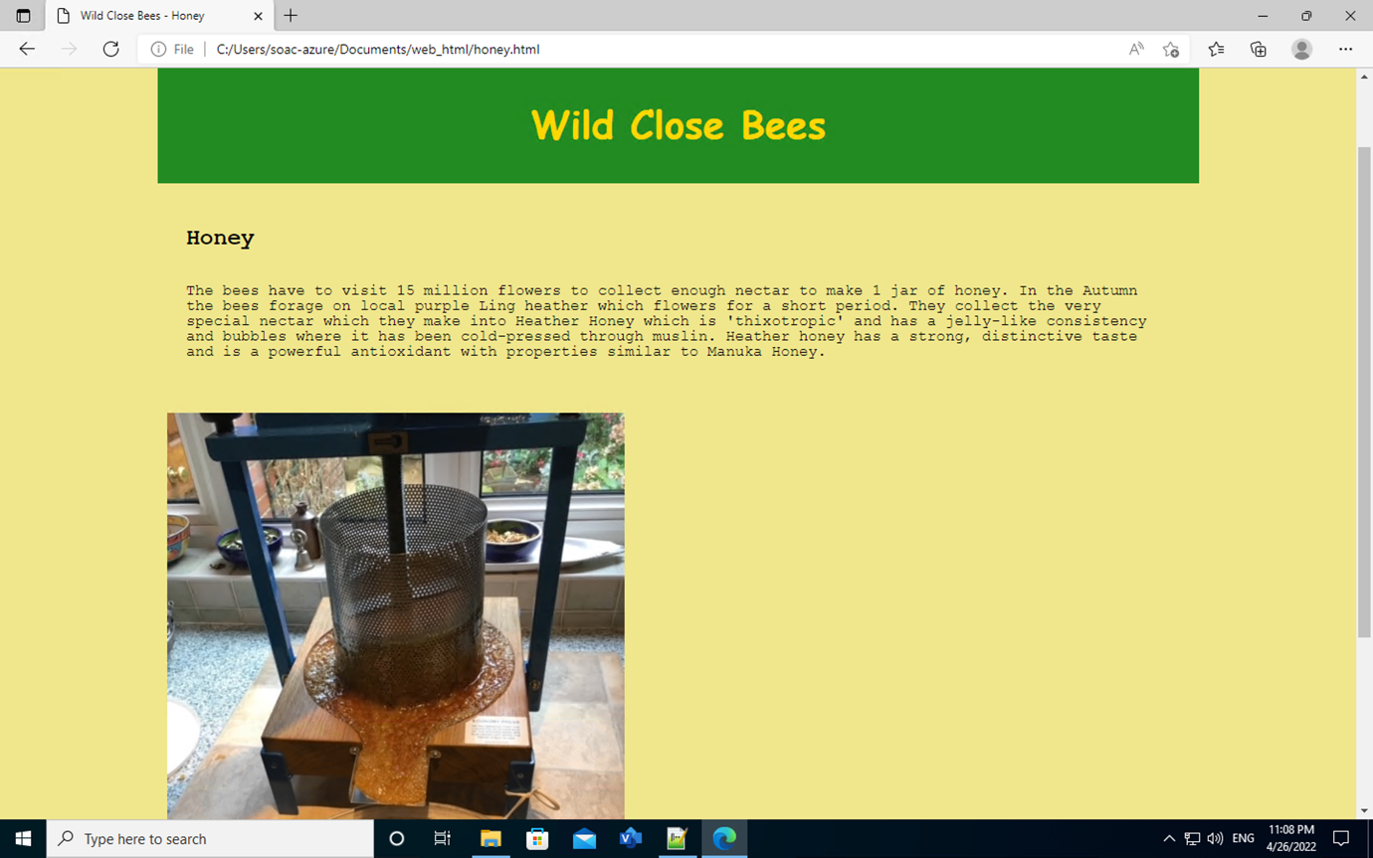
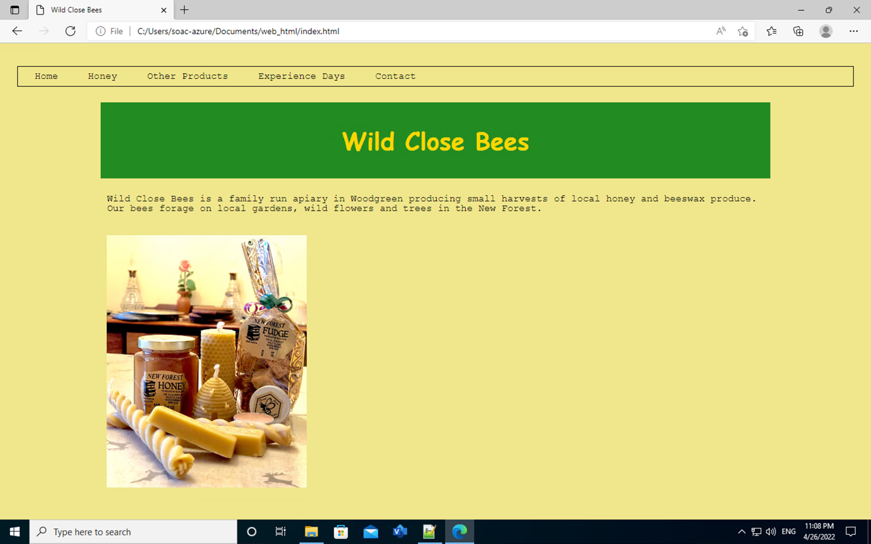

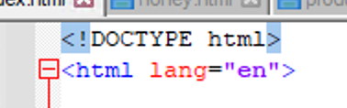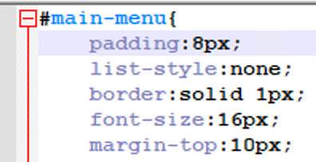

Validation

When I validated my home page which was my index HTML file and my CSS file, I only got two errors, one on each on the HTML and CSS.

HTML (http://validator.w3.org/) - you are only required to validate the HTML of your home page

With the HTML, I hadn't specified the language so that the website was in the correct language. The website had defaulted to ‘unspecified’ which was picked up when I ran the validation. I then was able to specify that it needed to be in English and correct this error.

CSS (http://jigsaw.w3.org/css-validator/) – you are only required to validate your website’s main CSS

With the CSS I forgot to put PX after the number on the padding and then with that adjustment the pattern was too big so there was too much of a gap above the menu bar and the menu was halfway down the page. Having seen this gap was too big, I then reduced the number from 30 to 8. This then pulled the green bar up the page and made it look more balanced.

Evaluation

Website Usefulness (usability and utility)
The website is very usable because it has a simple design and functions as it is intended. It looks nice because of the carefully chosen complementary colours which are the same as the beehives we have, and it is on theme. The beehives are painted a dark green which matches the green of the trees, and the gold is the colour of the honey and beeswax. The information is relevant to each page and there is no extra detail or confusion. I think that the website’s usability is about right because you can navigate using the menu on the top of the page. The look and feel of the website demonstrate that it is about bees, is the communication tool for a small business and is a supportive platform for education. Regarding the utility, I am using Microsoft Edge so the navigation is sufficient, and all of the pages are correctly linked together. The content (information) is fairly limited on this initial build of the website but in time we can add more detail about each of the aspects; products, environment, education.
I think there is quite a lot more that I could do to advertise and explain the Beekeeping Experience Days. For example, I could take pictures of people attending the days (noting data protection etc) and then show what kind of things would be available during the day. This might include pictures of people sitting at the classroom table learning about the bees, then wearing suits and looking in the hive, and then back in the classroom with tea and cake, discussing what they have seen. This kind of visual representation would help people visiting the website to understand what we offer in the package. I could do the same with pictures to explain about the honey extraction and wax processing.

Website Accessibility
Cao and Loiacono stated that ‘It is paramount that websites and apps be usable by all people across different situations. Even though a large portion of the population is able to access websites and apps without much trouble, there is also a large group of people who require additional tools or enhancements in order to use websites and apps. This includes people with temporary or changing disabilities and means that everyone must be able to perceive, understand, navigate and contribute to websites and apps.’
This was something that I considered carefully when designing the website. Noting the target audience is the general population, all of these groups and all levels of education needed to be considered. I used short sentences and simple English without any jargon. At the minute the website is only a few pages and in time this could grow much bigger, but I will be carefully to ensure that it is still simply set out with the sections well defined and clearly labelled. I have dyslexia and find it difficult to read so I think I am able to set the level so that others with limited education and any disabilities are able to access this information.
Cao and Loiacono [1] also said that ‘it is also the socially responsible thing to do (Lawton et al. 2005); it is a human right for everyone to have equal access and equal opportunity (Lawton 2017) [2]. Websites and apps support social inclusion on a local and global level; people from any background or situation can contribute to a worldwide online community. Accessible websites and apps can also hugely benefit companies.’
Wild Close Bees is a family run business which we will make into a Limited Company in due course. Although it started as a hobby, it is important that the bees ‘pay for themselves’ so that we are able to provide a service to the bees and to the community. It is good for people to understand bees and to help them by planting bee-friendly plants and not using insecticides. In return, the bees pollinate the plants which provide the food that mankind needs to survive so our existence is mutually dependant. Wild Close Bees provides a small contribution to this larger aim. The accessibility of this website, using pictures and communicating the information is
With reference to WCAG 2.1 [3] [4], the four main principles are:
- Perceivable - Information and user interface components must be presentable to users in ways they can perceive.
  - This means that users must be able to perceive the information being presented (it can't be invisible to all of their senses).
- Operable - User interface components and navigation must be operable.
  - This means that users must be able to operate the interface (the interface cannot require interaction that a user cannot perform)
- Understandable - Information and the operation of user interface must be understandable.
  - This means that users must be able to understand the information as well as the operation of the user interface (the content or operation cannot be beyond their understanding).
- Robust - Content must be robust enough that it can be interpreted reliably by a wide variety of user agents, including assistive technologies.
  - This means that users must be able to access the content as technologies advance (as technologies and user agents evolve, the content should remain accessible).

With reference to my Wild Close Bees website:
- Perceivable. The information and user interface components for my website are easily navigable without any prior knowledge of the content or this site.
- Operable – The user interface components and navigation are easily operable as you can navigate between the pages and the menu function tells you what is available.
- Understandable – The information and the operation of user interface is understandable because it is in a clear font and in simple English. The pictures make this more easily understood and improve accessibility.
- Robust – The content is robust enough to be interpreted reliably by a wide variety of user agents, including assistive technologies. The basic information is simply displayed and the website should not malfunction as there are simple ways of getting from one page to the next via the menu and links.

Website Search Engine Optimisation (SEO)

I have used best practise when during my HTML and CSS code.
I understand that the simpler the website is to find and use, the more likely it is that people will use the website and therefore become acquainted with Wild Close Bees.
Lawton, (2017) stated: ‘A website or app that is well designed and accessible provides better search-engine optimization (SEO) and usually requires less maintenance’ [2]. ‘Inaccessible websites and apps hinder usage for people with disabilities while also being inconvenient to people without disabilities…. Therefore, Web accessibility can benefit everyone.’ I have applied this principle to the development of my website for Wild Close Bees and believe that this is optimised to meet the target audience and provide the correct information.

References:

[1] Cao, Shiya and Loiacono, Eleanor, “Perceptions of Web Accessibility Guidelines by Student Website and App Developers” [Online]. 2018). SIGHCI 2018 Proceedings. 17. Available: https://aisel.aisnet.org/cgi/viewcontent.cgi?article=1004&context=sighci2018
[2] Lawton, H., Liam, M. 2017. “Web Design And Accessibility,” Available: https://www.w3.org/standards/webdesign/accessibility
[3] “References | Understanding WCAG 2.0” [Online]. Available: WCAG 2.1, (https://www.w3.org/TR/UNDERSTANDING-WCAG20/appendixE.html#WCAG20)
[4] “Accessibility - W3C” [Online]. Available: https://www.w3.org/standards/webdesign/accessibility
https://www.w3.org/TR/UNDERSTANDING-WCAG20/appendixE.html#WCAG20
[5] D. Meadows-Klue, How search engine optimisation works. London: Henry Stewart Talks, 2009.

Appendices
Cut and paste copies (text listings) of all your HTML and CSS.

<!DOCTYPE html>
<html lang="en">

<head>
<meta charset="utf-8" />
<title>Wild Close Bees</title>
<link rel="stylesheet" type="text/css"
href="CssP6.css">
</head>

<body>
<ul id="main-menu">
<li><a href="index.html">Home</a></li>
<li><a href="honey.html">Honey</a></li>
<li><a href="products.html">Other Products</a></li>
<li><a href="experience.html">Experience Days</a></li>
<li><a href="contact.html">Contact</a></li>
</ul>

<!-- creating a container -->
<div class="container">

<div class="top-para">
<h1> Wild Close Bees </h1>
</div>

<p>Wild Close Bees is a family run apiary in Woodgreen producing small harvests of local honey and beeswax produce.
Our bees forage on local gardens, wild flowers and trees in the New Forest.
</p>

<img src="a9.png" alt="Wild Close Bees Products">

</div>
</body>
</html>

<!DOCTYPE html>
<html lang="en">

<head>
<meta charset="utf-8" />
<title>Wild Close Bees - Honey</title>
<link rel="stylesheet" type="text/css"
href="CssP6.css">
</head>

<body>
<ul id="main-menu">
<li><a href="index.html">Home</a></li>
<li><a href="honey.html">Honey</a></li>
<li><a href="products.html">Other Products</a></li>
<li><a href="experience.html">Experience Days</a></li>
<li><a href="contact.html">Contact</a></li>
</ul>

<!-- creating a container -->
<div class="container">

<div class="top-para">
<h1> Wild Close Bees </h1>
</div>

<div class="bot-para">
<h2> Honey </h2>
<p>The bees have to visit 15 million flowers to collect enough nectar to make 1 jar of honey.
In the Autumn the bees forage on local purple Ling heather which flowers for a short period. They collect the very special nectar which they make into Heather Honey which is 'thixotropic' and has a jelly-like consistency and bubbles where it has been cold-pressed through muslin. Heather honey has a strong, distinctive taste and is a powerful antioxidant with properties similar to Manuka Honey.
</p>
</div>

<img src="a10.png" alt="Wild Close Bees Products">

</div>
</body>
</html>

<!DOCTYPE html>
<html lang="en">

<head>
<meta charset="utf-8" />
<title>Wild Close Bees - Other Products</title>
<link rel="stylesheet" type="text/css"
href="CssP6.css">
</head>

<body>
<ul id="main-menu">
<li><a href="index.html">Home</a></li>
<li><a href="honey.html">Honey</a></li>
<li><a href="products.html">Other Products</a></li>
<li><a href="experience.html">Experience Days</a></li>
<li><a href="contact.html">Contact</a></li>
</ul>

<!-- creating a container -->
<div class="container">

<div class="top-para">
<h1> Wild Close Bees </h1>
</div>

<div class="bot-para">
<h2> Wild Close Bee Products </h2>

<p>Pure Beeswax Candles: </p>
<ul>
<li>Skep candle</li>
<li>Small pillar candle</li>
<li>Christmas tree candle</li>
<li>Twisted table candles (dipped)</li>
</ul>
<p>The candles are made from pure beeswax, with no additives or preservatives. The colour of the wax varies depending on age and from where in the hive it has been harvested.</p>

<p>Pure Beeswax

Young bees, age 10-20 days old make wax scales which are then shaped into the wax comb.
It takes 1100 scales to make 1g of beeswax, and the bees eat 6-10g of honey to make each gram of wax.

The skep candles are therefore the equivalent of a jar of honey and the pillars / twists are equivalent to three jars.</p>

<p>Lipsalves
Ingredients: Almond oil, beeswax, cocoa butter and honey, no preservatives.
Pink = bronze non-Azo food dye and peppermint extract.</p>

<p>Beeswax wraps
These are made from pure beeswax, almond oil and pine resin. No preservatives.
Wash gently in warm water after use and store dry.</p>

<p>Honey Fudge
Ingredients: Sugar, condensed milk, butter, honey.
No preservatives</p>

</div>
<img src="a6.png" alt="Wild Close Bees Products">
<img src="a1.png" alt="Wild Close Bees Products">
</div>
</body>
</html>

<!DOCTYPE html>
<html lang="en">

<head>
<meta charset="utf-8" />
<title>Wild Close Bees - Experience Days</title>
<link rel="stylesheet" type="text/css"
href="CssP6.css">
</head>

<body>
<ul id="main-menu">
<li><a href="index.html">Home</a></li>
<li><a href="honey.html">Honey</a></li>
<li><a href="products.html">Other Products</a></li>
<li><a href="experience.html">Experience Days</a></li>
<li><a href="contact.html">Contact</a></li>
</ul>

<!-- creating a container -->
<div class="container">

<div class="top-para">
<h1> Wild Close Bees </h1>
</div>

<div class="bot-para">
<h2> Beekeeping Experience Days.</h2>

<p>We very much look forward to welcoming you to Wild Close for a Beekeeping Experiance day.</p>

<p>There will be a maximum of 5 guests to ensure that you all have opportunity to see the bees and that we have space to observe COVID-19 social distancing regulations.</p>

<p>Plan for the afternoon:
The afternoon starts with a short session in the honey parlour to talk through the colony make up; what bees we will see, what roles they have in the hive, how the hive is constructed, what the frames look like, how they are made, how to handle the frames. We can practice this with ‘dry’ frames.</p>

<p>We will then go into the apiary and look at up to 4 colonies, starting with a very small nucleus hive with just a few bees and gradually work up to a really busy hive.</p>

<p>Everyone will have the opportunity to get ‘hands on’ and we have another apiary a short distance away which we may visit depending on the temperament of the bees and what is happening in each of the colonies.</p>

<p>We will then return to the honey parlour and talk through honey processing and wax extraction. We may have frames to spin depending on the nectar flow and time of year. It will then definitely be time for a cup of tea and the opportunity to try some Wild Close honey. Depending on time we can talk about / demonstrate the wax extraction and candle making and lipsalves, beeswax wraps etc.</p>

<p>Inclement Weather Plan: Bees do not like flying in the rain and would not be impressed if we started opening their hives in the cold. If it looks like really bad weather, we will make a decision no later than the day before to postpone the event.</p>

<p>Legal: We have Third Party Insurance through the BBKA but you will be attending this event at your own risk. We are bee enthusiasts, not a commercial enterprise but are complaint with HSE legislation. We will reduce all risks as low as practicable but there are always things to trip over and bees do sting, particularly if you do not treat them with respect.</p>

<p>Equipment: We will provide bee suits and gloves, please wear thin but covering clothing underneath - it can be quite hot, but this is an extra layer for sting protection. We always wear wellies as the bees will climb upwards from the floor and a sting on the ankle is quite painful. If you are wearing your own bee suit, please make sure that it is washed before coming into the apiary to ensure the biosecurity of my bees. A baseball cap can be helpful to keep the hood in place and remember glasses if needed to be able to see the tiny eggs and larvae. Please do not wear strong perfume/aftershave.</p>

<p>Details that we require from you: Sizes for bee suits and gloves if you have not already done so.</p>

<p>Questions / things that you would like to see / do / talk about. Please let us know what previous experience you have with bees so that we do not go over things which you already know.</p>

<p>Refreshments: We will provide unlimited cordial / tea / coffee and cake: let us know if you have any allergies or dietary restrictions. Please remember say when you need refreshments, we can get quite carried away talking about the bees… </p>

</div>

<img src="a3.png" alt="Wild Close Bees Products">

</div>

</body>
</html>

<!DOCTYPE html>
<html lang="en">

<head>
<meta charset="utf-8" />
<title>Wild Close Bees - Contact</title>
<link rel="stylesheet" type="text/css"
href="CssP6.css">
</head>

<body>
<ul id="main-menu">
<li><a href="index.html">Home</a></li>
<li><a href="honey.html">Honey</a></li>
<li><a href="products.html">Other Products</a></li>
<li><a href="experience.html">Experience Days</a></li>
<li><a href="contact.html">Contact</a></li>
</ul>

<!-- creating a container -->
<div class="container">

<div class="top-para">
<h1> Wild Close Bees </h1>
</div>

<div class="bot-para">
<h2>For further information, please contact us at: </h2>
<p> Wild Close, Woodgreen, SP6 2QX</p>
<p> WildCloseBees@gmail.com</p>

</div>
<img src="a4.png" alt="Wild Close Bees Products">

</div>
</body>
</html>

#main-menu{
padding:8px;
list-style:none;
border:solid 1px;
font-size:16px;
margin-top:10px;
}

#main-menu > li {
display:inline;
padding:10px;
}

a{
color:black;
text-decoration:none;
}

a:hover{
color:green;
}

Body{
background-color:khaki;
color: black;
font-family: Courier;
font-size:16px;
line-height:1em;
}

.top-para{
background-color:ForestGreen;
font-family:"Brush Script MT", cursive;
font-size:20px;
color:Gold;
padding:18px;
text-align: center;
}

.bot-para{
background-color:khaki;
color:black;
margin:10px 10px 10px 10px;
padding:10px 10px 10px 10px;
text-align: left;
}

.container{
width:80%;
margin:auto;
}

*{
padding:10px;
}

