Name: Lecia Colman Butler
Student ID: 2523255
Module Code: LCHS4008
Module: Introduction to Public Health
Lecturer: Debra Odeh
Assignment Title: Type 1 Diabetes
Submission Date: 21st July 2026

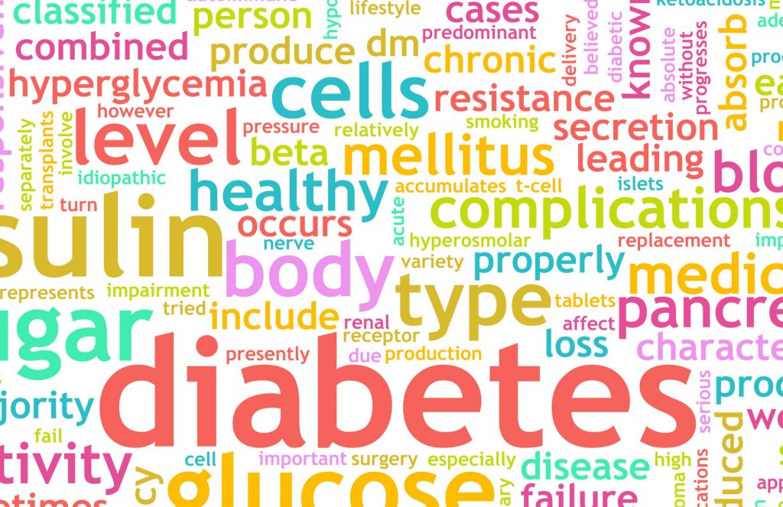

Contents Page

- Introduction ……………………………………………………………………………..2
- Approaches Used to Measure and Monitor Type 1 Diabetes…………………..3
- Factors Associated with Type 1 Diabetes…………………………………….……4
- Control of Type 1 Diabetes…………………………………………………………....5
- Implications of Type 1 Diabetes on Families and the Community……………………………………………………………………………….5
- Health and Social Care Services Available to Support People with Type 1 Diabetes………………...………………………………………………………………...6
- Conclusion ……………………………………………………………………………....7
- References ………………………………………………………………………………8

Introduction

Type 1 diabetes (T1D) is a chronic autoimmune condition in which the body’s immune system destroys the insulin-producing beta cells of the pancreas, resulting in an inability to produce insulin. Consequently, individuals require lifelong insulin therapy to regulate blood glucose levels (National Institute for Health and Care Excellence (NICE), 2023). T1D is most diagnosed in children, adolescents and young adults, although it can occur at any age (World Health Organization (WHO), 2024). Common symptoms include excessive thirst, frequent urination, unexplained weight loss, fatigue and blurred vision (National Health Service (NHS), 2024). The exact cause of T1D is not fully understood; however, genetic and environmental factors are believed to contribute to its development (Holt et al., 2021). Globally, around 8.75 million people live with T1D, while approximately 400,000 people in the United Kingdom have the condition (International Diabetes Federation, 2025; Diabetes UK, 2024). This report examines the approaches used to measure and monitor T1D at international and UK levels, explores the factors associated with the condition, discusses methods of disease control, evaluates its implications for individuals, families, communities and the National Health Service (NHS), and considers the health and social care services available to support people living with T1D.

Approaches Used to Measure and Monitor Type 1 Diabetes

Measuring and monitoring Type 1 diabetes are essential for understanding the burden of the disease, evaluating healthcare outcomes and informing public health planning. Measurement involves collecting data on the number of new diagnoses, diabetes-related complications and deaths associated with T1D to assess its impact on the population. Monitoring involves the continuous collection, analysis and interpretation of these data through surveillance systems to identify trends and evaluate the effectiveness of healthcare interventions. Internationally, organisations such as the World Health Organization and the International Diabetes Federation (IDF) use diabetes surveillance systems to monitor disease patterns, compare trends between countries and support public health planning (WHO, 2024; IDF, 2025).

Similarly, in the United Kingdom, Type 1 diabetes is monitored through the National Diabetes Audit, which evaluates the quality of diabetes care provided by GP practices and hospitals. The audit assesses whether individuals receive recommended annual health checks and achieve treatment targets, helping to improve patient outcomes and reduce inequalities in care (NHS England, 2024). The Office for Health Improvement and Disparities (OHID) also analyse national diabetes data to support public health planning and improve diabetes services (OHID, 2023).

At an individual level, monitoring includes glycated haemoglobin (HbA1c) testing, self-monitoring of blood glucose, continuous glucose monitoring and flash glucose monitoring. These methods enable healthcare professionals and individuals to assess blood glucose control, adjust insulin therapy and reduce the risk of diabetes-related complications (NICE, 2023; NHS England, 2023).

Factors (Risk Factors) Associated with Type 1 Diabetes

Control of Type 1 Diabetes Unlike Type 2 diabetes, Type 1 diabetes is not caused by lifestyle factors such as obesity, physical inactivity or an unhealthy diet. Instead, it is an autoimmune condition in which the immune system destroys the insulin-producing beta cells of the pancreas, resulting in lifelong insulin dependence (NICE, 2023).

The primary risk factor for Type 1 diabetes is genetic susceptibility. Variations in the human leukocyte antigen genes increase an individual’s risk of developing the condition; however, most people diagnosed with Type 1 diabetes have no close family history, indicating that genetics alone do not cause the disease (Holt et al., 2021).
Environmental factors are also believed to contribute to the development of Type 1 diabetes. Viral infections, particularly enteroviruses, may trigger the autoimmune response in genetically susceptible individuals. Other possible factors, including vitamin D deficiency and alterations to the gut microbiome, continue to be investigated, although their role has not yet been fully established (WHO, 2024).

Type 1 diabetes is most diagnosed during childhood and adolescence, although it can develop at any age (NHS, 2024). Understanding these risk factors supports earlier recognition, timely diagnosis and appropriate treatment, while ongoing research may improve future prevention and screening strategies (International Diabetes Federation, 2025).

Lifestyle management also plays an important role in controlling type 1 diabetes. Although diet and physical activity do not cause the condition, a balanced diet, carbohydrate counting and regular exercise help individuals manage blood glucose levels and maintain overall health (Diabetes UK, 2024). Structured education programmes, such as dose adjustment for normal eating equipping people with the knowledge and skills to adjust insulin doses safely according to their food intake and daily activities, promoting greater independence and self-management (NHS, 2024).

Regular reviews by healthcare professionals, including annual diabetes health checks, retinal screening, foot examinations and kidney function tests, are essential for detecting complications at an early stage. Effective disease control requires a collaborative approach between the individual and the multidisciplinary healthcare team, enabling personalised care, reducing hospital admissions and improving quality of life (WHO, 2024).

Control of type 1 Diabetes

Effective control of Type 1 diabetes aims to maintain blood glucose levels within the target range and reduce the risk of complications. As individuals with type 1 diabetes cannot produce insulin, lifelong insulin therapy is the primary treatment and is delivered through multiple daily injections or an insulin pump (NICE, 2023; Holt et al., 2021).
Regular monitoring is essential for effective disease control. Many people use continuous glucose monitoring or flash glucose monitoring systems to monitor glucose levels throughout the day, allowing insulin doses to be adjusted according to food intake and physical activity (NHS England, 2023). In addition, glycated haemoglobin (HbA1c) testing is carried out every three to six months to assess long-term blood glucose control (NICE, 2023).
Although lifestyle factors do not cause type 1 diabetes maintaining a balanced diet, carbohydrate counting and regular physical activity supports effective blood glucose management and overall health (Diabetes UK, 2024). Structured education programmes, such as Dose Adjustment for Normal Eating, help individuals develop the skills needed to manage insulin safely and independently (NHS, 2024).
Regular reviews by healthcare professionals, including retinal screening, foot examinations and kidney function tests, enable complications to be identified early and managed appropriately. Effective disease control therefore relies on partnership between individuals and the multidisciplinary healthcare team to improve health outcomes and quality of life (NICE, 2023).

Implications of Type 1 Diabetes on Families and the Community

Type 1 diabetes has significant implications for individuals, families and the wider community, particularly when blood glucose levels are not effectively managed. Poor disease control increases the risk of acute complications, including diabetic ketoacidosis, as well as long-term complications such as diabetic retinopathy, kidney disease and peripheral neuropathy (NICE, 2023). These complications can reduce an individual’s ability to carry out daily activities independently and may affect their education, employment and overall quality of life.

The impact of T1D also extends to families, who often provide practical and emotional support throughout disease management. Parents and carers may need to assist with insulin administration, monitor blood glucose levels and respond to diabetes-related emergencies. These responsibilities can place emotional and financial pressures on families while disrupting daily routines and employment (Diabetes UK, 2024).

At a community level, the long-term management of T1D increases demand for healthcare resources and support services. Preventable complications may result in additional hospital admissions, rehabilitation and ongoing care, creating financial pressures on the NHS and local services. Public health initiatives that promote early diagnosis, structured education and effective self-management are therefore essential to reduce complications, improve health outcomes and support the efficient use of healthcare resources (NHS England, 2024).

Health and Social Care Services Available to Support People with Type 1 Diabetes

People living with Type 1 diabetes require integrated health and social care services to support effective disease management and maintain independence. Healthcare professionals, including general practitioners (GPs), diabetes specialist nurses, endocrinologists and dietitians, provide ongoing clinical care through insulin management, routine monitoring, structured education and personalised dietary advice to help individuals manage their condition (NICE, 2023; NHS England, 2023).

Where diabetes-related complications affect an individual’s ability to live independently, social care services provide additional support following an assessment of need. Depending on individual circumstances, local authorities may arrange home adaptations, mobility equipment or assistance with personal care to promote safety and independence. Occupational therapists assess functional ability and recommend appropriate adaptations, while social care professionals work with individuals and their families to coordinate services and facilitate access to community support (NHS, 2024).

Voluntary organisations, including Diabetes UK, complement statutory services by providing education, emotional support, peer support groups and practical information for individuals and carers (Diabetes UK, 2024). By working collaboratively, health and social care services enable people with T1D to manage their condition effectively, maintain independence and achieve the best possible quality of life.

Conclusion

Type 1 diabetes is a lifelong autoimmune condition that requires effective monitoring, treatment and ongoing support to minimise complications and improve quality of life. This report has discussed the approaches used to measure and monitor the condition at both international and UK levels, highlighting the importance of epidemiological surveillance and regular clinical monitoring in improving patient outcomes. It has also examined the genetic and environmental factors associated with Type 1 diabetes and the strategies used to achieve effective disease control, including insulin therapy, blood glucose monitoring and structured education. Furthermore, the report has considered the wider implications of the condition for families, communities and the National Health Service emphasising the importance of early intervention and effective public health strategies. Finally, it has highlighted the valuable contribution of multidisciplinary health and social care services in supporting individuals with Type 1 diabetes and their families. Continued access to evidence-based care and patient education remains essential for improving long-term health outcomes across the United Kingdom.

References

Diabetes UK (2024) Type 1 diabetes. Available at: https://www.diabetes.org.uk (Accessed: 12 July 2026).
International Diabetes Federation (2025) IDF Diabetes Atlas. 11th edn. Brussels: International Diabetes Federation. Available at: https://diabetesatlas.org (Accessed: 8 July 2026).
National Health Service (2024) Type 1 diabetes. Available at: https://www.nhs.uk/conditions/type-1-diabetes/ (Accessed: 10 July 2026).
National Institute for Health and Care Excellence (2023) Type 1 diabetes in adults: diagnosis and management (NG17). Available at: https://www.nice.org.uk/guidance/ng17 (Accessed: 10 July 2026).
NHS England (2023) NHS England expands access to continuous glucose monitoring for people with type 1 diabetes. Available at: https://www.england.nhs.uk (Accessed: 14 July 2026).
NHS England (2024) National Diabetes Audit. Available at: https://digital.nhs.uk (Accessed: 14 July 2026).
Office for Health Improvement and Disparities (2023) Fingertips: Diabetes profile. Available at: https://fingertips.phe.org.uk (Accessed: 12 July 2026).
World Health Organization (2024) Diabetes. Available at: https://www.who.int/news-room/fact-sheets/detail/diabetes (Accessed: 8 July 2026).

