SHINGLES
Dana Gadzova (2128782)

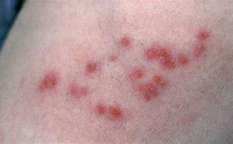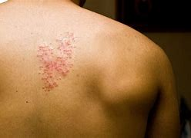
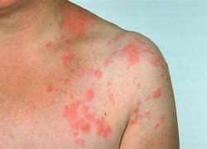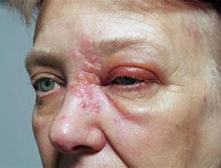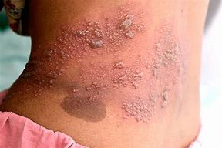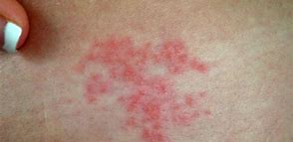

Shingles is a painful condition caused by the same virus that causes chickenpox. Anyone can get it but most common in older people. The main symptom of shingles is a painful, blotchy rash on 1 side of your body. It mainly affects the skin but can sometimes affect the ayes too. Medicine from a doctor can help speed up your recovery from shingles if it taken 3 days of the symptoms starting but not everyone needs it. Shingles is an infection that causes a painful rash. Get advice from 111 as soon as possible if you think you have it.
Check if u have shingles the first signs of shingles can be : a tingling or painful feeling in an area of skin or headache of feeling generally unwell. A rash will appear a few days later.Usually you get the shingels rash on your chest and tummy.but it can appear anywhere on your body including on your face,eyes and genitals.The rash appears as blotches on your skin.on 1 side of your body only. A rash on both the left and right of your body is unlikely to be shingles The blotches become itchy blisters that ooze fluid.A few days later, the blisters dry out and scab. The rash can be red , but this can be harder to see on brown and black skin. The rash can from a cluster that only appears on 1 side og your body the skin remains painful until after the rash has gone. The rash may be in and around your eye, making it sore and red It can affect your sight or hearing and make it hard to move 1 side of your face. Shingels can take up to 4 weeks for the rash to heal. Your skin can be painful for weeks after the rash has gone,but it usually gets better over time.Stay away from groups of people if you have shingles .You cannot spread shingles to other but people who have not had chickenpox before could catch chickenpox from you.This is becouse shingles is caused by the chickenpox virus .Try to avoid : pregnant people who have not had chickenpox before ,people with a weakened immune system like someone having chemoterapy ,babies less than 1 mounth old unless you gave birth to them becouse baby shut be protected from the virus by your immune system. About vaccination a shinglrs vaccine is avaible on the NHS for people in their 70s,it helps reduce your risk of getting shingles .if you get shingles after being vaccinated the symptoms can be much milder,you can ask your GP surgery if you can get the vaccine on the NHS.
Monitoring collection data,vaccination data, lateral flow test and PCR test data , mutation identity by scientist, Disese control diese can be controlled in different ways these include, immunisation, lifestyle behavioural changes ,medication like antibiotics antivirals and antifungals,modifying the environment vector control ,quarantine. Measuring prevalance data,incidence data mortality and morbidity data ,hospital data ,vaccine efficacy. shingles is caused when the chickenpox virus is reactivated ,after a person who had chickenpox the virus is lies dor,ant in certain nerves for many years .Shingles is more common in people with weekened immune system.People with fallowing condotions the compromise or suppress their immune system have a increased risk for herpes zoster: cancer,especially leukaemia,and lymphoma,human immunodeficiency virus HIV ,taking immunosuppressive medications including steroids chemotherapy or transplant¬ related immunosuppressive medication.

