University of Wales Trinity Saint David
Master of Business Administration

Module: Marketing Management
Module code: HKBM 7012
Student name: Luk Yau Yee
Student number: 2247752

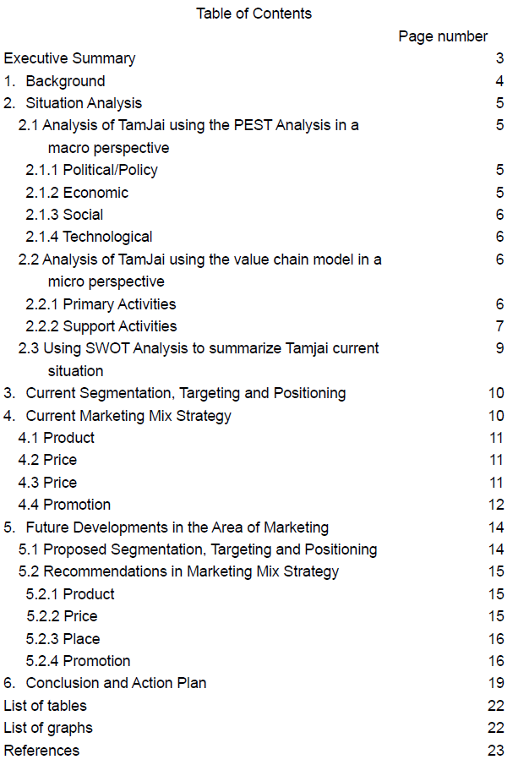
Executive Summary

Tam Jai, a top fast-food mixian chain in Hong Kong, should adopt a more comprehensive marketing approach and healthier offerings to cater to broader demographics. Inconsistent, non-standardized personal selling and high-sodium soup bases present challenges.

By utilizing traditional promotional tools, including print, outdoor, and radio advertising, TV, and social media, Tam Jai can reach diverse audiences. Introducing a low-sodium soup base will meet Hong Kong's growing demand for healthy food.

Waitstaff should receive cross-selling training for the new product, while promotional materials should be placed in high-visibility spots and sampling booths outside branches during launch week. Collaborations with TVB artists and young KOLs can promote intergenerational harmony through videos on TVB and social media.

An app revamp to be more elderly-friendly with larger font options will further enhance brand loyalty and sales. Given its market position and strategic locations, Tam Jai is primed to implement these strategies, solidifying its leadership in Hong Kong's competitive rice noodles industry.

- Background:
TamJai Yunnan Mixian (TamJai) is a popular fast-food rice noodles chain in Hong Kong that specializes in rice noodles, offering customers the option to choose their own soup base and toppings in a "cart noodle" concept. Since its establishment, Tamjai has positioned itself as a leading player in Hong Kong's competitive rice noodles industry, with 91 stores (同心飲食有限公司 (2021) in Hong Kong under its parent company Tamjai International, which also owns TamJai SamGor Mixian. Its acquisition by Toridoll and Heyi Holding Limited in 2017(Business Digest Editorial, 2023). Tamjai has gained popularity among young people (HK01, 2021). However, the Hong Kong Census and Statistics Department reports that the majority of the population falls within the age group of 30-69 years old (Census and Statistics Department Hong Kong Special Administrative Region, 2017). As Tamjai should positioned as a mass market and convenience good, it is essential to develop a comprehensive marketing plan that appeals to the broader demographic of customers between 30-69 years old, rather than just targeting young people.
Graph 1: Different Age Group % in 2023-2027

Created by Author
Source: Hong Kong Census and Statistics Department

- Situation Analysis
Tamjai is a leading chain store for rice noodles in Hong Kong, with its main competitors being Tamjai Samgor, Nam Kee Noodle, Mixian Sense, and Yugu Noodle. Tamjai has the most stores among its competitors, with locations in all 18 districts of Hong Kong. Below are the micro and macro analysis of Tamjai:

2.1 Analysis of TamJai using the PEST Analysis in a macro perspective
PEST analysis examines the macro environment affecting a business, focusing on Political, Economic, Social, and Technological factors. It guides businesses in understanding external factors and developing strategies to address them (Perera, 2017).
2.1.1 Political/Policy:
The Hong Kong government has implemented various measures to promote healthier eating habits among the public, such as voluntary reduction schemes for food and meal producers, increasing public awareness of healthier food options, and advocating for low-salt and low-sugar diets (Cheung, 2022). As a result, there is a growing demand for healthier food options in Hong Kong, which presents an opportunity for food businesses to cater to this trend and differentiate themselves in the market.
2.1.2 Economic:
According to the Hong Kong Government release on June 3, 2023, Hong Kong's real GDP grew by 4.3% year-on-year in the first quarter of 2023. The estimated real GDP growth for the whole year of 2023 is between 3.5% and 5.5% (Hong Kong Economy, 2023).
2.1.3 Social:
Graph 1 indicates a shift in the age distribution of the population over the next five years, with a decline in the percentage of young people and an increase in the percentage of middle-aged and elderly individuals.
According to a survey conducted by Euromonitor International, there is a growing demand for healthier food options in Hong Kong, with consumers showing a preference for products that are low in sugar, salt, and fat (Euromonitor International, 2021).
2.1.4 Technological:
According to the Hong Kong Census and Statistics Department, the percentage of households with internet access increased from 76.4% in 2015 to 90.1% in 2019, and reached 96.1% in 2022 (Census and Statistics Department Hong Kong Special Administrative Region (2022b)).
According to a report by Statista (Statista, 2023), the number of food delivery app users in Hong Kong is projected to reach 4.9 million in 2023, up from 3.6 million in 2019.

2.2 Analysis of TamJai using the value chain model in a micro perspective:
Porter's value chain model, developed by Michael Porter, helps organizations identify the activities that create value and contribute to their competitive advantage (Tarver, 2021).
2.2.1 Primary Activities:
Inbound logistics: Tamjai sources high-quality ingredients, such as non-GMO Canadian soybeans, pure beef and fish, and high squid content squid balls, as part of its global procurement strategy (香港品牌發展局 (n.d.)a). To reduce transportation costs and strengthen its supply chain, Tamjai has expanded its supplier network and increased direct and local food supplies through collaboration with selected contract manufacturing suppliers (香港品牌發展局 (n.d.)b).
Operations: According to an article in HK01, Tamjai's success can be attributed to its scientific management practices, including the centralization of its kitchen operations and the standardization of its cooking and service procedures (HK01, 2021). The menu is available in both Chinese and English, accompanied by pictures for customer easy reference.
Outbound logistics: TamJai has strategically positioned its 91 stores in high-traffic locations across all 18 districts of Hong Kong to attract customers by high accessibility (譚仔國際有限公司, 2023). TamJai also offers takeout service with discounts and delivery services through third-party platforms to increase accessibility for customers.
Marketing and sales: Tamjai maintaining an active presence on social media platforms such as Facebook, Instagram, and YouTube. Tamjai also collaborated with Master Steven from ViuTV, Hins Cheung, Manner and 100Most. An active presence on social media platforms and collaboration with celebrities can add value to a business by increasing brand exposure, fostering brand loyalty, and creating a positive brand image, ultimately leading to increased sales and profitability (Koivulehto, 2017).
Service: TamJai's staff are trained to provide fast and friendly service, ensuring a positive customer experience. Tamjai is highly concerned about customer feedback and has established a feedback mailbox to respond to customer opinions. Also conducts a monthly "mystery shopper program" to evaluate and assist the operations management team in developing training programs to improve service quality. (香港品牌發展局 (n.d.)c)
2.2.2 Support Activities:
Procurement: TamJai's procurement strategy focuses on sourcing high-quality and standardized ingredients, ensuring the authenticity and uniqueness of its rice noodles.
Technology development: TamJai uses technology to streamline its operations, such as digital ordering systems and online delivery platforms. TamJai also uses social media to engage with customers and promote its brand.
Human resource management: TamJai has launched the "Employee Children Scholarship" program, which provides eligible employees with subsidies for their children's annual tuition fees. Over HKD 2 million in scholarships have been awarded. Tam jai emphasizes a work-life balance for its employees, allowing them to leave early on festivals such as Mid-Autumn Festival, Winter Solstice, and New Year's Eve and have a day off on the first day of the lunar new year to spend time with their families. The company also organizes an annual anniversary banquet, which includes awards for outstanding performance, monthly performance bonuses, medical benefits, cross-district transportation allowances, free meals, fruit days, festival gifts, and free health shoes, among other employee benefits, to boost employee morale (香港品牌發展局 (n.d.)d) .
Firm infrastructure: There are 91 branches located across all 18 districts to meet the needs of customers.
2.3 Table 1: Using SWOT Analysis to summarize Tamjai current situation:
Strengths  - High-quality ingredients  - Standardization of cooking  - Menu has Chinese and English  - 91 stores in high-traffic locations across all 18 districts  - Collaboration with Youtuber/Celebrities/Channels/Platform which are popular among young people  - Conduct "mystery shopper program" monthly to keep service quality  - Employee loyalty  - The Tam Jai waitress's accent contributes to a sense of familiarity, approachability, and friendliness.  - Affordability price | Weaknesses  - Current marketing mix is not comprehensive referring to the demographic  - No standardized personal selling when taking order  - High sodium soup base (Metro Health Plus, 2020)  - Lack of elderly-friendly app
Opportunities  - The Hong Kong Government advocating for low-salt and low-sugar diets  - GDP starts to grow from 2023 Q1  - Middle age and elderly population increase  - Growing demand for healthier food options in Hong Kong  - Increase of households with internet access  - Popularity of food delivery app | Threats  - Young population decrease
Created by Author

- Current Segmentation, Targeting and Positioning
We will analyze Tamjai current segmentation, targeting, and positioning (STP) strategies below.
Table 2: Current STP of Tam Jai
Segmentation: | By age
Targeting: | Youth
Positioning: | 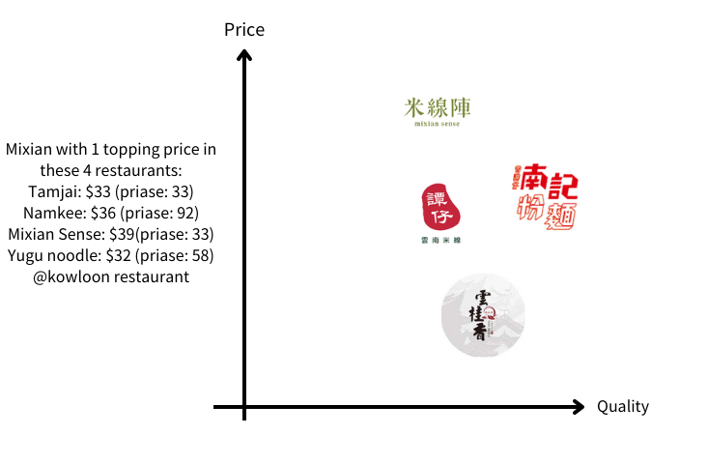
Created by Author
Source: Openrice
- Current Marketing Mix Strategy
Tamjai Mixian's marketing mix consists of product, price, place, and promotion. Below is the analysis and comment on the effectiveness of each element:
4.1 Product: Tamjai Mixian provides convenient fast food options through a streamlined order and delivery process, offering a single product line featuring Mixian. The brand caters to customers seeking a quick meal solution. However, Tamjai currently lacks a unique selling point to differentiate itself from other mixian establishments. As a convenience good, Tamjai boasts high product availability and maximum distribution.
4.2 Price: Tamjai Mixian's pricing strategy is harvesting, with prices similar to other mixian shop in Hong Kong. The brand also offers meal combos and promotional deals to attract customers, for example, half price of side dish. This pricing strategy has been effective in attracting price-conscious customers and promoting repeat business.
4.3 Place: Tamjai's product is extensively available, with 91 branches strategically located across 18 districts. The allocation of these branches is positively correlated with the population density of each district, ensuring wider accessibility of the product for potential customers. Additionally, Tamjai has collaborated with popular food ordering applications such as Foodpanda and Deliveroo to broaden its reach and offer greater convenience to customers.

Table 3: Distribution of Tam Jai branches and % of population of the districts
District | Number of branches | % of Hong Kong Population
Kowloon | 34 | 30.1%
New Territories | 40 | 53.7%
Hong Kong Island | 16 | 16.1%
Islands District | 1 | 0.01%
Created by Author
Source: Tam Jai Official website and Hong Kong Census and Statistics Department

4.4 Promotion: Promotion mix is a marketing term that refers to the combination of advertising, sales promotion, personal selling, and public relations tactics used to promote products or services to a target audience (Yousaf, 2014).
Advertising: In the case of Tamjai, advertising plays a relatively more important role than personal selling due to the large number of customers, low information needs of buyers, low product complexity, pre-set pricing, and ample resources available for promotion (Key Differences, 2017). Tamjai advertises through various channels, including their official website, social media platforms, and printed posters at their branches. In addition, Tamjai collaborates with celebrities who are popular among young people, such as Master Seven from ViuTV, Hins Cheung, MC $oHo & KidNey (明周, 2021). However, such advertising methods may not effectively reach and attract middle-aged and elderly populations as the celebrity endorsers may not be well-known within these age groups. ViuTV's audience age group mostly falls within the 25-34 range in Hong Kong, making it an ideal platform to reach out to younger generations (Similarweb, 2023).
Table 4: Updated frequency of Tam Jai’s social media
Social media platform | Videos/posts | Subscriber/Followers as of 1 Jul 2023
Youtube Channel  @tamjaiyunnanmixian1680 | 22 videos | 2.66k
Instagram  @譚仔雲南米線 | 764 posts | 28k
Facebook  @譚仔雲南米線 | 12 posts in Jun 2023 | 110k
Created by Author
Source: Tam Jai Social Media Platforms

Personal selling: There is no standardized personal selling among the branches.

Sales promotion: TamJai offers a loyalty program where customers can earn points for every purchase and then redeem those points for rewards, such as free dishes or discounts. Also, occasionally offers limited-time promotions, such as discounts on specific dishes or free items with a certain purchase amount. These sales promotions are designed to attract and retain customers, generate excitement, and ultimately increase sales for the company (Pipedrive, 2021).

Public relations: PR is a crucial component of the marketing mix that companies use to establish themselves as trustworthy brands, differentiate from competitors, and drive business growth (Falk, 2020). Tam Jai 's "Tam Jai Car Car. Tam Jai Art" charity art exhibition (ULifestyle, 2023) is an example of a PR effort that promotes the brand image and demonstrates the company's commitment to social responsibility while generating positive media coverage and enhancing its reputation.

- Future Developments in the Area of Marketing
In light of the aforementioned analysis, the following suggestions and proposed future developments are recommended for Tamjai with the objective of increasing sales by launching a new product to respond to the market need and utilizing differentiated marketing to implement a more comprehensive marketing plan that targets a larger portion of the population. Differentiated marketing is a strategy that involves targeting distinct customer segments with customized marketing tools, differentiate marketing strategies for different target, recognizing that each segment has unique needs and preferences (Kotler and Keller, 2014). This approach can gain the attention of the specified target groups (Lynn, 2011)

5.1 Proposed Segmentation Targeting and Positioning:
Table 5: Proposed STP for Tam Jai
Segmentation | Mass market
Targeting | Mass market
Positioning | Increasing quality by expanding menu and healthier choice  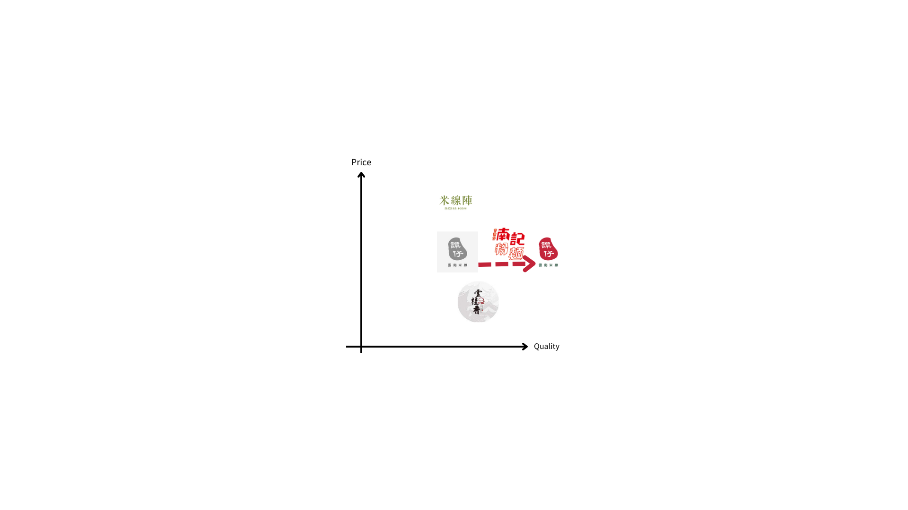
Created by Author
5.2 Recommendations in Marketing Mix Strategy
5.2.1 Product: Product development should collective customer commitment. As the demand for healthier food option is increasing and the demographic changes, Tamjai should have it product line extension by cocreation and listening to the Voice of Customer. Low sodium soup base with healthier topping, and also as Tamjai unique selling point.

5.2.2 Price: Tamjai could employ a penetration pricing strategy for its low sodium soup base during the introductory phase. This approach entails setting a relatively lower price for the product in question, thereby creating an incentive for potential customers to try it (Kenton, 2023). The underlying assumption is that once customers become familiar with the product and appreciate its value, they will continue to purchase it despite a subsequent increase in price. By adopting this pricing policy, Tamjai can successfully penetrate the market and establish a loyal customer base for its low sodium soup base.

5.2.3 Place: Tamjai's in-store positioning strategy could involve placing promotional flags or other marketing materials to increase the visibility, accessibility, and appeal of their low sodium soup base to customers. This would help draw attention to the product and make it more enticing for customers to purchase (Granbois,1968).

5.2.4 Promotion:
Advertising: Tam Jai's current social media advertisements appear to be unappealing to a significant portion of the population due to the lack of familiarity with the featured celebrities. To reach a more diverse audience, Tam Jai should incorporate advertising tools that can effectively target middle-aged and elderly demographics, thus increasing the comprehensiveness of their promotional strategy and expanding their market reach. For example, print advertising, outdoor advertising, radio advertising, event sponsorship, and influencer marketing.

Contrary to the notion that social media platforms should be differentiated according to age group, Yogesh and Yesha argue that social media has no significant impact on different demographic segments of consumers (Yogesh and Yesha, 2014). Therefore, by utilizing a greater number of advertising channels, Tam Jai can potentially reach a wider audience and foster brand trust (Hanaysha, 2022).

Additionally, social media has been shown to have a positive impact on consumers' purchasing decisions (Yogesh and Yesha, 2014), further underscoring the importance of frequent updates to social media platforms. As such, Tam Jai should consider increasing their social media post frequency from 12 to 15 posts per month.

These methods can be particularly effective for reaching older demographics who may not be as active on social media platforms. By incorporating such tools into their advertising strategy, Tam Jai can potentially reach a wider audience and foster brand trust, thereby increasing the comprehensiveness of their promotional strategy and expanding their market reach.

Personal selling: To enhance the overall customer experience and increase sales, TamJai could consider implementing cross-selling techniques that suggest customers try the low sodium soup base and inquire whether they would like a beverage or a dish of vegetables with their meal. This approach may heighten customer interest in the low sodium soup base, while also providing a more comprehensive and enjoyable dining experience (Chartier, 2021) . However, to effectively execute this strategy, TamJai would need to provide training to all its waiters and waitresses to ensure that they are well-versed in the benefits of the low sodium soup base and can offer cross-selling suggestions in a professional and persuasive manner.
Sales Promotion:
To promote the new low-sodium soup base, Tamjai could adopt various sales promotion strategies in the F&B industry. For instance, offering a sampling booth that allows customers to try the new product can increase the likelihood of a purchase and provide valuable feedback on customer preferences and opinions. Additionally, conducting giveaways on Tamjai's social media platforms, such as asking followers to comment on the advantages of a low-sodium diet to win a $5 cash coupon, can generate buzz and excitement around the brand. This approach can encourage customer engagement with the brand on social media and other channels, and can be an effective way to promote brand awareness and loyalty. Ultimately, the most effective sales promotion strategies will depend on factors such as the target audience, the competitive landscape, and the overall marketing strategy.

Public Relations: Collaborating with TVB artists and young KOLs to advocate for intergenerational harmony "老幼共融" is the suggested PR idea for Tam Jai, also as social responsibility in the aging city.
Tamjai can invite TVB artists and young KOLs to film the marketing video together, and share it on social media platforms and TVB channels. This tactic can help the Tamjai reach a wider audience, increase brand credibility, and promote its values while addressing an important social issue. Collaborating with TVB artists is a great way for Tam Jai to attract the attention of middle-aged and elderly audiences. TVB artists have a strong following among these age groups, and partnering with them can help Tam Jai reach a wider audience and increase brand visibility. According to a report by Nielsen, TVB dramas and variety shows were the top-rated programs among Hong Kong audiences aged 35 to 64 in 2020 (Nielsen, 2022). As such, collaborating with TVB artists can be an effective way for Tam Jai to attract the attention of middle-aged and elderly audiences who are avid TVB viewers.
Furthermore, launching a campaign that encourages intergenerational dining. Tam Jai can introduce a campaign that offers a discount to customers who dine with an elderly family member or friend, can have 10 % off. This campaign can help promote intergenerational harmony and encourage younger generations to spend more time with their elders while dining at Tam Jai's restaurants. By doing so, Tamjai can differentiate itself from competitors while promoting its brand values and commitment to social responsibility.

- Conclusion and Action Plan:
Table 6: Action Plan
Objectives: Adopting more comprehensive marketing plan, launch the new product, revamp support activities to increase the sales
Item | Related department
Keep current marketing strategies for targeting young generation | Sales and Marketing team
Adopting traditional promotional tools to reach out more potential customer, for example, print advertising, outdoor advertising, radio advertising, TV, etc. | Sales and Marketing team
Launch New Product and Development unique selling point – low sodium soup base | Product team and Centralize Kitchen
Set a competitive price at the beginning stage | Sales and Marketing team
Put Low Sodium Soup Base promotional material in high visibility and accessibility spot in the branches, i.e. cashier and the tables | All branches
Cross-selling techniques training workshop for all waiter and waitress | Training Team
Add two check points for "mystery shopper program"  - Have waiter/waitress ask you to try the low sodium soup base when taking order?  - Have waiter/waitress ask you to add on vegetables or side dish when taking order? | Training Team and Sales and Marketing team
Offering a sampling booth, outside of the branches, for the 1st week of new soup base launched | All branches
Conducting giveaways on Tamjai's social media platforms, i.e. Asking followers to comment on the advantages of a low-sodium diet to win a $5 cash coupon | Sales and Marketing team
Collaborating with TVB artists and young KOLs to advocate for intergenerational harmony, filming the video and plays it on TVB and social media platform | Sales and Marketing team
“Intergenerational harmony” campaign: 10% off if 1 young people + 1 elderly | Sales and Marketing team
Revamp the app to be more elderly-friendly, can choose bigger font size and using voice input to take order | IT
Created by author

List of table(s):
Page number
Table 1: Using SWOT Analysis to summarize Tamjai current situation: | 9
Table 2: Current STP of Tam Jai | 10
Table 3: Distribution of Tam Jai branches and % of population of the districts | 11
Table 4: Updated frequency of Tam Jai’s social media | 13
Table 5: Proposed STP for Tam Jai | 14
Table 6: Action Plan | 19

List of graph(s):
Page number
Graph 1: Different Age Group % in 2023-2027 | 4

References:
Business Digest Editorial (2023). 【生活中的品牌故事】譚仔米線是如何「合久必分，分久必合」的？How Tam Jai Mixian Underwent the Cycle of ‘Dividing and Reuniting’? [online] Business Digest Editorial. Available at: https://businessdigest.io/%E5%93%81%E7%89%8C%E6%95%85%E4%BA%8B/%E7%94%9F%E6%B4%BB%E4%B8%AD%E7%9A%84%E5%93%81%E7%89%8C%E6%95%85%E4%BA%8B-%E8%AD%9A%E4%BB%94%E7%B1%B3%E7%B7%9A%E6%98%AF%E5%A6%82%E4%BD%95-%E5%90%88%E4%B9%85%E5%BF%85%E5%88%86-%E5%88%86%E4%B9%85%E5%BF%85%E5%90%88-%E7%9A%84-how-tam-jai-mixian-underwent-the-cycle-of-dividing-and-reuniting [Accessed 24 Jul. 2023].
Census and Statistics Department Hong Kong Special Administrative Region (2017). 香港人口推算2020-2069. [online] 2017年至2066年香港人口推算. Available at: https://www.censtatd.gov.hk/en/data/stat_report/product/FA100061/att/B71710FA2017XXXXB0100.pdf [Accessed 24 Jul. 2023].
Census and Statistics Department Hong Kong Special Administrative Region (2022a). 地區概覽 (人口及住戶). [online] www.censtatd.gov.hk. Available at: https://www.censtatd.gov.hk/tc/map_ghs.html [Accessed 24 Jul. 2023].
Census and Statistics Department Hong Kong Special Administrative Region (2022b). Use of Information Technology. [online] www.censtatd.gov.hk. Available at: https://www.censtatd.gov.hk/en/scode590.html [Accessed 24 Jul. 2023].
Chapple, L., Eizenman, O. and Wilkie, J. (2022). Winning in loyalty | McKinsey. [online] McKinsey & Company. Available at: https://www.mckinsey.com/capabilities/growth-marketing-and-sales/our-insights/winning-in-loyalty [Accessed 24 Jul. 2023].
Chartier, J. (2021). The six c’s of cross-selling success | McKinsey & Company. [online] Mckinsey & Company. Available at: https://www.mckinsey.com/capabilities/strategy-and-corporate-finance/our-insights/the-strategy-and-corporate-finance-blog/the-six-cs-of-cross-selling-success [Accessed 24 Jul. 2023].
Cheung, I. (2022). Legislative Council of the Hong Kong Special Administrative Region - Measures to reduce dietary sodium and sugar. [online] Legco.gov.hk. Available at: https://www.legco.gov.hk/research-publications/english/essentials-2022ise03-measures-to-reduce-dietary-sodium-and-sugar.htm [Accessed 24 Jul. 2023].
Euromonitor International (2021). Health and Wellness in Hong Kong, China | Market Research Report | Euromonitor. [online] www.euromonitor.com. Available at: https://www.euromonitor.com/health-and-wellness-in-hong-kong-china/report [Accessed 24 Jul. 2023].
Falk, A. (2022). Council Post: How Public Relations Differs From Marketing. [online] Forbes. Available at: https://www.forbes.com/sites/forbesagencycouncil/2022/03/21/how-public-relations-differs-from-marketing/?sh=7c74199a30c0 [Accessed 24 Jul. 2023].
Granbois, D.H. (1968). Improving the Study of Customer In-Store Behavior. Journal of Marketing, 32(4), p.28. doi:https://doi.org/10.2307/1249334.
Hanaysha, J.R. (2022). Impact of social media marketing features on consumer’s purchase decision in the fast-food industry: Brand trust as a mediator. International Journal of Information Management Data Insights, [online] 2(2), p.100102. doi:https://doi.org/10.1016/j.jjimei.2022.100102.
HK01 (2021). 譚仔上市｜18區144分店 兩學者分析成功之道 抵食兼似麥當勞. [online] 香港01. Available at: https://www.hk01.com/%E7%A4%BE%E6%9C%83%E6%96%B0%E8%81%9E/613179/%E8%AD%9A%E4%BB%94%E4%B8%8A%E5%B8%82-18%E5%8D%80144%E5%88%86%E5%BA%97-%E5%85%A9%E5%AD%B8%E8%80%85%E5%88%86%E6%9E%90%E6%88%90%E5%8A%9F%E4%B9%8B%E9%81%93-%E6%8A%B5%E9%A3%9F%E5%85%BC%E4%BC%BC%E9%BA%A5%E7%95%B6%E5%8B%9E [Accessed 24 Jul. 2023].
Hong Kong Economy (2019). Hong Kong Economy - Hong Kong Economic Situation - Latest Development. [online] Hong Kong Economy. Available at: https://www.hkeconomy.gov.hk/en/situation/development/index.htm [Accessed 24 Jul. 2023].
Kenton, W. (2023). Penetration Pricing. [online] Investopedia. Available at: https://www.investopedia.com/terms/p/penetration-pricing.asp [Accessed 24 Jul. 2023].
Key Differences (2017). Difference Between Advertising and Personal Selling (with Comparison Chart). [online] Key Differences. Available at: https://keydifferences.com/difference-between-advertising-and-personal-selling.html [Accessed 24 Jul. 2023].
Koivulehto, E.I. (2017). DO SOCIAL MEDIA MARKETING ACTIVITIES ENHANCE CUSTOMER EQUITY? [online] Aalto University. Available at: https://core.ac.uk/download/pdf/84756563.pdf [Accessed 24 Jul. 2023].
Kotler , P. and Keller, K.L. (2014). Marketing management. 15th ed. Pearson.
Lynn, M. (2012). ‘Segmenting and Targeting Your Market: Strategies and Limitations’ by Michael Lynn. [online] https://onlinelibrary.wiley.com/doi/10.1002/9781119200901.ch23. Available at: https://onlinelibrary.wiley.com/doi/10.1002/9781119200901.ch23 [Accessed 24 Jul. 2023].
明周 (2021). 【專訪】《係咁先啦！》爆紅破366萬點擊 MC $oHo & KidNey 「呢首係文學作品」. [online] 明周娛樂. Available at: https://www.mpweekly.com/entertainment/focus/local/%E3%80%90%E5%B0%88%E8%A8%AA%E3%80%91%E3%80%8A%E4%BF%82%E5%92%81%E5%85%88%E5%95%A6%EF%BC%81%E3%80%8B%E7%88%86%E7%B4%85%E7%A0%B4366%E8%90%AC%E9%BB%9E%E6%93%8A-mc-oho-kidney-%E3%80%8C%E5%91%A2 [Accessed 24 Jul. 2023].
Nielsen (2022). 2022 Video Consumption Landscape Survey. [online] Available at: https://img.tvb.com/ti_img/event/static/adcentral/pdf/file_path_20221104090325000_83119452.pdf [Accessed 24 Jul. 2023].
Perera, R. (2017). The Pestle Analysis. [online] BOOKS BY Nerdyaut. Available at: https://books.google.com.hk/books?hl=zh-TW&lr=&id=ZWpLDwAAQBAJ&oi=fnd&pg=PA2&dq=pestle+analysis&ots=Duf3tL3DME&sig=VkNhZTtc6hj40afHpcNiTYvUZhE&redir_esc=y#v=onepage&q=pestle%20analysis&f=false [Accessed 24 Jul. 2023].
Pipedrive (2021). 12 Sales Promotion Examples to Win More Deals and How to Prepare Your Sales Team. [online] Pipedrive. Available at: https://www.pipedrive.com/en/blog/sales-promotion [Accessed 24 Jul. 2023].
Similarweb (2023). viu.tv的市場佔有率、收入及流量分析. [online] similarweb. Available at: https://www.similarweb.com/zh-tw/website/viu.tv/#overview [Accessed 24 Jul. 2023].
Statista (2023). Hong Kong: most popular food delivery apps 2020. [online] Statista. Available at: https://www.statista.com/statistics/1149435/hong-kong-favorite-food-delivery-apps/ [Accessed 24 Jul. 2023].
Tam Jai International Co. Limited (2023). 截至二零二三年三月三十一日止年度之 全年業績. [online] 截至二零二三年三月三十一日止年度之 全年業績. Available at: https://www1.hkexnews.hk/listedco/listconews/sehk/2023/0515/2023051500044_c.pdf [Accessed 24 Jul. 2023].
Tarver, E. (2021). What are the primary activities of Michael Porter’s value chain? [online] Investopedia. Available at: https://www.investopedia.com/ask/answers/050115/what-are-primary-activities-michael-porters-value-chain.asp [Accessed 24 Jul. 2023].
同心飲食有限公司 (2021). 搜尋分店 | 譚仔雲南米線. [online] 譚仔雲南米線. Available at: https://tamjaimixian.com/%E6%90%9C%E5%B0%8B%E5%88%86%E5%BA%97/ [Accessed 24 Jul. 2023].
ULifestyle (2023). 旺角好去處｜譚仔為期8日慈善藝術展覽揭幕！首次推出「譚仔車車」、惡搞12幅世界名畫. [online] ULifestyle. Available at: https://hk.ulifestyle.com.hk/activity/detail/20004498/%E6%97%BA%E8%A7%92%E5%A5%BD%E5%8E%BB%E8%99%95-%E8%AD%9A%E4%BB%94%E7%82%BA%E6%9C%9F8%E6%97%A5%E6%85%88%E5%96%84%E8%97%9D%E8%A1%93%E5%B1%95%E8%A6%BD%E6%8F%AD%E5%B9%95-%E9%A6%96%E6%AC%A1%E6%8E%A8%E5%87%BA-%E8%AD%9A%E4%BB%94%E8%BB%8A%E8%BB%8A-%E6%83%A1%E6%90%9E12%E5%B9%85%E4%B8%96%E7%95%8C%E5%90%8D%E7%95%AB [Accessed 24 Jul. 2023].
香港01 (2021). 譚仔上市｜創食辣等級、宣傳貼地 9個原因成功令年輕人愛食米線｜Opener. [online] 香港01. Available at: https://www.hk01.com/%E9%96%8B%E7%BD%90/684967/%E8%AD%9A%E4%BB%94%E4%B8%8A%E5%B8%82-%E5%89%B5%E9%A3%9F%E8%BE%A3%E7%AD%89%E7%B4%9A-%E5%AE%A3%E5%82%B3%E8%B2%BC%E5%9C%B0-9%E5%80%8B%E5%8E%9F%E5%9B%A0%E6%88%90%E5%8A%9F%E4%BB%A4%E5%B9%B4%E8%BC%95%E4%BA%BA%E6%84%9B%E9%A3%9F%E7%B1%B3%E7%B7%9A [Accessed 24 Jul. 2023].
香港品牌發展局H.K.B.D.C. (n.d.). Hong Kong Brand Development Council. [online] Hong Kong Brand Development Council. Available at: https://www.hkbrand.org/tc/event/2/page/3/brand/933?activePage=1&tab=153 [Accessed 24 Jul. 2023].
新城健康 (2020). 清湯、麻辣定煳辣 譚仔 湯底 熱量排行榜｜營養排行榜 文章版權為新城廣播有限公司所擁有, 原文請按： https://metrohealthplus.hk/15873/%E8%AD%9A%E4%BB%94-%E6%B9%AF%E5%BA%95-%E7%86%B1%E9%87%8F-%E6%8E%92%E8%A1%8C%E6%A6%9C-%E7%87%9F%E9%A4%8A%E6%8E%92%E8%A1%8C%E6%A6%9C/. [online] 新城健康＋. Available at: https://metrohealthplus.hk/15873/%E8%AD%9A%E4%BB%94-%E6%B9%AF%E5%BA%95-%E7%86%B1%E9%87%8F-%E6%8E%92%E8%A1%8C%E6%A6%9C-%E7%87%9F%E9%A4%8A%E6%8E%92%E8%A1%8C%E6%A6%9C/ [Accessed 24 Jul. 2023].
Yogesh, F. and Yesha, M. (2014). Effect of Social Media on Purchase Decision. Pacific Business Review Internatioal, Available at: http://www.pbr.co.in/2014/2014_month/May/9.pdf [Accessed 24 Jul. 2023].
Yousaf, S. (2014). Promotion mix management: A consumer focused Islamic perspective†. Journal of Marketing Communications, 22(2), pp.215–231. doi:https://doi.org/10.1080/13527266.2014.888575.

