Chapter 4 – Data analysis
- Introduction
Chapter 3 identified the method and methodology of this research. This chapter aims to achieve the fifth objective:
To analyse data collected to determine if police officers should be proactive or reactive in an effort to deter crime based on servicing police officers’ thoughts and opinions.

This chapter will analyse data collected through primary research. An online survey was conducted and shared with serving police officers enabling them to provide their thoughts and opinions on the research question. During this chapter, reference will be made to specific questions that have been answered by these serving police officers.

4.1 Data analysis
Data analysis requires the collection, cleaning and transforming of collected data in order to interpretate the data as findings which allows for any patterns or themes to become clear (Eldridge, 2023). The data was collected and analysed through Survey Monkey. Using Survey Monkey to collect data allowed for many advantages. For example, it permitted swift response times from respondents with easy to understand data.

4.2 Method for analysis
Due to the data being both qualitative and quantitative in nature, it was important to find two method of analysis that analyses both results. For data that was collected that is quantitative in nature these will be displayed using graphs whilst data collected that is qualitative in nature has been complied into a single document to assist in analysing the data.

4.3 Survey findings
4.3.1 Policing role statistics
Participants were categorised by role within the police service to allow for a range of different participant views depending on what their specific role is. This survey shows the answers of 25 participants who are currently serving police officers. This survey was shared via WhatsApp to serving police officers.
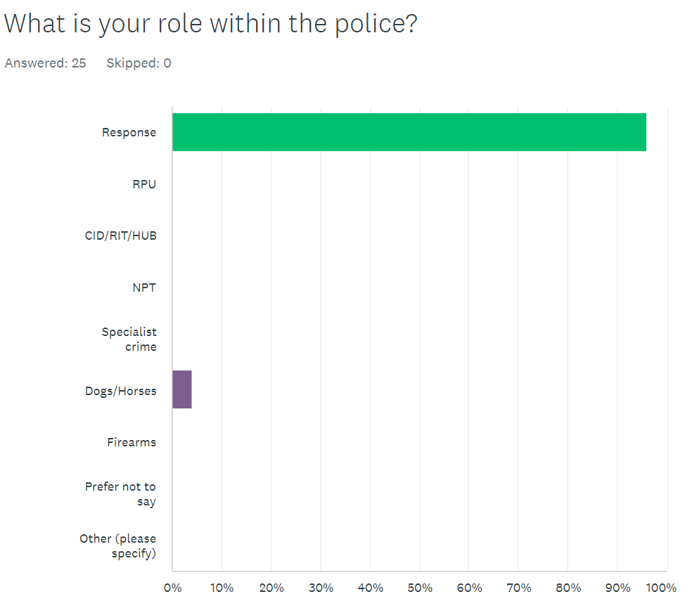
Figure 4.3.1 – Graph showing which department participants are in

As seen in Figure 4.3.1 of the 25 precipitants 96% were part of the response department and 4% were dogs/horse department. This research was undertaken as the researcher identified there is little to no acknowledgment of current police officers’ thoughts and opinions on the question should police officers be proactive or reactive in an effort to reduce crime rates? Previous research outlined in the previous literature review chapter discussed the benefits and negatives of both crime prevention strategies but didn’t provide current police officers thoughts or opinions on these strategies. All participants gave their permission in question 1 of the survey for their answers provided to be used within the dissertation.

4.3.2 Opinions on crime rates
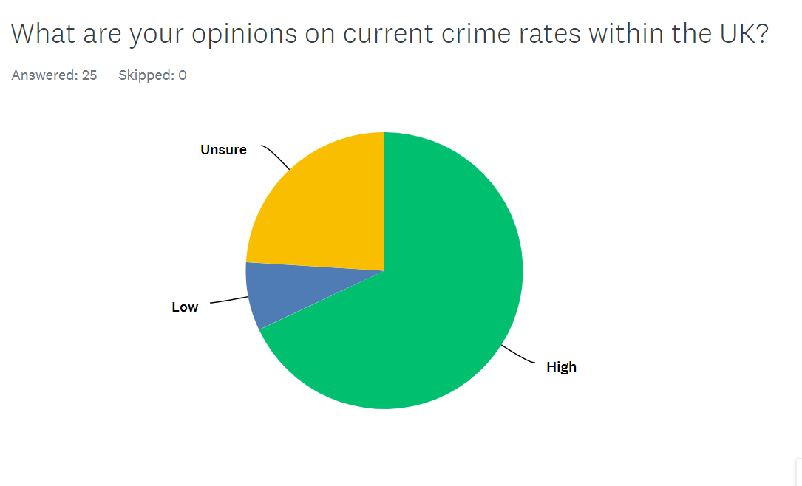
Figure 4.3.2 – Pie chart showing participants thoughts on crime rate within the UK.

As seen in Figure 4.3.2 the majority of participants are under the perception that the current crime rate in the UK is high with 68% of participants answering high with only 8% answering low and 24% answering unsure. This shows that the majority of participants believe that the current crime rate in the UK is high.

4.3.3 How long do you spend utilising the proactive policing strategy vs reactive policing strategy.
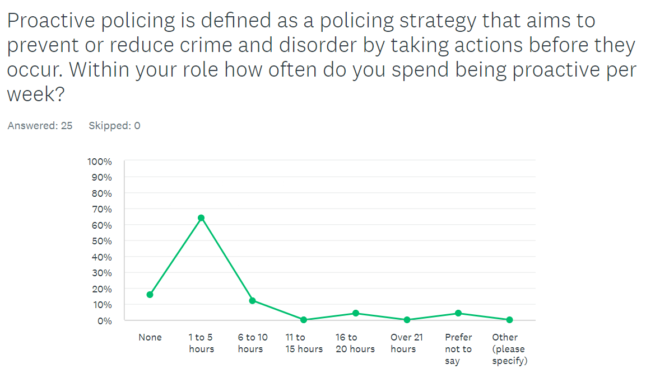
Figure 4.3.3 – Line graph showing how long participants spend being proactive per week.

As shown in Figure 4.3.3 it can be seen how much time serving police officers spend utilising the proactive policing strategy per week with 64% answering that they spend between 1 to 5 hours a week being proactive, 12% answering that they spend between 6 to 10 hours, 4% answering that they spend between 16 and 20 hours and 4% preferring not to say. Overall, between the participants in this survey none of them spent over 21 hours utilising proactive policing with the overall percentage being quite low.

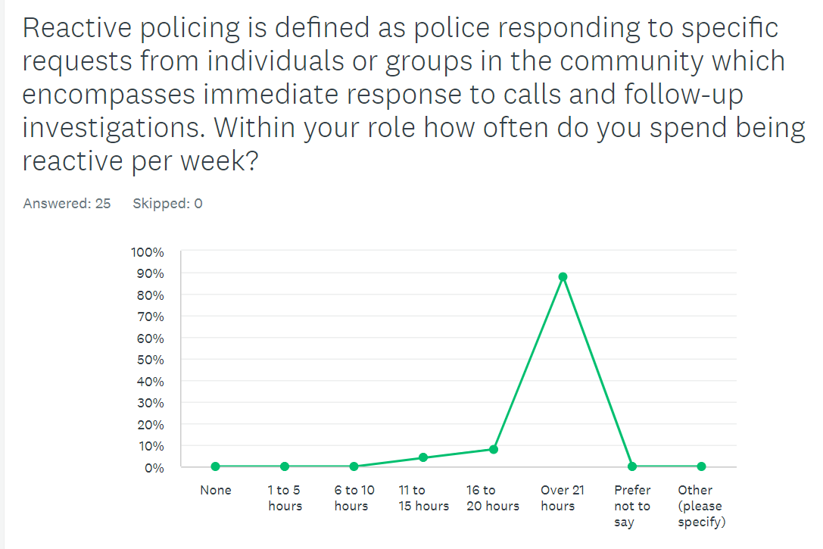
Figure 4.3.4 - Line graph showing how long participants spend being reactive per week.
In contrast to Figure 4.3.3, Figure 4.3.4 shows that the time per week police officers spend utilising the reactive policing strategy is significantly higher when compared to Figure 4.3.3 with 4% of participants answering 11 to 15 hours per week, 8% of participants answering 16 to 20 hours per week and 88% of participants answering over 21 hours per week. This shows that participants in this survey spend significantly more time being reactive rather than proactive.

4.3.5 Benefits and negatives of proactive policing and reactive policing.
Within the survey participants were asked about the benefits and negatives they have experienced of both proactive and reactive policing. Participants provided the following responses to proactive policing ‘’Proactive policing can increase workload/ prevent recourses being available to respond or be reactive. Positive: Prevent crimes occurring reducing need to respond/react’’ with another participant answering the following:
‘’One benefit would be preventing offences and targeting repeat offenders. Officers rarely have the time to commit to being proactive. This is due to the high volume of calls, low number of officers and the demand on mental health calls’’. When comparing these answers with the responses to reactive policing which are ‘’The benefit of reactive policing is safeguarding victims and conducting the relevant golden hour enquires’’ and ‘’The negatives of reactive policing are waiting for a crime to be committed. Public perception on policing is affected when they see police only react to incident rather than being proactive and preventing the crime.’’ It can be seen that participants have experienced both positives and negatives in both policing strategies but that they agree in both that proactive policing can prevent crimes before they take place.

4.3.3 Participants thoughts on proactive vs reactive policing to prevent crime.
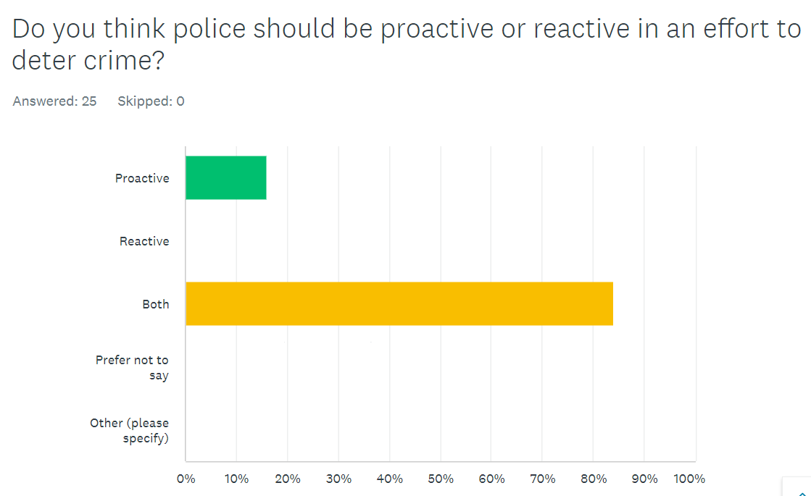
Figure 4.3.3 – Bar graph showing participants answers to which policing strategy should be utilised to deter crime.

As shown in figure 4.3.3 16% of participants answered proactive and 84% answered both. This shows the majority of participants believe both strategies should be utilised to deter crime with some answering that proactive policing should be utilised to deter crime. With this in mind it and comparing these findings with figure 4.3.3 and figure 4.3.4 it can be seen that currently, time isn’t equally spent utilising both policing strategies and that participants believe this should be equal.

4.4 conclusion
This chapter has successfully presented the findings of the research project derived from primary data collection in the form of a survey. This chapter has also completed the achieved the fifth objective.
In conclusion the present study identified that the majority of participants believe that both policing strategies should be utilised to deter crime and that currently the reactive strategy is being utilised significantly more than the proactive strategy. This study agrees with literature previously outlined in the literature review chapter that discussed the benefits of proactive policing and deterring crime with many participants believing it can prevent crime.

1099 words

Bibliography:
Eldridge, S. (2023) Data analysis [Internet]. Available at https://www.britannica.com/science/data-analysis (Accessed: 02/02/2024)

