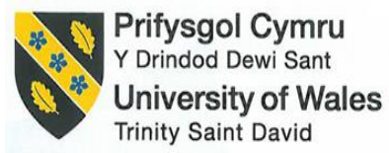

MANAGEMENT & ORGANISATIONAL BEHAVIOUR
Written report

Module Name: Management and Organisational Behaviour
Module Code: BMIH5004
Lecturer Name: Antoinette Milne
Student Name: Petre Chiriac
Student ID: 2246594
Word Count: 2200

I acknowledge the use of Grammarly (https://www.grammarly.com/) on 01 March 2025 to check my work using the prompt(s):

- Please check the following text for readability, grammar and syntax.
I confirm that I have not presented any AI generated text as my own work. I confirm I have copies of my drafts, notes, and other resources I used before, and after the use of AI tools which I may be asked to provide in evidence.

Executive Summary
The following pages of the report suggested the organisational structure that was adopted by the Marriott International at individual and corporate level. Further, it was found that the organisation followed a matrix structure at the corporate level and a functional structure at the individual level. Moreover, it also explored the influence of various recent changes that have taken place recently. In addition, it also demonstrated the summary of strategic sections that were taken from the annual report of the firm. In the end, several recommendations had been suggested to the higher management of the hotel for their further improvement and along with that proposed plan of implementation.

Table Contents
Executive Summary 3
Introduction 5
Organisational structure, culture, and goals 6
Corporate and individual-level structure 6
Examination of organisational culture and its influence on operations 8
Corporate and individual unit-level goals 9
Recent change initiatives 10
Determination of several change initiatives 10
Influence of recent changes 11
Examination of change management effectiveness 12
Strategic Direction 12
Present strategies 12
Strategies Implemented for Long-Term Objectives 13
Conclusion 14
Recommendations 15
References 16

Introduction
Marriot International (2025) informed that it is an international chain of hotels that runs its franchise hotels and restaurants and offers its consumers rented properties. Further, it is considered the largest hotel based on the number of rooms. Further, the hotel was incorporated in the year 1927 in Washington DC, with only nine seats, named A&W root beer stand, and the first hotel of the franchise was incorporated as Marriott Motor Hotel in the city of Virginia in 1957. In addition, the first international hotel of the group in Mexico in the year 1969 was Paraiso Marriott. Apart from that, as per Statista (2025), it is considered to be the largest market share in terms of revenue across the globe and in the USA.
In the monetary year 2023, the firm generated a total revenue of $ 23.71 billion,which is higher than the profits of the year 2022.
The following pages of the report aim to explore the organisational structure, culture, and goals of the chosen hotel group. Further, it will examine the influence of the culture of the organisation and its influence on its operations. It will also identify the recent change initiatives and their influence, and it will also summarise the strategic objectives of the firm, in the end, it provides some recommendations to the management of the hotel for further improvements.

Organisational structure, culture, and goals

Corporate and individual-level structure
As defined by Nene and Pillay (2019) and Agrawal et al. (2020), the organisational structure is that structure that tells about the formal breakdown of the jobs, structure, and divisions has been divided and structured. In addition, the structure of the organisation ensures coordination among the members of the organisation.
Further, the organisational structure has been bifurcated into several structures, which have been presented below –

Figure 1 - Types of Organisational Structure
As suggested by Dudovskiy (2023), the management of Marriott International has adopted a Matrix Organisational structure for managing its job role in the organisation. Further, the given structure includes the features of functional and divisional organisational structure. The organisational structure of Marriott has been provided below –
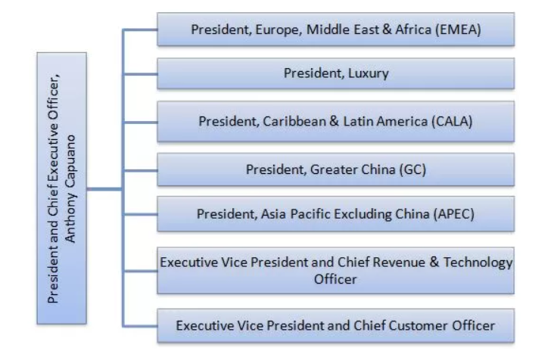
Figure 2 - Organisational Structure (Source: Dudovskiy, 2023)
The above chart demonstrates the organisational structure of the organisation, which combines the features of functional and organisational structure. Further, the functionalstructure of the organisation includes marketing, sales, and operations,and the organisational division is bifurcated based on geographic location. In addition, the chosen organisational structure helps in attaining uniformity and diversification in its global operations. In addition, as suggested by Geeks for Geeks (2023), the matrix structure enables the transfer of expertise and knowledge throughout the functional division of the organisation. However, the employee and member of the organisation have to report to both functional and divisional heads of the organisation, respectively, which leads to complex hierarchical relations and leads to chaos in the business enterprise.
In addition, at the individual level, the organisation adopts the functional level of organisational structure as it helps them in managing the tasks of an individual hotel and assists in aligning them with the overall organisational objectives in the long run. Further, the structure of the functional structure has been demonstrated below –
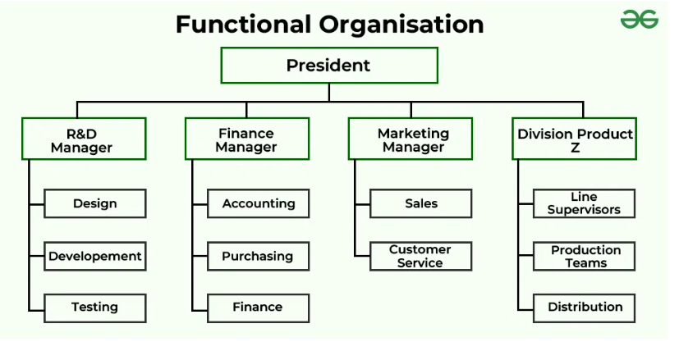
Figure 3 - Functional Organisational Structure (Source: Geeks for Geeks, 2023)
As defined by Geeks for Geeks (2023) and MasterClass (2021), the functional structure assists the organisation in utilising its available resources and skills at the right place to accomplish the organisational objectives over the period. In addition, each functional division is headed by the functional manager, who efficiently manages all its subordinates in such a manner that helps in achieving functional division goals along with overall objectives over the period.

Examination of organisational culture and its influence on operations
As per Heinz (2024) and Akpa et al. (2021), the organisational values and culture are considered to be the core values and beliefs of the organisation, and on those values, the operations and conduct of the organisation will be based or operated. Further, it is defined as how the employees in the enterprise interact with each other over the period.
Moreover, as suggested by Marriott International (2025b), the major operations of Marriott International have been based on various values that are suggested below –
Core Values | Description
Putting people first | By applying the given value, the higher management of the hotel will take them of its employees and provide an appropriate environment to grow.
Pursue Excellence | The company constantly provides good and efficient service and food to its consumers, helping to enhance their engagement level over the period.
Embrace change | The higher authority of the hotel group consistently promotes innovation in its organisation,explores new technologies, and integrates with the larger operations of the group.
Serve our world | The given hospitality enterprise regularly looks for sustainability and integrates it with the larger operations of the hotel and contributes to the reduction of carbon emissions over the period.
Table 1 - Core Values of Marriott International
As opined by Omodan et al. (2020); Haveman and Wetts (2019), the human relations theory is the theory of organisational behaviour, which is concerned with the social association of the people whowork in the business enterprise. Further, it is primarily concerned with job satisfaction, employee morale, and work productivity in the entities over the years. Moreover, the core values of the given enterprise are team collaboration, change management, innovation and sustainability,which assists them in fostering human relations in the coming years that perfectly align individual goals with the organisational goals over the period.

Corporate and individual unit-level goals
Corporate level goals
As recommended by EEL (2025), the corporate-level strategy of Marriott International is attaining sustainability in its operations by reducing its carbon emissions and positively contributingto the UN sustainability goals. Further, the enterprise consistently works towards the attainment of diversity and equity in the workplace. In addition, they are also looking to improve the disruptions in the supply chain and foster human rights practices.
Individual unit-level goals
At the individual level of hotels, Marriott International offers efficient customer services and tries to enhance user or guest experience through its operations in the longer run. Further, the higher management of the hotel group is continuously looking for the integration of sustainability with its larger operations, which also assists them in reducing their carbon footprints in the coming period. In addition, by aligning the corporate level strategy with the individual unit level strategy, the management of the enterprise might improve its operational efficiency, further increasing the level of satisfaction and engagement of the consumers in the longer run of operations.

Recent change initiatives

Determination of several change initiatives
In the past few years, the higher management of the given hospitality enterprise has implemented various changes and new initiatives in its operations to improve the consumer experience, and the same has beensuggested below –
1. Digital innovation and automation
As per EHL Insights (2024), hospitality firms in recent years have successfully integrated advanced technologies in their operations to maximise the satisfaction level of consumers over the period. Further, as per the Annual report (2023), the management continues to use its digital channels for hotel booking as in the fiscal year 2023, the mobile application contributed almost 22 per cent of its room bookings, which is higher than the previous year. In addition, the higher authority of the enterprise is continuously improving its digital integration over the coming years.
2. Sustainability initiatives
According to Chemmanur and Fenech (2024), the hospitality enterprise regularly adopts sustainability initiatives in its operations toreduce its carbon emissions and footprints of its operations over the period. Moreover, as per the Annual report (2023), the hotel group efficiently adopts various sustainable initiatives, such as implementingsoftware that tracks and manages the consumption of energy usage, etc. In addition, the enterprise also developed and built sustainable and energy-efficient hotel buildings to reduce its carbon footprint from its operations over the period.
3. Improvement in operational efficiency
As defined by Hanna and Gillis (2025), operational efficiency is that process that helps the business organisation reduce waste of efforts and resources and develophigh-quality products for its consumers. Further, to attain operational efficiency in its operations in the coming years. Moreover, the top authority of the organisation explores and adopts various initiatives such as AI chatbots, automated consumer services, and virtual kiosks for its consumers and helps in achieving a competitive edge over its rivals.

Influence of recent changes
Positive influence – Various digital initiatives have been integrated with the existing operations, such as virtual check-ins and check-outs, that will enhance consumer satisfaction and increase their level of engagement over the period. Further, applying various sustainability initiatives helps in improving the brand image and assists in the improvement of operational efficiency.
Negative influence – The above-suggested methods of sustainability and digitalisation would requirea significant investment of money that would influence the profitability of the enterprise in the coming years. In addition, some of the sustainability initiatives also require some operational modifications that are not possible, which affects operational efficiency.
Performance indicators
As defined by CFI (2025), performance indicators are those measures that are used by higher management to measure and monitor productivity over the period by optimising past performance. Further, if the higher management of Marriott International explores and adopts the above-suggested initiatives,then the profitability and operational efficiency of the hotel will be improved and enhanced in the coming years. Moreover, as suggested by Statista (2024), the chosen hospitality organisation was recognised as the highest revenue generator hotel in 2020 across the globe. In addition, all its key performance indicators, such as average daily rate (ADR), revenue per available room (RevPAR) and occupancy rate,were all registered growth and increment in recent years. Apart from that, the hotel also receives a score of 80 on the ACSI scale,which is a consumer satisfaction scale which is provided by the consumers to the hotels. It is the highest score which is received by the hotel in the country, and its primary competitors, such as Hilton and Hyatt, do not receive that much score on the scale.

Examination of change management effectiveness
As per Iacoviello and Downie (2024), change management is the process that suggests the willingness and the adoption of the change in the organisation and monitors the effectiveness of that change for maximising the profitability of the firm in the long run. Further, the hotel Marriott International efficiently manages and monitors change in the organisation. Moreover, as compared to its competitors, the management of the hotel efficiently integrated digitalisation and automation into its operations and launched its mobile application for online booking.
Apart from that, it is suggested to the management of the organisation to further invest in the skill development of its employees and make them tech-efficient,which assists in long-term sustainability over the period.

Strategic Direction

Present strategies
As informed by the Annual Report (2023), the development strategy of the enterprise is to provide the right product at the right place at the suitable price and to achieve that strategy; the hotel launches several products and services in the year 2023. Further, through sustainability issues, the management of the hotel is looking for eco-friendly and sustainable buildings and in the long run,they want to reduce the consumption of energy and water. Moreover, in the financing strategy, the higher authority of the organisation uses derivative instrumentsto minimise the financing risk over the years. At last, as its human capital strategy,the hotel focuses on three elements such as promoting leaders, investing in associates andproviding them ample opportunity to grow.

Strategies Implemented for Long-Term Objectives
Apart from that, the management of Marriott International has integrated AI and automation into its operations to maximise consumer satisfaction and engagement for the long term. In addition, they also explore and adopt various sustainable initiatives that assist them in achieving sustainability in their operations, and it also helps in reducing their carbon footprints and emissions from their operations over the period and also helps in attaining a competitive edge over its consumers.

Conclusion
The following pages of the report demonstrate the organisational structure that was followed by Marriott International. Further, it was found that at the corporate level, they followed a matrix organisational structure, and at the individual unit level, they adopted a functional structure. Moreover, it also suggested various recent changes and determined their influence on the operations of the firm in the long run. In addition, it also provided a summary of the strategies that were followed by the organisation and suggested some future strategies for its future operations. In the end, it suggested some of the recommendations to the management along with an implementation plan.

Recommendations
Based on the above literature and findings, several recommendations have been suggested to the management of Marriott International, and the same have been provided below –
- It has been recommended to the enterprise that it should continue to invest in itsAI initiatives and also provide additional benefits in its loyalty programs that strengthen its competitive position.
- Further, to attain sustainability in its larger operations, the management of the enterprise would collaborate with local vendors and suppliers to minimise its carbon footprint.
- It has been suggested that the hotel adopt various skill development programs and initiatives for improving the technical skills of employees over the period.

References
Agrawal, P., Narain, R. and Ullah, I. (2020) ‘Analysis of barriers in the implementation of digital transformation of supply chain using an interpretive structural modelling approach’, Journal of Modelling in Management, 15(1), pp. 297-317. Available at: doi 10.1108/JM2-03-2019-0066.
Akpa, V.O., Asikhia, O.U. and Nneji, N.E. (2021) ‘Organisational culture and organisational performance: A review of literature’, International Journal of Advances in Engineering and Management, 3(1), pp. 361-372. Available at: doi: 10.35629/5252-0301361372.
Annual Report (2023) Marriott International 2023 Annual Report. Available at: https://marriott.gcs-web.com/static-files/b82978a6-9d28-4e38-9855-fc4ae2cebe11 (Accessed: 14 February 2025).
CFI (2025) Key Performance Indicators (KPIs). Available at: https://corporatefinanceinstitute.com/resources/management/key-performance-indicators-kpis/ (Accessed: 14 February 2025).
Chemmanur, A. and Fenech, C. (2024) Assessing and addressing sustainability risks in the hospitality industry. Available at: https://www.deloitte.com/uk/en/Industries/consumer/blogs/sustainability-in-the-hospitality-industry.html (Accessed: 14 February 2025).
Dudovskiy, J. (2023) Marriott Organizational Structure Overview. Available at: https://research-methodology.net/marriott-organizational-structure-overview/ (Accessed: 13 February 2025).
EEL (2025) Marriott International's Vision for a Sustainable Future. Available at: https://www.environmentenergyleader.com/stories/marriott-internationals-vision-for-a-sustainable-future (Accessed: 13 February 2025).
EHL Insight (2024) Top 10 Trends in the Hospitality Industry in 2025. Available at: https://hospitalityinsights.ehl.edu/hospitality-industry-trends (Accessed: 14 February 2025).
Geeks for Geeks (2023) 6 Types of Organisation Structure. Available at: https://www.geeksforgeeks.org/6-types-of-organization-structure/ (Accessed: 13 February 2025).
Hanna, K T. and Gillis, A S. (2025) Operational efficiency. Available at: https://www.techtarget.com/searchbusinessanalytics/definition/operational- efficiency (Accessed: 14 February 2025).
Haveman, H.A. and Wetts, R. (2019) Organisational theory: From classical sociology to the 1970s, Sociology Compass, 13(3), p. e 12627. Available at: https://doi.org/10.1111/soc4.12627.
Heinz, K. (2024) Organizational Culture: Definition and Types. Available at: https://builtin.com/company-culture/types-of-organizational-culture (Accessed: 13 February 2025).
Icaoviello, A. and Downie, A (2024) What is change management? Available at: https://www.ibm.com/think/topics/change-management (Accessed: 14 February 2025).
Marriott International (2025) Our Story of Innovation. Available at: https://www.marriott.com/about/culture-and-values/history.mi (Accessed: 13 February 2025).
Marriott International (2025b) Core values and heritage. Available at: https://www.marriott.com/culture-and-values/core-values.mi#:~:text=Our%20core%20values%20make%20us,integrity%20and%20serving%20our%20world. (Accessed: 13 February 2025).
Master Class (2021) Functional Structure: 3 Characteristics of Functional Structure. Available at: https://www.masterclass.com/articles/functional-structure (Accessed: 14 February 2025).
Nene, S.W. and Pillay, A.S. (2019) ‘An investigation of the impact of organisational structure on organisational performance’, Financial Risk and Management Reviews, 5(1), pp.10-24. Available at: doi: 10.18488/journal.89.2019.51.10.24.
Omodan, B.I., Tsotetsi, C.T. and Dube, B. (2020) ‘Analysis of human relations theory of management: A quest to re-enact people’s management towards peace in the university system’, SA Journal of Human Resource Management, 18, p.10. Available at: https://doi.org/10.4102/sajhrm.v18i0.1184
Statista (2024) Marriott International - statistics & facts. Available at: https://www.statista.com/topics/1872/marriott-international/#topicOverview (Accessed: 14 February 2025).
Statista (2025) Revenue of Marriott from 1999 to 2023. Available at: https://www.statista.com/statistics/266279/revenue-of-the-marriott-international-inc-hotel-chain/ (Accessed: 13 February 2025).

