Jessica Cox
1901525
13/03/2020
Individual Practise

For my individual practice I have taken 8 images as a response to the short story “Handsomest Drowned Man”. I have taken the drowning element of the story and tried to embed this within my work. I came to this decision as I felt that the photograph for the “Handsomest Drowned Man” was the strongest when exploring all of the short stories in a visual way. This story had depth and allowed to interpret the male figure drowning in my own way. I decided initially to change the figure from male to female. I also used a young girl to give the image innocence and beauty to contradict the dark undertone of the story.
I have been inspired Tyurin Andrey because he explores figures under ice. His figures appear drown and almost preserved in ice. Their eyes are open which draws your attention directly to that. I have taken inspiration from this but then for my second image captured the girl with her eyes closed to send a slightly different message to the viewer.
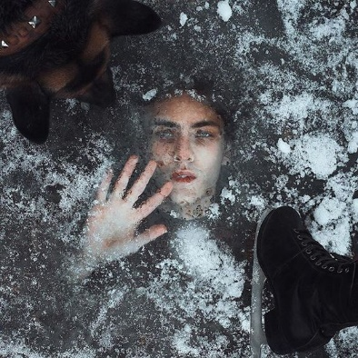

Figure 1 ‘Untitled’, Tyurin Andrey.
I have also looked at Nichole Flores work because she explores drowning through her images. When looking at her work it is apparent that there is blood coming from the mouth. I feel that this could be depicted in my work as it represents death.

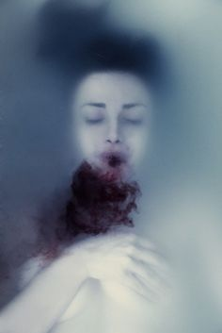

Figure 2 ‘Untitled’, Nichole Flores
Another photographer’s work that I have explored is Jessica Arndts, she sis inspired by Edwin Louis Cole and in particular the quote “you don’t drown by falling in the water: you drown by staying there”¹ . I chose the delve deeper into her work because of her representation of drowning closely links to my work giving the impression of losing control.
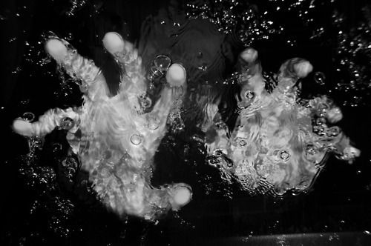
Figure 3 ‘untitled’ Jessica Arndt
I experimented with a variety of techniques while taking and editing my photos. The first thing that I tried was someone drowning in the bath. I think these was strong but they was not as effective what Andrey was portraying in his images. I then tried taking photos of someone drowning with Perspex over their face to make it to look like ice and even though some parts of the image was ice like they still didn’t look the way I wanted so I continued to edit these using Photoshop. When using Photoshop I used different layers and created an image which created depth.

After this I chose two final images which I felt worked well together. I think they work well together as it is about the sensation of drowning and then finally losing control. With the two images together you can see how the subject has lost control. This is illustrated in the closing of the eyes. In the first image the eyes a piercing like that of Andreys work. Some people would say the eyes are the opening to the soul and when the girls are then shut in the second images it signifies death or death of that soul.
Overall I am pleased with my images because they have represented the story and the meaning behind it. They have significantly developed from my initial ideas and portray my though process linking the story to the work by Andrey. My final two images are strong and stand out in comparison to the rest of the images.

Bibliography
- Edwin Louis Cole, https://www.pinterest.co.uk/pin/285274957616574411/ accessed 13/03/2020

Illustrations
Figure 1 ‘Untitled’, Tyurin Andrey.
Figure 2 ‘Untitled’, Nichole Flores
Figure 3 ‘untitled’ Jessica Arndt

