Plan for religious studies lesson.
Introduction: For my lesson plan I have chosen Martin Luther King Junior as being the topic for a year 8 set 2 class, as it is a part of the curriculum for year 8, religious studies. I have also put across the exercise that I would do in class in the ‘rationales’ of why I chose this particular lesson plan as well as in the embedded image which shows the lesson plan in brief which briefly mentions it. The coursework is arranged so that the introduction is first followed by the lesson plan then the analysis.

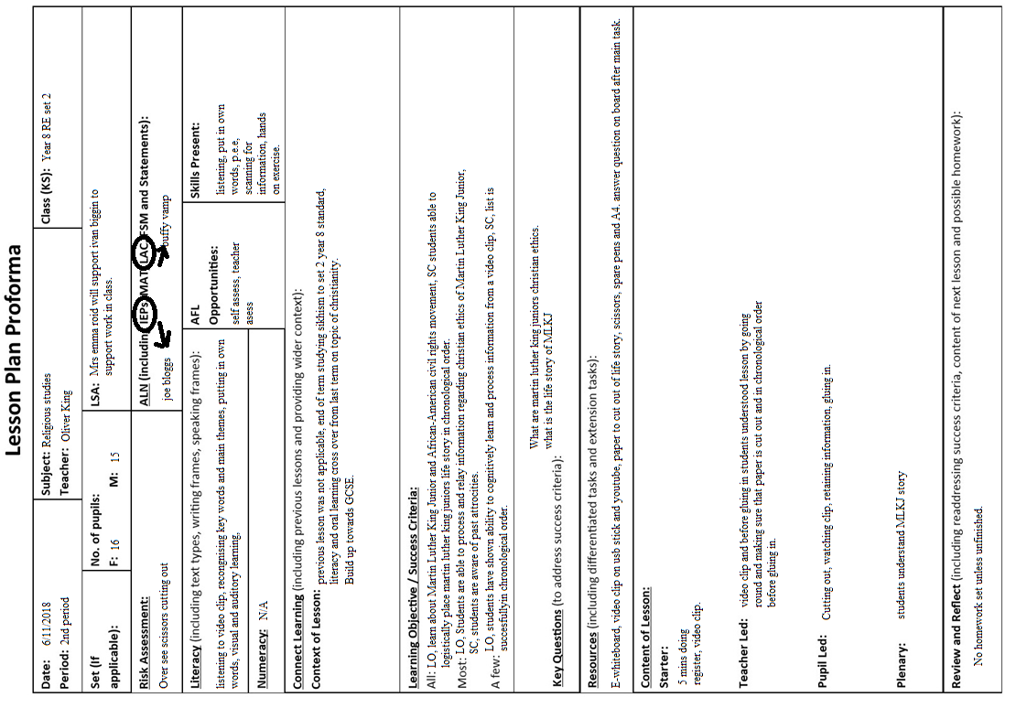

Structure of the lesson and reasoning (learning objectives/ success criteria)
The lesson will be structured around first watching a half an hour segment on Martin Luther King junior about his life story then students will have to cut out printed handouts with MLKJ’s life story in a non-chronological order and will attempt to place them in chronological order by cutting the main themes out and gluing them into exercise book with the main focus of the exercise to establish how much information students can take in within half an hour of watching short clip on MLKJ, simple memory exercise, extra emphasis will need to be made to make sure students have got it in the right order so that they can glue it in after. Then if there’s spare time students will be required to answer questions on white board about the importance of the American civil rights movement, question will structured as: “What is the importance of the American civil rights movement during the time of Martin Luther king junior”; to make sure they understood what the lesson was about. This lesson plan will fill one whole hour segment of class time. This exercise is; as a means of showing to students the importance of courage during times of adversity which was shown by MLKJ, the importance of non-violent action, the importance of basic human rights in the 20th century which has led to our current set of priorities in western society in the 21st century for equal rights. The lesson plays somewhat as a memory exercise, and those that are not paying attention or have learning-memory difficulties can be helped with the gluing in exercise in getting main themes in chronological order. According to author Walter H. Capps paraphrasing Rene Descartes The lesson will set in motion the training for intelligence needed for the methodology of learning which the cutting and sticking in exercise will do [6].
The lesson plan is about the life of ‘Martin Luther King Junior’ related to the movement within America for human rights of people of African-American descent. MLKJ fought against apartheid during 1950’s and sixties in which Martin Luther King fought for it to be abolished within the United States of America. He was a promoter for non-violent protest in the “Memphis sanitation worker strike” [2]. Providing leadership in the Montgomery bus boycott of 1955. He is well known for his famous "I Have a Dream" speech [3]. He was a main auxiliary in founding the Southern Christian Leadership Conference (SCLC) in 1957, which was a society which sought establish non-violent means of achieving civil rights for African Americans[4]. As means of lesson plan; due to the nature of religious studies being heavily secular in many secondary schools according to George Combe (1894) who believed that religious studies lessons should be secular but encompass the teachings of Christianity which the lesson will be heavily structured like; also it was a lesson plan that was observed while on placement in Bro Pedr School during the placement [5].

Main themes of lesson (connect learning and content of lesson)

Students with disbailities (ALN and Afl opportinuties)

Material needed for the lesson (Resources)
Students will be provided with A4 paper with the life story of MLKJ in non-chronological order, will print off 35 copies to cater for students that make mistakes and for the large class size, there will have to be plenty of glue and scissors for 30 students. Make sure the technical side of the lesson such as the electronic board’s sound is working and the 30 minute clip of MLKJ is on a USB stick and the clip is on YouTube as well for classroom use. There will be a copy of the seating arrangement for the lesson to make sure that students are sitting in the right place. I will make sure to take the register as the beginning of the lesson. Will also bear in mind fire alarms or students setting them off by making sure to take the register within the first five minutes of the lesson.

Students with ADHD (Attention deficit Hyperactivity disorder) will be made sure that they have a supervisor next to them to make sure that they are on target and to make sure further that there is less disruption in a classroom setting the seating arrangement will be boy-girl-boy-girl so that there is less likelihood of students attention being drawn away from the subject of the lesson and the seating arrangement will provide a social matter whereby students in particular boys will have to pay closer attention to teaching and students in general will less likely talk to friends inside their friendship group and their whole attention will be on the teachings of the lesson, also girls scientifically perform better than boys during their SATS and GCSEs so therefore the seating arrangement will greatly affect the boys outlook on their grades. For extreme cases of autism students will also have supervisors as will all students with an attention deficit. Some medications for ADHD can cause mood swings which will have to be in the back of the mind when approaching the subject matter of the lesson [7]. Also according to NHS awareness, students with autism should be addressed by their name so that they know that they are being talked to and everything should be addressed in terms so that they may understand also the noise of the room should be kept to a minimal hence the arrangement of boy-girl-boy-girl [8]. According to A.S Neil children should come to their own conclusion that they want to do it only that the teacher is the motivating force which would be applied in this set of circumstances [9].
Being the build up towards GCSE levels key stage 3 will allow for the attainment of cross-curricular targets such as the ability to analyse information from a very short clip and take from it what is of key value and apply it for the lesson. To be able to view the world through a third person perspective and psycho-analyse information that people thought in the past which are two very big traits which are of great importance for cross-curricular activities in all classes. If students can view an event or set of events from a third person perspective, then this greatly attributes towards sympathy and empathy which all students need when they need to analyse the past and this greatly contributes to social rationalising since students can then learn to take into account the thoughts of feelings of their counterparts later in life such as in the work place or social gatherings or even in a classroom environment or the playground [11]. Also the lesson the plethora of Christian ideology in regards to MLKJ will be addressed in a way that it will be explained in a non-religious context which will align with many other contextual situations in other lessons [12]. According to Julian stern an educational theorist religious studies offers the chance for cultural and religious understanding between faiths hence why the structure of the lesson for this particular lesson will be orientated towards ideology that encourages social cohesion which students will take home and to the playground with them [13]. Also according to her it is very important that students do not delve straight away into religious topics instead become independent thinkers so the lesson will be structured in a way as to teach students ethics in regards to the ideas in lesson so that they become motivated and independent learners in regards to religious studies which is a skill that can be applied in other classes [14].

Cross-curricular targets being met (Literacy and skills present)

Meeting welsh government targets for key stage 3 (Review and reflect and skills present)
Meeting Welsh Government guidelines: “Transferable skills, more effective learners, learners who analyse their values, better understanding of self and others, a sense of responsibility for others, citizens who respect and value diversity. Knowledge of issues facing the community including ethical and moral aspects, citizens who can ask meaningful, questions about what is important and, valuable in life including the contribution of the spiritual, learners who value and contribute to social cohesion”(Welsh Gov, 2018)[10]. For transferable skills students will learn to work as individuals and learn to analyse information given to them by the teacher and by short video clip and will learn how to retain information and how to view it in an applicable way for the objective of the lesson. Apart from learning about the civil rights movement in America they will also learn to view their place in the modern world much more coherently by psycho-analysing their own set of values as well as learning about values of diversity, responsibility and the ethical issues generations of people have had to endure in the past to make the world a safer place today. Students will also learn about social cohesion and will be allowed the opportunity in a safe environment to learn about the changes the ‘western’ world has had to make for greater social cohesion by learning about past generations values. Also by learning the Christian values that influenced MLKJ students then can garner more distinct values for themselves and question values that they have now within a safe environment free from influence.

Engaging students with MLKJ christian influences (connect learning)
With the Christian influences students will be at different levels with different ideas about fundamental Christian teachings. So there will be extra emphasis on the Christian idea of love thy neighbour which “there is no greater command”[15]. Particular emphasis on the idea that everyone was made in god’s image. Then finally come together and emphasize these key ideas being fundamental to the ideas of MLKJ. The reasoning to illustrate key Christian doctrine which was neglected during the time of the apartheid in America during the times of MLKJ and how reintroducing this doctrine was the key influence in turning the tide in the civil rights movement with eventual backing from influential white Christian Americans which helped reshape America. According to Dan Moulin (2011) the structure of religious studies lessons is structured in such a way that Christianity is defined as a set of rules so that the lesson does not seem that way I intend to objectivise the teachings of Christianity in relation to the American civil rights movement and how it influenced it to show that it was enduringly a force for good[16].

Bibliography and Footnotes:

"What Did Martin Luther King Do To Progress The Civil Rights Movement?", Yourdictionary, 2018 <http://biography.yourdictionary.com/articles/martin-luther-king-progress-civil-rights-movement.html> [Accessed 7 November 2018]. [1][2][3][4]
"Attention Deficit Hyperactivity Disorder (ADHD)", Nhs.Uk, 2018 <https://www.nhs.uk/conditions/attention-deficit-hyperactivity-disorder-adhd/> [Accessed 7 November 2018] [7]
"Treatment", Nhs.Uk, 2018 <https://www.nhs.uk/conditions/autism/treatment/> [Accessed 7 November 2018] [8]
Learning.Gov.Wales, 2018 <http://learning.gov.wales/docs/learningwales/publications/130425-re-guidance-for-14-to-19-year-olds-en-v2.pdf> [Accessed 7 November 2018] [11]
Learning Gov. Wales. 2018 <http://learning.gov.wales/docs/learningwales/publications/130425-re-exemplifying-learner-profiles-en-v2.pdf> [Accessed 8 November 2018] [10]
"Genesis 1:27 So God Created Man In His Own Image; In The Image Of God He Created Him; Male And Female He Created Them.", Biblehub.Com, 2018 <https://biblehub.com/genesis/1-27.htm> [Accessed 7 November 2018] https://biblehub.com/mark/12-31.htm] [15]
Arthur, James, "Secular Education And Religion", Oxford Handbooks, 2018 <http://www.oxfordhandbooks.com/view/10.1093/oxfordhb/9780199988457.001.0001/oxfordhb-9780199988457-e-25> [Accessed 7 November 2018] [5]
Tandfonline.Com, 2018 <https://www.tandfonline.com/doi/full/10.1080/01416200.2011.595916?scroll=top&needAccess=true> [Accessed 7 November 2018][15]
D, Wiebe, "The Politics Of Religious Studies", Theological Studies, 61 (2018), 199 <https://search.proquest.com/openview/b93e4d1dbdb48c2334c71adfb132fb93/1?cbl=1821244&pq-origsite=gscholar> [Accessed 8 November 2018][12]
Fitzgerald, T., 2003. The ideology of religious studies. Oxford University Press.[16]
Stern, J., 2018. Teaching religious education: Researchers in the classroom. Bloomsbury Publishing. [13][14]
Bresler, L., Cooper, D. and Palmer, J., 2001. Fifty modern thinkers on education: From Piaget to the present. Psychology Press.[9]
Capps, W.H., 1995. Religious studies: The making of a discipline. Fortress Press. [6]

Appendix of things needed for class:

>Use this list: and I will print them out not in chronological order 35 times
https://kinginstitute.stanford.edu/king-resources/major-king-events-chronology-1929-1968
>scissors will be supplied by school
>glue will be supplied by school
>usb stick with life story of MLKJ also;
Youtube link:
https://www.youtube.com/watch?v=qllIq284u20

