

LOCATION: Swansea | LLEOLIAD: abertawe
LEVEL 7 | LEFEL 7
EXAMINATION PERIOD | CYFNOD ARHOLIADAU
may 2017 | mai 7

MODULE CODE: M7X01643
Instrumentation & Control
TIME: 2 HOURS
answer all questions

Equipment or materials required – Calculator and Ruler
Adnoddau neu ddefnyddiau sydd eu hangen - Cyfrifiannell a Llywodraethwr

ANSWER ALL QUESTIONS

- Show that the closed loop transfer function of a control system can be given by
$$\frac{G}{1+GH}$$
[5 Marks]

- Develop the transfer function for the system shown, sketch the pole-zero plot and comment on the stability of the system.

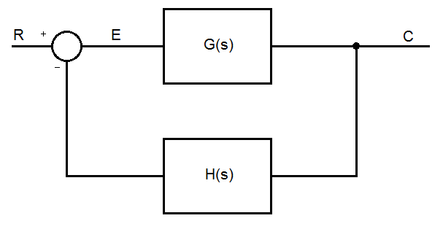
Where,
$$G\left(s\right)=\frac{K}{1+τs}$$
$$H\left(s\right)=\frac{1}{ts}$$

Given that the gain of the forward path is 3, the time constant of the forward path is 0.5 seconds and the time constant of the feedback loop is 0.1 seconds.
[15 Marks]

- Describe the key specifications you would consider when selecting a pressure sensor. Compare the pressure sensor requirements of a control system for:
  - Automatic tyre inflator that stops inflating once a pre-set pressure has been reached
  - Altitude control in an auto-pilot system of an aeroplane
[5 Marks]

- Describe a proportional – integral controller showing all the relevant signals present, coefficients and their functions.
[5 Marks]

- Using the root locus method, determine the value of K that will make the system critically damped, given the transfer function:

$$G\left(s\right)=\frac{1}{s^{2}+2s+K}$$

[10 Marks]

- Compare and contrast the features and benefits of a proportional controller and a two state controller, giving applications for each.
[10 Marks]

Diwedd/End

