Dion Graham
2441800@student.uwtsd.ac.uk>

Student name: Dion Graham
Student ID:2441800
Module name:
Introduction to Health and Social Care (LCHS4003_LON)
Module code: (LCHS4003_LON)
Lecturer name: Mark Kane

Table of Contents
Page 1: Pharmacy Poster
Page 2: 600 Words Essay, Discuss the origins of the National Health Service (NHS).
Page 3: 600 Words Essay, Discuss the origins of the National Health Service (NHS) continued….............................................................................................................................
Page 4: Reference List………………………………………………………………………………

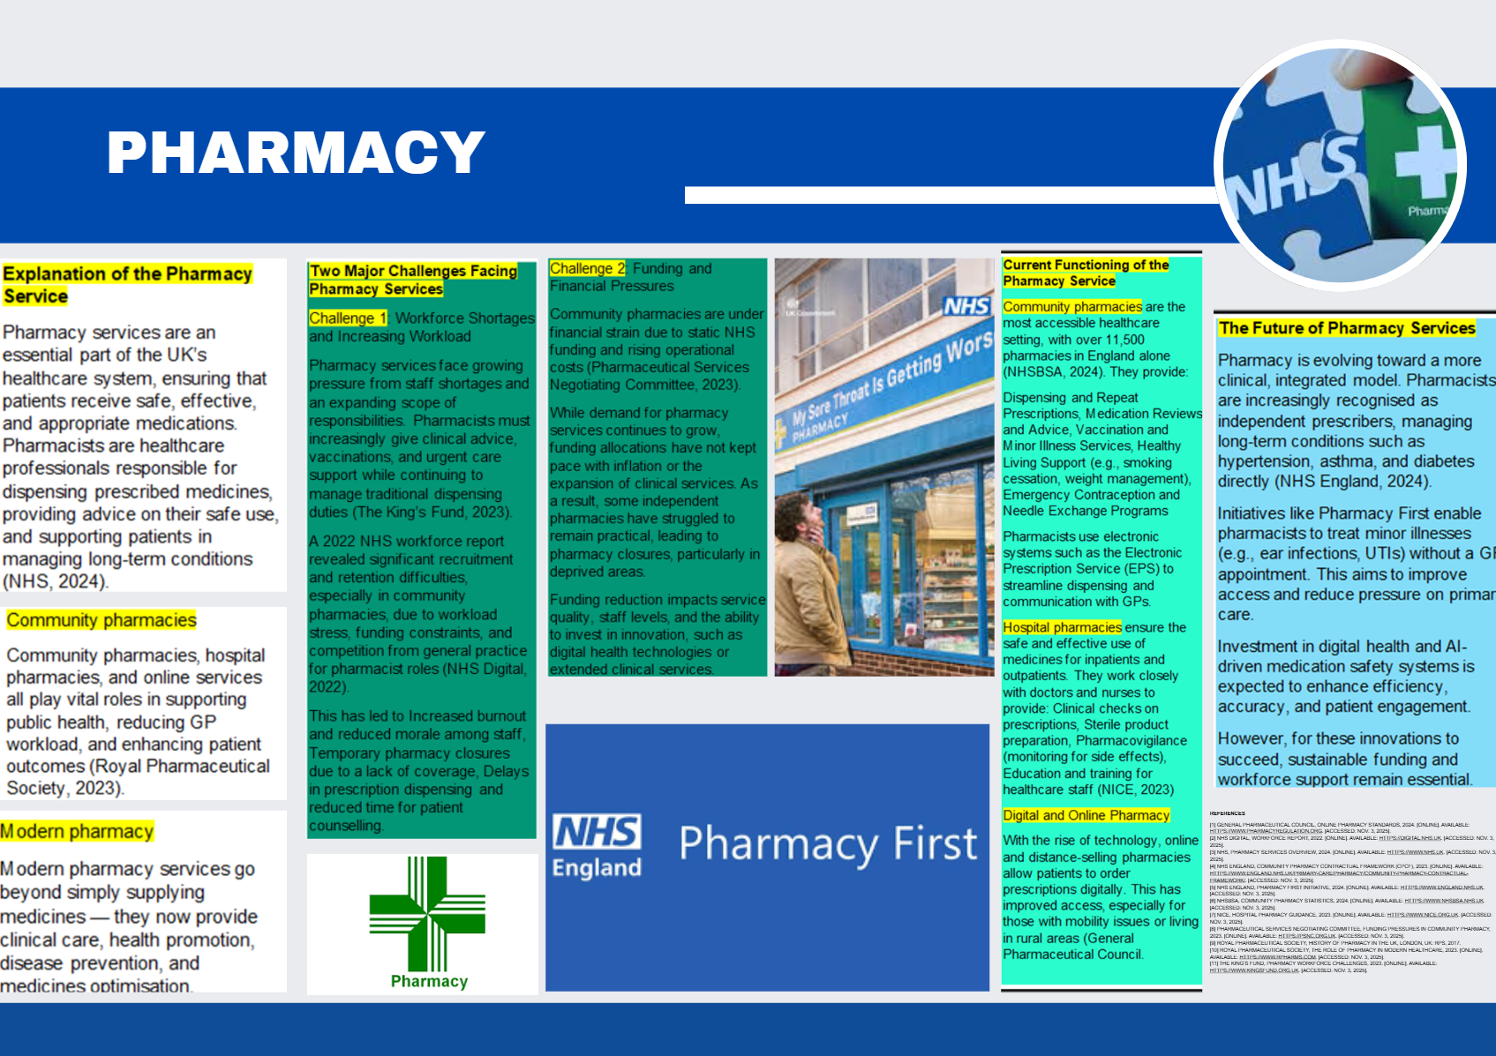

Page 1: Pharmacy Poster

Page 2: 600 Words Essay, Discuss the origins of the National Health Service (NHS).

Definition of the NHS
The National Health Service (NHS) is the publicly funded healthcare system of the United Kingdom. The NHS was founded on the principle that healthcare should be free at the point of use, universally available, and financed through general taxation. It is still one of the world’s most extensive publicly funded health services. It is also a central pillar of the UK’s welfare state.
The NHS: Origins, Structure, and Contemporary Challenges
The National Health Service (NHS) was set up on 5 July 1948 as a cornerstone of the British welfare state, marking a radical shift in healthcare provision. For the first time, all UK residents were offered free medical services at the point of use, regardless of income or social status. The historical context of its formation lies in the aftermath of World War II, a period when the nation was rebuilding and reimagining its social institutions. The inadequacies of existing healthcare systems during this era built public support for reform. The 1942 Beveridge Report, authored by economist William Beveridge, provided the ideological foundation for the NHS. It advocated for a comprehensive welfare system to combat the “five giants”: Want, Disease, Ignorance, Squalor, and Idleness (Clement, 2023).
The Labour government, led by Prime Minister Clement Attlee and Health Minister Aneurin Bevan, translated these ideals into policy. Bevan’s vision was clear: healthcare should be free, universal, and financed through general taxation. He famously said, “No society can legitimately call itself civilised if a sick person is denied medical aid because of lack of means” (HFMA, 2023; “Nye Bevan - TUC 150 Stories”). The NHS stands on three core principles: universality, equity, and free access at the point of delivery. These principles continue to underpin the service today, even as its structure and operations have evolved.
Initially, the NHS unified hospitals, general practitioners, and community services under a single umbrella, aiming to simplify access and ensure consistent care. Over the decades, however, its structure has grown more complex. Today, the NHS in England is not a single entity but a network of organisations running at national, regional, and local levels. NHS England oversees the budget and strategic direction, while Integrated Care Systems (ICSs) coordinate services across geographic areas to improve population health outcomes (NHS England, 2024). These systems aim to foster collaboration between health and social care providers, ensuring that services are tailored to local needs.
The 2022 merger of NHS England with NHS Improvement was a significant reform intended to streamline governance and enhance accountability (UK Parliament, 2022), as part of a broader effort to reduce duplication and improve efficiency. Despite these reforms, the NHS continues to face persistent challenges. Funding pressures, workforce shortages, and rising demand strain its capacity. The ageing population is a key factor, as older adults typically need more complex and ongoing care.

Continued Page 3:
Additionally, the COVID-19 pandemic exposed systemic vulnerabilities, including delayed treatments, unequal access to care, and limitations of digital infrastructure.
Critics argue that NHS bureaucracy hampers efficiency; for example, the separation between commissioners and providers can lead to fragmented care and service duplication. While ICSs promise better integration, their success depends on effective collaboration among diverse stakeholders, which is not always guaranteed and may be hindered by competing priorities, resource constraints, and organisational silos (HFMA, 2023).
Nonetheless, the NHS is still a symbol of national pride and social solidarity. It is the largest employer in Europe, with over 1.3 million staff, and continues to deliver care to millions each year, from routine check-ups to life-saving treatments (NHS England, 2024). Innovations such as digital health records, artificial intelligence, and telemedicine are being adopted to modernise services and improve patient outcomes. However, implementation varies by region, and digital inequality is still a concern.
In conclusion, the NHS was born out of a post-war commitment to social justice and collective responsibility. It has since evolved into a multifaceted healthcare system that reflects both the strengths and challenges of public service delivery. Its founding principles stay relevant, but its structure must adapt to new needs and expectations. Addressing funding, workforce sustainability, and governance reform will be crucial to keeping the NHS resilient, fair, and effective in the future.

Page 4:
Reference List
Clement, M. (2023). The founding of the NHS: 75 years on. History of Government. Available at: https://history.blog.gov.uk/2023/07/13/the-founding-of-the-nhs-75-years-on/ [Accessed 7 Nov. 2025].
Department of Health (1999). The history and development of the UK National Health Service 1948–1999. Available at: https://assets.publishing.service.gov.uk/media/57a08d91e5274a31e000192c/The-history-and-development-of-the-UK-NHS.pdf [Accessed 7 Nov. 2025].
HFMA (2023). Chapter 2: Structure and development of the NHS. Available at: https://www.hfma.org.uk/system/files/chapter-2---hfma-introductory-guide-to-nhs-finance.pdf [Accessed 7 Nov. 2025].
NHS England (2024). Structure of the NHS. Available at: https://www.england.nhs.uk/long-read/structure-of-the-nhs/ [Accessed 7 Nov. 2025].
UK Parliament (2022). The structure of the NHS in England. Available at: https://researchbriefings.files.parliament.uk/documents/CBP-7206/CBP-7206.pdf [Accessed 7 Nov. 2025].
“Nye Bevan - TUC 150 Stories”. Trades Union Congress. Available at: https://www.tuc.org.uk/TUC150/tuc-history/nye-bevan [Accessed 7 Nov. 2025].

