
Ian Lewis
pEMBROKESHIRE COLLEGE
HTML and CSS Web Development
Introduction to Web and Database Concepts Sam Flory (175864)

Contents
Title: HTML and CSS Web Development 3
Introduction: 3
Requirements: 4
Purpose: 4
Subject Matter: 4
Target Audience: 4
Implementation: 5
Screen grabs: 5
Home Page & Header navigation – 5
Drivers Page – 5
Teams Page – 6
Schedule Page – 7
Footer – 7
Validation: 8
HTML Validation – 8
CSS Validation – 10
Evaluation: 12
Section A: 12
Usability: 12
Accessibility: 13
Search Engine Optimisation (SEO): 14
Section B – Website Evaluation: 15
Usability: 15
Search Engine Optimisation (SEO): 16
Accessibility: 17
References 18
Appendices 20
Appendix A: HTML Code – 20
Index Page – 20
Drivers Page – 26
Teams Page – 38
Standings Page – 62
Schedule Page – 79
Appendix B: CSS Code – 93
Main CSS Styling Sheet – 93

Title: HTML and CSS Web Development

Introduction:
The following report presents a broad analysis of a website created to highlight both basic and complex functions of HTML and CSS web development. The websites’ goal of presenting content to the specified target audience, in both an accessible but engaging manner, done so using efficient and eloquent design choices. The report includes an implementation section, highlighting credited validation reports of both the HTML and CSS, see Appendix A,B, from The World Wide Web Consortium (W3C) who’s standards aim “to build rich interactive experiences that can be available on any device” [1] , alongside screen grabs of each webpages design and content.
Following this, an evaluation section breaks down the importance of website usability, accessibility and the benefits of search engine optimization (SEO) in making websites successful in the world of today. This report makes use of relevant studies and papers helping enhance this reports credibility of analysis into HTML and CSS web development.

Requirements:

Purpose:
The purpose of the website, in which this report is based upon, is to provide an engaging, interactive and hassle-free experience to end users who are searching for the latest updates and movements relating to the world of Formula One. The implementation of custom-made driver and team graphics accompanied by vast arrays of animation spread across its pages aid in fulfilling the websites core purpose of an easy-to-use and engaging portal for all things Formula One, all in one place.

Subject Matter:
Grand Prix Tracker presents itself as the go to place for real-time information providing motorsport fans with the detailed canvas required to keep updated on season schedules for the 2025 season and beyond, detailed historical information regarding each team and driver as well as live championship data for both the constructors and drivers’ championships. Detailed race statistics from wins, pole positions, podiums, fastest laps and more can all be tracked helping cater to both new and veteran motorsport enthusiasts.

Target Audience:
The websites design principle of an easy-to-use portal, which offers both engaging and interactive information using modern graphics and animations, helps to target every aspect of motorsport enthusiasts from varying different backgrounds from age, abilities and knowledge. The website integrates many universal design principles [2] to coincide with web accessibility guidelines which promote an ever “increasing emphasis on universal design principles” [3] to be used by all web developers to support equal access for all [3]. This implementation allows for the website to attract everyone from its target audience no matter the ability or age.

Implementation:

Screen grabs:

Home Page & Header navigation –
A cropped view of home page of GP Tracker website. Footer can be seen below on the following pages.
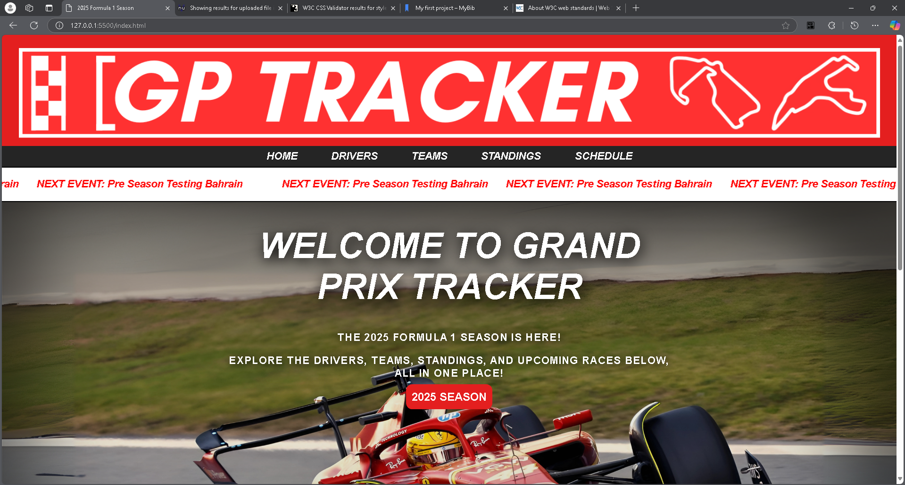
Figure 1 - Home Page of GP Tracker Website

Drivers Page –
A cropped view of the driver’s page of the GP Tracker website.
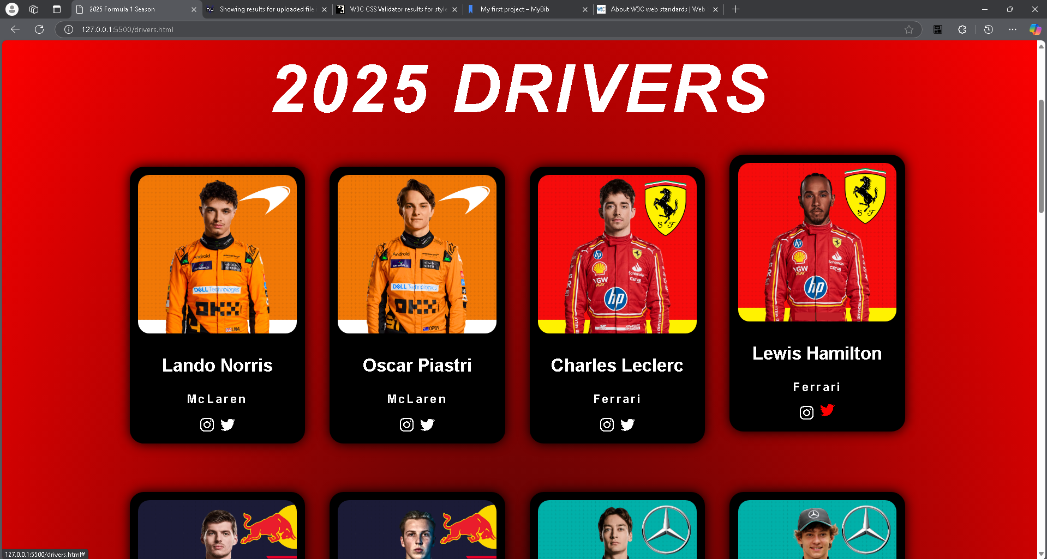
Figure 2 - Drivers Page of GP Tracker website

Teams Page –
A cropped view of the team’s page on the GP Tracker website.
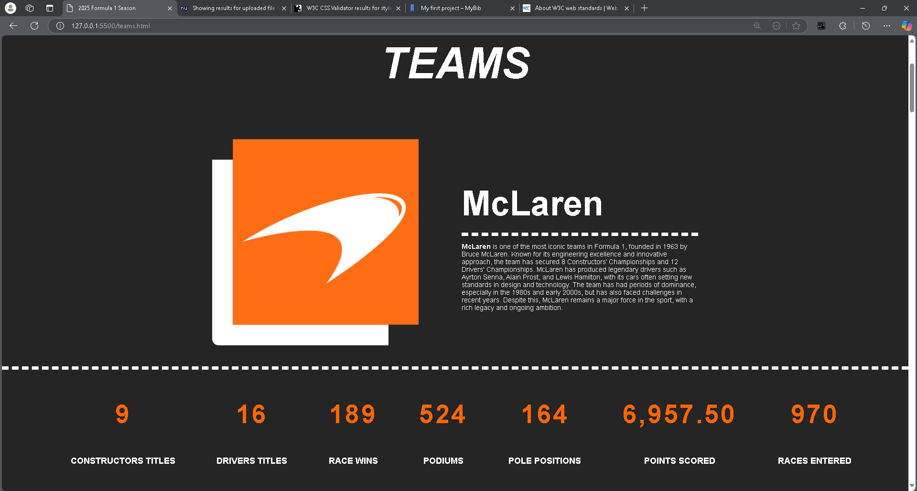
Figure 3 - Teams Page of GP Tracker website

Standings Page –
A cropped view of the standings page on the GP Tracker website.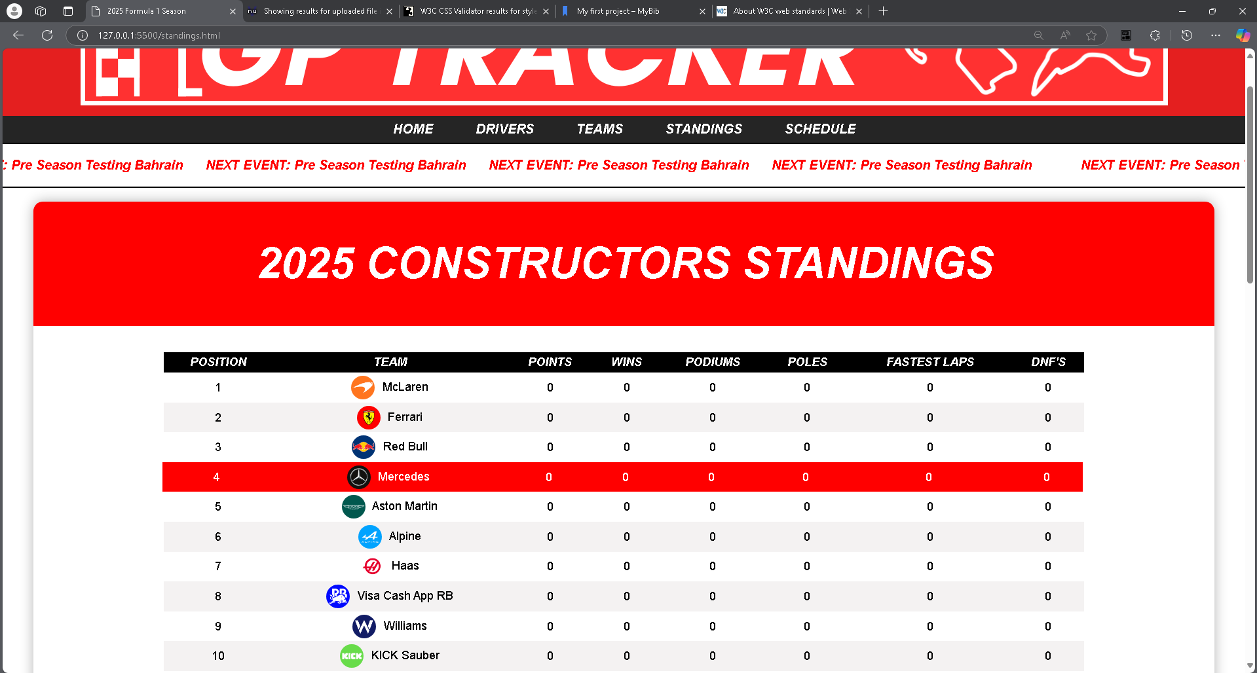
Figure 4 - Standings Page of GP Tracker website

Schedule Page –
A cropped view of the schedule page on the GP Tracker website.
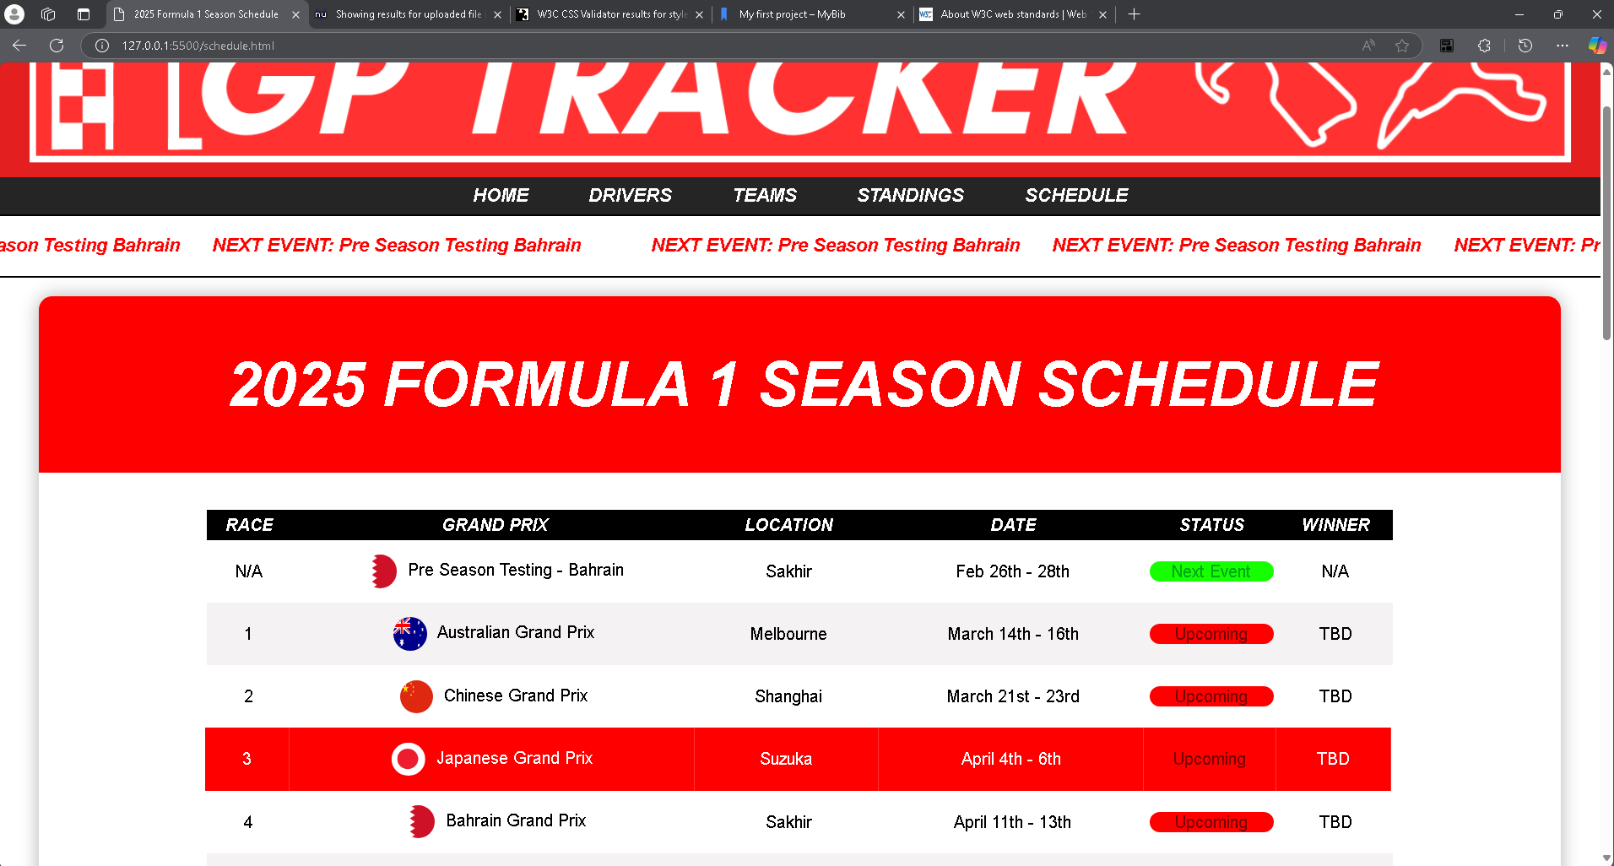
Figure 5 - Schedule Page of GP Tracker website

Footer –
A cropped view of the footer which appears on all pages of the GP Tracker website.
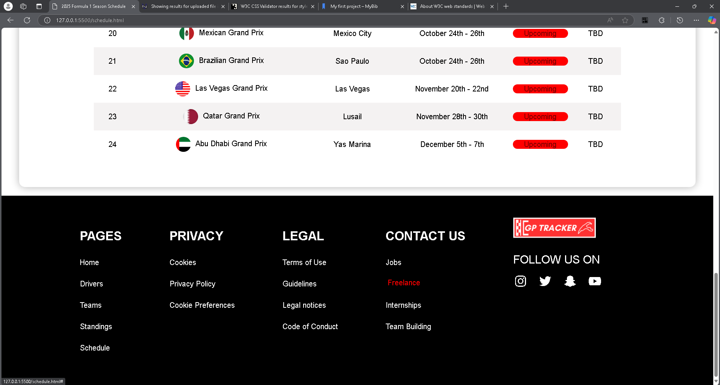
Figure 6 - Footer of GP Tracker website

Validation:

HTML Validation –
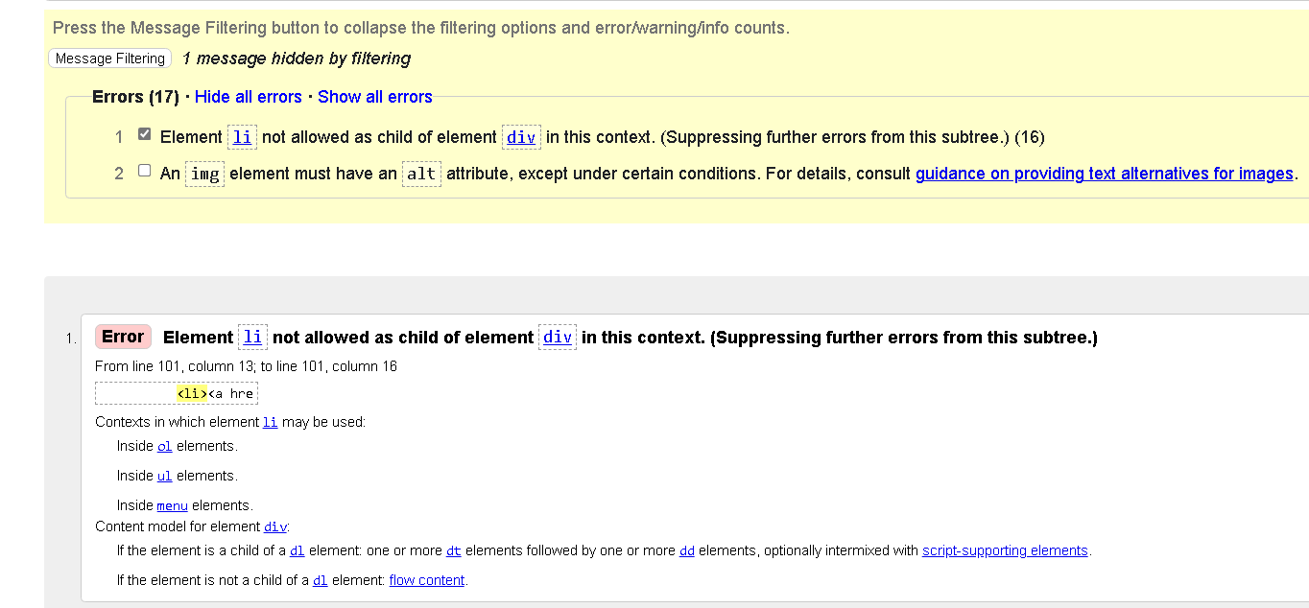
Figure 7 - HTML Validation Results
Based upon the results from the W3C HTML Validation tool [4], the GP Tracker website has a total of 17 errors, made up of 2 error types. The former being the use of a listed item being used independently as a child element within the div element. The right correction, as seen in figure 8, to be made is to place the list items within an unordered list as that is accepted within a div class [4].
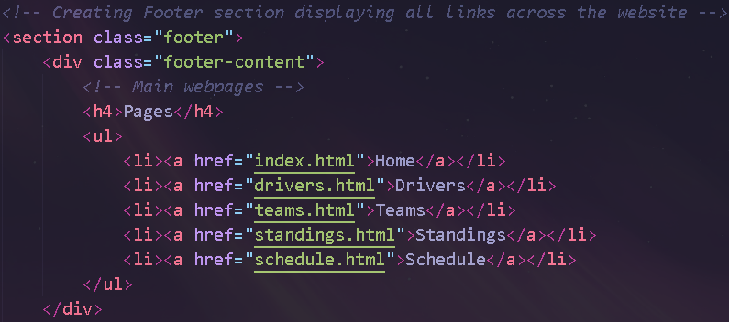
Figure 8 - Unordered List FIX for HTML Validation
Figure 9 - 2nd error type from HTML Validation
The latter of the 2 error types is a missing alt tag on the website logo within the website’s footer. The simple correction of implementing an appropriate alt tag will suffice to pass the HTML Validation.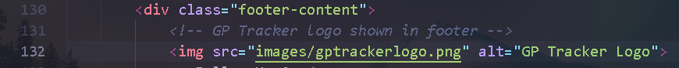
Figure 10 - Alt Tag FIX for HTML Validation

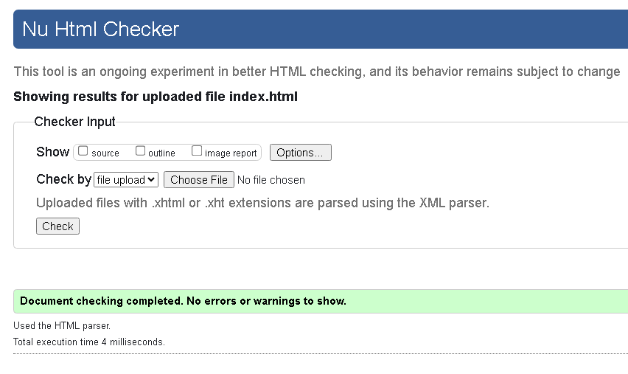
Figure 11 - HTML Validation results after FIXES applied
Upon completion of the specified fixes, the GP Tracker website passes on all basis on the HTML Validation.

CSS Validation –
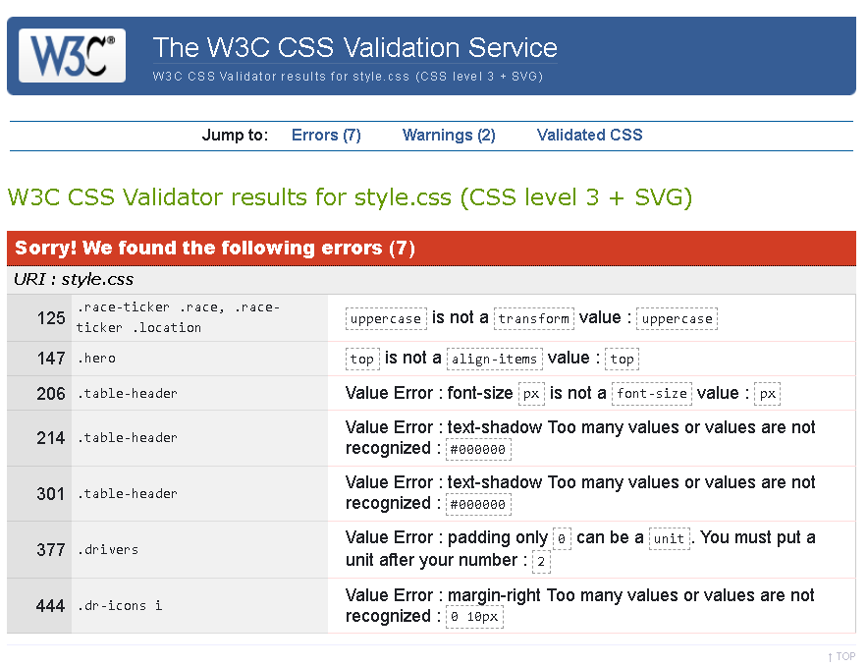
Figure 12 - CSS Validation results.
Based upon the results from the W3C CSS Validation tool [5], the GP Tracker website fails upon 7 total errors and 6 error types. Most errors are results of unused CSS elements that are not adding any effect on the website. For errors 1 and 2 a simple deletion of the faulty CSS element would be sufficient. For error 3, placing the value of 25 in front of px will fix this particular error. Errors 4 and 5 require a deletion of the misplaced CSS element and errors 6 requires the unit of px being entered after the value of 2 to fix said error. The final error also requires a deletion of the CSS element which was having no effect on the CSS output.
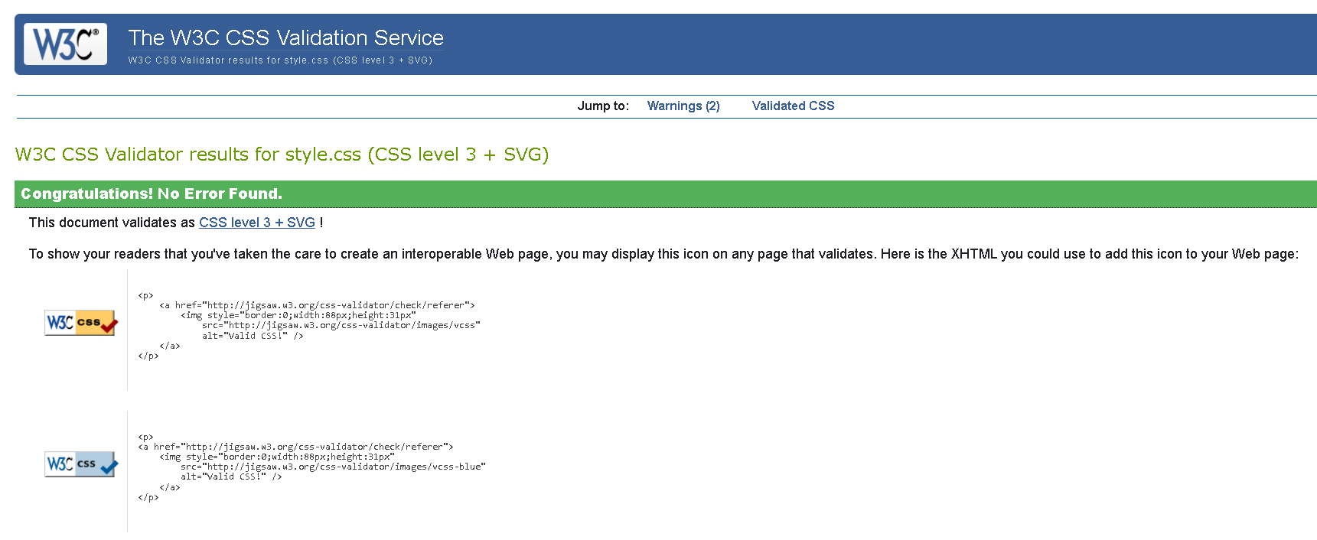
Figure 13 - CSS Validation results after FIXES applied
Upon completion of specified fixes, the GP Tracker website passes on all basis on the CSS Validation at Level 3 certification.

Evaluation:

Section A:

Usability:
For a website to serve upon its intended purpose to provide value to an end-user, the website must primarily be usable. Website usability refers itself to making the process of user navigation and interaction with a website’s elements done so with ease. Important design choices, which consider the following principles of ‘user centred design, effectiveness, consistency and learnability among many more [6], are crucial to making the website as user-friendly as possible, helping a user achieve their aims successfully [7] and in the fastest way possible. Failure in following the principles of usability only negate to create a below par user-experience, remembered for all the wrong reasons, leading to users finishing their search for information and finding an alternative website to complete their aims which for e-commerce websites leads to losses in revenue [8]. In definition, web usability’s primary role in web development is creating an environment in which a user feels comfortable enough to use the website to its full potential, allowing for a rapport to be made between the customer so that the website becomes the main source of information for future searches. This is a massive factor into why web usability is highly considered and implemented by businesses to help create and grow a loyal customer bases that maintain higher retention rates when it comes to buying products. Throughout B.Kumars (2024) case study, the impact of web usability through the world of -commerce is explored via prediction models and algorithms with key findings being a direct link between the use of usability principles having a positive “direct effect on purchase intentions.” {9} resulting higher chances of sales being completed on usable websites.

Accessibility:
Website accessibility is a concept within web development in which the design and function of a website is catered in a manner that allows for full usability by all, no matter an individual’s physical, mental, visual and cognitive disabilities. This stance is one taken by the founder of the World Wide Web and current W3C director, Sir Tim Berners Lee, stating that ‘Access by everyone regardless of disability is an essential aspect’ [10] of the web of today. The core foundations of website accessibility are built upon 4 vital principles, POUR [11]: Perceivable, Operable, Understandable and Robust. POUR defines that standardised content that appears on the web must be communicated effectively to the end user even through the use of assistive technologies. It must also be understandable by all users, be entirely accessible through just one of a person’s 5 senses and that all interactive content is navigable entirely through one assistive technology such as screen reader or keyboard assistant. This concept is encapsulated under the W3C’s WCAG (Web Content Accessibility Guidelines) guidelines in which there are 4 major guidelines [11]: 1.0, 2.0, 2.1 and 2.2 being the most recent and revised guidelines, with a websites conformance rated with either A, AA or AAA. The formers being the minimum requirements that satisfy WCAG guidelines and the latter being the industry standard for web accessibility with all possible criteria met. WCAG is only a set of standards and is not enforced by law across the world meaning some major websites fail to meet acceptable accessibility requirements. In the case study “Web Accessibility of the top research-intensive universities in the UK” by Sophia Alim [12], which reviewed a total of 66 UK’s universities websites for compliance with WCAG 2.0 through certain metrics, provided the key finding that 10.6% [12] of the sampled websites failed to comply with WCAG 2.0, the lowest level of web accessibility standards. This highlights a need for reviews into making WCAG a mandatory standard across the web instead of an advisory practice for web developers to aim for.

Search Engine Optimisation (SEO):
Within web development the practice of SEO (Search Engine Optimisation) is one employed by web developers to help improve the performance of a website by improving a websites presence [13] and performance within search engines such as Chrome, Edge, Firefox and others. SEO results can either be generated through paid for SEO elements, such as PPC (Pay-Per-Click) advertising where a top position within a SERP is paid for, or via organic SEO techniques which involves optimising a websites structure, content, keywords, meta tags and its links to help perform higher on SERP result pages for a given niche. The higher up a website appears on a SERP result page the higher the chance of reaping the benefits of increased website traffic allowing for increased sales in some instances, cost effective advertisement results in the long run with organic SEO techniques and higher website ratings due to appearing on one of the first results page as its proven that sites placed on the first page are ’10 more likely’ [14] to receive a click than a site placed on the 10th page, highlighting the importance of search engine optimisation, for smaller businesses in particular, in web development. In the study ‘’Fintech SEO Case Study) [15], which reviews the key findings from the implementation of a SEO strategy of a fintech company and the benefits it brought. The study highlights how the company before SEO implementation was performing poorly due to poor optimisation of website content and failing to implement common keywords into the website’s meta tags. Upon implementation of SEO the fintech website saw increases of 138.4% in user impressions, 73.9% increases in organic clicks, 150+ organic daily visitors and use of over 5,000 key words [15]. This study reinforces the importance of the inclusion of the practice of search engine optimisation within web development with how big the benefits can be from the low hanging fruit [15] of organic SEO practices within the websites structure.

Section B – Website Evaluation:

Usability:
As to the overall usability of the GP Tracker website, multiple factors, such as the design of the site, can be factored in to perform an appropriate evaluation. Starting off with the site’s functionality and utility. Among its vast array of features, the standouts are a race calendar with the additional functionality of informing the end user as to when what races have been, upcoming, or cancelled for the ongoing season, as well as a standings page containing all the stats and points the team, and drivers have accumulated so far. Detailed historical team data combined with a biography for each current team and driver offer the end user, no matter their interest level, all the information required to keep up with the world of formula one. As for usability, the GP Tracker website demonstrates a minimalist but modern take on a sports information site offering end users easy to access information in the forms specifically designed tables and graphics to aid the user’s usability of the site. Future improvements to the site could include improved accessibility for users of different languages, given the sport is international, as the website is currently only translated through English. Other changes include expanded an enhanced graphics with animation add more presence to the site as well as a personal profile area where end users can select their favourite driver and team and cater the information, they see on the site to what their team and driver preferences are. These changes help make the site more in line with the usability principles [6] discussed previously.

Search Engine Optimisation (SEO):
As for SEO techniques used on the GP Tracker include keyword optimisation, appropriate use of title tags, use of header tags to construct the websites, content quality, internal linking and use of alt tags (see figures 14 – 18). Keyword optimisation can be seen in figures 14 – 17). These techniques help to boost organic SEO success with keywords helping inform search engines what the site is about, title tags to improve CTR rates as they describe what the page is dedicated to, header tags to help search engines define what is the most important content on the page and alt tags which help include more keywords for SEO. One technique missed was making the site mobile friendly as not all pages conform to this.
Figure 14 - use of meta tag keywords for SEO
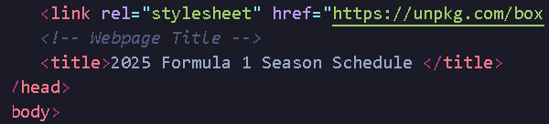
Figure 15 - Use of appropriate title tags
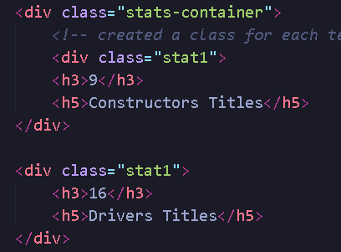
Figure 16 - use of header tags to structure content on the website
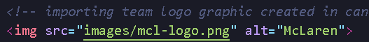
Figure 17- Use of alt tags
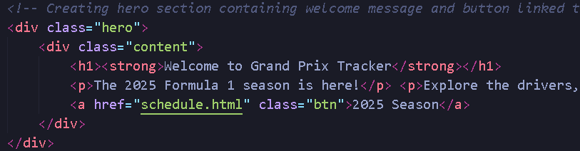
Figure 18 - Internal linking for SEO

Accessibility:
As to the websites conformity to WCAG 2.1 guidelines and the 4 core principles that make up web accessibility [11] , the website can be seen as perceivable as it makes use of alt tags for images, see figure 17, understandable as the text is clear and concise and all pages follow a predictable and consistent layout and the site is robust with standard HTML and CSS making up the backbone of the sites underlying construction. The site however doesn’t meet operable as the site does involve use by mouse and can’t be used entirely by a keyboard or one specific human sense as outlined by WCAG [11]. Web Accessibility tools help depict the accessibility of the GP tracker website with sites such as contrast checkers [16] evaluating the contrast between colours and text. GP tracker has a conformity level of AAA, the highest conformity level possible, with WCAG 2.1 with the colours of the site when displaying text to users. Most of the site’s buildup is made so that text is displayed to users on either a white or black background so that WCAG 2.1 conformity is met.
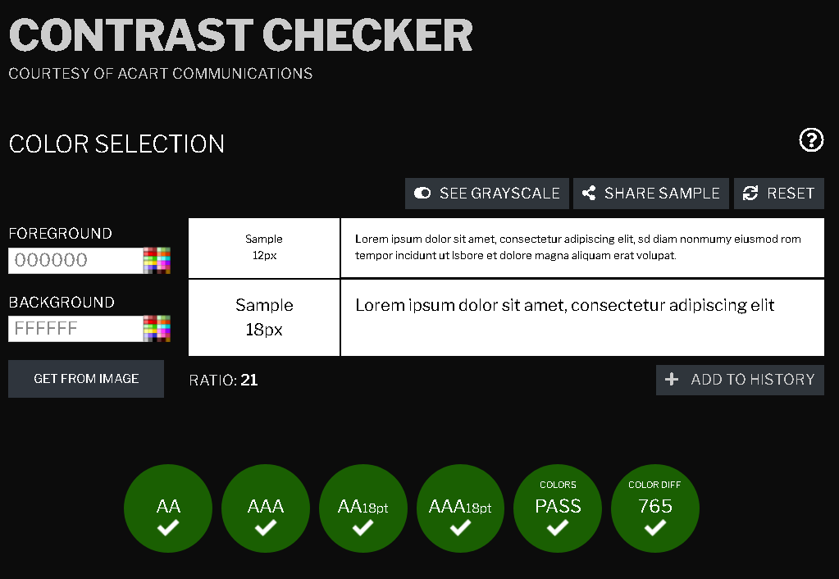
Figure 19 - AA conformity for the websites colors

References
[1] “About W3C Web Standards,” W3C, 2021. https://www.w3.org/standards/about/#what-are-web-standards (accessed Feb. 06, 2025).
[2] A. Lange, “Making Websites More Accessible: Strategies for Universal Design,” The A11Y Collective, Jun. 13, 2024. https://www.a11y-collective.com/blog/universal-design-for-websites/ (accessed Feb. 06, 2025).
[3] A. Ismail and K. S. Kuppusamy, “Web Accessibility Investigation and Identification of Major Issues of Higher Education Websites with Statistical measures: a Case Study of College Websites,” Journal of King Saud University - Computer and Information Sciences, vol. 34, no. 3, p. 902, Mar. 2022, doi: https://doi.org/10.1016/j.jksuci.2019.03.011.
[4] W3C, “The W3C Markup Validation Service,” W3.org, 2013. https://validator.w3.org/ (accessed Feb. 06, 2025).
[5] W3C, “The W3C CSS Validation Service,” W3.org, 2013. https://jigsaw.w3.org/css-validator/
[6] N. Amanto, “Information Architecture: Web Design for Usability,” Feb. 2024. Accessed: Feb. 06, 2025. [Online]. Available: https://www.researchgate.net/profile/Nicola-Antonio-Roberto-Amato/publication/377851756_Information_Architecture_Web_Design_for_Usability/links/65bb5e641e1ec12eff680240/Information-Architecture-Web-Design-for-Usability.pdf?__cf_chl_tk=P0ki83ODH1VGrk.U9TVm6vvyh4dVF3RbPhKlXji9MwE-1738847803-1.0.1.1-TmVb2Y_SwunmfYR4TSMs_eDcGNh2Gh6XrZlQlfc1wzI
[7] R. Alexander, N. Thompson, T. McGill, and D. Murray, “The Influence of User Culture on Website Usability,” International Journal of Human-Computer Studies, vol. 154, no. 154, p. 102688, Oct. 2021, doi: https://doi.org/10.1016/j.ijhcs.2021.102688.
[8] alberto, “What Is Web Usability?,” Business Case Studies, Nov. 2024. https://businesscasestudies.co.uk/what-is-web-usability/ (accessed Feb. 06, 2025).
[9] B. Kumar, S. Roy, A. Sinha, C. Iwendi, and Ľ. Strážovská, “E-Commerce Website Usability Analysis Using the Association Rule Mining and Machine Learning Algorithm,” Mathematics, vol. 11, no. 1, p. 25, Dec. 2022, doi: https://doi.org/10.3390/math11010025.
[10] W3C, “Introduction to Web Accessibility,” Web Accessibility Initiative (WAI), Mar. 07, 2024. https://www.w3.org/WAI/fundamentals/accessibility-intro/ (accessed Feb. 07, 2025).
[11] K. Rivenburgh, “A Guide to WCAG | Web Accessibility Guidelines Overview,” WCAG, Oct. 09, 2024. https://www.wcag.com/resource/what-is-wcag/#What_is_POUR_and_why_is_it_critical_to_WCAG_standards (accessed Feb. 08, 2025).
[12] S. Alim, “Web Accessibility of the Top Research-Intensive Universities in the UK,” SAGE Open, vol. 11, no. 4, pp. 1–18, Oct. 2021, doi: https://doi.org/10.1177/21582440211056614.
[13] Google, “SEO Starter Guide: the Basics,” Google Developers, Feb. 04, 2025. https://developers.google.com/search/docs/fundamentals/seo-starter-guide (accessed Feb. 09, 2025).
[14] B. Dean, “We Analyzed 4 Million Google Search Results. Here’s What We Learned About Organic CTR,” Backlinko, Aug. 27, 2019. https://backlinko.com/google-ctr-stats?form=MG0AV3 (accessed Feb. 09, 2025).
[15] Srdjan Stojadinovic, “Fintech SEO Case Study: 73.9% Organic Traffic Growth,” Omnius.so, Jul. 25, 2023. https://www.omnius.so/blog/fintech-seo-case-study (accessed Feb. 09, 2025).
[16] “WCAG - Contrast Checker,” Contrast Checker, 2017. https://contrastchecker.com/

Appendices

Appendix A: HTML Code –

Index Page –

<!DOCTYPE html>
<html lang="en">
<head>
<!-- Rendering text and ensuring responsiveness on all devices -->
<meta charset="UTF-8">
<meta name="viewport" content="width=device-width, initial-scale=1.0">
<!-- SEO keywords -->
<meta name="keywords" content="f1, Formula 1, Formula One, GP, Grand Prix, GPTRacker, Tracker, Race, Wins, Points, Pole, Poles, Pole Positions, Podiums, Podium, Lewis Hamilton, Max Verstappen, Mclaren, Mercedes, Ferrari, Red Bull">
<!-- Linking style sheet for website styling -->
<link rel="stylesheet" href="style.css">
<!-- linking BoxIcons for interactive social media icons -->
<link rel="stylesheet" href="https://unpkg.com/boxicons@latest/css/boxicons.min.css">
<!-- Webpage Title -->
<title>2025 Formula 1 Season</title>
</head>
<body>
<!-- Header section of webpage including the GP Tracker logo-->
<header>
<img src="images/gptrackerwide2.png" alt="Grand Prix Tracker Logo" width="1700" height="200">
</header>
<!-- Setting Navigation menu with all the links to the different webpages -->
<nav>
<a href="index.html">Home</a>
<a href="drivers.html">Drivers</a>
<a href="teams.html">Teams</a>
<a href="standings.html">Standings</a>
<a href="schedule.html">Schedule</a>
</nav>
<!-- creating section for a race ticker -->
<div class = "race-ticker">
<!-- unordered list for ticker items -->
<ul>
<!-- listed items information to be shown in theS ticker -->
<li>
<span class ="notice">NEXT EVENT:</span>
<span class ="race">Pre Season Testing</span>
<span class ="location">Bahrain</span>

</li>
<!-- 8 additional list items to ensure smooth transition between items in the race ticker -->
<li>
<span class ="notice">NEXT EVENT:</span>
<span class ="race">Pre Season Testing</span>
<span class ="location">Bahrain</span>
</li>
<li>
<span class ="notice">NEXT EVENT:</span>
<span class ="race">Pre Season Testing</span>
<span class ="location">Bahrain</span>
</li>
<li>
<span class ="notice">NEXT EVENT:</span>
<span class ="race">Pre Season Testing</span>
<span class ="location">Bahrain</span>
</li>
<li>
<span class ="notice">NEXT EVENT:</span>
<span class ="race">Pre Season Testing</span>
<span class ="location">Bahrain</span>
</li>
</ul>
<ul>
<li>
<span class ="notice">NEXT EVENT:</span>
<span class ="race">Pre Season Testing</span>
<span class ="location">Bahrain</span>
</li>
<li>
<span class ="notice">NEXT EVENT:</span>
<span class ="race">Pre Season Testing</span>
<span class ="location">Bahrain</span>
</li>
<li>
<span class ="notice">NEXT EVENT:</span>
<span class ="race">Pre Season Testing</span>
<span class ="location">Bahrain</span>
</li>
<li>
<span class ="notice">NEXT EVENT:</span>
<span class ="race">Pre Season Testing</span>
<span class ="location">Bahrain</span>
</li>
<li>
<span class ="notice">NEXT EVENT:</span>
<span class ="race">Pre Season Testing</span>
<span class ="location">Bahrain</span>
</li>
</ul>
</div>
<!-- Creating hero section containing welcome message and button linked to schedule.html webpage -->
<div class="hero">
<div class="content">
<h1><strong>Welcome to Grand Prix Tracker</strong></h1>
<p>The 2025 Formula 1 season is here!</p> <p>Explore the drivers, teams, standings, and upcoming races below, all in one place!</p>
<a href="schedule.html" class="btn">2025 Season</a>
</div>
</div>
<!-- Creating Footer section displaying all links across the website -->
<section class="footer">
<div class="footer-content">
<!-- Main webpages -->
<h4>Pages</h4>
<ul>
<li><a href="index.html">Home</a></li>
<li><a href="drivers.html">Drivers</a></li>
<li><a href="teams.html">Teams</a></li>
<li><a href="standings.html">Standings</a></li>
<li><a href="schedule.html">Schedule</a></li>
</ul>
</div>
<div class="footer-content">
<!-- Privacy pages -->
<h4>Privacy</h4>
<ul>
<li><a href="#">Cookies</a></li>
<li><a href="#">Privacy Policy</a></li>
<li><a href="#">Cookie Preferences</a></li>
</ul>
</div>
<div class="footer-content">
<!-- Legal Pages -->
<h4>Legal</h4>
<ul>
<li><a href="">Terms of Use</a></li>
<li><a href="">Guidelines</a></li>
<li><a href="">Legal notices</a></li>
<li><a href="">Code of Conduct</a></li>
</ul>
</div>
<div class="footer-content">
<!-- Contact pages -->
<h4>Contact Us</h4>
<ul>
<li><a href="#">Jobs</a></li>
<li><a href="#">Freelance</a></li>
<li><a href="#">Internships</a></li>
<li><a href="#">Team Building</a></li>
</ul>
</div>
<div class="footer-content">
<!-- GP Tracker logo shown in footer -->
<img src="images/gptrackerlogo.png" alt="GP Tracker Logo">
<p>Follow Us On</p>
<!-- Social media icons from BoxIcons -->
<div class="icons">
<a href="#"><i class='bx bxl-instagram'></i></a>
<a href="#"><i class='bx bxl-twitter'></i></a>
<a href="#"><i class='bx bxl-snapchat'></i></a>
<a href="#"><i class='bx bxl-youtube'></i></a>
</div>
</div>
</section>
</body>
</html>

Drivers Page –

<!DOCTYPE html>
<html lang="en">
<head>
<!-- Rendering text and ensuring responsiveness on all devices -->
<meta charset="UTF-8">
<meta name="viewport" content="width=device-width, initial-scale=1.0">
<!-- SEO keywords -->
<meta name="keywords" content="f1, Formula 1, Formula One, GP, Grand Prix, GPTRacker, Tracker, Race, Wins, Points, Pole, Poles, Pole Positions, Podiums, Podium, Lewis Hamilton, Max Verstappen, Mclaren, Mercedes, Ferrari, Red Bull">
<!-- Linking style sheet for website styling -->
<link rel="stylesheet" href="style.css">
<!-- linking BoxIcons for interactive social media icons -->
<link rel="stylesheet" href="https://unpkg.com/boxicons@latest/css/boxicons.min.css">
<!-- Webpage Title -->
<title>2025 Formula 1 Season</title>
</head>
<body>
<!-- Header section of webpage including the GP Tracker logo-->
<header>
<img src="images/gptrackerwide2.png" alt="Grand Prix Tracker Logo" width="1700" height="200">
</header>
<!-- Setting Navigation menu with all the links to the different webpages -->
<nav>
<a href="index.html">Home</a>
<a href="drivers.html">Drivers</a>
<a href="teams.html">Teams</a>
<a href="standings.html">Standings</a>
<a href="schedule.html">Schedule</a>
</nav>
<!-- creating section for a race ticker -->
<div class = "race-ticker">
<!-- unordered list for ticker items -->
<ul>
<!-- listed items information to be shown in theS ticker -->
<li>
<span class ="notice">NEXT EVENT:</span>
<span class ="race">Pre Season Testing</span>
<span class ="location">Bahrain</span>

</li>
<!-- 8 additional list items to ensure smooth transition between items in the race ticker -->
<li>
<span class ="notice">NEXT EVENT:</span>
<span class ="race">Pre Season Testing</span>
<span class ="location">Bahrain</span>
</li>
<li>
<span class ="notice">NEXT EVENT:</span>
<span class ="race">Pre Season Testing</span>
<span class ="location">Bahrain</span>
</li>
<li>
<span class ="notice">NEXT EVENT:</span>
<span class ="race">Pre Season Testing</span>
<span class ="location">Bahrain</span>
</li>
<li>
<span class ="notice">NEXT EVENT:</span>
<span class ="race">Pre Season Testing</span>
<span class ="location">Bahrain</span>
</li>
</ul>
<ul>
<li>
<span class ="notice">NEXT EVENT:</span>
<span class ="race">Pre Season Testing</span>
<span class ="location">Bahrain</span>
</li>
<li>
<span class ="notice">NEXT EVENT:</span>
<span class ="race">Pre Season Testing</span>
<span class ="location">Bahrain</span>
</li>
<li>
<span class ="notice">NEXT EVENT:</span>
<span class ="race">Pre Season Testing</span>
<span class ="location">Bahrain</span>
</li>
<li>
<span class ="notice">NEXT EVENT:</span>
<span class ="race">Pre Season Testing</span>
<span class ="location">Bahrain</span>
</li>
<li>
<span class ="notice">NEXT EVENT:</span>
<span class ="race">Pre Season Testing</span>
<span class ="location">Bahrain</span>
</li>
</ul>
</div>
<!-- Creating a section to display the driver linups for 2025 -->
<section class="drivers">
<div class="center">
<!-- Setting the header text to be displayed -->
<h1>2025 Drivers</h1>
</div>
<!-- creating the class for hosting teh drivers cards of all 20 drivers, including names, team, and social media icons -->
<div class="driver-content">
<div class="box">
<!-- importing driver image craeted from canva into the boxes created -->
<img src="images/lando.png">
<h3>Lando Norris</h3>
<h4>McLaren</h4>
<!-- linking social icons into boxes, done so for all other 19 drivers etc... -->
<div class="dr-icons">
<a href="#"><i class='bx bxl-instagram'></i></a>
<a href="#"><i class='bx bxl-twitter'></i></a>
</div>
</div>
<!-- repeated code for the remaining 19 other drivers -->
<div class="box">
<img src="images/piastri.png">
<h3>Oscar Piastri</h3>
<h4>McLaren</h4>
<div class="dr-icons">
<a href="#"><i class='bx bxl-instagram'></i></a>
<a href="#"><i class='bx bxl-twitter'></i></a>
</div>
</div>
<div class="box">
<img src="images/charles.png">
<h3>Charles Leclerc</h3>
<h4>Ferrari</h4>
<div class="dr-icons">
<a href="#"><i class='bx bxl-instagram'></i></a>
<a href="#"><i class='bx bxl-twitter'></i></a>
</div>
</div>
<div class="box">
<img src="images/lewis.png">
<h3>Lewis Hamilton</h3>
<h4>Ferrari</h4>
<div class="dr-icons">
<a href="#"><i class='bx bxl-instagram'></i></a>
<a href="#"><i class='bx bxl-twitter'></i></a>
</div>
</div>
<div class="box">
<img src="images/max.png">
<h3>Max Verstappen</h3>
<h4>Red Bull Racing</h4>
<div class="dr-icons">
<a href="#"><i class='bx bxl-instagram'></i></a>
<a href="#"><i class='bx bxl-twitter'></i></a>
</div>
</div>
<div class="box">
<img src="images/liam.png">
<h3>Liam Lawson</h3>
<h4>Red Bull Racing</h4>
<div class="dr-icons">
<a href="#"><i class='bx bxl-instagram'></i></a>
<a href="#"><i class='bx bxl-twitter'></i></a>
</div>
</div>
<div class="box">
<img src="images/george.png">
<h3>George Russell</h3>
<h4>Mercedes</h4>
<div class="dr-icons">
<a href="#"><i class='bx bxl-instagram'></i></a>
<a href="#"><i class='bx bxl-twitter'></i></a>
</div>
</div>
<div class="box">
<img src="images/kimi.png">
<h3>Kimi Antonelli</h3>
<h4>Mercedes</h4>
<div class="dr-icons">
<a href="#"><i class='bx bxl-instagram'></i></a>
<a href="#"><i class='bx bxl-twitter'></i></a>
</div>
</div>
<div class="box">
<img src="images/fernando.png">
<h3>Fernando Alonso</h3>
<h4>Aston Martin</h4>
<div class="dr-icons">
<a href="#"><i class='bx bxl-instagram'></i></a>
<a href="#"><i class='bx bxl-twitter'></i></a>
</div>
</div>
<div class="box">
<img src="images/lance.png">
<h3>Lance Stroll</h3>
<h4>Aston Martin</h4>
<div class="dr-icons">
<a href="#"><i class='bx bxl-instagram'></i></a>
<a href="#"><i class='bx bxl-twitter'></i></a>
</div>
</div>
<div class="box">
<img src="images/pierre.png">
<h3>Pierre Gasly</h3>
<h4>Alpine</h4>
<div class="dr-icons">
<a href="#"><i class='bx bxl-instagram'></i></a>
<a href="#"><i class='bx bxl-twitter'></i></a>
</div>
</div>
<div class="box">
<img src="images/jack.png">
<h3>Jack Doohan</h3>
<h4>Alpine</h4>
<div class="dr-icons">
<a href="#"><i class='bx bxl-instagram'></i></a>
<a href="#"><i class='bx bxl-twitter'></i></a>
</div>
</div>
<div class="box">
<img src="images/este.png">
<h3>Esteben Ocon</h3>
<h4>Haas</h4>
<div class="dr-icons">
<a href="#"><i class='bx bxl-instagram'></i></a>
<a href="#"><i class='bx bxl-twitter'></i></a>
</div>
</div>
<div class="box">
<img src="images/ollie.png">
<h3>Ollie Bearman</h3>
<h4>Haas</h4>
<div class="dr-icons">
<a href="#"><i class='bx bxl-instagram'></i></a>
<a href="#"><i class='bx bxl-twitter'></i></a>
</div>
</div>
<div class="box">
<img src="images/yuki.png">
<h3>Yuki Tsunoda</h3>
<h4>Visa Cash App RB</h4>
<div class="dr-icons">
<a href="#"><i class='bx bxl-instagram'></i></a>
<a href="#"><i class='bx bxl-twitter'></i></a>
</div>
</div>
<div class="box">
<img src="images/isack.png">
<h3>Isack Hadjar</h3>
<h4>Visa Cash App RB</h4>
<div class="dr-icons">
<a href="#"><i class='bx bxl-instagram'></i></a>
<a href="#"><i class='bx bxl-twitter'></i></a>
</div>
</div>
<div class="box">
<img src="images/carlos.png">
<h3>Carlos Sainz</h3>
<h4>Williams</h4>
<div class="dr-icons">
<a href="#"><i class='bx bxl-instagram'></i></a>
<a href="#"><i class='bx bxl-twitter'></i></a>
</div>
</div>
<div class="box">
<img src="images/alex.png">
<h3>Alex Albon</h3>
<h4>Williams</h4>
<div class="dr-icons">
<a href="#"><i class='bx bxl-instagram'></i></a>
<a href="#"><i class='bx bxl-twitter'></i></a>
</div>
</div>
<div class="box">
<img src="images/nico.png">
<h3>Nico Hulkenberg</h3>
<h4>KICK Sauber</h4>
<div class="dr-icons">
<a href="#"><i class='bx bxl-instagram'></i></a>
<a href="#"><i class='bx bxl-twitter'></i></a>
</div>
</div>
<div class="box">
<img src="images/gabriel.png">
<h3>Gabriel Bortoletto</h3>
<h4>KICK Sauber</h4>
<div class="dr-icons">
<a href="#"><i class='bx bxl-instagram'></i></a>
<a href="#"><i class='bx bxl-twitter'></i></a>
</div>
</div>
</div>
</section>
<!-- Creating Footer section displaying all links across the website -->
<section class="footer">
<div class="footer-content">
<!-- Main webpages -->
<h4>Pages</h4>
<ul>
<li><a href="index.html">Home</a></li>
<li><a href="drivers.html">Drivers</a></li>
<li><a href="teams.html">Teams</a></li>
<li><a href="standings.html">Standings</a></li>
<li><a href="schedule.html">Schedule</a></li>
</ul>
</div>
<div class="footer-content">
<!-- Privacy pages -->
<h4>Privacy</h4>
<ul>
<li><a href="#">Cookies</a></li>
<li><a href="#">Privacy Policy</a></li>
<li><a href="#">Cookie Preferences</a></li>
</ul>
</div>
<div class="footer-content">
<!-- Legal Pages -->
<h4>Legal</h4>
<ul>
<li><a href="">Terms of Use</a></li>
<li><a href="">Guidelines</a></li>
<li><a href="">Legal notices</a></li>
<li><a href="">Code of Conduct</a></li>
</ul>
</div>
<div class="footer-content">
<!-- Contact pages -->
<h4>Contact Us</h4>
<ul>
<li><a href="#">Jobs</a></li>
<li><a href="#">Freelance</a></li>
<li><a href="#">Internships</a></li>
<li><a href="#">Team Building</a></li>
</ul>
</div>
<div class="footer-content">
<!-- GP Tracker logo shown in footer -->
<img src="images/gptrackerlogo.png" alt="GP Tracker Logo">
<p>Follow Us On</p>
<!-- Social media icons from BoxIcons -->
<div class="icons">
<a href="#"><i class='bx bxl-instagram'></i></a>
<a href="#"><i class='bx bxl-twitter'></i></a>
<a href="#"><i class='bx bxl-snapchat'></i></a>
<a href="#"><i class='bx bxl-youtube'></i></a>
</div>
</div>
</section>
</body>
</html>

Teams Page –

<!<!DOCTYPE html>
<html lang="en">
<head>
<!-- Rendering text and ensuring responsiveness on all devices -->
<meta charset="UTF-8">
<meta name="viewport" content="width=device-width, initial-scale=1.0">
<!-- SEO keywords -->
<meta name="keywords" content="f1, Formula 1, Formula One, GP, Grand Prix, GPTRacker, Tracker, Race, Wins, Points, Pole, Poles, Pole Positions, Podiums, Podium, Lewis Hamilton, Max Verstappen, Mclaren, Mercedes, Ferrari, Red Bull">
<!-- Linking style sheet for website styling -->
<link rel="stylesheet" href="style.css">
<!-- linking BoxIcons for interactive social media icons -->
<link rel="stylesheet" href="https://unpkg.com/boxicons@latest/css/boxicons.min.css">
<!-- Webpage Title -->
<title>2025 Formula 1 Season</title>
</head>
<body>
<!-- Header section of webpage including the GP Tracker logo-->
<header>
<img src="images/gptrackerwide2.png" alt="Grand Prix Tracker Logo" width="1700" height="200">
</header>
<!-- Setting Navigation menu with all the links to the different webpages -->
<nav>
<a href="index.html">Home</a>
<a href="drivers.html">Drivers</a>
<a href="teams.html">Teams</a>
<a href="standings.html">Standings</a>
<a href="schedule.html">Schedule</a>
</nav>
<!-- creating section for a race ticker -->
<div class = "race-ticker">
<!-- unordered list for ticker items -->
<ul>
<!-- listed items information to be shown in theS ticker -->
<li>
<span class ="notice">NEXT EVENT:</span>
<span class ="race">Pre Season Testing</span>
<span class ="location">Bahrain</span>

</li>
<!-- 8 additional list items to ensure smooth transition between items in the race ticker -->
<li>
<span class ="notice">NEXT EVENT:</span>
<span class ="race">Pre Season Testing</span>
<span class ="location">Bahrain</span>
</li>
<li>
<span class ="notice">NEXT EVENT:</span>
<span class ="race">Pre Season Testing</span>
<span class ="location">Bahrain</span>
</li>
<li>
<span class ="notice">NEXT EVENT:</span>
<span class ="race">Pre Season Testing</span>
<span class ="location">Bahrain</span>
</li>
<li>
<span class ="notice">NEXT EVENT:</span>
<span class ="race">Pre Season Testing</span>
<span class ="location">Bahrain</span>
</li>
</ul>
<ul>
<li>
<span class ="notice">NEXT EVENT:</span>
<span class ="race">Pre Season Testing</span>
<span class ="location">Bahrain</span>
</li>
<li>
<span class ="notice">NEXT EVENT:</span>
<span class ="race">Pre Season Testing</span>
<span class ="location">Bahrain</span>
</li>
<li>
<span class ="notice">NEXT EVENT:</span>
<span class ="race">Pre Season Testing</span>
<span class ="location">Bahrain</span>
</li>
<li>
<span class ="notice">NEXT EVENT:</span>
<span class ="race">Pre Season Testing</span>
<span class ="location">Bahrain</span>
</li>
<li>
<span class ="notice">NEXT EVENT:</span>
<span class ="race">Pre Season Testing</span>
<span class ="location">Bahrain</span>
</li>
</ul>
</div>
<!-- creating a section for a teams heading to be displayed -->
<div class="teams">
<div class="title">
<!-- setting heading text to be "Teams" -->
<h1>TEAMS</h1>
</div>
<!-- creating a section for mclaren team -->
<div class="main">
<!-- importing team logo graphic created in canva into section -->
<img src="images/mcl-logo.png" alt="McLaren">
<div class="text">
<!-- setting a team heading -->
<h1>McLaren</h1>
<!-- horizontal line added to break up header and parargraph elements -->
<hr>
<!-- team information -->
<p><b>McLaren</b> is one of the most iconic teams in Formula 1, founded in 1963 by Bruce McLaren. Known for its
engineering excellence and innovative approach, the team has secured 8 Constructors’ Championships and 12
Drivers' Championships. McLaren has produced legendary drivers such as Ayrton Senna, Alain Prost, and Lewis
Hamilton, with its cars often setting new standards in design and technology. The team has had periods of
dominance, especially in the 1980s and early 2000s, but has also faced challenges in recent years. Despite this,
McLaren remains a major force in the sport, with a rich legacy and ongoing ambition.</p>
</div>
</div>
<!-- horizontal line added to break up paragraph and stat container elements -->
<hr>
<!-- creating a container for all team stats to simplyfy the css later on -->
<div class="stats-container">
<!-- created a class for each team stat that is reusued to simplyfy css later on -->
<div class="stat1">
<h3>9</h3>
<h5>Constructors Titles</h5>
</div>

<div class="stat1">
<h3>16</h3>
<h5>Drivers Titles</h5>
</div>

<div class="stat1">
<h3>189</h3>
<h5>Race Wins</h5>
</div>

<div class="stat1">
<h3>524</h3>
<h5>Podiums</h5>
</div>

<div class="stat1">
<h3>164</h3>
<h5>Pole Positions</h5>
</div>

<div class="stat1">
<h3>6,957.50</h3>
<h5>Points Scored</h5>
</div>

<div class="stat1">
<h3>970</h3>
<h5>Races Entered</h5>
</div>
<hr>
</div>
<!-- repeated code below; altered for each team and teams history and teams stats -->
<div class="teams">
<div class="main">
<img src="images/ferrari-logo.png" alt="McLaren">
<div class="text">
<h1>Ferrari</h1>
<hr>
<p>Ferrari is the most successful and historic team in Formula 1, established in 1929 by Enzo Ferrari. With a
passionate fanbase and a strong legacy, Ferrari has won 16 Constructors' Championships and 15 Drivers'
Championships, the most in F1 history. The team has produced legendary drivers, including Michael Schumacher,
who delivered five consecutive titles from 2000-2004, and Niki Lauda. Known for its red cars and relentless
pursuit of innovation, Ferrari has consistently been at the forefront of F1 technology. Despite recent
challenges, Ferrari remains a symbol of excellence, competitiveness, and tradition in the world of motorsport.</p>
</div>
</div>
<hr>
<div class="stats-container">
<div class="stat2">
<h3>16</h3>
<h5>Constructors Titles</h5>
</div>

<div class="stat2">
<h3>15</h3>
<h5>Drivers Titles</h5>
</div>

<div class="stat2">
<h3>248</h3>
<h5>Race Wins</h5>
</div>

<div class="stat2">
<h3>829</h3>
<h5>Podiums</h5>
</div>

<div class="stat2">
<h3>253</h3>
<h5>Pole Positions</h5>
</div>

<div class="stat2">
<h3>10,324</h3>
<h5>Points Scored</h5>
</div>

<div class="stat2">
<h3>1,098</h3>
<h5>Races Entered</h5>
</div>
<hr>
</div>
<div class="teams">
<div class="main">
<img src="images/redbull-logo.png" alt="McLaren">
<div class="text">
<h1>Red Bull</h1>
<hr>
<p>Red Bull Racing, founded in 2005, quickly became one of the most dominant teams in Formula 1. The team, owned by
the Red Bull energy drink company, won four consecutive Constructors' and Drivers' Championships from 2010 to
2013, with Sebastian Vettel at the helm. Known for its innovative designs, strong leadership, and strategic
brilliance, Red Bull has continued to be a major force in F1, regularly competing for wins and titles. With
stars like Max Verstappen, who became a dominant champion in the 2020s, Red Bull remains a powerhouse, blending
cutting-edge technology with aggressive racing tactics.</p>
</div>
</div>
<hr>
<div class="stats-container">
<div class="stat3">
<h3>6</h3>
<h5>Constructors Titles</h5>
</div>

<div class="stat3">
<h3>8</h3>
<h5>Drivers Titles</h5>
</div>

<div class="stat3">
<h3>122</h3>
<h5>Race Wins</h5>
</div>

<div class="stat3">
<h3>282</h3>
<h5>Podiums</h5>
</div>

<div class="stat3">
<h3>103</h3>
<h5>Pole Positions</h5>
</div>

<div class="stat3">
<h3>7,837</h3>
<h5>Points Scored</h5>
</div>

<div class="stat3">
<h3>393</h3>
<h5>Races Entered</h5>
</div>
</div>
</div>
<div class="teams">
<div class="main">
<img src="images/merc-logo.png" alt="McLaren">
<div class="text">
<h1>Mercedes</h1>
<hr>
<p>Mercedes-AMG Petronas Formula One Team, established in 2010, has been a dominant force in modern F1. With a rich
history dating back to the early 20th century, Mercedes reentered F1 in a new era and quickly established
superiority. From 2014 to 2020, the team won seven consecutive Constructors’ Championships, largely due to the
brilliance of Lewis Hamilton, who secured six of his seven Drivers’ Championships with Mercedes. The team’s
success is built on advanced engineering, strategic excellence, and powerful performance. Mercedes continues to
be a key contender in F1, maintaining its reputation for innovation and race-winning potential.</p>
</div>
</div>
<hr>
<div class="stats-container">
<div class="stat4">
<h3>8</h3>
<h5>Constructors Titles</h5>
</div>

<div class="stat4">
<h3>9</h3>
<h5>Drivers Titles</h5>
</div>

<div class="stat4">
<h3>129</h3>
<h5>Race Wins</h5>
</div>

<div class="stat4">
<h3>298</h3>
<h5>Podiums</h5>
</div>

<div class="stat4">
<h3>141</h3>
<h5>Pole Positions</h5>
</div>

<div class="stat4">
<h3>7,690.5</h3>
<h5>Points Scored</h5>
</div>

<div class="stat4">
<h3>317</h3>
<h5>Races Entered</h5>
</div>
<hr>
</div>
<div class="teams">
<div class="main">
<img src="images/aston-logo.png" alt="McLaren">
<div class="text">
<h1>Aston Martin</h1>
<hr>
<p>
Aston Martin F1 Team, rebranded in 2021, has a rich motorsport heritage that dates back to the 1950s. Originally
known as Racing Point, the team underwent a transformation when the luxury automotive brand Aston Martin took
over. Despite its relatively recent rebranding, Aston Martin has a strong legacy of competitiveness and
ambition. The team has attracted experienced drivers like Sebastian Vettel and Fernando Alonso, aiming to return
to the front of the grid. With a focus on technological innovation, Aston Martin strives to challenge the F1
elite, aiming for podium finishes and ultimately, future championship success.
</p>
</div>
</div>
<hr>
<div class="stats-container">
<div class="stat5">
<h3>0</h3>
<h5>Constructors Titles</h5>
</div>

<div class="stat5">
<h3>0</h3>
<h5>Drivers Titles</h5>
</div>

<div class="stat5">
<h3>0</h3>
<h5>Race Wins</h5>
</div>

<div class="stat5">
<h3>9</h3>
<h5>Podiums</h5>
</div>

<div class="stat5">
<h3>0</h3>
<h5>Pole Positions</h5>
</div>

<div class="stat5">
<h3>506</h3>
<h5>Points Scored</h5>
</div>

<div class="stat5">
<h3>96</h3>
<h5>Races Entered</h5>
</div>
<hr>
</div>
<div class="teams">
<div class="main">
<img src="images/alpine-logo.png" alt="Alpine">
<div class="text">
<h1>Alpine</h1>
<hr>
<p>Alpine F1 Team, a rebrand of Renault's F1 operation in 2021, carries a rich motorsport legacy. The team has won
two Drivers' Championships, with Fernando Alonso in 2005 and 2006. Alpine aims to challenge the front runners
with a focus on innovation and performance. Despite financial and technical challenges, the team has
consistently shown competitive potential, often battling for points and podiums. Known for their collaboration
with Renault for engine development, Alpine seeks to establish itself as a top contender in F1’s highly
competitive landscape, balancing ambition with a commitment to growth and improvement.</p>
</div>
</div>
<hr>
<div class="stats-container">
<div class="stat6">
<h3>0</h3>
<h5>Constructors Titles</h5>
</div>

<div class="stat6">
<h3>0</h3>
<h5>Drivers Titles</h5>
</div>

<div class="stat6">
<h3>1</h3>
<h5>Race Wins</h5>
</div>

<div class="stat6">
<h3>6</h3>
<h5>Podiums</h5>
</div>

<div class="stat6">
<h3>0</h3>
<h5>Pole Positions</h5>
</div>

<div class="stat6">
<h3>513</h3>
<h5>Points Scored</h5>
</div>

<div class="stat6">
<h3>90</h3>
<h5>Races Entered</h5>
</div>
<hr>
</div>
<div class="teams">
<div class="main">
<img src="images/haas-logo.png" alt="Alpine">
<div class="text">
<h1>Haas</h1>
<hr>
<P>Haas F1 Team, debuting in 2016, is an American-owned team known for its efficient and cost-effective approach to
Formula 1. Partnering with Ferrari for technical support and engine supply, Haas has been able to maintain a
competitive presence despite its relatively smaller budget compared to top teams. Their strategy focuses on
maximizing resources and performance, often prioritizing development over multiple seasons. Haas has produced
strong performances, particularly in the 2018 season, but has faced challenges with consistency and resources.
With drivers like Kevin Magnussen and Mick Schumacher, Haas remains determined to improve and move up the grid.
</P>
</div>
</div>
<hr>
<div class="stats-container">
<div class="stat7">
<h3>0</h3>
<h5>Constructors Titles</h5>
</div>

<div class="stat7">
<h3>0</h3>
<h5>Drivers Titles</h5>
</div>

<div class="stat7">
<h3>0</h3>
<h5>Race Wins</h5>
</div>

<div class="stat7">
<h3>0</h3>
<h5>Podiums</h5>
</div>

<div class="stat7">
<h3>1</h3>
<h5>Pole Positions</h5>
</div>

<div class="stat7">
<h3>307</h3>
<h5>Points Scored</h5>
</div>

<div class="stat7">
<h3>190</h3>
<h5>Races Entered</h5>
</div>
<hr>
</div>
<div class="teams">
<div class="main">
<img src="images/VB-logo.png" alt="Alpine">
<div class="text">
<h1>VCARB</h1>
<hr>
<P>Haas F1 Team, debuting in 2016, is an American-owned team known for its efficient and cost-effective approach to
Formula 1. Partnering with Ferrari for technical support and engine supply, Haas has been able to maintain a
competitive presence despite its relatively smaller budget compared to top teams. Their strategy focuses on
maximizing resources and performance, often prioritizing development over multiple seasons. Haas has produced
strong performances, particularly in the 2018 season, but has faced challenges with consistency and resources.
With drivers like Kevin Magnussen and Mick Schumacher, Haas remains determined to improve and move up the grid.
</P>
</div>
</div>
<hr>
<div class="stats-container">
<div class="stat8">
<h3>0</h3>
<h5>Constructors Titles</h5>
</div>

<div class="stat8">
<h3>0</h3>
<h5>Drivers Titles</h5>
</div>

<div class="stat8">
<h3>0</h3>
<h5>Race Wins</h5>
</div>

<div class="stat8">
<h3>0</h3>
<h5>Podiums</h5>
</div>

<div class="stat8">
<h3>0</h3>
<h5>Pole Positions</h5>
</div>

<div class="stat8">
<h3>46</h3>
<h5>Points Scored</h5>
</div>

<div class="stat8">
<h3>24</h3>
<h5>Races Entered</h5>
</div>
<hr>
</div>
<div class="teams">
<div class="main">
<img src="images/williams-logo.png" alt="Alpine">
<div class="text">
<h1>Williams</h1>
<hr>
<p>Williams F1 Team, founded in 1977, is one of the most successful teams in F1 history, with nine Constructors'
Championships and seven Drivers' Championships. The team was dominant during the 1980s and 1990s, with legends
like Nigel Mansell, Alain Prost, and Ayrton Senna driving for them. In recent years, however, Williams has
struggled with competitiveness and financial challenges. Despite these setbacks, the team remains a symbol of
resilience and passion for racing. Now under new ownership, Williams is focused on returning to the front of the
grid with a mix of experience and fresh engineering talent.</p>
</div>
</div>
<hr>
<div class="stats-container">
<div class="stat9">
<h3>9</h3>
<h5>Constructors Titles</h5>
</div>

<div class="stat9">
<h3>7</h3>
<h5>Drivers Titles</h5>
</div>

<div class="stat9">
<h3>114</h3>
<h5>Race Wins</h5>
</div>

<div class="stat9">
<h3>313</h3>
<h5>Podiums</h5>
</div>

<div class="stat9">
<h3>128</h3>
<h5>Pole Positions</h5>
</div>

<div class="stat9">
<h3>3,637</h3>
<h5>Points Scored</h5>
</div>

<div class="stat9">
<h3>857</h3>
<h5>Races Entered</h5>
</div>
<hr>
</div>
<div class="teams">
<div class="main">
<img src="images/Sauber-logo.png" alt="Alpine">
<div class="text">
<h1>KICK Sauber</h1>
<hr>
<p>Sauber F1 Team, established in 1993, has long been a consistent presence in Formula 1, known for its engineering
expertise and solid performances. Over the years, Sauber has partnered with manufacturers like BMW and Alfa
Romeo, helping to elevate its profile. In 2019, Sauber became Alfa Romeo Racing, a rebranding that continued
under its partnership with Fiat Chrysler Automobiles. Sauber has always been competitive, regularly battling for
points and podiums. While never achieving consistent title contention, Sauber remains a respected team in F1,
with a focus on development, driver talent, and the pursuit of greater success.
</p>
</div>
</div>
<hr>
<div class="stats-container">
<div class="stat10">
<h3>0</h3>
<h5>Constructors Titles</h5>
</div>

<div class="stat10">
<h3>0</h3>
<h5>Drivers Titles</h5>
</div>

<div class="stat10">
<h3>0</h3>
<h5>Race Wins</h5>
</div>

<div class="stat10">
<h3>10</h3>
<h5>Podiums</h5>
</div>

<div class="stat10">
<h3>0</h3>
<h5>Pole Positions</h5>
</div>

<div class="stat10">
<h3>517</h3>
<h5>Points Scored</h5>
</div>

<div class="stat10">
<h3>400</h3>
<h5>Races Entered</h5>
</div>
<hr>
</div>
</div>
<!-- Creating Footer section displaying all links across the website -->
<section class="footer">
<div class="footer-content">
<!-- Main webpages -->
<h4>Pages</h4>
<ul>
<li><a href="index.html">Home</a></li>
<li><a href="drivers.html">Drivers</a></li>
<li><a href="teams.html">Teams</a></li>
<li><a href="standings.html">Standings</a></li>
<li><a href="schedule.html">Schedule</a></li>
</ul>
</div>
<div class="footer-content">
<!-- Privacy pages -->
<h4>Privacy</h4>
<ul>
<li><a href="#">Cookies</a></li>
<li><a href="#">Privacy Policy</a></li>
<li><a href="#">Cookie Preferences</a></li>
</ul>
</div>
<div class="footer-content">
<!-- Legal Pages -->
<h4>Legal</h4>
<ul>
<li><a href="">Terms of Use</a></li>
<li><a href="">Guidelines</a></li>
<li><a href="">Legal notices</a></li>
<li><a href="">Code of Conduct</a></li>
</ul>
</div>
<div class="footer-content">
<!-- Contact pages -->
<h4>Contact Us</h4>
<ul>
<li><a href="#">Jobs</a></li>
<li><a href="#">Freelance</a></li>
<li><a href="#">Internships</a></li>
<li><a href="#">Team Building</a></li>
</ul>
</div>
<div class="footer-content">
<!-- GP Tracker logo shown in footer -->
<img src="images/gptrackerlogo.png" alt="GP Tracker Logo">
<p>Follow Us On</p>
<!-- Social media icons from BoxIcons -->
<div class="icons">
<a href="#"><i class='bx bxl-instagram'></i></a>
<a href="#"><i class='bx bxl-twitter'></i></a>
<a href="#"><i class='bx bxl-snapchat'></i></a>
<a href="#"><i class='bx bxl-youtube'></i></a>
</div>
</div>
</section>
</body>
</html>

Standings Page –

<!DOCTYPE html>
<html lang="en">
<head>
<!-- Rendering text and ensuring responsiveness on all devices -->
<meta charset="UTF-8">
<meta name="viewport" content="width=device-width, initial-scale=1.0">
<!-- SEO keywords -->
<meta name="keywords" content="f1, Formula 1, Formula One, GP, Grand Prix, GPTRacker, Tracker, Race, Wins, Points, Pole, Poles, Pole Positions, Podiums, Podium, Lewis Hamilton, Max Verstappen, Mclaren, Mercedes, Ferrari, Red Bull">
<!-- Linking style sheet for website styling -->
<link rel="stylesheet" href="style.css">
<!-- linking BoxIcons for interactive social media icons -->
<link rel="stylesheet" href="https://unpkg.com/boxicons@latest/css/boxicons.min.css">
<!-- Webpage Title -->
<title>2025 F1 Standings</title>
</head>
<body>
<!-- Header section of webpage including the GP Tracker logo-->
<header>
<img src="images/gptrackerwide2.png" alt="Grand Prix Tracker Logo" width="1700" height="200">
</header>
<!-- Setting Navigation menu with all the links to the different webpages -->
<nav>
<a href="index.html">Home</a>
<a href="drivers.html">Drivers</a>
<a href="teams.html">Teams</a>
<a href="standings.html">Standings</a>
<a href="schedule.html">Schedule</a>
</nav>
<!-- creating section for a race ticker -->
<div class = "race-ticker">
<!-- unordered list for ticker items -->
<ul>
<!-- listed items information to be shown in theS ticker -->
<li>
<span class ="notice">NEXT EVENT:</span>
<span class ="race">Pre Season Testing</span>
<span class ="location">Bahrain</span>

</li>
<!-- 8 additional list items to ensure smooth transition between items in the race ticker -->
<li>
<span class ="notice">NEXT EVENT:</span>
<span class ="race">Pre Season Testing</span>
<span class ="location">Bahrain</span>
</li>
<li>
<span class ="notice">NEXT EVENT:</span>
<span class ="race">Pre Season Testing</span>
<span class ="location">Bahrain</span>
</li>
<li>
<span class ="notice">NEXT EVENT:</span>
<span class ="race">Pre Season Testing</span>
<span class ="location">Bahrain</span>
</li>
<li>
<span class ="notice">NEXT EVENT:</span>
<span class ="race">Pre Season Testing</span>
<span class ="location">Bahrain</span>
</li>
</ul>
<ul>
<li>
<span class ="notice">NEXT EVENT:</span>
<span class ="race">Pre Season Testing</span>
<span class ="location">Bahrain</span>
</li>
<li>
<span class ="notice">NEXT EVENT:</span>
<span class ="race">Pre Season Testing</span>
<span class ="location">Bahrain</span>
</li>
<li>
<span class ="notice">NEXT EVENT:</span>
<span class ="race">Pre Season Testing</span>
<span class ="location">Bahrain</span>
</li>
<li>
<span class ="notice">NEXT EVENT:</span>
<span class ="race">Pre Season Testing</span>
<span class ="location">Bahrain</span>
</li>
<li>
<span class ="notice">NEXT EVENT:</span>
<span class ="race">Pre Season Testing</span>
<span class ="location">Bahrain</span>
</li>
</ul>
</div>
<!-- creating a table container for displaying the standings of the team standings in 2025 -->
<div class="table">
<!-- creating a header section in the table -->
<section class="table-header">
<!-- setting the text to appear in said table header -->
<h1>2025 Constructors Standings</h1>
</section>
<!-- creating section to include all content information needed for the 2025 team standings -->
<section class="table-content">
<table>
<!-- setting the table row with all required columns - positionm, team, points, wins etc... -->
<thread>
<tr>
<th> Position </th>
<th> Team </th>
<th> Points </th>
<th> Wins </th>
<th> Podiums </th>
<th> Poles </th>
<th> Fastest Laps </th>
<th> DNF'S</th>
</tr>
</thread>
<tbody>
<!-- start of rows which are representing each teams position and points in the standings -->
<tr>
<!-- position -->
<td> 1 </td>
<!-- linking team logo next to team name for css later -->
<td><img src="images/mcl-logo-v2.png" alt=""> McLaren</td>
<!-- all team information -->
<td> 0 </td>
<td> 0 </td>
<td> 0 </td>
<td> 0 </td>
<td> 0 </td>
<td> 0 </td>
</tr>
<!-- repeated sections modified for all remaining 9 teams -->
<tr>
<td> 2 </td>
<td><img src="images/ferrari-logo-v2.png" alt=""> Ferrari</td>
<td> 0 </td>
<td> 0 </td>
<td> 0 </td>
<td> 0 </td>
<td> 0 </td>
<td> 0 </td>
</tr>
<tr>
<td> 3 </td>
<td><img src="images/redbull-logo-v2.png" alt=""> Red Bull</td>
<td> 0 </td>
<td> 0 </td>
<td> 0 </td>
<td> 0 </td>
<td> 0 </td>
<td> 0 </td>
</tr>
<tr>
<td> 4 </td>
<td><img src="images/merc-logo-v2.png" alt=""> Mercedes</td>
<td> 0 </td>
<td> 0 </td>
<td> 0 </td>
<td> 0 </td>
<td> 0 </td>
<td> 0 </td>
</tr>
<tr>
<td> 5 </td>
<td><img src="images/aston-logo-v2.png" alt=""> Aston Martin</td>
<td> 0 </td>
<td> 0 </td>
<td> 0 </td>
<td> 0 </td>
<td> 0 </td>
<td> 0 </td>
</tr>
<tr>
<td> 6 </td>
<td><img src="images/alpine-logo-v2.png" alt=""> Alpine</td>
<td> 0 </td>
<td> 0 </td>
<td> 0 </td>
<td> 0 </td>
<td> 0 </td>
<td> 0 </td>
</tr>
<tr>
<td> 7 </td>
<td><img src="images/haas-logo-v2.png" alt=""> Haas</td>
<td> 0 </td>
<td> 0 </td>
<td> 0 </td>
<td> 0 </td>
<td> 0 </td>
<td> 0 </td>
</tr>
<tr>
<td> 8 </td>
<td><img src="images/vcarb-logo-v2.png" alt=""> Visa Cash App RB</td>
<td> 0 </td>
<td> 0 </td>
<td> 0 </td>
<td> 0 </td>
<td> 0 </td>
<td> 0 </td>
</tr>
<tr>
<td> 9 </td>
<td><img src="images/williams-logo-v2.png" alt=""> Williams</td>
<td> 0 </td>
<td> 0 </td>
<td> 0 </td>
<td> 0 </td>
<td> 0 </td>
<td> 0 </td>
</tr>
<tr>
<td> 10 </td>
<td><img src="images/kick-logo-v2.png" alt=""> KICK Sauber</td>
<td> 0 </td>
<td> 0 </td>
<td> 0 </td>
<td> 0 </td>
<td> 0 </td>
<td> 0 </td>
</tr>
</tbody>
</table>
</section>
</div>
<!-- copy of above table container with same information being displayed but instead for all 20 drivers with team icons and wins, points etc being displayed -->
<div class="table">
<section class="table-header">
<h1>2025 Drivers Standings</h1>
</section>
<section class="table-content">
<table>
<thread>
<tr>
<th> Position </th>
<th> Drivers </th>
<th> Points </th>
<th> Wins </th>
<th> Podiums </th>
<th> Poles </th>
<th> Fastest Laps </th>
<th> DNF'S</th>
</tr>
</thread>
<tbody>
<tr>
<td> 1 </td>
<td><img src="images/mcl-logo-v2.png" alt=""> Lando Norris</td>
<td> 0 </td>
<td> 0 </td>
<td> 0 </td>
<td> 0 </td>
<td> 0 </td>
<td> 0 </td>
</tr>
<tr>
<td> 2 </td>
<td><img src="images/mcl-logo-v2.png" alt=""> Oscar Piastri</td>
<td> 0 </td>
<td> 0 </td>
<td> 0 </td>
<td> 0 </td>
<td> 0 </td>
<td> 0 </td>
</tr>
<tr>
<td> 3 </td>
<td><img src="images/ferrari-logo-v2.png" alt=""> Charles Leclerc</td>
<td> 0 </td>
<td> 0 </td>
<td> 0 </td>
<td> 0 </td>
<td> 0 </td>
<td> 0 </td>
</tr>
<tr>
<td> 4 </td>
<td><img src="images/ferrari-logo-v2.png" alt=""> Lewis Hamilton</td>
<td> 0 </td>
<td> 0 </td>
<td> 0 </td>
<td> 0 </td>
<td> 0 </td>
<td> 0 </td>
</tr>
<tr>
<td> 5 </td>
<td><img src="images/redbull-logo-v2.png" alt=""> Max Verstappen</td>
<td> 0 </td>
<td> 0 </td>
<td> 0 </td>
<td> 0 </td>
<td> 0 </td>
<td> 0 </td>
</tr>
<tr>
<td> 6 </td>
<td><img src="images/redbull-logo-v2.png" alt=""> Liam Lawson</td>
<td> 0 </td>
<td> 0 </td>
<td> 0 </td>
<td> 0 </td>
<td> 0 </td>
<td> 0 </td>
</tr>
<tr>
<td> 7 </td>
<td><img src="images/merc-logo-v2.png" alt=""> George Russell</td>
<td> 0 </td>
<td> 0 </td>
<td> 0 </td>
<td> 0 </td>
<td> 0 </td>
<td> 0 </td>
</tr>
<tr>
<td> 8 </td>
<td><img src="images/merc-logo-v2.png" alt=""> Kimi Antonelli</td>
<td> 0 </td>
<td> 0 </td>
<td> 0 </td>
<td> 0 </td>
<td> 0 </td>
<td> 0 </td>
</tr>
<tr>
<td> 9 </td>
<td><img src="images/aston-logo-v2.png" alt=""> Fernando Alonso </td>
<td> 0 </td>
<td> 0 </td>
<td> 0 </td>
<td> 0 </td>
<td> 0 </td>
<td> 0 </td>
</tr>
<tr>
<td> 10 </td>
<td><img src="images/aston-logo-v2.png" alt=""> Lance Stroll </td>
<td> 0 </td>
<td> 0 </td>
<td> 0 </td>
<td> 0 </td>
<td> 0 </td>
<td> 0 </td>
</tr>
<tr>
<td> 11 </td>
<td><img src="images/alpine-logo-v2.png" alt=""> Pierre Gasly </td>
<td> 0 </td>
<td> 0 </td>
<td> 0 </td>
<td> 0 </td>
<td> 0 </td>
<td> 0 </td>
</tr>
<tr>
<td> 12 </td>
<td><img src="images/alpine-logo-v2.png" alt=""> Jack Doohan </td>
<td> 0 </td>
<td> 0 </td>
<td> 0 </td>
<td> 0 </td>
<td> 0 </td>
<td> 0 </td>
</tr>
<tr>
<td> 13 </td>
<td><img src="images/haas-logo-v2.png" alt=""> Esteban Ocon </td>
<td> 0 </td>
<td> 0 </td>
<td> 0 </td>
<td> 0 </td>
<td> 0 </td>
<td> 0 </td>
</tr>
<tr>
<td> 14 </td>
<td><img src="images/haas-logo-v2.png" alt=""> Ollie Bearman </td>
<td> 0 </td>
<td> 0 </td>
<td> 0 </td>
<td> 0 </td>
<td> 0 </td>
<td> 0 </td>
</tr>
<tr>
<td> 15 </td>
<td><img src="images/vcarb-logo-v2.png" alt=""> Yuki Tsunoda </td>
<td> 0 </td>
<td> 0 </td>
<td> 0 </td>
<td> 0 </td>
<td> 0 </td>
<td> 0 </td>
</tr>
<tr>
<td> 16 </td>
<td><img src="images/vcarb-logo-v2.png" alt=""> Isack Hadjar </td>
<td> 0 </td>
<td> 0 </td>
<td> 0 </td>
<td> 0 </td>
<td> 0 </td>
<td> 0 </td>
</tr>
<tr>
<td> 17 </td>
<td><img src="images/williams-logo-v2.png" alt=""> Carlos Sainz </td>
<td> 0 </td>
<td> 0 </td>
<td> 0 </td>
<td> 0 </td>
<td> 0 </td>
<td> 0 </td>
</tr>
<tr>
<td> 18 </td>
<td><img src="images/williams-logo-v2.png" alt=""> Alexander Albon </td>
<td> 0 </td>
<td> 0 </td>
<td> 0 </td>
<td> 0 </td>
<td> 0 </td>
<td> 0 </td>
</tr>
<tr>
<td> 19 </td>
<td><img src="images/kick-logo-v2.png" alt=""> Nico Hulkenberg </td>
<td> 0 </td>
<td> 0 </td>
<td> 0 </td>
<td> 0 </td>
<td> 0 </td>
<td> 0 </td>
</tr>
<tr>
<td> 20 </td>
<td><img src="images/kick-logo-v2.png" alt=""> Gabriel Bortoletto </td>
<td> 0 </td>
<td> 0 </td>
<td> 0 </td>
<td> 0 </td>
<td> 0 </td>
<td> 0 </td>
</tr>
</tbody>
</table>
</section>
</div>
<!-- Creating Footer section displaying all links across the website -->
<section class="footer">
<div class="footer-content">
<!-- Main webpages -->
<h4>Pages</h4>
<ul>
<li><a href="index.html">Home</a></li>
<li><a href="drivers.html">Drivers</a></li>
<li><a href="teams.html">Teams</a></li>
<li><a href="standings.html">Standings</a></li>
<li><a href="schedule.html">Schedule</a></li>
</ul>
</div>
<div class="footer-content">
<!-- Privacy pages -->
<h4>Privacy</h4>
<ul>
<li><a href="#">Cookies</a></li>
<li><a href="#">Privacy Policy</a></li>
<li><a href="#">Cookie Preferences</a></li>
</ul>
</div>
<div class="footer-content">
<!-- Legal Pages -->
<h4>Legal</h4>
<ul>
<li><a href="">Terms of Use</a></li>
<li><a href="">Guidelines</a></li>
<li><a href="">Legal notices</a></li>
<li><a href="">Code of Conduct</a></li>
</ul>
</div>
<div class="footer-content">
<!-- Contact pages -->
<h4>Contact Us</h4>
<ul>
<li><a href="#">Jobs</a></li>
<li><a href="#">Freelance</a></li>
<li><a href="#">Internships</a></li>
<li><a href="#">Team Building</a></li>
</ul>
</div>
<div class="footer-content">
<!-- GP Tracker logo shown in footer -->
<img src="images/gptrackerlogo.png" alt="GP Tracker Logo">
<p>Follow Us On</p>
<!-- Social media icons from BoxIcons -->
<div class="icons">
<a href="#"><i class='bx bxl-instagram'></i></a>
<a href="#"><i class='bx bxl-twitter'></i></a>
<a href="#"><i class='bx bxl-snapchat'></i></a>
<a href="#"><i class='bx bxl-youtube'></i></a>
</div>
</div>
</section>
</body>
</html>

Schedule Page –

<!DOCTYPE html>
<html lang="en">
<head>
<!-- Rendering text and ensuring responsiveness on all devices -->
<meta charset="UTF-8">
<meta name="viewport" content="width=device-width, initial-scale=1.0">
<!-- SEO keywords -->
<meta name="keywords" content="f1, Formula 1, Formula One, GP, Grand Prix, GPTRacker, Tracker, Race, Wins, Points, Pole, Poles, Pole Positions, Podiums, Podium, Lewis Hamilton, Max Verstappen, Mclaren, Mercedes, Ferrari, Red Bull">
<!-- Linking style sheet for website styling -->
<link rel="stylesheet" href="style.css">
<!-- linking BoxIcons for interactive social media icons -->
<link rel="stylesheet" href="https://unpkg.com/boxicons@latest/css/boxicons.min.css">
<!-- Webpage Title -->
<title>2025 Formula 1 Season Schedule </title>
</head>
<body>
<!-- Header section of webpage including the GP Tracker logo-->
<header>
<img src="images/gptrackerwide2.png" alt="Grand Prix Tracker Logo" width="1700" height="200">
</header>
<!-- Setting Navigation menu with all the links to the different webpages -->
<nav>
<a href="index.html">Home</a>
<a href="drivers.html">Drivers</a>
<a href="teams.html">Teams</a>
<a href="standings.html">Standings</a>
<a href="schedule.html">Schedule</a>
</nav>
<!-- creating section for a race ticker -->
<div class = "race-ticker">
<!-- unordered list for ticker items -->
<ul>
<!-- listed items information to be shown in theS ticker -->
<li>
<span class ="notice">NEXT EVENT:</span>
<span class ="race">Pre Season Testing</span>
<span class ="location">Bahrain</span>

</li>
<!-- 8 additional list items to ensure smooth transition between items in the race ticker -->
<li>
<span class ="notice">NEXT EVENT:</span>
<span class ="race">Pre Season Testing</span>
<span class ="location">Bahrain</span>
</li>
<li>
<span class ="notice">NEXT EVENT:</span>
<span class ="race">Pre Season Testing</span>
<span class ="location">Bahrain</span>
</li>
<li>
<span class ="notice">NEXT EVENT:</span>
<span class ="race">Pre Season Testing</span>
<span class ="location">Bahrain</span>
</li>
<li>
<span class ="notice">NEXT EVENT:</span>
<span class ="race">Pre Season Testing</span>
<span class ="location">Bahrain</span>
</li>
</ul>
<ul>
<li>
<span class ="notice">NEXT EVENT:</span>
<span class ="race">Pre Season Testing</span>
<span class ="location">Bahrain</span>
</li>
<li>
<span class ="notice">NEXT EVENT:</span>
<span class ="race">Pre Season Testing</span>
<span class ="location">Bahrain</span>
</li>
<li>
<span class ="notice">NEXT EVENT:</span>
<span class ="race">Pre Season Testing</span>
<span class ="location">Bahrain</span>
</li>
<li>
<span class ="notice">NEXT EVENT:</span>
<span class ="race">Pre Season Testing</span>
<span class ="location">Bahrain</span>
</li>
<li>
<span class ="notice">NEXT EVENT:</span>
<span class ="race">Pre Season Testing</span>
<span class ="location">Bahrain</span>
</li>
</ul>
</div>
<!-- table container created for displaying season schedule with all events; country, date etc.. -->
<div class="table">
<!-- creating a heading for the table -->
<section class="table-header">
<!-- setting the header text to appear in the table header -->
<h1>2025 Formula 1 Season Schedule</h1>
</section>
<section class="table-content">
<table>
<!-- setting the header row with all column titles required - race, gp, place, date, etc -->
<thread>
<tr>
<th> Race </th>
<th> Grand Prix </th>
<th> Location </th>
<th> Date </th>
<th> Status </th>
<th> Winner </th>
</tr>
</thread>
<tbody>
<!-- starts rows containing all race inform,ation for teh 2025 season -->
<tr>
<td> N/A </td>
<!-- importing flag of country of the race being displayed -->
<td> <img src="images/bahrain.png" alt=""> Pre Season Testing - Bahrain </td>
<td> Sakhir </td>
<td> Feb 26th - 28th </td>
<td>
<!-- creating a class for displaying upcoming and next events -->
<p class ="status next"> Next Event </p>
</td>
<td> N/A</td>
</tr>
<!-- repeated code applied with modifications based on each event -->
<tr>
<td> 1 </td>
<td><img src="images/australia.png" alt=""> Australian Grand Prix</td>
<td> Melbourne </td>
<td> March 14th - 16th </td>
<td>
<p class ="status upcoming"> Upcoming </p>
</td>
<td> TBD </td>
</tr>
<tr>
<td> 2 </td>
<td><img src="images/china.png" alt=""> Chinese Grand Prix</td>
<td> Shanghai </td>
<td> March 21st - 23rd </td>
<td>
<p class ="status upcoming"> Upcoming </p>
</td>
<td> TBD </td>
</tr>
<tr>
<td> 3 </td>
<td><img src="images/japan.png" alt=""> Japanese Grand Prix</td>
<td> Suzuka </td>
<td> April 4th - 6th </td>
<td>
<p class ="status upcoming"> Upcoming </p>
</td>
<td> TBD </td>
</tr>
<tr>
<td> 4 </td>
<td> <img src="images/bahrain.png" alt=""> Bahrain Grand Prix </td>
<td> Sakhir </td>
<td> April 11th - 13th </td>
<td>
<p class ="status upcoming"> Upcoming </p>
</td>
<td> TBD </td>
</tr>
<tr>
<td> 5 </td>
<td> <img src="images/saudi.png" alt=""> Saudi Arabian Grand Prix </td>
<td> Jeddah </td>
<td> April 18th - 20th </td>
<td>
<p class ="status upcoming"> Upcoming </p>
</td>
<td> TBD </td>
</tr>
<tr>
<td> 6 </td>
<td> <img src="images/usa.png" alt=""> Miami Grand Prix </td>
<td> Miami Gardens </td>
<td> May 2nd - 4th </td>
<td>
<p class ="status upcoming"> Upcoming </p>
</td>
<td> TBD </td>
</tr>
<tr>
<td> 7 </td>
<td> <img src="images/italy.png" alt=""> Emilia-Romagna </td>
<td> Imola </td>
<td> May 16th - 18th </td>
<td>
<p class ="status upcoming"> Upcoming </p>
</td>
<td> TBD </td>
</tr>
<tr>
<td> 8 </td>
<td> <img src="images/monaco.png" alt=""> Monaco Grand Prix </td>
<td> Monte Carlo </td>
<td> May 23rd - 25th </td>
<td>
<p class ="status upcoming"> Upcoming </p>
</td>
<td> TBD </td>
</tr>
<tr>
<td> 9 </td>
<td> <img src="images/spain.png" alt=""> Spanish Grand Prix </td>
<td> Barcelona </td>
<td> May 30th - June 1st </td>
<td>
<p class ="status upcoming"> Upcoming </p>
</td>
<td> TBD </td>
</tr>
<tr>
<td> 10 </td>
<td> <img src="images/canada.png" alt=""> Canadian Grand Prix </td>
<td> Montreal </td>
<td> June 13th - 15th </td>
<td>
<p class ="status upcoming"> Upcoming </p>
</td>
<td> TBD </td>
</tr>
<tr>
<td> 11 </td>
<td> <img src="images/austria.png" alt=""> Austrian Grand Prix </td>
<td> Spielberg </td>
<td> June 27th - 29th </td>
<td>
<p class ="status upcoming"> Upcoming </p>
</td>
<td> TBD </td>
</tr>
<tr>
<td> 12 </td>
<td> <img src="images/uk.png" alt=""> British Grand Prix </td>
<td> Silvertstone </td>
<td> July 4th - 6th </td>
<td>
<p class ="status upcoming"> Upcoming </p>
</td>
<td> TBD </td>
</tr>
<tr>
<td> 13 </td>
<td> <img src="images/belgium.png" alt=""> Belgian Grand Prix </td>
<td> Spa </td>
<td> July 25th - 27th </td>
<td>
<p class ="status upcoming"> Upcoming </p>
</td>
<td> TBD </td>
</tr>
<tr>
<td> 14 </td>
<td> <img src="images/hungary.png" alt=""> Hungarian Grand Prix </td>
<td> Budapest </td>
<td> August 1st - 3rd </td>
<td>
<p class ="status upcoming"> Upcoming </p>
</td>
<td> TBD </td>
</tr>
<tr>
<td> 15 </td>
<td> <img src="images/dutch.png" alt=""> Dutch Grand Prix </td>
<td> Zandvoort </td>
<td> August 29th - 31st </td>
<td>
<p class ="status upcoming"> Upcoming </p>
</td>
<td> TBD </td>
</tr>
<tr>
<td> 16 </td>
<td> <img src="images/italy.png" alt=""> Italian Grand Prix </td>
<td> Monza </td>
<td> September 5th - 7th </td>
<td>
<p class ="status upcoming"> Upcoming </p>
</td>
<td> TBD </td>
</tr>
<tr>
<td> 17 </td>
<td> <img src="images/azerbaijan.png" alt=""> Azerbaijan Grand Prix </td>
<td> Baku </td>
<td> September 19th - 21st </td>
<td>
<p class ="status upcoming"> Upcoming </p>
</td>
<td> TBD </td>
</tr>
<tr>
<td> 18 </td>
<td> <img src="images/singapore.png" alt=""> Singapore Grand Prix </td>
<td> Marina Bay </td>
<td> October 3rd - 5th </td>
<td>
<p class ="status upcoming"> Upcoming </p>
</td>
<td> TBD </td>
</tr>
<tr>
<td> 19 </td>
<td> <img src="images/usa.png" alt=""> United States Grand Prix </td>
<td> Austin </td>
<td> October 17th - 19th </td>
<td>
<p class ="status upcoming"> Upcoming </p>
</td>
<td> TBD </td>
</tr>
<tr>
<td> 20 </td>
<td> <img src="images/mexico.png" alt=""> Mexican Grand Prix </td>
<td> Mexico City </td>
<td> October 24th - 26th </td>
<td>
<p class ="status upcoming"> Upcoming </p>
</td>
<td> TBD </td>
</tr>
<tr>
<td> 21 </td>
<td> <img src="images/brazil.png" alt=""> Brazilian Grand Prix </td>
<td> Sao Paulo </td>
<td> October 24th - 26th </td>
<td>
<p class ="status upcoming"> Upcoming </p>
</td>
<td> TBD </td>
</tr>
<tr>
<td> 22 </td>
<td> <img src="images/usa.png" alt=""> Las Vegas Grand Prix </td>
<td> Las Vegas </td>
<td> November 20th - 22nd </td>
<td>
<p class ="status upcoming"> Upcoming </p>
</td>
<td> TBD </td>
</tr>
<tr>
<td> 23 </td>
<td> <img src="images/qatar.png" alt=""> Qatar Grand Prix </td>
<td> Lusail </td>
<td> November 28th - 30th </td>
<td>
<p class ="status upcoming"> Upcoming </p>
</td>
<td> TBD </td>
</tr>
<tr>
<td> 24 </td>
<td> <img src="images/uae.png" alt=""> Abu Dhabi Grand Prix </td>
<td> Yas Marina </td>
<td> December 5th - 7th </td>
<td>
<p class ="status upcoming"> Upcoming </p>
</td>
<td> TBD </td>
<!-- closing all previosly opened tags -->
</tr>
</tbody>
</table>
</section>
</div>
<!-- Creating Footer section displaying all links across the website -->
<section class="footer">
<div class="footer-content">
<!-- Main webpages -->
<h4>Pages</h4>
<ul>
<li><a href="index.html">Home</a></li>
<li><a href="drivers.html">Drivers</a></li>
<li><a href="teams.html">Teams</a></li>
<li><a href="standings.html">Standings</a></li>
<li><a href="schedule.html">Schedule</a></li>
</ul>
</div>
<div class="footer-content">
<!-- Privacy pages -->
<h4>Privacy</h4>
<ul>
<li><a href="#">Cookies</a></li>
<li><a href="#">Privacy Policy</a></li>
<li><a href="#">Cookie Preferences</a></li>
</ul>
</div>
<div class="footer-content">
<!-- Legal Pages -->
<h4>Legal</h4>
<ul>
<li><a href="">Terms of Use</a></li>
<li><a href="">Guidelines</a></li>
<li><a href="">Legal notices</a></li>
<li><a href="">Code of Conduct</a></li>
</ul>
</div>
<div class="footer-content">
<!-- Contact pages -->
<h4>Contact Us</h4>
<ul>
<li><a href="#">Jobs</a></li>
<li><a href="#">Freelance</a></li>
<li><a href="#">Internships</a></li>
<li><a href="#">Team Building</a></li>
</ul>
</div>
<div class="footer-content">
<!-- GP Tracker logo shown in footer -->
<img src="images/gptrackerlogo.png" alt="GP Tracker Logo">
<p>Follow Us On</p>
<!-- Social media icons from BoxIcons -->
<div class="icons">
<a href="#"><i class='bx bxl-instagram'></i></a>
<a href="#"><i class='bx bxl-twitter'></i></a>
<a href="#"><i class='bx bxl-snapchat'></i></a>
<a href="#"><i class='bx bxl-youtube'></i></a>
</div>
</div>
</section>
</body>
</html>

Appendix B: CSS Code –

Main CSS Styling Sheet –

/* Only first instance of CSS elements commented as no need for repeated comments */
/* body */
body {
/* setting font to be used on webpage */
font-family: sans-serif;
/* setting margin value from defualt */
margin: 0;
/* setting padding value from defualt */
padding: 0;
/* setting box sizing to apply consistnetly across all web pages on website */
box-sizing: border-box;
}
/* Header */
header {
/* setting background color */
background-color: #e41f1f;
/* aligning text into the center of the header */
text-align: center;
/* setting padding values to apply for top - right - left and bottom */
padding-top: 5px;
padding-right: 5px;
padding-bottom: 5px;
padding-left: 5px;
}
/* Navigation */
nav {
background-color: #252525;
/* stopping content from overflowing off the nav bar */
overflow: hidden;
/* making use of flexbox to align the items within the nav bar */
display: flex;
/* used to center the navigation items horizontally */
justify-content: center;
/* changing padding from defualt */
padding: 0px;
/* changing padding from default */
margin: 0px;
/* setting a gap value to be applied between each nav par element */
gap : 15px;
}
nav a {
/* setting the colour of each nav link to white */
color: rgb(255, 255, 255);
/* removing teh underline link from all links */
text-decoration: none;
/* adding padding for spacing purposes */
padding: 8px 25px;
text-align: center;
font-family: sans-serif;
/* transforming all text into all uppercase values */
text-transform: uppercase;
/* setting font size to 20 pixels */
font-size: 20px;
/* setting font weight to bold */
font-weight: bold;
/* setting nav links to be formatted as italic */
font-style: italic;
/* setting links as block elements for control ease */
display: block;
/* creating an animation for when user cursor hovers over the links - AESTHETICS */
transition: .5s ease all;

}
nav a:hover {
background-color: #ff0000;
color: rgb(255, 255, 255);
transition: .5s ease all;
/* making each link move left 5 pixels to add movement and show user what link they are highlighting */
transform: translate(-5px);
}
/* Race Ticker */
.race-ticker {
font-size: 20px;
font-style: italic;
padding-top: 0%;
padding-right: 0%;
padding-bottom: 0%;
padding-left: 0%;
/* adding a black border to race ticker to seperate it from nav bar and hero item */
border-block: 2px solid #000000;
overflow: hidden;
/* disabling any effects being applied when a user hovers or selects the ticker */
user-select: none;
background-color: rgb(255, 255, 255);
color: rgb(255, 0, 0);
/* setting gap between elements to make reading of each race ticker item clear */
--gap: 35px;
/* flexbox used for layout */
display: flex;
/* custom gap created to space elements out in the race ticker */
gap: var(--gap);

}
.race-ticker ul {
/* removing defualt list style for customisation later */
list-style : none;
/* disabling shrinking of items */
flex-shrink: 0;
/* setting a minimum width so that full width is applied always */
min-width: 100%;
display:flex;
/* aligning items ot have space between */
justify-content: space-between;
align-items: center;
/* using custom gap variable again for element spacing */
gap: var(--gap);
/* setting scroll animation to late 35 seconds and to repeat infinitlely */
animation: scroll 35s linear infinite;
}
/* creating scroll keyframes for animation */
@keyframes scroll {
/* setting content to move left and off screen */
to {
transform: translateX(calc(-100% - var(--gap)))
}
}
.race-ticker .notice{
/* making notice text bold */
font-weight: bold;
}
.race-ticker .race,
.race-ticker .location {
/* making both race and location text bold and uppercase */
font-weight: bold;
transform: uppercase;
}
.race-ticker .price {
/* adding space around the price text */
margin-inline: 4px
}
/* Hero */
.hero{
/* setting height of section */
height: 100vh;
/* importing image to be set as background */
background-image: url(images/lh-sf24-barcelona.png);
/* setting size to cover all of the section */
background-size: cover;
/* centering image */
background-position: center;
/* setting image to not repeat once it ends */
background-repeat: no-repeat;
opacity: 1.7;
display: flex;
justify-content: center;
/* aligning items to top of section so center of image can be seen */
align-items: top;

}
.content{
text-align: center;
color:#ffffff;
text-transform: uppercase;
/* setting line height to normal so no big spaces */
line-height: normal;
font-weight: bold;
/* setting minimum width of content for sizing instances */
max-width: 50%;
}
.content h1{
font-size: 68px;
/* setting shadow to appear beind text and altering position and opacity */
text-shadow: 3px 6px 25px rgba(0, 0, 0, 1);
font-style: italic;
}
.content p{
font-size: 20px;
letter-spacing: 1.2px;
text-shadow: 3px 2px 15px rgba(0, 0, 0, 1);
}
.content .btn{
font-size: 22px;
background-color: #e41f1f;
color: #ffffff;
padding: 11px;
/* making the button have curves so its not just a square */
border-radius: 12px;
/* removing hyperlink underline from button link */
text-decoration: none;
/* setting a transition between the hover color animation */
transition: 0.5s ease all;
}
.content .btn:hover{
/* setting bg color and text change color when cursor hovers over button */
background-color: #ffffff;
color: #ff0000;
}
/* Standings Table */
div.table {
/* setting height and width of table */
width: 95%;
height: 95%;
/* adding curve to table box */
border-radius: 0.9rem;
overflow: hidden;
/* adding space around table */
margin: 1.3rem auto;
/* adding shadow to table to create illusion of floating on webpage */
box-shadow: 0 0 20px rgba(0, 0, 0, 0.3);
}

.table-header {
/* setting height and width of table header */
width: 100%;
height: 5%;
font-size: px;
color: #ffffff;
text-align: center;
text-transform: uppercase;
font-style: italic;
background-color: #ff0000;
padding: 0.1rem .1rem;
margin: 0;
text-shadow: #000000;
}

.table-body {
width: 100%;
margin: 0 auto;
border-radius: 0.5rem;
/* allowing horizontal scrolling if content overflows */
overflow-x: auto;
/* flexbox to center content within table */
display: flex;
justify-content: center;
}

table {
width: 100%;
font-weight: 500;
/* creating a single line border */
border-collapse: collapse;
}

/* logo styling within table */
td img {
width: 36px;
height: 36px;
/* adding space on the rightside of logo from text elements */
margin-right: .4rem;
border-radius: 50%;
vertical-align: middle;
}

/* styling for cells, header and table */
table, th, td {
padding: 0.3rem;
text-align: center;
/* setting font size of text in rows */
font-size: 18px;
}

/* set styles for header only */
th {
/* making headder stay at top scrolling IF required */
position: sticky;
top: 0;
text-transform: uppercase;
font-style: italic;
color: #ffffff;
background-color: #000000;
}

/* making every even numbered row a differnet color to white to spruce up table and help distinquish each row */
tbody tr:nth-child(even) {
background-color: rgba(240, 238, 238, 0.733);
}

tbody tr:hover {
background-color: #ff0000;
color: #ffffff;
border-collapse: collapse;
/* animation for when cursor hovers over each row and setting row to move left 2 pixels */
transition: .5s ease all;
transform: translate(-2px);

}

/* Schedule Table */
/* same as previous table css just modified slighlty for schedule tables information */
div.table {
width: 95%;
height: 95%;
border-radius: 0.9rem;
overflow: hidden;
margin: 1.3rem auto;
box-shadow: 0 0 20px rgba(0, 0, 0, 0.3);
}

.table-header {
width: 100%;
height: 5%;
font-size: 44px;
color: #ffffff;
text-align: center;
text-transform: uppercase;
font-style: italic;
background-color: #ff0000;
padding: 0.1rem .1rem;
margin: 0;
text-shadow: #000000;
}

.table-body {
width: 100%;
margin: 0 auto;
border-radius: 0.5rem;
overflow-x: auto;
display: flex;
justify-content: center;
}

table {
width: 100%;
font-weight: 500;
border-collapse: collapse;
}

td img {
width: 36px;
height: 36px;
margin-right: .4rem;
border-radius: 50%;
vertical-align: middle;
}

table, th, td {
padding: 0.3rem;
text-align: center;
font-size: 18px;
}

th {
position: sticky;
top: 0;
text-transform: uppercase;
font-style: italic;
color: #ffffff;
background-color: #000000;
}

tbody tr:nth-child(even) {
background-color: rgba(240, 238, 238, 0.733);
}

tbody tr:hover {
background-color: #ff0000;
color: #ffffff;
border-collapse: collapse;
transition: .5s ease all;
transform: translate(-2px);

}
tbody tr:hover {
background-color: #ff0000;
color: #ffffff;
border-collapse: collapse;
transition: .5s ease all;
transform: translate(-2px);

}
/* setting status styles for either next or upcoming with font color and background changes */
.status.next {
color: #00a716;
background-color: #15ff00;
border-radius: 75px;
}
.status.upcoming {
color: #790000;
background-color: #ff0000;
border-radius: 75px;
}

/* Driver cards */
.drivers {
box-sizing: border-box;
padding: 2;
margin:0;
/* using a radial gradient as a background */
background: radial-gradient(#240505, #ff0000);
overflow: hidden;
}

.driver-content {
width: 100%;
max-width: 1300px;
margin: 0 auto;
display: grid;
/* using a grid template for automatic spacing on differnet screen sizes */
grid-template-columns: repeat(auto-fit, minmax(300px, auto));
gap: 33px;
align-items: center;
text-align: center;
margin-top: 4rem;
}

.driver-content img {
width: 100%;
height: auto;
border-radius: 19px;
margin-bottom: 1px;
}

.center h1 {
font-size: 7rem;
color: #ffffff;
text-align: center;
text-transform: uppercase;
font-style: italic;
letter-spacing: 5px;
margin-bottom: 1rem;
margin-top: 1rem;
}

.box {
background-color: #000000;
padding: 14px;
border-radius: 23px;
transition: .5s ease all;
box-shadow: 0 0 20px rgba(0, 0, 0, 1);
margin-bottom: 3rem;
margin-right: 0.5rem;
}

.box h3 {
color: #ffffff;
font-size: 30px;
font-weight: 600;
margin-bottom: 5px;
}

.box h4 {
color: #ffffff;
font-size: 20px;
font-weight: 600;
margin-bottom: 15px;
letter-spacing: 3px;
}

.dr-icons i {
display: inline-block;
font-size: 30px;
color: #ffffff;
margin-right: 0 10px;
transition: .5s ease all;
}

.dr-icons i:hover {
color: #ff0000;
/* making each icon move up 5 pixels when hovered over*/
transform: translateY(-5px);
}

.box:hover {
/* making each box move up 20 pixels when hovered over */
transform: translateY(-20px);
}

/*Teams*/
/* Same CSS used already throughout above, just different values so not commented here */
.title {
font-size: 50px;
text-align: center;
color: white;
padding-bottom: 35px;
font-style: italic;
}

.teams{
width: 100%;
padding: 5px 0px;
background-color: #252525;
}

.teams img{
height: auto;
width: 480px;
margin-right: 100px;
border-radius: 15px;
padding-top: 15px;
}

.text{
width: 550px;
}

.main{
width: 1130px;
max-width: 95%;
margin: 0 auto;
display: flex;
align-items: center;
justify-content: space-around;
padding-bottom: 40px;
}

.text h1{
color: #fff;
font-size: 80px;
text-transform: capitalize;
margin-bottom: 20px;
}

hr{
border: none;
border-top: 8px dashed;
}

.text p{
color: #fff;
font-size: 16px;
}

hr{
color: #ffffff;
}

.stats-container{
background-color:#252525;
display: flex;
flex-direction: row;
gap: 6rem;
justify-content: center;
align-items: flex-start;
padding-left: 160px;
padding-bottom: 16px;
}

.stat1{
text-align: center;
margin: 0;
padding: 0;
}

.stat1 h3{
color: #ff6600;
font-size: 60px;
letter-spacing: 4px;
}

.stat1 h5{
color: white;
font-size: 20px;
text-transform: uppercase;
}

.stat2{
text-align: center;
margin: 0;
padding: 0;
}

.stat2 h3{
color: #ff0000;
font-size: 60px;
letter-spacing: 4px;
}

.stat2 h5{
color: white;
font-size: 20px;
text-transform: uppercase;
}
.stat3{
text-align: center;
margin: 0;
padding: 0;
}

.stat3 h3{
color: #ffd900;
font-size: 60px;
letter-spacing: 4px;
}

.stat3 h5{
color: white;
font-size: 20px;
text-transform: uppercase;
}
.stat4{
text-align: center;
margin: 0;
padding: 0;
}

.stat4 h3{
color: #00ffff;
font-size: 60px;
letter-spacing: 4px;
}

.stat4 h5{
color: white;
font-size: 20px;
text-transform: uppercase;
}
.stat5{
text-align: center;
margin: 0;
padding: 0;
}

.stat5 h3{
color: #e5ff00;
font-size: 60px;
letter-spacing: 4px;
}

.stat5 h5{
color: white;
font-size: 20px;
text-transform: uppercase;
}
.stat6{
text-align: center;
margin: 0;
padding: 0;
}

.stat6 h3{
color: #ff84da;
font-size: 60px;
letter-spacing: 4px;
}

.stat6 h5{
color: white;
font-size: 20px;
text-transform: uppercase;
}
.stat7{
text-align: center;
margin: 0;
padding: 0;
}

.stat7 h3{
color: #eb001f;
font-size: 60px;
letter-spacing: 4px;
}

.stat7 h5{
color: white;
font-size: 20px;
text-transform: uppercase;
}
.stat8{
text-align: center;
margin: 0;
padding: 0;
}

.stat8 h3{
color: #ff0000;
font-size: 60px;
letter-spacing: 4px;
}

.stat8 h5{
color: white;
font-size: 20px;
text-transform: uppercase;
}
.stat9{
text-align: center;
margin: 0;
padding: 0;
}

.stat9 h3{
color: #0066ff;
font-size: 60px;
letter-spacing: 4px;
}

.stat9 h5{
color: white;
font-size: 20px;
text-transform: uppercase;
}
.stat10{
text-align: center;
margin: 0;
padding: 0;
}

.stat10 h3{
color: #00ff22;
font-size: 60px;
letter-spacing: 4px;
}

.stat10 h5{
color: white;
font-size: 20px;
text-transform: uppercase;
}

/* Footer */
section {
padding: 40px 11% 70px;
}
.footer {
display: grid;
/* setting 4 sections for 3 page columns and then socials and logo column */
grid-template-columns: repeat(auto-fit, minmax(100px, auto));
gap: 3.5rem;
background: #000000;
/* making posiiton relative to page size */
position: relative;
left: 0;
right: 0;
bottom: 0;
}
.footer-content h4{
color: #fff;
margin-bottom: 1rem;
padding-left: 35px;
font-size: 30px;
text-transform: uppercase;
}
.footer-content li{
margin-bottom: 10px;
}
.footer-content li a{
display: block;
color: #fff;
text-align: left;
font-size: 18px;
font-weight: 500;
line-height: 1.9;
transition: all .35s ease;
text-decoration: none;
}
.footer-content li a:hover{
/* making each element shift up and left when hovered over */
transform: translateY(-3px) translateX(5px);
color: #ff0000;
}
.footer-content p{
color: #fff;
font-size: 27px;
line-height: 30px;
margin: 20px 0;
text-transform: uppercase;
}
.icons a{
display: inline-block;
font-size: 35px;
color: #ffffff;
margin-right: 20px;
transition: all .35s ease;
}
.icons a:hover{
color: #ff0000;
transform: translateY(-5px);
}
/* making footer auto adjust sizing based on screen width narrowing or widening based on screen resolution */
@media (max-width: 1690px){
section{
padding: 50px 5% 40px;
}
}
@media (max-width: 1120px){
.footer{
display: grid;
grid-template-columns: repeat(auto-fit, minmax(200px, auto));
gap: 2rem;
}
}
@media (max-width: 700px){
.footer{
display: grid;
grid-template-columns: repeat(auto-fit, minmax(150px, auto));
gap: 2.5rem;
}
}

