The Impact of Various Leadership on Effectiveness and Performance of Organization

By Kalina Koycheva-1813735

Table of Contents
Chapter 1: Introduction 3
Research topic 3
Background of the research 3
Significance of the research 3
Purpose of the research 3
Research aim 4
Research objectives 4
Research questions 4
Chapter 2: Literature Review 4
Different styles of leadership used within the organization. 4
Impact of different leadership styles on the business performance and effectiveness. 5
Suitable leadership style that could enhance the business performance and effectiveness. 6
Chapter 3: Research Methods and Methodology 6
Chapter 4: Conclusion 9
Chapter 5: References 10
Books and Journals: 10
Online: 10

Chapter 1: Introduction

Research topic
“To determine the impact of various leadership styles on the effectiveness and performance of the organization”.

Background of the research
A leader's role can provide a huge impact on the business performance and effectiveness. There are different styles of leadership that could be used within the firm. The current topic of research will be based on the leadership and its different styles that could exploit within the organization in order to improve overall performance and effectiveness (Clifton, Larsson and Schnurr, 2020).

Significance of the research
Leaders act as a backbone of any organization as they are linkage that directly connect with the employees in order to direct, motivate, lead, guide along with control their activities to reach the ultimate goals of the business. It is important that leaders should play their role effectively as it could effect the employees' performance as well. Effective leaders clearly communicate the goals and vision of business to their team members. They know how to utilise the available resources in an optimum way to attain the goals efficiently. Also, they appreciate and reward the performance of team members in order to motivate them for better work in the organisation.

Purpose of the research
The motivation of the current research is based on dual perspectives that are personal and professional. From personal viewpoint, understanding the concept of leadership will help in leading and guiding subordinates to work towards the goals accomplishments. It may also help in using different styles of leadership as per the need and demands of business situation. On the other hand, from professional viewpoint, effective leadership can help in reaching the goals on a timely basis. It helps in communicating proper direction and purpose of business to the employees so that they would understand why they hire for the position and what should they do for gaining their personal along with professional goals.

Research aim
“To evaluate the various set of leadership styles along with determining its impact on the effectiveness and performance of organization”.

Research objectives
- To review the concept of the commonly used leadership style within a firm.
- To analyse the impact of various leadership styles on the effectiveness and performance of organization.
- To recommend and investigate the most suitable set of leadership style that have a positive influence on the effectiveness and performance of the organization.

Research questions
- What leadership styles can be used within the organization?
- Elaborate the impact of different leadership styles on the effectiveness and performance of organization.
- What are the most likely set of leadership styles you could give as recommendation to enhance the business performance along with its effectiveness?

Chapter 2: Literature Review

Different styles of leadership used within the organization.
As per the viewpoint of Solinger, Jansen and Cornelissen, (2020) leadership is all about taking challenges and risks which could increase the business growth and performance. Effective leaders always attempt to motivate and influence their team members to attain something new and better for the firm. They always measure and track the business success by seeking at the learning and attainments of their team members (Solinger, Jansen and Cornelissen, 2020). The following are the characteristics of effective leadership-
- Effective leaders always try to clearly communicate the business vision, mission and objectives.
- A strong leader appreciates informed results, provide good judgments and welcomes challenging opinions.
- They are always inspiring and positive in leading others.
From the opinion of Hughson (2020) leadership used a procedure of influencing team members to work in a collaborative manner to achieve great things in business. Effective leaders utilise different methods, techniques or styles to reach the goals of business while engaging workforce who directly report to them (Hughson, 2020). Such leadership styles are discussed underneath:
- Democratic leadership: A leader who uses democratic leadership style possesses a high value and respect by their team members as they think that leaders are the most knowledgable, skilled and diverse among all. They are excellent listeners and encourage team members to give their suggestions and feedback on something, although ultimate decisions will be taken by themselves only.
Advantages | Disadvantages
- Provide employees with a voice which increase morale, engagement and retention.  - It increases creativity. | - It tend to prolong the process of decision-making.  - It can increases conflicts.

- Transformational leadership: These kind of leaders are highly committed to business purpose and big picture objectives. They establishes the goals by mapping out where the organisation is going and what will occur when they reach end results. In order to engage their employees, these leaders set expectations in front of them.

Advantages | Disadvantages
- It increases employee's morale along with retention.  - It places high value of a future goal of the business. | - As these leaders are future focused, they might neglect the present day problems.  - It might avoid the preferences at workplaces.

Impact of different leadership styles on the business performance and effectiveness.
As per the perspective of Duggan (2019) leadership styles influences the company by affecting employee productivity, morale, decision-making speed along with metrics. Effective and strong leader carefully assess the business problems, examine the skill-sets of followers, consider the alternatives and then make informed decisions. Strong leaders motivates and leads the business effectiveness by inspiring and motivating the employees. Loyal and committed workforce expect their leaders give a clarity in vision of the strategic direction of company. They also want to see consistency in choices made in context to issues or challenges of business. Concise and clear communication in choices from leaders regularly make sure that all followers understand what to do. With such type of business structure, the leaders enable business performance and effectiveness (Duggan, 2019).
On the other side, according to the viewpoint of Khanal and et.al. (2021) ineffective leaders and their leadership can do bigger damage to the firm as they are highly accountable for influencing and leading those who report to them. Entire team performance and effectiveness can be harmed, if leaders are not strong and ineffective. Ineffective leadership styles develop bad morale, and shackle the employee engagement and satisfaction, along with goals may be not clear and productivity may suffer. These negative impacts can be significant to the business performance and effectiveness (Khanal and et.al., 2021).

Suitable leadership style that could enhance the business performance and effectiveness.
As per the opinion of Heller (2019) the theory of contingency suggests that there is no single way to run the organisation. It is important to consider both internal and external factors as the organisational success depends on it. The suitable candidate should hire as per the business scenario in order to deal issues or challenges. Overall, it suggests that leadership styles should be changed and altered as different situations of business will always arise (Heller, 2019).
From the perspective of Norris, Ghahremani and Lemoine (2021) delegative or laissez faire is the most suitable leadership style that can be utilised by leaders to bring effectiveness and performance within the business. This leadership style helps in building trusts among employees as leaders let their followers to make decisions by their own. These leaders believe in less interference and direction. It brings creativity in organisation as employees can put different ideas in the working (Norris, Ghahremani and Lemoine, 2021).

Chapter 3: Research Methods and Methodology
The research onion framework introduced by Saunders in which he introduced different phases that helps in the evolution of research work. It benefits depends on its adaptability for almost any kind of research methodology. In context with current research, the different phases are as follows:
Research philosophy
This is the first stage that explains a set of beliefs the investigation is done upon. Basically, there are three main philosophies of research such as positivism, interpretivism along with pragmatism (Gupta and Gupta, 2022). Here, in this research, positivism will be used as these are more scientific in nature and outcomes are more reliable. It is also seen that it delivers high structure methodology to gather the information. Whereas, interpretivism focuses more on qualitative data and covers small samples of the knowledge.
Research approach
In the second layer of the research onion model, the research approaches involves deductive and inductive. For the present research work, deductive research approach will be exploited as it helps in testing the existing theories together with hypothesis in a more accurate way for gathering the knowledge about the chosen topic. Whereas, the inductive approach is more suitable for qualitative research work as it helps in gathering a particular set of knowledge to attain the end results.
Research strategy
It may include literature review, experimental research, case study research, surveys, interviews and much more (Mukherjee, 2019). Survey will be used for gaining the information about the topic. The reason behind this selection is that it helps in attaining the knowledge from a large size of sample population.
Research method
This layer helps researcher to choose between qualitative or quantitive research method. It covers three methods of doing investigation such as mono, mixed and multi method. For the existing research report, mono method will be used to collect the information as it assists in effective evaluation of views and thoughts of the respondents.
Time-horizon
This layer covers two types of time-horizon such as longitudinal and cross-sectional. For the present research, cross-sectional will be exploited because it assists in collecting the suitable type of knowledge on the provided topic effectively. It is cost effective as well.
Data collection and analysis
In this layer, the researcher need to opt primary or secondary data collection method. Primary data collection method will be used by the researcher as it is based on more reliability and validity (Thompson Burdine, Thorne and Sandhu, 2021). Also, secondary data collection method is not efficient to collect certain information that the investigator wants to study.
Sampling- It is of two types that are probability and non-probability method of sampling. For the current research, probability sampling method will be considered as it is based on random selection method where researcher will get strong statistical data without any sort of biasness. The sample size will be 20 in order to collect the information about the chosen topic.
Frequency distribution method- This will be used to analyse the collected information. The reason behind this is that the researcher will get the data in tabular form the purpose of interpretation.
Time prospects of the research
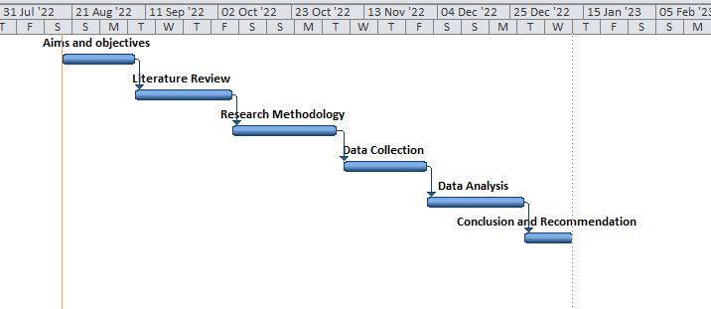

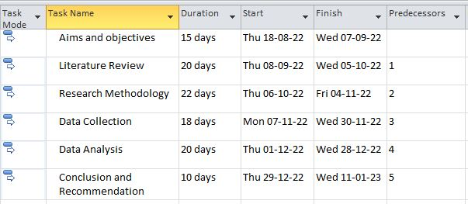
From the above images, it is highlighted that the research work or activities such as to prepare aims as well as objectives, the investigator will require fifteen days, for making literature review, it will take twenty days. The investigator will need hundred days to finish the research project. It will further support in examining which investigation require to finish first and which can be done later with opening date of the research work and end date of the research.
Ethical considerations
It is very much important to conduct the research in an ethical way to gain the end results. There are certain ethical considerations which is needed to ascertain by the investigator-
- It should not damage mentally or physically to anyone whether the person is participating in the investigation or not.
- The information should be assembled in a fair manner without considering any individual usefulness.

Chapter 4: Conclusion
It has been concluded that the an organisation's effectiveness and performance is highly influenced by the leaders and their styles used within the organisation. If leaders play their role effectively then it can bring positive influences to the business, but somehow if leaders are not effective and strong enough to play their role then it can harm the employees along with business performance and effectiveness.

Chapter 5: References

Books and Journals:
Solinger, O.N., Jansen, P.G. and Cornelissen, J.P., 2020. The emergence of moral leadership. Academy of Management Review, 45(3), pp.504-527.
Clifton, J., Larsson, M. and Schnurr, S., 2020. Leadership in interaction. An introduction to the Special Issue. Leadership, 16(5), pp.511-521.
Khanal, J. and et.al., 2021. Context-specific leadership practices: An examination of evidence of successful community school headteachers in Nepal. Leadership and Policy in Schools, pp.1-25.
Heller, F.A., 2019. Leadership, Decision Making, and Contingency Theory. In Managing Democratic Organizations (pp. 211-227). Routledge.
Norris, K.R., Ghahremani, H. and Lemoine, G.J., 2021. Is it laissez-faire leadership or delegation? A deeper examination of an over-simplified leadership phenomenon. Journal of Leadership & Organizational Studies, 28(3), pp.322-339.
Gupta, B.N. and Gupta, N., 2022. Research methodology. SBPD Publications.
Mukherjee, S.P., 2019. A guide to research methodology: An overview of research problems, tasks and methods. CRC Press.
Thompson Burdine, J., Thorne, S. and Sandhu, G., 2021. Interpretive description: a flexible qualitative methodology for medical education research. Medical Education, 55(3), pp.336-343.

Online:
Hughson C., 2020. 13 common leadership styles. [Online] Available through: <https://www.ivey.uwo.ca/academy/blog/2020/01/13-common-leadership-styles/>
Duggan T., 2019. The Effects of Leadership Styles on the Organization. [Online] Available through: <https://yourbusiness.azcentral.com/effects-leadership-styles-organization-5247.html>

