Dissertation Research Proposal
  - AN INVESTIGATION INTO THE EFFECTS NATURAL DISASTERS HAVE ON TOURISM.
Table of Contents
1.0 Introduction…………………………………………………………………………………2
  - Background….……………………………………………………………………….2
  - Literature review………………………………..............………………….............2
  - Rationale....…………………………………………………………………………..3
  - Aims and Objectives.……………………………………………………....….…....4
- Research Design…………………………………………………………………………...4
  - Methodology…………………………………….……………………………………4
  - Sample…………………………….………………………………………………….5
  - Data Collection……………….....…………………………………………………...6
    - Qualitative data…………...………………………………………………6
    - Quantitative data…………………...………………………………….....6
  - Limitations and Ethical Considerations………………........................................6
    - Time Management……………………………….......……….......……..6
    - Ethical Risks.................................…..................................................6
- Resources and Planning………………………………………………………................6
  - Resources…………………………………………………………………..........…..6
  - Gantt Chart……………………………………………………………………….......7
- References………………………………………………………………............……….....8

- Introduction
“An investigation into the effects natural disasters have on tourism.”
As explained by Veal (2011) a research proposal summarizes how the research project will be carried out and how the research will be conducted. It examines the whole process from the beginning to the end.
Research projects can shape the choices of topic and the research design that goes with it. The point of research is to add to the knowledge that is already there and to back up the findings of the project. (Veal, 2011)

1.1 Background
There have been several remarkable natural disasters that have occurred over the years, some of the most popular to name a few are; the 2004 tsunami in Phuket, Thailand, the 2011 earthquake and tsunami in Japan, the 2010 earthquake in Haiti and one that has occurred most recently 2017 hurricane Irma in the USA.
Natural disasters are continuing to have an increasing effect on tourism all over the world, whether that be negative or positive. They have a major effect on what visitors/tourists think about the country, such as how safe it is perceived to be and what actions have been taken to ensure this.
Out of the wide variety of natural disaster types, the most serious are earthquakes as they are incredibly unpredictable and unpreventable due to the way in which they are created/formed (Vere-Jones, 1995). When disastrous earthquakes occur, tourist-related facility providers and destinations are put at risk and in a difficult position where they are faced with a challenge of declining visitor numbers and decelerating revenues as well as the recovery costs on top (Tsai & Chen, 2011).

1.2 Literature Review
A recent study was completed by Kim and Marcouiller in 2015 titled ‘Considering disaster vulnerability and resiliency: the case of hurricane effects on tourism-based economies.’ The study was conducted to examine the vulnerability and resiliency of 10 tourism based regional economies including US national parks or seashores, which were situated on the Gulf of Mexico or Atlantic Ocean coastline, affected by several hurricanes over a period of 26 years.
This study into the effects of natural disasters on tourism will look at more than just hurricanes and given the most recent hurricanes that have occurred (Irma and Harvey in the USA) a comparison can be done between the two studies to acknowledge what has changed in the two years after another two hurricanes have happened.
Research has been conducted by looking at newspaper articles providing detailed accounts about the disasters and how they have affected the country and the surrounding areas. Disaster clean up reports and charities have also provided a lot of research into what is being done to help get the country back to normal and tourism boards and committees have been looked at to examine what has been completed regarding marketing and advertisement of the country and the regeneration/rebranding that was needed in some destinations e.g. Haiti to ensure that the country still receives the visitors it needs to gain the right amount of tourism and economic boost.

1.3 Rationale
With the need of tourism in every country in the world it is a good research study to look at possible factors that can have a massive effect on the tourism of a certain area. Many evaluations can be made from looking at various previous studies and reports, especially disaster clean up reports, relief and response team reports much like The American Red Cross Haiti disaster relief and recovery update reports which have been completed every year. They have been working with Haiti and people from the local communities to reshape and help to bring the country back to its former glory. This has included providing measles and polio vaccinations for the local people, especially children and the reopening of schools for the students to continue their studies and for some to start their studies.
An article in Volume 32 of Tourism Management states that natural disasters have a negative impact on the tourism industry in Taiwan. Due to the centralization of tourist facilities, which leads to a gathering of large amounts of visitors during the holiday seasons, can put a lot of people in danger. Which means; operators of tourism in Taiwan are at a high risk of natural disasters. This came to light after the government of Taiwan created and continue to promote the “Double Tourist Plan”. (Tsai & Chen 2011).

1.4 Aims and Objectives
One definition of a research aim is that of Norbert Elias; “The aim, as far as I can see, is the same in all sciences. Put simply and cursorily, the aim is to make known something previously unknown to human beings. It is to advance human knowledge, to make it more certain or better fitting… the aim is… discovery. (Elias, 1996).
Aim:
The main aim of this study is to find out just how much natural disasters affect tourism at a destination, why these natural disasters affect tourism and what is being down to help prevent tourism decline due to these natural disasters.
Objectives:
The following objectives will support the overarching aim of the study:
- Thoroughly investigate previous destination case studies and disaster reports to gain a wide variety of research from different destinations and disasters.
- Study disaster committee, charities, foreign offices and the D.E.C to gather clean up reports and research what is being done to regenerate and recover the destinations in crisis.
- Critically analyze world destination tourism statistics and academic tourism literature.

- Research Design

2.1 Methodology
Methodology is the way in which knowledge and understanding are established e.g. the method that is used in the classic positivist approach is the controlled experiment, only possible in a small number of tourism and leisure research contexts. Distinctive methodologies can be easily found especially when using the quantitative and qualitative divide. The ontological and epistemological perspectives can influence the choice of method used in a study (Veal, 2011).
To conduct effective research, Saunders et al (2009) created ‘The Research Onion’ – a model that outlines all the layers involved and which should be considered when conducting research. To gain an effective research pathway, an aspect from each layer of the onion must be chosen. Figure 1 below shows The Research Onion and the philosophies, strategies, techniques, choices, horizons and approaches included within it and the pathway chosen for this study is outlined.
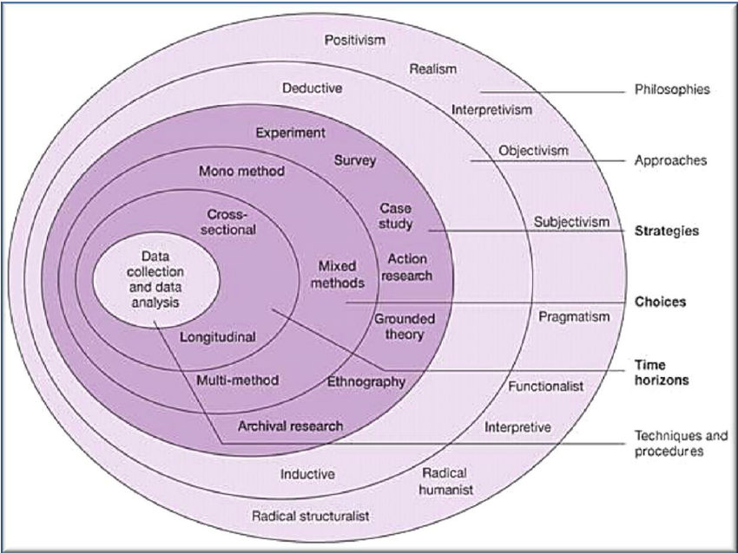
Figure 1. The Research Onion (Saunders et al, 2009).
Data collection and data analysis will be performed by the researcher which is the center of the onion. Cross-sectional design will be used rather than longitudinal due to not completing the study over a course of many years. The researcher will use a mixed methods choice in the form of a questionnaire (quantitative data) as well as some small-scale interviews (qualitative data). Having a mix of both types of data provides the researcher with a wider sample of data and findings to interpret. A grounded theory and survey strategy will be undertaken to fully provide an understanding and to be able to analyze collected data. The study will take an inductive approach rather than deductive and will follow an interpretivism philosophy angle.

2.2 Sample
The sample that will be used for data collection will be hand-picked to gain the best findings and research. Hand-picking the sample will enable the researcher to get results only from those who have an interest or previous experience regarding the research aim. Questionnaires will be presented to many people to gain their knowledge, thoughts and feelings regarding travel intention considering natural disasters. Interviews will be held with those who have been involved with natural disaster clean up or have been at a destination whilst a natural disaster has occurred.
2.3 Data Collection
The two forms of surveys that are being used in this study are interviews and questionnaires. They will provide two different forms of data in different formats.
Questionnaires can be presented to a majority of different groups and they are flexible in terms of being able to ask open and closed questions. These questionnaires will provide a mix of both qualitative and quantitative data.
2.3.1 Qualitative data
This approach is generally not concerned with numbers but typically with information in the way of words, orally and in writing. This type of research generally helps to make it possible to collect a large amount of information about the subject research, which may be individuals, places or organisations (Veal, 2011).
2.3.2 Quantitative data
The quantitative approach involves numerical data. Relying on numerical evidence to draw up conclusions, which is often necessary to study large numbers of people and use computer programs to analyze the data, such as SPSS (Veal, 2011).

2.4 Limitations and Ethical Considerations
2.4.1 Time Management
With there only being a specific time frame for this research to be competed, time management is a critical factor. Without the right time management, there could be limitations to the amount of research that can be conducted and affect the overall depth of the research study.
2.4.2 Ethical considerations
To not cause any age issues, only participants over the age18 or over will be used in the research. Participation will be optional and they will have the right to withdraw at any time.

- Resources and Planning

3.1 Resources
The resources being used in this study will consist of journals, articles, books, reports and professional websites. These will be provided by the University libraries and online databases. These resources will contribute to the literature review and help to form the secondary data.

3.1 Gantt Chart
A Gantt chart is a tool that will help to map out specific tasks that need to be completed in a certain time frame by certain dates. It helps the researcher to keep on track with deadlines and to help the researcher ensure they are on target to reach the overall goal. Without it then it is possible that deadlines and research will be scattered and will not be carried out within the correct time or by the deadline dates set.

- References

Elias, N (1986). Quest for Excitement: Sport and Leisure in the Civilizing Process. Oxford: Basil Blackwell. p19-62.
Kim, H, & Marcouiller, D 2015, 'Considering disaster vulnerability and resiliency: the case of hurricane effects on tourism-based economies', Annals of Regional Science, 54, 3, pp. 945-971. (Accessed from: Business Source Complete, EBSCOhost)[Accessed on: 16 November 2017].
Sonmez, S.F. (1998). Tourism, Terrorism and Political Instability. Annals of Tourism Research. Vol. 25, p416-456.

Saunders, M., Lewis, P. and Thornhill, A. (2016) Research Methods for Business Students, 6th Edition, Financial Times/Prentice Hall:Harlow.

The American National Red Cross. (2017). Haiti Disaster Relief & Recovery. (Available from: http://www.redcross.org/about-us/our-work/international-services/haiti-assistance-program#News-Articles). [Accessed on: 17th Nov 2017].

Tsai, C & Chen, C. (2011). The Establishment of a Rapid Natural Disaster Risk Assessment Model for the Tourism Industry. Tourism Management. Vol. 32, p158-171.

Veal, A.J (2011). Research Methods for Leisure & Tourism. 4th ed. England: Pearson. p34-58.

Vere-Jones, D. (1995). Forecasting Earthquakes and Earthquake Risk. International Journal of Forecasting. Vol.11, p503-538.

