

INTERNATIONAL MARKETING
MODULE CODE: LCMB7006
STUDENT ID: 2220408
STUDENT NAME: GURPREET SINGH
ASSIGNMENT TITLE: ASSESSMENT 1
NAME OF LECTURER: DR. TUSHARA BALENDRAN

Executive Summary
The development of this report focussed on the emergence of Cadbury as a well-known brand in India. It focused on macro environment by using PESTLE factors in this case and it highlighted cultural differences between these two countries with help of Hofstede’s cultural dimensions. Analysing threats and weaknesses along with strengths and opportunities of Cadbury enriched its quality. This report described the marketing mix of Cadbury in the context of business in the UK and India. 7 elements of the marketing mix in India and the UK have been compared for the product of Cadbury Fruit and Nut. Directional development strategy of Cadbury has been developed considering the Ansoff Matrix. Product development factor of Ansoff matrix has been analysed for introducing the product in market of India and UK. The recommendation for Cadbury has been provided based on the TOWS matrix to support the recommendation in an appropriate manner. It has supported the overall analysis of the company by providing sound analysis in an effective manner.

Table of Contents

Introduction 4

Background information about the company 4

The macro-environment 5

PESTLE Factors 5

Hofstede cultural model 6

Porter’s Five Forces 9

SWOT Analysis 12

STP Analysis (perception map) 14

Marketing mix strategy (7P) 15

Directional development strategy 18

Recommendations 20

Conclusion 22

References 23

Introduction
International marketing is a process of distributing, promoting and advertising a company's products and services across national borders. International marketing is important due to its ability to help a business to reach international audiences. The report is going to focus on the involvement of Cadbury as an organisation in terms of international marketing. It will focus on the market involvement of Cadbury Dairy Milk Fruit and Nut in the UK and India. USD 5.73 billion is the net worth of Cadbury and it has a 68% market share in global marketplaces (Cadbury, 2023). Furthermore, this report will integrate necessary theories and models to highlight the context of international marketing based on Cadbury’s standpoint.

Background information about the company
John Cadbury, a Quaker, who used to sell tea, coffee and drinking chocolate, founded Cadbury in 1824. John Cadbury took help from his brother Benjamin followed by his sons Richard and George to establish this company properly. Mission statement of Cadbury is, “Cadbury means quality; this is our promise” (Cadbury, 2023). The company addresses that it developed its reputation based on its quality and its commitment to continuous improvement can ensure deliverance of its promise. “Working together to create brands people love” is a vision developed by Cadbury. Cadbury was quick to support the war effort however possible and Bourneville Factory had a major influence in this case (Cadbury, 2023). Cadbury operates as a British multinational confectionery organisation owned by “Mondelez International” and based in Uxbridge, UK.
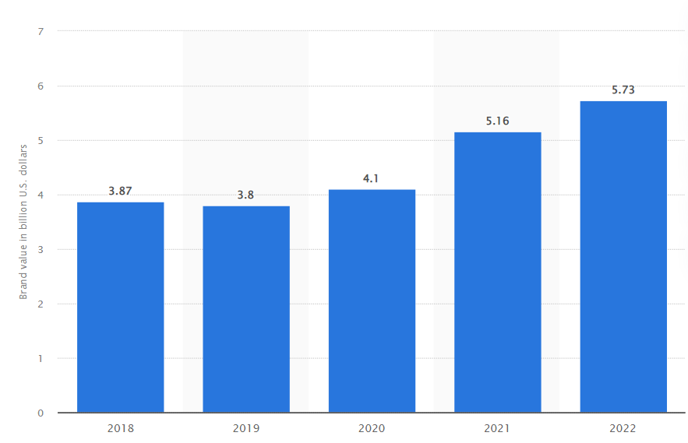
Figure 1: Brand value of Cadbury in global marketplaces (2018-2022)
(Source: Statista, 2023)
International marketing influenced this company to expand its activities in multiple countries. Delivering value to customers is a part of Cadbury’s international marketing and it focuses on expanding its activities with factual purposes (Linkedin, 2023). As a result, these parts of international marketing helped Cadbury to turn into “world's second-largest confectionery brand”. It is to note revenue expanded by 30.3% and it fostered domestic salary rates for Cadbury. Cadbury Dairy Milk Fruit and Nut is a delicious combination of crunchy almonds and dried grapes, scattered through the classic, creamy taste (Cadbury, 2023). It is one of the well-known Cadbury products and it developed with help of sustainably sourced cocoa.

The macro-environment

PESTLE Factors
- Political
“Corporate tax” can enhance market involvement of organisations due to its ability to affect competitiveness of businesses. Rate of “corporate tax” in the UK is 25% and it can focus on highlighting the competitiveness of companies (Pwc, 2023). On the other hand, the rate of “corporate tax” in India is 22% and it poses a major influence on income taxes (Pwc, 2023). Managing paid bribes can help Cadbury to enhance its involvement in both UK and Indian markets. In the past, Cadbury faced an accusation of tax evasion thus; it needed to focus on maintaining corporate taxes for its business operations. Additionally, Brexit had a major influence on practices of Cadbury and this company addressed the need to raise its prices to manage its commitment to stay in the UK market (Theguardian, 2023). Snacking firm Mondelez International stated it would invest 4000 crore in India into its manufacturing (Indiatimes, 2023). Mondelez International invested 1500 crore to manufacture Cadbury and Oreo in the past. Therefore, political aspects can impose opportunities and limitations on operations of Cadbury.
- Economic
“The CPIH inflation rate” is 6.5% in the UK and Mondelez International, parent company of Cadbury, blamed inflation after reducing the size of its products by 10%. In contrast to this, the inflation rate for consumer prices in India was 7.5% every year (Worlddata, 2023). Mondelez International revealed that it reduced the size of large Cadbury bars from 200 grams to 180 grams.
- Social
Literacy is one of the major social factors due to its ability to enhance the level of workforce for organisational functions. The literacy rate in the UK is 99%, which indicates one in every hundred faces difficulties in reading and writing (Una, 2023). “Empowering Children through Stories in Their Own Language” is a concept developed by Cadbury to enhance the level of literacy (Mondelezinternational, 2023). On the other hand, India’s “literacy rate” is 77.70% and it is trying to improve its level of literacy every year. Managing constant improvement in literacy can help Cadbury to develop a positive image in Indian and UK market sections.

Hofstede cultural model
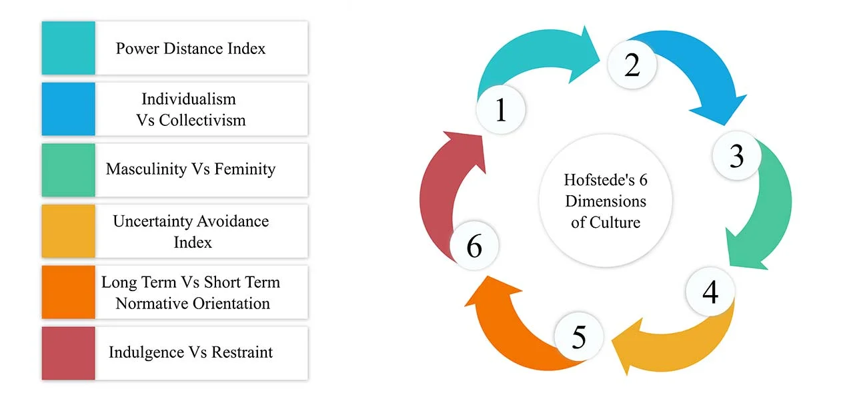
Figure 2: “Hofstede cultural model”
(Source: Simplypsychology.org, 2023)
“Hofstede's Cultural Dimensions” is a framework defining cultural differences of multiple countries. As opined by Chun et al. (2021), Hofstede’s model can highlight the pervasiveness of the cultural dimensions in both academic and business environments to manage accuracy over time. Integration of this cultural model can be beneficial due to its ability to provide important information about differences between countries like the UK and India. On the other hand, “Hofstede model of cultural dimensions” as a model focuses on six factors, which cannot depict other relevant cultural behaviour based on perception of Cadbury.
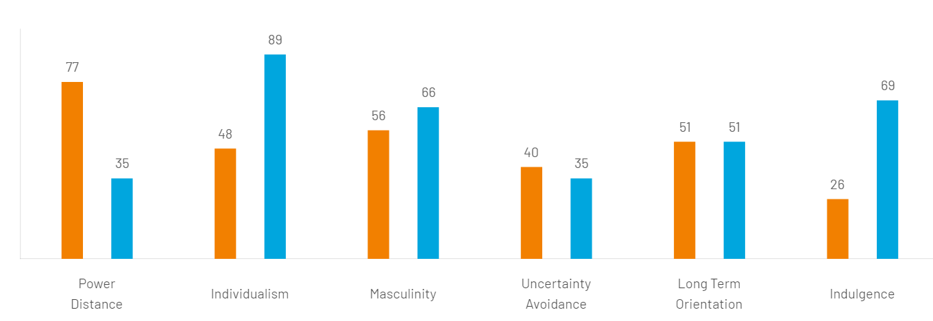
Figure 3: Country Comparison with help of “Hofstede model of cultural dimensions” (UK and India)
(Source: Hofstede-insights, 2023)
- Power Distance
In this dimension, India and UK hold 77 and 35 points respectively. 77 is a high score in this dimension of “power distance” and it highlights “an appreciation for hierarchy and a top-down structure in society”. This dimension of cultural aspects can influence Cadbury to distribute its market power equally in India. Contradictorily, at 35 the UK depicts a lower ranking and it highlights that it focuses on reducing inequalities among societies (Hofstede-insights, 2023). This score can influence Cadbury to offer its services and products in UK market sections equally.
- Individualism
India holds 48 points and UK holds 89 points in a dimension named “individualism” as per this model. India received an intermediate score and it highlights that in this country both collectivist and individualistic traits are key players (Hofstede-insights, 2023). The Individualist aspect of Indian society can influence Cadbury to focus on Indian philosophy to dominate this market section with Cadbury Dairy Milk Fruit and Nut. On the other hand, the UK's 89 points highlight its individualistic society, which can motivate Cadbury to highlight the key purpose of this product.
- Masculinity
India receives 56 points on this dimension and it highlights its dependence on a masculine society. The development of this model stated “India is very masculine in terms of visual display of success and power” and brand label, flash and ostentation are key success facts (Hofstede-insights, 2023). Cadbury needs to integrate these aspects in its advertising to enhance involvement of its Cadbury Dairy Milk Fruit and Nut in the Indian market. In contrast to this, the UK holds 66 points in this dimension and it focuses on a culture of modesty. Cadbury to elevate its involvement in the UK needs to have a clear performance ambition as per demand of this dimension.
- Uncertainty Avoidance
In a dimension named “uncertainty avoidance” India receives 40 points and the UK receives 35 points respectively. India’s score indicates that this country has a medium-low preference in terms of avoiding uncertainties. Thus, Cadbury needs to assess risk factors before offering other products and services in the Indian market. Contradictorily, the UK has a low score in this dimension and it highlights that as a country it is comfortable to go along by changing plans (Hofstede-insights, 2023). As a low UAI country, Cadbury can face multiple ambiguous situations as a way of expression in UK. In terms of work terms, it requires proper planning to enhance the sales ratio of Cadbury Dairy Milk Fruit and Nut.
- Long-term Orientation
In terms of “long-term orientation”, both countries receive 51 points and 51 points as a score act intermediately. Cadbury will not be able to determine dominant preference in Indian culture, which can turn into a major issue in future. India as a country has a greater tolerance for religious views and Cadbury needs to focus on this part to dominate the Indian market. In addition, with this intermediate score, Cadbury cannot determine aspects of British culture to leverage its market involvement.
- Indulgence
India receives a low score of 26 while UK receives a high score of 69 in this dimension of “indulgence”. “Culture of restraint” is a major factor influencing the essence of indulgence in India and India has a tendency of pessimism and cynicism (Hofstede-insights, 2023). Restrained societies like India do not put emphasis on gratification control and leisure time, which can turn into an issue for Cadbury. However, indulgent British culture can help Cadbury to focus on the impulses and desires of its people in terms of fun.
Advantages and Disadvantages of Hofstede Model
Hofstede's Cultural Dimensions can help organisations like Cadbury decide on their starting approach, actions and decisions based on general insights into how individuals in a specific society might react and think. On the other hand, the main disadvantage of this model is that it does not pay more attention to communities and their ethics. Companies to highlight cultural differences between countries, can use Hofstede’s cultural dimensions, which can act as a major advantage,. It helps in understanding different civilizations, cultures, and diversity as an advantageous factor. In addition, companies like Cadbury can use this model in expanding business practices on international platforms by not facing any kind of cultural barriers.
In contrast, accuracy of this theory can act as a disadvantage for companies and individuals. Additionally, this theory is outdated thus; it cannot define cultural differences between countries with latest information, which can be a major disadvantage. Hofstede does not take into account cultural diversity, women empowerment and migration and this aspect can be a disadvantage (Uhlich et al. 2022). However, it helps companies overcome the cultural and geographical differences within a short period. Another advantage of this is that it can foster context of motivation by minimising conflicts within organisational contexts.
- Technological
Cadbury says it is trying to use AI (“artificial intelligence”) and “machine learning” as two technological advancements. Use of these technologies such as AI can help this company “to recreate the actor's face and voice” to take name of local stores in its advertisements (News18, 2023). It influenced this company to customise its promotional videos as well, which is effective for the Indian market. On the other hand, high-speed wrapping and laser cutting are two procedures integrated by Cadbury to manage its operations in the UK. It focuses on quality assurance to capture the attention of customers in the UK market.
- Legal
Integration of “The Food Safety Act 1990” might influence Cadbury to sell accurate products to its customers in the UK. In the past, Cadbury caused a major ruckus by developing possibilities for a salmonella outbreak, thus in the UK it needs to integrate this act. Additionally, Cadbury lost more ground in its long-running battle in protecting its purple chocolate wrap (Bbc, 2023). This issue can turn into a problematic matter for Cadbury in capturing market position in the UK. Contradictorily, “Food Safety and Standards Act 2006” influences businesses to manage basic science-based standards to avoid further issues in India (Fssai, 2023). It can perform as an act to consolidate laws relating to food for better development of Cadbury.
- Environmental
It is to note in March 2021, this company removed plastic windows from every “Cadbury chocolate shell egg”. Apart from this, it moved its business practices to “100% sustainably sourced cardboard” and it eliminated “108 tonnes of cardboard” from marketplaces (Cadbury, 2023). Implication of these sustainable factors helped Cadbury to develop a positive image in the UK market. On the other hand, in India, Cadbury aims for “a goal of zero water discharge”.

Porter’s Five Forces
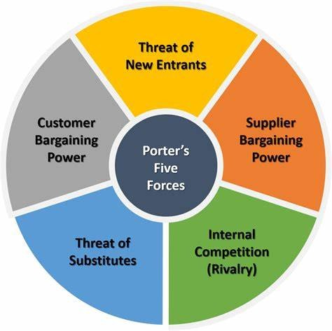
Figure 4: “Porter’s Five Forces”
(Source: Linkedin, 2023)
Porter's Five Forces act as a model identifying and analysing five competitive forces to shape every industry. It is effective in determining weaknesses of every industry as well with the help of five forces. As opined by Goyal (2020), this model focuses on the external environment to enable a company’s focus to gravitate towards changes in the external environment, which is an advantage. On the other hand, this model can oversimplify the industrial value chain, which is a disadvantage.
Factors | Power (UK market) | Power (Indian Market)
“The Bargaining Power of Supplier” | Low | Medium
“Bargaining power of Buyers” | High | High
“The Threat of New Entrants” | Low | Low
“Threat of Substitute Products” | High | High
“Competitive Rivalry” | High | High
Table 1: Level of impact of each force in UK and Indian market
(Source: Self-created)
- The Bargaining Power of Suppliers
The Company is paying special attention to integrate sustainable sourcing of raw materials. In 2021, Cadbury launched a program named “Cocoa Life Program” to source “100% cocoa sourcing” by the end of 2025 (Cocoalife, 2023). Cadbury focused on this aspect in the Indian market and this initiative helped this force to become a moderate one in India. However, in the UK, suppliers do not have any significant influence on raw material sourcing for Cadbury, thus it is low. The majority of the raw materials are sourced from the developing sector due to the nature of Cadbury’s SC (supply chain).
- Bargaining power of Buyers
In countries, UK and India “bargaining power of buyers” as a force is high for Cadbury. The large buying pool helped Cadvury to get a competitive position in UK and Indian markets. Additionally, in 2022 due to a misunderstanding, Cadbury faced significant issues in India and it has to declare that it offers 100% vegetarian products (Cadbury, 2023). Price sensitivity of customers motivated this company to offer products based on preferences of customers in India and UK.
- The Threat of New Entrants
Cadbury operates as one of the largest established chocolate brands in the UK and India. Mars, Nestle, Ferrero, Hershey and other brands are existing in market segments like India and UK. Thus, new entrants need to establish themselves like these brands, which requires a huge amount of capital. In contrast, Cadbury is trying to offer “healthy chocolates” to capture a leading position in market sections of UK and India (Cadbury, 2023). A new entrant will require high capital investment and development of a high capital investment cannot guarantee massive economies of scale to new entrants.
- Competitive Rivalry
“Mondelez International Business” is operating in multiple business dimensions and Cadbury faces intense competition in the UK and India. Cadbury offers a wide portfolio of products and it includes products such as desserts, cakes, chocolate bars, biscuits and drinks. In the UK, this company is a well-known product is Cadbury Dairy Milk and it is the most-purchased product in India. However, Cadbury still faces an intense level of competition from companies such as Ferrero, Mars and Hershey.
- Threat of Substitute Products
In the UK and Indian market sections, alternatives to fruit bars are present and the chocolate industry needs to focus on the development of chocolates with ingredients like antioxidants and vitamins. The above analysis highlights “The Bargaining Power of Suppliers” is a low and moderate force in UK and Indian markets respectively, which is a difference. However, factors related to other forces provide the same effects on Cadbury accordingly.
Benefits of Applying Porter’s Five Forces Situational Model
Applying “Porter’s Five Forces Situational Model” can help Cadbury to understand its current business situation in UK and Indian markets. Apart from this, power shift to customers can be a beneficiary aspect highlighted by this model to organisations (Linkedin, 2023). Applying this model can be advantageous for Cadbury in determining multiple market dynamics in the UK and India. It can help Cadbury by defining current market boundaries effectively.

SWOT Analysis
UK | Strengths | Weaknesses | Opportunities | Threats
UK | - Premium quality brand  - Enhanced brand recognition  - Incorporation of customer-oriented and quality-driven approaches (Cadbury, 2023) | - Inadequate product differentiation  - Product recalls  - Controversies in advertisements | - Development in rural market areas  - Fresh tastes | - Increasing number of health campaigns  - Heavy taxation
INDIA | Strengths | Weaknesses | Opportunities | Threats
INDIA | - Strong presence of Cadbury as a chocolate brand  - Enhanced global presence (Cadbury, 2023)  - Potential of ownership | - Limited range of products  - Lack of regulatory compliance  - Product recalls | - Expansion in emerging market sections  - Expansion of product ranges | - Integration of new food trends  - Sugar tax in UK (Instituteforgovernment, 2023)

Table 2: SWOT of Cadbury India and Cadbury UK
(Source: Influenced from Cadbury, 2023)
Cadbury is a well-known global brand and it helped in capturing the attention of customers in the UK market. Cadbury has a global presence and it helped this company to operate at international levels. Cadbury generates high-profit margins by operating in international markets. Additionally, ownership of a wealthy parent company manages stock baking to manage its profit margins. Contradictorily, a limited range of products can provide an unstable secured position for Cadbury. Cadbury cannot expand in American regions due to regulatory issues and another aspect is it tends to recall its products. Expansion in emerging markets can influence Cadbury to enhance its product ranges, which can be an opportunity (Cadbury, 2023). In the UK, sugar taxes can restrain Cadbury from its operations, which is a threat.
Cadbury made a name of itself as a leading confectionery company globally and its development as a premium-quality brand helped its development. In addition, enhanced brand recognition turned into a key strength for Cadbury in India. Cadbury runs proper marketing and advertising campaigns and it has a significant effect on the mindset of customers in a wrong way. An opportunity exists for Cadbury to come up with fresh tastes to capture opportunities in market sections. Additionally, restrictions in regulatory compliance can be a threat to Cadbury in its expansion.

STP Analysis (perception map)
- Segmentation
Market segmentation can be defined as the process of dividing a huge or large customer base into different subgroups of geographic, demographic, psychographic and behavioural segmentation. Cadbury, the “British multinational confectionery company” has also divided its huge customer base into different segments of geographic and demographics to successfully operate in the UK and Indian markets.
- Geographic
Geographic segmentation is the way of sub-grouping the entire customer base as per tier geographic locations. In the case of the UK, Cadbury has targeted the consumers of London, the capital of the UK as the headquarters of this company is situated here (Cadbury.co.uk, 2023). In addition, this confectionery company has been able to attract customers from the entire UK. On the other hand, Cadbury has also been successfully operating in the Indian market since 1948 (Cadburybusiness.co.in, 2023). In India also, this company has been able to attract customers across the entire nation, especially, Mumbai, Delhi, Chennai and Kolkata which has resulted in more than 65% of the confectionery market in India. The UK and India are also known as the top two markets for Cadbury across the globe.
- Demographic
Demographic segmentation is considered the process of sub-grouping target customers based on their age, income and gender. In the UK, the target audience of Cadbury includes customers, children, adults, teenagers and even seniors. The specific age group of this company in the market is from 13 to above 65 (Cadbury.co.uk, 2023). In addition, the product items of Cadbury are consumed by both males and females from a middle to high-income class group. On a similar note, in the case of India, Cadbury also targets customers from the age group of 13 to above 65 including both genders of male and female (Cadburybusiness.co.in, 2023). However, in the UK, Cadbury mostly targets people from higher income classes in comparison to India as the “per capita income” is higher among the UK people than Indians.
- Targeting and Positioning
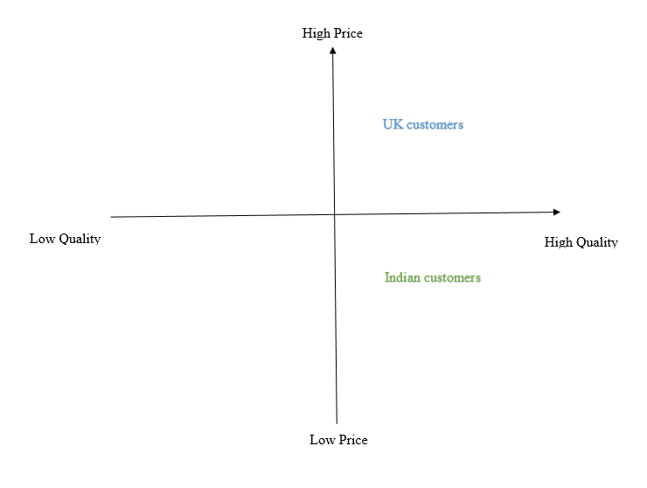
Figure 5: Perception Map
(Source: Self-created)
The target customers of Cadbury in the UK are positioned in the high-price and high-quality quadrant and target customers of India are positioned at low price and high-quality quadrant.

Marketing mix strategy (7P)
- Product
The product difference between the UK and India in Cadbury dairy milk is in the product ingredient and the packaging. In the UK the core ingredient of this product is dried grapes, crunchy almonds and classic and creamy cocoa (Cadbury.co.uk, (2023). In India the portion, size is different and in the UK edition, it differs in packaging also. In India, 80 gm, 36 gms, and 165 gms of Cadbury are manufactured. In the UK 48 gms, 180 gms and 300 gms packages are famous (Cadbury.co.uk, 2023). Cadbury developed different portion sizes in these two countries due to the nature of purchasing the products in the UK and India. The packaging type differs in these two regions as the UK product is semi-cylindrical in shape. In contrast, the product of India is rectangular and can be divided into multiple squares.
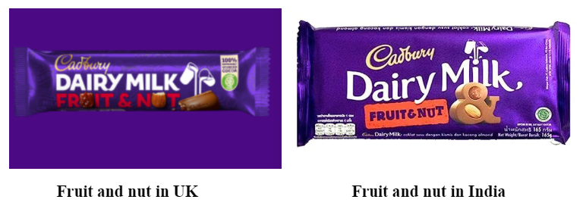
Figure 6: Comparison of two products
(Source: Cadbury.co.uk, 2023)
- Price
The price of products is dependent on the local market situation that differs in different locations of the world. The price of 49 grams of Fruit and nut in the UK costs 0.75 pounds which is 76.66 rupees in India which is based on the price skimming strategy (Cadburygiftsdirect.co.uk, 2023). On the other hand, a 36 gm product costs 45 Indian rupees that costs around 0.44 pounds in the UK (Amazon.in, 2023). The pricing is based on demand-based pricing. Demand of small sized Cadbury product is high in India than UK. However, the price of the product is dependent on its size as the size of the product is low in India the cost is comparatively low, which is different from the UK.
- Place
The Cadbury fruit and nut is available in the store and the online retail sites in UK and India and has a similar approach in distributing the products among customers
Cadbury Market Entry Methods
Cadbury manufactures its product in India after its successful entry into the country’s market. In partnership with Kraft Food, Cadbury establishes its distribution network within India in the year 2010 (Reuters.com, 2019). This approach of doing business in India by Cadbury reflects the use of licensing strategy for entering into the Indian market as a brand from UK. The US organisation Kraft becomes the supporting organisation for conducting business in India. Licensing of the production process of Cadbury enables the organisation in reducing the production cost and spreading the product at a reasonable price in the market.
Factors influencing market entry modes
The presence of strong competitors like Nestle influenced Cadbury to enter into the market with a strong strategy that can enable the organisation in providing the product at a competitive price. The CAGR of Indian chocolate market is 8 to 10 per cent over the upcoming 5 years, which is a potential factor in entering the market (Indiatimes.com, 2022). High cost of exporting in this market influenced Cadbury to set up local facilities as a part of market entry to conduct successful business. Currently, Cadbury captures the 55.95 market share of the Indian chocolate market (Statista.com, 2023). It reflects the effectiveness of the market entry strategy adopted by Cadbury in India.
Advantages and Disadvantages of Chosen Entry Methods
Requirement of capital investment is not required in licensing market entry mode that enables organisations to adopt this market entry without the presence of the sector in the foreign market. Cadbury gets the benefit of penetrating into the Indian Market and enhancing global investment of 150 million dollars without prior difficulties (Reuters.com, 2019). However, the percentage of generated revenue might be lower than the other market entry mode in licensing due to poor quality management, which is a major disadvantage of this market entry mode (Nibusinessinfo.co.uk, 2020). Lack of control over monitoring the usage of licences is difficult in “licensing strategy” (Tien and Ngoc, 2019). Organisations can face legal issues in future operational processes due to misuse of licences in foreign markets, which is the disadvantage of this mode.
- Promotion
Promotion of Fruit and Nut in the UK is dependable on the traditional promotional approach of advertising the product. Cadbury has adopted the TV advertisement promotion strategy in promoting the product in the UK market (Cadbury.co.uk, 2023). The example of “Hiding Easter egg” promotional strategy can be taken that has been adopted by Cadbury in UK (Cadbury.co.uk , 2023). “There is a glass and a half in everyone” is promotional line of the advertisement of Cadbury for promoting the product. In terms of India, the organisation adopted sales promotion by conducting several campaigns to connect with people. The example of the “Heart the Happiness” campaign can be taken as a part of a sales promotion, which is partnered with DeltaX (Indiatimes.com, 2022). It enables the organisation to communicate with a large number of customers and promote the product effectively.
- People
Indian market has the potential to inverse market reach of Cadbury invested in the organisation to develop a strong team. In India Cadbury has a dedicated department in R&D, Technology hubs and manufacturing to create a positive impact on the growing Indian market (Mondelezinternational.com, 2023). On the contrary, the UK market is stable, and Cadbury has a firm grip over that market. It enables the organisation to focus on targeting the effects of the exciting teams, which is different from the approach taken in India.
- Process
Cadbury has developed a customer communication team in India that can effectively gather feedback regarding the new product that can help in further improvement of Cadbury Fruit and Nuts. Similarly, Cadbury relies on this customer-centric approach in the UK (Mondelezinternational, 2023). It enables this organisation to give prior focus on maintaining strong customer service to improve the process.
- Physical Evidence
The packaging of the product is innovative in India that can attract Indian customers to the product. Innovative and eye-catching product packaging provides advantages in giving fruit and nuts as gifts to someone. On the other hand, packing of the product is more traditional in the UK, which has less creative involvement in the packaging process.
Similarities and Differences in Cadbury in India and UK markets
Lack of product range is a major similar weakness for Cadbury in the UK and India. Product recalls are another similar weakness identified in this analysis however; brand recognition turned into a different factor in this case. UK and India both are the most dynamic and vibrant economies in the world (pwc.co.uk, 2023). Similarities between the UK and Indian customer segmentation of the UK include similar age groups and similar genders of customers. Cadbury targets the higher-income class people of the UK for its high-priced products. However, in India, Cadbury sells more affordable products to target people from lower-middle-class people of India. India and the UK have a Parliamentary form of government. However, both countries are very culturally different because in India more conservative cultural traits are observed comparing to UK (thewire.in, 2020). Conversely, in the UK, people tend to be less traditional and more relaxed when it comes to clothing. On the other hand, Indians tend to follow traditions when it comes to areas such as clothing. In terms of community spirit, India tends to hold a better position than the UK. The value placed on individualism refers to British people not focusing on rituals, whereas Indians focus on conducting rituals.

Directional development strategy
Ansoff matrix
Development of a product or service in a new or exerting market requires a suitable strategy that can help in developing the business's effectiveness in the new market or existing market. Ansoff Matrix is the fundamental framework that provides support in securing growth opportunities (Culturehive.co.uk, 2023). Ansoff matrix categories four factors named “market penetration”, “market development”, “product development”, and “diversification” that can help in new or existing market penetration or product development. The market penetration factor helps in increasing sales of the existing products in the existing market to develop business efficiency (Ionos.co.uk, 2019). Market development is the condition of introducing existing products into new markets. Product development enables the introduction of new products to an existing market and diversification provides strategies for entering into new markets with new products (Clarissia, 2020). In the case of Cadbury, the organisation introduced a new product in the existing market of India that can be developed with the help of a Product development strategy.
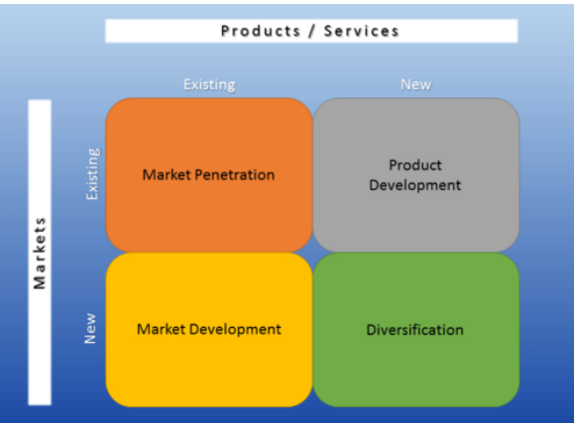
Figure 7: Ansoff Matrix
(Source: Ionos.co.uk, 2019)
Product development strategy- Fruit and Nut is the new product of Cadbury that the organisation needs to implement in the existing market of India. In India, the market share of Cadbury is high, approximately covering more than half of the chocolate market (Statista.com, 2023). In this scenario placing a new product will require promotion of product information through the existing marketing channel of the organisation that can help in ensuring the successful implementation of Cadbury Fruit and Nut. The global brand teams lead the marketing function of Cadbury in India (Indiatimes.com, 2022). It enables the organisation in considering the international marketing initiatives that can help Cadbury in promoting the product in the market. However, in the UK, organisations need to adopt a product development strategy that can help in promoting the product in the existing market without facing prior difficulties regarding the marketing process. Marketing initiatives of Cadbury revolve around the target customer aged 13, which is 30% of the total viewing audience of the advertisement program (Mondelezinternational.com, 2023). Therefore, considering marketing elements suitable for target customers in India and UK will be effective for Cadbury in implementing new products successfully.

Recommendations
TOWS Matrix
Internal Factors | External Factors
Internal Factors | Strength (S)  Strong brand reputation (cadbury.co.uk, 2023)  Global presence  Wealthy parent company (indiatimes.com, 2023) | Opportunities (O)  Digital transformation (Bandoim, 2023)  Increasing popularity of gifting culture  Emerging market | Threats (T)  Competitive marketplace  Supply chain disruptions
Internal Factors |  | SO strategy  Using the digital media to maximise the customer reach  Utilising the global presence to implement strong values in emerging market | ST strategy  Fostering culture of innovation to eliminate competitors  Merger and acquisition to enhance the supply chain
Internal Factors | Weaknesses (W)  Limited range of products  Perception of traditional brand | WO strategy  Elevating the product portfolio through digital transformation  Collaboration with similar companies to operate the business appropriately | WT strategy  Experimentation of the product portfolio to attract new customers  Securing the transportation budget for the betterment of brand perception
Table 3: TOWS Matrix
(Source: Self-created)
Analysis
It can be analysed from the TOWS matrix that the brand reputation of Cadbury and its global presence has provided a competitive advantage to the company. Digital transformation within the organisational context has helped the company to grow effectively while expanding its network in an effective manner (Bandoim, 2023). Therefore, based on the strength and opportunity of Cadbury, the company needs to utilise the digital media to expand its reach of customers in the competitive marketplace. The supply chain of the company can be disrupted based on the progression value of the market and shortage of labour in the dynamic marketplace. It can be recommended that, merger and acquisition can enhance the supply chain prospect of the company through innovative technology and resource management. It has been reported that, Vodafone and Mannesmann merger has elevated its business operation prospect by 20%, which is worth $180 billion in the niche marketplace (Linkedin.com, 2023). Therefore, the experimentation of product portfolio and securing the transportation approach of the supply chain of the company can elevate its market performance over the course of time.

Conclusion
It can be concluded from the study that different business scenarios and different cultures of the UK and India require a focussed approach regarding the new product of Cadbury. Fruit and Nut is a product that is launched by Cadbury in India and the UK. The external factors of the UK and India are different and that has a major impact on the business practices of Cadbury in the countries. Cultural differences in the UK and India force change in the marketing and placing approach of new products. The demands of local customers’ needs to be considered in two places that make the organisation develop differently sized products. Hofstede cultural dimensions helped in differentiating cultures of the UK and India to develop different approaches in the countries. The STP analysis helped in segmenting different customer bases in the operating countries to develop a proper marketing strategy. The marketing mix has been used to categorise the marketing approach and find differences in these approaches in India and UK. The categorisation highlights organisational intention of capturing market position with different initiatives that can help successful implementation of Fruit and Nut.

References
Amazon.in, (2023). Cadbury Dairy Milk Chocolate Bar Fruit and Nut, 36 g. Available at: https://www.amazon.in/Cadbury-Dairy-Milk-Fruit-Nut/dp/B08C2HKQQ6?th=1 [Accessed on: 20/07/23]
Bandoim, L (2020), cadbury-plans-to-make-a-vegan-version-of-its-dairy-milk Available at: https://www.forbes.com/sites/lanabandoim/2020/02/24/cadbury-plans-to-make-a-vegan-version-of-its-dairy-milk-chocolate-bar/ [Accessed on: 25th July, 2023]
Bbc (2023). Cadbury loses legal battle over purple wrapper. Available at: https://www.bbc.com/news/business-47113644 [Accessed on: 27/07/2023]
Cadbury (2023). CADBURY DAIRY MILK FRUIT AND NUT CHOCOLATE BAR. Available at: https://www.cadbury.co.uk/products/cadbury-dairy-milk-fruit-and-nut-chocolate-bar-110g/ [Accessed on: 27/07/2023]
Cadbury (2023). Cadbury Sustainability. Available at: https://www.cadbury.co.uk/about/impact/sustainability/#:~:text=We're%20committed%20to%20sustainable%20packaging&text=In%20March%202021%2C%20we%20removed,of%20cardboard%20from%20the%20market. [Accessed on: 27/07/2023]
Cadbury (2023). Cadbury UK | Cadbury Chocolate. Available at: https://www.cadbury.co.uk/ [Accessed on: 27/07/2023]
Cadbury (2023). OUR STORY. Available at: https://www.cadbury.co.uk/about/history/our-story/ [Accessed on: 27/07/2023]
Cadbury.co.uk, (2023), Cadbury Available at: https://www.cadbury.co.uk/ [Accessed on: 25th July, 2023]
Cadbury.co.uk, (2023), Cadbury, Available at: https://www.cadbury.co.uk/ [Accessed on: 27/07/023]
Cadbury.co.uk, (2023), The Cadbury Foundation, Available at: https://www.cadbury.co.uk/about/impact/cadbury-foundation/ [Accessed on: 27/07/023]
Cadbury.co.uk, (2023). ALL FRUIT & NUT CHOCOLATE PRODUCTS. Available at: https://www.cadbury.co.uk/products/flavour/fruit-and-nut-chocolate/ [Accessed on: 20/07/23]
Cadbury.co.uk, (2023). CADBURY DAIRY MILK FRUIT & NUT CHOCOLATE BAR, 49G. Available at: https://www.cadbury.co.uk/products/cadbury-dairy-milk-fruit-and-nut-chocolate-bar-49g/ [Accessed on: 20/07/23]
Cadbury.co.uk, (2023). OUR ADVERTISING. Available at: https://www.cadbury.co.uk/explore/seasonal/lastest-campaigns/ [Accessed on: 20/07/23]
Cadbury.co.uk, (2023). OUR ADVERTISING. Available at: https://www.cadbury.co.uk/explore/seasonal/lastest-campaigns/ [Accessed on: 27/07/2023]
Cadburybusiness.co.in, (2023), Cadbury, Available at: https://cadburybusiness.co.in/ [Accessed on: 27/07/023]
Cadburygiftsdirect.co.uk, (2023). DAIRY MILK FRUIT & NUT CHOCOLATE BAR 49G. Available at: https://www.cadburygiftsdirect.co.uk/dairy-milk-fruit-nut-49g-bar.html#:~:text=%C2%A322.00%20%C2%A318.33&text=Sign%20In%20or%20register%20to%20save%20products%20to%20your%20account.,-Simply%20tap%20the [Accessed on: 20/07/23]
Chun, D., Zhang, Z., Cohen, E., Florea, L. and Genc, O.F., (2021). Long-term orientation and the passage of time: Is it time to revisit Hofstede’s cultural dimensions?.International Journal of Cross Cultural Management, 21(2), pp.353-371.
Clarissia, S.M.S., (2020). A study on Ansoff Matrix Technique: As a growth strategy and an adaptive learning technique adopted in the leading brand of products. BIMS Journal of Management, 18.
Cocoalife (2023). BUILDING A PROMISING FUTURE FOR COCOA FARMING COMMUNITIES. Available at: https://www.cocoalife.org/the-program/approach/ [Accessed on: 27/07/2023]
Culturehive.co.uk, (2023). The Ansoff Matrix. Available at: https://www.culturehive.co.uk/AMAresource/the-ansoff-matrix/ [Accessed on: 20/07/23]
Fssai (2023). Food Safety and Standards Act 2006. Available at: https://fssai.gov.in/cms/food-safety-and-standards-act-2006.php [Accessed on: 27/07/2023]
Goyal, A., 2020. A critical analysis of Porter’s 5 forces model of competitive advantage. Goyal, A.(2021). A Critical Analysis of Porter’s, 5.
Hofstede-insights (2023). COUNTRY COMPARISON TOOL. Available at: https://www.hofstede-insights.com/country-comparison-tool?countries=india%2Cunited+kingdom [Accessed on: 27/07/2023]
Indiatimes (2023). Cadbury maker Mondelez to invest Rs 4000 crore in India by 2026. Available at: https://economictimes.indiatimes.com/industry/cons-products/fmcg/cadbury-maker-mondelez-to-invest-rs-4000-crore-in-india-by-2026/articleshow/98867581.cms [Accessed on: 27/07/2023]
Indiatimes.com, (2022). Cadbury Dairy Milk’ allows people to unlock the happiest moments of 2022. Available at: https://brandequity.economictimes.indiatimes.com/news/advertising/cadbury-dairy-milk-allows-people-to-unlock-the-happiest-moments-of-2022-with-latest-campaign/96534523 [Accessed on: 20/07/23]
Indiatimes.com, (2022). Changing consumer preferences, rising income levels. Available at: https://retail.economictimes.indiatimes.com/news/food-entertainment/personal-care-pet-supplies-liquor/changing-consumer-preferences-rising-income-levels-and-health-consciousness-driving-premium-chocolates-consumption-in-india/92711967 [Accessed on: 20/07/23]
Indiatimes.com, (2022). Mondelez promotes Anil Viswanathan to VP-marketing. Available at: https://brandequity.economictimes.indiatimes.com/news/the-people-report/mondelez-promotes-anil-viswanathan-to-vp-marketing/89664271 [Accessed on: 20/07/23]
Indiatimes.com, (2023), cadbury-maker-mondelez-to-invest-rs-4000-crore-in-india Available at:https://economictimes.indiatimes.com/industry/cons-products/fmcg/cadbury-maker-mondelez-to-invest-rs-4000-crore-in-india-by-2026/articleshow/98867581.cms [Accessed on: 25th July, 2023]
Instituteforgovernment (2023). Sugar tax. Available at: https://www.instituteforgovernment.org.uk/article/explainer/sugar-tax#:~:text=The%20levy%20is%20paid%20to,8g%20of%20sugar%20per%20100ml [Accessed on: 27/07/2023]
Ionos.co.uk, (2019). Ansoff Matrix – what actually is it. Available at: https://www.ionos.co.uk/startupguide/productivity/ansoff-matrix/ [Accessed on: 20/07/23]
Linkedin (2023). Is Michael Porter’s Five Force Model still relevant today?. Available at: https://www.linkedin.com/pulse/michael-porters-five-force-model-still-relevant-today-pandey [Accessed on: 27/07/2023]
Linkedin (2023). Simplified Strategy for Finance Professionals - Porter's 5 Forces. Available at: https://www.linkedin.com/pulse/strategy-finance-porters-5-forces-elrouby-acma-cgma-fpac-mba [Accessed on: 27/07/2023]
Linkedin (2023). The marketing strategy that made Cadbury the world's 2nd largest confectionery brand. Available at: https://www.linkedin.com/pulse/marketing-strategy-made-cadbury-worlds-2nd-largest-brand-arora- [Accessed on: 27/07/2023]
Linkedin.com, (2023), examples-successful-company-mergers-acquisitions Available at: https://www.linkedin.com/pulse/examples-successful-company-mergers-acquisitions-shalini-singh [Accessed on: 25th July, 2023]
Mondelezinternational (2023). CADBURY HELPS WITH LITERACY IN AFRICA. Available at: https://www.mondelezinternational.com/News/Cadbury-Helps-with-Literacy-in-Africa [Accessed on: 27/07/2023]
Mondelezinternational, (2023). Humaning: Our Approach to Marketing. Available at: https://www.mondelezinternational.com/About-Us/Our-Way-of-Doing-Business/Marketing-Approach [Accessed on: 20/07/23]
Mondelezinternational.com, (2023). OUR BUSINESS IN INDIA. Available at: https://www.mondelezinternational.com/India/India-Business [Accessed on: 20/07/23]
Mondelezinternational.com, (2023). RESPONSIBLE MARKETING. Available at: https://www.mondelezinternational.com/Snacking-Made-Right/ESG-Topics/Responsible-Marketing [Accessed on: 20/07/23]
News18 (2023). Cadbury's New AI Tool Will Let You Create Free Ad With Shah Rukh Khan's Face and Voice. Available at: https://www.news18.com/news/tech/cadburys-new-ai-tool-will-let-you-create-free-ad-with-shah-rukh-khans-face-and-voice-4358408.html#:~:text=providing%20some%20information.-,Cadbury%20says%20it%20is%20using%20machine%20learning%20and%20AI%20technology,create%20their%20custom%20promotional%20videos. [Accessed on: 27/07/2023]
Nibusinessinfo.co.uk, (2020). How to manage your patents. Available at: https://www.nibusinessinfo.co.uk/content/advantages-and-disadvantages-licensing-patents [Accessed on: 20/07/23]
Pwc (2023). India - Corporate - Taxes on corporate income. Available at: https://taxsummaries.pwc.com/india/corporate/taxes-on-corporate-income [Accessed on: 27/07/2023]
Pwc (2023). United Kingdom - Corporate - Taxes on corporate income. Available at: https://taxsummaries.pwc.com/united-kingdom/corporate/taxes-on-corporate-income#:~:text=General%20corporation%20tax%20rates,year%20beginning%201%20April%202022). [Accessed on: 27/07/2023]
pwc.co.uk (2023), The UK and India Available at: https://www.pwc.co.uk/services/strategic-international-markets/india-business-group.html#:~:text=The%20UK%20and%20India%20are,flows%20of%20trade%20and%20investment. [Accessed on: 27/07/2023]
Reuters.com, (2019). As rural India develops taste for chocolate, a dominant Mondelez extends its reach. Available at: https://www.reuters.com/article/india-chocolate-idINKCN1UO065 [Accessed on: 20/07/23]
Simplypsychology.org (2023). Hofstede’s Cultural Dimensions Theory & Examples. Available at: https://www.simplypsychology.org/hofstedes-cultural-dimensions-theory.html [Accessed on: 27/07/2023]
Statista (2023). Brand value of Cadbury worldwide from 2018 to 2022(in billion U.S. dollars). Available at: https://www.statista.com/statistics/1337772/cadbury-brand-value/ [Accessed on: 27/07/2023]
Statista.com, (2023). Market share of leading chocolate confectionery companies across India in 2021. Available at: https://www.statista.com/statistics/1353289/india-chocolate-confectionery-company-market-share/ [Accessed on: 20/07/23]
Theguardian (2023). Cadbury says chocolate could get smaller after Brexit. Available at: https://www.theguardian.com/business/2017/mar/24/cadbury-warns-chocolate-could-get-smaller-after-brexit#:~:text=Cadbury%20has%20said%20it%20may,to%20staying%20in%20the%20UK. [Accessed on: 27/07/2023]
thewire.in (2020), Book Review: 'The Indian Conservative' Is Less History, More Right-Wing Apologia Available at: https://thewire.in/books/book-review-indian-conservative [Accessed on: 20/07/2023]
Tien, N.H. and Ngoc, N.M., (2019). Comparative Analysis of Advantages and disadvantages of the Modes of Entrying the International Market. International journal of advanced research in engineering and management, 5(7), pp.29-36.
Uhlich, M., Luginbuehl, T. and Schoebi, D., (2022). Cultural diversity within couples: Risk or chance? A meta‐analytic review of relationship satisfaction. Personal Relationships, 29(1), pp.120-145.
Una (2023). International Literacy Day. Available at: https://una.org.uk/international-literacy-day-factsheet#:~:text=In%20the%20UK%20the%20literacy,struggle%20to%20read%20and%20write. [Accessed on: 27/07/2023]
Worlddata (2023). Inflation rates in India. Available at: https://www.worlddata.info/asia/india/inflation-rates.php#:~:text=The%20inflation%20rate%20for%20consumer,the%20price%20increase%20was%208%2C227.70%25. [Accessed on: 27/07/2023]

