How has changing technology impacted on charity advertising?

Luke Tucker - P142247
Advertising and Brand Design, UWTSD.
Julia Lockheart
6,347 Words.

Table of Contents

List of Illustrations III

Abstract IV

Introduction. 1

Chapter One – History of charity and advertising. 3

Chapter Two - Digital technology and how it is used in charity advertising. 6

Chapter Three - How technology has enhanced creativity in campaigns 9

Chapter Four – How social media has changed how charities fundraise. 16

Chapter Five - How technology has helped reach a broader and specific audience. 22

Chapter Six –How technology has assisted easier and alternative ways to donate-. 26

Conclusion. 32

Reference List: 34

Additional Reading List ...…………………………………………………………40

List of Illustrations

- Barnardos (2017) Before and after images in Victorian times…....……4

- Action for Children (2016) A Sunny Smile booklet..…….........…………5

- Campaign Live (2015) Look at Me campaign for Womens Aid……….10

- Randy Matheson (2012) Drag Him Away campaign by NCDV……….11

- D&AD (2015) The Social Swipe campaign by Miseror……...…………12

- Campaign Live (2016) Battersea’s ‘Looking for You’ Campaign.….....14

- Our Family World (2015) Unicef using Virtual Reality in their campaign……………………………………………………………………15

- Amnesty International (2016) 360 Virtual Reality campaign.....……....15

- CAF Online (2017) Graph showing how people have given to charity in the last 12 months…………...........………………………………………16

- Lyfe Marketing (2017) Graph showing the price of advertising to reach 1000 people……………..………………….……………………..……….17

- American Red Cross (2017) An example of a Tweet from The Red Cross...................................................................................................18

- Unicef (2013) Likes don’t save Lives campaign by Unicef…….……..20

- NewsNich (2015) Donate Now tool on the ALS Association Facebook page….……………………………………………………………………...21

- CityAm (2012) An example of the Ice Bucket challenge...………...…..25

- Deeson (2017) Unicef using a suggested donation on their website……………………………………………………………………...27

- Barclaycard (2017) An example of a contactless charity box..........…28

- DigitalWorks (2012) Minewater Barcodrop campaign………..………..29

- Inspiration Room (2011) Simon on the Streets QR campaign…..……30

- Sofii (2017 A screenshot of gameplay from the Christmas truce winter map…………………………………………………...…………...........…..31

Abstract.

This dissertation will research how changing technology has impacted charity advertising. It will look at the history of charity advertising and how methods have changed over the years. It will examine the way technology has increased the number of platforms available to deliver key messages and how it has enhanced the creative approaches charities can use in their campaigns to gain supporters. It will highlight the technological support available for non-profit organisations and show how this can help charities use data to reach broader and more specific audiences. Finally, it will explore how new technology has made it easier for people to donate to their chosen charity and how innovative technology has helped to create interesting and effective new ways to donate.

Introduction.

The charity sector has grown greatly since its early beginnings and is now a big business, including registered and un-registered charities, community groups, self-help groups, mutual societies and co-operatives, with an estimated annual income of £73.1 billion according to Keen and Audickas. (2017) Government statistics show that there were a total of 167,443 charities registered in the UK in England and Wales in 2017. GOV (2017) Statistics from the UK Giving Report shows that 61% of the population in the UK donates to charities. Charities Aid Foundation (2017) Technological advances such as the printing press, radio, television and the internet have had a major impact on the ways charities advertise. As technology is constantly evolving and charity organisations will need to be aware of the impact this is having, and how they can use it to their best advantage.

Within this dissertation, I will be researching how technology has impacted on charity advertising. In chapter 1, I will look at the history of charities and early methods of charity advertising. In chapter 2, I will give an explanation of digital technology and how it is used in charity advertising and will also look at the support available for non-profit organizations to improve their digital capabilities. In chapter 3, I will look at examples of various advertising campaigns showing how technology has enabled advertisers to be creative and innovative. In chapter 4, I will examine how technology has helped to develop new platforms to communicate and will look at social media and how it has impacted on the way charities fundraise. In chapter 5, I will investigate the way technology has helped charity organisations reach broader and specific audiences by analysing data and managing information systems. I will also look at the way technology enables information to be shared on a large scale. Finally, chapter 6 will examine how technology has assisted charities in offering easier and alternative ways to donations to be made.

Haworth (2016) states that “Intrusive offline fundraising doesn’t have a place in a world of digital communication that people are used to being in control of and participating in.” He says that soon digital fundraising will take over traditional methods and that charities should embrace these new methods. This dissertation will examine the impact these digital changes have on charity advertising.

Chapter 1 – History of charity and advertising.

This chapter will look at the history of charity advertising and how it has evolved since its conception. The oldest known charities date back to the 12th century, and most were founded by religious groups, or wealthy people to help the poor, sick and disabled. Want2Donate (2017) The oldest charitable institute was reported to be the Hospital of St Cross which was founded in 1132 in Winchester by Henry of Blois. At this time, there was a civil war in England and Normandy, known as The Anarchy, which resulted in England being in upheaval with armies ravaging the land with villages and crops being destroyed. The hospital was set up to help people who were starving as a result of the war. Ross (n.d.) By the 1700’s this type of philanthropic work by rich benefactors had become widespread. One of the first charitable organisations, The Foundling Hospital was set up in 1741 by Tomas Coram. who created a hospital which cared for orphaned babies whose mothers were unable to support them. Coram (2017)

In Victorian times, the charity Barnardos used print advertising to gain financial support from wealthy people. They created before and after images of poor, dirty, malnourished children dressed in rags; contrasted by more positive images of them being educated and taught work, in orphanages. Ash (2016)
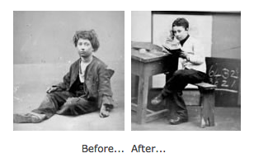

1.Barnardos (2017) Before and after images in Victorian times.
The world’s first charity street collection, Lifeboat Saturday, took place in 1891 in Manchester on behalf of the Royal National Lifeboat Institution (RNLI), a charity that aims to save lives at sea. It was organised by cotton merchant Sir Charles Macara after witnessing the RNLI’s worst ever lifeboat disaster five years earlier and it raised £5,000, equivalent to £250,000 today. This marked a change in charity fundraising, as previously charities relied on donations from influential and wealthy people, but this was a completely different approach where ordinary people were asked to help. Breeze (2017)

Bucket collections became popular and were held during the First World War with a nationalistic flag day theme. Over 15,000 war charities were registered and the National Relief Fund was established in 1914 raising over 2 million pounds within two weeks of it being founded. Sargeant and Jay (2014)


The Industrial Revolution with its invention of the steam-powered printing press in the 1840’s, led to mass production of newspapers and charities started to use this method to advertise. Further technological developments such as the invention of the radio had a big impact on charity advertising as it gave them a new way to publicise their campaign. Radio broadcasts for entertainment began in 1922 and the first charity appeal was aired on the 17th February 1923 in aid of Winter Distress League, a charity representing homeless veterans of the First World War. Colpus (2017) The invention of television further impacted on charity advertising. The first BBC television charity appeal Lifeline was in October 1986 for the National Star Centre for Disabled Youth and raised over £13,000. BBC (2017) Alongside this new technology, charities continue to use traditional methods using posters and flyers to advertise local events such as fayres, raffles and functions. In the 1960’s the charity Action for Children, who help vulnerable and neglected children and their families in the UK, sold Sunny Smile booklets in schools and churches, where a donation was paid to buy a photo of a child living in a children’s home. Action for Children (2016) Charities are now expanding their ways of fundraising, continuing to use traditional forms of advertising such as sponsored events and printed adverts but are now also taking advantage of the new technology available.

2. Action for Children (2016) A Sunny Smile booklet.

Chapter 2 – Digital technology and how it is used in charity advertising

‘Technology is a body of knowledge devoted to creating tools, processing actions and extracting of materials’ (Ramey 2013). Technology is dynamic and keeps on evolving as demands change. It has progressed from the industrial age where manufacturing and processing ideas were invented and developed, to the current information age. Technological advances have impacted society greatly by the invention of the internet and technical tools such as personal computers and mobile devices like tablets and smart phones. Digital technology has developed new ways to communicate with the introduction of platforms such as social media. Innovations have been made in the process of managing information, with systems available to analyse and store data, assisting advertisers in targeting specific audiences. Technological advances have given advertisers the tools to enable them to flourish creatively and produce interesting and interactive campaigns. Charity advertisers need to market their campaign across multi-channel platforms to reach broader audiences and stay relevant in today’s digital society. The various ways technology has impacted on charity advertising will be examined in depth in further chapters.

In order to keep up to date with ever changing technology, charities can now take advantage of free marketing support available from organizations such as Google and Microsoft who offer grants and support to help charities improve their online presence and raise awareness of their cause. An example of this is the Google for Nonprofits programme, which is available in over 50 countries and gives charities access to free versions to Google’s premium products of Gsuite, Google One Today and YouTube, enabling viewers to make donations directly using a donation card through the charities donation video. The programme also offers free advertising through its Google Adwords platform and helps them to manage their paid search campaigns more effectively. This support has proved to be successful as within a year of Charity:Water joining the programme, its websites traffic increased by 350%, total visitors increased by 300% and it had a 333% increase in video views. Translate Media (2017)

There is also a UK based charity, Tech Trust that helps other charities make more effective use of technology, providing a software donation programme, email marketing service, and a payments processing service. They help a total of 38,000 charities and are also developing new services of a combined digital self-assessment/signposting tool and a marketplace for tech suppliers to UK charities. Moorut (2017) Making use of this type of free technological support is vital for charities to ensure their website functions efficiently, looks professional, and shows clearly the aims and values of the charity.

Charities such as Oxfam, Shelter and Unicef use companies such as iRaiser. that provide a digital fundraising platform to help non-profit organisations. They help create an efficient online payment form to manage donations, sponsorships, subscriptions and memberships in a single software package. iRaiser helps charities create crowd funding and event fundraising on their webpage. iRaiser helps increase online donations by using intelligent algorithms to maximise average donation and uses data from social networks to profile audiences and improve online supporter journeys. This support helps charities fundraise to their full potential Lake (2013)

Statistics supplied by Firth (2011) reveals that in 2010 consumers spent almost half of their waking hours watching television, using their mobiles and other mobile communication devices and are therefore, being exposed to more marketing messages than ever. In order to capture this audience, charities advertisers should use modern technology to create multi-channel campaigns.

Chapter Three. - How technology has enhanced creativity in campaigns.

Although charity adverts are not designed to sell goods or products, they still follow the same approaches and methods used in commercial advertising.
Advertisers use psychology to engage with their consumers using advertising strategies such as: emotive, persuasive, positive and shock, and new technology brings opportunities for charity advertisers to portray these styles in a far more immersive and personal way, using interactive and innovative methods to connect emotionally with the audience.

A charity that embraced new technology to create a shocking, realistic and hard-hitting campaign is Women’s Aid, whose aim is to build a future where domestic violence is not tolerated. Their campaign used an interactive billboard with facial recognition technology to raise awareness of their cause. WCRS created the campaign in 2015, called ‘Look at Me’ and featured images of female victims of domestic violence and displayed messages such as ‘Don’t Turn a Blind Eye’, encouraging passers-by to take notice. Using facial recognition software, people who looked at the advert as they walked past were logged and added to a progress chart. The more people that looked at the image, the more the bruises on the woman’s face healed and disappeared. The images are shocking but the message being delivered is positive, pointing out that domestic violence can be stopped. Hoddinott (2015) This campaign immersed the viewer emotionally into the campaign and helped to deliver the message that the more people who acknowledge that domestic violence is an issue, the more it will be reduced.
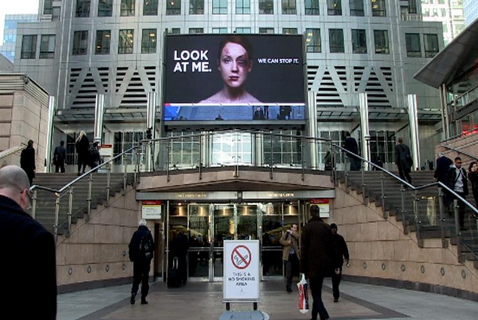

3) Campaign Live (2015) ‘Look at Me’ campaign for Womens Aid.
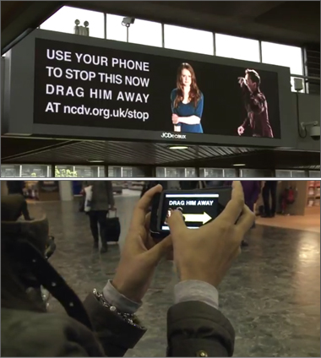
The National Centre for Domestic Violence (NCDV) is another charity that uses a similar advertising technique. Using innovative technology, an interactive e-motion billboard was placed in Euston station in 2012 to raise awareness of the need for people to intervene and report incidents of domestic violence. The campaign by JWT London called ‘Drag Him Away’ displayed a domestic situation between a man and a woman, where the man was becoming threatening and it included a call to action saying ‘Use your phone to stop this now.’ Viewers could scan a QR code, which enabled them to interact with the advert and drag the man away from the woman to adjacent billboards. As the viewer needed to physically interact by using their phone to swipe the man away from the victim, it made them feel very connected and emotionally involved in the situation and also fulfilled their need to help. The message is clear. The best way to stop domestic abuse is to separate people in an abusive relationship in the form of an injunction. This new technology has given the charity advertisers an opportunity to create an interactive campaign where the viewer feels they can have a positive influence on the outcome. This would not have been possible in the past when this technology was not available. NCDV (2012)
4) Randy Matheson (2012) ‘Drag him away’ campaign by NCDV.

This type of emotionally connected advert follows the principles of socialist Maslow’s hierarchy of needs (1943) cited by McLeod. (2016) Human behaviour depends on a range of needs, and in order to reach the highest
level, people have to fulfill the need for self-esteem by having self-confidence and gaining the respect of others. Charity advertisers exploit this need, by making people feel they are doing good by helping others, thereby gaining respect. If an advert connects emotionally with the donor it can create a high level of empathy along with self-efficacy and the understanding that they are in a position to help, which makes them feel good. Basil, Ridgway and Basil (2008)

Innovative technology has assisted charities in using the positive outcome approach in their adverts. The German charity Miseror has been fighting poverty in Africa, Asia and Latin America for over 50 years and used modern technology when they introduced a campaign in 2015 called ‘The Social Swipe’ created with Kolle Rebbe. An interactive billboard poster that accepts credit cards was initially placed at international airports. The donor becomes involved in the experience when their card is swiped through the poster. As it swipes through, it cuts through the bound hands of an imprisoned Filipino child, or slices a loaf of bread for a Peruvian family. The card is deducted with a minimal amount, showing the donor that even a small donation can make a huge difference. When the transaction appears on their credit card bill, donors are asked to turn this donation into a monthly deduction. D&AD (2015)
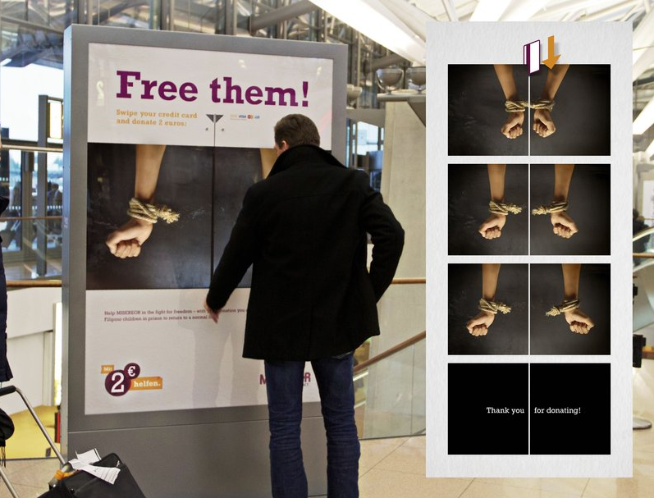

5) D&AD (2015) ‘The Social Swipe’ campaign by Miseror.
The social swipe involves a simple way to donate, giving an instant emotional feel-good factor to the donor. Results showed over three thousand dollars were raised in the first month and a 23% increase in donors making monthly donations on three or more occasions. SOFII (2015). Kapin (2013) suggests, as the donor feels more emotionally connected to a charity they are more likely to continue with a regular donation.

Another charity that used a new and creative form of technology in their campaign was The Battersea Dogs and Cats Home who used Radio Frequency Identification (RFID) in their advert at Westfield Stratford shopping centre in East London in 2015. They worked with Creation Company Films Limited and OgilvyOne UK to create a campaign called #LookingForYou where leaflets containing a hidden RFID tag were handed out to shoppers. When they carried the leaflets passed billboards in the shopping centre, a video of Barley, a former dog from the home, was activated. Barley engaged with the shoppers and appeared to follow them on numerous billboards around the shopping centre. Oakes (2015) When shoppers left the centre, Barley appeared on a giant billboard with the words ‘There’s a dog looking for you at Battersea’ and reminded shoppers to read the leaflet they were given earlier. The interactive style of this campaign made it a great success, leading to a 33% increase of site traffic and ten times more follow-ups than Battersea have dogs. The objective of this creative campaign was to highlight Battersea’s mission to rehome dogs and using this innovative and creative technology enabled the charity to engage emotionally with their audience. Exterion Media (2017)


6) Campaign Live (2016) Battersea’s ‘Looking For You’ Campaign.

Virtual Reality is another new technology which enables users to experience a three dimensional image or environment, which appears very realistic by using computer generated simulation software. This technology puts people directly into the situation rather than just watching a film or reading about the problem and makes them more involved and feel the need to help. The charity Unicef with the United Nations used this technology in 2015 to create a virtual reality campaign called Clouds Over Sidra. They ran a street campaign inviting people to experience life as a Syrian refugee. People felt as if they were being immersed into life as a refugee and felt an emotional involvement as they encountered the realities of day-to-day life in a camp. Patrick Milling Smith who helped produce the virtual reality videos, described them as the ultimate empathy machines that could persuade donors to pledge more aid. Data showed that in New Zealand when people experienced the virtual reality film, the number of donors doubled. Anderson (2015)
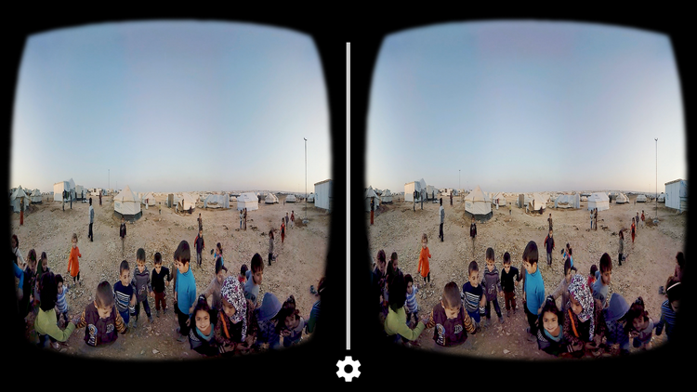
7) Our Family World (2015) Unicef using virtual reality in their campaign.

Amnesty International, a human rights charity won the Third Sector 2016 Digital innovation of the year award for its 360 Syria virtual reality campaign. In May 2015, they ran a three-month street campaign showing the devastation and destruction caused by the barrel bombing of Aleppo in Syria. The stark images experienced had a profound impact on viewers and the charity reported the campaign attracted 1935 people to give regular donations. Charity donors no longer want to be passive but want to be pro-active in their support and innovative technology allows this to happen. Third Sector (2016)

8) Amnesty International UK (2016) 360 Virtual Reality Campaign.

Chapter Four – How social media has changed how charities fundraise.

Technology has impacted on charity advertising by the introduction of new platforms and social media has given charities new ways to fundraise. Statistics reported by the Charities Aid Foundation (2017) shows that at present people still use traditional methods as the percentage of people donating online in 2016 was only 26% compared to cash 58%.
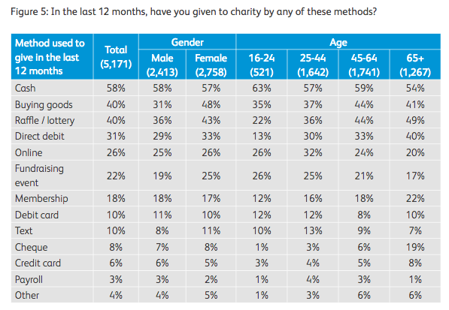
9) CAF Online (2017) Graph showing how people have given to charity in the last 12 months.

However, although online donations only make up a third of the total monies given, it is still an important method that charities need to take full advantage of to maximize their fundraising potential.

Technology has improved greatly since the worldwide web was developed with the first website going live in 1991. Wolchover (2012) There are now various low cost social media platforms that charities use to fundraise such as Facebook, Twitter and Instagram. Macarthy (2013) reports that Facebook is a hugely popular application, used for both personal and business use and is the most visited social network in the world with over a billion users. It can be used to share photographs, videos, daily updates, events and news with friends who also use Facebook. Businesses have Facebook pages to share information with their followers and can also access analytics, custom tabs and advertising tools. Twitter is another popular platform where users can ‘tweet’ information in 140 characters or less, which can be read, clicked, followed and re-tweeted. It is used by millions individuals to interact with friends and businesses can use it to promote their brand and interact with customers. Instagram is an app made to share photos and videos to your followers who can ‘like’ the content you upload.

Social media is cheaper than any other form of advertising available today and statistics compiled by Lyfe Marketing (2017) show that it costs roughly $2.50 to reach 1000 people compared to broadcast television costing $28.
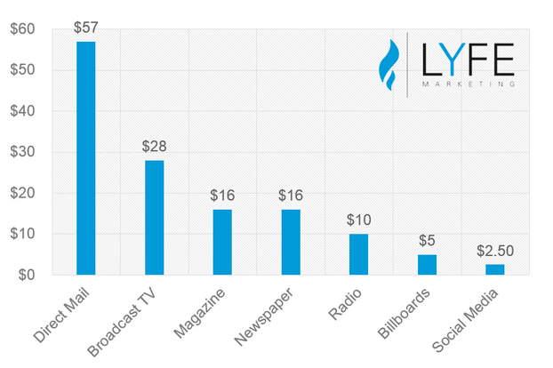

10) Lyfe Marketing (2017) Graph showing the pricing of advertising to reach 1000 people.
As well as being cost effective, it can also be monitored and data gathered in a more accurate way which can be used to improve future campaigns. The data gathered can also be used to amend or stop a particular advert if it is proving to be ineffective.

These platforms enable charities to reach large audiences quickly, for example when a disaster occurs, charities can create a status, tweet or page, which can be shared within seconds. An example of a charity using this method is the Red Cross who help vulnerable people in the UK and worldwide, by responding to emergencies, conflicts and national disasters. During hurricane Irma in 2017, they used their twitter account to share warnings and give up-to-date information on the path of the storm. During power blackouts it is much easier to access social media than conventional news. Red Cross (2017)
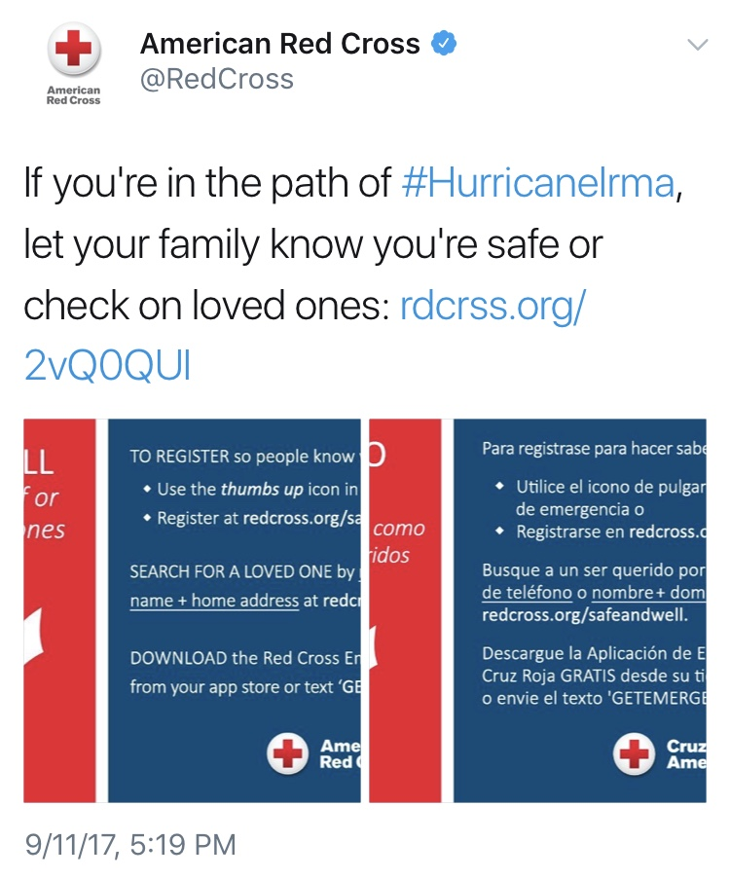

11) American Red Cross ( 2017) An example of a tweet from the Red Cross.

The Red Cross also gave details on how to donate money and supplies to help victims. This is far more effective than previous methods such as television advertisements or print, which have long preparation times.

The platform of social media has also enabled much smaller charities and individuals to publicise their cause and start new appeals. John Thompson is the man behind the social media campaign FirstFiver. In 2016 after seeing all the negative feedback online about the new polymer notes, he had the idea of donating his first note to charity knowing they would be happy to receive the money regardless of the material it was made of. He created a Twitter Poll and as a result the Twitter Hashtag #FirstFiver was created where people joined in and tweeted to tell others which charity they had donated their first fiver to. Figures from the Charities Aid foundation estimate that 12.5 million pound was raised through this campaign. Lake (2016)

Charities can also use platforms such as Facebook to promote thought provoking and persuasive appeals such as the Forsman & Bodenfors campaign for Unicef called ‘Likes don’t save Lives.’ Unicef is a children’s charity that saves lives and defends their rights. On their Facebook page in 2013 they shared a range of statements such as ‘Like us and we will feed zero children’ People regularly like photos, statements and comments online and Unicef’s simple appeal makes the reader reflect that it takes more than just liking a picture to actually help the child. They have a series of adverts relating to liking such as ‘Like us and we will vaccinate zero children against polio’, ‘Like us and we will educate zero children’ and ‘Likes don’t save lives, money does.’ In our culture, it is the norm to give to people less fortunate than us and failure to do so can result in a feeling of guilt. Basil, Ridgway and Basil (2008) Unicef is giving a harsh message, reminding people that although liking a statement may raise awareness, money is needed to help make changes and this campaign aims to remind people they are in a position to help by donating to the charity. Weissman (2013)
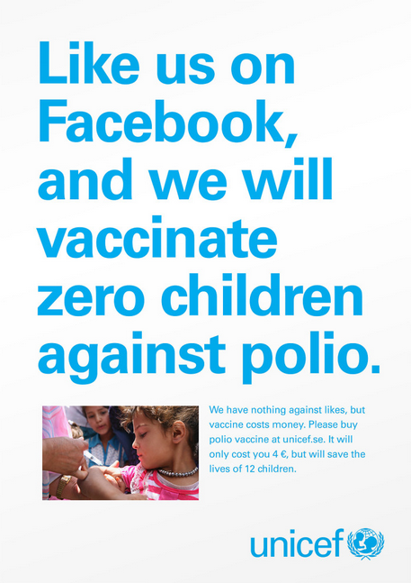

12) Unicef (2013) ‘Likes don’t save Lives’ campaign by Unicef.
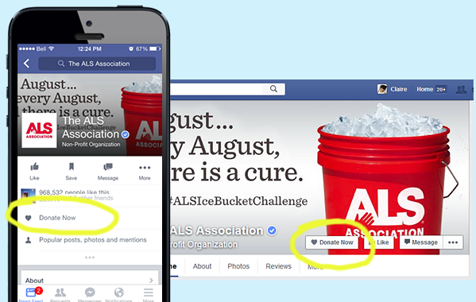
Social Media has also given charities a new and easier way to donate as Facebook has now rolled out tools to enable users the ability to donate to charities directly through the platform by using a ‘donate’ button on the charities page. It has been available in America since March 2017 and Facebook reported that it has made it easier for people to raise millions for charity including more than $10 million for hurricane Harvey. Facebook also allow donations to be collected through Facebook live events. Ariana Grande’s benefit concert on 4th June to honour victims of the Manchester terror attack used donation buttons on the Facebook live stream to raise more than $450,000. The donate buttons can help charities to raise funds as research has shown, that although charities receive a lot of likes from users, they do not necessarily receive donations. For example, the previously mentioned Unicefs ‘Likes don’t save lives’ campaign. By having a donation button on the top of the page, users may be prompted to donate to the charity rather than just liking. Dudman (2017)

13) NewsNich (2015) Donate Now tool on the ALS Association Facebook page.

Chapter Five - How technology has helped reach a broader and specific audience.

New technology has enabled charity advertising to reach a much bigger audience. The internet has enabled charities to open up their campaigns and advertise to a wide range of people all over the world. Internet users leave digital footprints wherever they are online. This is a trail of data created while browsing the Internet, such as the websites visited, emails sent, and information submitted online. TechTerms (2014)

Safko (2010) examines the strategies used in social media and reports that analysing data can enable advertisers to target specific audiences. This information can be used by advertisers to produce algorithms which is a mathematical formula that is designed to solve a problem and can be used, for example, in search engine optimisation to make sure the charity gets a high-ranking listing. It can also be used with Facebook, using behavioral algorithms to make sure their advertisments target users who are most likely to be interested in their cause. He states that as individuals are sharing their sentiments, opinions, hobbies and viewpoints online, this technology enables charities to match donors to organisations that they are likely to support, by finding out which issues are important to them. Campaigns are therefore more cost effective and productive. Advertisers use demographics, a study of a population, to group consumers into specified units such as age, gender, income, spoken language so that campaigns can be served to a particular group.
Charities also use a liking-based marketing technique, as psychological research has shown that friends are more likely to support a cause that a friend is already involved with. Fennis and Stroebe (2010) state “Friends are more powerful sources of influence than strangers” Data can be scrutinised to retrieve donor preferences and latest technology means that complex analysis of data that previously took a long time to process can now be done quickly. The charity Parkinson’s UK, which helps to support Parkinson’s sufferers and funds research into the neurological condition, uses algorithms to understand the connections between people as charity advertisers realise the importance of friends’ influence. Parkinson’s UK scrutinise data every two weeks to identify new donors added to their fundraising database, and look to find any donors making a large donation. By doing this Parkinson’s UK found out more information about a donor who had made a £1000 donation to his friend’s fundraising page. Parkinson’s UK relationship with the fundraiser enabled them to learn that this new donor had also been diagnosed with Parkinsons and they formed a relationship with him. This resulted in the donor giving over £100,000 to the charity and he also shared his contacts with the charity resulting in further new supporters. Falvey (2017)

Although data collected can be very useful to charities, they have to ensure that they protect donors’ privacy and security. This is not only an ethical issue, but can also have a negative impact on a charities reputation if it becomes known that they are irresponsible with data. Bowcott (2017) reported that eleven UK charities were fined for data protection breaches in 2016 when they screened for wealthy donors without consent. New general data protection regulations are coming in to effect in May 2018 and charities need to ensure their databases are updated and that they meet the new regulations, which have tightened up the control of how personal data is used and when consent is required. Charities need to ensure when identifying potential donors, that they only use relevant data and at no time use coercion tactics. If charities are practicing ethical fundraising, their reputation will help to develop good relationships and ensure donor retention.

Another advantage of digital technology is the way it enables things to be shared on a large scale through social media and charities now make use of this platform. An example of this occurred when a relatively small, fun challenge of pouring ice water over your head, whilst nominating others to do the same, went viral (spread rapidly through social network sites) in 2014 when the US golfer Chris Kennedy was nominated to undergo the challenge. Participants were asked to donate to the charity ALS and very soon hundreds of the world’s richest and most powerful men and women, such as Mark Zuckerberg, Bill Gates, and Rita Ora took part. Millions of ordinary people joined them in helping to raise over 116 million dollars, which helped to fund a breakthrough for ALS, which is a charity that works to discover treatments and a cure for ALS and to help support people affected with Motor Neurone Disease. The extent of this campaign was reported as 2.5 million ice bucket videos uploaded and 4 million posts on Instagram. As well as raising funds for the charity, it also helped to raise awareness of the rare condition. Dinnenn (2014) Another similar viral challenge was the No Makeup Selfie which raised 8 million pound for Cancer Research in just 6 days with stars such as Gwyneth Paltrow, Holly Willoughby and Cameron Diaz taking part. The Guardian (2014)


Unfortunately, the popularity of these viral challenges can result in spin off challenges where people copy the concept of nominating people online. This led to accidents and five fatalities when the ‘neknominate’ challenge became popular in 2014. This involved the irresponsible practice of people nominating each other to down (drink quickly) an alcoholic drink. This highlighted an ethical issue for Facebook as it appeared to be assisting the trend through its easy way of sharing to a large user base.

14) CityAm (2012) An example of the Ice Bucket challenge.

Chapter Six – How technology has assisted easier and alternative ways to donate.

McPherson (2007) suggests that new technology has developed a society of multi-taskers that are driven by the need for convenience and charities need to ensure they realise the importance of making it easy for people to donate. Technology has assisted charities in making the donation process easier and there are now many ways to donate in addition to the traditional methods of cash and cheque payments. Charities can now collect funds from online donations such as donate buttons on charity websites, Facebook pages and websites such as Just Giving. Charities are using good interface designs on their webpages ensuring they are clear and easy for donors to use, making the process of donation easier. A good charity website should contain a simple donation tool on the front page and also give the donor information on where their money will be used. This knowledge helps make the charity accountable and trusted by the donor. Charities can use technology to apply psychology in their persuasive designs to ensure their website donation pages have maximum impact. For example Unicef’s website suggest amounts to donate by using a selection tool, as research has shown that even though a donor may reject the amount suggested they are more likely to make a smaller donation than to not make one at all. Other charities such as Macmillan, a charity that supports cancer sufferers and their families, allows
supporters to personalize their online donation by putting an accompanying message in memory of a loved one. These approaches appeal to people’s emotions and make them more likely to donate. Jongbloet (2017)

15) Deeson (2017) Unicef using a suggested donation on their website.

Donation via text is also a popular way of giving, as it is very simple without the need to input bank details, as these are already held by the phone provider, who forwards the donation to the charity on the donor’s behalf. Pennies.org.uk is another technology driven method, where customers can donate to a charity by rounding up their bill when buying goods or services online and in stores. This is an effective method as it uses the details already provided making it a quick way to donate.

Charities have now incorporated technology into their charity boxes by equipping them with a contactless reader and a chip and pin terminal. A four-month trial in 2016 included Barnardos, Oxfam and the The British Legion and boxes were placed in Sainsburys supermarkets and railway stations. The trials showed that people who gave contactless payments tended to give three times as much as the pound usually given by a cash donation. This gives supporters another option of payment as less people now carry cash, especially the younger generation. Everett (2017)
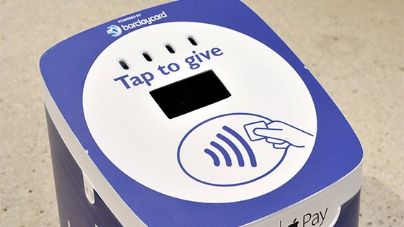
16) Barclaycard (2017) An example of a contactless charity box.
Charities are looking at ways to make their appeals different and are creating ambient campaigns using new technology, which is innovative, unusual and often used in unexpected locations to make donating experiential. The company Minewater created a charity campaign in 2012 to raise money for clean drinking water for children in Africa. They made their brand of bottled water stand out by using barcode technology in their campaign called Minewater Barcodrop. An additional barcode in the shape of a tear was put on bottles of water and if people were happy to donate an additional 10% of the price they would scan the tear. If they chose not to donate, the tear was easily removable. Research from the charity found that previously, people often intended to donate but did not actually get around to doing this. However, this double barcode was a really simple and easy idea and over 50% of people participated and donated. By providing such an easy way to donate, people were keen to get involved and sales for the water went up by 244% after the campaign was introduced. The simplicity of the campaign, allowing people to donate as they purchased the water compared to having to sign up online helped the campaign’s success. Lee (2012) People who supported this campaign enjoyed the easy way to donate and the unique barcode concept. Donors want to enjoy the experience of giving and this relates to research, which suggests that by donating to charity, donors will actually feel happier. This theory dates back as far as ancient Greece, when philosopher Aristotle argued that the goal of life was to achieve happiness by performing moral duties. In modern society, popular opinion agrees that helping others improves your mood. MRI evidence shows that giving money to charity leads to brain activity in the regions that experience pleasure and reward. Oppenheimer and Olivola (2010)
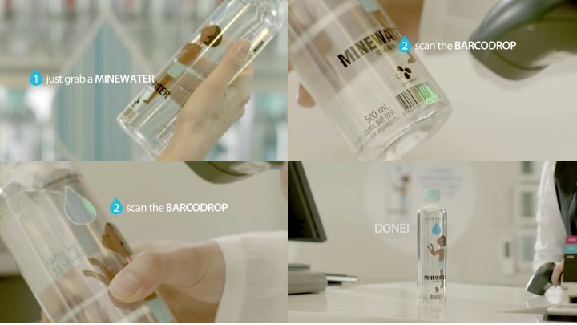

17) Digital Works (2012) The Minewater Barcodrop campaign.

Another charity that used barcode technology was a small UK fundraiser called “Simon on the Streets.” It is an independent charity based in West Yorkshire which supports the homeless community, in particular those who sleep rough on the street. Simon of the Streets worked with the creative agency Propaganda where they used QR codes in a campaign during the Christmas period in 2011 to give passers-by an easy and unique way to donate. They placed the QR codes on pieces of cardboard and laid them on blankets surrounded by bottles and belongings mimicking the outdoor dwellings of homeless people. When the code was scanned, it would take the user to a JustGiving page to donate directly to the charity. This was effective as it was a simple and novel idea where people could donate to the homeless, secure in the knowledge that their money would be put to good use rather than being spent on alcohol or drugs. Macleod (2011) It raised £1,435 in a week, but also increased awareness as many people scanned the barcode out of curiosity.
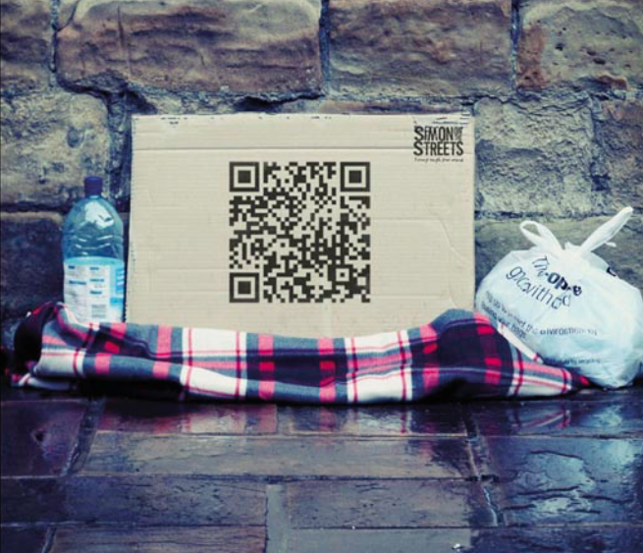

18) Inspiration Room (2011) Simon on the Streets QR code campaign.

War Child is another charity that uses new technology in an unusual format to raise awareness and funds for their cause by teaming up with gaming companies. The charity protects, educates and stands up for the rights of children caught up in conflict through war. They created a campaign in 2017 by producing peaceful in-game playing sequences. One of the companies, Wargaming.net raised funds by selling packs of three or ten especially designed peace emblems in the European PC version of the World of Tanks. Another was Blackmill games and M2H who raised funds by dedicating a Christmas truce winter map, which allowed players to throw snowballs at each other, play football matches, sing along with Christmas carols and send Christmas cards. War Child raised a lot of attention for their cause as over 60,000 players took a break from fighting to play football and other peaceful playing sequences and they made over $130,000 for the charity. This was a successful campaign as they reached a wide range of audiences outside of their normal target market. It also went on to win ‘Most Innovative Fundraising

Campaign’ award at the 2017 National Fundraising Awards. (Al-Obaidi 2017)

19) Sofii (2017) A screenshot of gameplay from the Christmas truce winter map.

which allowed players to throw snowballs at each other.

Conclusion.

The research obtained for this dissertation has shown that technology has had a big impact on charity advertising in various ways. It has increased the number of platforms available for charities to relay their message, therefore making campaigns more visible. It has also enabled creative advertisers to use many innovative and unique ways of getting their message across using methods such as: virtual reality, interactive billboards and QR codes. Technology has also impacted on the way people actually donate money to charities, using new methods such as contactless cards, intergrated donate buttons on social media, and through gaming platforms. As technology continues to progress it is likely that further new methods will be introduced in the future.

It is also important to note that even though currently online donations only make up approximately 30% of charity giving, this may change in the future. Although the aging population favour traditional methods of donating, it is likely that online donations will increase as the current younger generation age, as they have grown up with technology playing a large part in all aspects of their lives. It is very important that charities are aware of these modern ways of advertising and collecting monetary donations and use them alongside their traditional methods. The use of digital technology varies greatly amongst charities and while some are benefiting from using cutting-edge technology, others are struggling to master the basics. Amar (2017) reports “less than half of charities are using social media to engage with donors.” It is vital they take advantage of the free support offered to remain competitive and gain new supporters from these avenues.

Technology is likely to impact further on charity advertising as it continues to evolve. As well as impacting on fundraising, technology has also helped promote new ways for people to help by means other than cash donations. Social media has made it easier for charities to reach a broader audience and explain what their aspirations and values are and through this platform they can encourage people to offer their time and expertise to help. During the devastation caused when hurricane Sandy hit Haiti in 2012, crowd sourcing crisis information helped alleviate the situation. The formation of the International Network of Crisis Matters has resulted in experts from many different fields now working together in emergency situations. The advances in charity advertising due to technology are vast and will continue to develop and be impacted by ever changing new technology. Charities should embrace the new fundraising opportunities digital technology may bring, making sure they remain ethical and combine them with well-established traditional methods, to ensure they remain relevant and optimise their fundraising.

Reference List:

Books:

Ash, S. (2016) Funding Philanthropy: Doctor Barnado’s Metaphors, Narratives and Spectacles. Oxford: Oxford University Press.

Breeze, B. (2017) The New Fundraisers: Who Organizes Charitable Giving in Contemporary Society? Bristol: Policy Press

Colpus, E. (2017) Female Philanthropy in the Interwar World: Between self and other. London: Bloomsbury Academic

Firth, L. (ed) (2011) The Media. Cambridge: Independence.

Fennis, B. and Strobe, B. (2010) The Psychology of Advertising. East Sussex: Psychology Press

Haworth, M. (2016) The Digital Fundraising Book. Manchester: Reason Digital.

Kapin, A. (2013) Social Change Anytime Everywhere: How To Implement Online Multichannel Strategies to Spark Advocacy, Raise Money and Engage Your Community. New Jersey: John Wiley & Sons.

Macarthy, A. (2013) Five Hundred Social Media Marketing Tips. Stafford: Amazon UK.

McPherson, R. (2007) Digital Giving: How Technology is Changing Charity. New York: iUniverse, Inc.

Oppenheimer, D. and Olivola, C. (2011) The Science of Giving: Experimental Approaches to the Study of Charity. Hove: Psychology Press.

Safko, L. (2010) The Social Media Bible: Tactics, Tools & Strategies for Business Success. New Jersey: John Wiley & Sons Inc.

Sargeant, A. and Jay, E. (2014) Fundraising Management: Analysis Planning and Practice. Abingdon Oxon: Routledge.

Websites:

Action For Children (2016) Saying thanks for 70 years of fundraising. Available at: https://www.actionforchildren.org.uk/news-and-blogs/our-people/2016/july/saying-thanks-for-70-years-of-fundraising/ (Accessed: 17 November 2017)

Amar, Z (2017) Lloyds Business Digital Index 2017 shows digitally mature charities are pulling ahead. Available at:

https://www.charitydigitalnews.co.uk/2017/11/05/lloyds-business-digital-index-2017-shows-digitally-mature-charities-are-pulling-ahead/

(accessed: 28 November)

Al-Obaidi, S. (2017) War Child - Armistice. Available at: http://sofii.org/case-study/war-child-armistice (Accessed: 4 November 2017)

BBC (2017) The Beginnings of Charity Appeals on the BBC. Available at:
http://www.bbc.co.uk/charityappeals/about/history (Accessed: 30 November 2017)

Charity Aid Foundation (2017) CAF UK Giving 2017. Available at: https://www.cafonline.org/docs/default-source/about-us-publications/caf-uk-giving-web.pdf?sfvrsn=8 (Accessed: 8 November 2017)

Coram (2017) Coram and The Foundling Hospital. Available at: http://www.coram.org.uk/about-us/our-heritage-foundling-hospital (Accessed: 17 November 2017)

D&AD (2015) The Social Swipe. Available at; https://www.dandad.org/awards/professional/2015/direct/24649/the-social-swipe/ (Accessed: 3 December 2017)

Dinneen, S. (2014) The Digital Revolution: How Technology is Changing Charity. Available at: http://www.cityam.com/205707/digital-revolution (Accessed: 9 November 2017)

ExterionMedia (2017) Pioneering Battersea Dogs & Cats Home #LookingForYou Campaign Launches at Westfield. Available at: https://www.exterionmedia.com/uk/who-we-are/latest-news/news/pioneering-battersea-dogs-and-cats-home-digital-campaign-launches-at-westfield
(Accessed: 29 November 2017)

Falvey, S. (2017) How Analytics and Big Data Can Transform Giving. Available at: http://blog.justgiving.com/how-analytics-and-big-data-can-transform-giving/ (Accessed: 12 November 2017)

GOV (2017) Recent Charity Register Statistics: Charity Commission. Available at; https://www.gov.uk/government/publications/charity-register-statistics/recent-charity-register-statistics-charity-commission, (Accessed:17 November 2017)

Hoddinott, H. (2015) Watch: Behind Women's Aid's 'look at me' Interactive Billboard Campaign. Available at: https://www.campaignlive.co.uk/article/watch-behind-womens-aids-look-me-interactive-billboard-campaign/1337266 (Accessed:25 November 2017)

Jongbloet, M. (2017) Four Persuasive Design Techniques Charities Can Use to Encourage Donation. Available at: https://www.deeson.co.uk/blog/four-persuasive-design-techniques-charities-can-use-encourage-donation (Accessed: 5 December 2017)

Keen, R. and Audickas, l. (2017) Charities and the Voluntary Sector: Statistics. Available at: http://researchbriefings.parliament.uk/ResearchBriefing/Summary/SN05428
(Accessed: 23 November 2017)

Lake, H. (2013) Chameleon Launches iRaiser Digital Fundraising Platform to UK Charities. Available at: https://fundraising.co.uk/2013/07/11/chameleon-launches-iraiser-digital-fundraising-platform-uk-charities/#.WhDjD0tpF0c
(Accessed: 19 November 2017)

Lake, H. (2016) #firstfiver Campaign May Have Raised £12.5m Says CAF Research. Available at; https://fundraising.co.uk/2016/11/14/firstfiver-campaign-may-raised-12-5m-says-caf-research/, (Accessed: 24 November 2017)

LyfeMarketing (2017) Traditional Media vs Social Media Advertising. Available at; https://www.lyfemarketing.com/traditional-media-versus-social-media/ (Accessed: 29 November 2017)

Macloed, D. (2011) Simon on the Streets QR Codes, Available at; http://theinspirationroom.com/daily/2011/simon-on-the-streets-qr-codes/ (Accessed: 19 November 2017)

McLeod, A. (2016) Maslow’s Hierarchy of Needs. Available at: https://m.simplypsychology.org/maslow.html (Accessed: 7 December 2017)

Moorut, M. (2017) Technology Trust is Changing its Name. Available at: https://www.charitydigitalnews.co.uk/2017/10/26/technology-trust-is-changing-its-name (Accessed: 19 November 2017)

National Centre for Domestic Violence (2012) Drag Him Away. Available at; http://www.ncdv.org.uk/drag-him-away/ (Accessed: 6 December 2017)

Oakes, O. (2015) Battersea's Digital Dog 'Follows' Shoppers in Outdoor Campaign. Available at: https://www.campaignlive.co.uk/article/batterseas-digital-dog-follows-shoppers-outdoor-campaign/1345635 (Accessed: 8 December 2017)

Ramey, K. (2013) What is Technlolgy – Meaning of Technology and its Use. Available at: https://www.useoftechnology.com/what-is-technology/ (Accessed: 3 December 2017)

Red Cross (2017) If you're in the path of #HurricaneIrma, let your family know you're safe or check on loved ones. Available at: https://twitter.com/redcross/status/907277495510200321 (Accessed: 15 November 2017)

Ross, D. (no date) St Cross Hospital, Winchester. Available at: http://www.britainexpress.com/counties/hampshire/winchester/st-cross.htm
(Accessed: 7 December 2017)

Showcase of Fundraising Innovation and Inspiration (2015), ‘Social Swipe’: raising money for Misereor through interactive posters. Available at:http://sofii.org/case-study/social-swipe-raising-money-for-misereor-through-interactive-posters (Accessed: 7 December 2017)

Tech Terms (2014) Digital Footprint. Available at: https://techterms.com/definition/digital_footprint (Accessed: 21 November 2017)

The Guardian (2014) No-makeup Selfies Raise £8m for Cancer Research UK in Six Days. Available at: https://www.theguardian.com/society/2014/mar/25/no-makeup-selfies-cancer-charity (Accessed: 1 December 2017)

Third Sector (2016) Third Sector Awards 2016: Digital Innovation of the Year - Winner: Amnesty International UK for 360 Syria. Available at:
https://www.thirdsector.co.uk/third-sector-awards-2016-digital-innovation-year-winner-amnesty-international-uk-360-syria/digital/article/1406932
(Accessed: 1 December 2017)

Translate Media (2017) How the charity sector can evolve in the digital age. Available at: https://www.translatemedia.com/translation-blog/charity-sector-evolve-digital-age/ (Accessed: 19 November 2017)

Want2Donate (2017) History of British Charities, Available at: https://www.want2donate.org/giving-guide/history-of-british-charities (Accessed: 15 November 2017)

Weissman, S. (2013) UNICEF: Likes Don’t Save Lives. Available at: https://digiday.com/marketing/unicef-likes-dont-save-lives/ (Accessed: 13 November 2017)

Wolchover, N. (2012) What was the first website ever?. Available at: https://www.livescience.com/34152-first-website-world-wide-web.html (Accessed: 1 December 2017)

Newspaper and Journal articles:

Anderson, M. (2015) ‘Can tearjerker virtual reality movies tempt donors to give more aid?’,The Guardian, [Online]. Available at: https://www.theguardian.com/global-development/2015/dec/31/virtual-reality-movies-aid-humanitarian-assistance-united-nations (Accessed: 5 November 2017)

Basil, D., Ridgway, N. and Basil, M. (2008) ‘Guilt and Giving : A Process Model of Empathy and Efficacy’, Psychology and Marketing, 25(1) : 1-23, Wiley Interscience [Online]. Available at: http://onlinelibrary.wiley.com/store/10.1002/mar.20200/asset/20200_ftp.pdf?v=1&t=jaz620ao&s=52bef67b57e212b0deb071e7120c6111527847e0
(Accessed: 18 November 2017)

Bowcott, O. (2017) ‘UK Charities Fined by Watchdog for Wealth Screening of Donors’, The Telegraph, [Online] Available at: https://www.theguardian.com/uk-news/2017/apr/05/uk-charities-fined-by-watchdog-for-wealth-screening-of-donors
(Accessed: 27 November 2017)

Dudman, J. (2017) ‘Facebook to roll out donate buttons to UK and European users’, The Guardian, [Online]. Available at: https://www.theguardian.com/society/2017/jun/28/digital-technology-apps-charity-sector-fundraising (Accessed: 7 November 2017)

Everett, C. (2017) ‘How Apps and Tech are Transforming the Way Charities Raise Money’, The Guardian, [Online]. Available at:
https://www.theguardian.com/voluntary-sector-network/2017/sep/12/facebook-donate-buttons-uk-charities (Accessed: 11 November 2017)

Videos:

Lee, H. (2012) Donating 2 Barcode Water- Minewater. Available at: https://youtu.be/23zXbeL9gvs (Accessed: 8 December 2017)

Photographs:
Action for Children (2016) Saying thanks to 70 years of fundraising [Online]. Available at:https://www.actionforchildren.org.uk/news-and-blogs/our-people/2016/july/saying-thanks-for-70-years-of-fundraising/ (Accessed: 1 December 2017)
American Red Cross (2017) If you’re in the path of #HurricaneIrma, let your family know you’re safe or check on loved ones [Online]. Available at: https://twitter.com/redcross/status/907277495510200321 (Accessed: 17 November 2017)
Amnesty International UK (2016) A 360- degree photosphere showing the scale of destruction in Aleppo [Online]. Available at: https://www.amnesty.org.uk/press-releases/amnestys-virtual-reality-themed-360syria-project-wins-prestigious-third-sector-award (Accessed: 15 December 2017)
Barclaycard (2017) Charities miss out on more than £80m a year by only accepting cash donations [Online]. Available at: https://www.home.barclaycard/media-centre/press-releases/contactless-donation-boxes.html (Accessed: 7 December 2017)
Barnardos (2017) What advertising has Barnardo’s done in the past [Online]. Available at: http://www.barnardos.org.uk/what_we_do/advertising_campaigns/students_advertising_history.htm (Accessed: 29 November 2017)
Campaign Live (2016) Battersea Dogs and Cats Home [Online]. Available at: https://www.campaignlive.co.uk/article/school-reports-2016-ogilvyone/1387168 (Accessed: 18 December 2017)
Campaign Live (2015) The look at me billboard at Canary Wharf [Online]. Available at: https://www.campaignlive.co.uk/article/watch-behind-womens-aids-look-me-interactive-billboard campaign/1337266#28ODQfempwbGrHhZ.99 (Accessed: 3 December 2017)
Charities Aid Foundation (CAF) (2017) How people give [Online]. Available at: https://www.cafonline.org/docs/default-source/about-us-publications/caf-uk-giving-web.pdf (Accessed: 28 November 2017)
CityAM (2012) The Ice Bucket Challenge became a global phenomenon [Online] Available at:http://www.cityam.com/205707/digital-revolution, (Accessed: 13 November 2017)
D&AD (2015) The Social Swipe [Online]. Available at: https://www.dandad.org/awards/professional/2015/direct/24649/the-social-swipe/ (Accessed: 2 December 2017)
Deeson (2017) Four persuasive design techniques charities can use to encourage donation. Available at: https://www.deeson.co.uk/blog/four-persuasive-design-techniques-charities-can-use-encourage-donation (Accessed: 16 November 2017)
DigitalWorks (2012) Barcode Water. Available at: https://m.blog.naver.com/dworker/150142919743 (Accessed: 3 December 2017)
Inspiration Room (2011) Simon on the streets QR Codes [Online]. Available at: http://theinspirationroom.com/daily/2011/simon-on-the-streets-qr-codes/,
(Accessed: 9 December 2017)
Lyfemarketing (2017) Traditional Media vs.Social Media [Online]. Available at: https://www.lyfemarketing.com/traditional-media-versus-social-media/ (Accessed: 2 December 2017)
NewsNish (2015) Donate Now button is now for the help of non-profit organization in Facebook [Online]. Available at: http://www.newsnish.com/technology/web-social/donate-now-button-is-now-for-the-help-of-non-profit-organization-in-facebook
(Accessed: 7 December 2017)
OurFamilyWorld (2015) Help save lives with UNICEF Canada survival gifts and UNICEF 360° [Online]. Available at: https://www.ourfamilyworld.com/2015/12/01/help-save-lives-with-unicef-canada-survival-gifts-unicef-360/ (Accessed: 17 November 2017)
SOFII (2017) War Child – Armistice [Online] Available at: http://sofii.org/case-study/war-child-armistice (Accessed: 3 December 2017)
RandyMatheson (2012) Drag Him Away Campaign [Online]. Available at: http://randymatheson.com/?p=1420 (Accessed: 5 December 2017)
Unicef (2013) Likes don’t save lives [Online]. Available at: http://www.adsoftheworld.com/media/print/unicef_likes_dont_save_lives
(Accessed: 30 November 2017)

Additional Reading List.

Books.

Brierley, S. (2000) The advertising handbook. London: Routledge.

Dubois, B.(2000) Understanding the consumer: a European perspective. London: Financial Times Prentice Hall.

Firth, L. (2007). Customers and consumerism. Cambridge: Independence.

Firth, L (2011) Consumerism and Ethics. Independence Educ Pub.

Hegarty, J. (2015). Hegarty on creativity: there are no rules. New York: Thames & Hudson.

Hoyer, W.D. et al. (2013). Consumer behavior. Mason, Ohio: South-Western Cengage Learning.

Qualman, E. (2011). Socialnomics: how social media transforms the way we live and do business. Hoboken, NJ: Wiley.

Websites.

Ainsworth, D. (2015) ‘There are more than twice as many charities in the UK as you’ve been told’. Civil Society Voices, [Online]. Available at: https://www.civilsociety.co.uk/voices/the-are-more-than-twice-as--many-charities-in-the-uk-as-you-ve-been-told.html (Accessed 12 November 2017)

Maisto, R (2015) Social Media Marketing V Traditional Marketing. Available at; https://brandmint.co/blog/2016/11/2/social-media-marketing-vs-traditional-marketin (Accessed 11 November 2017)

RNLI (2016) Remembering the 125th Anniversary of the worlds first charity street collection. Available at: https://rnli.org/news-and-media/2016/october/07/remembering-the-125-anniversary-of-the-world-first-charity-street-collection (Accessed:17 November 2017)

Science and Media Museum (2011) A short history of British television advertising. Available at: https://blog.scienceandmediamuseum.org.uk/short-history-british-television-advertising/ (Accessed: 15 November 2017)

