November 15, 2019
Francis, Jordan
UWTSD

corrosion of steel
Study Skills Assignment 1

Abstract
There are numerous forms of corrosion in steel with a need for clear understanding for reduction and potential elimination. Some of the many types, as identified in this report are pitting, crevice, intergranular, galvanic and uniform. Corrosion in steel is identified as a considerable problem in need of eradicating, with it costing billions of pounds in damage worldwide. It is essential that methods of prevention are implemented worldwide to help with the problem.

Contents Page
0
Abstract 1
Contents Page 2
Introduction 3
Steel Corrosion 4
Types of Corrosion 5
Pitting Corrosion 5
Crevice Corrosion 7
Intergranular Corrosion 9
Galvanic Corrosion 10
Uniform Corrosion 11
The cost of rust 12
Conclusion 14
Recommendations 15
Bibliography 16

Introduction
The objective of this technical report is to examine in detail a chosen scientific or engineering topic with the use of various IT skills, secondary research, critical thinking, academic skills and report writing convention. The chosen topic of investigation is the corrosion of steel; ‘a type of material deterioration by which environmental aspects like acids, moisture and oxygen react with the chemicals of the steel, consequently generating the permanent disintegration and destruction of the material and essential properties within’ (Corrosionpedia Inc., 2019).
The importance of this report examining this ‘environmental attack’ (Tiwari, Rawlins, & Hihara, 2014) known as corrosion is to provide an understanding and history of it, alongside a relation to the need for prevention. Ultimately, the formation of corrosion on any material can become a very costly problem, resulting in ‘billions of dollars in financial costs per annum for many businesses’ (Wright, 2019) therefore it is imperative that organisations and individuals are aware of the opportunities available for the prevention of corrosion.
Throughout this report, corrosion is investigated thoroughly by explaining its background, the different types of corrosion and their formation, as well as a large consideration to the costs involved in corrosion, using data from a multinational steel manufacturing company; Tata Steel.
Tata Steel, founded by Jamsetji Tata in ‘1907’ (TataSteel, 2019), is ‘a global company delivering a vast range of markets including construction, automotive, packaging and engineering with high-quality strip steel. With operations in over 25 countries, made up of the Netherlands, the UK and many other locations across Europe,’ (Tata Steel, 2019) Tata Steel is ranked as one of the biggest steel producing organisations globally (Ochremedia, 2019).

Steel Corrosion
‘Steel is extensively seen as the number 1 most resilient and versatile material in building and construction, but even with all this power, corrosion in the form of rust will eventually become apparent if the steel surface is not treated as it should.’ (Steelfab, 2017) Essentially, the formation of steel corrosion is a chemical reaction by which ‘the oxidisation of the iron in the steel produces rust, accounting for up to six times the volume of the original material.’ (Capital Steel & Wire Inc., n.d.) This is the uneven, dented and usual orange/brown appearance that can be seen on a materials surface, as below in figure 1.
Figure 1
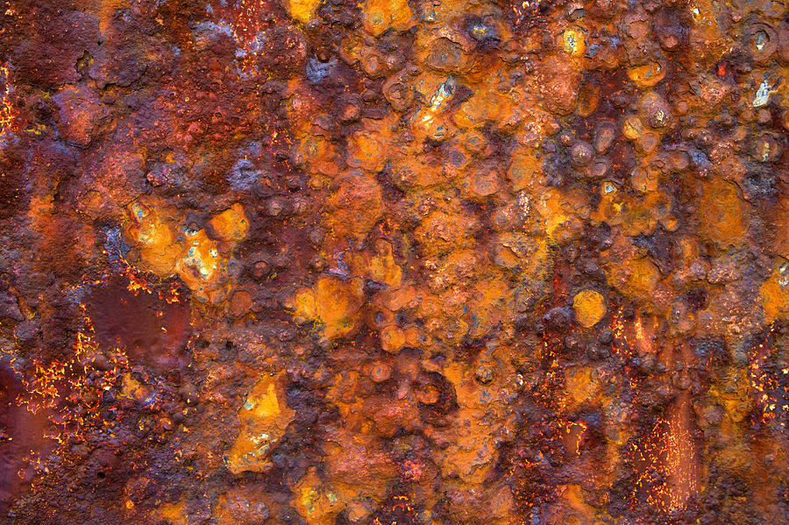
(Hare, 2019)
There are different types of corrosion such as pitting, crevice, intergranular, galvanic and uniform which are contingent on different environmental factors as explained further in this report.

Types of Corrosion

Pitting Corrosion
Pitting corrosion is one style of corrosion found in steel where ‘hemispherical and cup-shaped craters or cavities known as pits are composed in the steel. Pits both with their mouth open and uncovered or covered with partly porous membrane of corrosion products can be originated, as this type of attack can adopt a variety of shapes.’ (NACE International, n.d.) Figure 2 below provides a representation of the appearance of this pattern of holes, known as pitting, on steel.
Figure 2
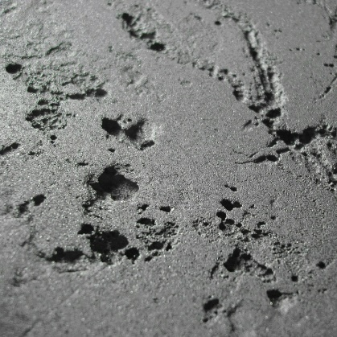
(Glister, 2019)
‘The detection, predication and design against this form of corrosion is challenging, causing damage to material that is more dangerous than any other. For example, a pit can be the cause to the breakdown of a whole engineering system even though it is only small, narrow and with minimal overall metal loss in comparison to other forms of corrosion.’ (NACE International, n.d.)
The chemistry behind the formation of pitting is explained via the below diagram (Figure 3), whereby the environment and material factors contribute to pit formation.

Figure 3
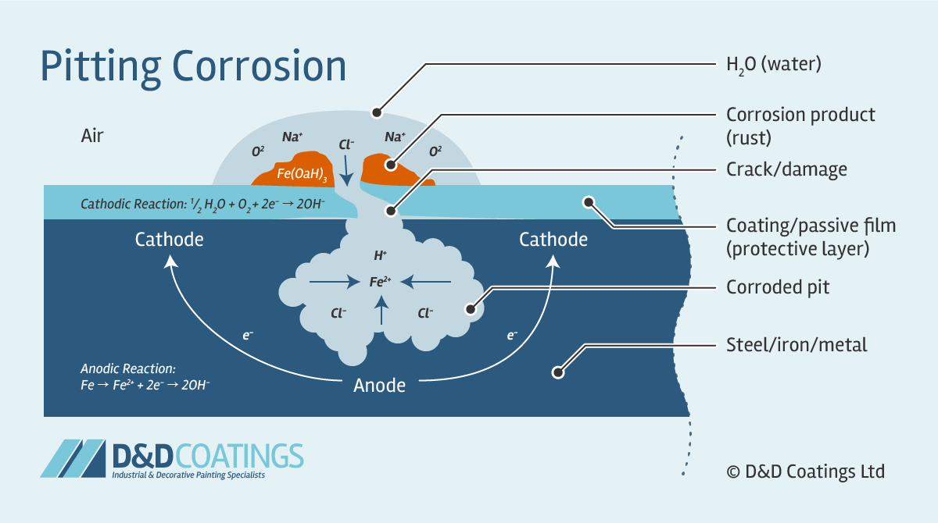
(D&D Coatings Ltd., 1997)
The diagram plays a part in portraying that when ‘high electron demand by the cathode; a ‘negatively charged electrolyte’ (Helmenstine, 2019) with a large surface area like the material coating is put on the smaller anode; a ‘positively charged electrolyte’ (Helmenstine, 2019) with only a small area such as the exposed metal, a pit, cavity or small hole will begin formation. This formation is subtle but will happen quickly with significant damaging effects; while only a small spot of rust is noticeable on the steel surface, further damage occurs deep in the metal structure below.’ (D&D Coatings Ltd., 1997)

Crevice Corrosion
Another form of corrosion is crevice corrosion. Here, ‘two closely adjoining surfaces form a crevice, inevitably gathering water which aids in corrosion formation.’ (Head of School of Materials Science and Engineering, 2013) . ‘The formation is like that of pitting corrosion, however the initiation and propagation of the attack is different, in that it is influenced by the geometric effects of the crevice.’ (Lyons, Plisga, & Lorenz, 2016) See figure 4 below for a visual representation of crevice corrosion on steel.
Figure 4
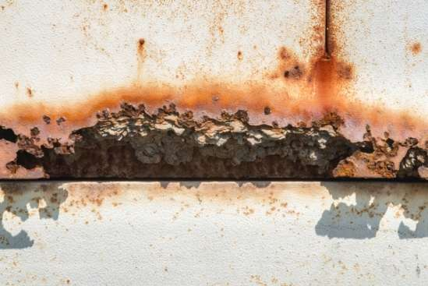
(Ferbabdez, 2017)
The main factor creating and accelerating this from of corrosion is the local environment. The below diagram (Figure 5) explains the process by ‘a de-passivation of the steel surface within the crevice due to a new environment with dissolved oxygen, pH decreases and enriched Chlorine ions. This makes the rate of reactions both inside and outside of the crevice equal, allowing corrosion inside the crevice to proceed intensively.’ (Hiromoto, 2019)

Figure 5
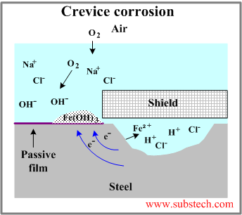
(Kopeliovich, 2012)

Intergranular Corrosion
‘Intergranular corrosion is an attack on the boundaries of grains that make up the alloys of steel.’ (Steelfab, 2017) Unlike pitting corrosion for example whereby the reaction takes place on the surface of the material, the grains of material here are more susceptible to corrosion than their insides. ‘The attack is caused by local changes in configuration; an anodic condition is created when an element impervious to corrosion in a crystallite is lost. From this, the occurrence of this form of erosion is made apparent along the affected boundary and has potential to accelerate corrosion rates by causing surrounding grains to also dislodge due to disintegration of the boundary.’ (Steelfab, 2017)
The below image (Figure 6) provides a visual of the effect of intergranular corrosion.
Figure 6
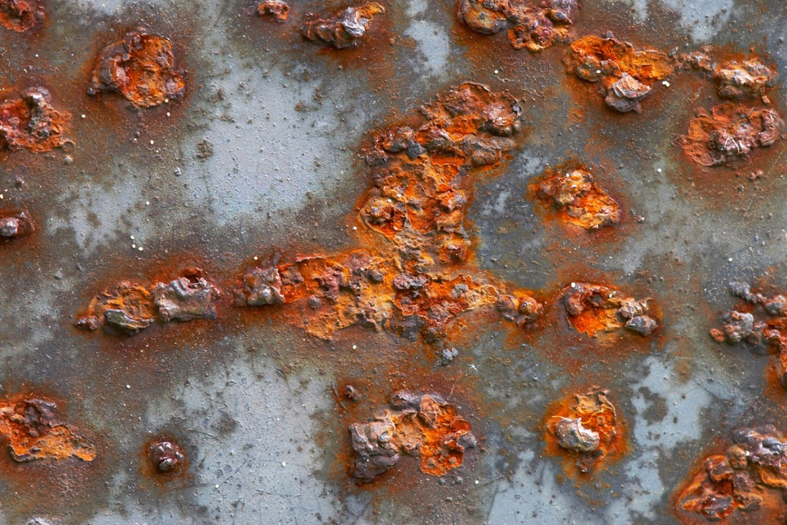
(Steelfab, 2017)

Galvanic Corrosion
‘When two different metals are in contact electrically within a common electrolyte, security is provided to the metal that is known to resist chemical action and therefore the more functioning metal tends to corrode at an accelerated rate. This is where galvanic corrosion occurs,’ (Corrosionpedia Inc, 2019) as shown in the image on and surrounding a screw head in figure 7.
‘There a few factors affecting the rate of galvanic corrosion, including the respective capacity of the anode, the type of metal i.e. steel, aluminum or iron for example, the ratio of surface area between positive and negative electrons, and the surrounding environmental conditions; temperature, humidity, salinity.’ (Palit, 2018)
Figure 7
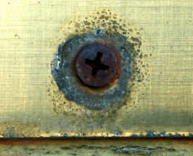
(NACE International, n.d.)

Uniform Corrosion
The final form of corrosion, seen as the most common, is uniform corrosion. ‘Uniform corrosion is distinguished when corrosion products evenly cover either a big percentage of an area or the whole surface area. It is known to usually take an effect on metallic exterior with a ‘uniform chemical composition’ (Affonso, 2006) and a microstructure with only a single access point to the corrosive solution. This type of corrosion is formed when material is in clear exposure to many different liquid solutions, the atmosphere and the soil.’ (Affonso, 2006)
Figure 8
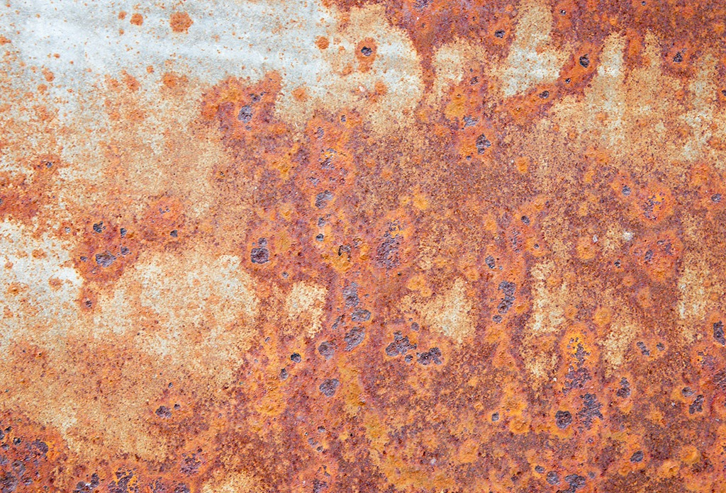
(Steelfab, 2017)

The cost of rust
To gain a further understanding on the corrosion of steel metal, data collection and analysis has been undertaken to provide evidence on the need for its prevention by using information on financial expenses.
Essentially, there is a large financial cost that comes with corrosion of steel material, with its slow paced and somewhat hidden process causing extensive damage to equipment, buildings and in the case of the steel manufacturing industry; the final product. This inevitably has a negative effect on profits and sales on a huge scale. Many studies have been done to investigate ‘the risk of rust’ (Digest, 2012) and put figures behind the problem, to enforce the size of the matter. ‘One American company carried out research and analysis on the problem of corrosion and calculated that combating the issue alongside the repairs and replacement of corroded machinery, equipment etc. totals a costly $279 billion per year.’ (Digest, 2012)
Looking more specifically at Tata Steel’s CRP Port Talbot, a huge financial cost can be accumulated here if rust becomes apparent. Material identified with rust is categorised as defective and any defective material must be marked with a diversion or rejection code (833 for rust) sending it for further checking on the inspection line, whereby a decision can be made after thorough checks to determine if the product is satisfactory for customers or not; some customers accept imperfections more than others.
The company figures for the cost of repairing defective (rust-prone), cold rolled and annealed material are displayed in the below table (Figure 9). Taking 18 ton as an average coil weight, this amasses to a hefty sum per coil, without considering the potential for damage to numerous coils; the trend usually seen with rust in the workplace is that with one corroded coil there comes a handful due to a local issue.
Figure 9
Method of repair | Cost per tonne | Cost per coil (avg. 18t)
Nonprime | £175 | £3,150
Re-application | £93 | £1,674
Rework/Repair | £11.03 | £199
Looking further into the problem of corrosion in Tata Steel, week 44, a week where rust on the temper mill seemed to be a problem; 5 coils were identified with rust spots and made ‘non-prime’ material. Taking information on these coils via a query on a work-based system (SQL), the appropriate data has been selected and presented below using Microsoft excel:

From this data, a sum of 54.38t of material was labelled non-prime for rust in week 44, accumulating a total cost of £9,516.50 as further displayed below.
Cost /t (Non-Prime) | Weight / coil (t)
£175 | 14.54
£175 | 10.14
£175 | 9.44
£175 | 10.38
£175 | 9.88
Total tonnage | 54.38
Total Cost | £9,516.50

Overall, the need for prevention here is clearly enforced by considering an example of a worsened case scenario; this level of corrosive material becoming apparent every week for a year, totalling a costly £494,858 for the organisation.

Conclusion
There are several different forms of steel corrosion; pitting, crevice, intergranular, galvanic, uniform. Each form has different contributing factors however all share a similarity in that an environment of oxygen, iron and moisture plays a huge role in the formation. Generally, no matter which type, corrosive surfaces can be identified by appearance.
This report, alongside many other investigations conducted across several nations has concluded that it is evident that the cost of corrosion on steel is completely extortionate and therefore there is a tremendous need for sustainable methods of corrosion prevention and mitigation to be implemented in companies worldwide. In Tata Steel, a colossal financial cost of near to £500,000 per annum has been estimated to deal with the company’s current rust issue if it is to continue in the way it does currently. This financial waste in the form of defects; ‘a product or service failure to meet customer expectations’ (Skhmot, 2017) clearly identifies the immense need for improvement on the subject.

Recommendations
An extension on this investigation would regard researching into methods of prevention for each type of corrosion and using root cause analysis to draw a conclusion on the best preventive method. To further this, the mechanism of avoidance can be implemented in a company like Tata Steel where data is recorded before and after implementation so that a comparison can be made to check how preventative it has been. In doing this, financial figures can be tracked, and the company should begin to see a loss in cash-outflow from the improvements in the corrosion sector.

Bibliography

Affonso, L. O. (2006). Machinery Failure Analysis. Elsevier.
Capital Steel & Wire Inc. (n.d.). News. Retrieved from Capitalsteel.net: https://www.capitalsteel.net/news/blog/why-does-steel-rust-plus-other-steel-rusting-questions-answered
Corrosionpedia Inc. (2019). Galvanic Corrosion. Retrieved from Corrosionpedia: https://www.corrosionpedia.com/definition/568/galvanic-corrosion
Corrosionpedia Inc. (2019). Type of Corrosion. Retrieved from Corrosionpedia: https://www.corrosionpedia.com/definition/217/steel-corrosion
D&D Coatings Ltd. (1997). Retrieved from D & D Coatings: https://www.ddcoatings.co.uk/2276/what-is-pitting-corrosion
Digest, D. (2012). The financial cost of rust and corrosion. Retrieved from Domson Engineering and Inspection Ltd.: https://domson.ca/cost-rust-corrosion/
Duret-Thual, C. (2014). Understanding Biocorrosion. Elsevier.
Ferbabdez, S. (2017). Chemistry. Retrieved from Phy Org: https://phys.org/news/2017-09-nanoscale-glimpse-crevice-pitting-corrosion.html
Glister, P. (2019, August). Retrieved from Abfad: https://www.abfad.co.uk/editorial/pitting-corrosion-and-storage-tank-failure/
Hare, D. (2019). Rust photographs. Retrieved from Fineartamerica: https://fineartamerica.com/featured/heavy-rust-tuxtures-73-david-hare.html
Head of School of Materials Science and Engineering. (2013). 5; Crevice Corrosion. Retrieved from UNSW Sydney: http://www.materials.unsw.edu.au/tutorials/online-tutorials/5-crevice-corrosion
Helmenstine, A. M. (2019). How to define anode and cathode. Retrieved from ThoughtCo: https://www.thoughtco.com/how-to-define-anode-and-cathode-606452
Hiromoto, S. (2019). Metals for Biomedical Devices (Second Edition). Elsevier.
Kopeliovich, D. D. (2012). Materials Engineering. Retrieved from SubsTech Substances & Technologies: http://www.substech.com/dokuwiki/doku.php?id=crevice_corrosion
Lyons, W. C., Plisga, G. J., & Lorenz, M. D. (2016). Standard handbook for petroleum and natural gas engineering (Third edition). Elsevier.
NACE International. (n.d.). Corrosion Basics. Retrieved from NACE International: https://www.nace.org/resources/general-resources/corrosion-basics/group-1/pitting-corrosion
NACE International. (n.d.). Galvanic Corrosion. Retrieved from NACE International: https://www.nace.org/resources/general-resources/corrosion-basics/group-1/galvanic-corrosion
Ochremedia. (2019). The Top 10 Largest Steel Producing Compaines in the World. Retrieved from SteelTechnology.com: https://www.steel-technology.com/articles/steel-producing-companies-of-the-world
Palit, S. (2018). Direct Synthesis of metal Complexes. Elsevier.
Shi, C., Gong, Y., Yang, Z.-G., & Tong, Q. (2019). Engineering Fracture Mechanics. Elsevier.
Skhmot, N. (2017). The 8 Wastes of Lean. Retrieved from The Lean Way: https://theleanway.net/The-8-Wastes-of-Lean
Steelfab. (2017). A guide to Intergranular corrosion & how to treat it. Retrieved from Steel fabrication Services: https://steelfabservices.com.au/a-guide-to-intergranular-corrosion-how-to-treat-it/
Steelfab. (2017). Uniform Attack Corrosion: Watch Rust Forming on a Piece of Steel. Retrieved from Steel Fabrication Services: https://steelfabservices.com.au/uniform-attack-corrosion-watch-rust-forming-on-a-piece-of-steel/
Tata Steel. (2019). About Us: At a glance. Retrieved from Tatasteeleurope.com: https://www.tatasteeleurope.com/en/about%E2%80%93us/at-a-glance
TataSteel. (2019). About us: Heritage. Retrieved from Tatasteeleurope.com: https://www.tatasteeleurope.com/en/about%E2%80%93us/heritage
Tiwari, A., Rawlins, J., & Hihara, L. H. (2014). Intelligent Coatings for Corrosion Control. Elsevier.
Wright, J. (2019). Inhibiting Rust and Corrosion to Prevent Machine Failures . Machinery Lubrication. Retrieved from https://www.machinerylubrication.com/Read/29116/inhibiting-rust-corrosion

