Organisational Audit of Hilton Hotel Group

Hilton Hotel Group Report

Tika Devi Dhimal
2013579
Organisational Audit of Hilton Hotel Group

Management & Organisational Behaviour (BMIH5004)

6th July, 2022

CONTENTS
- Executive summary
- Introduction
- Organization Structure
- Culture
- Goals
- Recent Changes and initiatives
- The impact of recent events and how the situations were managed
- Strategic decisions and current business performances
- Conclusions
- references

Executive summary:

Hilton Hotel Group is a multinational hospitality company that has been managing, financing, and developing many major hotels and brands all over the world. Conrad Hilton launched the corporation on May 31, 1919. Hilton's present president and Chief executive officer is Christopher J. Nassetta. Hilton hotels have become successful through various initiatives, strategies and through tackling adversities, like the global pandemic, COVID 19 in clever ways and even turning them into positive results for the marketing and growth of their business. This report will look into their structures of work, management, strategies and ways in which they faced global issues that affected each and every business in the world, including the hospitality industry which Hilton Hotel Group is a big part of.

INTRODUCTION:
And since Dec 31, 2020, Hilton was one of the world's biggest hotel enterprises, with 6,478 hotels totaling 1,019,287 accommodations in 119 countries or regions. Hilton has been an industrial innovation for more than century, motivated by its founder Conrad Hilton's mission to "spread the planet with warmth and comfort of hospitality." The premium trademark collection comprises of the premium and luxury hotel brands, as well as the full-professional service hotel brands.Hilton have over 112 million registered users in our award-winning guest rewards program, Hilton Honors, as of December 31, 2020.

ORGANIZATIONAL STRUCTURE:
The structure of the organization of Hilton is best defined as segmental. This is due to the fact that Hilton's C-suite is in charge of handling a wide array of different units and departments in various parts of the globe. In addition to that, Hilton Hotel Group divides its business into three sectors and hence three primary operations. The three sectors are as follows:
- Ownership: These are the properties that are owned by Hilton directly
- Management and Franchise: The properties that are managed by Hilton or franchised to others
- Timeshare: These are the Hilton timeshare properties (mainly vacation properties)
Hilton Hotels and Resorts leads the first two components, Management and Ownership and Finance. Hilton Grand Vacations, a distinct corporation since 2008, manages the timeshare. This restructure of separate Hlton's timeshare occurred during the administration of CEO Christopher J. Nassetta. This happened immediately after he took charge in 2007. During that time, he also implemented a number of changes, including the gradual restructuring of senior management, increased interaction ,communication between Hilton Hotels and specific business units, relocating the main office, enhancing organizational culture to promote more unity, and increasing the speed of decision-making at all levels of the work.
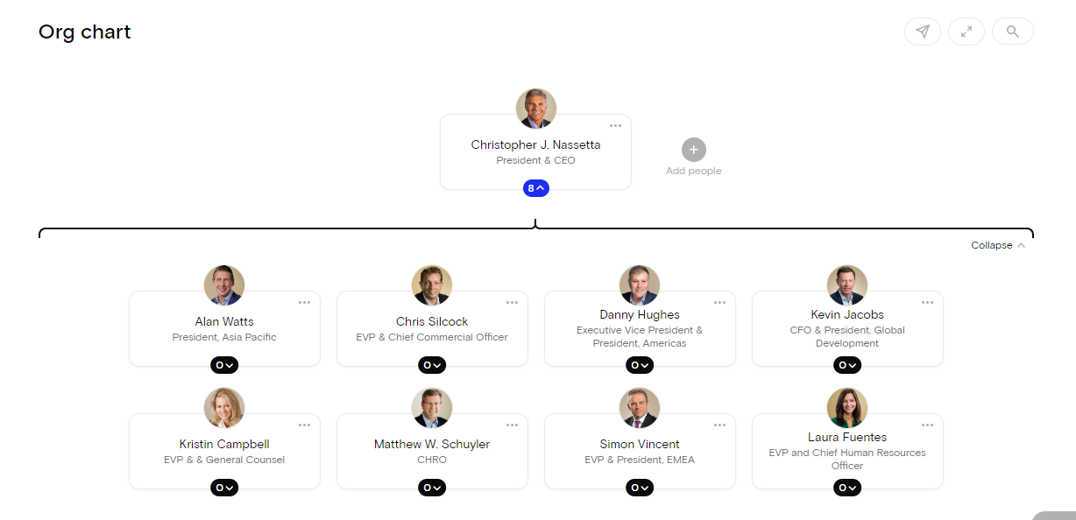
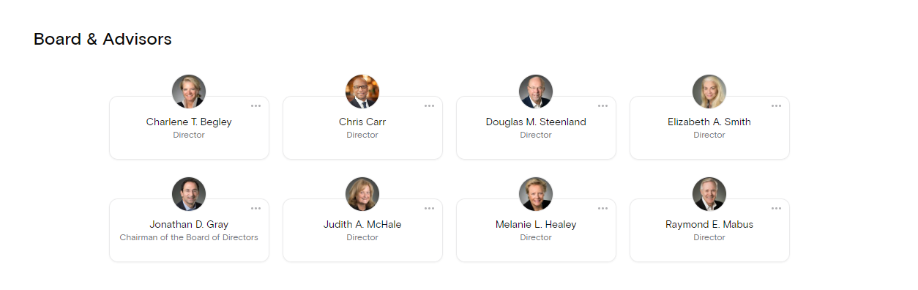

CULTURE:
Hilton Hotels Group follow a culture of great hospitality, employee support, and providing jobs and making careers to people in new ways. Hilton Hotels have been a part of the hospitality industry for over a century and in that time, they have served over 3 billion guests, and maintained their status of trust and exceptional service through unmatched standard of quality of their properties and service. Employees at Hilton have communicated that they enjoy their work because of their colleagues, the opportunity to grow their careers, a connection between them and their guests, and several other benefits and facilities. Hilton has made it a part of their culture to integrate a good working environment for its employees.
Hilton’s culture is about embracing and integrating diversity of the nature of all their guests, and the unique voice, perspectives, and opinions of their employees, partners and owners. Diversity and talent management is a core part of the culture at Hilton and they promised that it will continue on for the foreseeable future.

GOALS:
Hilton hotels have made it their goal to redefine and advance successful travel globally. For this, they have tried to improve their social impact, and have tried to reduce their environmental effect significantly by 2030. Their 2030 goals align with the United Nation's Sustainable Development Goals (SDGs). For goals in relation to the environmental effect, they have identified the following as important pillars to build a strategy around: carbon usage reduction, cut water use, and cut the waste by half within 2030. Hilton also has many goals in relation to providing job opportunities and building relationships with the public and other companies. Creating learning and growth opportunities, impacting the community members in a meaningful way, promoting responsible inclusive conduct, public affairs, partnerships, and policies and reporting are a to name a few key points.

RECENT CHANGES AND INITIATIVES:

One of the biggest impact a recent event has had on Hilton and all other companies, especially in the hospitality industry is covid 19. However, Hilton have managed to face it in a very clever way, by changing and implementing new strategies and facilities, and from the situation itself, they have managed to find ways by which they could provide new working opportunities to the people. During the pandemic, the travel and tourism sector took a massive hit and the numbers dropped for every single hotel, resorts and vacation sites throughout the hospitality industry and Hilton was not a stranger to this unfortunate situation. In addition to that, they had to maintain all the government rules and restrictions like, wearing masks, cleaning the floor constantly, providing ample ventilation, making sure that guests are not affected with covid, and many more. A lot of people were hesitant to travel and live in hotels, and these rules and restrictions complicated the process even more. However, in the midst of all these barriers and complications, Hilton have survived and done well in many areas.

THE IMPACT OF RECENT EVENTS AND HOW THE SITUATIONS WERE MANAGED

Hilton have introduced several facilities, like covid testing, working from home, “CleanStay”, and have donated huge sums to money to the front-line workers during the pandemic period. This also generated a lot of publicity and helped in the already well-established branding and marketing of Hilton Hotel Group. 3 Hotels have helped massively during the pandemic period for the hospitality group – Hilton Garden Inn in South Africa, Tru by Hilton Savannah Airport, and Hilton Garden Inn in China are all locations. As previously stated, Hilton collaborated with RB, the producer of Lysol and Dettol, to create "Hilton CleanStay" and "Hilton EventReady" for client hygiene and cleanliness throughout the pandemic time. They also sought advice from the Mayo Clinic. In addition, they have developed "Workspaces by Hilton" in the United States, United Kingdom, and Canada, which enable alternate working possibilities. Prior to the epidemic, most hotels had daily housekeeping. However, Hilton has decided to discontinue its automated daily housekeeping services. Instead, the corporation will only provide the service to visitors upon demand. In addition, Hilton has established its team member assistance program to help Hilton team members affected by Covid. In addition, they have established a new Hilton Alumni Network platform that provides access to relevant job prospects, services, news, and statistics.

Hilton have done all they could to tackle the horrible situation created by the global pandemic. They have followed the government rules and restrictions and along with that, they have launched their own cleanliness and hygiene programs to make their hotels and resorts a safe place for the guests. They have provided alternative working options for their employees, launched several programs to help frontline workers and the employees who are suffering to help everyone financially. Overall, they have done a great job facing the global pandemic that provided a massive threat to all business corporations, especially the hospitality industry, and have come out now standing in good stead.

STRATEGIC DECISIONS AND CURRENT BUSINESS PERFORMANCES

In addition to all these problems caused by the pandemic, Hilton needs to face competition from some other giants of the hospitality industry, such as, Hyatt, Marriot, and Intercontinental Hotel Group (IHG). Hilton needs to find their own clever strategies to battle with these tough competitors. In terms of strategies, Hilton Hotel Group uses both enterprise marketing and individual brand marketing strategies. The enterprise marketing strategy speaks with a wider population of consumers who buy the portfolio of 18 globally recognized brands across over a hundred countries, while the individual brand marketing strategy involves brand campaigns consulting and surveying the feedback of customers on particular consumer targets about individual brands. Although there are several properties and brands under Hilton Hotel Group, they keep each project unique and true to itself by communicating and knowing the specific consumer designs, needs and specific targets. As Hilton Hotel Group is a multinational company, they launch campaigns that takes into consideration, the needs and objectives of their customers across a variety of nations that differ in culture and traditions., further making their brands unique and satisfactory to the consumers across every part of the globe. It’s safe to say that Hilton’s marketing strategy is a reliable method for such a company which is competing with others at the highest level. Throughout the years, these strategies have come out to be proven ones for Hilton Hotel Group.

CONCLUSION:
In conclusion, Hilton Hotel Group have become one of the giants of the hospitality industry through clever decision making and strategies. It is clearly seen once you look at their statistical data and even the numbers during the covid 19 period, which surprisingly show that compared to many other hotel groups or companies, they have done a fair job in surviving and doing relatively well in one of the most challenging events in the history of the world. Here are some of the statistics to conclude the report.
In 2021, Hilton Hotel Group made around 5.79 billion US dollars in sales, up from 4.31 billion the previous year. The total income decrease, as compared to former years, is a result of covid 19, which has had a substantial impact on the hotel, travel, and tourist sectors. In 2021, Hilton had a gross revenue of 407 million US dollars. In 2021, they had an estimated average day to day fee of 128.82 US dollars. In 2021, this amount increased from the previous year's rate of 114.03 US dollars, with a revenue per occupancy rates (RevPAR) of 73.65 US dollars. This statistic represents a 60.4 percent rise over the previous year's RevPAR of 46 US dollars.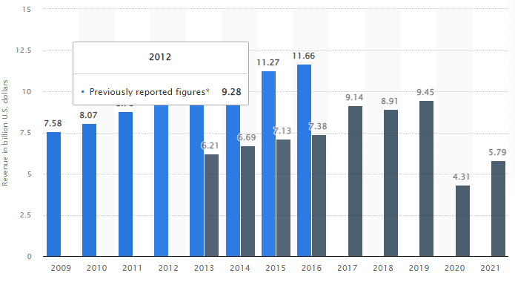
Fig: Revenue of Hilton Worldwide Holdings from 2009 to 2021(in billion U.S. dollars)

References
Heath, T. (2014) “Christopher Nassetta: The man who turned around Hilton” The Washington Post, Available at: https://www.washingtonpost.com/business/capitalbusiness/christopher-nassetta-the-man-who-turned-around-hilton/2014/07/03/43071478-fd5a-11e3-932c-0a55b81f48ce_story.html
Annual Report (2015) Hilton Worldwide
Dudovskiy, 2016, “Hilton Organizational Structure”, Available at: https://research-methodology.net/hilton-organizational-structure/
Organimi, “Hilton’s Organizational Structure”, Available at: https://www.organimi.com/organizational-structures/hilton/#:~:text=The%20first%20two%20divisions%20%E2%80%93%20ownership,publicly%20traded%20company%20in%202008.
The org, “Hilton Worldwide”, Available at: https://theorg.com/org/hilton-worldwide/org-chart
Hilton, “Our Culture”, Available at: https://jobs.hilton.com/us/en/culture#:~:text=We%20are%20diverse%20by%20nature,and%20inclusive%20environment%20for%20all.
Careerbliss, 2021, “CareerBliss on Culture: Hilton Worldwide Has Culture of Hospitality”, Available at: https://www.careerbliss.com/blog/careerbliss-on-culture-hilton-worldwide-has-culture-of-hospitality/
Lambrano, 2020, “A Brief History of the Corporate Culture Transformation at Hilton”, Available at: https://www.linkedin.com/pulse/brief-history-corporate-culture-transformation-hilton-lambrano-ms-1e
Lamo, 2019, “The Center of Success: A Case Study on Hilton’s Company Culture”, Available at: https://digitalcommons.calpoly.edu/cgi/viewcontent.cgi?article=1002&context=expindsp
Stravelandtourism, “The Hilton Hotel”, Available at: http://stravelandtourism.weebly.com/the-hilton-hotel.html
Hilton, “Our Journey Towards 2030”, Available at: https://esg.hilton.com/toward2030/
Hilton, “Our Approach”, Available at: https://esg.hilton.com/our-approach/#:~:text=Travel%20with%20Purpose%20is%20Hilton's,our%20environmental%20impact%20by%202030.
(2021). Hospitality industry and Covid-19. Available at: https://commonslibrary.parliament.uk/research-briefings/cbp-9111/
David Yechiam Aharon. (2021). COVID-19, government measures and hospitality industry performance. Available at: https://journals.plos.org/plosone/article?id=10.1371/journal.pone.0255819
Hilton. (2021). What to Expect During Your Stay. Available at: https://www.hilton.com/en/p/what-to-expect/
Hilton. (2021). CleanStay. Available at: https://www.hilton.com/en/corporate/cleanstay/
Hilton, 2021, “Hilton Global Trends Report Unpacks Surprising Ways the Pandemic Changed People, Profiles Expected 2022 Traveler Passions”, Available at: https://stories.hilton.com/releases/hilton-global-trends-report-on-2022-travel-change
Coleman, 2021, “Hilton Is Getting Rid of This at Its Hotels Nationwide as of This Week”, Available at: https://www.yahoo.com/lifestyle/hilton-getting-rid-hotels-nationwide-210957669.html?guccounter=1&guce_referrer=aHR0cHM6Ly93d3cuZ29vZ2xlLmNvbS8&guce_referrer_sig=AQAAAC9eH7zJX0NIRRAKxlSa6LrgKrccUdLqTY7KYjQBlK_C8JBFUzBdD0weXp7ESd1odzk-L6PGkJNLBducJzUd1YK_PJIW20cc4cyZxT1nGMFUlydHIPQ5taUdLegXY6cE7yt91qjix72XXApqT-sRBAah8MxEBexTYSXBjbC9bKll
Lane, 2021, “New Hilton Report: The Pandemic Changed Travel Trends, And People”, Available at: https://www.forbes.com/sites/lealane/2021/11/04/new-hilton-report-the-pandemic-changed-travel-trends-and-people/?sh=6afb3f4f36d2
2022, “Hilton Celebrates Growth and Development Milestones as Company Prepares for a New, Reinvigorated Era of Travel”, Available at: https://finance.yahoo.com/news/hilton-celebrates-growth-development-milestones-130000825.html
Grano, 2021, “Social Spotlight: Hilton’s pandemic strategy proves the business value of social”, Available at: https://sproutsocial.com/insights/social-spotlight-hilton/
Sanchez, 2019, “How Hilton's Growth Strategy Is Delivering Strong Results”, Available at: https://www.nasdaq.com/articles/how-hiltons-growth-strategy-is-delivering-strong-results-2019-11-29
Dudovskiy, 2016, “Hilton Hotels Business Strategy and Competitive Advantage”, Available at: https://research-methodology.net/hilton-hotels-business-strategy-and-competitive-advantage/
S. Lock, 2022, “Hilton Worldwide Holdings - statistics & facts”, Available at: https://www.statista.com/topics/1880/hilton-worldwide/#topicHeader__wrapper

