
Operating systems:
Computer Architecture and Operating Systems.

May 26, 2021
Scott davison / 152891
HND Year 1

Table of Contents: Page Number:
1.1– Introduction: 1
2.1– Key Functions Of General Operating Systems: 1
3.1– Use Of CLI Commands In A Windows OS: 2
3.2– Use Of Batch Scripts In A Windows OS: 6
4.1– Use Of CLI Commands In A Linux OS: 11
4.2– Use Of Bash Scripts In A Linux OS: 14
5.1– Conclusion: 15
6.1– Reference List: 16

1.1– Introduction:
In this written report, the author will be talking about the key and common functions of modern operating systems, the use of command line interface commands on Windows and Linux, the use of batch scripts on Windows and the use of bash scripts on Linux. The author will be using Windows 10 and Kali Linux to demonstrate the use of command line interface commands and batch/bash scripts.

2.1– Key Functions Of General Operating Systems:
There are many different types of operating systems that are available for use. Most computers already have an operating system pre-loaded on them but sometimes (especially when building your own computer) you will have to manually put an operating system on there. You can install an operating system by USB drive or a disk. The most common operating systems used by many are Windows, Mac, and Linux.
According to [1], “An operating system (OS) exploits the hardware resources of one or more processors to provide a set of services to system users. The OS also manages secondary memory and I/O (input/output) devices on behalf of its users.” An operating system has several key functions; the three main functions are managing the computers resources, providing a user interface, and executing instructions for applications and services. The operating system looks basic but there is much more necessary work taking place behind the scenes that the user cannot see. As it says in [2], “a computer consists of processor, memory and I/O components with one or more modules of each type.” Operating systems allow users to run several programs at once, it uses something called scheduling to do so. As seen in [3], “The OS decides the best way to swap between running, runnable and waiting processes. It controls which process is being executed by the CPU at any point in time, and shares access to the CPU between processes.”
As said above, the operating system provides a graphical user interface which is an essential part of the operating system because it allows the user to interact with programs and other icons easily by simply clicking on the icons. Graphical user interfaces are useful for both uneducated and educated users but mostly uneducated users because graphical user interfaces make the computer more easier to use.
Operating systems can be useful for other things such as error detection and security. The operating system will monitor the overall health of your computer and can tell the user when an error is present and can sometimes advise the user on how to fix the error. The operating system also provides users with a file management system, in which users can view different directories that contain their files. The user can also manipulate the file system by adding new files, deleting files, and renaming files thanks to the operating system. As it says in [4], “Your operating system controls the actual physical operation of these storage devices”.
The operating system is also responsible for things such as resource allocation. The operating system allocates resources for programs when they need them, and de-allocates resources whenever a program is terminated. The de-allocated resources will be allocated to different running programs. Operating systems also handles device management. Operating systems also come with a command line interface which allows you to enter commands that can perform the same tasks as a graphical user interface.

3.1– Use Of CLI Commands In A Windows OS:
According to [5], “The Command Prompt is a program included with all versions of Windows. It is located in the Accessories folder within the Programs folder. When launched, it provides a command line interface (CLI) to control the underpinnings of the Windows operating system.”
The author will demonstrate some of the most common command line interface commands. Most of these commands can be found on Microsoft’s Windows Commands pdf. [6]
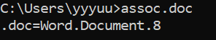
The first command the author has used on the CLI is “assoc”. This command displays what programs are assigned to open certain file types. Since the outputs for the command are too large for a single screenshot, the author used an example. The example command was still “assoc” but this time it was “assoc .doc”. This tells the author that .doc is a Word Document.
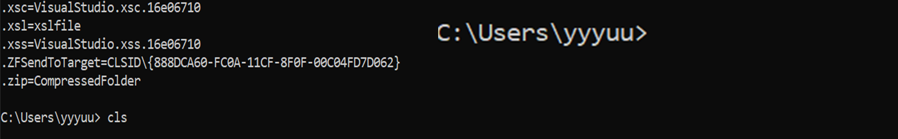
The second command the author has used is a very simple one, it clears the command line interface. The command is “cls”. The left side is before the “cls” command was used and the right side is after the “cls” command was used.
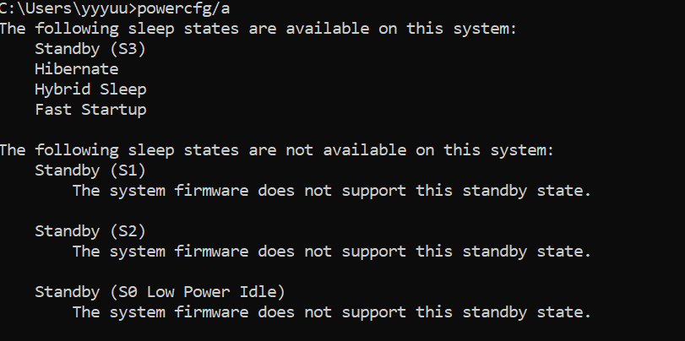
The third command the author has used is “powercfg/a”. This command can be used to show what sleep states are available on your system and what sleep states aren’t available on your system.

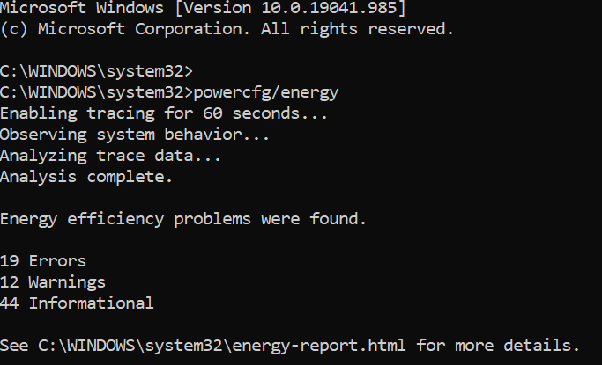
This command is similar to the last one but “powercfg/energy” gives you a report based on how energy efficient your computer system is.
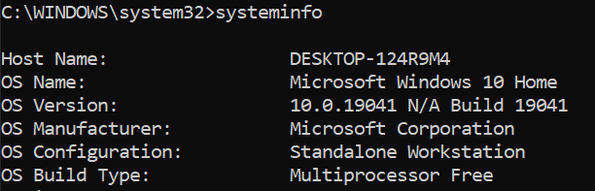
The next command the author has used is “systeminfo”. This command displays a lot of information about your computer system, it displays a lot more information (some of it is a bit confidential) and for that reason the image doesn’t show the entire system information.
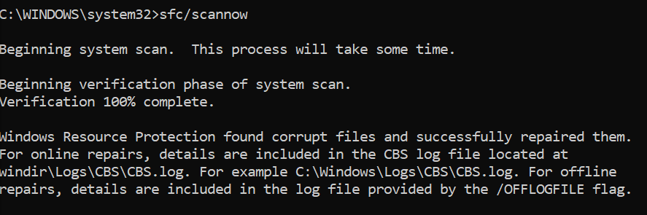
The next command the author used in the command line is “sfc/scannow”. This command is a system file checker. It scans and repairs any broken or missing system files by replacing them files with cached copies held by Windows especially for this.
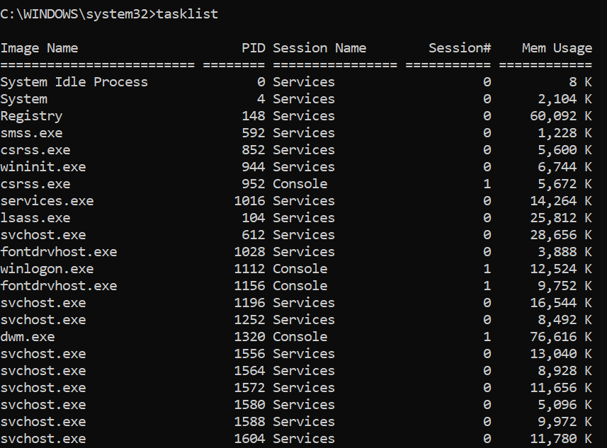
The penultimate command the author is demonstrating is “tasklist”. This shows a list of all the tasks currently running.
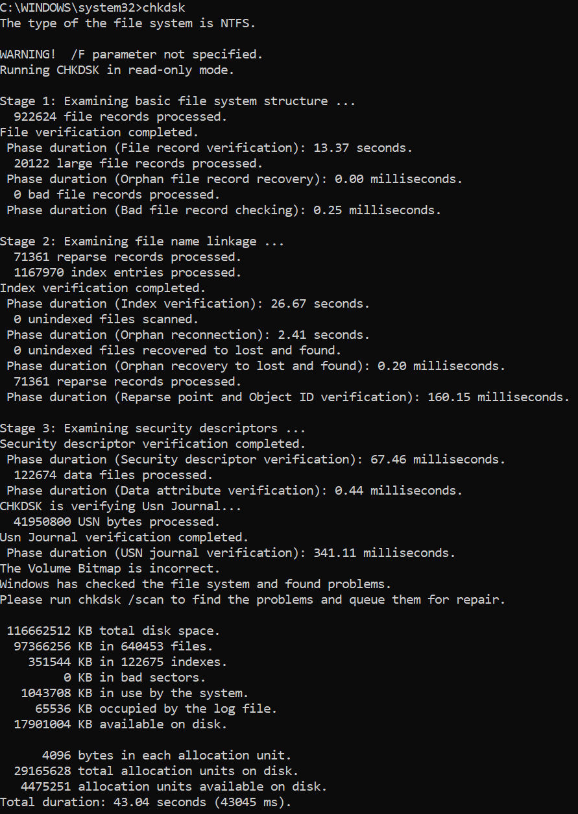
The final command the author has demonstrated on the command line interface is “chkdsk c:” This scans the drive for physical errors and bad sectors. You can use “chkdsk /f” to fix the bad sectors and physical errors.

3.2– Use Of Batch Scripts In A Windows OS:
A batch script is a file that contains commands in a text file. As [7] says, “A batch file is an unformatted text file that contains one or more commands and has a .bat or .cmd file name extension.” The batch scripts are executed in the command line by typing out the file name. The commands in the batch script will be executed in the order that they are written.
Batch scripts can also be used to help load programs and/or run several processes at one time. The author will demonstrate batch scripts that you can use with the command line to execute commands. As [8] says, “Cmd.exe runs the commands sequentially as they appear in the file”.
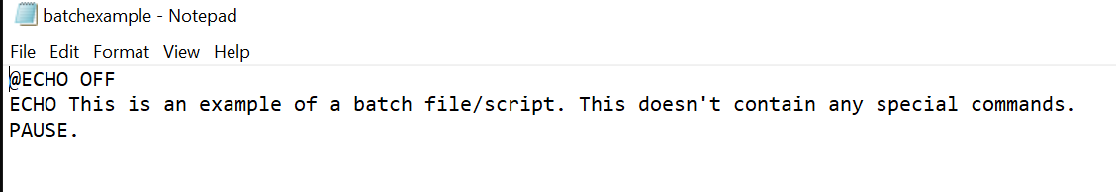
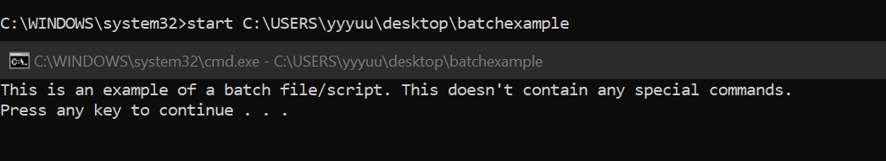
The first batch script the author has demonstrated was a batch script that the author created themselves. The batch script uses “@ECHO OFF”, “ECHO” and “PAUSE”. “@ECHO OFF” command starts the message on a new line, and it disables the display prompt. The “ECHO” command prints the text in the notepad in the command line. And the “PAUSE” command allows the command line window to stay open after the batch script has been executed. Without the “PAUSE” command, the command line window will close as soon as the batch script is executed.
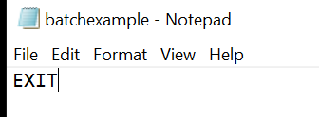
The second batch script the author has demonstrated was a batch script that the author created themselves. The batch script uses an “EXIT” command that simply closes the command line interface. The author can’t actually show the results because it closes the command line interface.
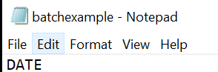
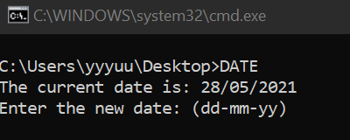
The third batch script the author has demonstrated was a batch script that the author created themselves. The batch script uses a “DATE” command that displays the system date.
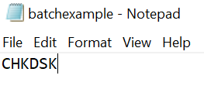
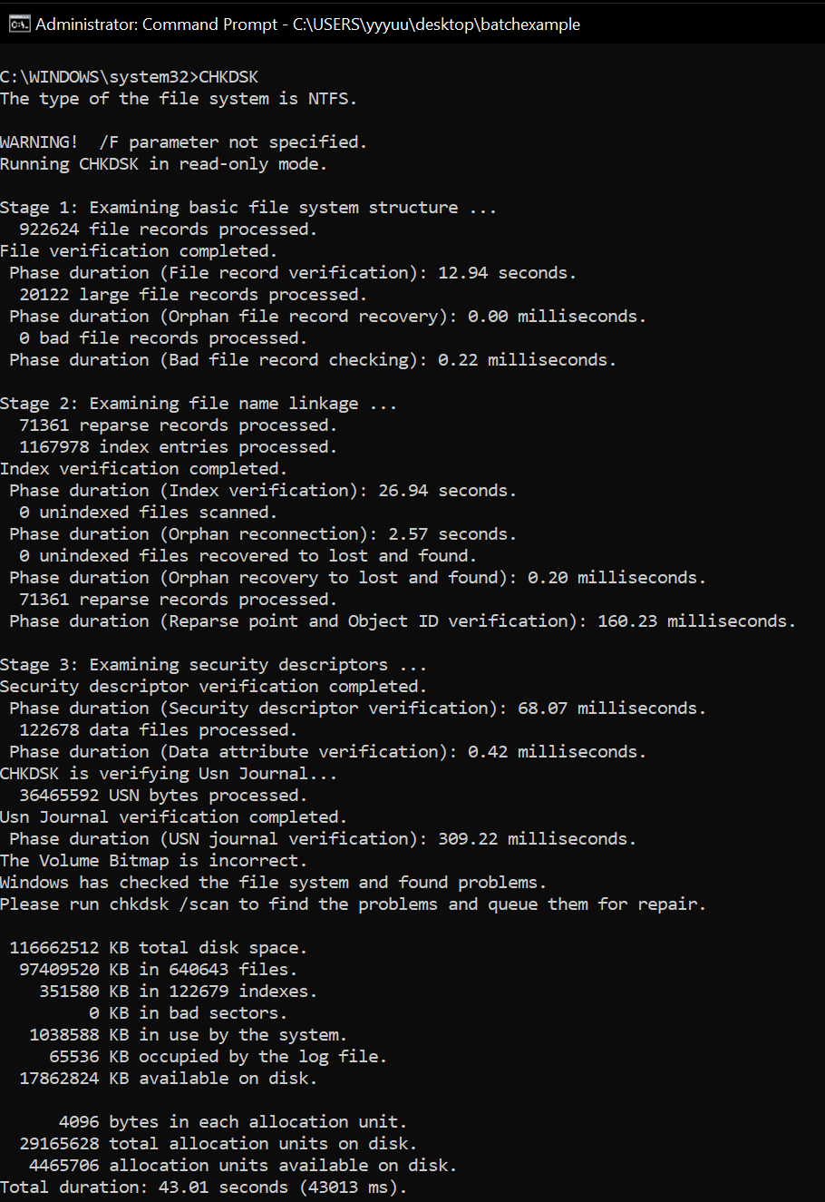
The penultimate batch script the author has demonstrated was a batch script that the author created themselves. The batch script uses a “CHKDSK” command which checks the disk for any errors or corruption.
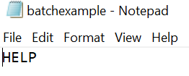
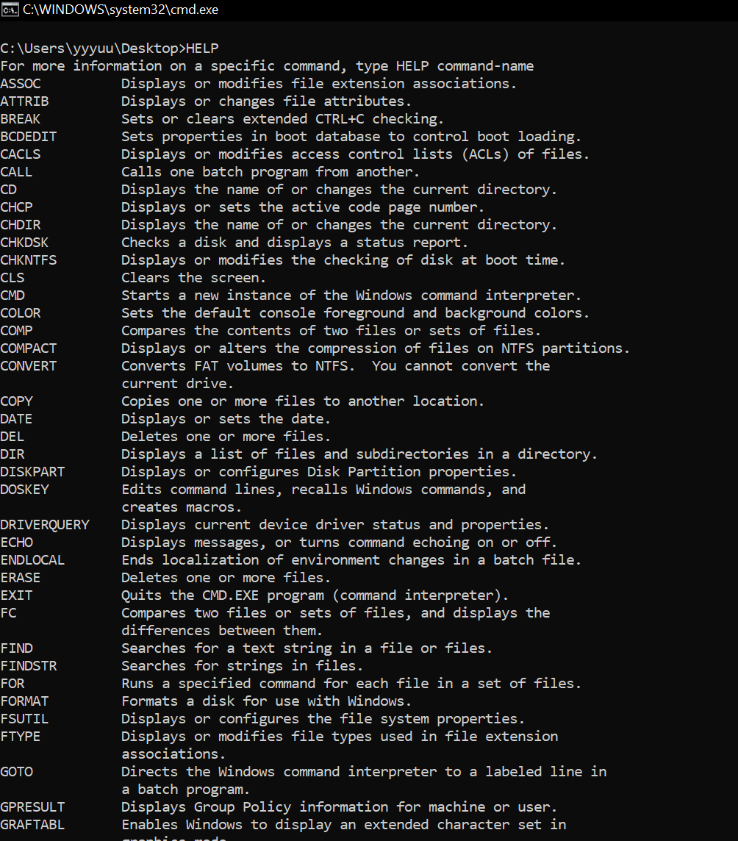
The last batch script the author has demonstrated uses a “HELP” command which shows a list of all of the Windows supplied commands available for use.

4.1– Use Of CLI Commands In A Linux OS:
As [9] says, “The shell is a program that takes keyboard commands and passes them to the operating system to carry out.” Kali Linux’s command line is known as a shell. Some commands on Kali Linux are very similar to commands on the Windows command line but others are different but do similar things. The author will demonstrate some of the most common command line interface commands on Kali Linux. The screenshots may be low quality, that is because the author took the pictures from their phone. A few of the commands used can be seen in [10].
To start with, this is what the Linux command line looks like when you launch it. As [11] shows, “I used CTRL + ALT + T”. That is the shortcut to open the Kali Linux command line.
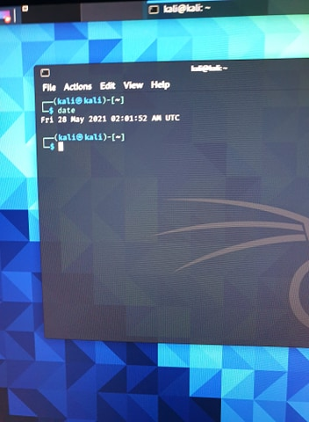
The first command the author used on the Kali Linux command line was “date”. This command was also used on the Windows command line and it displays both the date and time of the system.
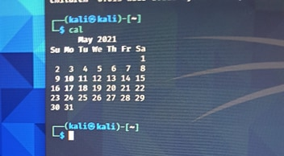
The second command the author used on the Kali Linux command line was “cal”. This command displays a calendar showing the month.
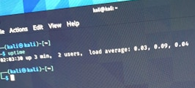
The third command the author used on the Kali Linux command line was “uptime”. This command shows the uptime of Kali Linux in that current session. It also displays how many users there are.
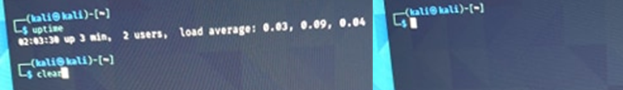
The fourth command the author used on the Kali Linux command line was “clear”. It clears all of the text in the command line. The left side shows the command being entered; the right side shows the command line after the “clear” command was executed.
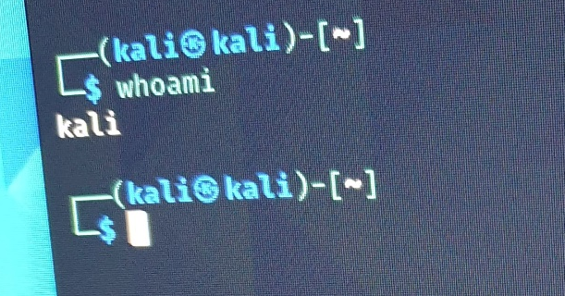
The fifth command the author used on the Kali Linux command line was “whoami”. This command display the current user’s username.
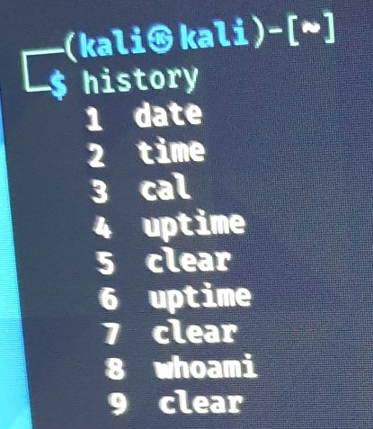
The next command the author used on the Kali Linux command line was “history”. This command shows the history of the user’s inputs.
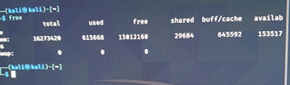
The penultimate command the author used on the Kali Linux command line was “free”. This command shows the memory being used and how much of the memory is free.
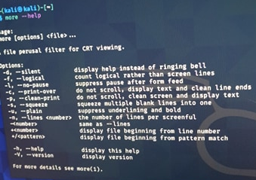
The last command the author used on the Kali Linux command line was “--help”. This command shows the user all the options they have for the command they have entered.

4.2– Use Of Bash Scripts In A Linux OS:
The author doesn’t have any screenshots of their own for the bash scripts on Kali Linux due to hardware problems, however some of the screenshots used were taken from a group exercise that the author took part in for their university course and the rest are taken from the Internet. According to [12], “A Bash script is a plain text file which contains a series of commands.” A bash script is basically the same as a batch script for the Windows command line. They both have commands written in a plain text file and they can both be used with their command lines. Both a batch script and a bash script are both executed from top to bottom.
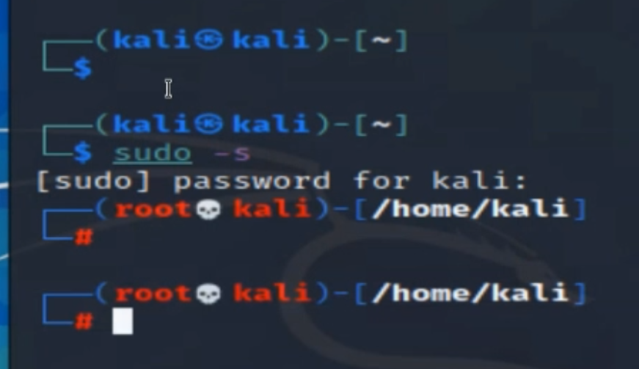
This bash script activates the administrator privileges for Kali Linux. The command was “sudo -s” and that was inputted into gedit and executed on the Kali Linux command line. As [13] says, “Text Editor (gedit) is the default GUI text editor in the Linux operating system.”
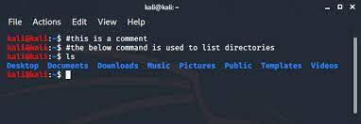
Everything in the Kali Linux command line was placed in there by a batch script. The batch script had commands such as “echo” to output the “this is a comment” text and the batch script included the “ls” command. The “ls” command lists all of the directories and if you specify a directory, it can show all of the files in that directory.
In order to create a bash script that can be useable in the Kali Linux command line, you need to use a text editor such as gedit or Notepad++ [14]. You would then enter several commands that you can use normally in the Kali Linux command line but some commands you use in bash script files, you wouldn’t normally use in the Kali Linux command line. You save the file containing the commands by using the .sh file extension and to execute it on the Kali Linux command line, you can either double click on the .sh file and it will launch on the Kali Linux command line, or you can go into the Kali Linux command line and put the directory the .sh file is saved in and choose to launch it from that directory.

5.1– Conclusion:
The author has talked about the key features of operating systems, shown the usage of commands on the Windows command line, shown the usage of batch scripts on the Windows command line, shown the usage of commands on the Kali Linux command line and shown the usage of bash scripts on the Kali Linux command line.
To summarise, the key functions of an operating system are managing the computer’s resources, providing a user interface and executing instructions for applications and services. The graphical user interface is an essential part of the operating system because it allows the user to launch programs and interact with the other icons easily by simply clicking on the icons displayed on the graphical user interface. The operating system allocates resources for programs when they need them, and de-allocates resources whenever a program is terminated. And lastly the operating system manages devices such as peripherals, printers and monitors. Command line commands are useful because they allow you to perform commands such as viewing errors on your storage devices, repairing the errors and launching programs. Bash/Batch scripts are not as useful as using the normal command line, but they can be used to input commands onto the command line from a .bat or .sh file.

6.1– Reference List:
[1] W. Stallings, (28th Feb 2011). “Operating Systems: Internals and Design Principles”. [Online]. Available:. [Accessed 27- May- 2021].
[2] W. Stallings, (28th Feb 2011). “Operating Systems: Internals and Design Principles”. [Online]. Available: https://repository.dinus.ac.id/docs/ajar/Operating_System.pdf. [Accessed 27- May- 2021].
[3] BBC, (2021). “Operating Systems: Managing the CPU”. [Online]. Available: https://www.bbc.co.uk/bitesize/guides/ztcdtfr/revision/3. [Accessed 27- May- 2021]
[4] R. Power and R. Ford, (2009). “Operating System Fundamentals”. [Online]. Available: https://www.researchgate.net/publication/339413127_Operating_System_Fundamentals. [Accessed 27- May- 2021].
[5] B. Lyons, (2017). “An Introduction to Using the Command Line Interface (CLI) to Work with Files and Directories”. [Online]. Available: https://www.weareavp.com/wp-content/uploads/2017/07/CLI_Windows_Tutorial.pdf. [Accessed 27- May- 2021].
[6] Microsoft. “Windows Commands”. [Online]. Available: https://download.microsoft.com/download/5/8/9/58911986-D4AD-4695-BF63-F734CD4DF8F2/ws-commands.pdf. [Accessed 27- May- 2021].
[7] riptutorial. “Learning batch-file”. [Online]. Available: https://riptutorial.com/Download/batch-file.pdf. [Accessed 27-May 2021].
[8] riptutorial. “Learning batch-file”. [Online]. Available: https://riptutorial.com/Download/batch-file.pdf. [Accessed 27-May- 2021].
[9] W.E. Shotts Jr. (2008). “The Linux Command Line Second Internet Edition”. [Online]. Available: https://wiki.lib.sun.ac.za/images/c/ca/TLCL-13.07.pdf. [Accessed 28- May- 2021]
[10] A. Khoo. “Linux Command Cheat Sheet”. [Online]. Available: https://www.loggly.com/wp-content/uploads/2015/05/Linux-Cheat-Sheet-Sponsored-By-Loggly.pdf. [Accessed 28- May- 2021].
[11] redhat. (19th Feb 2020). “How to open a Linux terminal window”. [Online]. Available: https://www.redhat.com/sysadmin/linux-terminal-window. [Accessed 28- May- 2021].
[12] ryanstutorials. “What is a Bash Script”. [Online]. Available: https://ryanstutorials.net/bash-scripting-tutorial/bash-script.php. [Accessed 28- May- 2021].
[13] ubuntu. (2017). “gedit”. [Online]. Available: https://help.ubuntu.com/community/gedit. [Accessed 28 – May- 2021].
[14] notepad++. “Notepad++ Downloads”. [Online]. Available: https://notepad-plus-plus.org/downloads/. [Accessed 28- May- 2021].

