Astra Kesans-Parkin
1704225

Assignment 2
Supporting Abilities and Behaviours
Table of Contents
1. Introduction 2
2. Main Body 3
The Setting 3
What is Challenging Behaviour? 3
Strategies to Manage Challenging Behaviour 5
Strategy in Placement 7
Evaluation of Strategies 9
Positive Environment 9
Clear Boundaries 10
Punishment 11
Physical Restraint 12
3. Recommendations 13
4. Conclusion 14
5. Reference List 15
6. Appendix 1 – Positive Behaviour Policy 17
7. Appendix 2 – Safeguarding Policy 21

Introduction
Research carried out by the Association of Teachers and Lecturers (2013) shows that out of 844 educational staff members, 54% believe that behaviour worsened between 2008-2013 with almost 90% of them confirming that they dealt with challenging behaviour in the school year 2012-2013, with this in mind, it is imperative that all schools have strategies in place to deal with this behaviour. This report will look at what challenging behaviour means and what falls under the category of challenging, it will look at what various strategies can be used to deal with challenging behaviour and how these are used in a local primary school setting as well as providing some recommendations on how the school could improve their management of behaviour.

Main Body

The Setting
The Swansea school is a mainstream primary school, which the Department for Education (DfE) (2015) explains is a maintained school that is not a special school, located within a residential area of Swansea. A report conducted by Estyn, Her Majesty’s Inspectorate for Education and Training in Wales (2017) shows that the school had 583 pupils between the ages of three and 11 attending at that time with various race, religions and abilities. The school has many teachers, teaching-assistants, lunch time assistants, volunteers, receptionists and administration staff working within it daily. The school also has its own special educational needs co-ordinator working within the building and various services such as speech and language therapists visit the school to provide extra help when required.

What is Challenging Behaviour?
Birkett (2007) suggests that there are many ways at looking at what is considered challenging behaviour as it varies depending on the age of the pupils and their capabilities, and stresses the importance of understanding the difference between troubled and troublesome children. Buchanan and Ritchie (2004) explains that a troubled child is one who may display disruptive behaviour due to an underlying condition such as attention deficit disorder, whereas a troublesome child is one who creates challenging behaviour through choice. While both troubled and troublesome children may show challenging behaviour, it is important to recognise why this is happening to determine the best course of action to take, for example a troubled child may need specialist help and a troublesome child could benefit from an Individual Education Plan (IEP). Kern et al (2018) explain that a school will draw up an IEP to create a plan of action which includes targets and strategies to help deal with any challenging behaviour.
Emerson (1995) explains that challenging behaviour is when intense and unusual behaviour is displayed frequently or if it can potentially cause harm to the person or others or when it impacts aspects of people’s lives. Scope (2018) agrees with this definition and suggests that it is not necessarily the behaviour that is challenging, however the impact of the behaviour that causes the challenges. Oxleas Community Learning Disability Teams (2012) splits challenging behaviour into four categories and these are shown in the table below, along with some examples.
Type of behaviour | Examples
Self-injurious | Scratching and head-banging.
Aggressive | Hitting, throwing and verbal abuse.
Stereotyped | Rocking and repetitive movements.
Non-person directed | Withdrawal, stealing, damage to property.

Birkett (2007) used a report produced by Ofsted (2005) to separate challenging behaviour into two categories: low-level disruption and high-level disruption. Some examples of these behaviours are outlined in the table below.
Low-level disruption | High-level disruption
Shouting in class | Throwing items.
Leaving class without permission | Verbally abusing the teacher.
Not handing in homework or completing work | Refusal to leave the room when asked.
Using a mobile phone in class | Hitting a teacher.
Refusing to work | Breaking or vandalising school property.

Research carried out by The University of Birmingham (2003) identified two types of behaviour found to be the most challenging, which were violence; including hitting and throwing objects and verbal aggression; including swearing, screaming and tantrums. Ofsted’s (2005) research discovered that the most common type of challenging behaviour is persistent and low-level disruption, while the occurrence of severe violence is rare.
The Swansea School (2016, a) has categorised relevant challenging behaviour into different levels of severity. Level one behaviour includes misbehaving in class, level two behaviour is such things like bullying, level three behaviour includes causing physical harm to a pupil, whilst serious assault or damage to property falls into level four (for a comprehensive list, please see appendix one).

Strategies to Manage Challenging Behaviour
Strategies used to manage challenging behaviour can be split into proactive and reactive strategies. Shepherd and Linn (2014) explain that the term proactive means doing something before a situation happens to try to prevent it or prepare for it, whereas the term reactive is dealing or reacting to a situation when it happens. A key factor in both proactive and reactive strategies for managing challenging behaviour is consistency. Rogers (2009) suggests that consistency is important when dealing with challenging behaviour, as it allows for children and staff to be clear what the boundaries are and to effectively reward good behaviour or punish bad behaviour the same way as other members of staff to avoid confusion.
The table below shows a list of many proactive and reactive strategies that are used to manage challenging behaviour.
Proactive Strategies | Reactive Strategies
Learn triggers that cause the behaviour, such as noise, to help prevent the behaviour arising. (S) | Distraction can be useful with low level challenging behaviour as it helps aim the pupils focus elsewhere. (S)
Ensuring the individual feels valued and listened to. (S) | Letter or phone call home to parents (M)
Staff appropriately supported and trained to prevent and handle challenging behaviour. (S) | Removal from the class room or event by a member of staff. (M)
Have a set of policies and procedures outlining how things are dealt with to ensure consistent and fair treatment. (S) | Punishment such as taking away points or loosing playtime. (M)
Create an Individual Education Plan (IEP) which will outline skills to be taught, any needs, success criteria, strategies and rewards.  (SCE) | Remind offender of the rules and give them a choice such as ‘You know you should be listening and not talking during story time, if I hear you talking again you will have to move’. (B)
Positive reinforcement is when a reward is given for an action that makes the individual want to do it again. (M) | Ignore the behaviour if appropriate and safe to do so. (B)
Having an effective routine can help minimise disruption to children which in some cases may help reduce behavioural outbursts. (M) | Broken record technique – keep repeating instruction without listening to child’s response. (B)
A seating plan is a practical way of minimising disruption as it allows the staff members to place talkative children away from each other. (B) | Exclusion is when a pupil has been removed from school and is unable to go back for a certain amount of days. (B)
A positive environment is essential to making pupils feel safe and happy. (B) | Use of physical restraint, such as holding a pupil back. (D)
Setting realistic expectations about behaviour based on child’s age-range to see if the behaviour being demonstrated is appropriate for their age. (E)
Clear set boundaries are important, so each pupil and staff member know what is expected of them. (E)
Reference key for table:
(S) = Scope (2018), (SCE) = Service Children's Education (2013), (M) = Mukherji, P. (2001),
(B) = Birkett, V. (2007), (E) = Emerson, E. and Einfeld, S. (2011) and (D) = DfE (2013).

Strategy in Placement
The Swansea School (2016, a) has many strategies in place which are outlined in their 'Positive Behaviour Education Policy' (for a comprehensive list see appendix one). The school’s main strategy is promoting positive behaviour and encouraging and developing the pupils, with the aim of minimising challenging behaviour. To do this the school provides a positive learning environment in which the pupils are praised for their efforts and rewarded with a point system, which Daly et al (2006) explains comes from Skinner’s theory of positive reinforcement. The school recognises the importance of having clear guidelines outlined in their policies to ensure that all staff are aware of how to deal with situations which aids in providing a consistent approach. The school will, if necessary, create an IEP for pupils with Special Educational Needs and pupils displaying challenging behaviour. Musser (2001) explains that the IEP should include clear strategies that should be used by all staff members to help the child improve and develop with a consistent approach. As previously explained, the school splits challenging behaviour into different levels of severity and with this the sanctions are also split up appropriately which can be seen in the table below.
Levels | Behaviour | Sanctions
One | - Misbehaving in class.  - Annoying class mates.  - Incidents in the playground. | - A discussion.  - A time out.  - Loss of points.
Two | - Offensive behaviour  - Bad language.  - Bullying.  - Persistent level One behaviour. | - Withdrawal of privileges.  - Apology.  - Loss of playtime.  - Reported to headteacher.
Three | - Swearing at pupils or staff.  - Causing physical injury.  - Damage to property.  - Persistent level Two behaviour. | - Parents contacted.  - Immediate referral to headteacher.  - Withdrawal from class/premises.  - Possible exclusion.
Four | - Serious physical assault.  - Threat of serious injury/damage | - Immediate exclusion and investigation.
In their ‘Safeguarding Policy’, The Swansea School (2016, b) clarifies that physical restraint is only to be used as a last resort and at the minimum needed for the situation and in line with the guidelines provided by the DfE (2013).

Evaluation of Strategies
This section will examine and evaluate two proactive and two reactive strategies used within the Swansea school to manage challenging behaviour.

Positive Environment
Dorman et al (2006) suggest that pupils who are educated in a positive environment learn more effectively, Bucholz and Sheffler (2009) and Young (2014) agree with this and suggest that this may be due to the pupils feeling safe and valued which can help increase pupil’s self-esteem and lowers the chances of challenging behaviour arising. Lewis (2009) agrees, however also points out that if the environment is not consistent or if the school does not receive required funding it may cause issues, therefore it is vital to recognise the importance that a positive environment has on the education and behaviour of children and the necessity of making it a priority.

Clear Boundaries
Mukherji (2001) explains that giving children clear boundaries is important for helping create a stable and secure environment for the child. Boundaries help children to identify how far they can go and help them to learn what is expected from them. Crowe (2010) explains that without clear communication and consistency from both staff and parents, this strategy may be difficult to introduce as the children may not respect it, although if staff and parents are able to work together this could be a successful strategy.

Punishment
Mukherji (2001) suggests that by punishing challenging behaviour it is less likely to happen again, Birkett (2007) agrees and adds that punishment gives teachers a tool to control their environment and may help develop respect from pupils if used appropriately as well as helping reinforce expectations to the child. Imary (2008) disagrees with both Mukerji (2001) and Birkett (2007) and argues that punishment is a negative action that it is based on fear and has the potential to lead to more extreme sanctions while also only providing a short-term fix and as it is a reaction it does not prevent the action from happening. Hayden (2007) observes that although punishment is a negative reaction it is sometimes needed if more positive strategies have not worked but should be used with care and consideration for the child involved.

Physical Restraint
Physical restraint with children is only to be used as a last resort explains the DfE (2013) and it can be used if trying to prevent harm to an individual such as breaking up a fight or preventing self-harm. Menon et al (2012) observe that physical restraint may cause harm if used incorrectly and some practitioners may use it when it is not necessary through intention or by accident. Restraining a person could also be a cause of embarrassment for that individual which could lower their self-esteem. Mind (2015) appreciates both views and emphasise that physical restraint should only be used if necessary and it should not cause any pain or distress to the individual.

Recommendations
- School to have a clear definition of what challenging behaviour means to them and ensure that all staff members are aware of this.
- Training to be given to all staff members on appropriate ways to implicate strategies and when they should be applied.
- Extra funding to help towards hiring more support staff and providing training.
- More research to be carried out by the government on how to prevent and manage challenging behaviour.

Conclusion
This report has determined what the term challenging behaviour means, and it has looked at many proactive and reactive strategies available to aid in the prevention and management of challenging behaviour. This report has also examined how a local school incorporates different strategies into their organisation. Four strategies used in the school have been evaluated and recommendations have been made based on the information throughout the report.

Reference List
Association of Teachers and Lecturers. (2013). Press Release. Retrieved 17/4/18, from Association of Teachers and Lecturers: https://www.atl.org.uk/Images/disruptive-behaviour-on-rise.pdf
Birkett, V. (2007). How to Manage and Teach Children with Challenging Behaviour. Cambridge: LDA.
Buchanan, A., & Ritchie, C. (2004). What Works for Troubled Children? Retrieved 1/5/18, from Barnardos: http://www.barnardos.org.uk/what_works_for_troubled_children__-_summary_1_.pdf
Bucholz, J. L., and Sheffler, J. L. (2009). Creating a Warm and Inclusive Classroom Environment: Planning for All Children to Feel Welcome. Electronic Journal for Inclusive Education, 2(4).
Crowe, C. (2010). Teaching Children with Challenging Behavior. Educational Leadership, 67(5), 65-67.
Daly, M., Byers, E., and Taylor, W. (2006). Understanding Early Years Theory in Practice. Harlow: Heinemann.
Department for Education. (2013). Use of Reasonable Force. Retrieved 13/4/18, from Department for Education: https://assets.publishing.service.gov.uk/government/uploads/system/uploads/attachment_data/file/444051/Use_of_reasonable_force_advice_Reviewed_July_2015.pdf
Department for Education. (2015). Mainstream Free Schools: Assessing the Need for a New School. Retrieved 2/4/18, from Gov.UK: https://www.gov.uk/government/publications/mainstream-free-schools-assessing-the-need-for-a-new-school
Dorman, J., Aldridge, J., and Fraser, B. (2006). Using Student Assessment of Classroom Environment to Develop a Typology of Secondary School Classrooms. International Educational Journal, 7(7), 906-615.
Emerson, E. (1995). The Form and Function of Challenging Behaviours. Journal of Intellectual Disability Research. 39(5), 388-398.
Emerson, E., and Einfeld, S. L. (2011). Challenging Behaviour (3 ed.). Cambridge: Cambridge University Press.
Estyn, Her Majesty’s Inspectorate for Education and Training in Wales. (2017). Burlais Primary School. Retrieved 2/4/18, from School Guide: https://docs.google.com/gview?url=https%3A%2F%2Fwww.estyn.gov.wales%2Fsites%2Fdefault%2Ffiles%2Fdocuments%2FBurlais%2520Primary%2520School.pdf&embedded=true
Hayden, C. (2007). Children in Trouble: The Role of Families, Schools and Communities. Basingstoke: Palgrave Macmillan.
Imray, P. (2008). Turning the Tables on Challenging Behaviour: A Practitioner’s Perspective to Transforming Challenging Behaviours in Children, Young People and Adults with SLD, PMLD or ASD. Abingdon: Routledge.
Kern, L., Hetrick, A. A., Custer, B. A., & Commisso, C. E. (2018). An Evaluation of IEP Accommodations for Secondary Students With Emotional and Behavioral Problems. Journal of Emotional and Behavioral Disorders.
Lewis, R. (2009). Understanding Pupil Behaviour: Classroom Management Techniques for Teachers. Abington: Routledge.
Menon, K., Baburaj, R., and Bernard, S. (2012). Use of Restraint for the Management of Challenging Behaviour in Children with Intellectual Disabilities. Advances in Mental Health and Intellectual Disabilities, 6(2), 62-75.
Mind. (2015). Restraint Guidance. Retrieved 17/4/18, from Mind: https://www.mind.org.uk/media/3352178/restraintguidanceweb.pdf
Mukherji, P. (2001). Understanding Children's Challenging Behaviour. (C. Hobart, & J. Frankel, Eds.) Cheltenham: Nelson Thornes LTD.
Musser E H , Bray M A , Kehle T J , Jenson W R , (2001). Reducing Disruptive Behaviors in Students with Serious Emotional Disturbance. School Psychology Review, 30, 294--304.
Ofsted. (2005). Managing Challenging Behaviour. Retrieved 10/4/18, from Excellence Gateway: https://www.excellencegateway.org.uk/content/eg1242
Oxleas Community Learning Disability Teams. (2012). Challenging Behaviour: Information for Carers and Staff. Retrieved 1/5/18, from Oleas National Health Service: http://oxleas.nhs.uk/site-media/cms-downloads/Challenging_behaviour_final_4.pdf
Rogers, B. (2009). How to Manage Children's Challenging Behaviour (2 ed.). London: Sage.
Scope. (2018). Challenging behaviour. Retrieved 10/4/18, from Scope: https://www.scope.org.uk/support/parents/challenging-behaviour/overview
Service Children's Education. (2013). Guidance: Managing Challenging Behaviour. Retrieved 10/4/18, from Gov.UK: https://assets.publishing.service.gov.uk/government/uploads/system/uploads/attachment_data/file/339074/Managing_Challenging_Behaviour_Final-U.pdf
Shepherd, T. L., & Linn, D. (2014). Behavior and Classroom Management in the Multicultural Classroom: Proactive, Active, and Reactive Strategies. Beaverton: Ringgold Inc., 1(36), 357.
Swansea School. (2016, a). Positive Behaviour Education Policy. Swansea: Swansea School.
Swansea School. (2016, b). Safeguarding Policy. Swansea: Swansea School.
University of Birmingham. (2003). A Study of Children and Young People Who Present Challenging Behaviour. Retrieved 10/4/18, from The Learning Exchange: http://lx.iriss.org.uk/content/study-children-and-young-people-who-present-challenging-behaviour
Young, J. (2014). Encouragement in the Classroom. Alexandria, VA: ASCD.

Appendix 1 – Positive Behaviour Policy
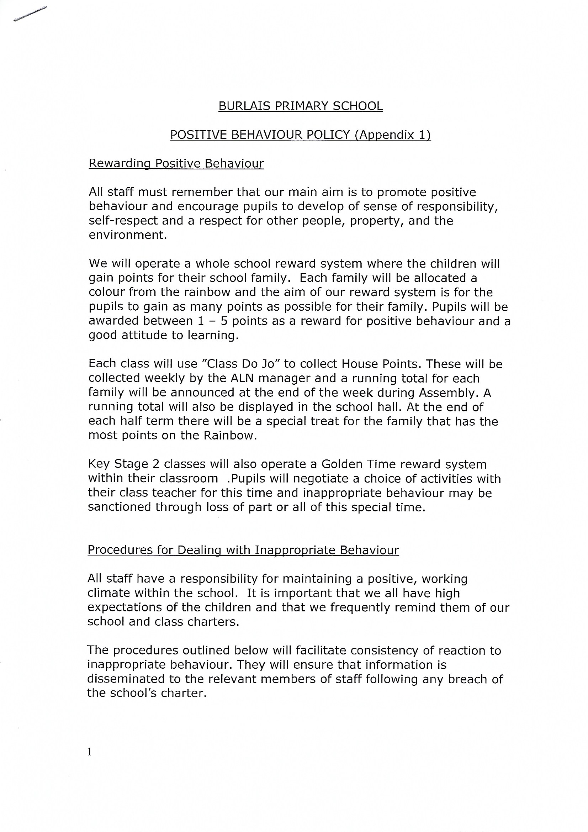

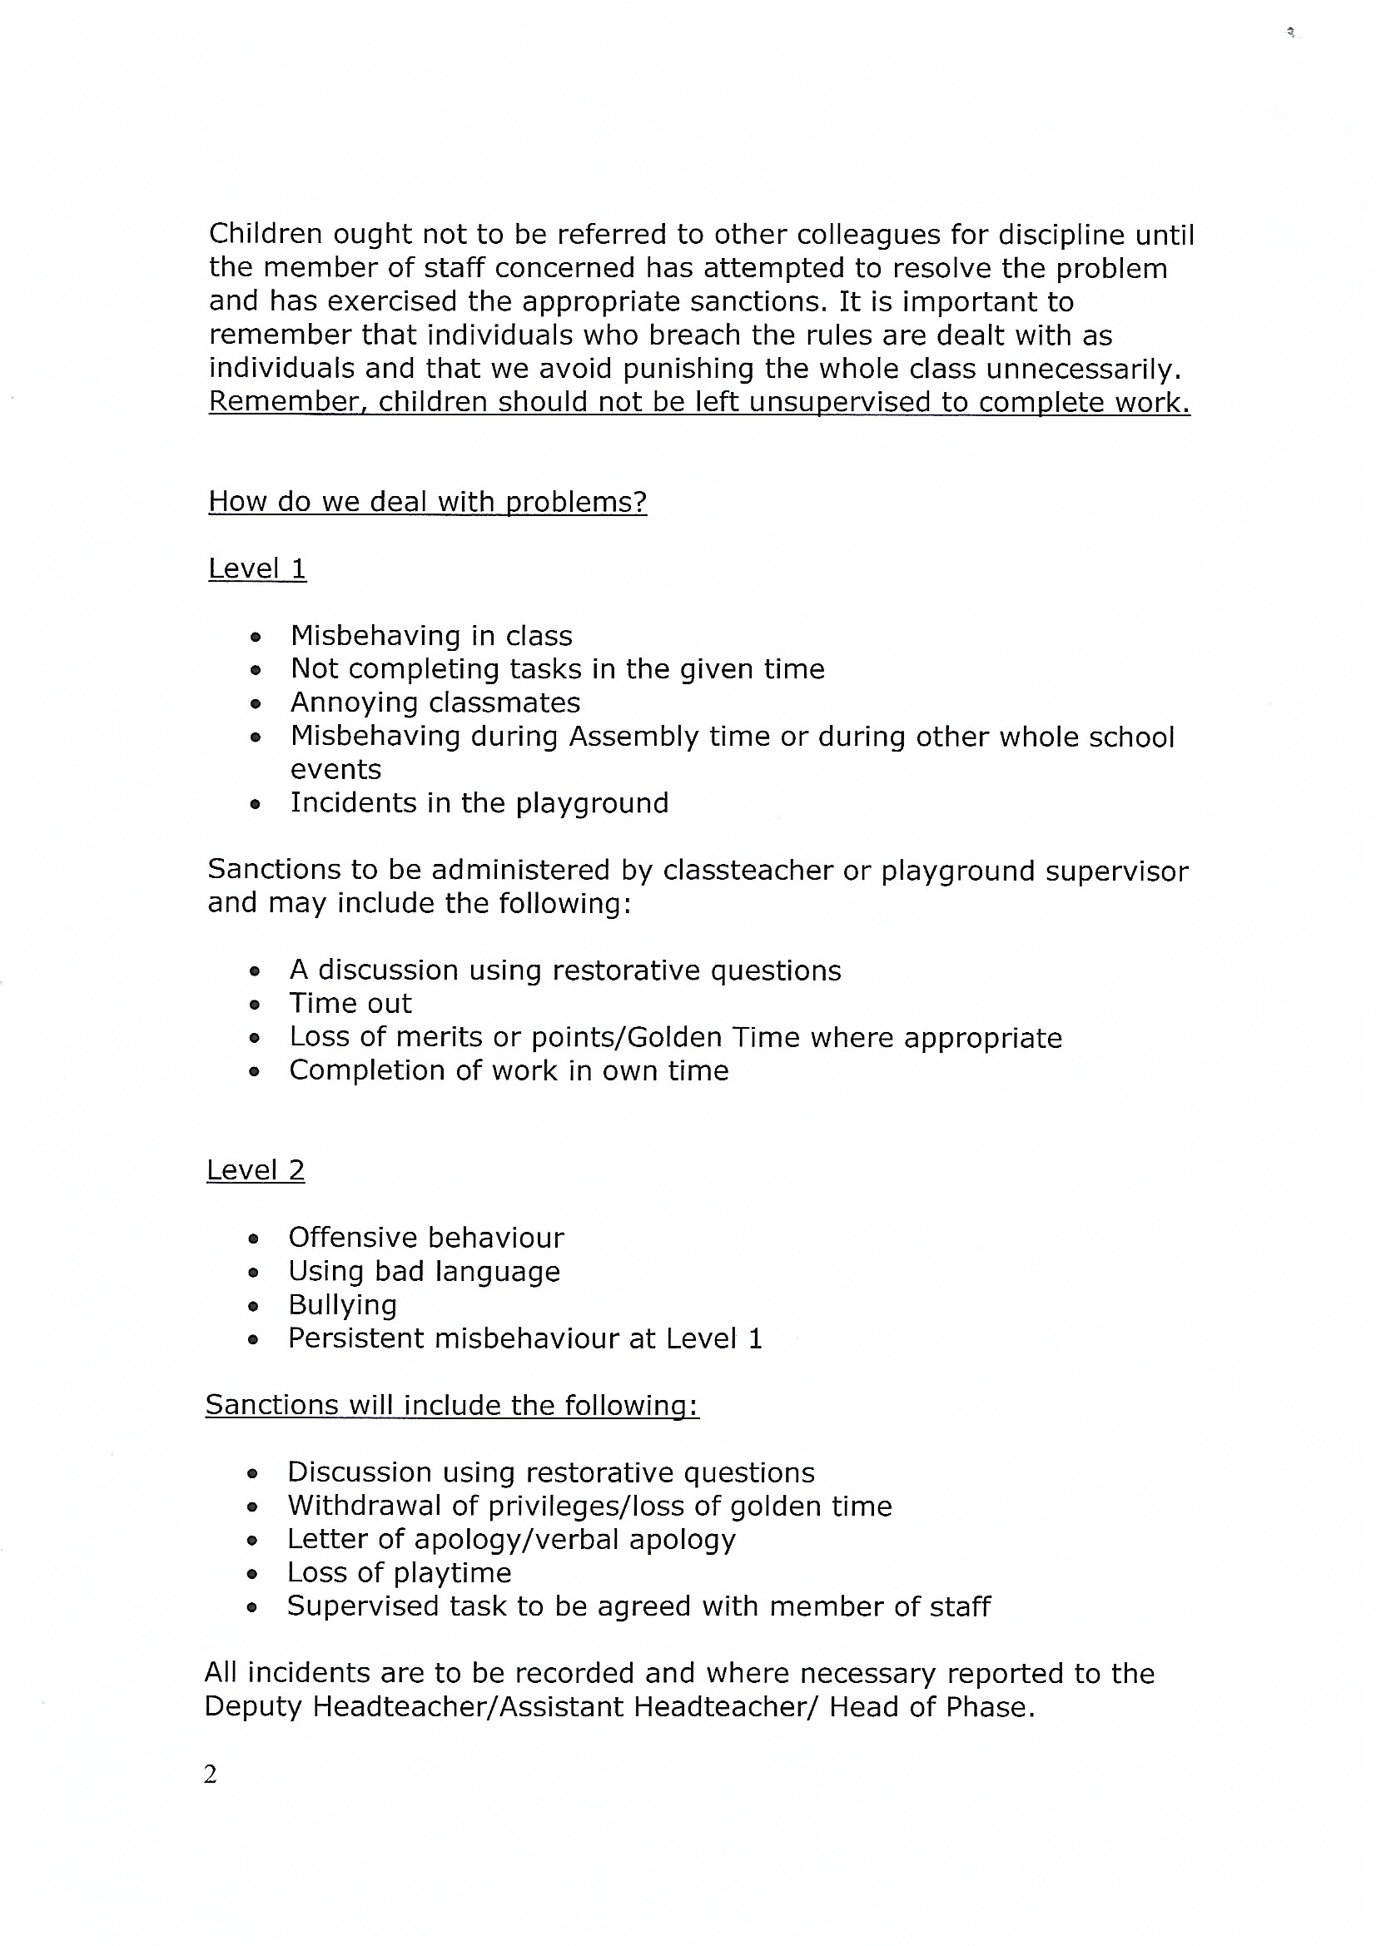

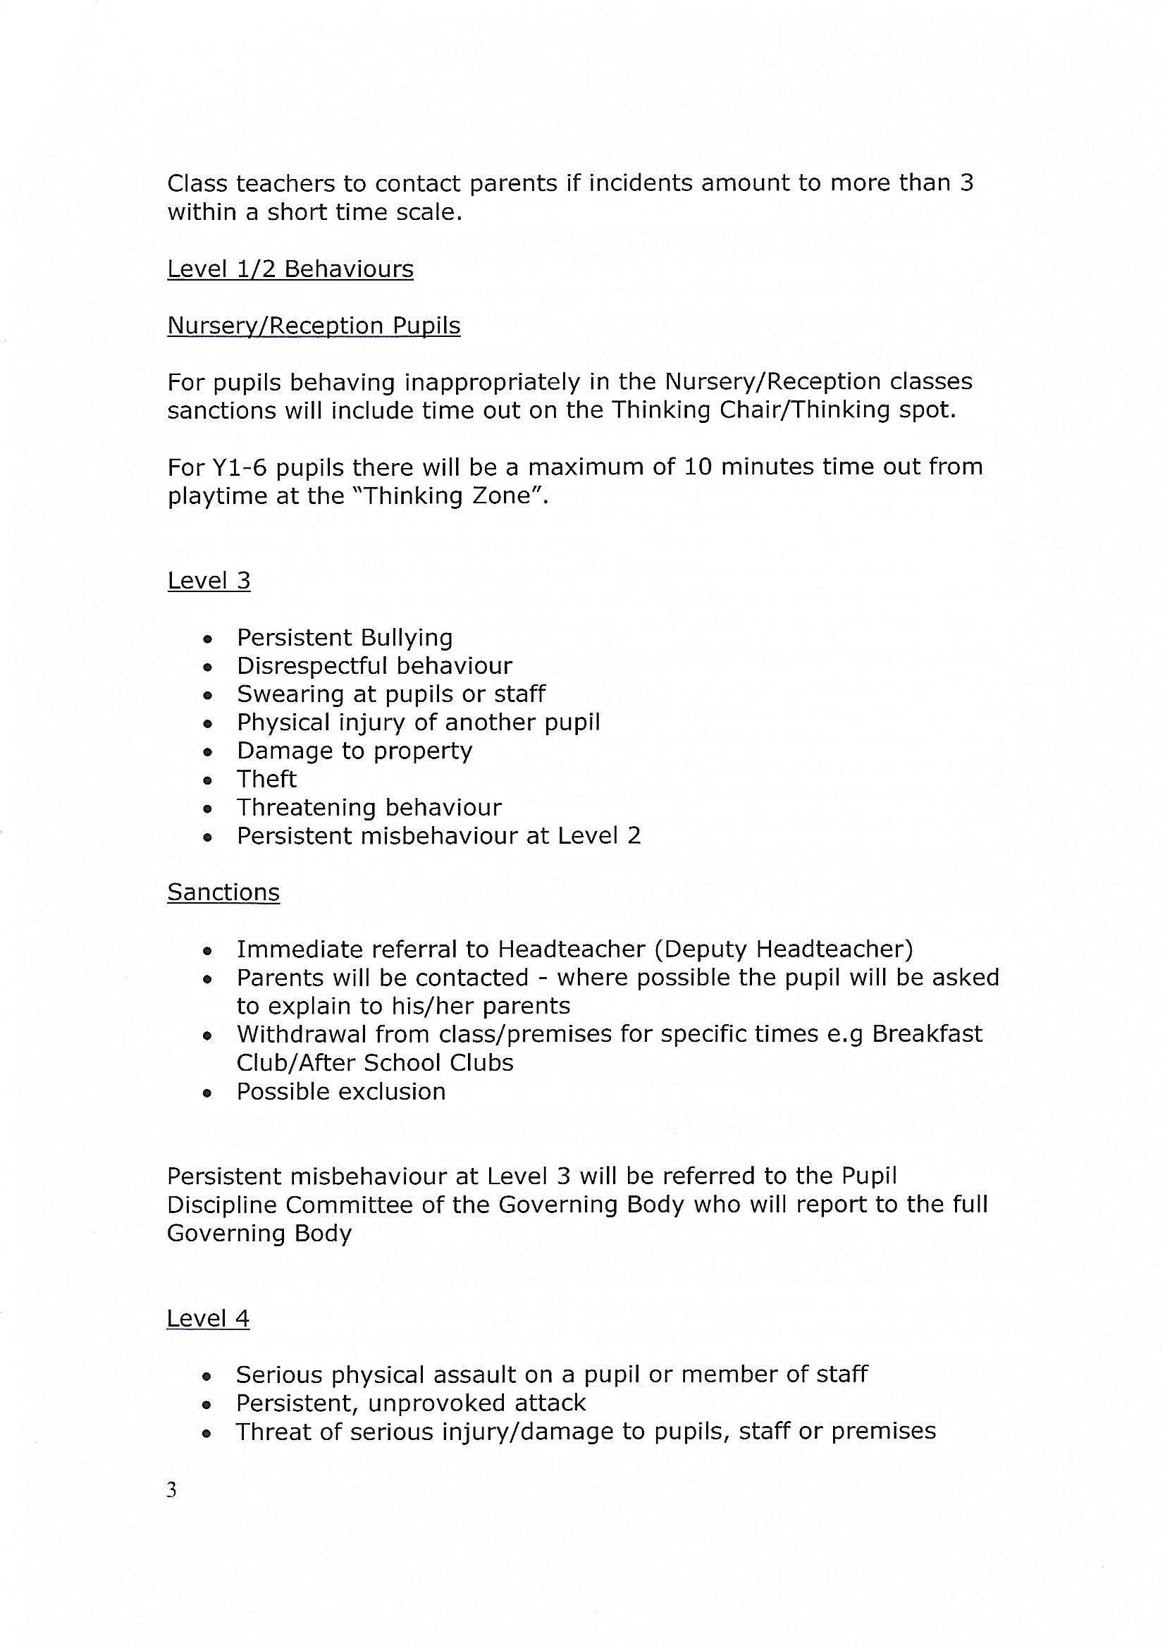

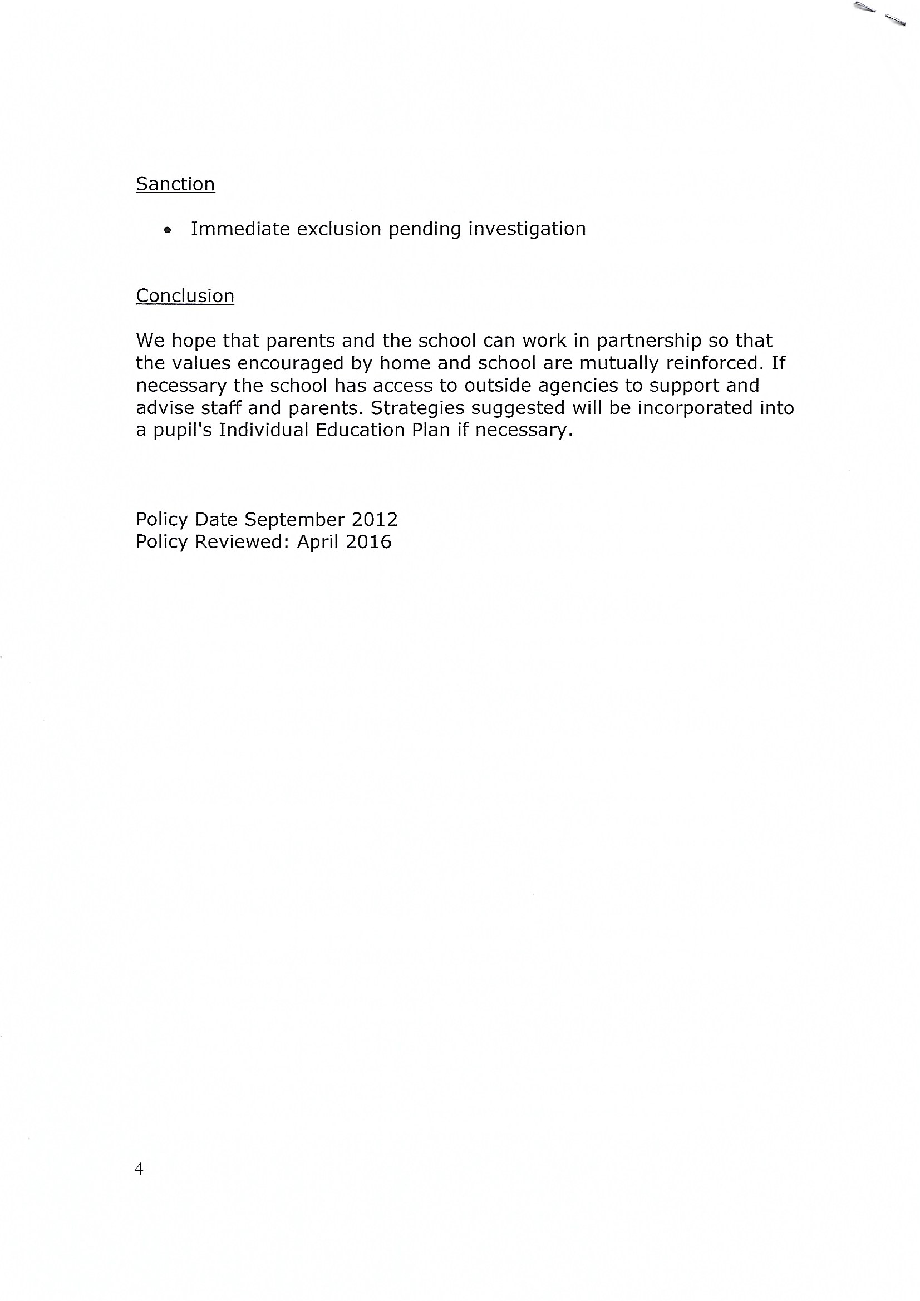

Appendix 2 – Safeguarding Policy
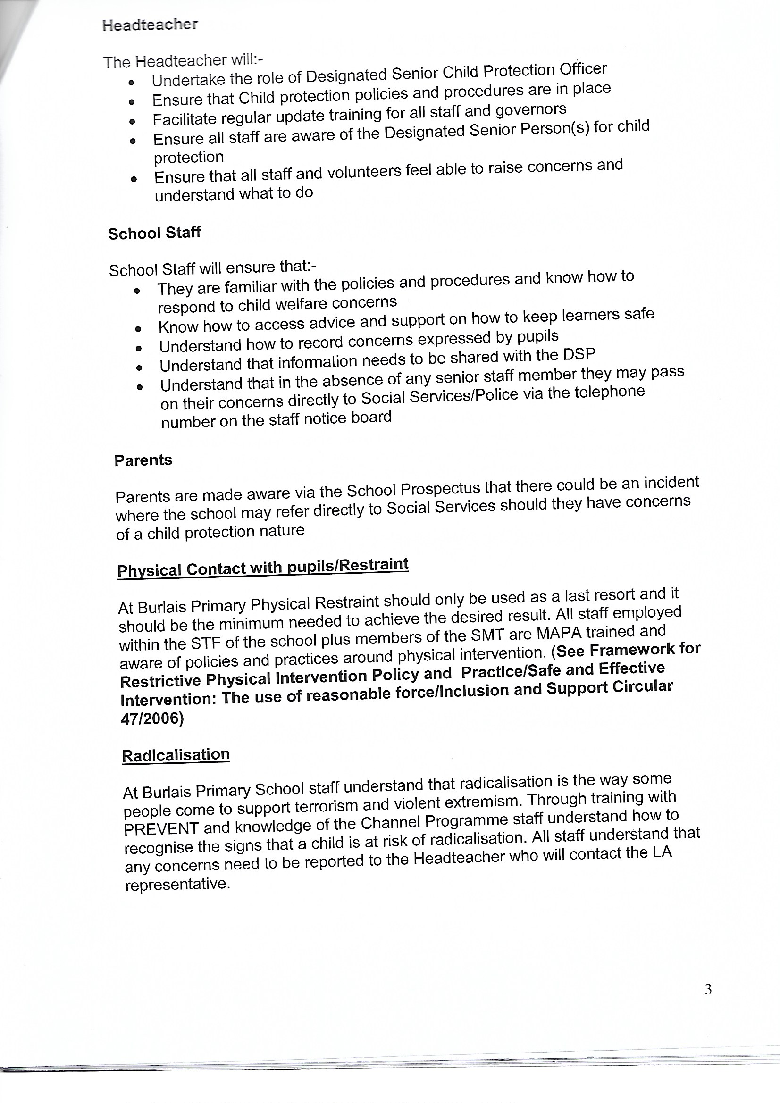

For the purpose of this report and to maintain confidentiality, the school discussed will be referred to as the Swansea school.

