LEARNING IN THE DIGITAL ERA E-PORTFOLIO PART 2
Luke Doherty (2206505)

CALL FOR WORKS

The original recording of Plastic Sea was done in my studio in 2018 with drums, bass and guitar and was mixed in Pro Tools 9. The recording was done live in one take including the solo, but the final vocals and second rhythm guitar was added later. For drums I used an AKG D112 on the bass drum as well as a sub microphone I made from a old NS10 speaker, an AKG D40 on the snare drum top and bottom as well as the three toms. A matched pair of AKG C430s in a Glen Johns configuration was used as overheads and a Rode NT2A set in figure of eight as a mono room microphone. For bass guitar I used a SM57 in the centre of a 10” bass speaker and a direct DI for the back of the bass amplifier. And for the guitar I used two separate amplifiers in stereo and recorded them using two Sennheiser e906s on the edge of the 12” speaker cone. And a AKG perception120 as a guitar room mic. For the vocals that I recorded later I used a Rode NT2A. I chose these combinations as I believed they would achieve the sound I was looking for while minimising the opportunity for phase issues, as well as being quick and simple to setup as we were working with limited time.

While mixing I started with the low frequencies first, and then I worked up to the vocals trying to leave as much space as possible in the centre of the mix to let the vocals be heard clearly. I used the LCR method as I had had previous success with that approach.

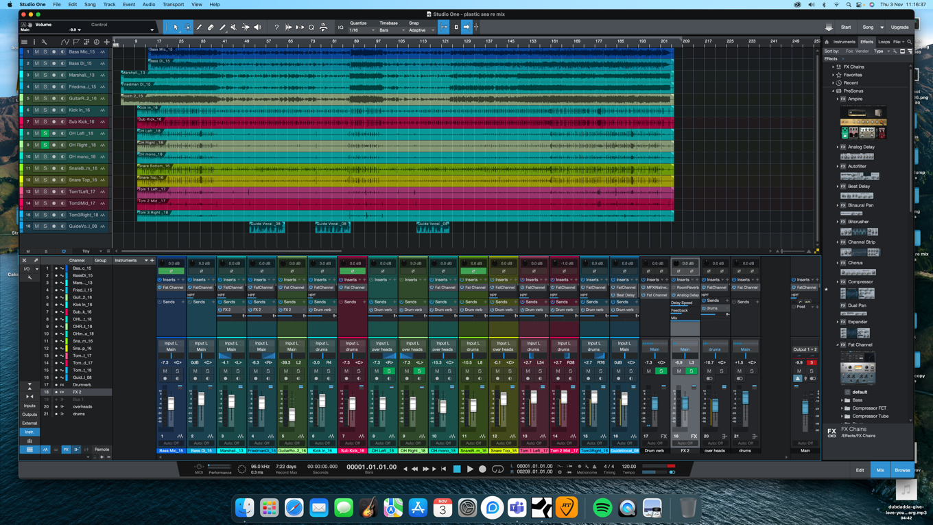
After listening to the recording of the song for several years on radio and other public outlets there were some things about it that I didn’t like about the original mix, so when I remixed it, I attempted to fix that by removing low frequencies from the guitars to add clarity to the bass, and then I removed sub-frequencies from the bass in order to allow more room for the kick drum (Figure 16, Figure 17).
Figure 16: Screenshot of the initial Stems imported into Studio One from Pro Tools 9.
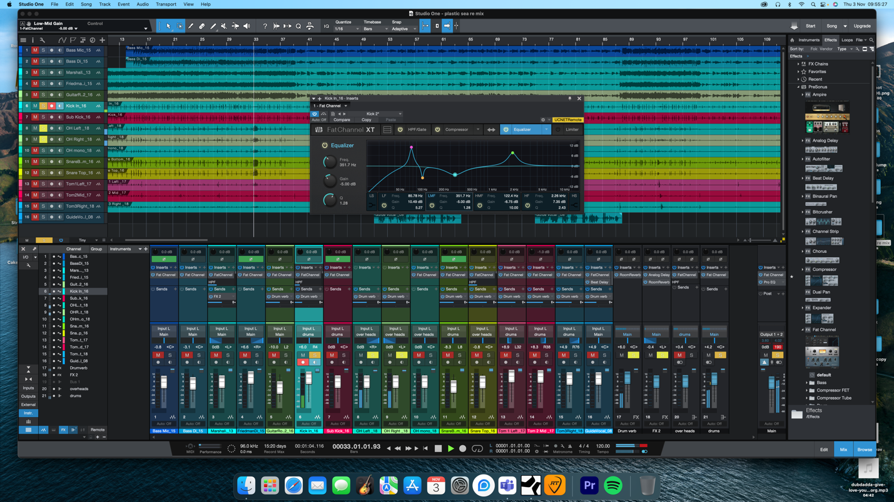
Figure 17: Screenshot of remixing the track and experimenting with EQ adjustments to the kick drum in Studio One.
Due to changing from Pro Tools 9 on PC to Studio One 4 on mac I ran into a few issues with compatibility as well as having to mix purely on headphones and not studio NS10 monitors I had used originally. I had always wanted to add extra guitar solos to the song as I felt it was missing something, but due to trying to keep the song simple so that the band could still play it live and have sound the same I never got around to adding extra guitar solos. However, as I was planning to make the music video to accompany the song, I thought it would be appropriate to add some extra guitar solos. Not being able to turn an amplifier up loudly meant that I had to record my guitar amplifier using a load box (Fryette Power Station) and turn the volume almost off while still having the amplifiers sound going into my recording interface into a speaker emulation within AmpliTube 5. By doing this, I was able to get the sound I wanted out of a big loud guitar amplifier without having to play loudly in a small flat. After I was happy with what I had mixed and recorded I bounced the recording down in the same format I used originally (WAV 32bit 96KHZ) to have the highest audio quality I could achieve.

When it came to making the music video for the song, I already had an idea for the video. I wanted a music video to highlight the ongoing issues of plastic in the world's oceans and how it is affecting the wildlife and the climate. The video is made to show as many forms of pollution and climate issues as possible while keeping the sense of time moving forwards at a gradually increasing rate to symbolise time running out to combat climate change and plastic pollution. I have included clips of my band playing live (Figure 18) in various places to bring the focus back to the music while using clips of the sea and pollution and plastic from Pexels to keep with the narrative of the song (Figure 19). I combined the audio and video within Adobe Premiere Pro to make my finale music video that I uploaded to my YouTube channel (Figure 20).
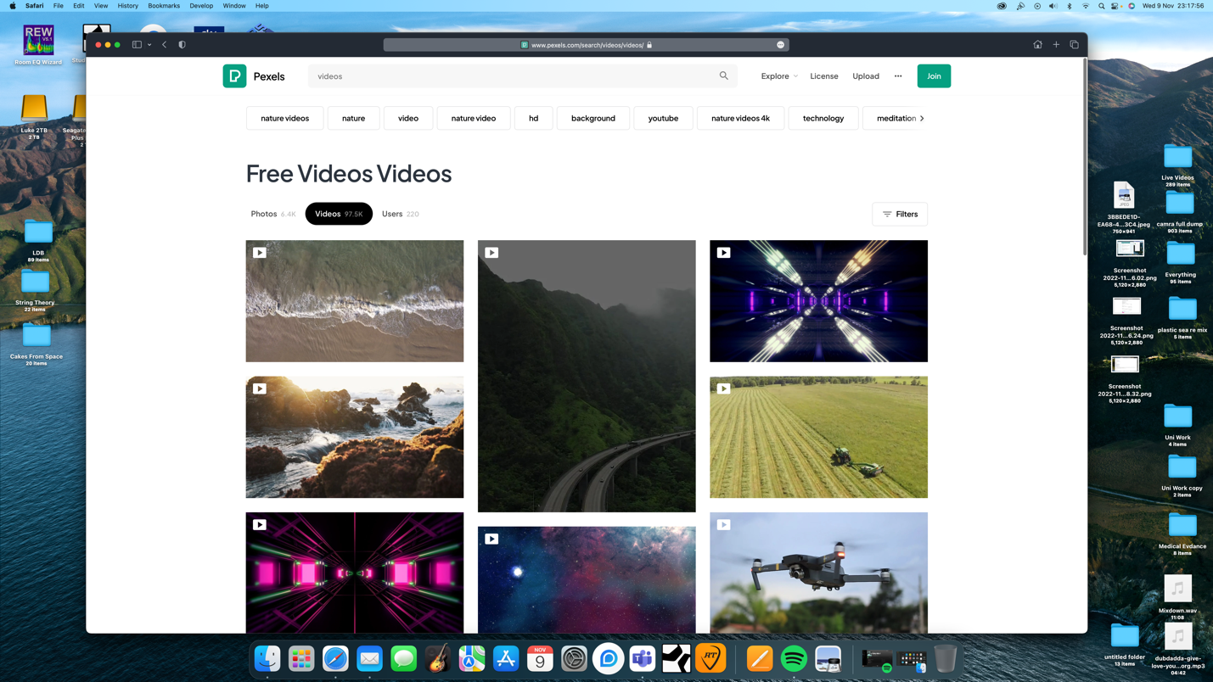
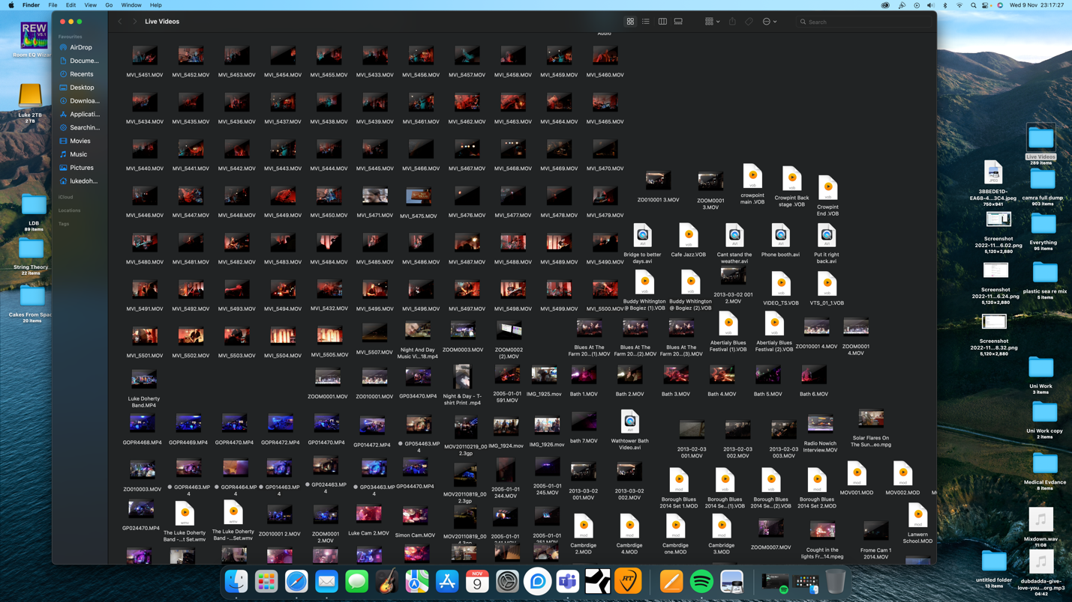
Figure 19: The website Pexels that provides royalty free clips. I used this website to get some clips of the ocean for the music video.
Figure 18: Some of the band clips I used in the music video.

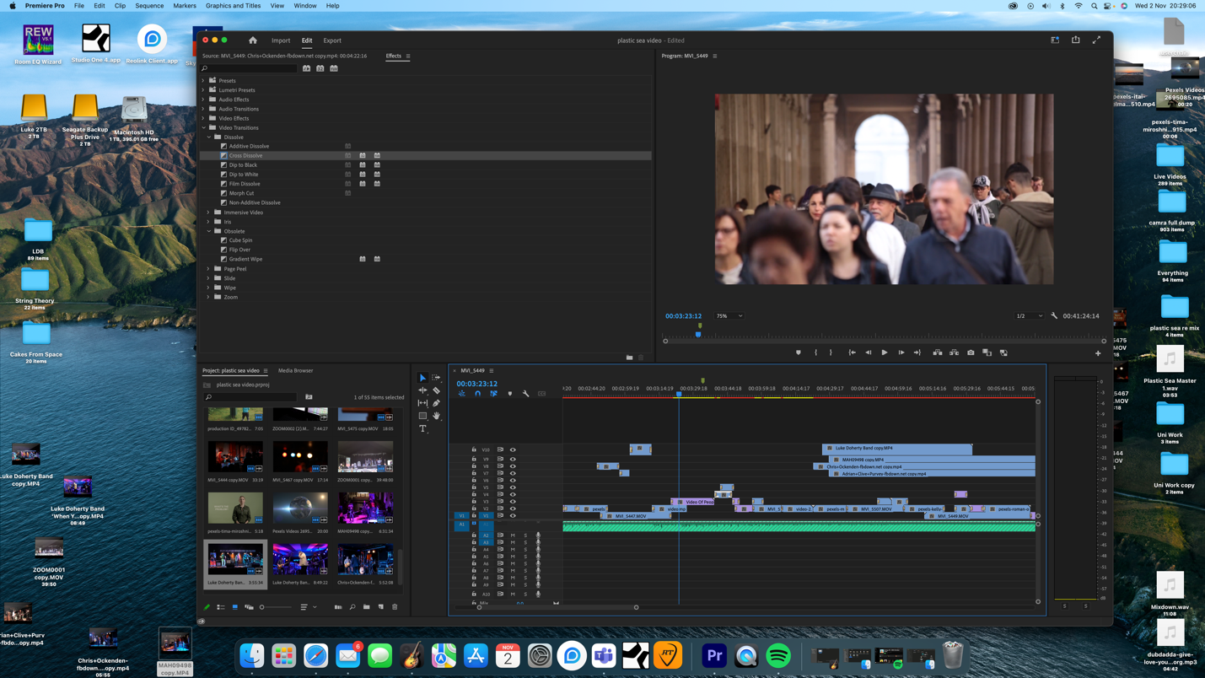
Figure 20: Editing the final video on Adobe Premiere Pro using the remixed audio, clips from Pexels and my own band recordings.
Here is the link to the final video that was uploaded to my YouTube channel: https://www.youtube.com/watch?v=e_GYSorb88k

Onedirve folder link : part 2 - Call for works

