6 How useful is the Bayeux Tapestry as a source for the events surrounding the Norman invasion of England?

There is much conjecture about the Bayeux Tapestry: who designed it, who worked it and, perhaps most importantly, its reliability as an historical document. While the first two points will probably never be resolved, the last is the subject of this essay. The Tapestry is a linen cloth approximately 70 m by 50 cm with woollen embroidery in three bands, the broadest in the middle and with the end missing. It has been much repaired, reducing its use as a reliable record of the events which it portrays. Musset has much to say on this and on the authenticity of the Tapestry in his book The Bayeux Tapestry. Although it is an embroidery (rather than a tapestry) it must be regarded as a document just as a manuscript would be. Although it has a small amount of text it is still overwhelmingly pictorial, clearly intended to be seen and understood by illiterate members of its audience while the use of text lends a perhaps spurious verisimilitude. Clanchy says that the Tapestry: ‘with its summary captions in Latin … assumes an audience in which someone could read’, thus the text could be read aloud to the less literate. It is generally believed that it was designed by a man and worked mainly by women (probably in Kent) to the commission of Bishop Odo, William’s half-brother. The many Anglo-Saxonisms in the text have led many historians to believe that the designer was Anglo-Saxon. When using the Tapestry as a source, one should be wary of any bias introduced into the story by its designer in deference to the commissioner. Any such bias will affect the verisimilitude of the piece, although it is a valuable part of the whole meaning. For the sake of simplicity, it will be referred to as the Tapestry throughout this essay.
As well as portraying major events of the time, it shows glimpses into the work of carpenters and shipbuilders, cooks and soldiers. Musset considers this everyday detail crucial in dating the Tapestry: ‘The technical details of the shipping and weaponry, not to mention the artistic style are simply too authentic to have been subsequent fabrications.’ This makes the Tapestry invaluable to those interested in recreating life and working practices of the late eleventh century. The borders show many things: fables, real or fabulous creatures, comments on the main panel, people working, battle scenes, and there has been much debate over their meaning. Some may have been mere whimsy on the part of the designer or embroiderer, but others surely have meaning. Do the foxes and wolves represent William the crafty Norman or Harold the perfidious Anglo-Saxon? The latter seems more probable, given the Tapestry’s likely provenance and there is much more to say about these borders, but it falls outside the remit of this essay.
There are manuscripts from the period and from shortly afterwards dealing with Battle of Hastings and its surrounding events, including the Anglo-Saxon Chronicle, the work of Henry of Huntingdon, William of Jumieges, William of Newburgh, William of Poitiers and Guy of Amiens’ Carmen de Hastingae Proelio. I shall attempt to find verification or contradiction of the events shown in the Tapestry from these and other works, focussing on just a few of the events shown.
It may be helpful here to review the sources I have used and compare them with the Tapestry. Some primary sources are more biased than others. The Anglo-Saxon Chronicle, written in the vernacular rather than Latin, has a generally Anglo-Saxon bias, although it does seem to try to be an accurate record of events. Presumably the dated entries in the Chronicle were compiled very shortly after the events which they record. William of Jumieges’ Gesta Ducum Normannorum, is called by Van Houts ‘… a piece of propaganda justifying William the Conqueror’s actions.’ Written between the late 1050s and around 1070, this work is also contemporary. William of Poitiers had been William I’s chaplain and wrote a biography of that king and based his account of the battle on eye-witness accounts. Both of these men show bias towards William I. Guy of Amiens was chaplain to William’s queen Matilda and wrote the Carmen de Hastingae Proelio in around 1068. Henry of Huntingdon was an Anglo-Norman arch-deacon with a Norman father and an Anglo-Saxon mother writing in the twelfth century and seems ambivalent towards of William: while he felt that Harold, as an oath-breaker deserved his fate, he considered William rapacious, unreliable and savage. While William of Jumieges and William of Poitiers were writing at the time of these events, our other two chroniclers wrote during the twelfth century. The tapestry and all our sources contain indisputable facts: Edward died, Harold took the throne, William invaded and won the battle in which Harold died, but where a difference of opinion arises, we see that bias taints all these works as much as it does the Tapestry.

THE OATH
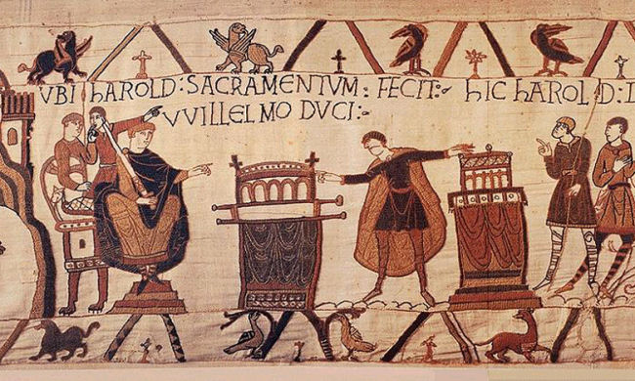
In this evocative scene, Harold stands touching two reliquaries, swearing an oath before Duke William. The text says ‘Ubi Harold sacramentum fecit’ (Where Harold makes an oath). There is no mention of the subject of the oath, yet almost every historian, both modern and contemporary, tells us that Harold swore to help ensure William’s succession to the English throne on the death of Edward. William of Jumieges says: ‘After Harold had … sworn fealty to him [William] about the kingdom with many oaths…’, and in his edition of Gesta Ducum Normannorum, Orderic Vitalis repeats this claim.

THE DEATH OF EDWARD THE CONFESSOR
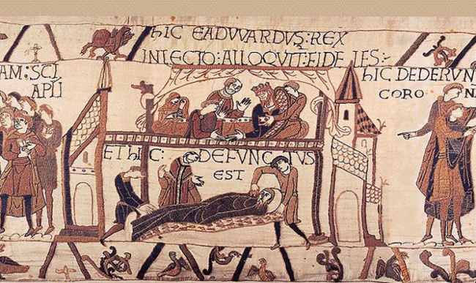
Several versions of the Anglo-Saxon Chronicles record the death of Edward although none tell us who was present. The C and D versions give us this:

Yet did the wise king entrust his kingdom
To a man of high rank, to Harold himself,
The noble earl, who ever
Faithfully obeyed his noble lord
In words and deeds, neglecting nothing
Whereof the national king stood in need.

CORONATION OF HAROLD
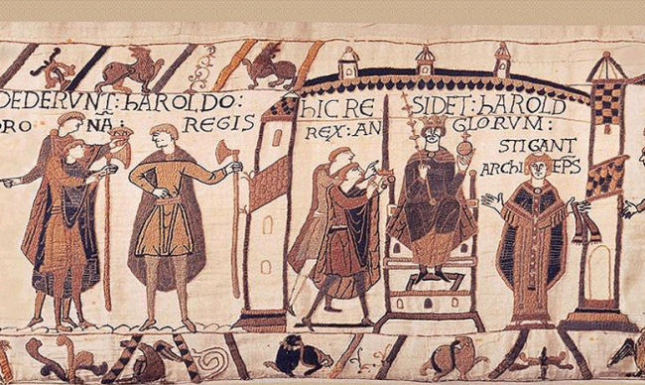
William of Poitiers tells us that Harold: ‘… violated his oath and seized the royal throne with acclamation, with the connivance of a few wicked men.’ Henry of Huntingdon calls him a usurper and William of Jumieges says: ‘…Harold immediately seized Edward’s kingdom, thus perjuring the fealty he had sworn to the Duke.’ No-one disputes the fact that Harold was crowned, but all these commentators agree that he did it unjustly. Alternatively, the A version of the Anglo-Saxon Chronicle tells us that Harold ‘came to the throne and ruled for forty weeks and a day’, the C and D texts that ‘he was consecrated king but was not to enjoy a tranquil reign…’ while the E version says that Harold ‘succeeded to the kingdom of England as the king granted it to him and as he was elected thereto.’ None of the versions mention any oath to William.

THE COMET
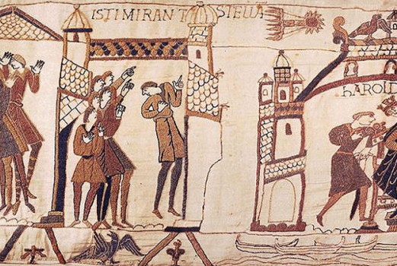
The comet which appears in the Tapestry is one thing capable of scientific proof. Broughton in a 1979 article for the Journal of the Royal Astronomical Society of Canada gives a table with all appearances of Halley’s Comet including that of April to June 1066. Three versions of the Anglo-Saxon Chronicle mention it, that is A, C and D. The Carmen de Hastingae mentions the comet: ‘… a blazing comet with outstretched tail informed the English of their destined ruin.’ If we are to believe Broughton, the comet would have passed out of visibility before October 1066. William of Jumieges mentions it as an omen: ‘At that time a star appeared in the north-west, its three-forked tail stretched far into the southern sky remaining visible for fifteen days; and it portended, as many said, a change in some kingdom.’ It is also mentioned in the Anglo-Saxon Chronicles. All commentators seem agreed that it was significant.

PEVENSEY
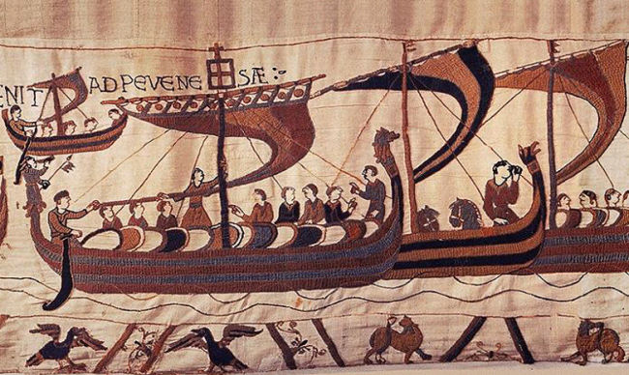
The site of the landing at Pevensey is generally agreed upon. William of Poitiers says: ‘Carried by a favourable breeze to Pevensey, they [the Norman fleet] disembarked easily from the ships without having to offer battle.’

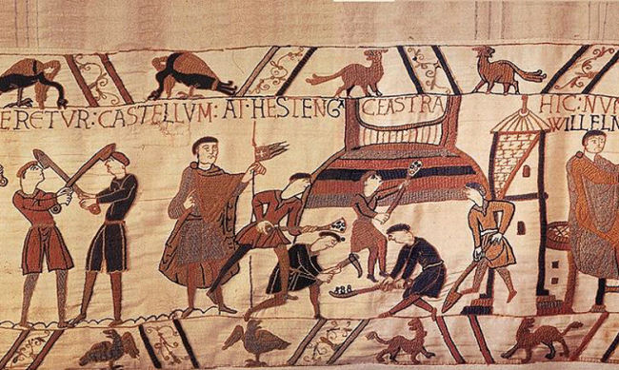
Orderic Vitalis goes on to tell us that the Normans built there ‘a strongly entrenched fortification’ and then did the same in Hastings. The D version of the Anglo-Saxon Chronicle agrees with this as does William of Poitiers.

THE SAXONS DEFEND A HILL
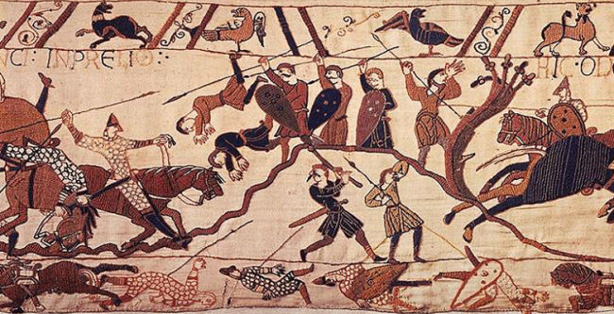
During the battle depiction, a group of Saxons is seen defending a hill with Normans attacking. William of Poitiers says: ‘they [Harold et al.] took their stand on higher ground, on a hill near to the wood… they lined up all on foot in a dense formation’ and William of Malmesbury: ‘Getting possession of an eminence, they drove back the Normans, who in the heat of pursuit were struggling up the slope, into the valley beneath, where, by hurling their javelins and rolling down stones on them as they stood below, the English easily destroyed them to a man. This latter is more in favour of the English. The Carmen de Hastingae: ‘Near the forest was a hill and a valley and land too rough to be tilled. The English, as was their custom, advanced in mass formation and seized this position on which to fight.’

THE DEATH OF HAROLD
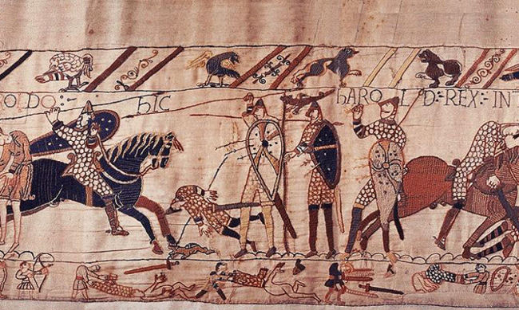
Perhaps the most famous scene is towards the end with a figure usually thought to be Harold holding the shaft of an arrow which seems to protrude from his eye. This scene in the Tapestry is uncertain: there has been repair in this area, and it is not completely certain that the figure in question is Harold. That the specific circumstance of Harold’s death is not mentioned in any other contemporary source is suspicious in itself. William of Malmesbury says: ‘He [Harold] was constantly striking down the enemy at close quarters, so that no one could approach him with impunity, for straightway both horse and rider would be felled by a single blow. So it was at long range, as I have said, that the enemy’s deadly arrow brought him to his death. William of Jumieges says only that ‘Harold himself fell mortally wounded, at the first encounter of the troops. William of Newburgh has only this to say: ‘The latter [Harold] falling by the chance of battle…’ Henry of Huntingdon: ‘Meanwhile the whole shower sent by the archers fell around King Harold, and he himself sank to the ground, struck in the eye.’ The Carmen de Hastingae tells us that William with three knights attacked Harold: ‘The first of the four, piercing the king’s shield and chest with his lance, drenched the ground with a gushing stream of blood. The second with his sword cut of his head below the protection of his helm. The third liquefied his entrails with his spear. And the fourth cut off his thigh and carried it some distance away.’ The translation of Amatus of Montecassino’s Historia Normannorum in the early fourteenth century says that William gouged out the eye with an arrow, not that Harold was shot in the eye. The fact that Amatus original text is lost and what remains is a not particularly reliable translation leads one to think that one should not put too much faith in this work. The question of Harold’s death has become so muddied with time that it is now impossible to know which account is true.

Something which should be addressed here is relative meaning of history both for us as twenty first century historians and for the intended audiences of these primary sources. Although we may require facts and the analysis of those facts now, a thousand years ago the purpose of a Historia was different: the writer needed to find approval from the person commissioning the work and he needed to convince his audience that what he said was right (not necessarily true). We can see from the variety of primary source material used that right and true were not always the same: what was right for William the Conqueror and his followers was not necessarily so for an Anglo-Saxon, displaced from his home and deprived of his title. What we would now consider the facts of the conquest take on different colouring for different participants in those events. Many of the events portrayed in the Tapestry happened, others may have happened, some probably did not. That is not the point of the Tapestry: it was designed and made to convey a point of view: that of the conquerors of Hastings.

Shortly after the scene showing Harold’s death the Tapestry ends abruptly and perhaps appropriately with fleeing Saxons. How much has been lost can never be known, but we may assume that it went on to show William’s coronation. What remains, presumably the great bulk of the work, is now a national treasure to both the countries involved in the battle and although the Tapestry has been shown to be unreliable to our twenty-first century minds, for the audience for whom it was created I suspect it sufficed.

BIBLIOGRAPHY
All tapestry images from the Anglo-Saxon Archaeology website: http://anglosaxon.archeurope.info/index.php?page=bayeux-tapestry
Amatus of Montecassino, The History of the Normans, ed. & trans. Dunbar, Prescott H, intro. Loud, Graham (Woodbridge: The Boydell Press, 2004)
The Anglo-Saxon Chronicle, ed. & trans. Garmonsway, G N, (London: Everyman, 1975).

Carmen de Hastingae Proelio, as provided in course reader.
Henry of Huntigdon, Historia Anglorum, as provided in course reader.
Orderic Vitalis, Gesta Normannorum Ducum, as provided in course reader.
William of Jumieges, Gesta Normannorum Ducum, as provided in course reader.
William of Malmesbury, Gesta Regum Anglorum, as provided in course reader.
William of Newburgh, Historia Rerum Anglicarum, as provided in course reader.
William of Poitiers, Gesta Guillelmi, as provided in course reader.

Anderson, John D., 'The Bayeux Tapestry: A 900-Year-Old Latin Cartoon', The Classical Journal, 81 (1986), pp. 253-257.
Broughton, R. P.,’ The Visibility of Halley’s Comet’, Journal of the Royal Astronomical Society of Canada, vol. 73, Feb. 1979, pp. 24-36.
Carter, John M., 'Writing Games in the Bayeux Tapestry', The English Journal, 74 (1985), pp. 31-34.
Clanchy, M. T., From Memory to Written Record: England 1066-1307 (Oxford: Blackwell, 1996).
Dodwell, C. R., 'The Bayeux Tapestry and the French Secular Epic', The Burlington Magazine, 108 (1966), pp. 549-560.
Holmes, Urban T., 'The Houses of the Bayeux Tapestry', Speculum, 34 (1959), pp. 179-183.
Lewis, Suzanne, The Rhetoric of Power in the Bayeux Tapestry, (Cambridge: Cambridge University Press, 1998).
McNulty, J. B., 'The Lady Aelfgyva in the Bayeux Tapestry', Speculum, 55 (1980), pp. 659-668.
Musset, Lucien, The Bayeux Tapestry, New ed. (Woodbridge: Boydell Press, 2005).
Noxon, Gerald, 'The Bayeux Tapestry', Cinema Journal, 7 (1967), pp. 29-35.
Owen-Crocker, Gale ed. King Harold II and the Bayeux Tapestry, (Woodbridge: The Boydell Press, 2005).
Parker, Rozsika, The Subversive Stitch: Embroidery and the Making of the Feminine, Rev. reprint. Edn. (London: Women's Press, 1996).
Stenton, Frank, The Bayeux Tapestry (London: Phaidon, 1965).
Van Houts, Elizabeth, The Normans in Europe (Manchester: Manchester University Press, 2000)

Lucien Musset, The Bayeux Tapestry trans. Rex, Richard (Wooddbridge: Boydell, 2002) pp. 14-17.
Suzanne Lewis, The Rhetoric of Power in the Bayeux Tapestry (Cambridge: Cambridge University Press, 1998). p. 10. ‘When its status as "text" is recognized, however, the Bayeux Tapestry can be seen as a distinctive narrative, uniquely capable of creating a challenging horizon of multiple expectations that defined its purpose or project for late-eleventh -century audiences in ways that have not yet been considered.’
M T Clanchy, From Memory to Written Record: England 1066-1307 (Oxford: Blackwell, 1996) p. 125.
C. R. Dodwell, 'The Bayeux Tapestry and the French Secular Epic', The Burlington Magazine, 108 (1966), p. 549; John D. Anderson, 'The Bayeux Tapestry: A 900-Year-Old Latin Cartoon', The Classical Journal, 81 (1986) p. 253.
Musset, Bayeux Tapestry pp. 36-38.
Musset, Bayeux Tapestry p. 16.
Musset, Bayeux Tapestry pp. 72-75; Shirley Ann Brown, ‘The Bear, Harold and the Tapestry’ in King Harold II and the Bayeux Tapestry ed. Gale Owen-Crocker (Woodbridge: The Boydell Press, 2005).
Elizabeth Van Houts, The Normans in Europe (Manchester: Manchester University Press, 2000) p. 113.
Van Houts, Normans, p. 34.
Van Houts, Normans, p.118.
Henry of Huntingdon, Historia Anglorum, as provided in course reader.
Anglo-Saxon Archaeology website.
William of Jumieges in The Normans in Europe, ed. Elizabeth Van Houts, (p. 114.
William of Jumieges in Normans, ed. Van Houts, p. 114.
Anglo-Saxon Archaeology website.
The Anglo-Saxon Chronicle pp. 194 & 195.
Anglo-Saxon Archaeology website.
William of Malmesbury, Gesta Regum Anglorum, as provided in course reader.
Henry of Huntingdon History of the English People 1000-1154 as provided in course reader.
William of Jumieges in Normans, ed. Van Houts, p. 114.
The Anglo-Saxon Chronicle p. 194.
The Anglo-Saxon Chronicle p. 197.
Anglo-Saxon Archaeology website.
Broughton, R. P., ‘The Visibility of Halley’s Comet’, Journal of the Royal Astronomical Society of Canada, vol. 73, Feb. 1979, p. 24-36.
The Anglo-Saxon Chronicle pp. 196 & 197.
Carmen de Hastingae as provided in course reader.
William of Jumieges in Normans, ed. Van Houts, p 114.
Anglo-Saxon Archaeology website.
William of Poitiers in Normans, ed. Van Houts, p. 121.
Anglo-Saxon Archaeology website.
Orderic Vitalis as provided in course reader.
The Anglo-Saxon Chronicle p. 199.
William of Poitiers in Normans, ed. Van Houts, p. 121.
Anglo-Saxon Archaeology website.
William of Malmesbury as provided in course reader.
Carmen de Hastingae as provided in course reader.
Anglo-Saxon Archaeology website.
William of Malmesbury as provided in course reader.
William of Jumieges as provided in course reader.
William of Newburgh as provided in course reader.
Henry of Huntingdon as provided in course reader.
Carmen de Hastingae Proelio as provided in course reader.
Amatus of Montecassino, History of the Normans p. 46. ‘William first went against Harold, fought against him, gouged out his eye with an arrow, and slew a great many English men.’

