Swansea Metropolitan University
An Introduction to Microsoft Word 2007-2010

Jamie Tavender/Rhian Pole/John Apps

Introduction:
Microsoft Word is an essential tool for the creation of documents. Its ease of use has made Word one of the most widely used word processing applications currently on the market. Therefore, it's important to become familiar with the various facets of this software, since it allows for compatibility across multiple computers as well as collaborative features. Word is a fairly simple program to use for completing simple tasks.

Opening Microsoft Word:
To run Word on your computer: Start >> Programs >> Microsoft Office >> Microsoft Office Word 2007-2010. If there is an icon of Microsoft Word available on your desktop (shaped like a square with a "W" in the middle), you can open up the program by double-clicking it, as well.

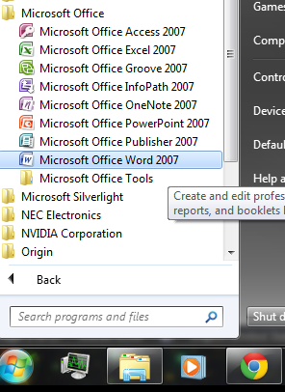

Making a New Blank Document:
When Word is opened, a new blank document should automatically open. If not, then you can begin a new blank document in a variety of ways.
First, find the New icon, which looks like a blank sheet of paper, located after you click the menu bar in Word in the top right hand corner. Click on the icon to bring up a new blank document.
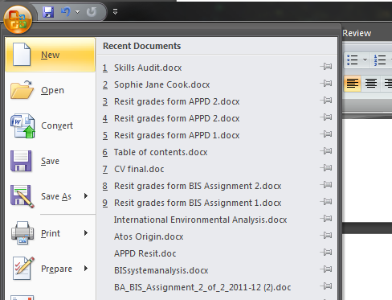
Opening a Document:
To open to view, edit, or print a document, you must first open up that file in Word.
You can open a file by clicking on the Open icon (with a picture of a folder) after you click the menu bar in Word in the top right hand corner
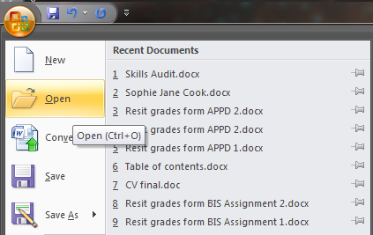

The Word 2007/2010 Window:
As already mentioned, when Word is first started, a new blank page titled Document1 is usually opened automatically. This is a fresh page where you can begin typing a new document.
- At the top of the window are 4 clickable buttons. These are the menu button, Save, Undo Previous Action,
- Below that row of buttons is what is known as “The Ribbon”, which consists of a number of “tabs” and buttons for various tools to use in creating and editing your document.
- Directly below the ribbon is a ruler.
- Use the ruler to set tabs, indents, and margins.
- There are scrollbars on the right side and on the bottom of the screen.
- By clicking on the arrows at the ends of the scrollbars, you can move up and down or left and right through your document.

Take a couple of minutes to familiarise yourself with this screen before continuing!!

The Ribbon:

The ribbon is the interface used in Word where the previous (Word 2003) toolbars are now placed on tabs in a tab bar. The ribbon provides a user interface in Word with a large toolbar filled with graphical representations of control elements which are grouped by different functionality. The Ribbon contains tabs to expose different sets of control elements, eliminating the need for many different icon-based tool bars. Some of these tabs are contextual and appear only when a certain type of object is selected providing specific tools for items such as tables or images or headers/footers (Ericson, 2006).

Saving a Document:
When you are working with any sort of media in any software, you should be sure to save your work often. In Word, there are numerous options for saving documents in a variety of file types.
To save a new, unsaved document, you can click on the Save icon, shaped like a floppy disk located above the ribbon. Or, you can click the menu button and press save, which works in the same way as pressing the floppy disc. Finally, pressing the menu button and pressing Save As will allow you to save the document in a particular file location, and then every time you save after this it will update to this current file location. (Shortcut: Ctrl + S).
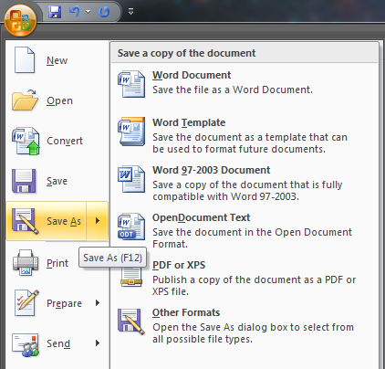
One you press Save As, a dialogue box should appear, offering you a number of options. To save the document in the desired location on your computer, locate and select the folder on your computer. Give your document a name in the file name text box. While you can give your document long names, make sure you save it with a name you can remember.
Please note that it's good practice not to use spaces or special characters in file names. For example, a long file name may look like this:
APPD_assignment_draft.doc
or
expos_sample_paper1.doc
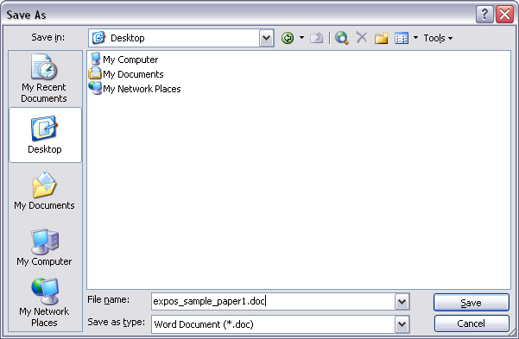

Now that the very basics of word have been covered, other basics and slightly higher level tools will be discussed and shown. The majority of these will all be found on the “Home” tab in the ribbon, however some are not on the home tab and that will be specified at the point of discussion

Formatting Text / Paragraphs within Word’s Ribbon:
In a word processing program such as Word, there are numerous options available for presenting your text. This part of the tutorial will guide you through several of the important features in Word that will allow you to edit, modify, and display text (and non-text) components.

The Home Tab:
Use the following graphic as a guide to the home tab (moving from left to right).

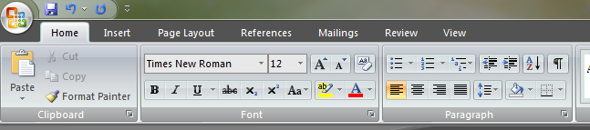

Clipboard
The first part of this section discusses the options available to you in the “clipboard” section of the home tab
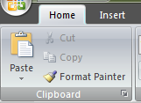

- Copy/Cut:
Copy the current selection to the clipboard, which can then be pasted elsewhere in the document, or into a completely separate program/document.

- Paste:
Clicking on the Paste button inserts the text that has been most recently added to the Clipboard (the text would have been added there by Cutting or Copying). With Paste, you can either insert the copied text into a document or replace selected text.

- Format Painter
Allows the user to copy formatting from one location, and apply it to another

Font
Use the following graphic in the home tab as a guide to the font section:

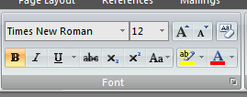

- Font:
Font is a simple but important factor in Word documents. The choice of font (the style of the text itself) can influence the way others view documents, either on the screen or in print. For example, Arial font looks better on screen, while Times New Roman is clearer in print. To apply a font to text, select desired text with your cursor, and choose a font from the font drop down menu.

- Font Size:
You may encounter times in which you need to display some text larger or smaller than other text. Selecting desired text with the cursor and choosing a font size from the drop down menu changes the size of text.

- Bold:
Places the text in bold.

- Italic:
Places the text in italics.

- Underline:
Underlines the text.

- Highlight:
Highlight the current selection; default color is yellow.

- Font Color:
Change the font color; the default/automatic color is black.

Paragraph
Use the following graphic in the home tab as a guide to the paragraph section:

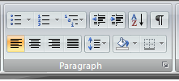

- Align Left:
Aligns the selection to the left of the screen / paper.

- Center:
Aligns the selection to the center of the screen / paper.

- Align Right:
Aligns the selection to the right of the screen / paper.

- Justify:
Aligns the selection to both the left and right of the screen / paper.

- Line Spacing:
Adjust the line spacing (single-spaced, double-spaced, etc.)

- Numbering:
Create a numbered list.

- Bullets:
Create an unordered, bulleted list.

- Decrease Indent:
Decreases the indentation of the current selection (to the left).

- Increase Indent:
Increases the indentation of the current selection (to the right).

- Outside Border:
Places a border around the current selection; click the drop-down for a wide selection of bordering options.

Miscellaneous
Working with Text in the Review Tab
Use the following graphic in the review tab as a guide to the proofing section:
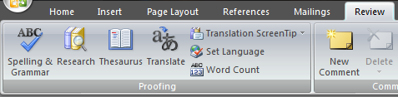
- Spelling and Grammar:
Clicking begins a review of your document in search of spelling and grammatical errors that may need to be corrected.

- Thesaurus
Clicking this button will suggest other words with a similar meaning to the word you have selected

Creating a Table in the Insert Tab
Use the following graphic in the insert tab as a guide to the tables section:
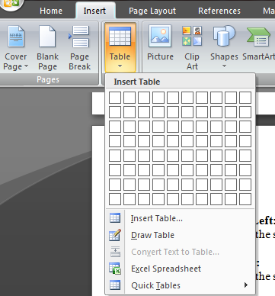
- Insert Table:
When this icon is clicked, a small window will appear in the form of a grid of squares. Use this window as a guide to indicate how many rows and columns you would like your table to contain. Once selected, a table will automatically appear in Word. Selecting the Tables and Borders button will allow you to modify the table. To modify an aspect of the table, select, or place the cursor in, the area and apply changes such as borders and colors.

How to Print your Document
Once you have formatted your document accordingly, and of course added the content you wish to add, you may wish or need to print this document out onto paper. This is a simple process in Microsoft Word.
Simply press the menu button, and hover the mouse over “Print”.
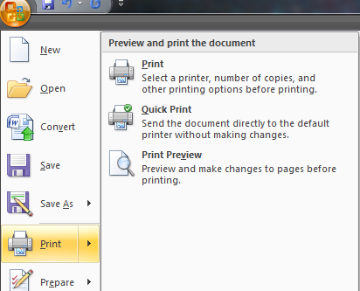
Now you have two options:
- Print:
Selecting Print gives the user a number of options about their document and how it will be printed.

- Print Preview:
To get an idea of the appearance of your document in print before you actually print it out, you can click on this icon to view your document from a zoom-out distance.

Working with text:
Typing and inserting text:
To enter text, just start typing! The text will appear where the blinking cursor is located. Move the cursor by using the arrow buttons on the keyboard or positioning the mouse and clicking the left button. The keyboard shortcuts listed below are also helpful when moving through the text of a document:
Move Action | Keystroke
Beginning of the line | Home
End of the line | End
Top of the document | Ctrl + Home
End of the document | Ctrl + End
Selecting text:
To change any attributes of text it must be highlighted first. Select the text by dragging the mouse over the desired text while keeping the left mouse button depressed, or hold down the Shift key on the keyboard while using the arrow buttons to highlight the text. The following table contains shortcuts for selecting a portion of the text:
Selection | Technique
Whole word | Double-click within the word
Whole paragraph | Triple-click within the paragraph
Several words or lines | Drag the mouse over the words, or hold down Shift while using the arrow keys
Entire document | Choose Edit > > Select All from the menu bar, or press Ctrl + A
Deselect the text by clicking anywhere outside of the selection on the page or press an arrow key on the keyboard.
Deleting text:
Use the Backspace and Delete keys on the keyboard to delete text. Backspace will delete text to the left of the cursor and Delete will erase text to the right. To delete a large selection of text, highlight it using any of the methods outlined above and press the Delete key.

Moving and Copying Text:

Moving text:
- To move text, select and highlight the section you want to move.
- From the home tab, choose Cut.
- Move the cursor to the place you would like the text to be inserted. Click in the document to place the cursor there.
- From the home tab, choose Paste.

Copying text:
- To copy text, select and highlight the section you want to copy.
- From the home tab, and choose Copy. Move the cursor to the place you want the copied text to be inserted.
- From the home tab, and choose Paste.
Shortcuts:

Word provides you with shortcut keystrokes that are a combination of letters and symbols that act as codes that allow you to accomplish frequently executed tasks. For example, if you would like to move text, you can highlight the selection and press the Ctrl + X keys instead of selecting Cut from the home tab. This keystroke is written out for you directly across from the Cut command in the home tab.

Here are some other commonly used shortcuts:
- Paste: Ctrl + V
- Copy: Ctrl + C
- Undo: Ctrl + Z
- New document: Ctrl + N
- Open document: Ctrl + O
- Print document: Ctrl + P

Paragraph spacing:
To access the Paragraph formatting options, either right-click within a paragraph, and click the paragraph option as seen below:

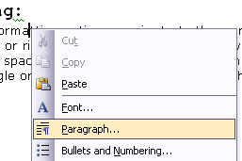

Or, in the home tab, in the section named “paragraph”, you can press the arrow in the bottom right hand corner as seen below:

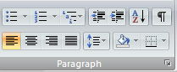

Doing either of the above will make a window appear with options for modifying spacing and indenting. Here, you can choose to make the text in your document single or double spaced, as well as edit the margins for the document.

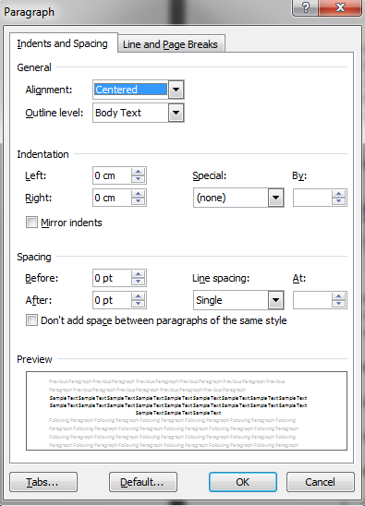

Remember that when doing your assignments, lecturers ask for a double line spaced paragraphing system to allow for easier feedback to be written on the paper copies.

Headers / footers:
Headers and footers are important aspects of a Word document if you wish to include information such as page numbers and headings on every page. To access the header and footer options, go to the insert tab and select options for the row also called header and footer

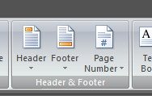

A dotted-line box called Header will automatically appear, as well as a sub-menu for formatting header and footer properties. The cursor will already be placed in the Header box. If you scroll down on your current page opened in Word, you will see a dotted-line box called Footer. To add text in the Header or the Footer, simply click the cursor inside either one of the boxes, and type the text you want.

To add page numbers to your document, simply select the page number option. The page number will then be inserted and applied to all of the pages in your document.

Footnotes & Endnotes:

To add footnotes or endnotes:

Click within the document where you want to insert your footnote / endnote reference mark.

From the reference tab, select Insert Footnote.

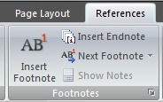

Type in the footnote or endnote in the footnote / endnote window that appears at the bottom, and click on your document above to continue typing in your document.

Using Bulleted / Numbered Lists:

Lists:
To create a bulleted or numbered list, use the list features provided by Word in the home tab.
Bulleted and Numbered Lists:
Select the Bulleted List button or Numbered List button in the home tab
- Type the first entry and press Enter. This will create a new bullet or number on the next line. If you want to start a new line without adding another bullet or number, hold down the Shift key while pressing Enter.
- Continue to type entries and press Enter twice when you are finished typing to end the list.
- Use the Increase Indent and Decrease Indent buttons on the formatting toolbar to create lists of multiple levels.
NOTE: You can also type the text first, highlight the section, and press the Bulleted List or Numbered List buttons to add the bullets or numbers.

Nested Lists:

To create a nested list, such as a numbered list inside of a bulleted list, follow these steps:

- Type the list and increase the indentation of the items that will make up the nested list by clicking the Increase Indent button for each item.
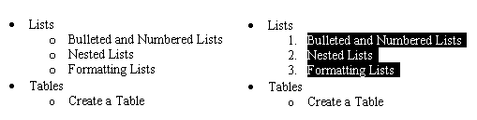
- Highlight the items and click the Numbered List button on the formatting toolbar.

Formatting Lists:

Using the Bullets and Numbering dialog box can change the bullet image and numbering format.

To do this, simply press the “define new bullet” option or “define new number format” option available to you once the previously stated buttons are pressed:

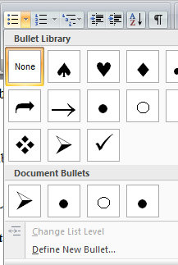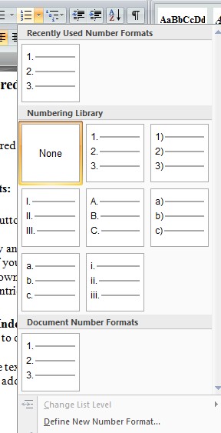

Page Size and Orientation:

Change the orientation page within the Page layout tab on the ribbon.

- Select page layout on the ribbon.
- Click orientation in the “Page Setup” section of this tab
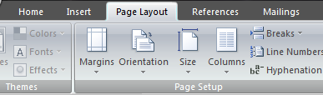

- Change the orientation from Portrait or Landscape by checking the corresponding option.

Inserting an Image:
In Word, it's possible to add ClipArt or other images to a document. Click the cursor in your document where you wish to place an image. Then go to the insert tab and select an option on the illustrations section.

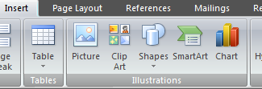

From there, you will find a number of options to choose from. ClipArt searches through your computer's Clipart library. From File will allow you to insert an image saved elsewhere on your computer. Other options include AutoShapes and Charts.

Wrapping styles:

You can further refine the layout of the graphic and text. Using the five wrapping styles, you can create documents with just the look you want.

Wrapping style | Result
The In line with text style insets the graphic in the text at the location of the insertion point. The graphic moves as you add or delete text. The text does not wrap around the graphic; white space extends to the margins on either side of the graphic. | 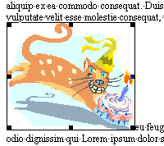
The Square style wraps the text around all sides of a square bounding the graphic. The graphic moves as you add or delete text. | 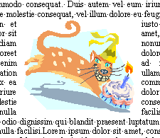
The Tight style wraps the text around the graphic in an irregular shape bounding the actual image. The graphic moves as you add or delete text. | 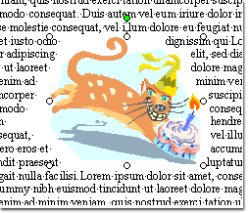
The Behind text style has no border around the graphic. The graphic floats on its own layer behind the text. | 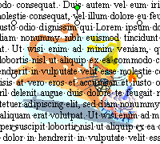
The In front of text style has no border around the graphic. The graphic floats on its own layer in front of the text. | 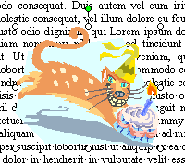
In most cases, you can get the results you want by using these choices from the Layout tab. If you want even more control in positioning your graphic, see Help on how to use the advanced layout options.

Apply wrapping styles to a graphic:
- Click your graphic to select it.
- On the Format tab that appears on the ribbon, click Picture.
- Click a wrapping style, and then click OK.

Margins:

To change page margins:
- From the page layout tab select margins
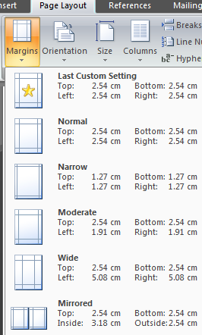
- From here there is a list of preset margins for the user to choose from that will change the entire document.

Page Numbers:
To insert page numbers:
- From the Insert tab, select Page Numbers.
- In the page numbers pop-up window, make sure the position and alignment of the page numbers is to your preference.

Suppressing page numbers on first page:
Uncheck the Show Number on First page checkbox, if you do not wish the number to appear on the first page.

Spelling and Grammar:

By default, Word 3007-2010 will automatically spell and grammar check your documents as you type. A wavy red line will underline possible spelling errors. A wavy green line will underline possible grammar errors.

Word will cycle through your document looking for possible spelling and grammar mistakes. You can choose whether to Ignore, Ignore All, Correct, Add, Change, etc. Be sure to read the options carefully. The options will change depending on whether the possible error is a grammatical one or a spelling one.

Thesaurus:

To use the Thesaurus:

1. Highlight the word.
2. Select thesaurus in the review tab on the ribbon
3. In the Thesaurus meanings box, select the appropriate meaning, and then
select the desired Synonym from the list.
4. Select Replace.

AutoCorrect:

Word automatically corrects common spelling and grammatical errors as you type. For example, if you type the word "teh", Word will change it to "the" as soon as you press the space bar. You can also use AutoCorrect as a boilerplate text. For example, instead of typing Georgia Perimeter College each time you need it, you can abbreviate by typing gpc and the Auto Correct option will automatically replace it with the entire name. As another example, you can type International Business Machines by setting up to replace the abbreviation of IBM.

Online Help:

Word offers excellent and extensive online help that can be accessed by selecting Microsoft Office Word Help. Word Help will appear in the task pane. Select Connect to Microsoft Office Online. You can find almost everything you need to know from the online help that is available.

How to Quit:
To close Word 2007-2010 completely, choose Options Menu > > Close (shortcut: ALT + F4).

Activity 1:

Key in the following text as shown (font style ‘Times New Roman’, size 12):

Your computer and you

The science of ergonomics can reach parts of the body other technologies can’t. The word ergonomics is derived from the Latin word ergon which means work, and nomos meaning laws. It is a study of the relationship between workers and their environment.

Our bodies are not designed to perform repetitive actions or to remain sitting in one position for long stretches of time. Computing requires us to stay still, staring at a VDU and performing the restricted actions required to operate a keyboard, mouse or both.

Repetitive strain injury

Repetitive strain injury, or RSI, is a general term for disorders involving arms, wrists, hands and fingers, arising from repeated actions, which cause stress to tendons, muscles or nerves. Problems occur as a result of repetitive finger, hand or arm movements, but can also be induced by poor posture and long hours of sitting in the same position – all of which are involved in the continual use of a computer.

Performing stretching exercises helps. It increases the circulation and flexibility, improves posture and reduces tension, and thus lessens the chance of injury. This should be done frequently.

Extracted from Paul Wright

Now make the following changes:

***Tip: If you’re not sure about something, try using the online help facility!!

- Using the icons on the formatting toolbar, centre, embolden and underscore the ‘Your computer and you’ heading and the ‘Repetitive strain injury’ heading.
- Change the font style and size of both headings to Arial, size 14 (formatting toolbar).
- Change the font style and size of all paragraph text to Arial, size 10 (formatting toolbar).
- Using the ‘Find and replace’ function (in the Edit drop-down menu), replace the word ‘Latin’ in the first paragraph with the word ‘Greek’. (Note: This handout does not provide information on ‘Find and replace’. You will need to use the online help facility).
- Put the two Greek words ‘ergon’ and ‘nomos’ into italic print (formatting toolbar).
- In the first sentence of the last paragraph, add the words ‘at intervals’ after the word ‘exercises’.
- Cut the last sentence of the last paragraph ‘This should be done frequently’ and paste after the sentence ‘Performing stretching exercises helps’ (icons on standard toolbar).
- Make a new paragraph after the first sentence in the first paragraph.
- Join the last two paragraphs together so that they form one paragraph.
- Indent the last paragraph (icon on formatting toolbar).
- Justify the document except for the final line ‘Extracted from…’ which should be right aligned (icons on formatting toolbar).
- Spell check the document (tools drop-down menu).

The finished document should look like this:

Your computer and you

The science of ergonomics can reach parts of the body other technologies can’t. The word ergonomics is derived from the Greek word ergon which means work, and nomos meaning laws. It is a study of the relationship between workers and their environment.

Our bodies are not designed to perform repetitive actions or to remain sitting in one position for long stretches of time. Computing requires us to stay still, staring at a VDU and performing the restricted actions required to operate a keyboard, mouse or both.

Repetitive strain injury

Repetitive strain injury, or RSI, is a general term for disorders involving arms, wrists, hands and fingers, arising from repeated actions which cause stress to tendons, muscles or nerves. Problems occur as a result of repetitive finger, hand or arm movements, but can also be induced by poor posture and long hours of sitting in the same position – all of which are involved in the continual use of a computer. Performing stretching exercises at intervals helps. This should be done frequently. It increases the circulation and flexibility, improves posture and reduces tension, and thus lessens the chance of injury.
Extracted from an article by Paul Wight

Activity 2:
Type the following text as shown:

TIPS TO AVOID PC PROBLEMS
- To avoid neck strain, sit with your VDU directly in front of you, at eye level or a little lower.
- Tilt your monitor so that you avoid reflections from windows and lights.
- Adjust the brightness and contrast of your VDU to a comfortable level. Clean the screen regularly.
- Rest your eyes by:
  - Closing them completely for a moment at intervals.
- Refocusing to a distant object occasionally.
- Blinking frequently.
- When using the keyboard, keep your forearms, wrists and hands in a straight line. Use a wrist rest if necessary.
- Put your mouse mat at a comfortable distance so that you do not have to stretch to move the mouse.
- Take frequent breaks throughout the day in order to give your muscles and joints a chance to recover from constant use.

Activity 3:
- Use the print screen button on your keyboard to copy the current screen, then paste it into your document (a screen capture / dump).
- Click on the File pull-down menu, select Print and a dialogue box appears. While holding down the Alt key, press the Print Screen button on the keyboard to copy the dialogue box, and then paste it into your document.
- Resize the screen dumps (click on the picture, hold and drag).

Activity 4:
Insert a suitable image (from ClipArt / AutoShapes / WordArt etc.) into your document and apply a Wrapping Style of your choice.



References

Richard Ericson (2006-11-06). "Final Review: The Lowdown on Office 2007". Computerworld.

