Adebare Akinwale Moronkeji
1818408
(BMSW4001- LON)
Lecturer- Peter Allen
ACADEMIC & employability skills

Student Name – Adebare Akinwale Moronkeji
Student ID – 1818408
Programme of Study – Academic and Employability Skills (BMSW4001 – LON)
Assignment Title – Academic and Employability Skills
Lecturer- Peter Allen

Executive Report
Reflective writing is a process of looking at an event or a collection of events, how they happened, the interpretation of events, the evaluation of events that took place or occurred, analysis of events and planning for future expectations or outcome. Reflection however, is where you analyse something that has happened in order to learn from it and improve your practical application in the future. In reflective writing, there is the need for critical thinking, in order to have a worthwhile presentation at last. Reflective writing involves learning power, mindfulness, application and summarising.

Academic and Employability Skills
What is a skill? A skill could be well described as the ability to do things or something well. Also, it could be described as power to follow a task through to a logical conclusion. There are so many skills available to we human beings. Such skills available to us could be skills such as: personal skills, leadership skills, learning skills, presentation skills, writing skills, numeracy skills, parenting skills and a host of others.
Personal skills are skills that are based on how one personally maintains a healthy lifestyle, both physically and mentally taking care of the wellbeing of the mind and body. Leadership skills, are the abilities to perform a lead role effectively and successfully. These skills are highly sought after and in great demand in places of work. It includes motivation, enthusiasm and respect. Someone who can move people to do tasks given at any time.
Learning skills are skills that one acquires along the way as we grow and develop in life. These include formal and informal experiences and ideas that we stumble across in our developmental stages. Those things we learn from, encounter and allow ourselves to grow from them.
Presentation skills are skills that we display when we are getting our messages or information across effectively. Lack of ambiguity in delivering of our messages, information, opinions and new ideas to our superiors, subordinates and colleagues. These skills are very essential and of paramount importance in every life endeavour. One could be, a student, an administrator, executive, politician, business person or entrepreneur. One needs presentation skills.
Writing skills are skills that allow you to disseminate your information, ideas, message and opinion to a wider audience. It is not practically possible to present one at every occasion. Clarity of purpose is essential through non-face to face communications. Writing to get information, writing to make a demand, writing to apply for or demand for something. Writing to complain about issues of special attention. Writing to strategise at a workplace. Writing a press release on behalf of oneself or organisation we represent. A well written curriculum vitae (CV) with no grammatical blunders or spelling errors is very essential for a good job prospect.
Numeracy skills, are skills that we acquire through learning basic counting, adding, subtracting and multiplying. These skills are not only for scientific professionals, neither are they solely for accountants nor cashiers at the tills. Numeracy skills propel people to well paid jobs, higher standards of living and life with less stress. These skills are worth acquiring.
Parenting skills are skills that tend to be one of the hardest set of skills for human beings to possess. These are the skills we need to equip another human being with useful life skills. Children are not born with parenting manuals or upbringing instructions. Some books, materials and websites available for parenting skills make things complicated.
Reflective writing
When I was in one of my previous places of work, there were about 23 of us in the workforce, the work force consisted of a diverse racial and cultural mix. When a task needed to be carried out, most of the time the junior cadres of the work force did the most arduous parts of the job. One day, I sat down and took inventory of my progression at the work place, it gave me a sad reflection. I decided to go and acquire a skill that would give me a sort of independence and control of my own life. The interpretation I got from the working environment propelled me into action. I decided on an upward movement in my personal career. The options that were opened onto me were limited due to cash/ capital constraints. Nevertheless, I took a bull by the horn and went to become a driving instructor. Though the process was capital intensive the outcome was highly rewarding. I left a 9-5 job, became my own boss and was then able to determine when I would and would not work. I was able to earn more money which aided me in working towards gaining financial stability. My lifestyle was less stressful and I was able to spend more time with the family and have more time to myself for exercise, leisure and socialising. After all this I evaluated how far I have been and how much better and further I could go. Now is the time to explore another area of academic excellence. That is pursuing a career in learning modern techniques of doing things. What will the introduction of artificial intelligence (AI) do to my current job? Will I still be gainfully employed in the next ten to twenty years? This is a soul searching that needs urgent attention.
The plan for the future must start now. That is why I decided to follow a path of education. Learning they say, never stops. It is from cradle to grave. Knowledge is a pre-condition to a noble and good character, ignorance left a man no better than a slave. Reflecting on the past, considering the present and gazing towards the future. I realised that, the future is already here. My experience, my belief and feeling is transforming my life from tedious, repetitive tasks to more challenging roles in the future.
Employability Skills
In the next discussion, I am going to explain the skills that are necessary for the future that I intend to achieve. Organisation is very important. Failure to organise or prepare, is preparing to fail. We need thinking skills, writing skills and presentation skills. These are the skills necessary for some of the tasks ahead. Also, there are some skills that will aid or support my effective learning. These skills include understanding oneself, adaptive skills, academic skills, transferrable skills and job-related skills. Getting to know oneself will depend on the (SWOT) analysis. That is the strengths that you possess, weaknesses that you know you possess that could be a hindrance to yourself or your progress, the opportunities that are there for you. Lastly, what threats do you envisage that you may encounter. Furthermore, there is need for personal planning, evaluating, achievements and personal appraisal if need be. In personal development planning, there are list of goals, both achievable and non-achievable. There is need for a time scale for the attaining of set goals. The progress made or attained should be monitored. There must be a continuous assessment, addressing the pitfalls that may arise is very important.
In conclusion, the aforementioned points are more crucial in employability skills. They are communication, teamwork, problem solving, taking initiative and enterprise, planning and organising, self-management, learning and technology.
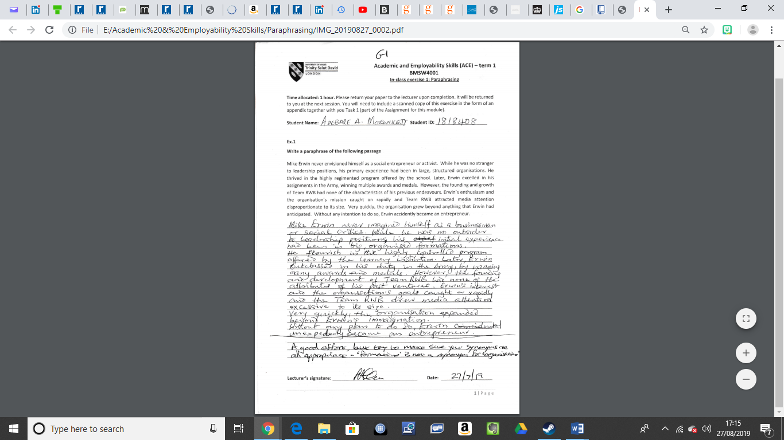
Appendix 1.1

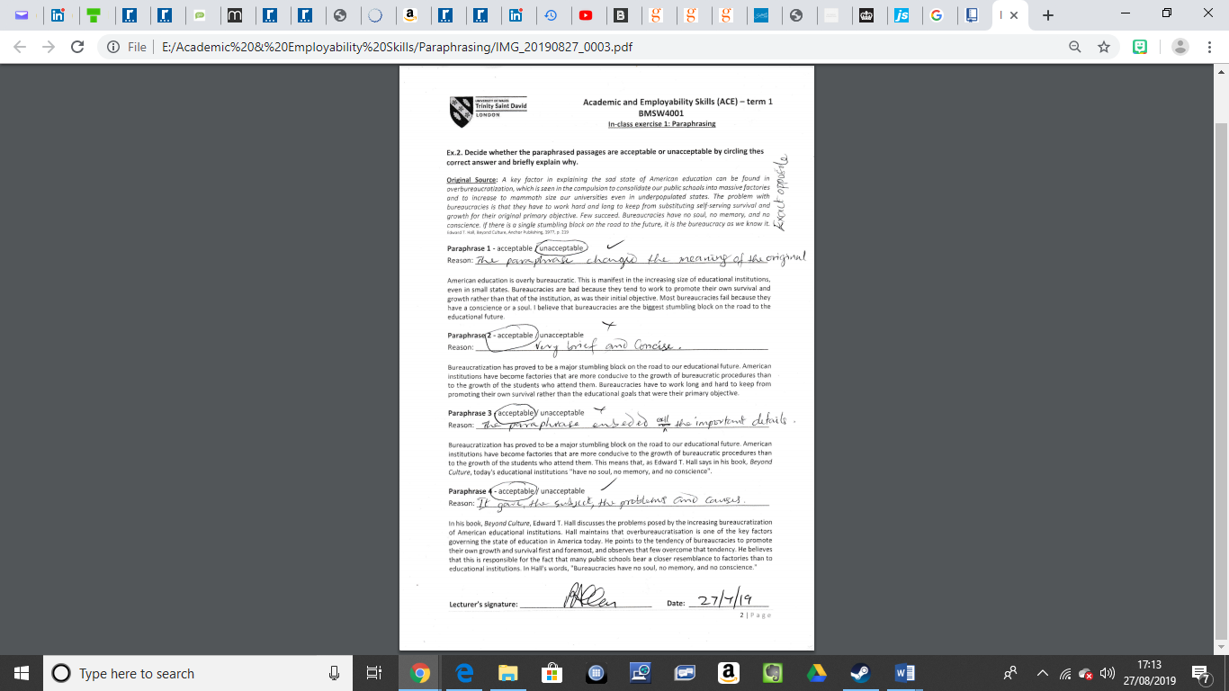
Appendix 1.2

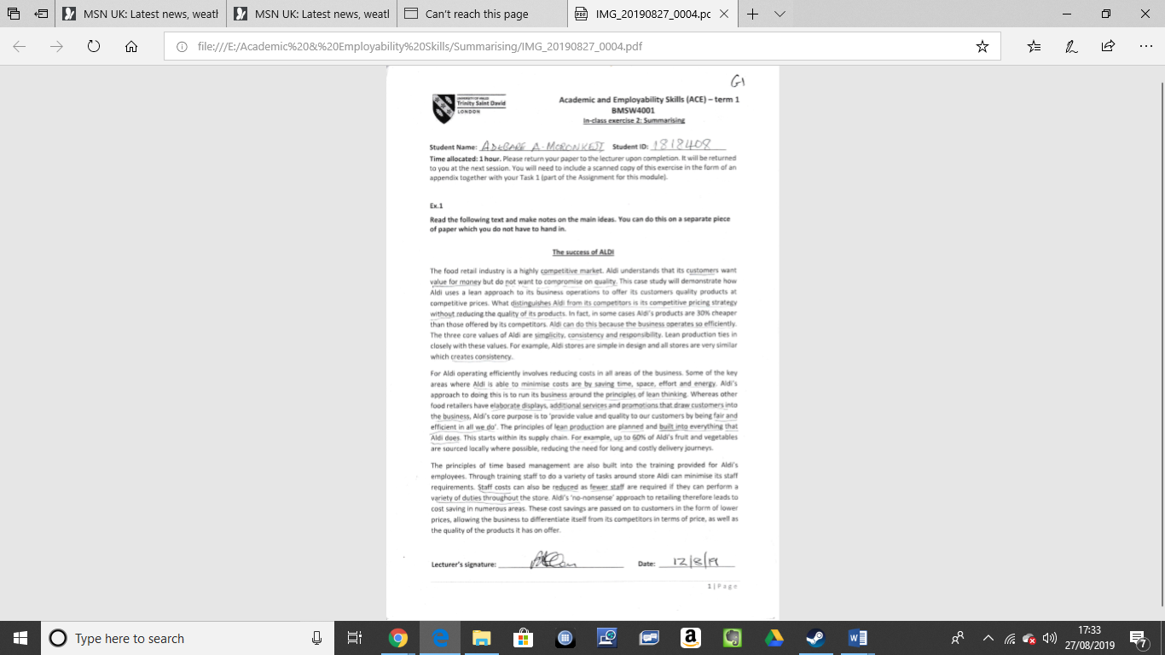

Appendix 2.1
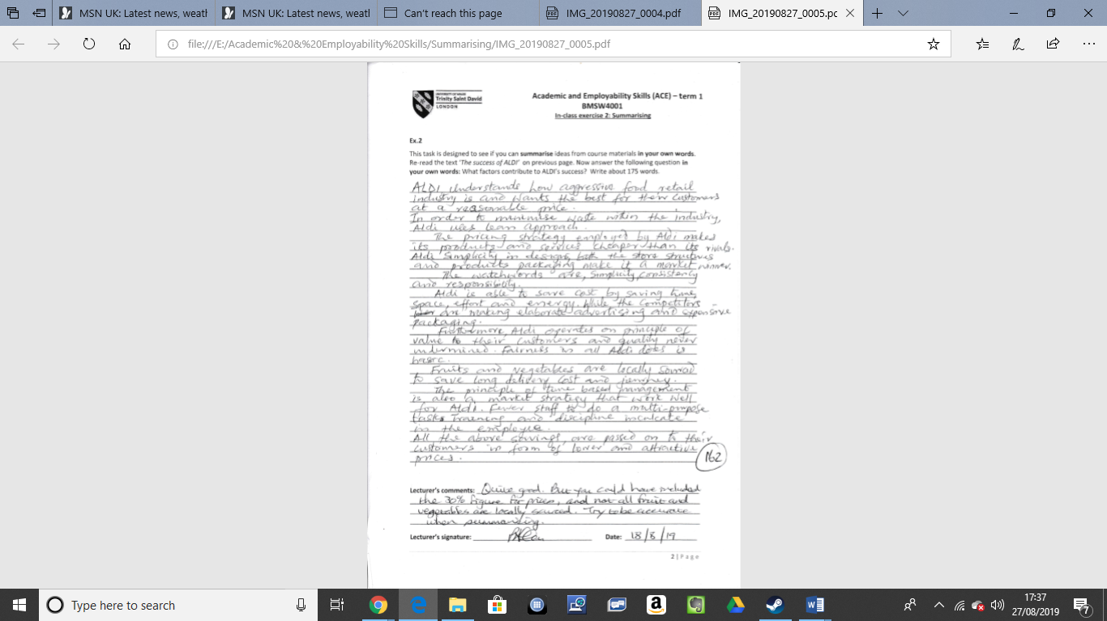
Appendix 2.2

References
Anon, (n.d.). Reflective writing: a basic introduction - ask.fxplus.ac.uk. [online] Available at: https://ask.fxplus.ac.uk/sites/default/files/public/reflective%20writing.pdf [Accessed 2019].
Anon, (n.d.). WRITTEN Reflective writing: a ASSIGNMENTS basic introduction. [online] Available at: https://www.bradford.ac.uk/academic-skills/media/academicskillsadvice/documents/academicskillsresources/personaldevelopmentplanninggoalsettingandsapra/Reflective-Writing-Infosheet.pdf [Accessed 2019].
Kent.ac.uk. (2019). Employability Skills - Careers and Employability Service - University of Kent. [online] Available at: https://www.kent.ac.uk/ces/student/skills.html [Accessed 25 Aug. 2019].
Morgan, P. (2017). The business student's guide to study and employability. London [etc.]: SAGE Publications, p.436.
Skillsyouneed.com. (2019). Skills You Need - Helping You Develop Life Skills. [online] Available at: https://www.skillsyouneed.com/ [Accessed 27 Aug. 2019].

