Learning in the Digital Era
Assignment 1: E-Portfolio
Sukhpreet Kaur
2542000
CertHE Computing Skill for Workplace

Table of Contents
E-Portfolio 2
Task 1 Summary 2
Task 2 5
Task 3 6
Task 4 8

E-Portfolio
https://uniwales.wixsite.com/sukhpreet-kaur
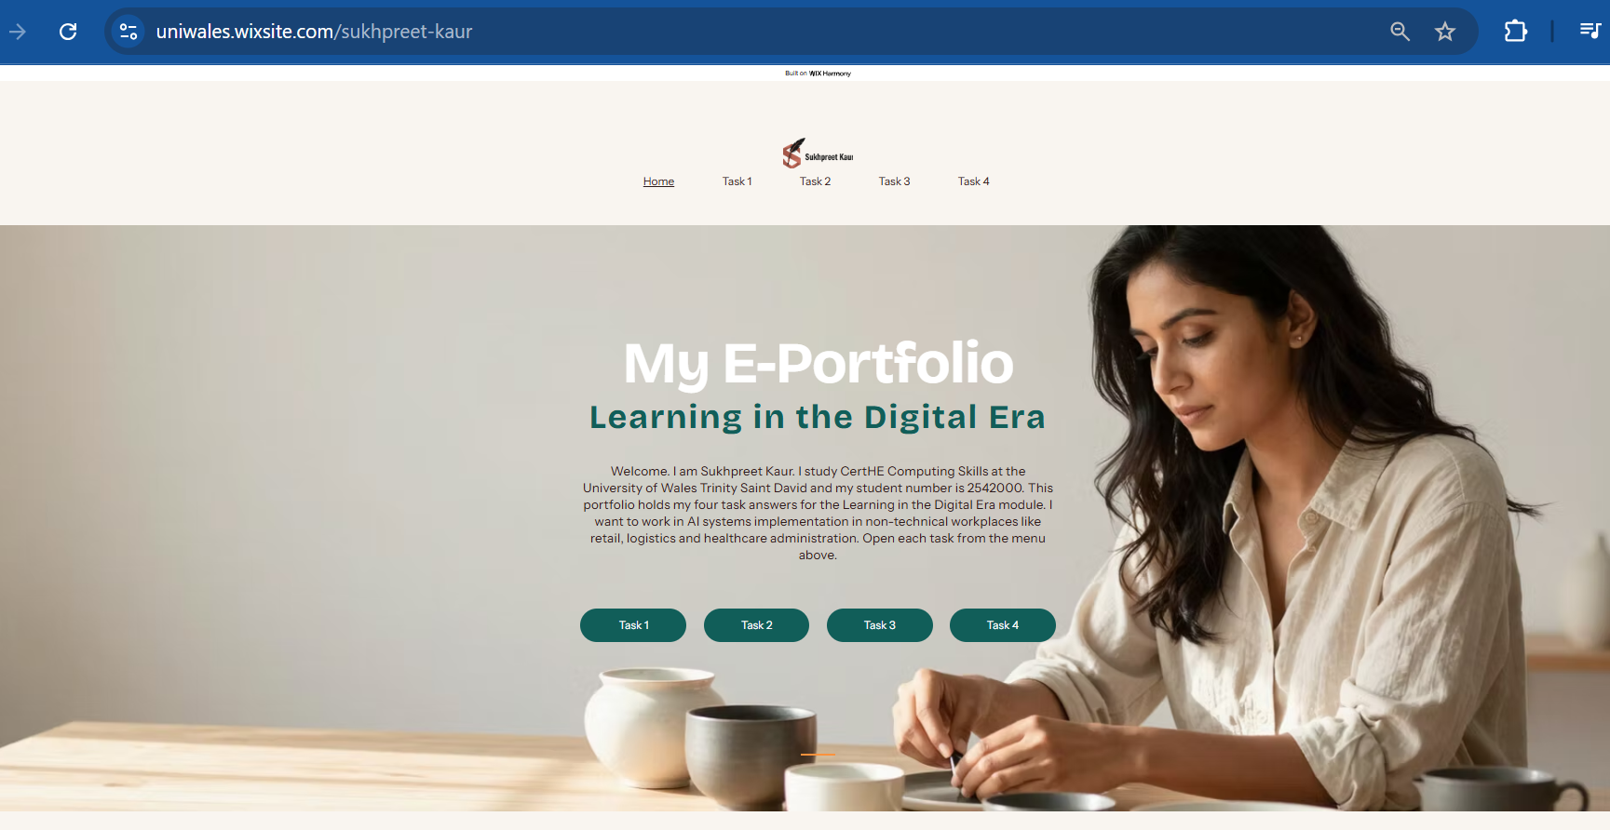

Task 1 Summary
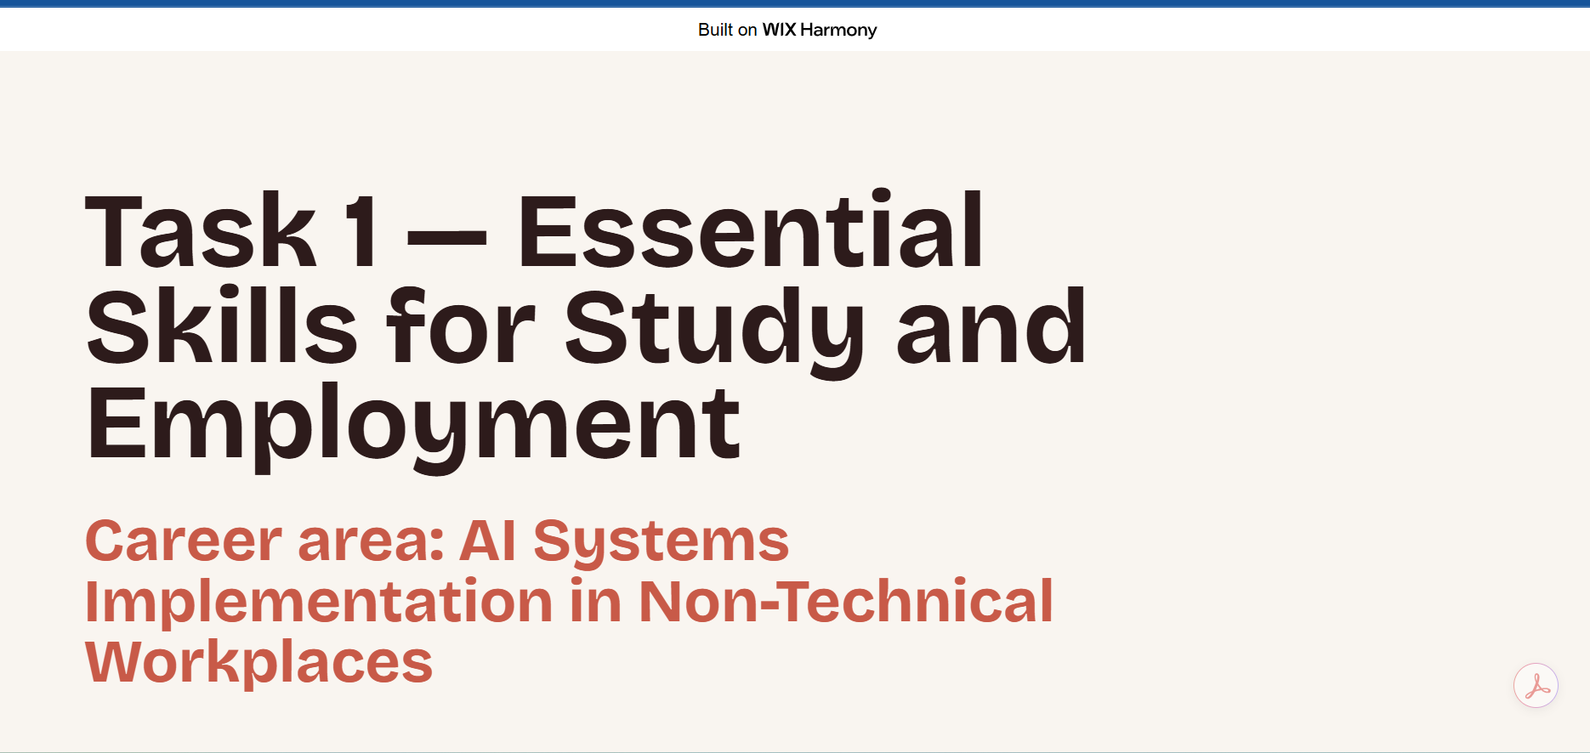
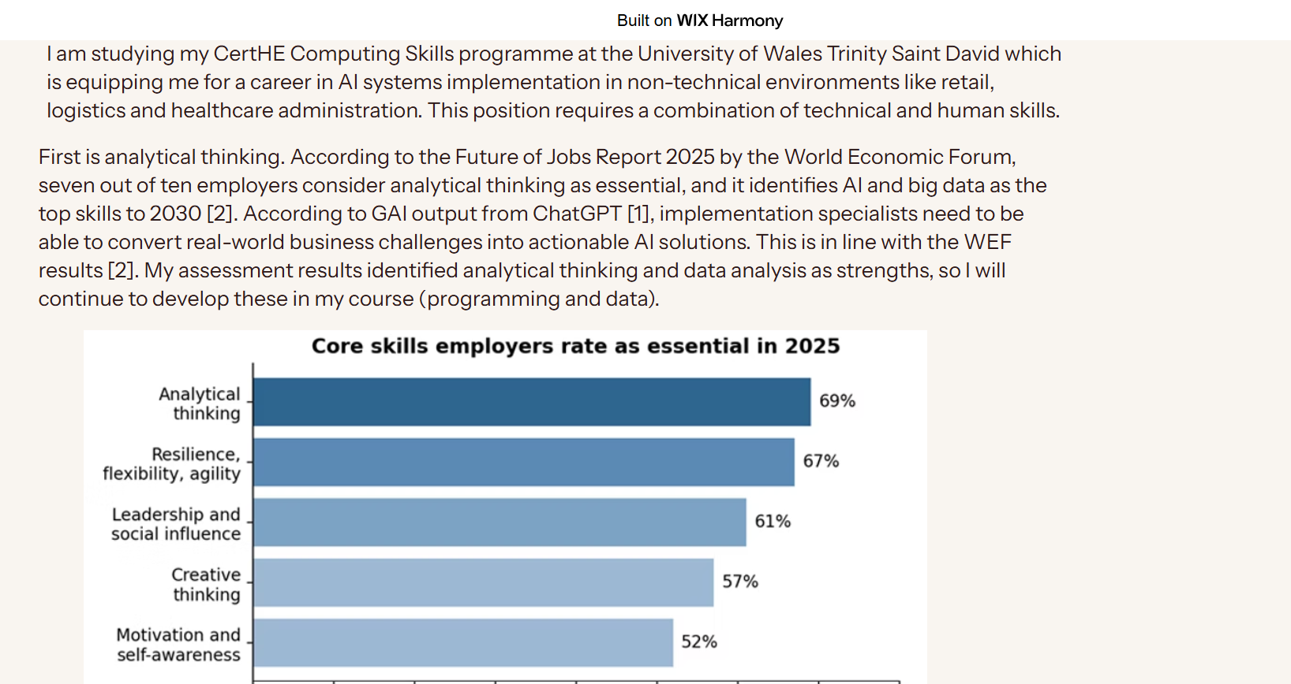
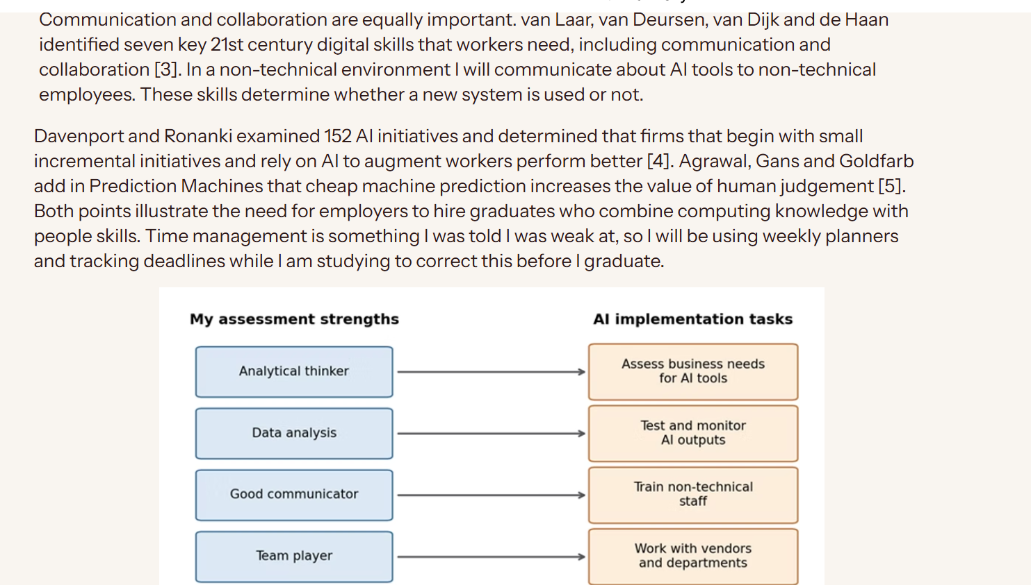
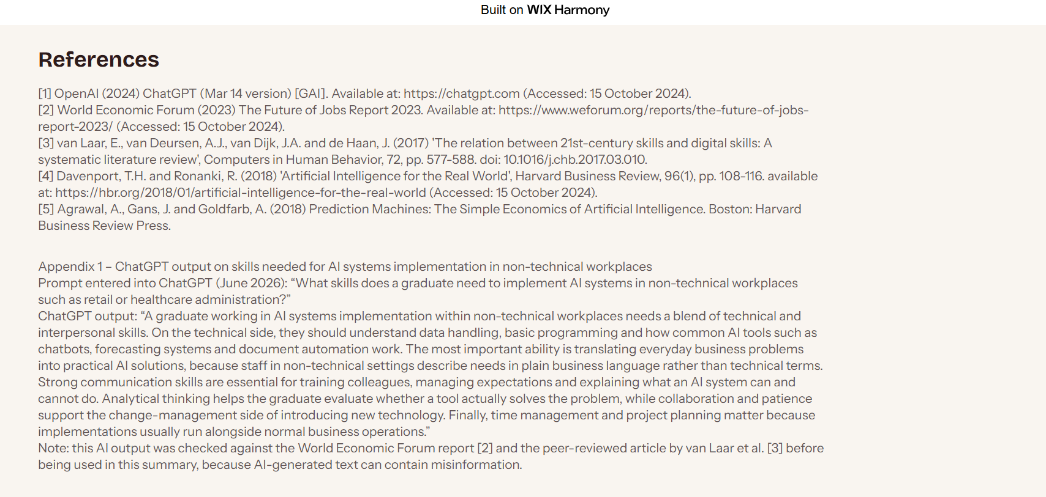
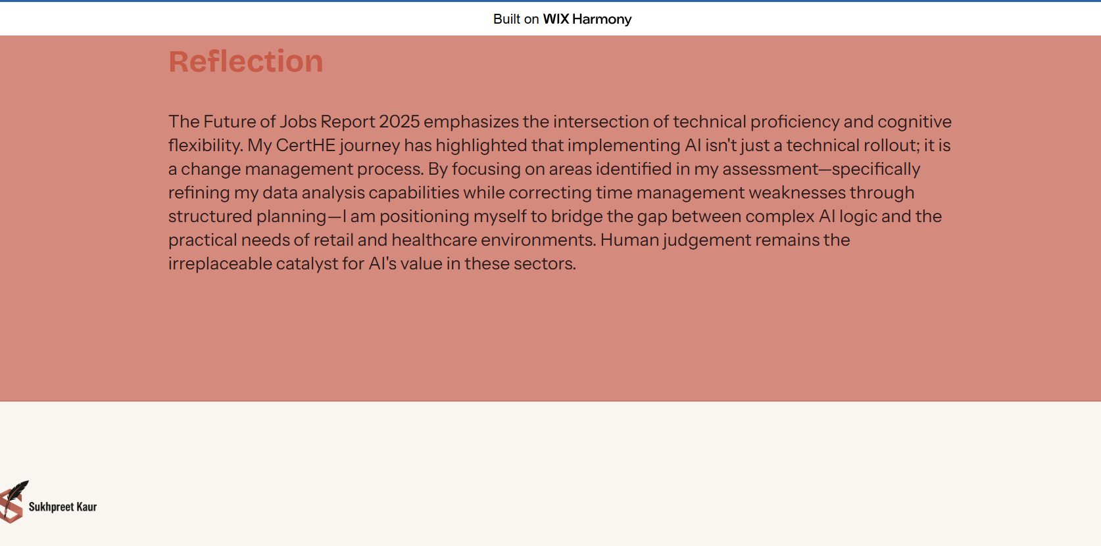

Task 2
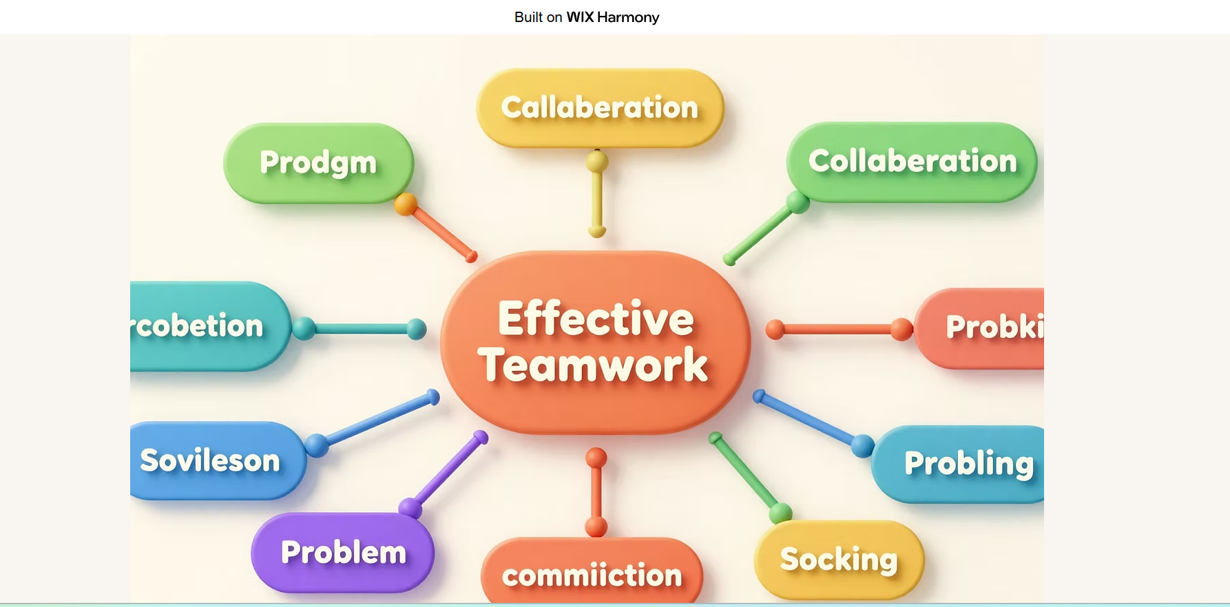
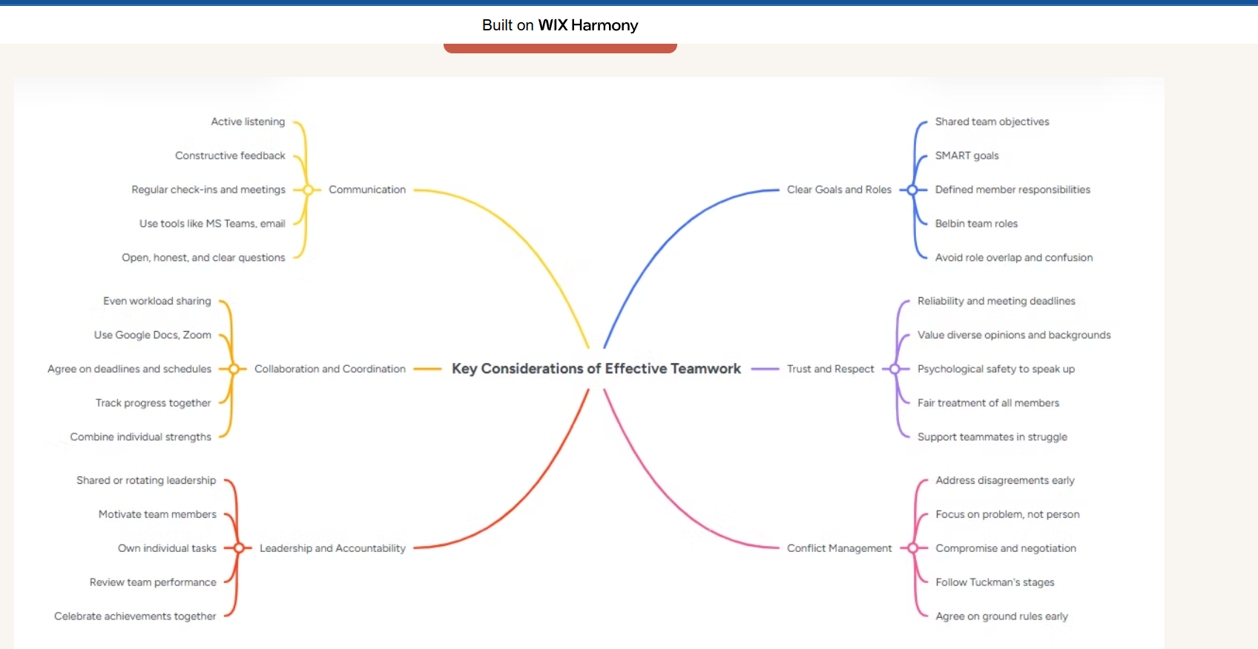
https://mm.tt/map/4037648193?t=AjHN5DtuTx
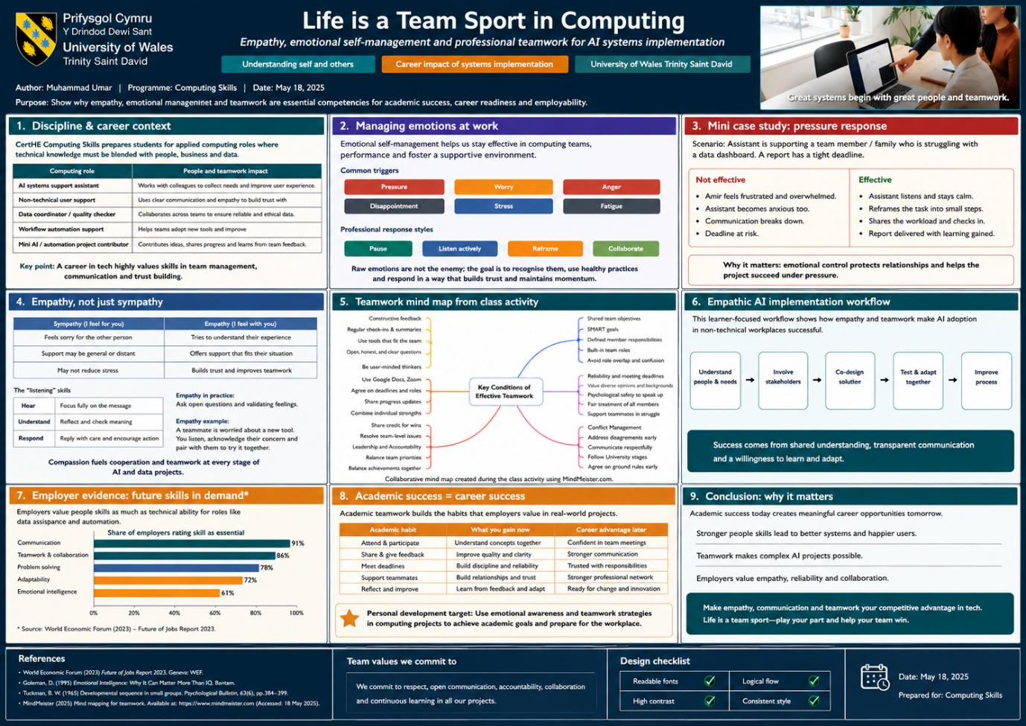
poster image.png

Task 3
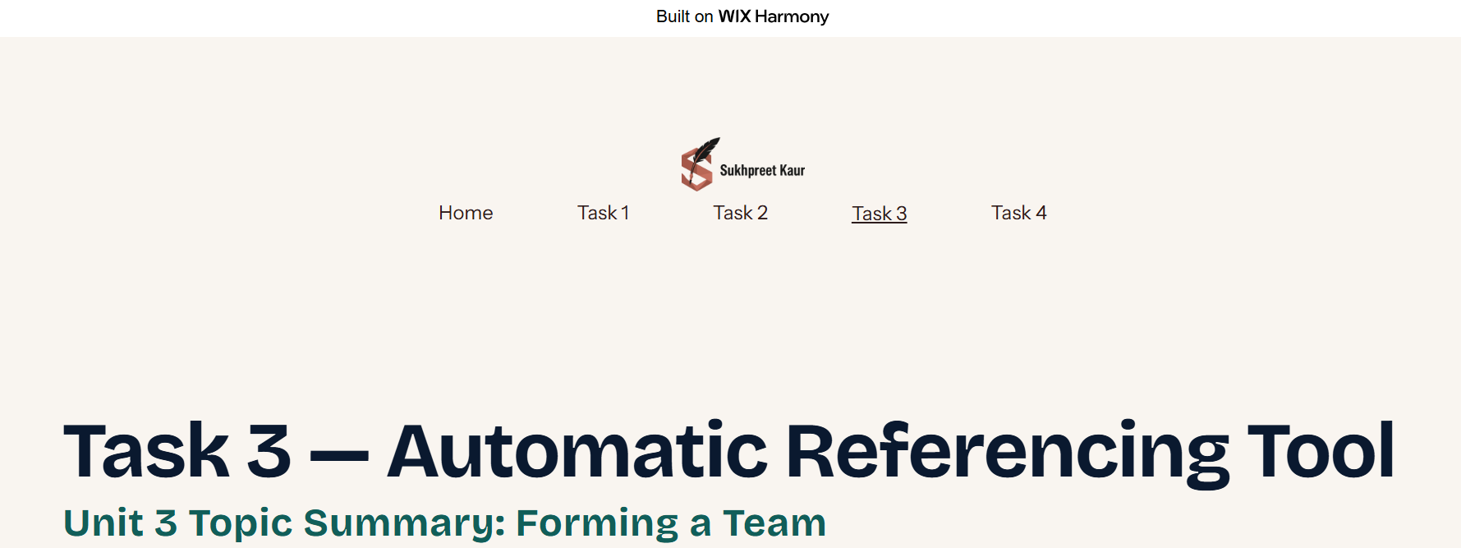
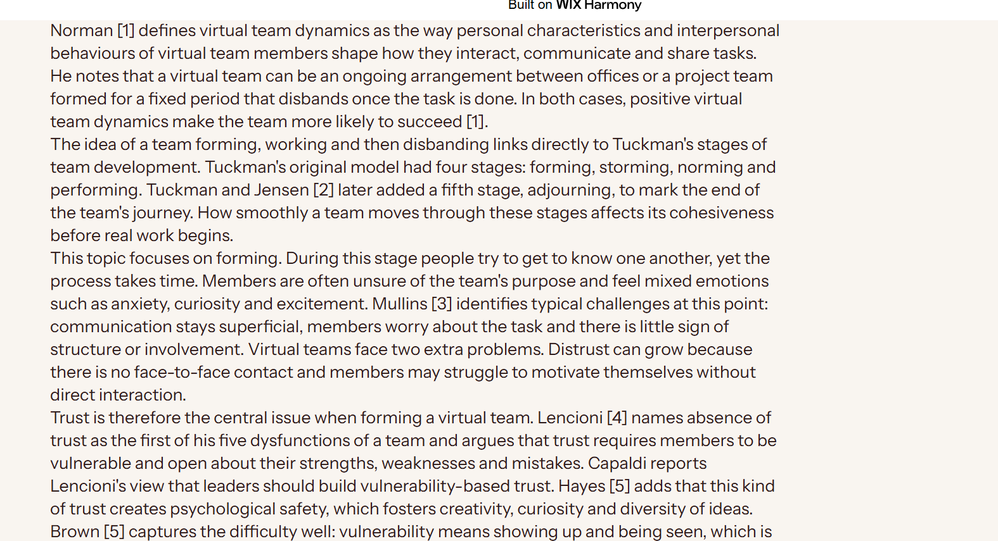
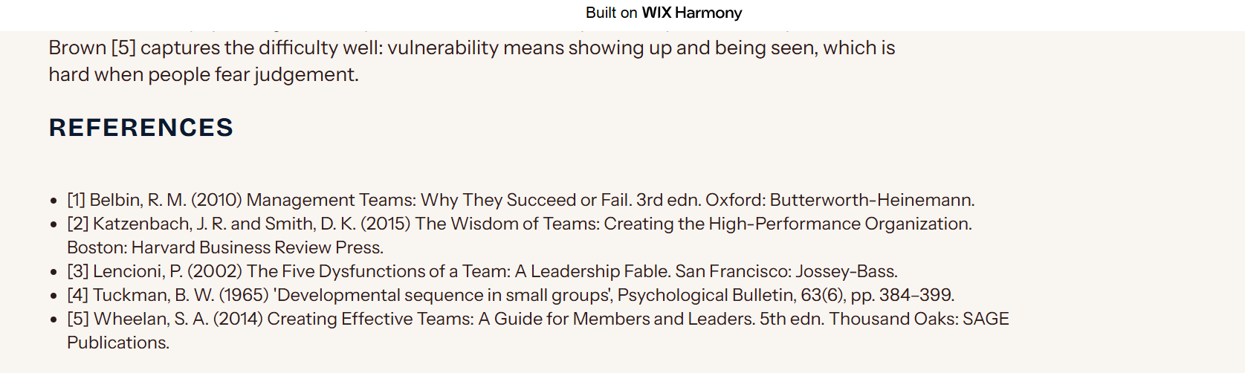
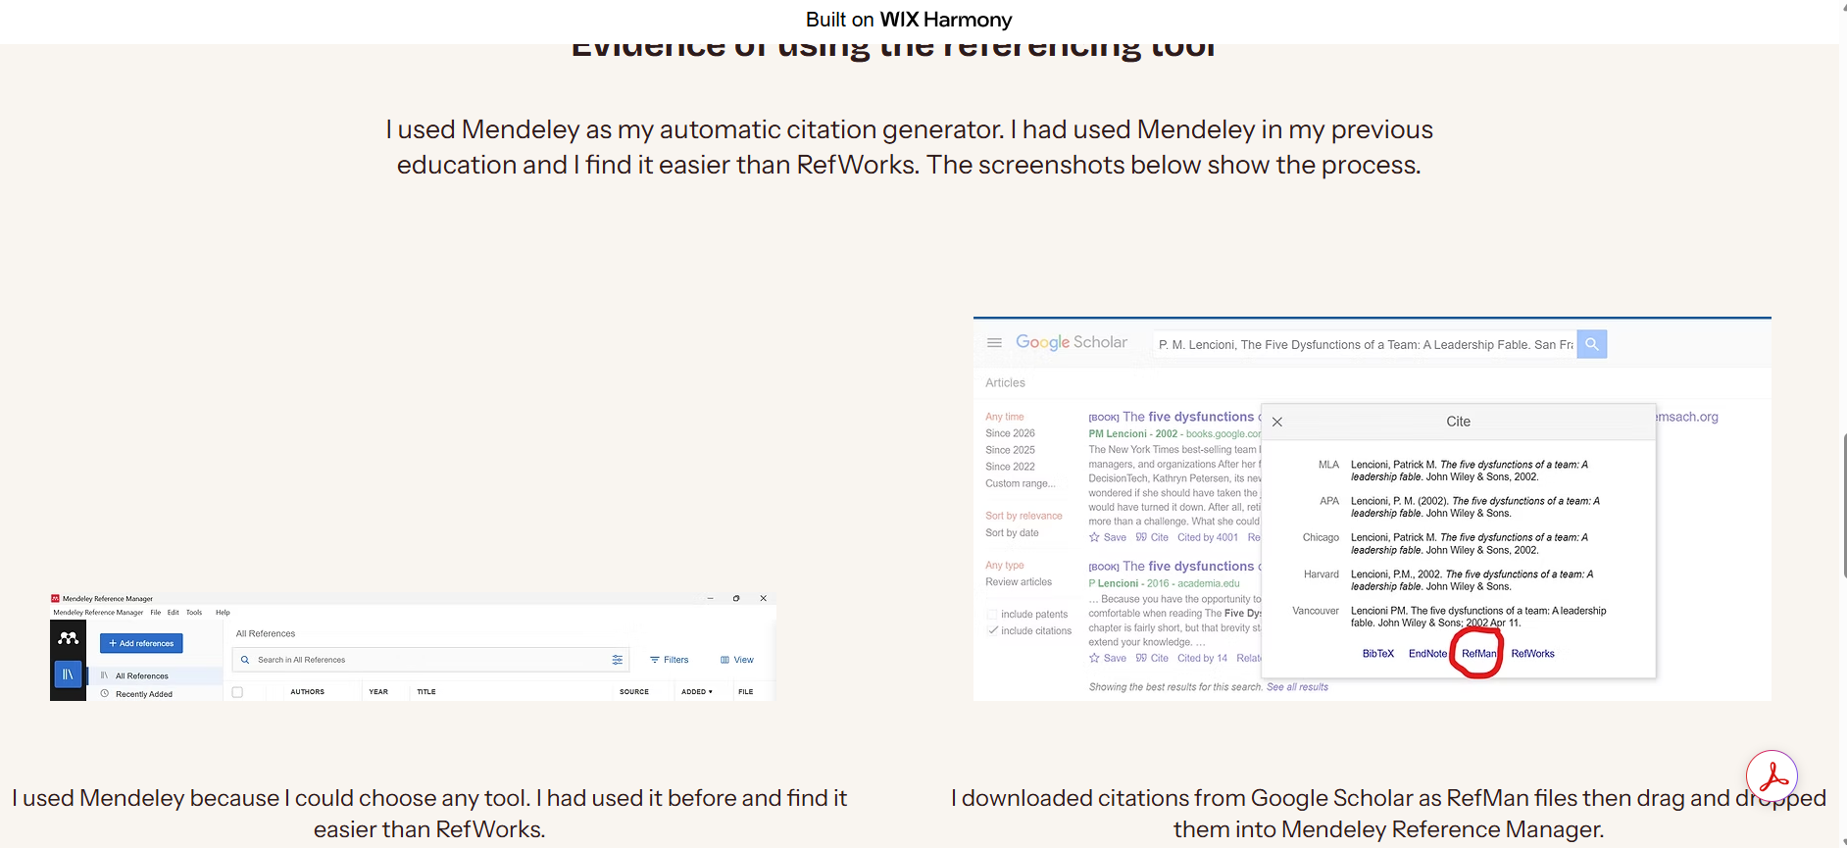
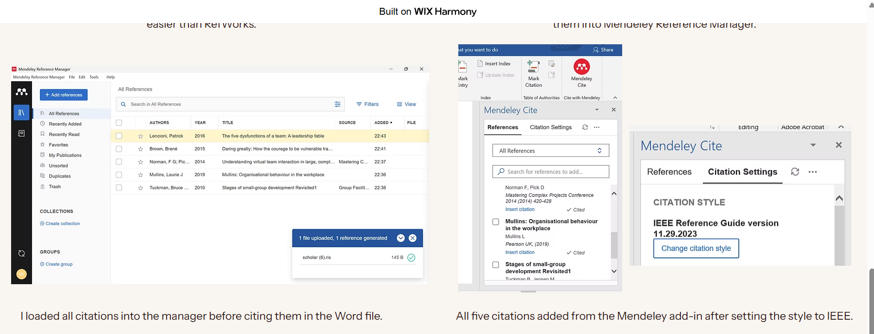
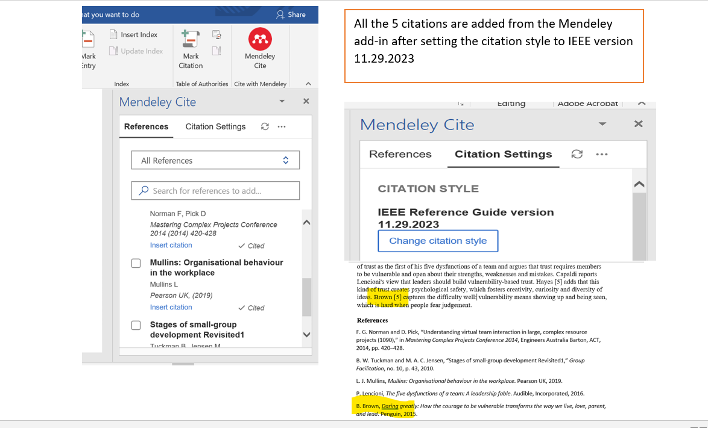

Task 4
https://uniwales.wixsite.com/sukhpreet-kaur/task-4 

