Richard Bakewell (2204367)
Date submitted: 18/10/2023.
BA Archaeology
Module: HPHP4018
Module Lead: Quentin Drew
A discussion on the nature and direction of Archaeology and it’s relationship within the wider range of humanities.
This essay discusses the nature and direction of archaeology and its connection with the broader scope of humanities subjects. The paper begins by briefly outlining what archaeology is, its main aims and objectives, ethical and moral dilemmas, and its importance today. Secondly, it discusses the subject's future, including the current state within the education sector, how it can assist in tackling global issues and the advancements in technology and science. Finally, it examines its role and place within the sciences and humanities and how it benefits from and contributes to interdisciplinary collaborations.

Archaeology' comes from the Greek 'arkhaiologia', translated as 'the study of ancient things' (Blau, 2014), and is a unique field that aims to comprehend and reconstruct past human behaviour, culture, beliefs, values, and society by analysing material evidence (Fagan and Durrani, 2016, p. 6). Archaeology is a critical field for the scientific study of human history and prehistory through the excavation and analysis of artefacts, structures, and other physical remains. It is both an academic and physical pursuit that requires a creative and imaginative mind (Renfrew and Bahn, 2020, p. 12). The objective is to preserve and protect these remains to benefit future generations (Fagan and Durrani, 2016, p. 66). It educates us on the emergence and evolution of human societies and the development of social, political, and economic systems throughout history. Archaeology has a wide range of coverage, dating back several million years to when our human ancestors roamed the earth, leaving behind scarce evidence (Tryon et al., 2010). However, our understanding of human civilisation is limited to just two hundred years of archaeological practice and exploration (Yoffee and Fowles, 2011). Archaeological work aims to explain past events of human history, particularly during periods with limited or scarce written records, to understand the tapestry of human history and the diversity of cultures. Unlike historians who rely solely on written documents, which often present only one perspective or opinion to explain the past, archaeologists strive to provide verifiable information supported by evidence (Pyddoke, 1964, pp. 9-16).

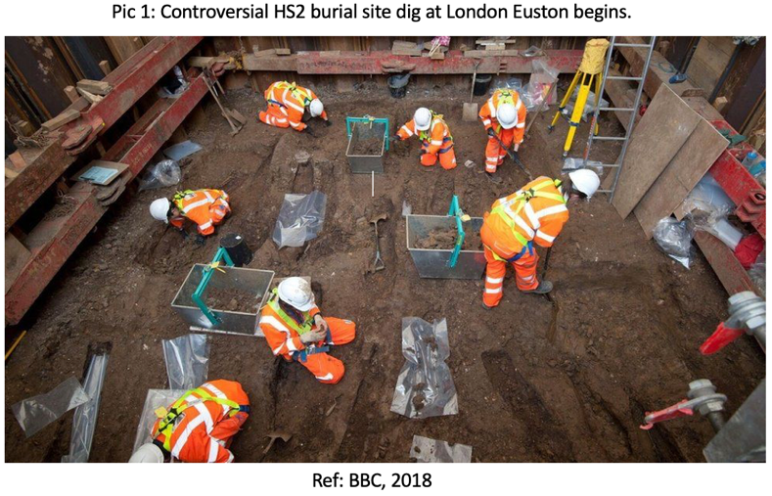
Ethical and moral dilemmas can arise in the field of archaeology. Ethics in the past would be concerned with the scientific methods used during excavation, that the process was documented correctly, the publishing of a report, and that artefacts ended up in museums and not in private collectors' hands (Zimmerman et al., 2003, p.3). However, ethics now include various viewpoints and concerned parties, such as indigenous people, whose concerns must be considered (Scarre and Scarre, 2006, pp. 1-11). Another ethical question is how far archaeology should impede the progress of modern life, for example (Pic 1), the construction of roads and rail networks (Renfrew and Bahn, 2020, p. 17). Moral questions such as respectfully and professionally handling human remains found during excavations require thoughtful examination of their research potential and ethical implications (Swain, 2013). Archaeologists are required to follow a set of ethical guidelines and moral principles while conducting their work. This helps them decide what is right and how to act accordingly. They can seek assistance from organisations like the Chartered Institute for Archaeologists, which provides an archaeological ethics database (Chartered Institute for Archaeologists, 2023) for guidance.

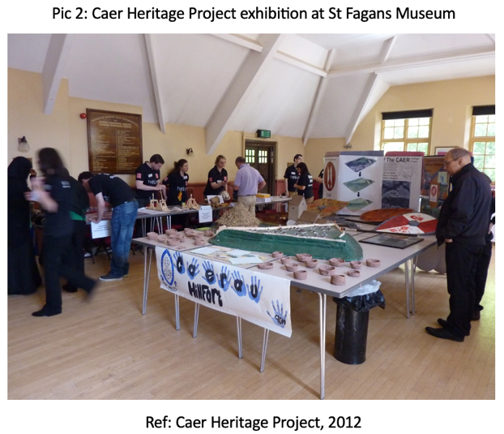
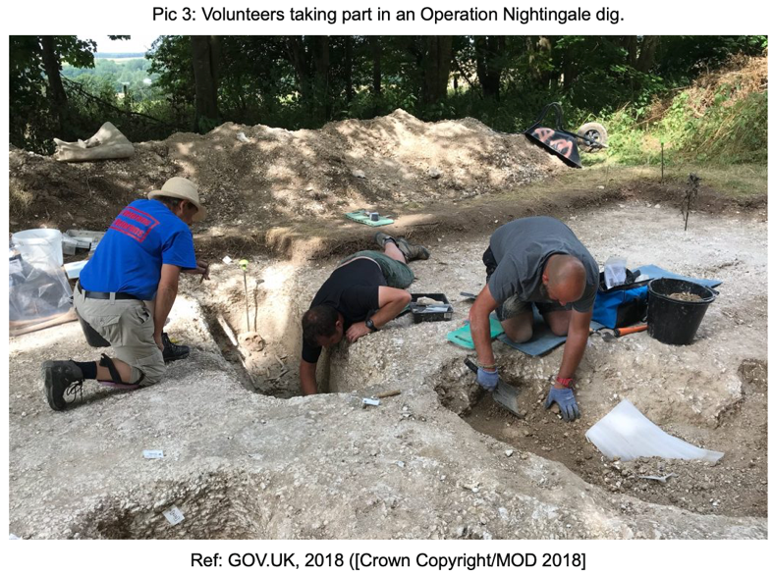
Due to the government's strategic priorities and focus on promoting STEM subjects, funding cuts for university teaching of humanities subjects threaten the discipline's future (The Conversation, 2021). Archaeology programs at universities like Sheffield are under threat, which is concerning for the future (BBC, 2021). The possibility for students to study archaeology in secondary school is decreasing, as exam boards like AQA (AQA, 2023) have announced that it will no longer be included in their syllabus (The Conversation, 2016). Archaeologists now engage with the public through various educational initiatives, including community projects (Pic 2) to school engagement (Caer Heritage Project, 2023), initiatives such as Op Nightingale (Pic 3), providing opportunities and support for military veterans (GOV.UK, 2020). Engagement with the public about archaeology and heritage conservation, sharing information and encouraging participation is increasingly important to keep the discipline in the public eye and avoid its demise (Chartered Institute for Archaeologists, 2023). The UK employs over 7,000 archaeologists in various roles, and a 2019 report (Federation of Archaeological Managers and Employers, 2020) shows that heritage tourism is worth £17 billion to the economy, highlighting the importance of this field (The Conversation, 2021).

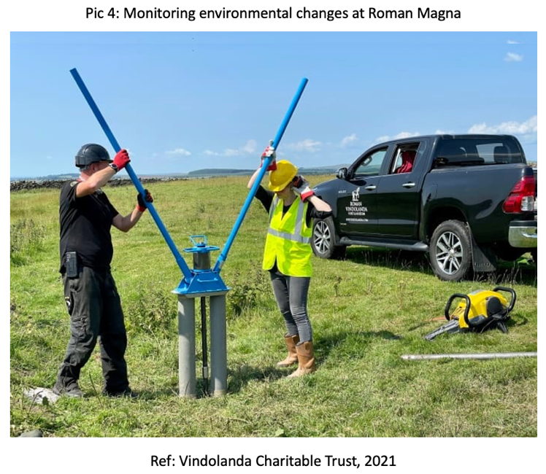
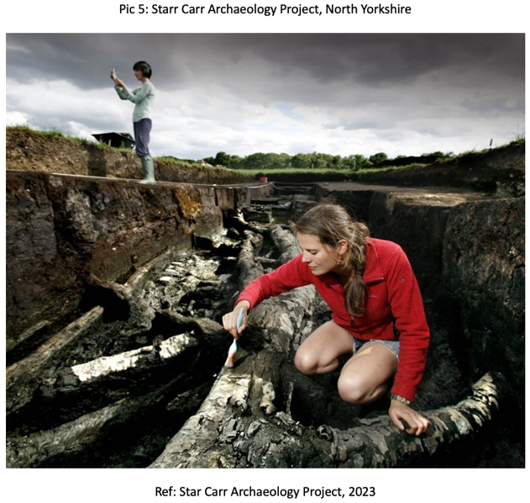
The future may also examine how archaeology can assist with tackling today's issues by collaborating with other fields to find solutions to significant problems that face humankind, such as climate change, health, conservation, and heritage (Lewis, 2018). Learning from history and what our ancestors faced and how they dealt with it equips us to make wiser and more informed decisions in the future backed by evidence and not just theory. Evidence of past human interactions with natural and social environments will assist in informing the present (University of Oxford, 2023). For example, archaeology has helped with agricultural techniques and future farming practices due to historical evidence (Reed and Ryan, 2019). The University of York BioArCh facility, which runs SeaChanges, examined how marine vertebrates were exploited to aid biodiversity recovery (The Conversation, 2021; University of York, 2023). Climate change significantly threatens archaeological sites globally (Hollesen, 2022). The increasingly hot summers and wetter winters have caused landscape alterations by eroding soil layers. To illustrate this, the Roman site of Magna (Pic 4), located in Northumberland, is being closely observed to assess the impact of these weather changes on such sites (The Conversation, 2022; Vindolanda Charitable Trust, 2019). Another example of environmental change affecting archaeology is at Star Carr (Pic 5) in North Yorkshire, a Mesolithic site of national importance, where the deterioration of artefacts is due to geochemical alterations (The Conversation, 2016; Boreham et al., 2011).

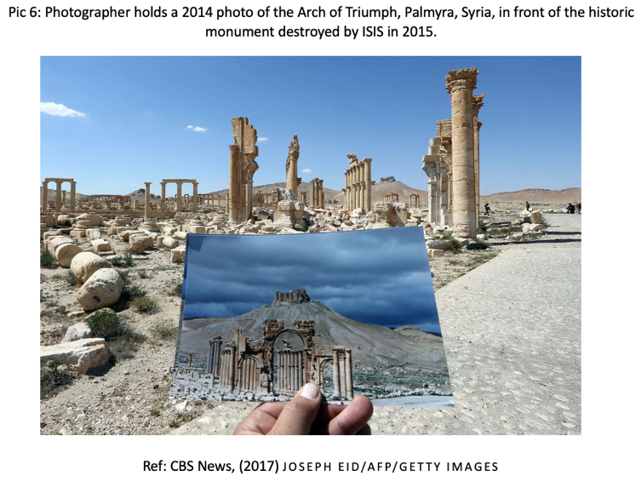
Environmental change threatens archaeological and historical sites, while war and criminality have caused significant damage and looting (Elia, 1997), as the Islamic State routinely damaged and destroyed historical sites such as Palmyra (Pic 6) in Syria (National Geographic, 2015). The looting in nations such as Egypt, Syria, Lebanon, Iraq, and Afghanistan find their trade in these stolen items profitable in the markets of Europe. This is despite many countries signing up to UNESCO (UNESCO, 2023) conventions to combat this trade (Polk, 2014). These criminal acts are nothing new and have been carried out for generations. Climate and environmental change and ongoing instability in some areas of the world bring a new urgency to protect the world's heritage from being lost forever (Scientific American, 2022).
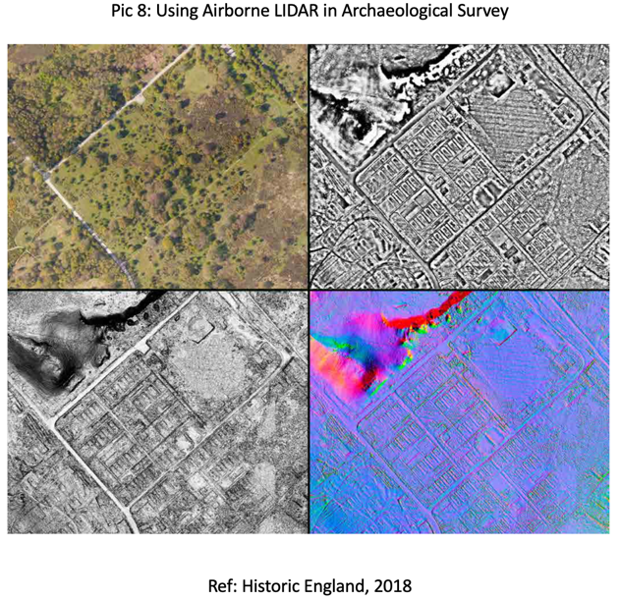
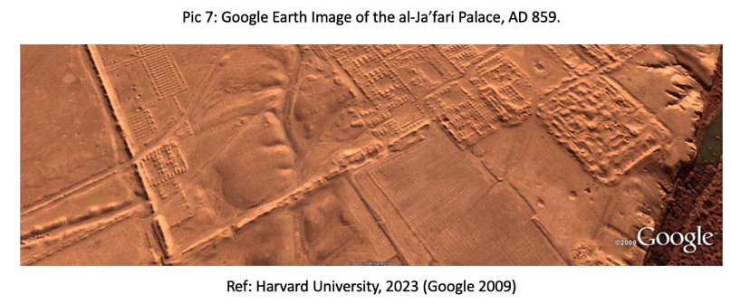
The future of archaeological practice may rely on advancements in technology rather than the more traditional excavation techniques, as noted by the historian Mary Beard (BBC, 2014). The continuous progress of technology has dramatically influenced the field (NBC News, 2017). Archaeology has access to several notable technologies that aid in their research. For example, with the help of satellite imagery, even the most inaccessible regions of the world can be studied using commonly available tools like Google Earth (Pic 7) (Luo et al., 2018). Although these resources can help identify signs of settlements or foundations, the presence of archaeologists on site is necessary to clarify the findings. LIDAR, or Light Detection and Ranging Technology (National Oceanic and Atmospheric Administration, 2023), is an excellent tool as it generates a three-dimensional image, providing the added benefit of penetrating through foliage that would typically obstruct visibility. Drone technology can achieve unique aerial photography of a site (Campana, 2017). The recent development of LIDAR drones (Pic 8) presents enticing archaeological opportunities (Casana et al., 2021). Advancements in shallow geophysics have allowed surveying much larger areas in real time. Rapid sample recording has been made possible through advances in soil geochemistry. Additionally, the ground-penetrating radar software has undergone improvements, enabling three-dimensional modelling that enhances the reliability of imaging for users (The Conversation, 2015). Technological advancements within the field allow archaeologists to see below ground to an extent without breaking ground. With the threats of environmental and climate change affecting archaeology yet to be found, these tools allow new discoveries to be documented for future archaeologists to explore. Archaeological science has progressed rapidly over the past two decades with advancements in dating, where analysis can now be made on individual molecules, stable isotopes, trace element analysis and protein and proteomics. It is crucial to ensure that ethical considerations are not overshadowed by the development of science in the management and care of the involved artefacts, as noted by Birch and Szpak (2022).
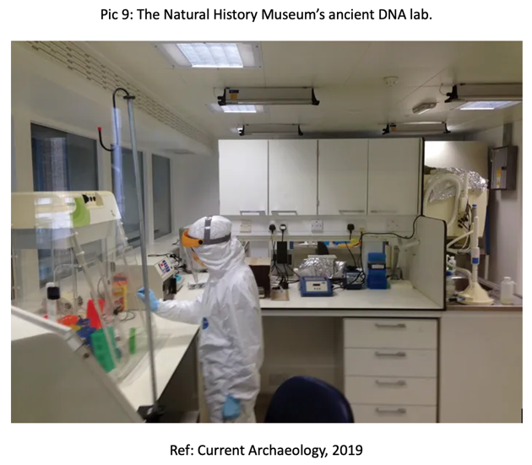

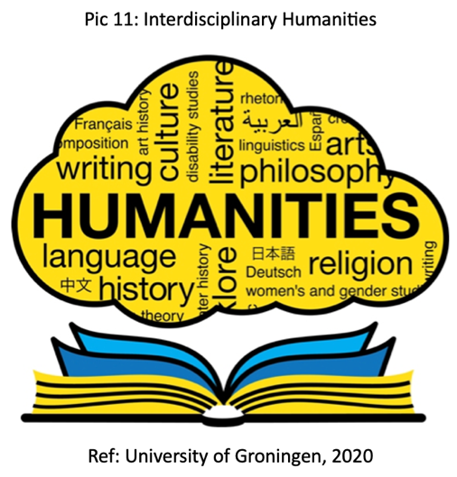
There's often a debate about whether archaeology is a natural or social science. Natural science (Cambridge Dictionary, 2023) deals with hard facts that can be precisely reproduced by following the same method (Pic 9). On the other hand, social science (Cambridge Dictionary, 2023) deals with the human element and is open to interpretation (Pic 10). Archaeology falls somewhere between the two disciplines as it draws aspects of both (Smith et al., 2012). As summarised above, archaeology studies human history through the material and environmental evidence left behind. It uses scientific methods to recover and analyse artefacts, producing accurate data concerning them, but the process aims to provide an understanding of past human cultures (Erciyas, n.d.). Archaeology draws on a range of scientific disciplines. Incorporating other areas of expertise can enhance it (Maggio, 2018). The interdisciplinary work by archaeologists is evidenced by a survey of its department within the University of York, where they were found to work with almost every other department (The Conversation, 2021). Archaeology is about teamwork and using an interdisciplinary approach combining natural science, social science, and humanities subjects to gather, analyse and interpret evidence revealing the past. The issue of categorising archaeology into one specific discipline is, therefore, impossible to do. The humanities (Pic 11) encompass the study of human culture, languages, literature, the arts, history, and philosophy (Britannica, 2023). It is an academic field that explores the human experience and how people create and perceive their surroundings (Drees, 2021). To avoid entering the realm of antiquarianism, an archaeologist must inquire about the who, what, when, why, and where of the materials that they recover or observe to provide answers to essential questions (Johnson, 2005, p.13). To do this, the interdisciplinary approach must be utilised, drawing on other fields within the natural and social sciences and the humanities. Archaeology as a profession contributes and gains from this approach.
Richard Bakewell (2204367)
Date submitted: 19/10/2023.
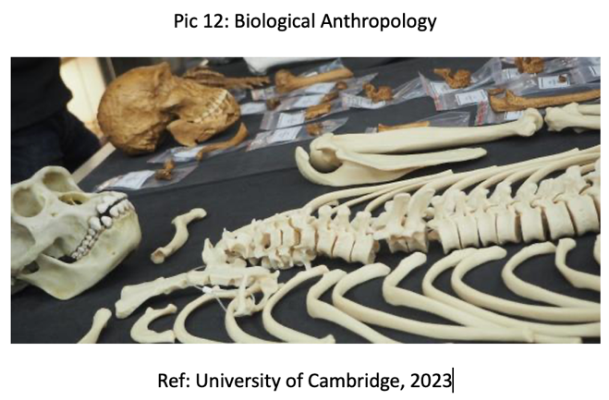
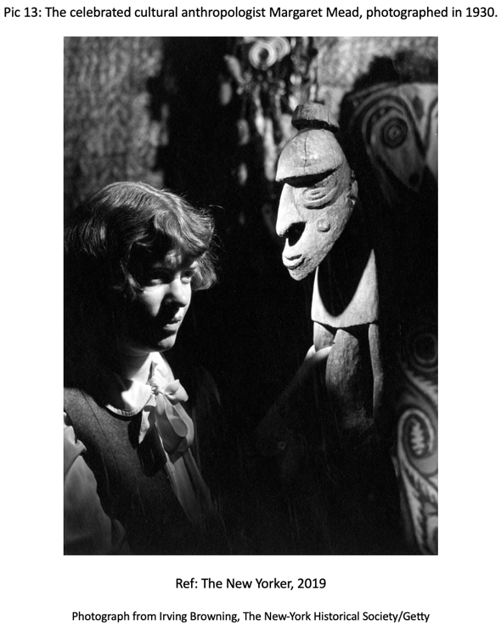
The study of archaeology, anthropology, and history are closely connected. Anthropology, specifically, is described as the scientific investigation of individuals, science, and culture, according to Collins (2023). Anthropology has two main branches - biological (Pic 12) and cultural (Pic 13), conducting research on human societies and development. Biological anthropology deals with humans' physical and biological evolution (University of Cambridge, 2023), while cultural anthropology focuses on human society and culture (Britannica, 2023). Cultural anthropology can be further divided into ethnography (Britannica, 2023) and ethnology (Minganti, 2013). Exploring the relationship between archaeology and anthropology is essential to understanding human civilisation. The archaeologist may unearth artefacts without understanding their purpose, but working alongside an anthropologist knowledgeable about modern-day culture can uncover answers and vice versa. Archaeology has a close connection to history in various disciplines. It covers a wide range of human history, whereas traditional historical sources of written records date back to approximately 3000 years ago. Historians who study written texts can provide valuable insights into human civilisations and cultures, but they only have access to the opinions and observations of the authors. On the other hand, archaeologists offer physical evidence to support the historians (Renfrew and Bahn, 2020, p. 12-13).

To conclude, the field of archaeology continues to evolve, from its scientific methods to its more holistic practices and engagement within the sciences and humanities. It contributes significantly to understanding human culture throughout history and, in turn, protecting its heritage. The humanities, of which archaeology is one subject, equip individuals with the knowledge and skills that can be applied to multiple sectors to address global issues (HEPI, 2023). The future lies not only in making new discoveries but also in addressing these worldwide concerns that face humankind today by learning from our ancestors' experiences in dealing with similar events. For example, Roman concrete manufacturing techniques can enhance modern concrete, resulting in better durability and an improved environmental impact, according to recent studies (The Conversation, 2023). The advancements in archaeological science and technology have significantly improved the ability of practitioners to locate and comprehend sites and materials. These new tools offer quicker and less time-consuming assessments than traditional methods. However, despite these valuable resources' availability, an archaeologist's work still requires breaking ground and utilising the skills that can only be gained through experience. Archaeology covers various natural and social sciences and practical-based skills, providing individuals with transferable skills for many other sectors. Archaeologists are employed across diverse areas, such as universities, heritage bodies, museums, and commercial enterprises. The humanities, including archaeology, are facing funding challenges, partly due to the country's financial strain on the public sector, as the Council for British Archaeology reported (2021). Additionally, there is a threat from the government's emphasis on STEM subjects in education, putting the teaching of archaeology at risk, which could have negative consequences for its future.

REFERENCES
AQA (2023) About us. Available at: https://www.aqa.org.uk/about-us (Accessed: 16 October 2023).

BBC (2014) A point of view: is the archaeological dig a thing of the past? Available at: https://www.bbc.co.uk/news/magazine-27236869 (Accessed: 12 October 2023).

BBC (2018) Controversial HS2 burial site dig at London Euston begins. [Online image] Available at: https://www.bbc.co.uk/news/uk-england-london-45971226 (Accessed: 18 October 2018).

BBC (2021) University of Sheffield confirms archaeology department closure. Available at: https://www.bbc.co.uk/news/uk-england-south-yorkshire-57820390 (Accessed: 12 October

2023).

Birch, S. and Szpak, P. (2022) ‘Current developments and future directions in archaeological science’, PNAS, 119(43). Available at: https://doi.org/10.1073/pnas.2212490119

Blau, S. (2014) ‘Archaeology: Definition’, Encyclopedia of Global Archaeology, pp. 449. Available at: https://doi.org/10.1007/978-1-4419-0465-2_131

Boreham, S., Conneller, C., Milner, N., Taylor, B., Needham, A., Boreham, J. and Rolfe, C. J. (2011) ‘Geochemical indicators of preservation status and site deterioration at Star Carr’, Journal of Archaeological Science, 38(10), pp. 2833–2857. Available at: https://doi.org/10.1016/j.jas.2011.01.016

Britannica (2023) Cultural anthropology. Available at: https://www.britannica.com/science/cultural-anthropology (Accessed: 17 October 2023).

Britannica (2023) Ethnography. Available at: https://www.britannica.com/science/ethnography (Accessed: 17 October 2023).
Britannica (2023) Humanities. Available at: https://www.britannica.com/topic/humanities (Accessed: 13 October 2023).

Caer Heritage Project (2012) CAER Heritage Project Exhibition at St Fagans. [Online image] Available at: https://caerheritageproject.com/2012/06/21/caer-heritage-project-exhibition-at-st-fagans/ (Accessed: 18 October 2023).

Caer Heritage Project (2023) Caer Heritage Hidden Hillfort. Available at: https://caerheritageproject.com/home/ (Accessed: 16 October 2023).

Cambridge Dictionary (2023) The natural sciences. Available at: https://dictionary.cambridge.org/dictionary/english/natural-sciences (Accessed: 16 October 2023).

Cambridge Dictionary (2023) Social science. Available at: https://dictionary.cambridge.org/dictionary/english/social-science?q=social+sciences (Accessed: 16 October 2023).

Campana, S. (2017) ‘Drones in Archaeology. State-of-the-art and Future Perspectives’, Archaeological Prospection, 24(4), pp. 275-296. Available at: https://doi.org/10.1002/arp.1569

Casana, J., Laugier, E. J., Hill, A. C., Reese, K. M., Ferwerda, C., McCoy, M. D. and Ladefoged, T. (2021) ‘Exploring archaeological landscapes using drone-acquired lidar: Case studies from Hawai’i, Colorado, and New Hampshire, USA’, Journal of Archaeological Science Reports, 39, p. 103133. Available at: https://doi.org/10.1016/j.jasrep.2021.103133

CBS News (2017) Photographer holds a 2014 photograph of the Arch of Triumph, Palmyra, Syria, in front of the historic monument destroyed by ISIS in 2015. [Online image] Available at: https://www.cbsnews.com/pictures/world-treasures-destroyed-isis-islamic-extremists/ (Accessed: 18 October 2023).
Chartered Institute for Archaeologists (2023) Resources for professional ethics. Available at: https://www.archaeologists.net/membership/ethics (Accessed: 15 October 2023).

Chartered Institute for Archaeologists (2023) Delivering public benefit from archaeology. Available at: https://www.archaeologists.net/sites/default/files/Public%20benefit%20leaflet.pdf (Accessed: 16 October 2023).

Collins (2023) Anthropology. Available at: https://www.collinsdictionary.com/dictionary/english/anthropology (Accessed: 13 October 2023).

Council for British Archaeology (2021) CBA Response to the Office for Students Recurrent Funding Consultation 2021-2022. Available at: https://www.archaeologyuk.org/resource/cba-response-to-the-office-for-students-recurrent-funding-consultation-2021-22.html (Accessed: 13 October 2023).

Current Archaeology (2019) The Natural History Museum’s ancient DNA lab. [Online image] Available at: https://archaeology.co.uk/articles/sciencenotes/science-notes-laboratory-spotlight-the-natural-history-museums-ancient-dna-lab.htm (Accessed: 18 October 2023).
Drees, W. (2021) What are the Humanities for? Available at: https://www.cambridge.org/core/books/abs/what-are-the-humanities-for/what-are-the-humanities/6E650FDCF137483A894F373D8FAE3088 (Accessed: 13 October 2023).

Elia, R. (1997) ‘Looting, collecting, and the destruction of archaeological resources’, Nonrenewable Resources, 6, pp. 85-98. Available at: https://link.springer.com/article/10.1007/BF02803807#citeas (Accessed: 16 October 2023).

Erciyas, D. (n.d.) ‘Is archaeology a science or humanities?’. Available at: https://www.academia.edu/36831847/ARCHAEOLOGY_SCIENCE_OR_HUMANITIES
(Accessed: 12 October 2023).

Fagan, B. and Durrani, N. (2016). Archaeology: a brief introduction. Abingdon, Oxon: Routledge.

Federation of Archaeological Managers and Employers (2020) State of the Archaeological Market 2019. Available at: https://www.archaeologists.net/sites/default/files/State-of-the-Archaeological-Market-2019-1.pdf (Accessed: 16 October 2023).

GOV.UK (2018) Volunteers taking part in an Operation Nightingale dig, [Crown Copyright/MOD 2018]. [Online image] Available at: https://insidedio.blog.gov.uk/2018/10/01/breaking-ground-with-operation-nightingale/ (Accessed: 18 October 2023).

GOV.UK (2020) Operation Nightingale. Available at: https://www.gov.uk/guidance/operation-nightingale (Accessed: 12 October 2023).

Harvard University (2023) Google Earth image of the al-Ja’fari Palace, AD 859. [Online image] Available at: https://scholar.harvard.edu/jasonur/pages/corona-photography-0 (Accessed: 18 October 2023).
HEPI (2023) Humanities education is a UK strength: New report shows it is a mistake to set up a Humanities vs STEM contest. Available at: https://www.hepi.ac.uk/2023/03/30/humanities-education-is-a-uk-strength-new-report-shows-it-is-a-mistake-to-set-up-a-humanities-vs-stem-contest/ (Accessed: 13 October 2023).

Hollesen, J. (2022) ‘Climate change and the loss of archaeological sites and landscapes: A global perspective’, Antiquity, 96(390), pp. 1382-1395. Available at: https://doi.org/10.15184/aqy.2022.113

Historic England (2018) Using Airborne Lidar in Archaeological Survey. [Online image] Available at: https://historicengland.org.uk/images-books/publications/using-airborne-lidar-in-archaeological-survey/ (Accessed: 18 October 2023).

JavaTpoint (2021) Social Science: What is it? [Online image] Available at: https://www.javatpoint.com/social-science (Accessed: 18 October 2023).
Johnson, M. (2005) Archaeological Theory: An Introduction. 2nd edn. Oxford: Blackwell Publishing

Lewis, K. (2018) ‘Finding Archaeology in 2017: What Is Archaeology and Why Are We Doing It? Why Should We Be Doing It?’, American Anthropologist, 120, pp. 291-304. Available at: https://doi.org/10.1111/aman.13049

Luo, L., Wang, X., Guo, H., Lasaponara, R., Shi, P., Bachagha, N., Li, L., Yao, Y., Masini, N., Chen, F., Ji, W., Cao, H., Li, C. and Hu, N. (2018) ‘Google Earth as a Powerful Tool for Archaeological and Cultural Heritage Applications: A Review’, Remote Sensing (Basel, Switzerland), 10(10), p. 1558. Available at: https://doi.org/10.3390/rs10101558

Maggio, A. (2018) ‘Interdisciplinary and Archaeology’, Encyclopedia of Global Archaeology, pp. 1-7. Available at: https://doi.org/10.1007/978-3-319-51726-1_2851-1

Minganti, K. (2013) ‘Ethnology’, Encyclopaedia of Sciences and Religions, pp. 775-778. Available at: https://doi.org/10.1007/978-1-4020-8265-8_1522

National Geographic (2015) Here are the ancient sites ISIS has damaged and destroyed. Available at: https://www.nationalgeographic.com/history/article/150901-isis-destruction-looting-ancient-sites-iraq-syria-archaeology (Accessed: 12 October 2023).

National Oceanic and Atmospheric Administration (2023) What is LIDAR? Available at: https://oceanservice.noaa.gov/facts/lidar.html (Accessed: 16 October 2023).

NBC News (2017) These technologies are giving new life to the Ancient World. Available at: https://www.nbcnews.com/mach/science/these-technologies-are-giving-new-life-ancient-world-ncna792921 (Accessed: 16 October 2023).

Polk, K. (2014) ‘The global trade in illicit antiquities: some new directions’, Heritage Crime, pp. 206-223. Available at: https://link.springer.com/chapter/10.1057/9781137357519_12 (Accessed: 12 October 2023).

Pyddoke, E. (1964) What is archaeology? London: John Baker Publishers Ltd.

Reed, K. and Ryan, P. (2019) ‘Lessons from the past and the future of food’, World Archaeology, 51(1), pp. 1-16. Available at: https://doi.org/10.1080/00438243.2019.1610492

Renfrew, C. and Bahn, P. G. (2020). Archaeology: theories, methods and practice. London: Thames & Hudson Limited.

Scarre, C. and Scarre, G. (2006) The Ethics of Archaeology: Philosophical Perspectives on Archaeological Practice. Available at: https://books.google.co.uk/books?hl=en&lr=&id=-W-F_ifgYHYC&oi=fnd&pg=PR1&dq=archaeology+ethics+and+indigenous+people&ots=l5lrQbTrza&sig=z86fAosgo1B5WJ9pCzYOA3Y8EpI#v=onepage&q=archaeology%20ethics%20and%20indigenous%20people&f=false (Accessed: 16 October 2023).

Scientific American (2022) Climate change is adding urgency to Archaeology. Available at: https://www.scientificamerican.com/article/climate-change-is-adding-urgency-to-archaeology/ (Accessed: 16 October 2023).

Smith, M., Feinman, G. and Drennan, R. (2012) ‘Archaeology as a social science’, PNAS, 109(20), pp. 7617-7621. Available at: https://doi.org/10.1073/pnas.1201714109

Star Carr Archaeology Project (2023) Star Carr Archaeology Project, North Yorkshire. [Online image] Available at: http://www.starcarr.com/ (Accessed: 18 October 2023).
Swain, H. (2013) ‘The ethics of displaying human remains from British archaeological sites’, Public Archaeology, 2(2), pp. 95-100. Available at: https://doi.org/10.1179/pua.2002.2.2.95
The Conversation (2015) Six tools that are revolutionising archaeology by helping us find sites without digging. Available at: https://theconversation.com/six-tools-that-are-revolutionising-archaeology-by-helping-us-find-sites-without-digging-51826 (Accessed: 12 October 2023).

The Conversation (2016) Environmental change could be damaging some of the world’s most precious archaeology. Available at: https://theconversation.com/environmental-change-could-be-damaging-some-of-the-worlds-most-precious-archaeology-67999 (Accessed: 12 October 2023).

The Conversation (2016) How community digs can inspire the next generation of archaeologists. Available at: https://theconversation.com/how-community-digs-can-inspire-the-next-generation-of-archaeologists-70352 (Accessed: 12 October 2023).

The Conversation (2021) Six reasons to save archaeology from funding cuts. Available at: https://theconversation.com/six-reasons-to-save-archaeology-from-funding-cuts-161465 (Accessed: 12 October 2023).

The Conversation (2022) How climate change is washing away precious evidence of our distant past. Available at: https://theconversation.com/how-climate-change-is-washing-away-precious-evidence-of-our-distant-past-175758#:~:text=At%20some%20UK%20sites%20of,acidity%20and%20low%20in%20oxygen (Accessed: 12 October 2023).

The Conversation (2023) What makes archaeology useful as well as exciting? It offers lessons from the past. Available at: https://theconversation.com/what-makes-archaeology-useful-as-well-as-exciting-it-offers-lessons-from-the-past-197539#:~:text=The%20short%20answer%20is%20that,kinds%20of%20options%20I%20mean (Accessed: 13 October 2023).

The New Yorker (2019) The celebrated cultural anthropologist Margaret Mead, photographed in 1930. [Online image] Available at: https://www.newyorker.com/magazine/2019/08/26/how-cultural-anthropologists-redefined-humanity (Accessed: 18 October 2023).
Tryon, C., Pobiner, B. and Kauffman, R. (2010) ‘Archaeology and Human Evolution’, Evolution: Education and Outreach, 3, pp. 377-386. Available at: https://evolution-outreach.biomedcentral.com/articles/10.1007/s12052-010-0246-9 (Accessed: 16 October 2023).

UNESCO (2023) UNESCO in brief. Available at: https://www.unesco.org/en (Accessed: 17 October 2023).

University of Cambridge (2023) Biological Anthropology. Available at: https://www.arch.cam.ac.uk/about-us/biological-anthropology (Accessed: 17 October 2023).

University of Cambridge (2023) Biological Anthropology. [Online image] Available at: https://www.arch.cam.ac.uk/about-us/biological-anthropology (Accessed: 18 October 2023).

University of Groningen (2020) Interdisciplinary Humanities. [Online image] Available at: https://www.rug.nl/about-ug/video/archive/2017/making-meaning_-interdisciplinary-humanities-_-ucg?lang=en (Accessed: 18 October 2023).

University of Oxford (2023) Professor Shadreck Chirikure: We owe a lot to the past. Archaeology can take us back to the future. Available at: https://www.ox.ac.uk/news-and-events/oxford-people/Shadreck-Chirikure#:~:text=Professor%20Chirikure%20insists%2C%20'Archaeology%20allows,' (Accessed: 17 October 2023).

University of York (2023) SeaChange. Available at: https://www.york.ac.uk/yesi/networks/marine-coastal-enviros-ecosystems-people-network/seachange/ (Accessed: 16 October 2023).

Vindolanda Charitable Trust (2019) Monitoring environmental changes at Roman Magna. Available at: https://www.vindolanda.com/news/monitoring-magna (Accessed: 16 October 2023).

Vindolanda Charitable Trust (2021) Monitoring environmental changes at Roman Magna. [Online image] Available at: https://www.vindolanda.com/news/monitoring-magna (Accessed: 18 October 2023).

Yoffee, & Fowles, S. (2011). ‘Archaeology in the Humanities’, Diogenes (English Ed.), 58(1-2), pp. 35–52. Available at: https://doi.org/10.1177/0392192112441906

Zimmerman, L., Vitelli, K. and Hollowell-Zimmer, J. (2003) Ethical Issues in Archaeology. Available at: https://books.google.co.uk/books?hl=en&lr=&id=oQMNX4aBytQC&oi=fnd&pg=PR7&dq=Ethical+and+moral+dilemmas+can+arise+in+the+field+of+archaeology&ots=C9mciay3PO&sig=ab8czKOOxSiY3NQth0aew1zuJfE&redir_esc=y#v=onepage&q=Ethical%20and%20moral%20dilemmas%20can%20arise%20in%20the%20field%20of%20archaeology&f=false (Accessed: 16 October 2023).

