Using one of the establishments visited examine the strengths and weaknesses of their collection rationale.

In this essay I will be assessing the positives and negatives of the museum and park of St Fagan’s National Museum of History through the evaluation of their collections. I will highlight what they portray well through their exhibits and also bring to attention the aspects of Welsh life they consciously supress or emphasise that I saw prominently displayed.
Figure 1: Map and Guide of St Fagans Museum Park
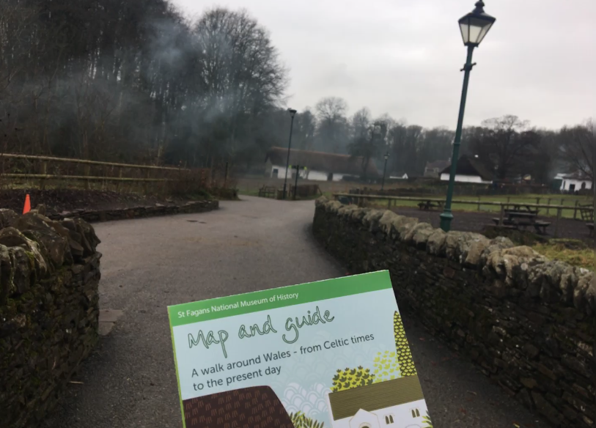

St Fagan’s collection rationale is based entirely on Wales’ industrial past, focusing their collections on farming, industry, community, and productivity. The entrance galleries include a Welsh Life gallery and a Welsh Culture gallery, that you reach before entering the park itself. This is a strength as it is a familiarity with those who visit that are Welsh, but also provides an insight to life for those who are not. Although it is hailed for its importance within the Welsh museum sector, it may also be viewed as a little randomised and lacking any direct chronology or artefacts of note.
The strengths of these galleries are that they bring together the sense of community from the working class aspects of Welsh life, exploring cooking, holidays, dressing, and farming. As these topics are relatable amongst a large number of visitors, they can hope to find familiarity with the stories and concepts discussed in the gallery. Including the various achievements and attributes certain people, cultures or families have had and their affect on the way Welsh life is lived and or portrayed. One of the most notable of the featured artefacts is a tractor, facing the window facing the outdoor park, allowing for that level of interactivity and personal involvement in the history. (See Fig.3)
The gallery works to create an interactive display focus, whilst also balancing the technological with the pen and paper aspects. Another strength of the collection is that they kept visitors engaged and contributing throughout their time in the galleries through questions and post it note answers. This allowed for opinions to be shared and discussions to be open and public, however it did not go entirely to plan on certain political issues, raising issues that may not have been considered during the design phase of the exhibitions. Figure 4 shows a discussion wall featuring a quote from Margaret Thatcher, as a politician she was extremely disliked in this country, leading to some colourful language on small yellow post it notes. This display was not received well and as one visitor said, “An extremely bold move to put a smiling Thatcher in a Welsh museum.”
Figure 2: Welsh Life Gallery – Cooking (with related activity table)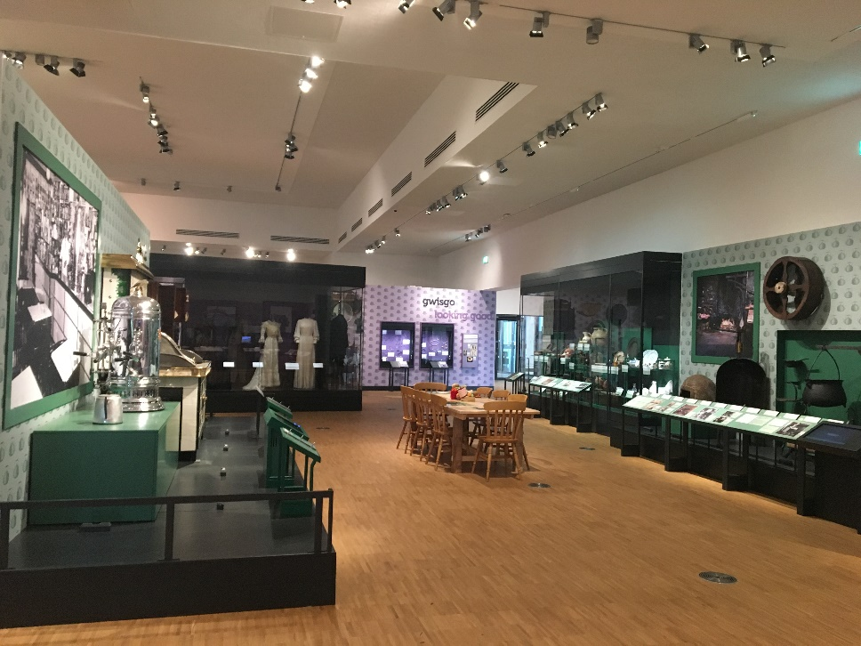

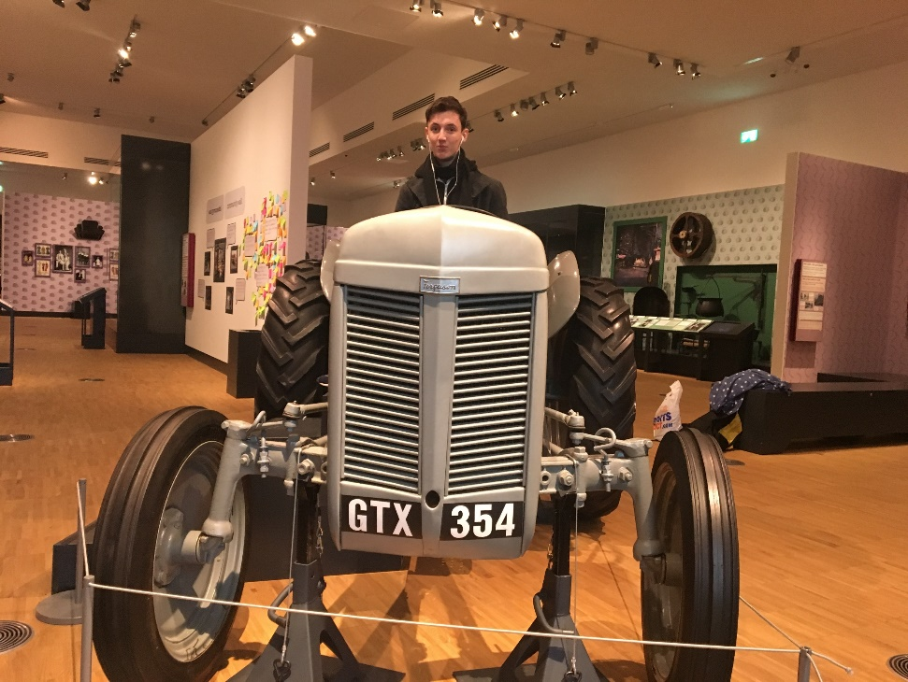
Figure 3: Reconstructed Tractor

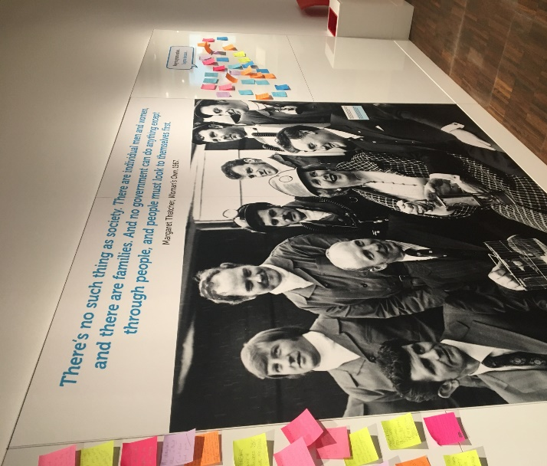
Figure 4: Discussion Wall Featuring Margaret Thatcher

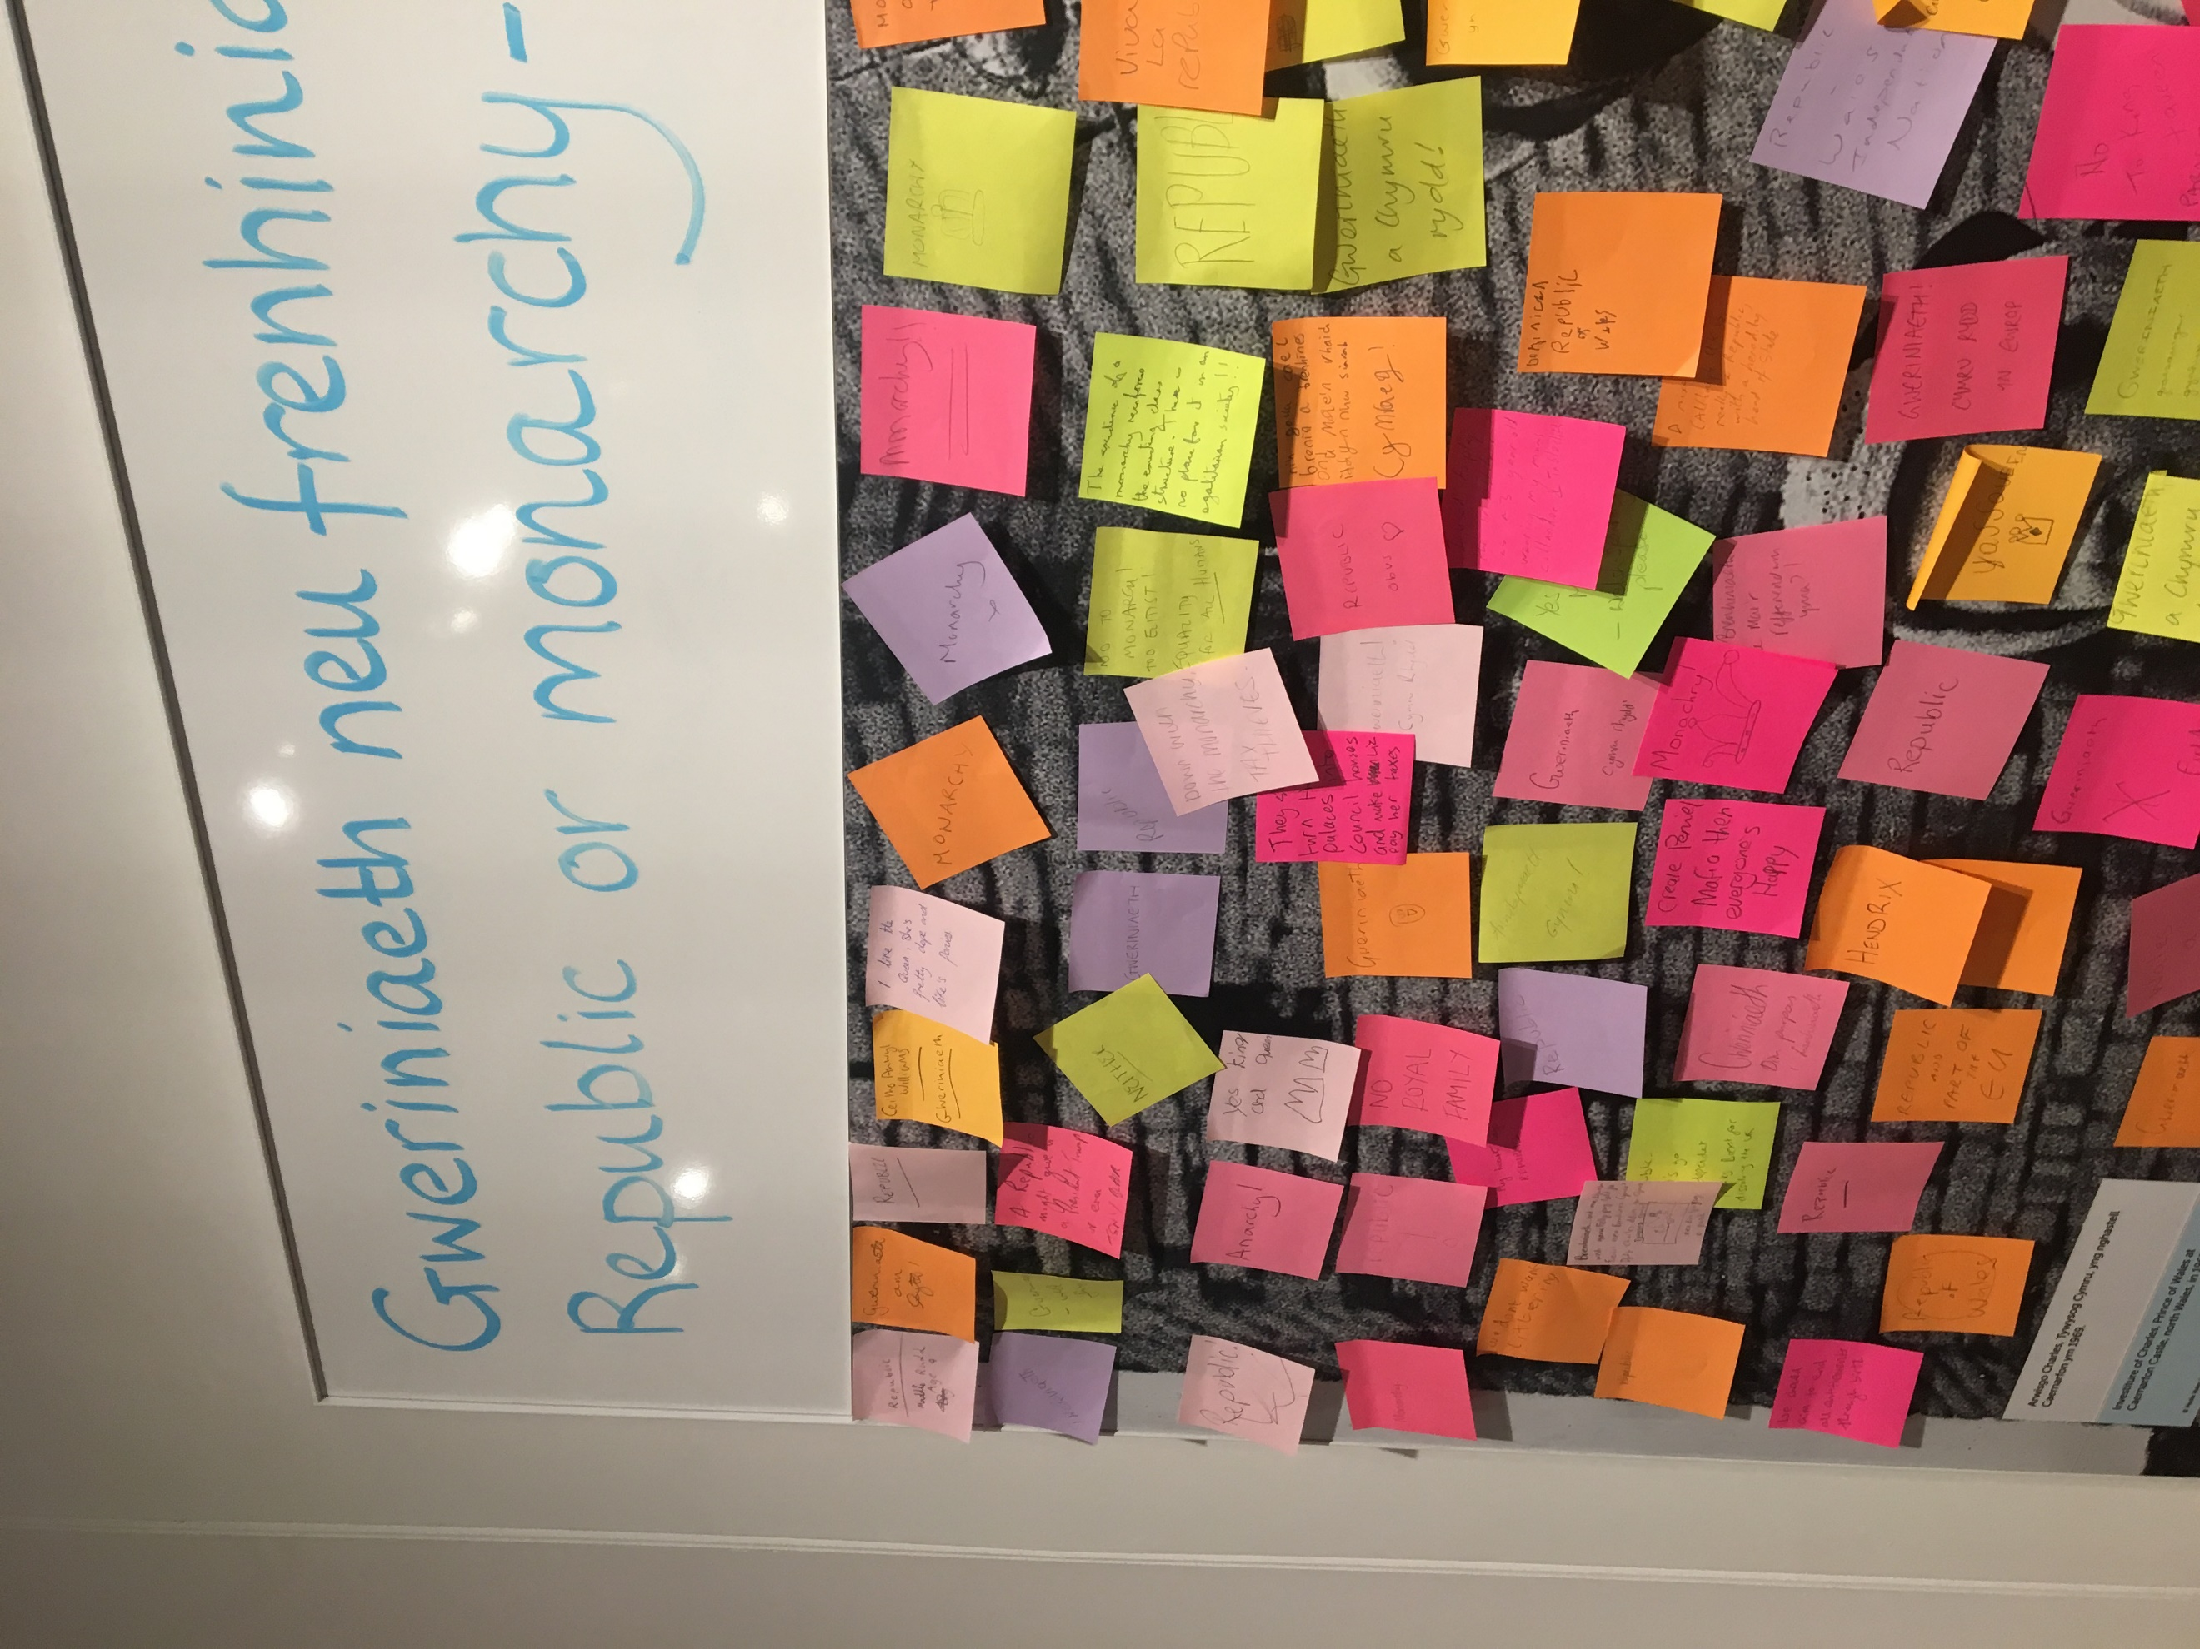
Figure 5: Post it note contributions from visitors

The newly opened galleries and their spaces are very good uses of the building to display and engage visitors in Welsh culture, and in doing so have kept the exhibits welcoming and interactive. The reconstructed houses can be classed themselves as an interactive exhibit, with their contents being of the period and created to look as part of the era from which they originate. These themselves come with an immense collection rationale, making up the most memorable and exciting part of the historic park. The buildings in the park span a large historic timeline, with roundhouses, the newly added medieval court through to the modern builds including prefab houses. Although the range of houses is commendable, these also offer no direct chronology and can lead to the park being a mismatched array of random period buildings following no structure or physical order. As each building has itself a history, there seems to be no grouping, there are options to do so, create pathways to follow perhaps with the timeline, or following with social order or function within society. Grouping the buildings should have been a decision made at the start of the park, having industrial buildings, working builds, and presented houses in their own respective zones. See to figure 6,7,8 with photographs of working buildings such as the Bakehouse and Shops next to redundant ‘museum’ buildings in the immediate vicinity.
Overall, the collection rationale was not as varied as many other successful outdoor or open air museums and the organisation of the outdoor buildings followed no exact path or chronology, which was disappointing. On reflection of the visit, I have a greater understanding and appreciation of the work they have created here, however there was no explanation, gallery or billboard explaining their heroic efforts in salvaging so many buildings, I believe that would be a starting point to get an overview and complete understanding of the site and the decisions and processes involved in creating the museum complex.
Figure 6: Gwalia Stores, Functioning Goods Shop
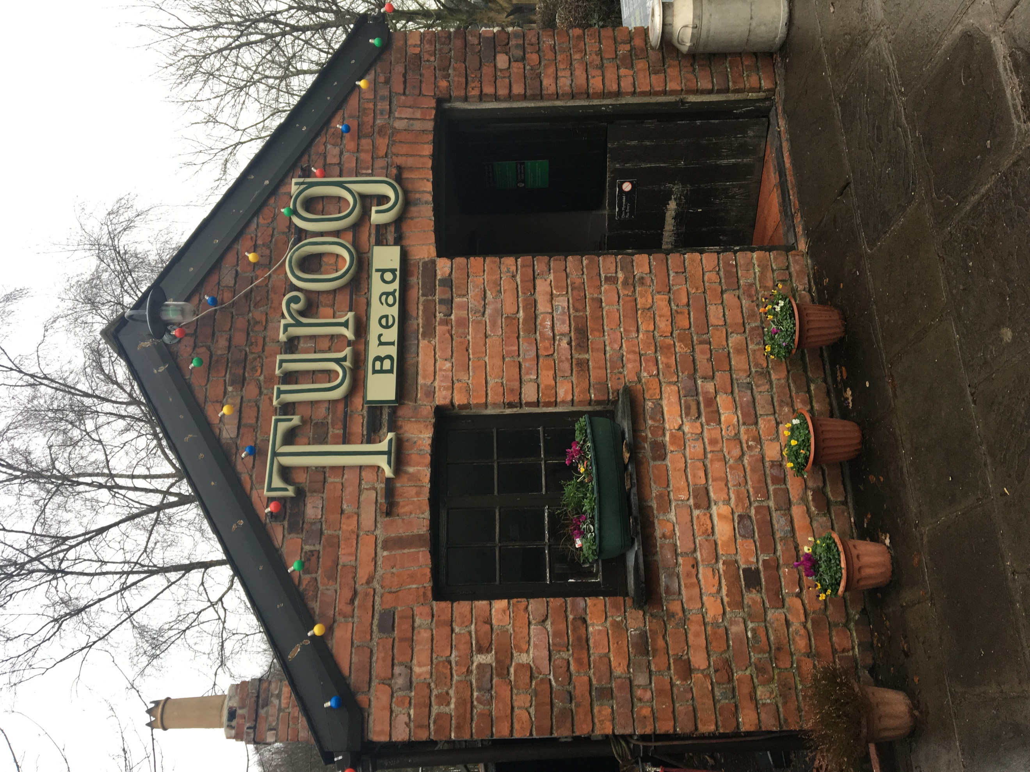
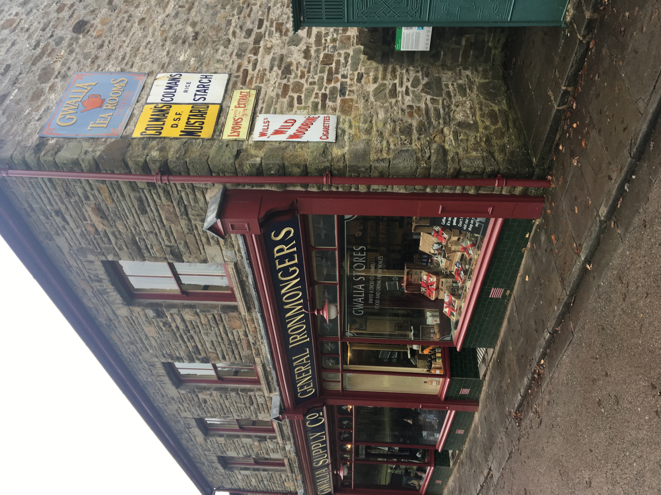

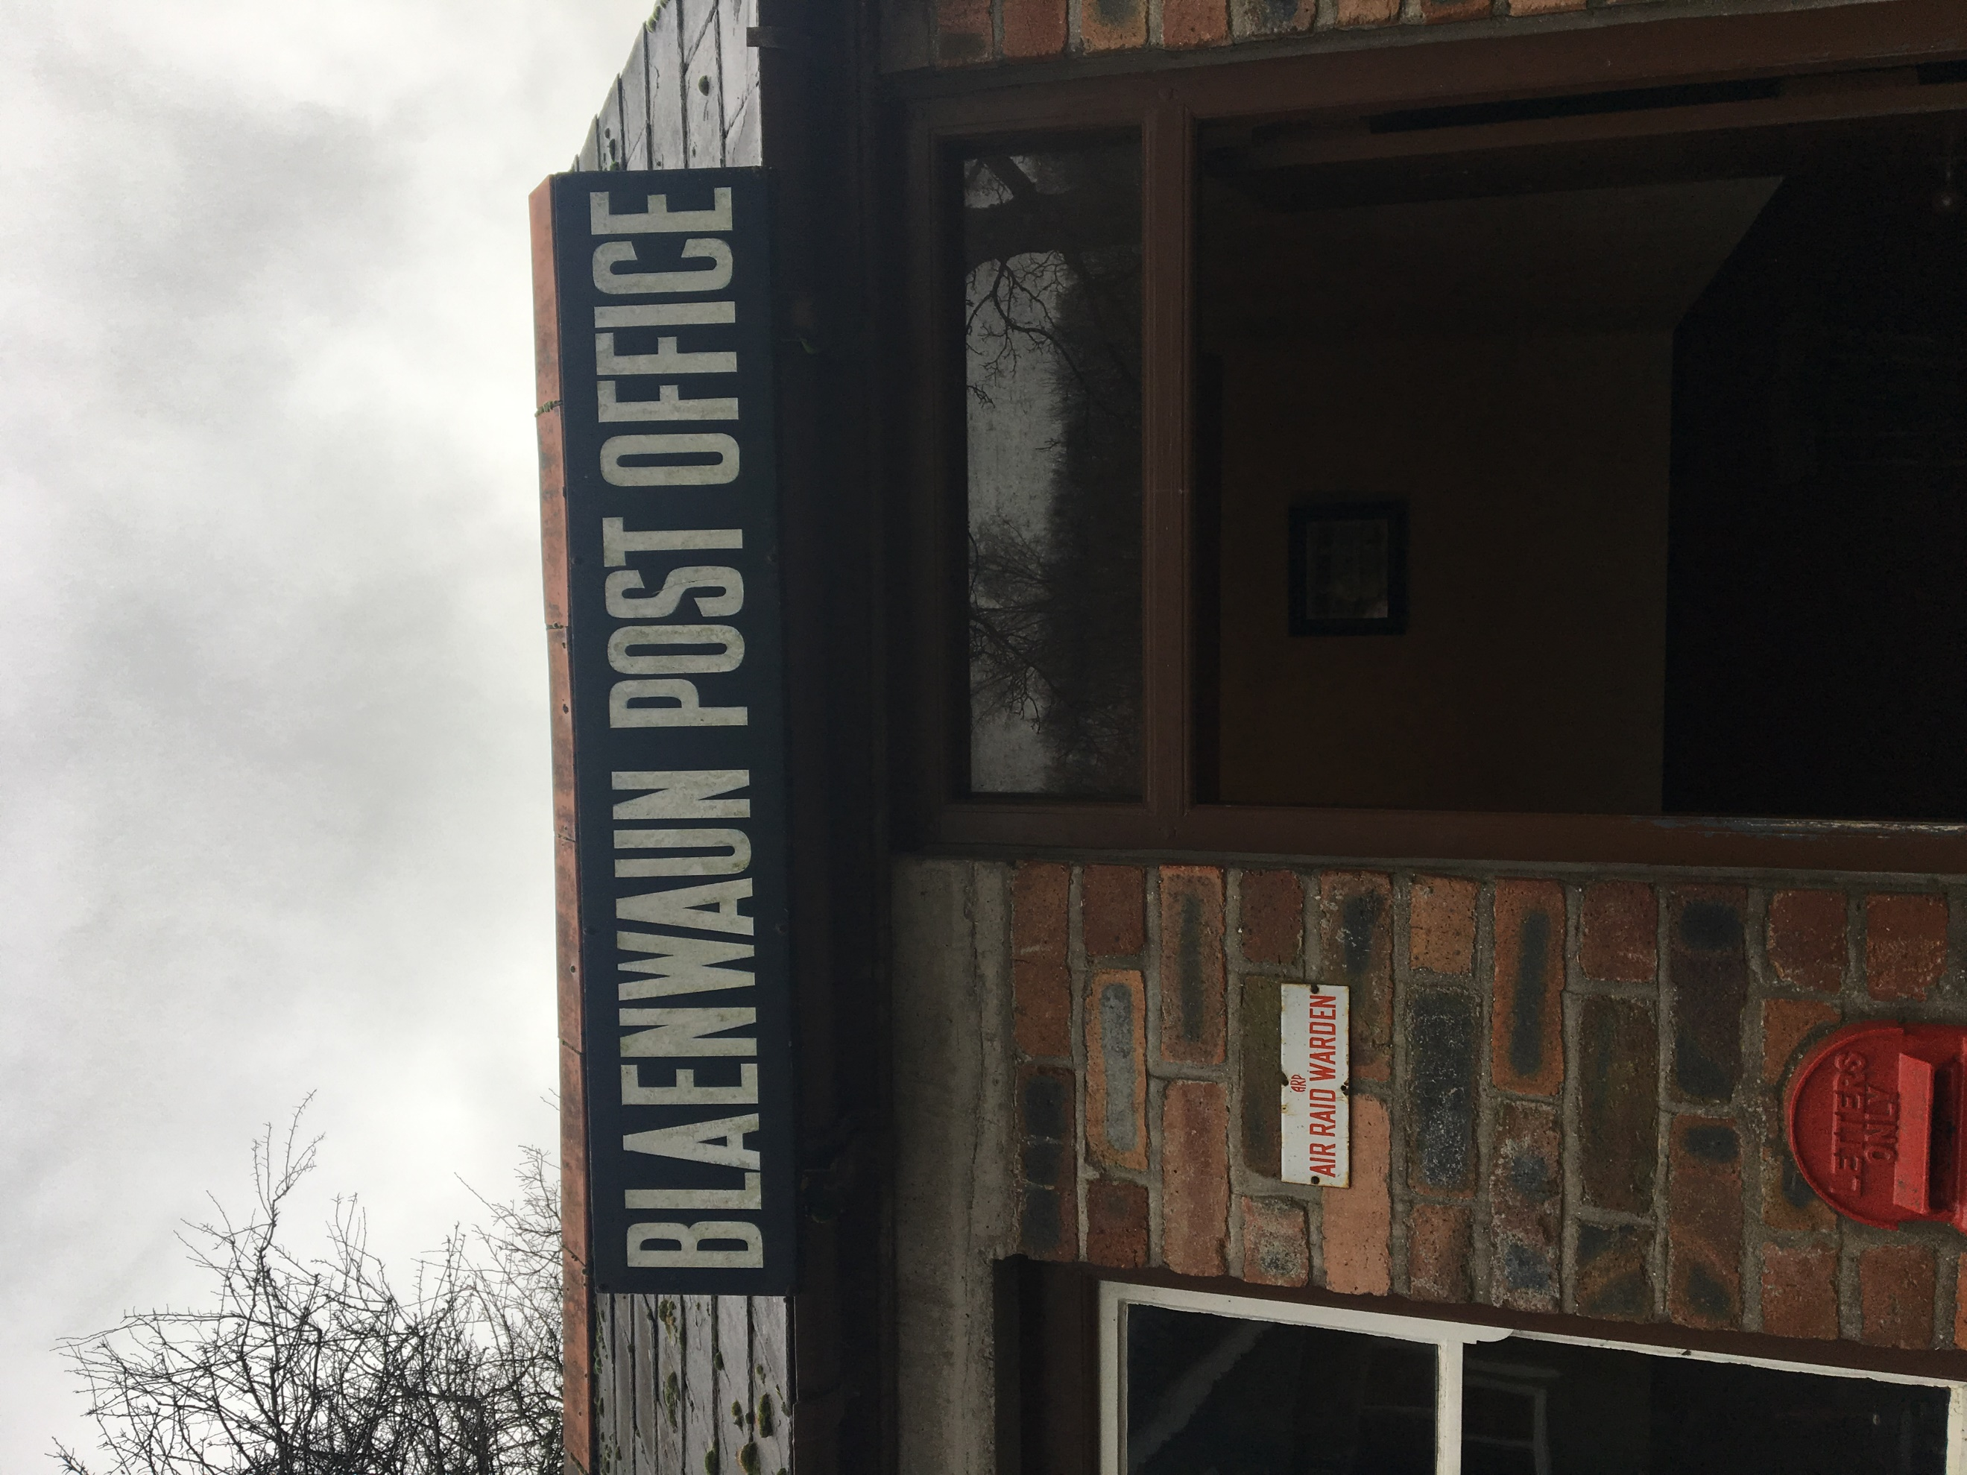
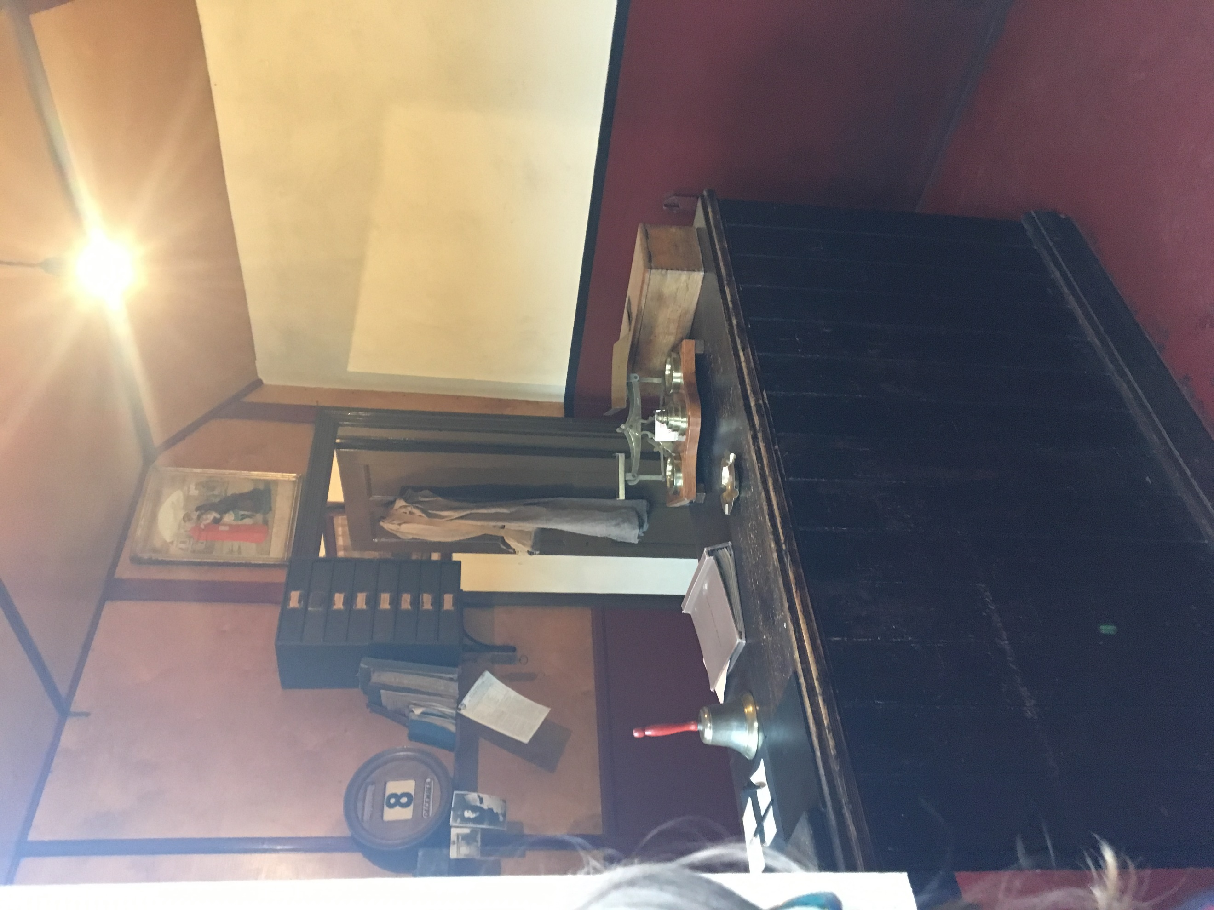
Figure 8: Functioning Bakehouse

Although the museum has taken great care to address prominent aspects of Welsh life, every building within the area has been taken from a rural or suffering, small or farming orientated regions of Wales. This creates a very specific atmosphere in the park and although it is varied, it does not represent every aspect of the progression of the history or the architecture. Another aspect of the park that has been disputed is that of the reconstructions, these roundhouses and medieval halls are blurring the lines as to where authentic ends and fantasy begins, confusing and misleading to visitors.
Figure 8: Post Office, Non Functional Museum Building
The second gallery (figures 9&10) represents the industries and productions of the Welsh people, being predominantly focused on material production the gallery is separated by trade, wood, textile, metal, stone and clay. These galleries are again well presented with the option of interacting with the topics given in the room.
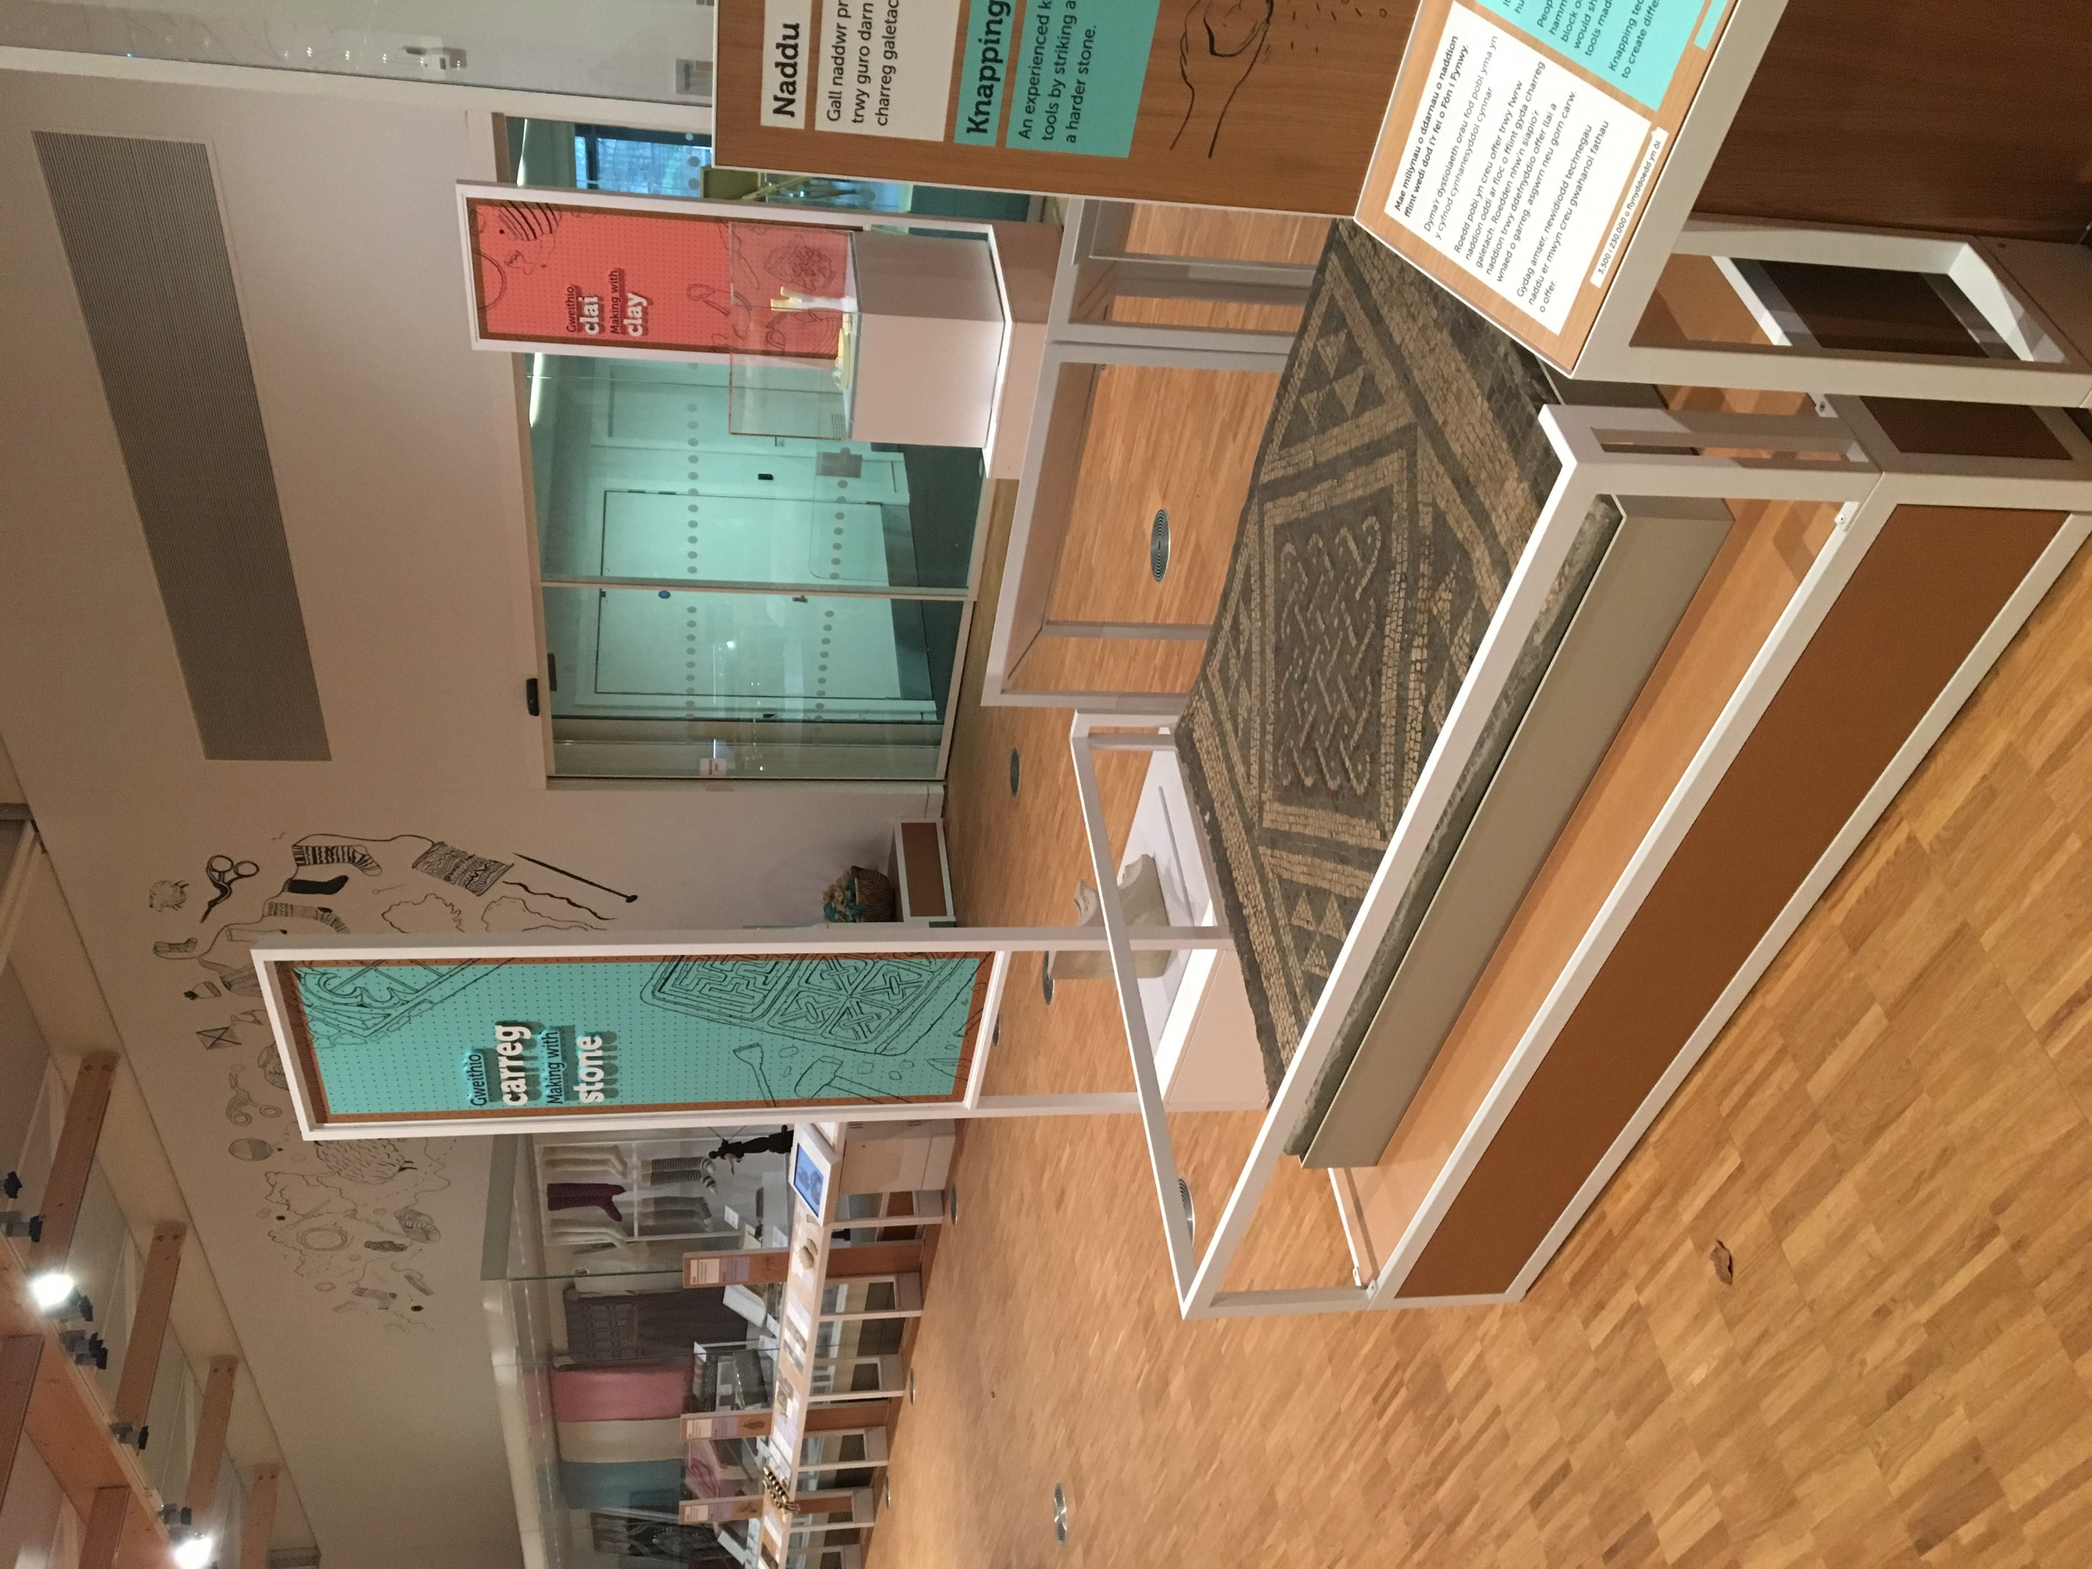
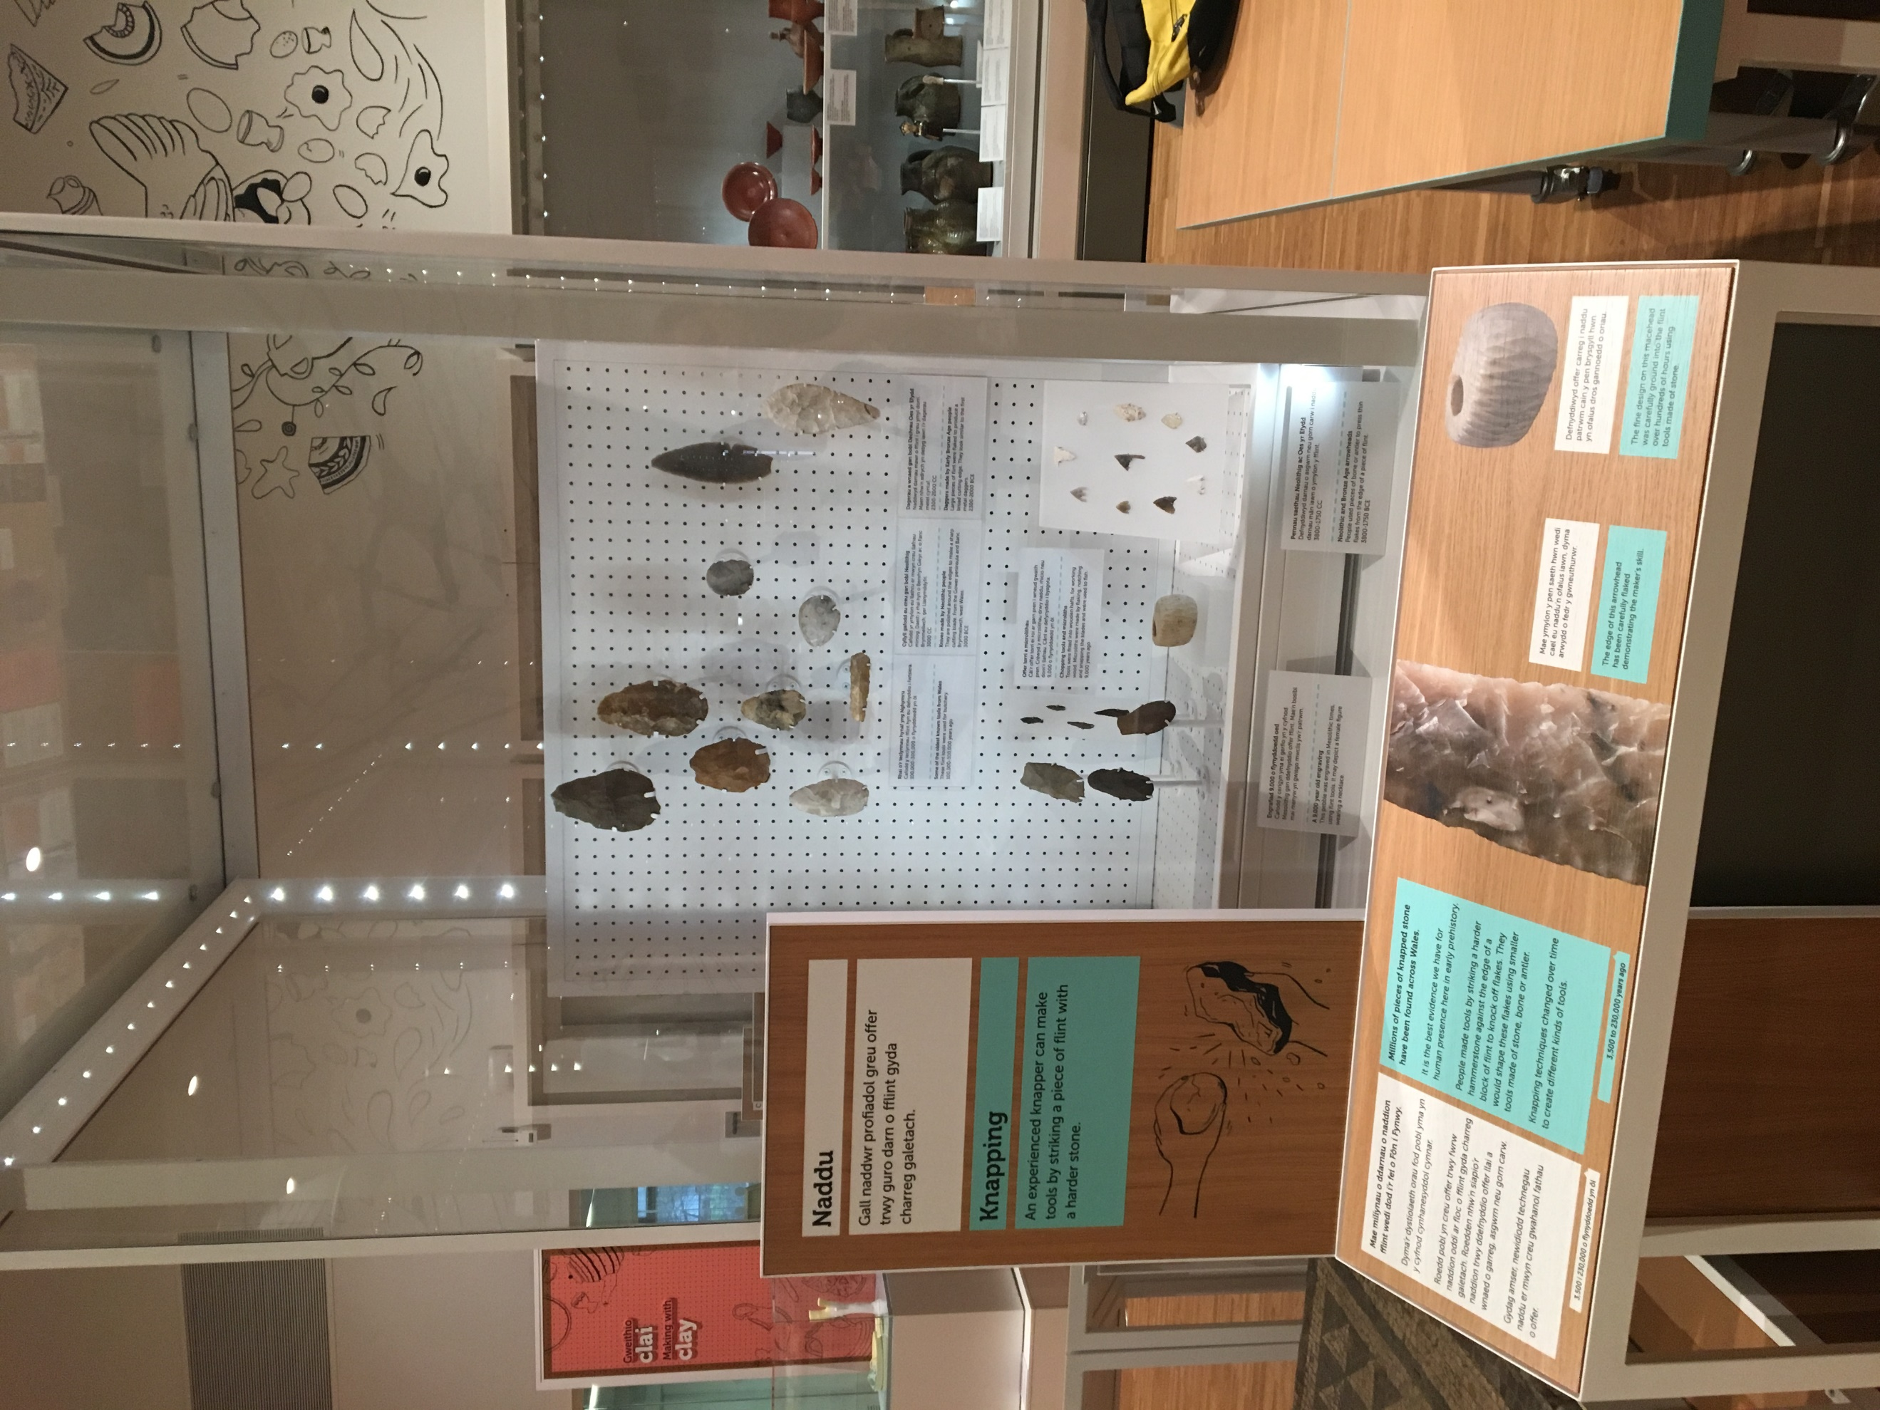
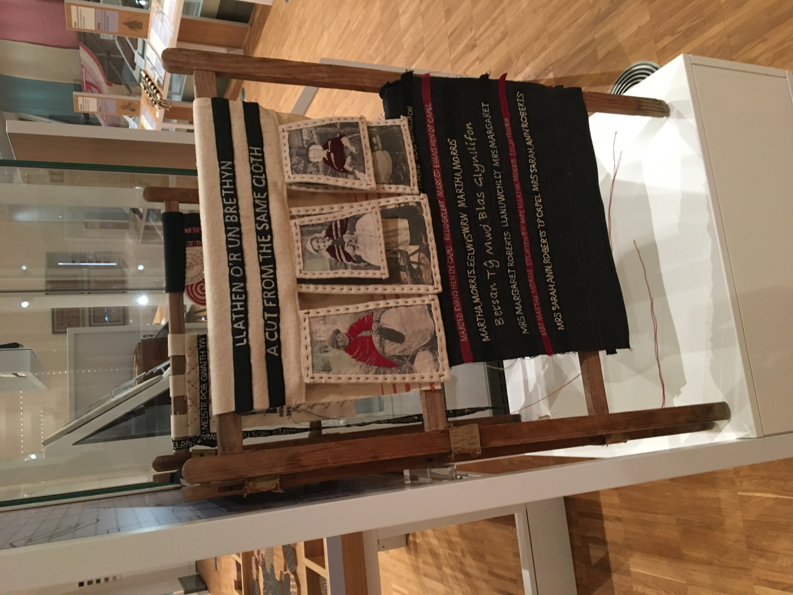
Figures 9,10&11:
Craft Gallery, with photographs representative of Textiles and Clay/Stone work

