Module Name: Marketing Essentials

Students Name: Sultana Begum

Student Id: 2234842

Table of Contents
Component 1 4
Introduction 4
Competitor Analysis 4
SWOT Analysis 5
PESTLE analysis 6
STP (Segmentation, Targeting and Positioning) 6
Action Plan (Gantt Chart) 7
Conclusion 7
References 9
Component 2 10
1. Introduction 10
2. Situation Analysis 10
3. Objectives 13
4. Strategy 14
5. Tactics 14
6. Action 15
7. Control 16
8. Conclusion 16
References 17
Appendix A: SMART TABLE 19
Appendix B: Marketing Mix 20
Appendix C: PESTLE Analysis 21
Appendix D: Perceptual map 22
Appendix E: Customers- (Segmentation and Targeting/ Customer profile) 23
Appendix F: Company- Swot Analysis 24
Appendix G: GANTT Chart for action plan 25
Appendix H: Presentation Slides 25

Component 1

1. Introduction
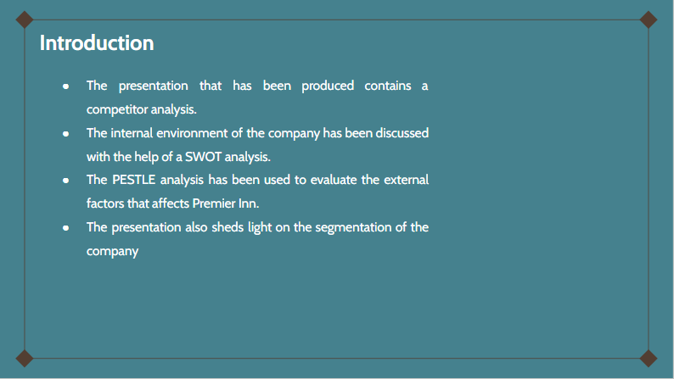
Premier Inn hotel will be the focus of the presentation. The presentation that has been produced contains a competitor analysis. The internal environment of the company has been discussed with the help of a SWOT analysis. PESTLE analysis has been used to evaluate the external factors. The presentation also sheds light on the segmentation of the company and finally, an action plan has been produced to show the various activities of Premier Inn.

2. Competitor Analysis
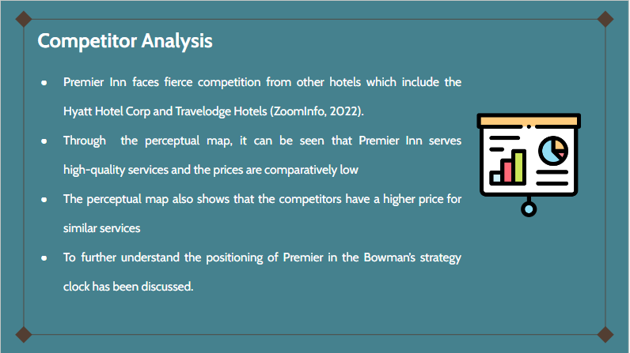
Premier Inn faces fierce competition from other hotels which include the Hyatt Hotel Corp and Travelodge Hotels (ZoomInfo, 2022). Through the perceptual map, it can be seen that Premier Inn serves high-quality services and the prices are comparatively lower than its competitors. To further understand the positioning of Premier in the Bowman’s strategy clock has been discussed.

3. SWOT Analysis
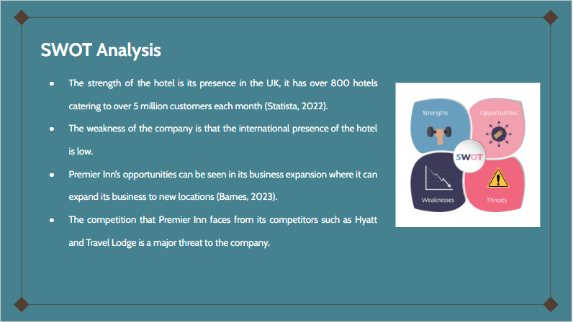
The major strength of the hotel is its presence in the UK where it has over 800 hotels and caters to over 5 million customers each month (Statista, 2022). The weakness of the company is that the international presence of the hotel is low. Premier Inn’s opportunities can be seen in its business expansion where it can expand its business to new locations (Barnes, 2023). The competition that Premier Inn faces from its competitors such as Hyatt and Travel Lodge is a major threat to the company.

4. PESTLE analysis
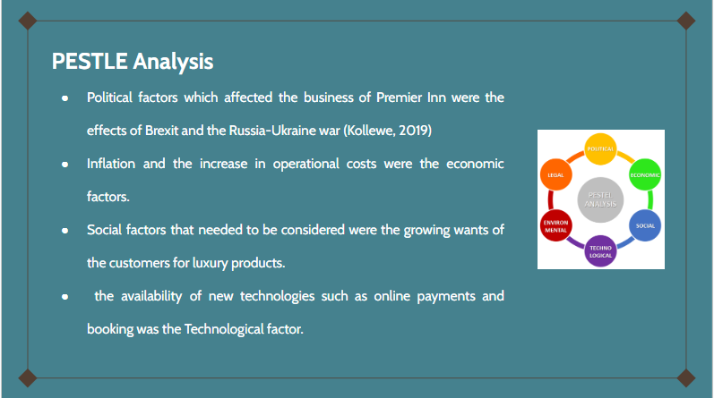
Political factors which affected the business of Premier Inn were the effects of Brexit and the Russia-Ukraine war (Kollewe, 2019). Inflation and the increase in operational costs were the economic factors. Social factors that needed to be considered were the growing wants of the customers for luxury products. the availability of new technologies such as online payments and booking was the Technological factor.

5. STP (Segmentation, Targeting and Positioning)
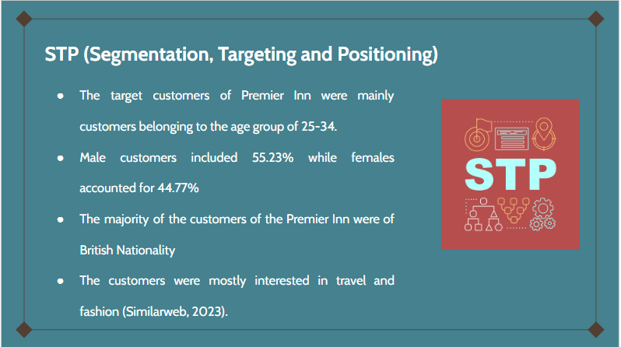
The target customers of Premier Inn were mainly customers belonging to the age group of 25-34. Male customers included 55.23% while females accounted for 44.77%. The majority of the people were of British Nationality and were mostly interested in travel and fashion (Similarweb, 2023).

6. Action Plan (Gantt Chart)
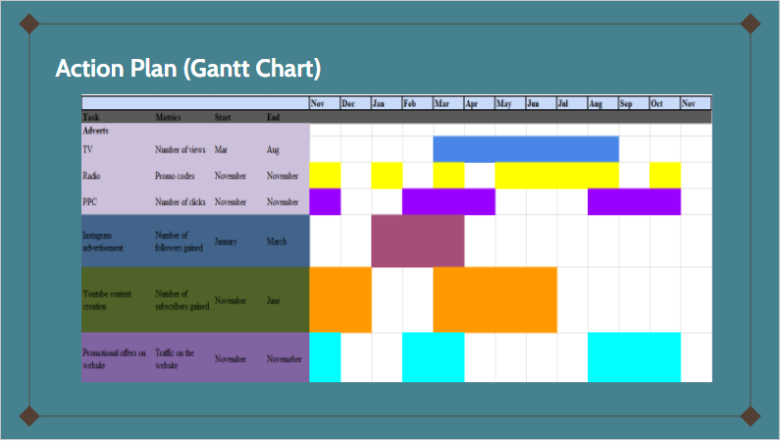
The Gantt chart which has been presented shows the various activities and the different channels utilised by Premier Inn.

7. Conclusion
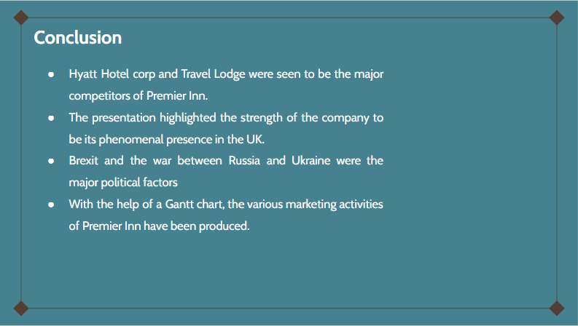
Hyatt Hotel Corp and Travel Lodge were seen to be the major competitors of Premier Inn. The presentation highlighted the strength of the company to be its phenomenal presence in the UK. However, Premier Inn had the potential to grow in the international market. Brexit and the war between Russia and Ukraine were the major political factors. In addition to this, the presentation highlights other external factors that affected Premier Inn. The majority of the customers of the hotel were of British nationality. With the help of a Gantt chart, the various marketing activities of Premier Inn have been produced.

References
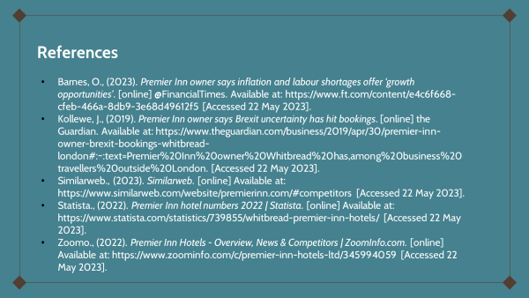
Barnes, O., (2023). Premier Inn owner says inflation and labour shortages offer ‘growth opportunities’. [online] @FinancialTimes. Available at: https://www.ft.com/content/e4c6f668-cfeb-466a-8db9-3e68d49612f5 [Accessed 22 May 2023].
Kollewe, J., (2019). Premier Inn owner says Brexit uncertainty has hit bookings. [online] the Guardian. Available at: https://www.theguardian.com/business/2019/apr/30/premier-inn-owner-brexit-bookings-whitbread-london#:~:text=Premier%20Inn%20owner%20Whitbread%20has,among%20business%20travellers%20outside%20London. [Accessed 22 May 2023].
Similarweb., (2023). Similarweb. [online] Available at: https://www.similarweb.com/website/premierinn.com/#competitors [Accessed 22 May 2023].
Statista., (2022). Premier Inn hotel numbers 2022 | Statista. [online] Available at: https://www.statista.com/statistics/739855/whitbread-premier-inn-hotels/ [Accessed 22 May 2023].
Zoomo., (2022). Premier Inn Hotels - Overview, News & Competitors | ZoomInfo.com. [online] Available at: https://www.zoominfo.com/c/premier-inn-hotels-ltd/345994059 [Accessed 22 May 2023].

‌

Component 2

1. Introduction
Marketing plan is deceased as the advertising strategy mainly adopted by the business in order to especially target the market and engage with customers to achieve their business objective. The essay introduces with a situation analysis of the which is followed by the aim of the marketing plan along with a smart table. The essay also presents with various strategies and tactics that are adopted in this marketing plan. Lastly, it also highlights the measurable outcome of this marketing plan.

2. Situation Analysis
5c Analysis
Company- SWOT Analysis
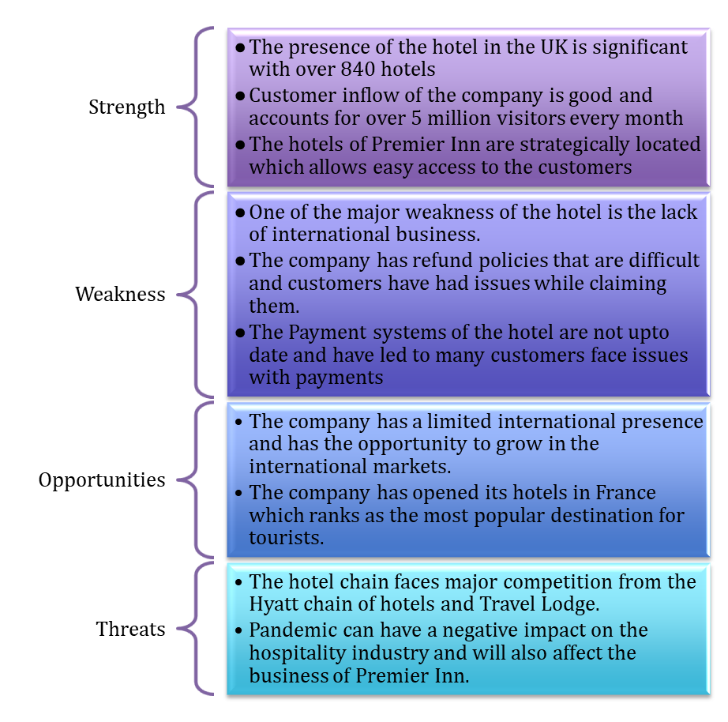
Table No. 1: SWOT analysis of Premier Inn
(Source: Created by the learner)
“Customers- (Segmentation and Targeting/ Customer profile)”
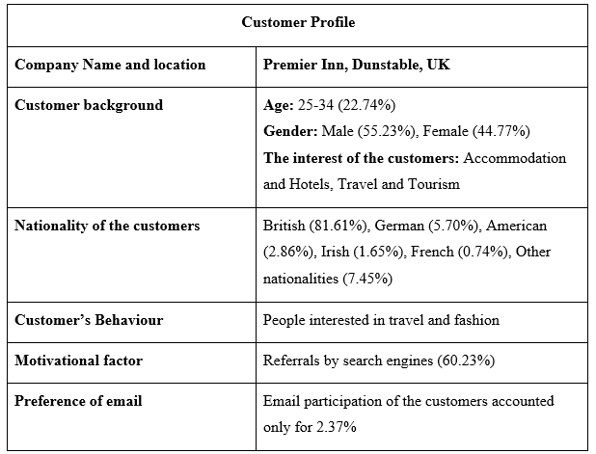
Table No. 2: Customer profile
(Source: Similarweb, 2023)
Competitors
Perceptual Map
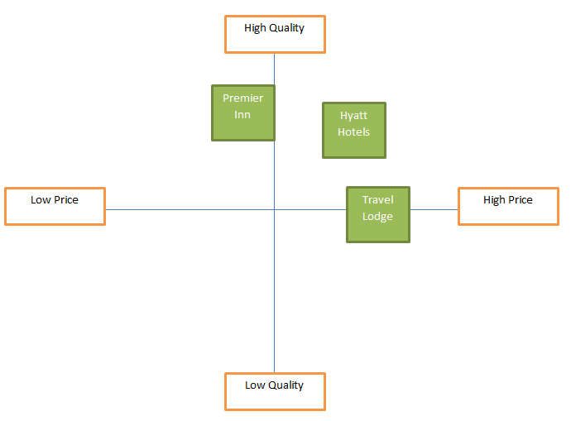
Fig. No.1: Perceptual map
(Source: Created by the learner)
The perceptual map that has been presented has shown that Premier Inn in comparison to its competitors have a lower price point but offers a higher quality of services.
Bowman’s Strategy Clock
Premier Inn may use Bowman's eight techniques to compete. Price and customer value distinguish strategies (Mindtools.com, 2023). The first place is low-priced and low-valued. Low-price businesses rely on big volume. Premier Inn is third because consumers sense excellent value despite cheap pricing. Customers get significant value from organisations in the fourth place. Focused on distinction, the fifth place is high-priced and high-value (Mindtools.com, 2023). Seventh is high price, poor value, while eighth is low value, ordinary price.

Collaborators
Premier Inn has partnered with various other firms to provide value to guests. Costa Coffee, Dubai Parks and Resorts, and others (Premierinn, 2020). This partnership improves Premier Inn's services.
Climate
PESTLE elements | Description
Political | Brexit and the Russia-Ukraine conflict have produced political uncertainty, which hurts the hotel business (Kollewe, 2019).
Economic | Inflation and additional taxes increase operational costs and reduce profitability.
Social | Customer's need for luxury and value has a significant impact on the business.
Technological | Enhancing the experience of the customers by the adoption of technology such as online booking and payments (Davronov and Ismatillayeva, 2019).
Legal | Lawsuits due to breach of policies may negatively impact the brand's reputation.
Environmental | Sustainable programmes and contributions to society enhance the image of the brand (Cerchione and Bansal, 2020).
Table No. 3: Macro analysis
(Source: Created by the learner)
Marketing Mix
Factors | Description
Products | The services of Premier Inn include Luxury hotel rooms, with various amenities.
Price | Price of the rooms is in the range of £50 -£60 as the rooms are luxuries a moderate pricing strategy is employed (Statista, 2022).
Place | The hotel chain has over 800 hotels at various locations within the UK (Anon, 2023).
Promotions | The company makes use of traditional advertisements as well as social media for the purpose of promotion.
Table No. 4: Marketing Mix
(Source: Created by the learner)

3. Objectives
The specific aim of this marketing plan is to determine the strategic approaches that are employed to targeted potentiual audience.

Specific | Measurable | Achievable | Relevant | Time-bound
To increase its online traffic by 5000 | By observing its monthly web traffic | By incorporating effective digital marketing channel | To increase its conversion rate | 3-months
To increase its social media follower by 8000 | By evaluating their monthly increase in follower | By increasing their online and social presence | To increase the awareness of their brand | 2-months
Table No. 5: SMART Objectives
(Source: Created by the learner)

4. Strategy
The new proposition of Premier Inn is focused on improving the brand reputation after receiving poor feedback from the customers. In addition to this, the company has not been able to get good reviews has negatively impacted the business of the Hotel. For this purpose of careful analysis, the company needs to make use of Ansoff’s Matrix Market Development strategy. This will enable the hotel to supply its existing services to the new markets where it will able to improve the image of the brand (Clarissa, 2020).
First, the price of the hotel’s services needs to be changed to make it more competitive with its competitors. In addition to this, the company needs to invest in training its employees and make use of technology to gain an advantageous position. Furthermore, the company has the opportunity to open new hotels at new locations to increase its customer base.

5. Tactics
Communication mix is an evident tool that assists to address the prominent issue according to the current issue of the company, therefore there are various tactics for communicating such as website, advertisements, direct marketing, public relation, sales promotion as well as digital pr (Amin and Priansha, 2019). Essentially, the tactics of the communication mix will focus on providing the essential promotional messages associated with their various channels of communication. Thus significantly, the direct market and advertisement assist the company to build trust and bring more credibility to their business approaches, for instance, the company has facing some technical issues with its navigator software “What3word”. Thus using the tactic of direct marketing and advertisement it was able to comprehend the issue to its customer and create awareness regarding their issue in navigating the system (Anon, 2023). Another issue that the company was associated with was a high threat from its competitors like Sixsens and holiday inn and timely conflicts and issues. Thus the tactic of Public Relations is effective for the company to build a better communicative channel among its business rivals and customers (Twum and Yalley, 2021). The tactic of public relations assists to help resolve the ongoing dispute with its competitors in the industry.
The tactic of communication mix is a potential strategy which can be incorporated by the Premier Inn to make substantial improvements in their current aspects of the marketing mix. Thus the prominent changes that can be made are the company adopting a competitive pricing strategy in order to create a competitive environment in its industry while also securing better profits and attracting more travellers. Therefore Premier Inn can adopt new technological advancements in order to enhance their customer services and effectively manage the requirements of the customers. Thus the company can initiate to provide with various additional services such as tour guides, car rentals and excursions in order to facilitate their consumers with a greater value of their service and products. Therefore the company can approach better promotional strategies in order to ensure the constant promotion of their services and seasonal offers. Lastly, especially focusing on social media promotion will help the company to promote its new activities and connect with larger groups of travellers which will also assist to grow the business.

6. Action
Name of the company: Premier Inn
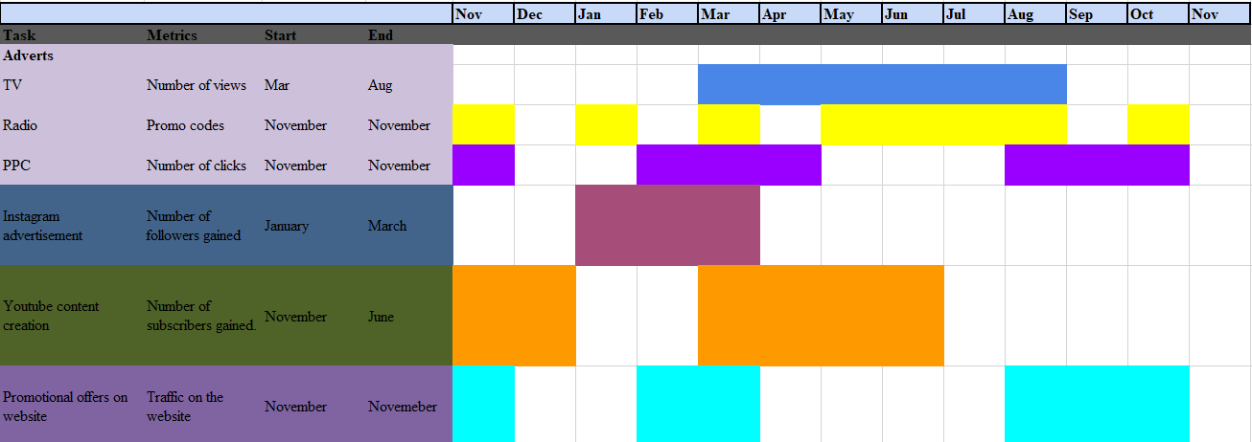Table No. 6: Gantt Chart
(Source: Created by the learner)
These channels were used keeping in mind the diverse demographics of the customers. The use of Radio was used to target older people while TV helped to target younger generations who were more inclined to visual advertisements. Advertisements via television were done from March to August as this period marked the highest demand for hotels. The metrics were collected on the basis of the number of views and tune-in to the radio frequencies. For PPC the number of clicks made by the customers was calculated. Other metrics included ROI and impressions.

7. Control
Measuring the success is a prominent aspect for businesses inorder to track their positive transition and observe the rate of success, inorder to measure the success of this marketing plan it will specifically assess the monthly increase rate of new customers. Therefore it will also observe the positive initiative that has been adopted by the company along with their overall increase in sales and profits. Thus, market development strategy has helped the organisation supply their present service in a new market, giving them additional commercial prospects. Thus, many communication tactics have been used to handle scenario analysis and help the organisation improve services.

8. Conclusion
In conclusion, this essay lays out a whole marketing strategy for Premier Inn in order to establish who the organisation should be focusing its attention on as customers. In the article, a scenario analysis is discussed, which evaluates the internal and external environments of the market using a SWOT analysis, a PESTLE analysis, and a marketing mix. In addition to that, it delves into the use of a variety of tactics, including "Bowman's Strategy Clock," market development, and communication technique. In conclusion, it uses a variety of key performance indicators (KPIs) in order to assess the level of success achieved by the marketing strategy.

References
Amin, M. and Priansah, P., (2019). Marketing communication strategy to improve tourism potential. Budapest International Research and Critics Institute-Journal (BIRCI-Journal), 2(4), pp.160-166.
Anon., (2023). hotels. [online] Available at: https://www.premierinn.com/gb/en/hotels.html [Accessed 20 May 2023].
Anon., (2023). what3words. [online] Available at: https://www.premierinn.com/gb/en/news/2019/what3words.html [Accessed 20 May 2023].
Cerchione, R. and Bansal, H., (2020). Measuring the impact of sustainability policy and practices in tourism and hospitality industry. Business Strategy and the Environment, 29(3), pp.1109-1126.
Clarissia, S.M.S., (2020). A study on Ansoff Matrix Technique: As a growth strategy and an adaptive learning technique adopted in the leading brand of products. BIMS Journal of Management, p.18.
Davronov, I.O. and Ismatillayeva, S.S., (2019). Тhe role of innovative technologies for improving economy of hotels.
Hospitality Net., (2023). Premier Inn by Whitbread PLC. [online] Available at: https://www.hospitalitynet.org/brand/23000188/premier-inn.html [Accessed 20 May 2023].
Kollewe, J., (2019). Premier Inn owner says Brexit uncertainty has hit bookings. [online] the Guardian. Available at: https://www.theguardian.com/business/2019/apr/30/premier-inn-owner-brexit-bookings-whitbread-london#:~:text=Premier%20Inn%20owner%20Whitbread%20has,among%20business%20travellers%20outside%20London. [Accessed 20 May 2023].
Mindtools.com., (2023). MindTools | Home. [online] Available at: https://www.mindtools.com/a2rq300/bowmans-strategy-clock [Accessed 20 May 2023].
Premierinn.com., (2020). Premier Inn Hotel Partners and Tourist Attractions. [online] Available at: https://mena.premierinn.com/en/attractions-partners [Accessed 20 May 2023].
Qld.gov.au., (2022). Using direct marketing | Business Queensland. [online] Available at: https://www.business.qld.gov.au/running-business/marketing-sales/marketing/activities/direct-marketing [Accessed 20 May 2023].
Similarweb., (2023). Similarweb. [online] Available at: https://www.similarweb.com/website/premierinn.com/#traffic-sources [Accessed 20 May 2023].
Small Business - Chron.com., (2019). What Is a Marketing Communication Mix? [online] Available at: https://smallbusiness.chron.com/marketing-communication-mix-63541.html [Accessed 20 May 2023].
Statista., (2022). Premier Inn ARR 2022 | Statista. [online] Available at: https://www.statista.com/statistics/740692/premier-inn-arr-average-room-rate/ [Accessed 20 May 2023].
Twum, K.K. and Yalley, A.A., (2021). Green Integrated Marketing Communication. Green Marketing in Emerging Markets: Strategic and Operational Perspectives, pp.117-144
‌

‌

‌

Appendix A: SMART TABLE
Specific | Measurable | Achievable | Relevant | Time-bound
To increase its online traffic by 5000 | By observing its monthly web traffic | By incorporating effective digital marketing channel | To increase its conversion rate | 3-months
To increase its social media follower by 8000 | By evaluating their monthly increase in follower | By increasing their online and social presence | To increase the awareness of their brand | 2-months

Appendix B: Marketing Mix

Factors | Description
Products | The services of Premier Inn include Luxury hotel rooms, with various amenities.
Price | Price of the rooms is in the range of £50 -£60 as the rooms are luxuries a moderate pricing strategy is employed (Statista, 2022).
Place | The hotel chain has over 800 hotels at various locations within the UK (Anon, 2023).
Promotions | The company makes use of traditional advertisements as well as social media for the purpose of promotion.

Appendix C: PESTLE Analysis

PESTLE elements | Description
Political | The political instability that is caused by Brexit and the recent Russia-Ukarine war has negative implications for the hospitality industry (Kollewe, 2019).
Economic | Inflation and additional taxes increase operational costs and reduce profitability.
Social | Customer's need for luxury and value has a significant impact on the business.
Technological | Enhancing the experience of the customers by the adoption of technology such as online booking and payments (Davronov and Ismatillayeva, 2019).
Legal | Lawsuits due to breach of policies may negatively impact the brand's reputation.
Environmental | Sustainable programmes and contributions to society enhance the image of the brand (Cerchione and Bansal, 2020).

Appendix D: Perceptual map

Appendix E: Customers- (Segmentation and Targeting/ Customer profile)

Customer Profile
Company Name and location | Premier Inn, Dunstable, UK
Customer background | Age: 25-34 (22.74%)  Gender: Male (55.23%), Female (44.77%)  The interest of the customers: Accommodation and Hotels, Travel and Tourism
Nationality of the customers | British (81.61%), German (5.70%), American (2.86%), Irish (1.65%), French (0.74%), Other nationalities (7.45%)
Customer’s Behaviour | People interested in travel and fashion
Motivational factor | Referrals by search engines (60.23%)
Preference of email | Email participation of the customers accounted only for 2.37%

Appendix F: Company- Swot Analysis

Appendix G: GANTT Chart for action plan

Appendix H: Presentation Slides

